MANUSCRIPT TITLE
Ming Su^{1,2}, and Min Yang^{1,2,✉}
2025-01-05
Abstract
ABSTRACT
¹ State Key Laboratory of Environmental Aquatic Chemistry, Research Center for Eco-Environmental Sciences, Chinese Academy of Sciences
² University of Chinese Academy of Sciences
✉ Correspondence: Min Yang <yangmin@rcees.ac.cn>

Introduction
为什么做这个东西，做这个东西的意义
别人怎么做的，别人为什么没能完成，别人做到了那些程度，
我们怎么做的，不同在哪
TBD

Materials and Methods

Study sites
TBD

Sampling procedure
TBD

Laboratory water quality analysis
TBD

Phytoplankton quantification
TBD

Data analysis
TBD
$$N\left(t\right)=\frac{K}{1+\frac{K−N_{0}}{N_{0}}e^{−rt}} \left(1\right)$$
$$d2t = 1 - bT\left( \frac{N(t)}{K} \right)^{`} = 1 - bT\frac{are^{rt}}{e^{2rt} + {2ae}^{rt} + a^{2}}\quad\quad(2)$$
$$d2t=\frac{1}{2}+\frac{K−N\left(t\right)}{K}c+d \left(3\right)$$
Where.

Results

Spatiotemporal distribution characteristics of mib in Lake Taihu
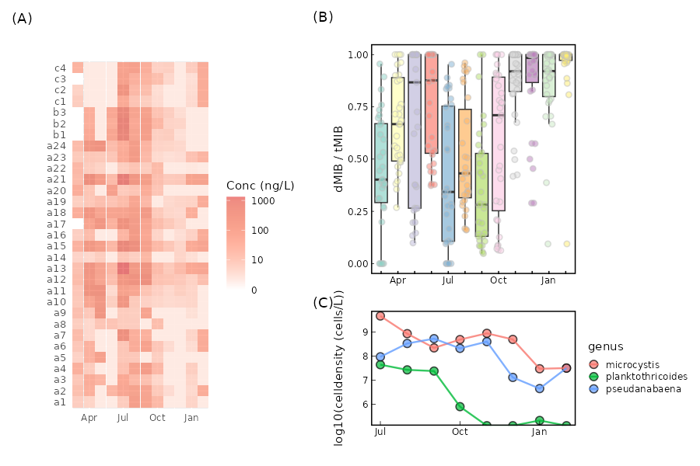

Construction of model between the cultured algae growth and d2t change
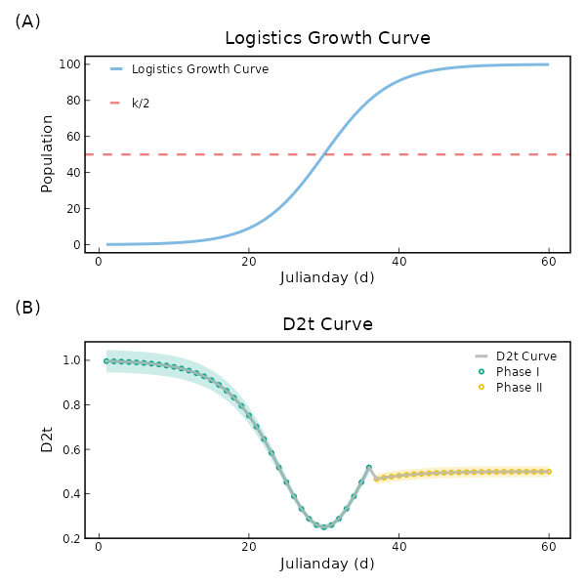
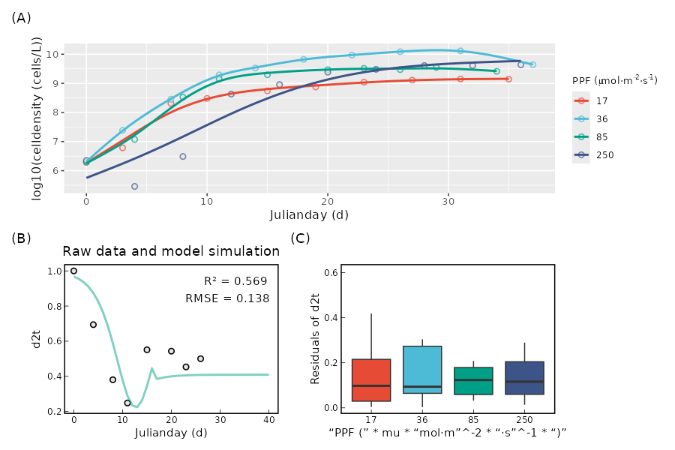

Field application of d2t model for MIB warning
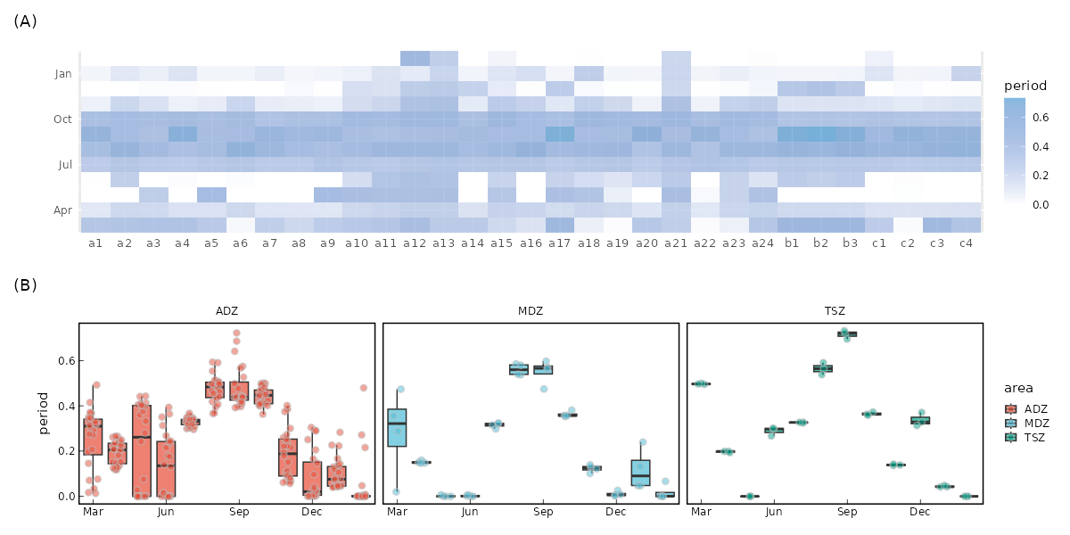
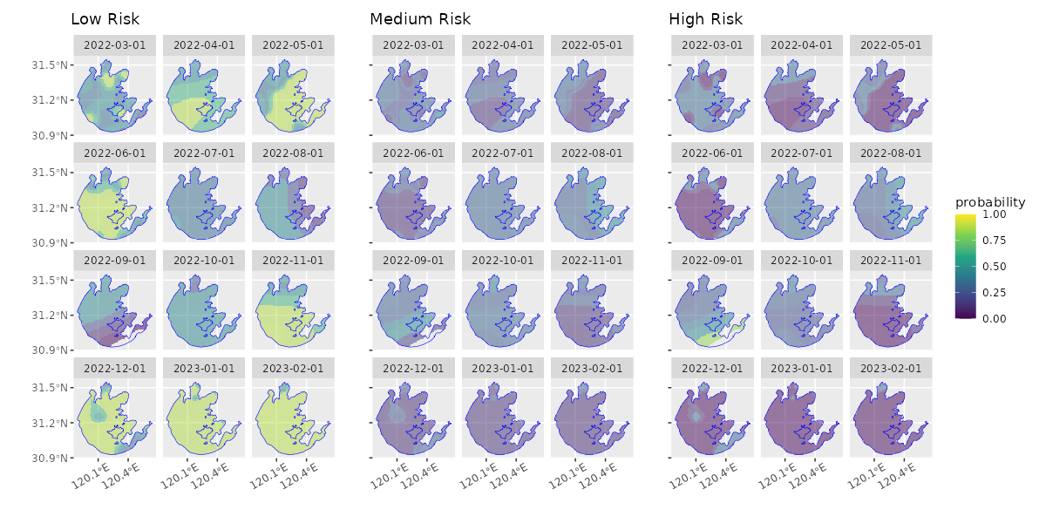

Discussion

Biological interpretation of the d2t model
(I) When the cell density is low, the change in d2t is represented by the variation in environmental carrying capacity; (II)when the cell density exceeds 80% of K, the change is represented by the remaining environmental carrying capacity.

The difference of d2t model between different algae species
不同藻种d2t模型的区别，提出从10%K到达50%K的时间T0作为比较的值
……拓展到全国样品

Conclusion
TBD

Declaration of Competing Interest
The authors declare that they have no known competing financial interests or personal relationships that could have appeared to influence the work reported in this paper.

Acknowledgements
This work was financially supported by the National Natural Science Foundation of China (52030002, 51878649), and Youth Innovation Promotion Association CAS.

References

