MANUSCRIPT TITLE
Ming Su^{1,2}, and Min Yang^{1,2,✉}
2025-01-25
Abstract
ABSTRACT
¹ State Key Laboratory of Environmental Aquatic Chemistry, Research Center for Eco-Environmental Sciences, Chinese Academy of Sciences
² University of Chinese Academy of Sciences
✉ Correspondence: Min Yang <yangmin@rcees.ac.cn>

Introduction
为什么做这个东西，做这个东西的意义
别人怎么做的，别人为什么没能完成，别人做到了那些程度，
我们怎么做的，不同在哪
TBD

Materials and Methods

Study area and sampling
Lake Taihu (30°55’40”-31°32’58”N, 119°52’32”-120°36’10”E), located in the southeastern part of the Yangtze River Delta, is the third largest shallow freshwater lake in China, with a surface area of 2,578 km². In recent years, rapid industrialization and urbanization in the surrounding watershed have led to increasingly frequent outbreaks of algal blooms. Microcystis and Pseudanabaena have become the dominant harmful algal species in the lake, resulting in deteriorating water quality. The presence of microcystins and the odorous compound 2-methylisoborneol (2-MIB) has further impacted water usage in the surrounding regions. From March 2022 to February 2023, water samples were collected monthly from 31 sampling sites distributed across different regions of the lake (see Figure). With an average depth of approximately 2 meters and well-mixed conditions, approximately 2 liters of surface water samples were collected from 0.5 meters below the water surface using a Kemmerer water sampler.

Phytoplankton identification and physicochemical analysis
Subsamples (1000 mL) for cell counting were preserved with 5% Lugol’s iodine solution (Sherr and Sherr, 1993) and allowed to settle for 48 hours. The samples were then pre-concentrated 20-fold and stored in the dark until cell enumeration. Cyanobacterial species were identified according to Komárek and Anagnostidis (1998), with revisions based on Komárek et al. (2014). Phytoplankton identification and enumeration were performed using an upright microscope (Olympus BX53, Japan) following the protocol established by Utermöhl (1958). Subsamples for 2-methylisoborneol (MIB) analysis were stored in amber glass bottles with airtight seals. The production potential of MIB was calculated by measuring its total concentration. To prevent biodegradation, 10 mg L⁻¹ HgCl₂ was added to the samples (Li et al., 2010), and analysis was conducted within 72 hours using solid-phase microextraction (SPME) coupled with gas chromatography-mass spectrometry (GC-MS) (Agilent 6890/5975, Agilent Tech., USA) following the procedures established by Liang et al. (2005) and previous studies (Su et al., 2015). In situ measurements of physicochemical variables, including water temperature, pH, dissolved oxygen (DO), turbidity, and conductivity, were performed using a multiparameter probe (EXO2, USA). Water transparency was measured using a 20 cm diameter Secchi disk with alternating black and white quadrants, expressed as Secchi depth (SD). Nutrient concentrations, including nitrate, nitrite, ammonia, total nitrogen (TN), and total phosphorus (TP), were analyzed according to Chinese national standard methods.

Data analysis
The Logistic growth model was employed to fit the changes in cell density of cultured Pseudanabaena (Equation 1).
$$N\left(t\right)=\frac{K}{1+\frac{K−N_{0}}{N_{0}}e^{−rt}} \left(1\right)$$
$$a=\frac{K−N_{0}}{N_{0}} \left(2\right)$$
In this model, K represents the environmental carrying capacity, which is the maximum cell density that the algal population can achieve under specific environmental conditions. N₀ denotes the initial cell density at time t = 0, and r represents the intrinsic growth rate, reflecting the maximum growth rate of the cells under ideal conditions. In aquatic environments, 2-methylisoborneol (MIB) primarily exists in two forms: dissolved MIB (dMIB) and cell-bound MIB (cMIB). The sum of these two forms constitutes the total MIB (tMIB). The dMIB is mainly released into the water environment through the lysis and death of odor-producing algal cells. To elucidate the dynamics of dMIB and tMIB during the cultivation of Pseudanabaena, a model was developed to describe the ratio of dMIB to tMIB (denoted as d2t) over time. Since dMIB is associated with cell lysis and death, the change in d2t was modeled using the variation in environmental carrying capacity when the cell density was low (less than 80% of K) (Equation 3). When the cell density approached K (greater than 80% of K), the remaining environmental carrying capacity was used to represent the change in d2t (Equation 4).
$$d2t=1−bT{\left(\frac{N\left(t\right)}{K}\right)}^{′}=1−bT\frac{are^{rt}}{e^{2rt}+{2ae}^{rt}+a^{2}} \left(3\right)$$
$$d2t=\frac{1}{2}+\frac{K−N\left(t\right)}{K}c+d \left(4\right)$$
In these equations, b and c are coefficients of variation, T is the doubling time of the algal cells under cultivation conditions, and d is a correction factor that accounts for the accumulation and volatilization effects of MIB in the cultivation system.

Results

Spatiotemporal distribution characteristics of mib in Lake Taihu
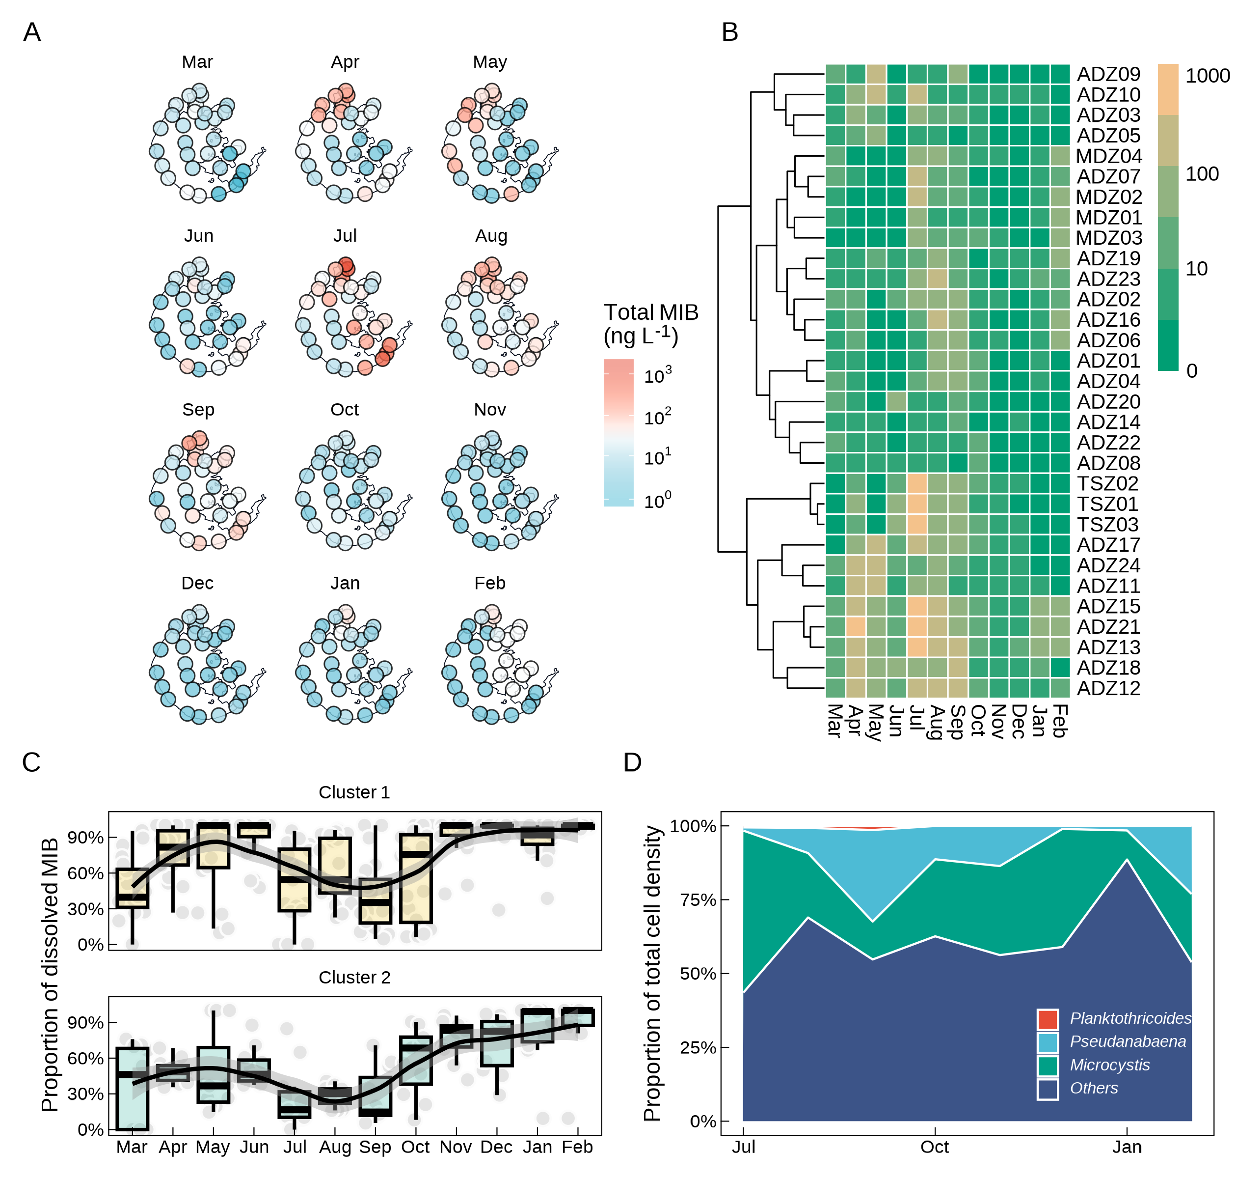

Construction of model between the cultured algae growth and d2t change
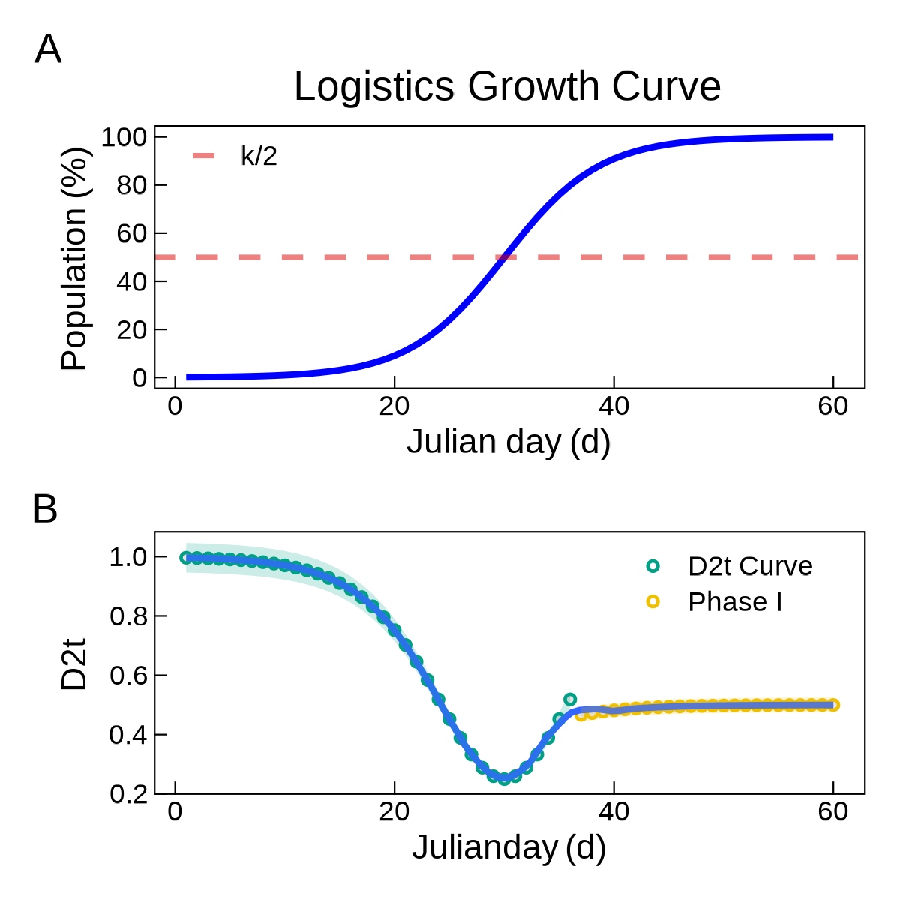
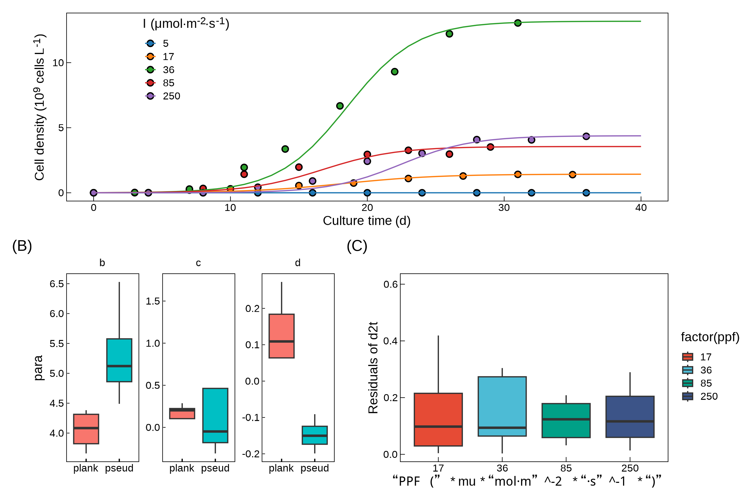
Fig. 1

Field application of d2t model for MIB warning
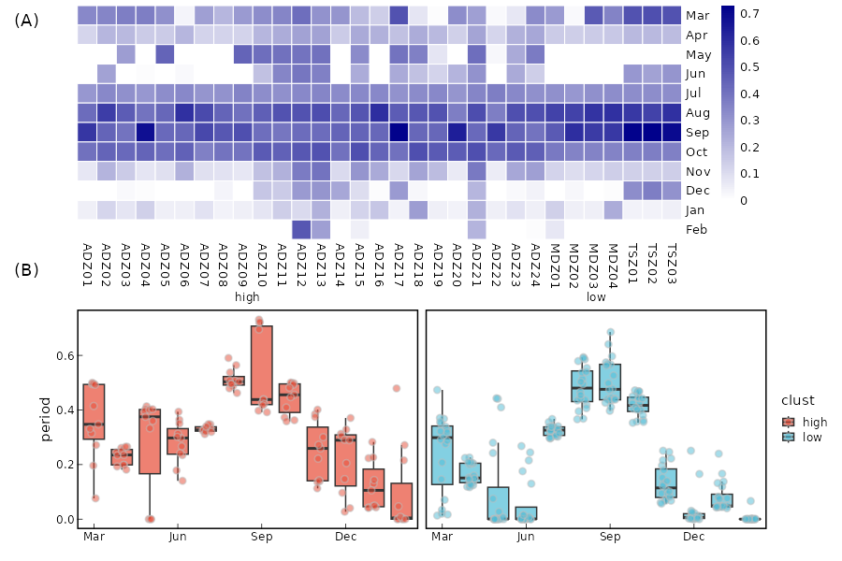
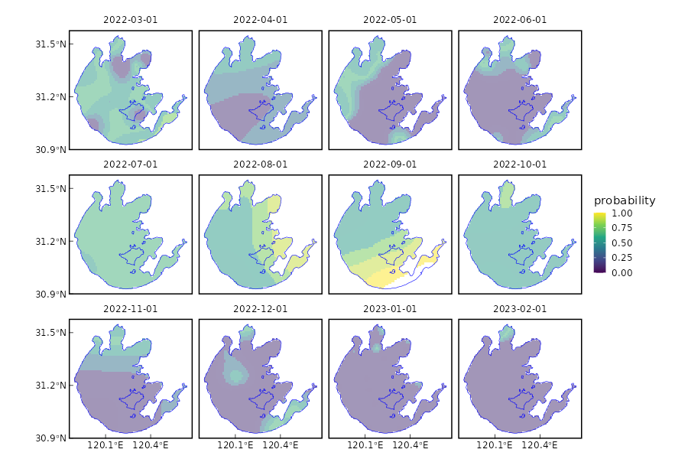
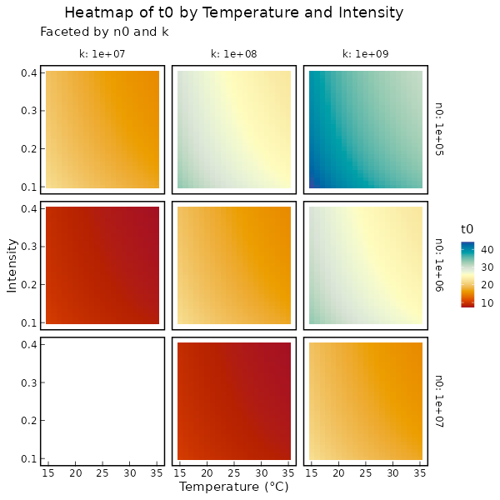
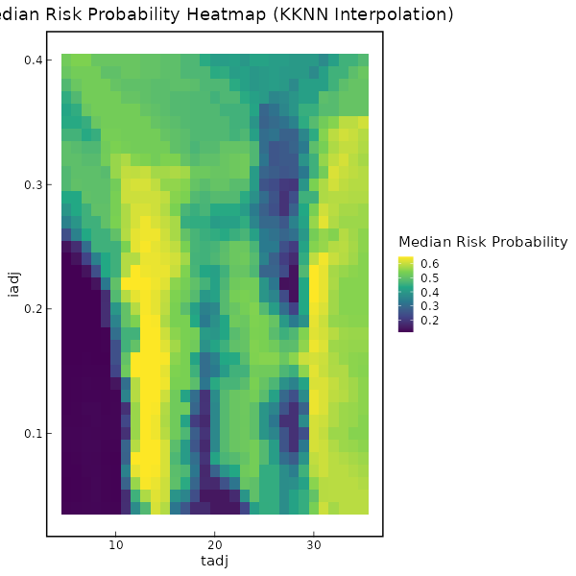

Discussion

Biological interpretation of the d2t model
(I) When the cell density is low, the change in d2t is represented by the variation in environmental carrying capacity; (II)when the cell density exceeds 80% of K, the change is represented by the remaining environmental carrying capacity.

The difference of d2t model between different algae species
不同藻种d2t模型的区别，提出从10%K到达50%K的时间T0作为比较的值
……拓展到全国样品

Conclusion
TBD

Declaration of Competing Interest
The authors declare that they have no known competing financial interests or personal relationships that could have appeared to influence the work reported in this paper.

Acknowledgements
This work was financially supported by the National Natural Science Foundation of China (52030002, 51878649), and Youth Innovation Promotion Association CAS.

References

