MANUSCRIPT TITLE
Ming Su^{1,2}, and Min Yang^{1,2,✉}
2025-03-06
Abstract
ABSTRACT
¹ State Key Laboratory of Environmental Aquatic Chemistry, Research Center for Eco-Environmental Sciences, Chinese Academy of Sciences
² University of Chinese Academy of Sciences
✉ Correspondence: Min Yang <yangmin@rcees.ac.cn>

Introduction
为什么做这个东西，做这个东西的意义
别人怎么做的，别人为什么没能完成，别人做到了那些程度，
我们怎么做的，不同在哪
TBD

Materials and Methods

Study area and sampling
Lake Taihu (30°55’40”-31°32’58”N, 119°52’32”-120°36’10”E), located in the southeastern part of the Yangtze River Delta, is the third largest shallow freshwater lake in China, with a surface area of 2,578 km². In recent years, rapid industrialization and urbanization in the surrounding watershed have led to increasingly frequent outbreaks of algal blooms. Microcystis and Pseudanabaena have become the dominant harmful algal species in the lake, resulting in deteriorating water quality. The presence of microcystins and the odorous compound 2-methylisoborneol (2-MIB) has further impacted water usage in the surrounding regions. From March 2022 to February 2023, water samples were collected monthly from 31 sampling sites distributed across different regions of the lake (see Figure). With an average depth of approximately 2 meters and well-mixed conditions, approximately 2 liters of surface water samples were collected from 0.5 meters below the water surface using a Kemmerer water sampler.

Phytoplankton identification and physicochemical analysis
Subsamples (1000 mL) for cell counting were preserved with 5% Lugol’s iodine solution (Sherr and Sherr, 1993) and allowed to settle for 48 hours. The samples were then pre-concentrated 20-fold and stored in the dark until cell enumeration. Cyanobacterial species were identified according to Komárek and Anagnostidis (1998), with revisions based on Komárek et al. (2014). Phytoplankton identification and enumeration were performed using an upright microscope (Olympus BX53, Japan) following the protocol established by Utermöhl (1958). Subsamples for 2-methylisoborneol (MIB) analysis were stored in amber glass bottles with airtight seals. The production potential of MIB was calculated by measuring its total concentration. To prevent biodegradation, 10 mg L⁻¹ HgCl₂ was added to the samples (Li et al., 2010), and analysis was conducted within 72 hours using solid-phase microextraction (SPME) coupled with gas chromatography-mass spectrometry (GC-MS) (Agilent 6890/5975, Agilent Tech., USA) following the procedures established by Liang et al. (2005) and previous studies (Su et al., 2015). In situ measurements of physicochemical variables, including water temperature, pH, dissolved oxygen (DO), turbidity, and conductivity, were performed using a multiparameter probe (EXO2, USA). Water transparency was measured using a 20 cm diameter Secchi disk with alternating black and white quadrants, expressed as Secchi depth (SD). Nutrient concentrations, including nitrate, nitrite, ammonia, total nitrogen (TN), and total phosphorus (TP), were analyzed according to Chinese national standard methods.

Model Development
The Logistic growth model was employed to fit the changes in cell density of cultured Pseudanabaena (Equation 1).
$$N\left(t\right)=\frac{K}{1+\frac{K−N_{0}}{N_{0}}e^{−rt}} \left(1\right)$$
$$θ=\frac{K−N_{0}}{N_{0}} \left(2\right)$$
The parameter K represents the environmental carrying capacity, which denotes the maximum cell density that algae can reach under specific environmental conditions. N0 is the initial cell density at t = 0, while r represents the intrinsic growth rate, indicating the maximum growth rate of cells under ideal conditions. θ denotes the initial growth potential.
In aquatic environments, MIB primarily exists in two forms: dissolved MIB (dMIB) and cell-bound MIB, with their sum constituting the total MIB (tMIB). The dMIB fraction is mainly released into the water due to the lysis of odor-producing cyanobacterial cells. The ratio f (dMIB/tMIB) serves as an odor index, reflecting both the proportion of dissolved MIB in total MIB and the relative abundance of cells at different growth stages. To characterize the temporal variation of dMIB and tMIB produced by Pseudanabaena during cultivation, a time-dependent model for f was constructed. Since dMIB is associated with cell lysis and death, different approaches were used to describe the variation of f based on cell density. When the cell density was low (less than 80% of K), changes in the carrying capacity were used to express the variation in f (Equation 3). When the cell density approached K (greater than 80% of K), the remaining carrying capacity was used instead (Equation 4).
$$f=1−α_{1}T{\left(\frac{N\left(t\right)}{K}\right)}^{′}=1−α_{1}T\frac{θre^{rt}}{e^{2rt}+{2θe}^{rt}+θ^{2}} \left(3\right)$$
$$d2t=\frac{1}{2}+\frac{K−N\left(t\right)}{K}α_{2}+β \left(4\right)$$
In this model, α1 and α2 are variation coefficients, T represents the cell doubling time under cultivation conditions, and β is a correction factor that accounts for the accumulation and volatilization effects of MIB in the cultivation system. Logistic curve fitting was applied to the cell growth data under various environmental conditions using Equation (1), yielding the initial cell density (N0), environmental carrying capacity (K), and intrinsic growth rate (r). These parameters, along with f and t, were then incorporated into Equations (3) and (4), and linear regression was employed to estimate the model parameters α1, α2 and β along with their statistical significance. Furthermore, by adjusting the intrinsic growth rate r, this model enables the simulation of potential trends in cell growth and MIB production under different environmental conditions.

Statistical analysis and illustration
All data analysis and illustration were performed using R 4.4.2. Data pretreatment and summary were performed using the dplyr package in R, regression analysis including linear and generalized linear models were performed using the stats package, generalized additive modeling was performed using the mgcv package quantile regression analysis was performed using the quantreg package; contour figures were created by the graphics package, other figures were prepared using the ggplot2 package.

Results

Spatiotemporal distribution characteristics of mib in Lake Taihu
Between March 2022 and February 2023, two severe MIB outbreaks were observed in Taihu Lake (Fig. 1A). The high MIB concentration outbreaks primarily occurred in the spring (40.04 ± 77.52 ng L$​^{−1}$) and summer (106.73 ± 230.38 ng L$​^{−1}$), with significant peaks in April (66.47 ± 101.47 ng L$​^{−1}$) and July (232.45 ± 360.68 ng L$​^{−1}$), demonstrating a marked seasonality (p < 0.001). Notably, between the two MIB outbreaks, the MIB concentrations in June across the lake were relatively low. In addition to seasonal variation, the distribution of MIB concentrations across the lake also exhibited spatial heterogeneity. The regions with the highest MIB concentrations were mainly concentrated in the northern Meiliang Bay area and the southeastern East Taihu Lake area. The April MIB peak was primarily centered around Meiliang Bay, while the July peak was predominantly observed in both Meiliang Bay and East Taihu Lake.
A cluster analysis was performed on MIB concentrations from all 31 sampling sites throughout the year, classifying them into five distinct clusters (Clust1–Clust5) based on concentration levels. These clusters also corresponded spatially to five distinct lake regions (Fig. S). The highest MIB concentrations during both outbreak periods were primarily located within Clust4 and Clust5.Furthermore, analysis of the variation in f at different clusters revealed a characteristic trend: during the decline phase of f, the lowest values were often followed by an MIB outbreak (Fig. 1C). Concurrent analysis of odor-producing cyanobacteria in water samples using epic-PCR identified Pseudanabaena and Planktothricoides as the dominant MIB-producing species during the study period. The spatial distribution of their cell densities is shown in Fig. 1D, with Microcystis identified as the dominant cyanobacterial genus in Taihu Lake. Throughout the sampling period, Pseudanabaena was the primary MIB-producing species, reaching its highest relative abundance (31.0%) in September. In contrast, Planktothricoides had a much lower relative abundance, accounting for only 1.4%.

Construction of model between the cultured algae growth and f change
In the previous analysis, a distinct pattern in the f was observed in Taihu Lake water samples. Concurrently, pure cultures of the two odor-producing cyanobacteria from Taihu Lake were grown under different light conditions. It was found that during their growth and odor production, the f initially decreased. This ratio reached its lowest point at approximately half of the maximum cell density. During this phase, both dMIB and tMIB concentrations increased slowly. Subsequently, the ratio began to increase gradually and eventually stabilized near 0.5, with dMIB and tMIB concentrations rising rapidly during this period.
To characterize this pattern, a logistic growth-based model was constructed to express the variations in the f. Logistic fitting of the growth of Pseudanabaena and Planktothricoides (Fig. 3A) showed good fit results. Based on the f variations during the growth period, the model parameters α1, α2 and β were derived. Fig. 3B compares the model parameters for both odor-producing cyanobacteria, revealing significant differences in the parameters α1 and β. The parameter α1 for Pseudanabaena was significantly greater than that for Planktothricoides (p-value = TBD), while the parameter β showed the opposite trend (p-value = TBD). The distribution of the model parameters under different conditions is shown in Fig. 3C, demonstrating a good fitting performance.
#> Converting page 1 to ../figures/modelconceptnew.png... done!
#> Converting page 2 to ../figures/modelconceptnew.png... done!
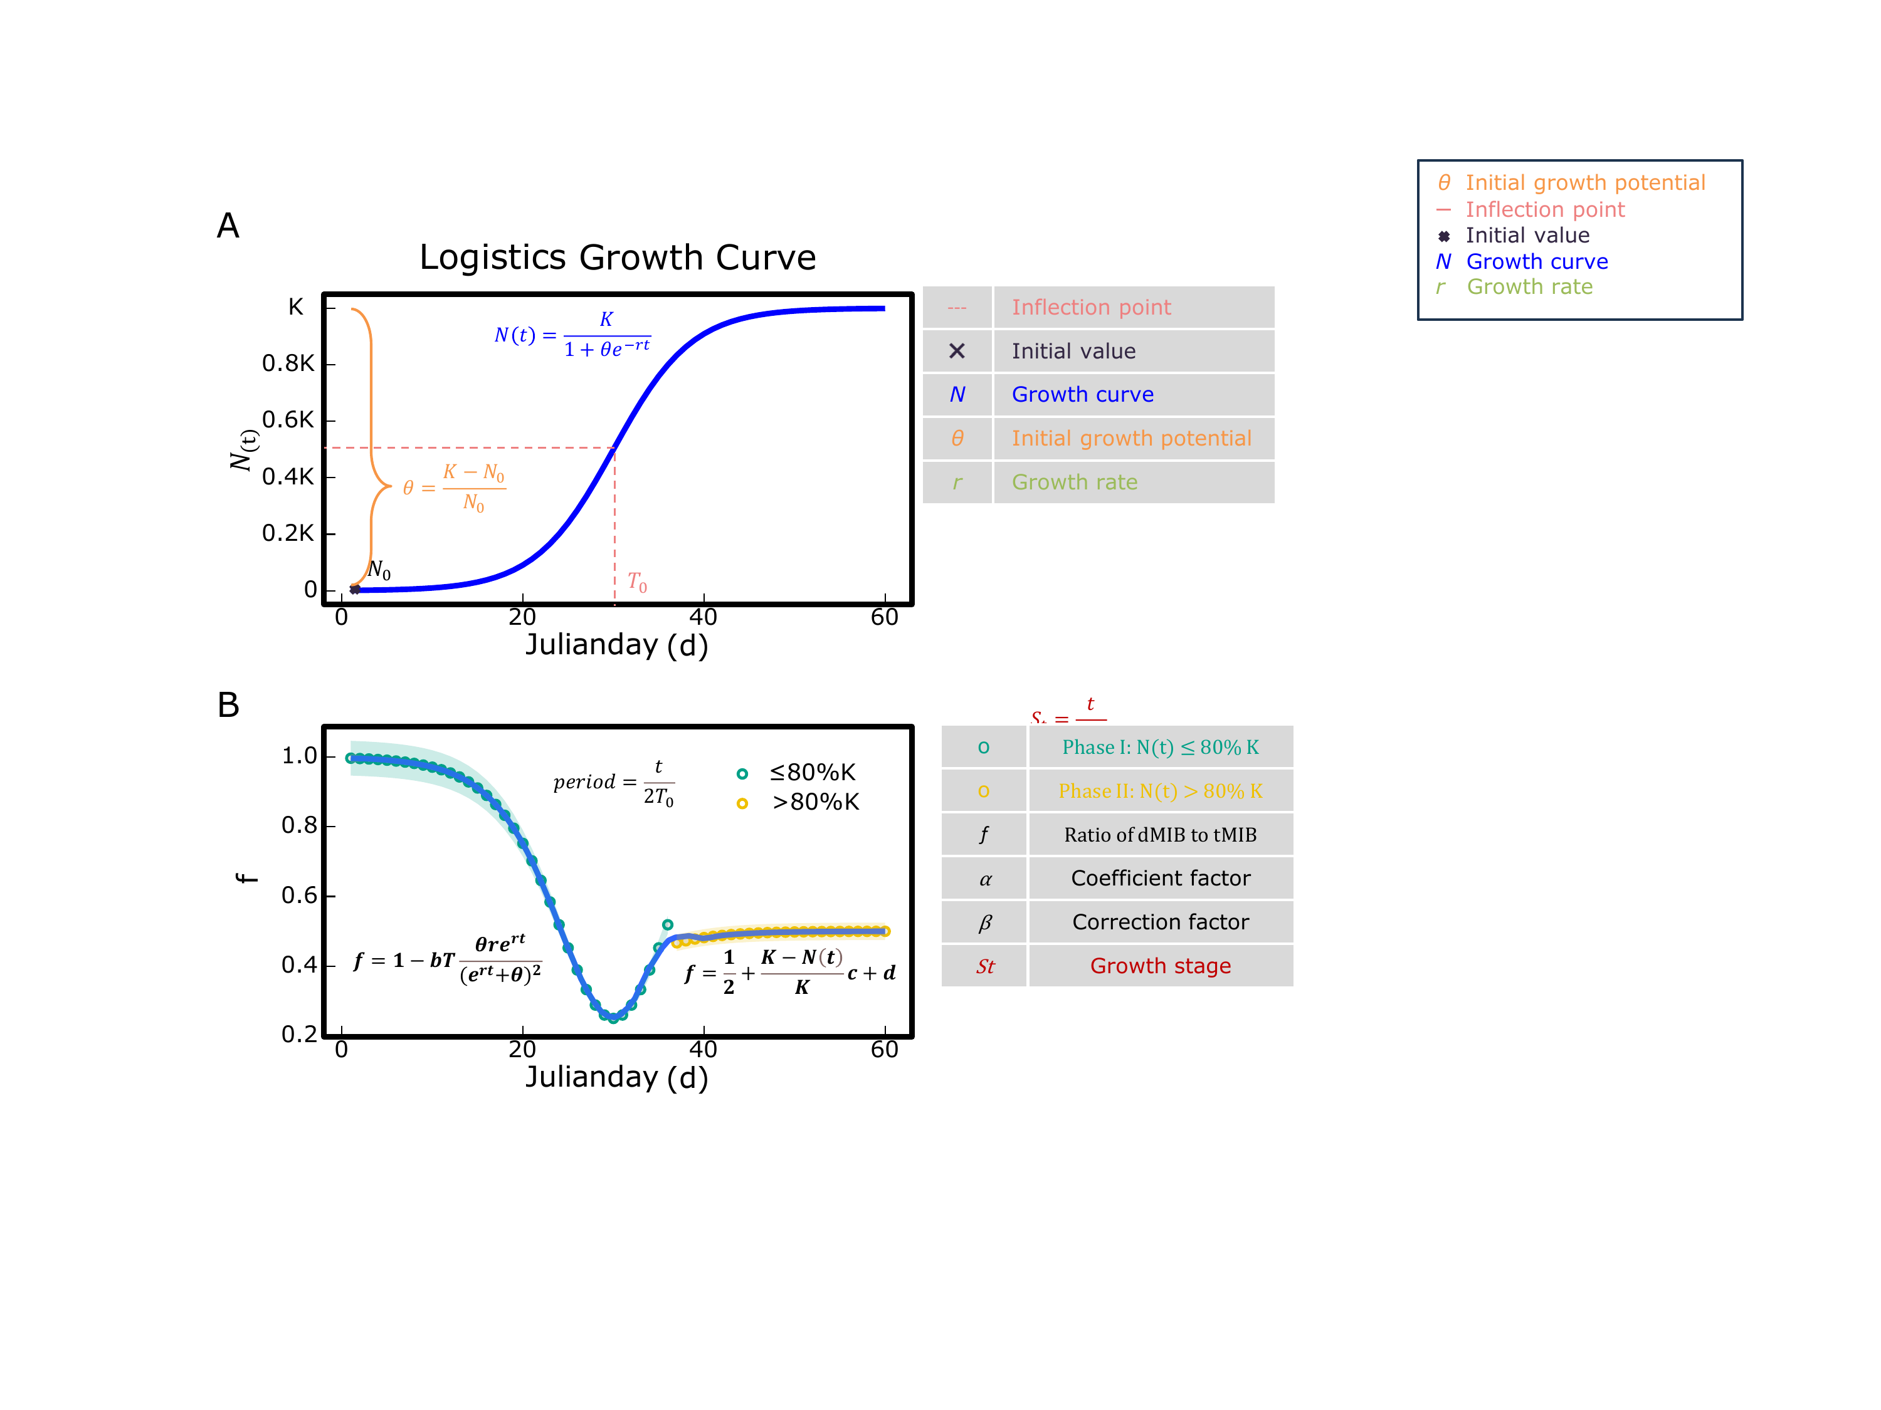
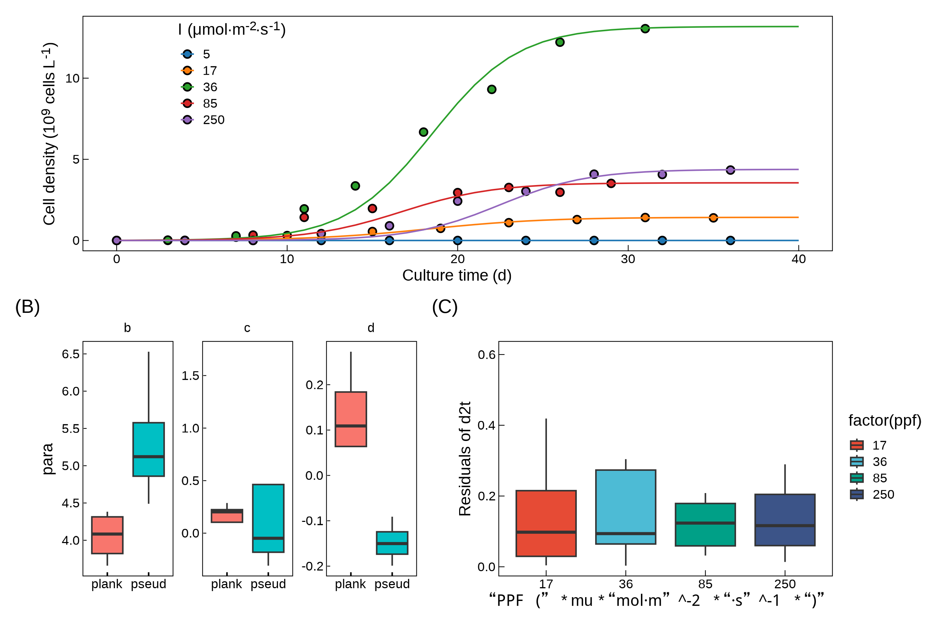
Fig. 1

Field application of f model for MIB warning
After establishing the model based on the cultivation data, it was applied to the various sampling points in Taihu Lake to calculate the growth information of the odor-producing cyanobacteria at each location and determine the period values. The growth of odor-producing cyanobacteria at different sampling points in Taihu Lake exhibited two distinct growth trends throughout the year. As temperatures increased, a significant growth phase occurred from May to November, followed by a smaller-scale growth period between December and April after the winter production. The two distinct cell density growth phases in different seasons led to two separate MIB concentration peaks in Taihu Lake throughout the year. Further analysis of the growth stages of odor-producing cyanobacteria at different cluster locations revealed that TBD…
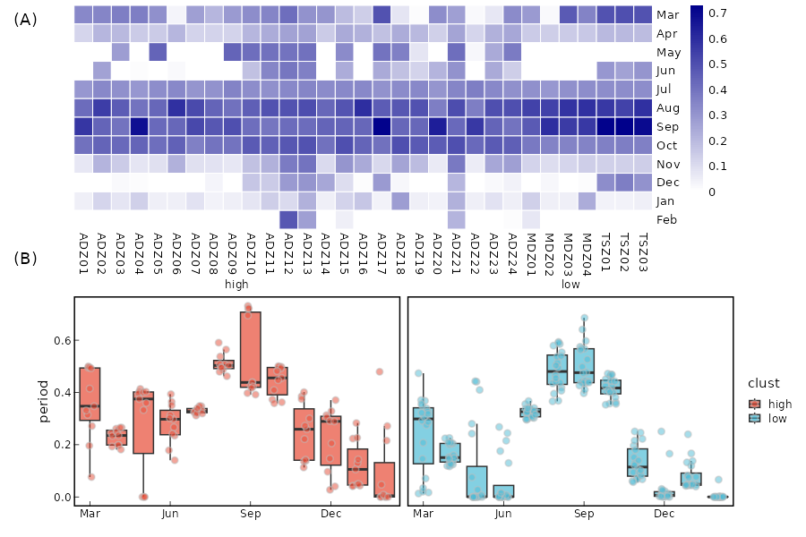
To extend the model’s application to the entire Taihu Lake, data on water temperature, solar radiation, and odor-producing cyanobacteria growth under different conditions from various sources were collected for different months. Based on temperature and light intensity, a relationship with the intrinsic growth rate (r) of the cyanobacteria was established. The model was then applied to Taihu Lake as a whole, yielding growth stage data for odor-producing cyanobacteria in different regions, as shown in Fig. 5. It was found that the distribution of the growth stages of odor-producing cyanobacteria exhibited seasonal differences. From spring (starting in March 2022) to winter (ending in February 2023), the growth stages across the lake showed an increasing trend followed by a decrease. Spatially, in different seasons, the northern and East Taihu Lake regions exhibited significantly higher growth stages than other areas.
In general, the seasonal pattern was as follows: in early spring, odor-producing cyanobacteria began to grow earliest in the northwest and southeast regions; by summer, most of the lake had growth; in autumn, the northern, southern, and East Taihu Lake regions were in the later stages of growth; and in winter, except for a small part of the northern lake region, the growth of odor-producing cyanobacteria was minimal across the lake.
Further analysis of the relationship between the period and tMIB revealed the distribution of odor risk throughout the year in Taihu Lake. The probability of MIB concentrations exceeding 10 ng/L was highest in early spring and summer, with lower probabilities of exceeding the threshold in other seasons. The northern (Meiliang Bay) and southeastern (East Taihu Lake) regions exhibited a higher risk of MIB concentrations exceeding the threshold compared to other areas.
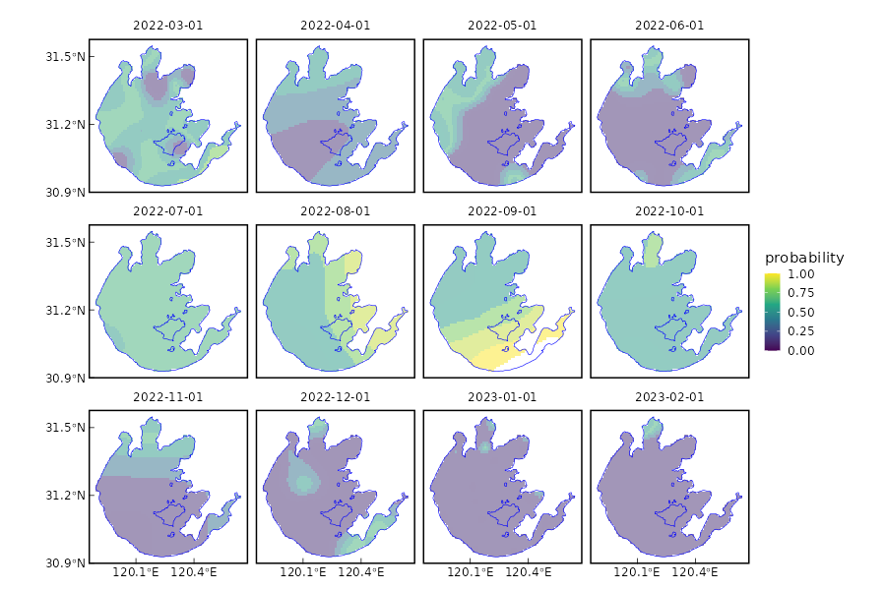
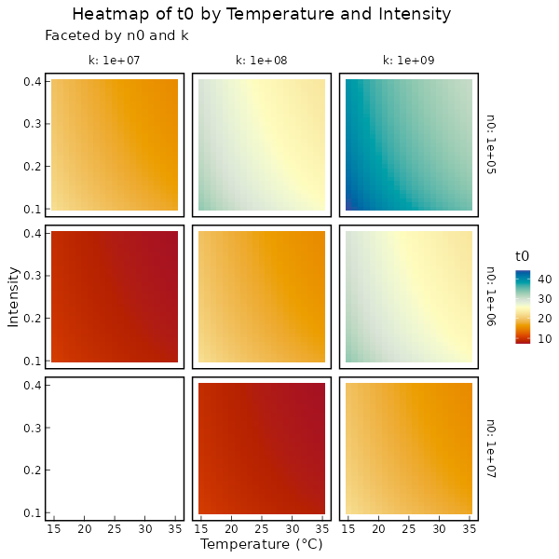
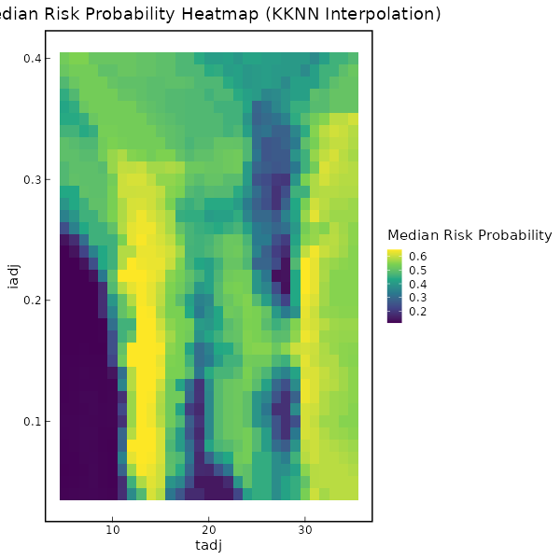

Discussion

Biological interpretation of the d2t model
(I) When the cell density is low, the change in d2t is represented by the variation in environmental carrying capacity; (II)when the cell density exceeds 80% of K, the change is represented by the remaining environmental carrying capacity.

The difference of d2t model between different algae species
不同藻种d2t模型的区别，提出从10%K到达50%K的时间T0作为比较的值
……拓展到全国样品

Conclusion
TBD

Declaration of Competing Interest
The authors declare that they have no known competing financial interests or personal relationships that could have appeared to influence the work reported in this paper.

Acknowledgements
This work was financially supported by the National Natural Science Foundation of China (52030002, 51878649), and Youth Innovation Promotion Association CAS.

References

