Construction and Application of an 2-Methylisoborneol Intracellular and Extracellular Distribution Model Based on Cellular Crowding Effects
Ming Su^{1,2}, and Min Yang^{1,2,✉}
2025-04-08
Abstract
ABSTRACT
¹ State Key Laboratory of Environmental Aquatic Chemistry, Research Center for Eco-Environmental Sciences, Chinese Academy of Sciences
² University of Chinese Academy of Sciences
✉ Correspondence: Min Yang <yangmin@rcees.ac.cn>

Introduction
The issue of taste and odor (T&O) in drinking water sources is one of the most prominent water quality concerns, with earthy-musty odors caused by 2-methylisoborneol (MIB) being a major type of T&O problem (Devi et al., 2021; Suurnäkki et al., 2015; WHO, 2011). MIB is an odorous terpenoid derivative that has become a persistent and problematic contaminant in drinking water due to its extremely low odor threshold concentration (OTC) of 10 ng L$​^{−1}$ and its resistance to conventional water treatment processes (AWWA, 2010; Gillogly et al., 1999; Izaguirre and Taylor, 2004; Li et al., 2019; Suffet et al., 1999; C. Wang et al., 2023; Wang et al., 2020). MIB can be produced by actinomycetes (Gerber, 1969), cyanobacteria (Tabachek and Yurkowski, 1976), fungi (Yamada et al., 2014), and myxobacteria (Dickschat et al., 2007). However, in drinking water sources, filamentous cyanobacteria are the primary producers, including Pseudanabaena, Planktothrix, Phormidium, Oscillatoria, Lyngbya, and Planktothricoides (Cao et al., 2023; Izaguirre et al., 2007; Lu et al., 2023; Su et al., 2021, 2015; Van Der Ploeg et al., 1995; Zhang et al., 2009). MIB is a secondary metabolite of odor-producing cyanobacteria, existing in a bound form within the cells by associating with intracellular proteins, which is known as intracellular or particulate MIB(pMIB) (Bentley and Meganathan, 1981; Wu and Jüttner, 1988). When the cell wall ruptures or cells undergo lysis upon death, the intracellular MIB is released into the surrounding water, becoming dissolved or extracellular MIB(dMIB), and the sum of intracellular and extracellular MIB constitutes the total MIB concentration(tMIB) (Rashash et al., 1995; Zhang et al., 2016).
The intracellular and extracellular distribution of MIB is not constant, which may be related to its biosynthesis and release mechanisms (Alghanmi et al., 2018; Oh et al., 2017; Wang et al., 2024; Zhang et al., 2016). The biosynthetic pathway of MIB in cyanobacteria primarily involves the methylation of the precursor geranyl diphosphate (GPP) and the subsequent cyclization of methyl-GPP (Giglio et al., 2011; Komatsu et al., 2008; Wang et al., 2011). During the cyclization process, 2-methylisoborneol synthase (2-MIBS) is encapsulated within the Sg Enc protein shell, where it catalyzes the formation of MIB (Andreas and Giessen, 2024). However, as the Sg Enc protein shell lacks obvious pores and the direct observation of MIB migration remains challenging, the mechanisms governing MIB release and its intracellular-extracellular distribution patterns are not yet well understood.
The MIB production capacity of odor-producing cyanobacteria is a complex phenomenon that varies significantly with growth stages and environmental stressors (Lu et al., 2022; Wang et al., 2024; Zhang et al., 2016). TMIB concentrations increase during the exponential phase and decline in the senescent phase, consistent with changes in cell density (Wang et al., 2024). During the lag phase, MIB remains primarily intracellular, with the highest pMIB concentration observed in the late exponential phase, while its release into the extracellular environment mainly occurs during the stationary and senescent phases (Alghanmi et al., 2018). Some studies suggest a negative correlation between MIB production and cell growth rate, as Pseudanabaena sp. accumulates higher intracellular MIB concentrations and secretes more extracellular MIB under growth-inhibiting temperature and light conditions (Jia et al., 2019; Wang and Li, 2015; Zhang et al., 2016). One hypothesis proposes that cyanobacteria increase extracellular geosmin/MIB levels under unfavorable environmental conditions to suppress the growth of competing algal species, thereby maintaining ecological dominance (Wang and Li, 2015). Alternatively, some researchers suggest that extracellular MIB release is merely a consequence of cell damage or death under adverse conditions (Zhang et al., 2016; Zimba et al., 1999).
In high-cell-density environments, due to limited space and resources, cells may experience a crowding effect that inhibits their proliferation, migration, metabolism, and other activities, thereby impacting their growth and death (Bermudez et al., 2024; Eisenhoffer and Rosenblatt, 2013; Lawson-Keister and Manning, 2021; Yang et al., 2024). Under the influence of crowding effects, the main mechanisms that limit cell growth include resource competition, spatial constraints, and cell cycle arrest (G0 phase) (Drewinko et al., 1984; Eisenhoffer et al., 2012). Additionally, under crowding effects, cells may undergo death due to mechanisms such as triggering programmed cell death, metabolic stress-induced cell damage, mechanical damage caused by spatial constraints, and cell-to-cell interactions (Bar et al., 2004; Nishio et al., 2017; Sheridan and Simmons, 1981). The crowding effect influences the growth and death of cell populations, which in turn indirectly affects the release of intracellular metabolic products.
The crowding effect on cells can be further described through cell growth curves, and different models exist to represent various scenarios. The Monod model, in its simplest form, represents the functional relationship between specific growth rate and the concentration of essential substrates. In fact, it is purely empirical and was proposed based on curve fitting of experimental data (Liu, 2007; Monod, 1949). The Gompertz model is commonly used to describe growth, decay, and death processes. In this model, the growth rate is related to the current population size and its ratio relative to the limit value. It is typically effective in describing the early and mid-phase behaviors of tumor cells or the proliferation of organisms (Chaturvedi et al., 2023; Czajkowska et al., 2024; Tjørve and Tjørve, 2017). The exponential growth model is used to describe the process where, under ideal conditions, the cell population increases exponentially over time. In this model, cell division occurs uniformly and without constraints (Y. Wang et al., 2023). The Logistic growth model primarily focuses on two parameters: intrinsic growth rate (r) and carrying capacity (K), and describes changes in cell population over time by considering various combinations of r and K (Karim et al., 2023). The Richards Growth Model introduces additional parameters to combine the Logistic and Gompertz models, adapting to more diverse growth curves and capable of representing more complex proliferation patterns than the Logistic model (Lv et al., 2015). Among these models, the Logistic model is widely used to capture the growth dynamics of cells under resource-limited conditions. It is applicable to many practical issues such as cell proliferation and population growth and is one of the most commonly used models (Peleg and Cole, 1998; Peleg and Corradini, 2011).
Based on the literature description and our previous research, we found that the ratio of dMIB to tMIB (f) in odor-producing cyanobacteria during the growth process is not a constant but exhibits a certain pattern of variation. Therefore, we hypothesize that the changes in f may be related to the cell crowding effect. To test this hypothesis, we developed a model describing the variation of f over time based on indoor culture data of odor-producing cyanobacteria and the Logistic growth model. This model was used to explain the release pattern of MIB during the cell growth process and was ultimately applied to describe the growth stage distribution of odor-producing cyanobacteria and predict the odor risk during MIB outbreaks in Taihu Lake. The results of this study provide a new perspective on the release patterns of MIB during the growth stages of odor-producing cyanobacteria, enhancing the understanding of MIB release processes, and offering valuable references for controlling MIB and odor-producing cyanobacteria in lakes and reservoirs.

Materials and Methods

Study area and sampling
Lake Taihu (30°55’40”-31°32’58”N, 119°52’32”-120°36’10”E), located in the southeastern part of the Yangtze River Delta, is the third largest shallow freshwater lake in China, with a surface area of 2,578 km². In recent years, rapid industrialization and urbanization in the surrounding watershed have led to increasingly frequent outbreaks of algal blooms. Microcystis and Pseudanabaena have become the dominant harmful algal species in the lake, resulting in deteriorating water quality. The presence of microcystins and the odorous compound 2-methylisoborneol (2-MIB) has further impacted water usage in the surrounding regions. From March 2022 to February 2023, water samples were collected monthly from 31 sampling sites distributed across different regions of the lake (see Figure). With an average depth of approximately 2 meters and well-mixed conditions, approximately 2 liters of surface water samples were collected from 0.5 meters below the water surface using a Kemmerer water sampler.

Phytoplankton identification and physicochemical analysis
Subsamples (1000 mL) for cell counting were preserved with 5% Lugol’s iodine solution (Sherr and Sherr, 1993) and allowed to settle for 48 hours. The samples were then pre-concentrated 20-fold and stored in the dark until cell enumeration. Cyanobacterial species were identified according to Komárek and Anagnostidis (1998), with revisions based on Komárek et al. (2014). Phytoplankton identification and enumeration were performed using an upright microscope (Olympus BX53, Japan) following the protocol established by Utermöhl (1958). Subsamples for 2-methylisoborneol (MIB) analysis were stored in amber glass bottles with airtight seals. The production potential of MIB was calculated by measuring its total concentration. To prevent biodegradation, 10 mg L⁻¹ HgCl₂ was added to the samples (Li et al., 2010), and analysis was conducted within 72 hours using solid-phase microextraction (SPME) coupled with gas chromatography-mass spectrometry (GC-MS) (Agilent 6890/5975, Agilent Tech., USA) following the procedures established by Liang et al. (2005) and previous studies (Su et al., 2015). In situ measurements of physicochemical variables, including water temperature, pH, dissolved oxygen (DO), turbidity, and conductivity, were performed using a multiparameter probe (EXO2, USA). Water transparency was measured using a 20 cm diameter Secchi disk with alternating black and white quadrants, expressed as Secchi depth (SD). Nutrient concentrations, including nitrate, nitrite, ammonia, total nitrogen (TN), and total phosphorus (TP), were analyzed according to Chinese national standard methods.

Model Development
The Logistic growth model was employed to fit the changes in cell density of cultured Pseudanabaena (Equation 1).
$$N\left(t\right)=\frac{K}{1+\frac{K−N_{0}}{N_{0}}e^{−rt}} \left(1\right)$$
$$θ=\frac{K−N_{0}}{N_{0}} \left(2\right)$$
The parameter K represents the environmental carrying capacity, which denotes the maximum cell density that algae can reach under specific environmental conditions. N0 is the initial cell density at t = 0, while r represents the intrinsic growth rate, indicating the maximum growth rate of cells under ideal conditions. θ denotes the initial growth potential.
In aquatic environments, MIB primarily exists in two forms: dissolved MIB (dMIB) and cell-bound MIB, with their sum constituting the total MIB (tMIB). The dMIB fraction is mainly released into the water due to the lysis of odor-producing cyanobacterial cells. The ratio f (dMIB/tMIB) serves as an odor index, reflecting both the proportion of dissolved MIB in total MIB and the relative abundance of cells at different growth stages. To characterize the temporal variation of dMIB and tMIB produced by Pseudanabaena during cultivation, a time-dependent model for f was constructed. Since dMIB is associated with cell lysis and death, different approaches were used to describe the variation of f based on cell density. When the cell density was low (less than 80% of K), changes in the carrying capacity were used to express the variation in f (Equation 3). When the cell density approached K (greater than 80% of K), the remaining carrying capacity was used instead (Equation 4).
$$f=1−α_{1}T{\left(\frac{N\left(t\right)}{K}\right)}^{′}=1−α_{1}T\frac{θre^{rt}}{e^{2rt}+{2θe}^{rt}+θ^{2}} \left(3\right)$$
$$d2t=\frac{1}{2}+\frac{K−N\left(t\right)}{K}α_{2}+β \left(4\right)$$
In this model, α1 and α2 are variation coefficients, T represents the cell doubling time under cultivation conditions, and β is a correction factor that accounts for the accumulation and volatilization effects of MIB in the cultivation system. Logistic curve fitting was applied to the cell growth data under various environmental conditions using Equation (1), yielding the initial cell density (N0), environmental carrying capacity (K), and intrinsic growth rate (r). These parameters, along with f and t, were then incorporated into Equations (3) and (4), and linear regression was employed to estimate the model parameters α1, α2 and β along with their statistical significance. Furthermore, by adjusting the intrinsic growth rate r, this model enables the simulation of potential trends in cell growth and MIB production under different environmental conditions.

Statistical analysis and illustration
All data analysis and illustration were performed using R 4.4.2. Data pretreatment and summary were performed using the dplyr package in R, regression analysis including linear and generalized linear models were performed using the stats package, generalized additive modeling was performed using the mgcv package quantile regression analysis was performed using the quantreg package; contour figures were created by the graphics package, other figures were prepared using the ggplot2 package.

Results

Spatiotemporal distribution characteristics of mib in Lake Taihu
Between March 2022 and February 2023, two severe MIB outbreaks were observed in Taihu Lake (Fig. 1A). The high MIB concentration outbreaks primarily occurred in the spring (40.04 ± 77.52 ng L$​^{−1}$) and summer (106.73 ± 230.38 ng L$​^{−1}$), with significant peaks in April (66.47 ± 101.47 ng L$​^{−1}$) and July (232.45 ± 360.68 ng L$​^{−1}$), demonstrating a marked seasonality (p < 0.001). Notably, between the two MIB outbreaks, the MIB concentrations in June across the lake were relatively low. In addition to seasonal variation, the distribution of MIB concentrations across the lake also exhibited spatial heterogeneity. The regions with the highest MIB concentrations were mainly concentrated in the northern Meiliang Bay area and the southeastern East Taihu Lake area. The April MIB peak was primarily centered around Meiliang Bay, while the July peak was predominantly observed in both Meiliang Bay and East Taihu Lake.
A cluster analysis was performed on MIB concentrations from all 31 sampling sites throughout the year, classifying them into five distinct clusters (Clust1–Clust5) based on concentration levels. These clusters also corresponded spatially to five distinct lake regions (Fig. S). The highest MIB concentrations during both outbreak periods were primarily located within Clust4 and Clust5.Furthermore, analysis of the variation in f at different clusters revealed a characteristic trend: during the decline phase of f, the lowest values were often followed by an MIB outbreak (Fig. 1C). Concurrent analysis of odor-producing cyanobacteria in water samples using epic-PCR identified Pseudanabaena and Planktothricoides as the dominant MIB-producing species during the study period. The spatial distribution of their cell densities is shown in Fig. 1D, with Microcystis identified as the dominant cyanobacterial genus in Taihu Lake. Throughout the sampling period, Pseudanabaena was the primary MIB-producing species, reaching its highest relative abundance (31.0%) in September. In contrast, Planktothricoides had a much lower relative abundance, accounting for only 1.4%.
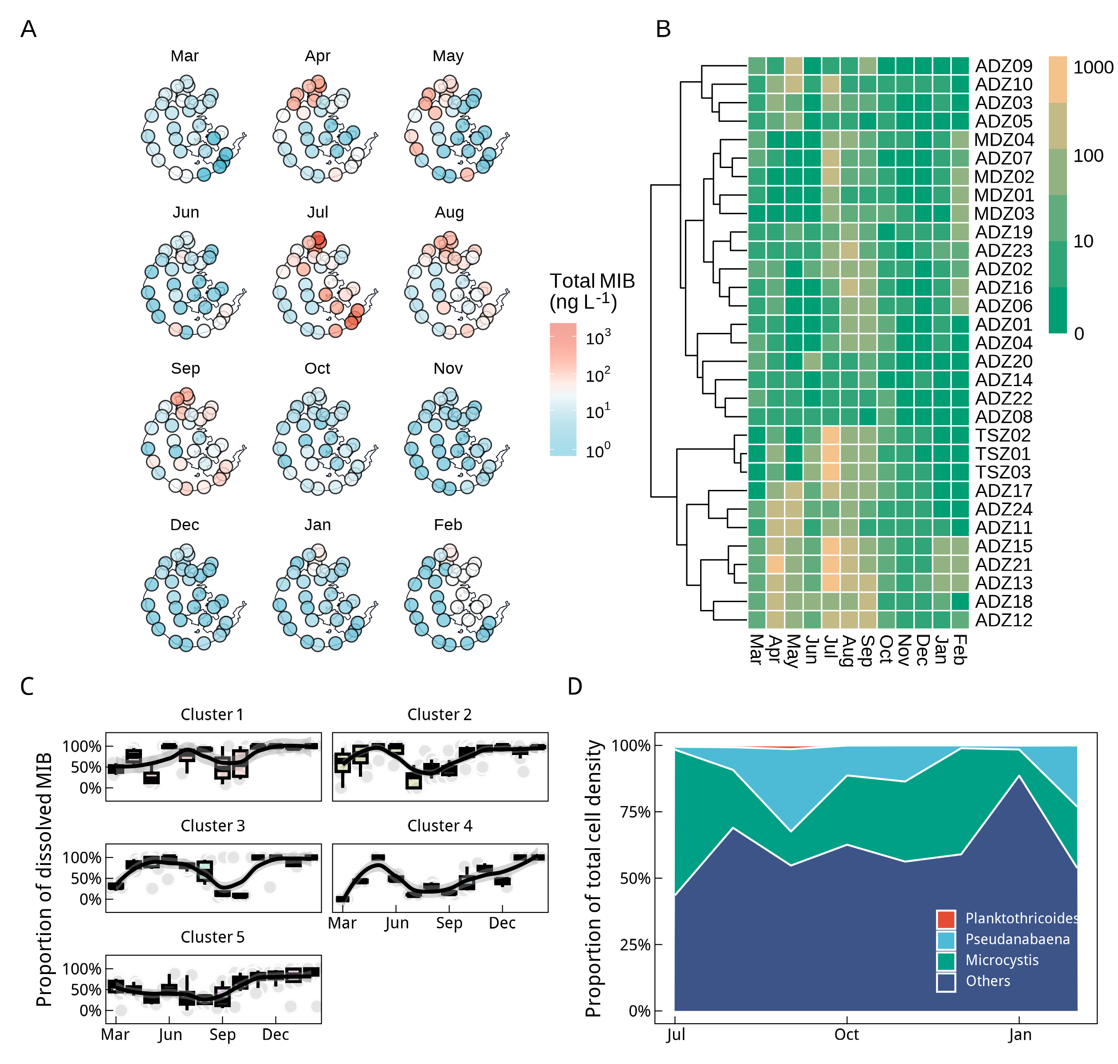
Fig. 1 Distribution of mib and dominant algae in Lake Taihu

Construction of model between the cultured algae growth and f change
In the previous analysis, a distinct pattern in the f was observed in Taihu Lake water samples. Concurrently, pure cultures of the two odor-producing cyanobacteria from Taihu Lake were grown under different light conditions. It was found that during their growth and odor production, the f initially decreased. This ratio reached its lowest point at approximately half of the maximum cell density. During this phase, both dMIB and tMIB concentrations increased slowly. Subsequently, the ratio began to increase gradually and eventually stabilized near 0.5, with dMIB and tMIB concentrations rising rapidly during this period.
To characterize this pattern, a logistic growth-based model was constructed to express the variations in the f. Logistic fitting of the growth of Pseudanabaena and Planktothricoides (Fig. 3A) showed good fit results. Based on the f variations during the growth period, the model parameters α1, α2 and β were derived. Fig. 3B compares the model parameters for both odor-producing cyanobacteria, revealing significant differences in the parameters α1 and β. The parameter α1 for Pseudanabaena was significantly greater than that for Planktothricoides (p-value < 0.01), while the parameter β showed the opposite trend (p-value < 0.01). The distribution of the model parameters under different conditions is shown in Fig. 3C, demonstrating a good fitting performance.
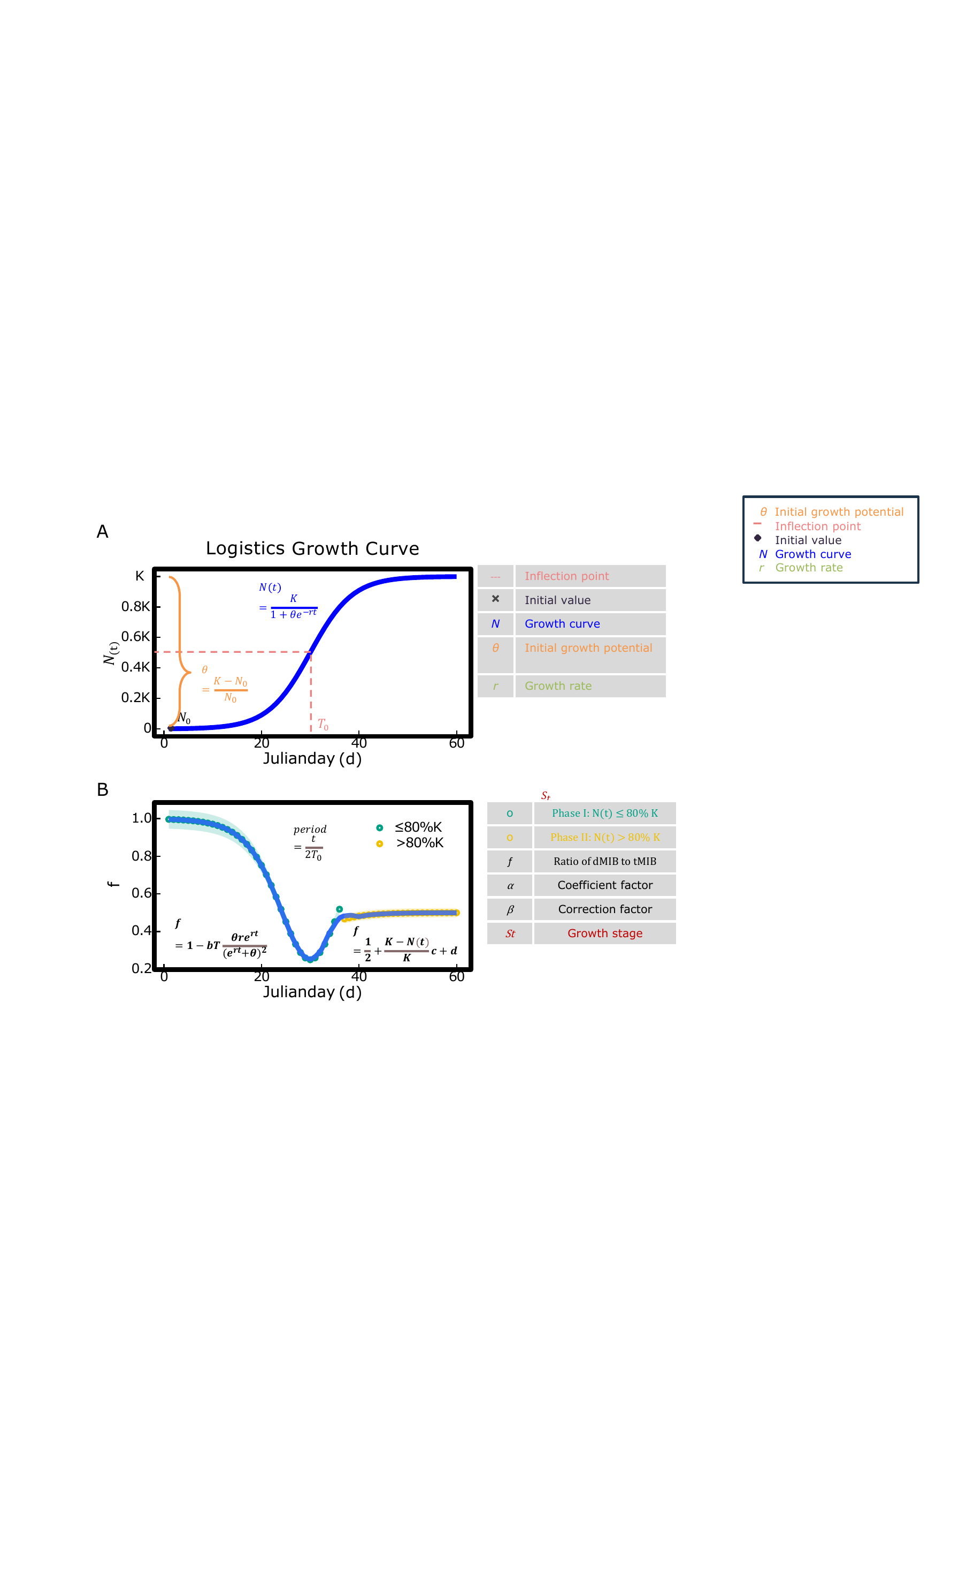
Fig. 2

Field application of f model for MIB warning
After establishing the model based on the cultivation data, it was applied to the various sampling points in Taihu Lake to calculate the growth information of the odor-producing cyanobacteria at each location and determine the St values. The growth of odor-producing cyanobacteria at different sampling points in Taihu Lake exhibited two distinct growth trends throughout the year. As temperatures increased, a significant growth phase occurred from May to November, followed by a smaller-scale growth St between December and April after the winter production. The two distinct cell density growth phases in different seasons led to two separate MIB concentration peaks in Taihu Lake throughout the year. Further analysis of the growth stages of odor-producing algae at different clustering points revealed that the growth stages of the algae and the MIB outbreaks were synchronized at different clustering locations. When the St value approaches 0.5, it indicates that the growth stage of the odor-producing algae is near the inflection point of the logarithmic phase, suggesting a high risk of significant MIB release.
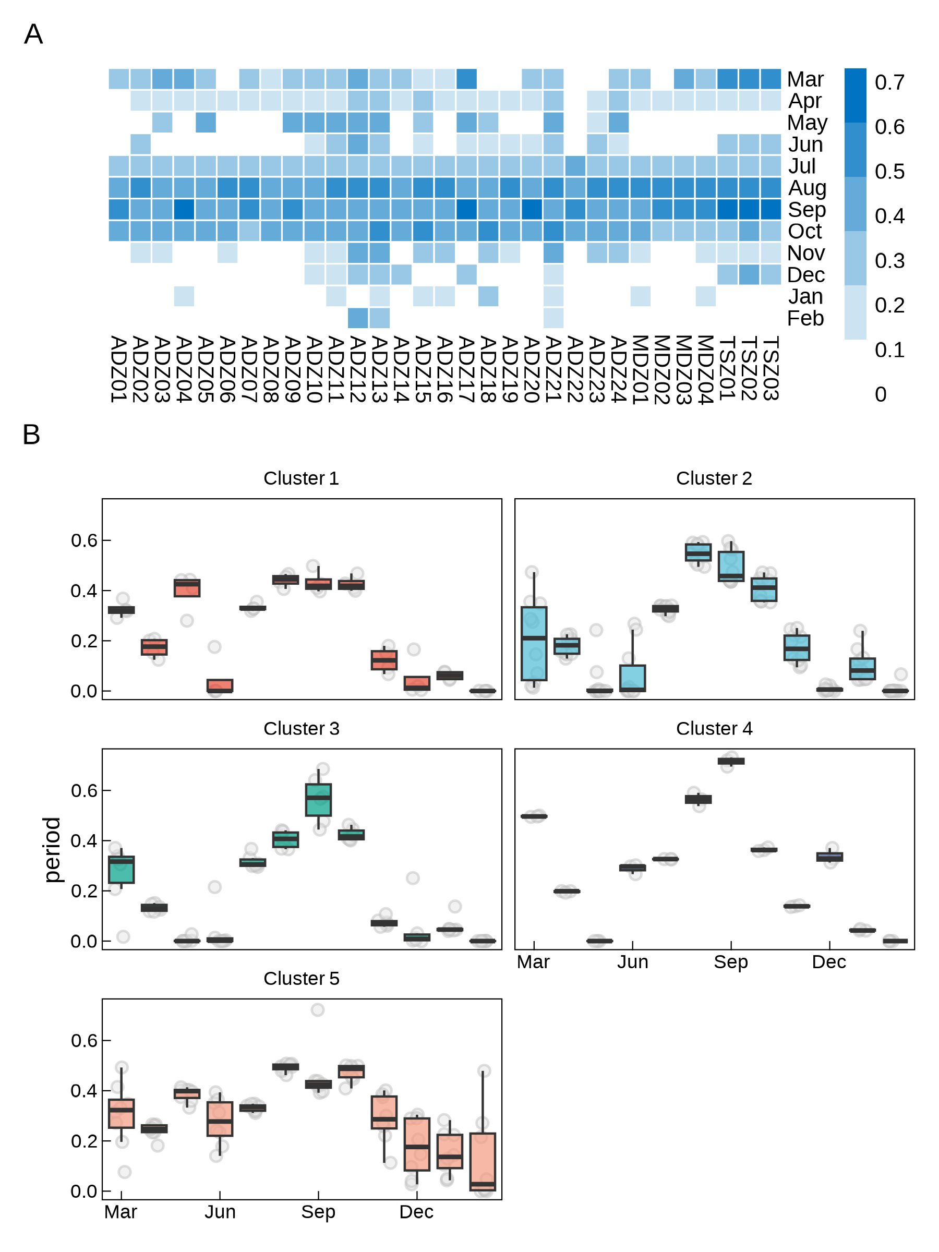
Fig. 3
To extend the model’s application to the entire Taihu Lake, data on water temperature, solar radiation, and odor-producing cyanobacteria growth under different conditions from various sources were collected for different months. Based on temperature and light intensity, a relationship with the intrinsic growth rate (r) of the cyanobacteria was established. The model was then applied to Taihu Lake as a whole, yielding growth stage data for odor-producing cyanobacteria in different regions, as shown in Fig. 5. It was found that the distribution of the growth stages of odor-producing cyanobacteria exhibited seasonal differences. From spring (starting in March 2022) to winter (ending in February 2023), the growth stages across the lake showed an increasing trend followed by a decrease. Spatially, in different seasons, the northern and East Taihu Lake regions exhibited significantly higher growth stages than other areas.
In general, the seasonal pattern was as follows: in early spring, odor-producing cyanobacteria began to grow earliest in the northwest and southeast regions; by summer, most of the lake had growth; in autumn, the northern, southern, and East Taihu Lake regions were in the later stages of growth; and in winter, except for a small part of the northern lake region, the growth of odor-producing cyanobacteria was minimal across the lake.
Further analysis of the relationship between the St and tMIB revealed the distribution of odor risk throughout the year in Taihu Lake. The probability of MIB concentrations exceeding 10 ng/L was highest in early spring and summer, with lower probabilities of exceeding the threshold in other seasons. The northern (Meiliang Bay) and southeastern (East Taihu Lake) regions exhibited a higher risk of MIB concentrations exceeding the threshold compared to other areas.
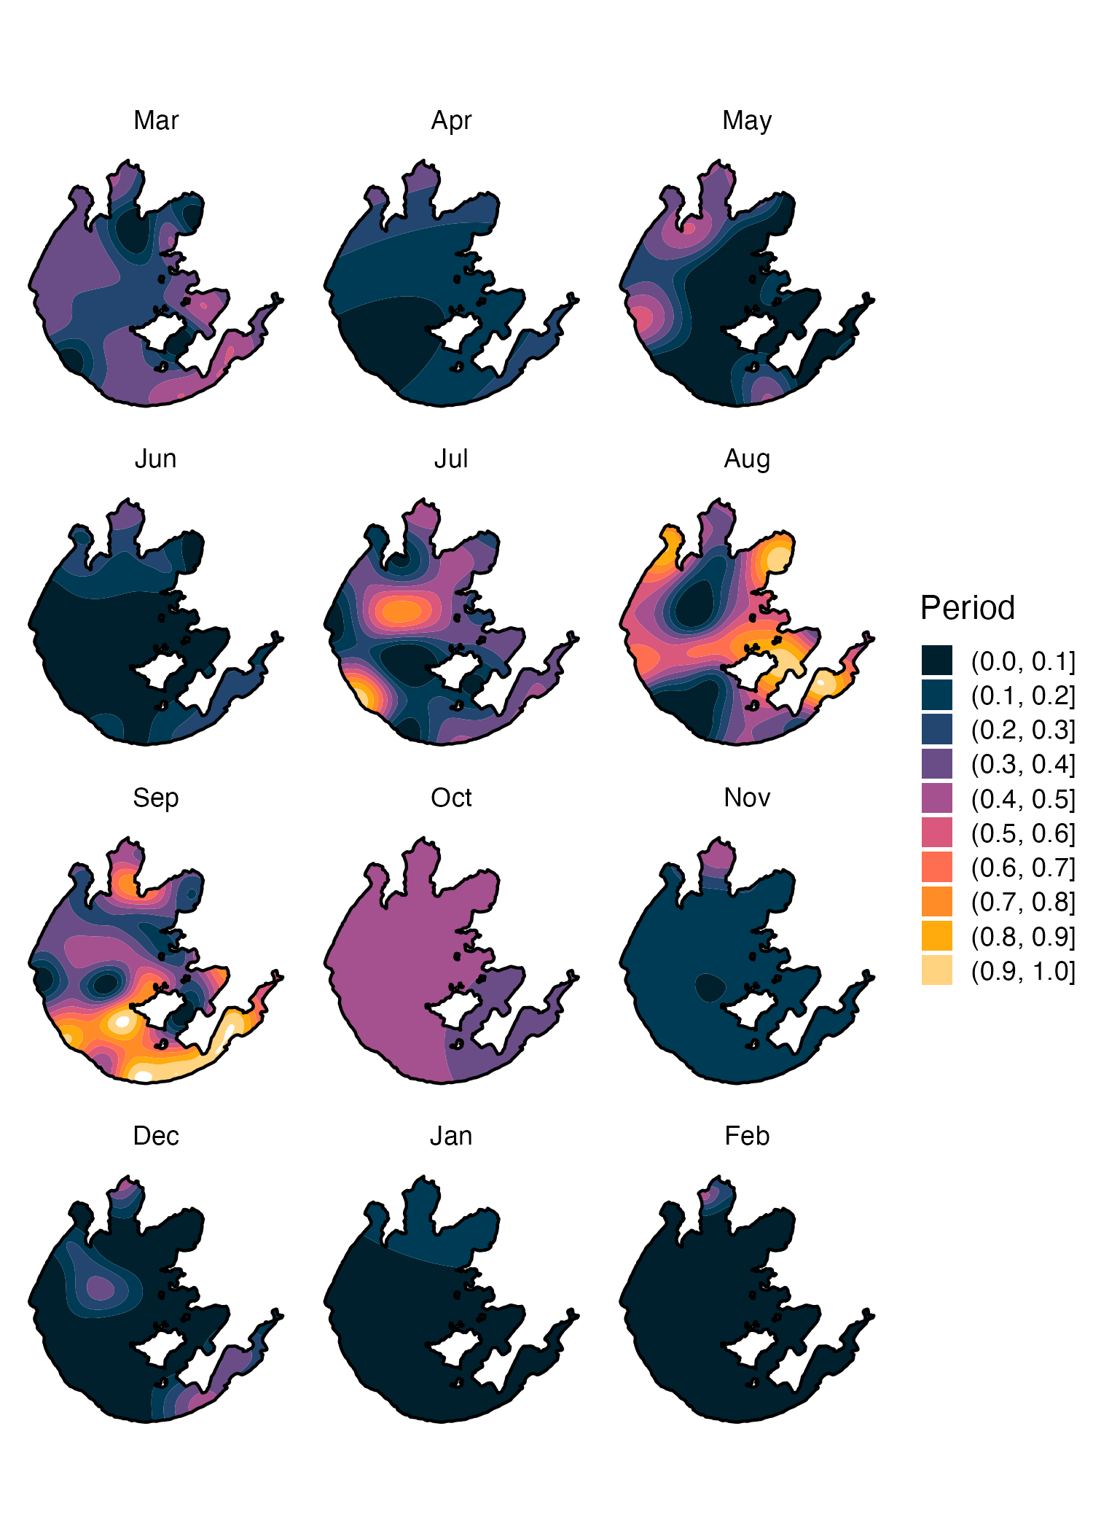
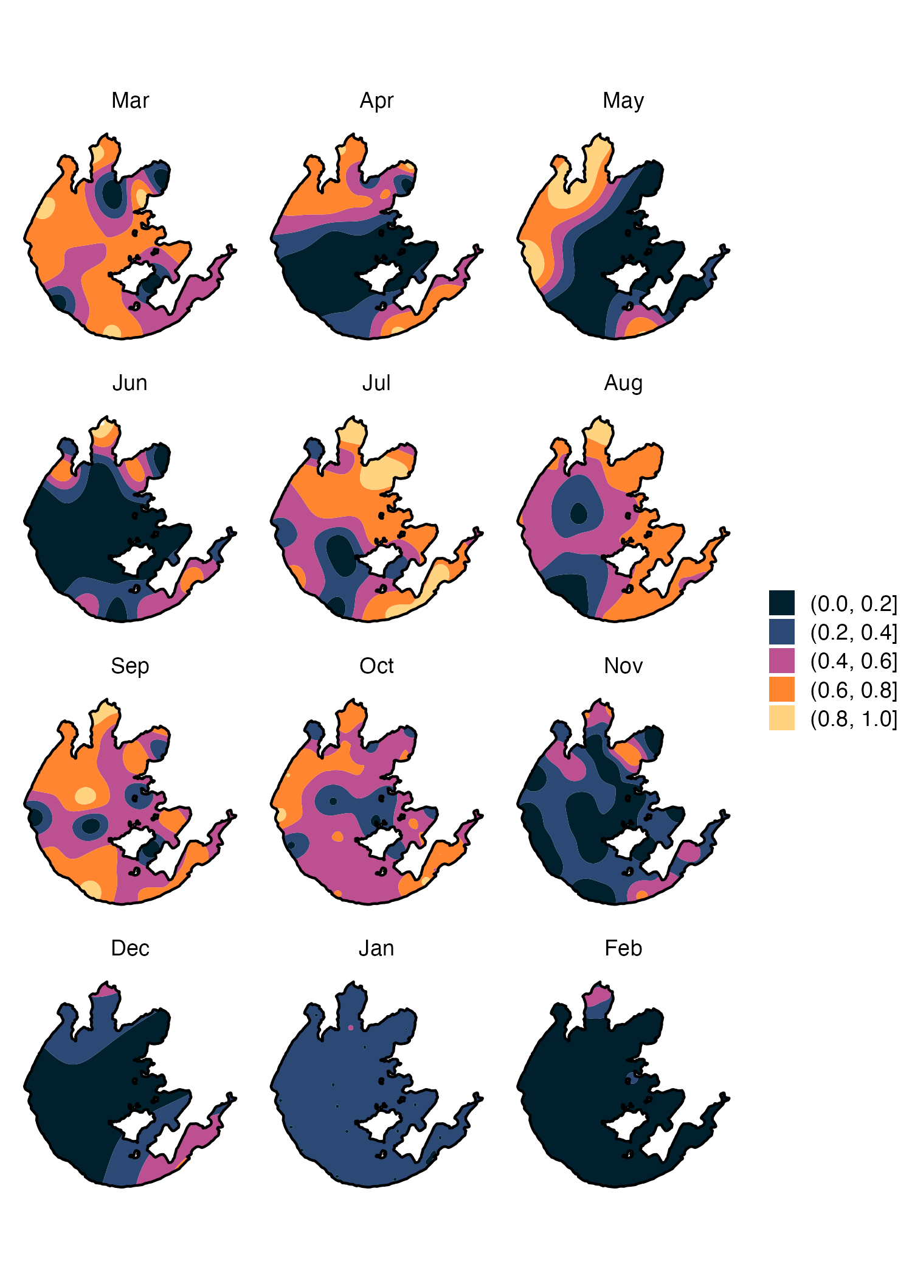
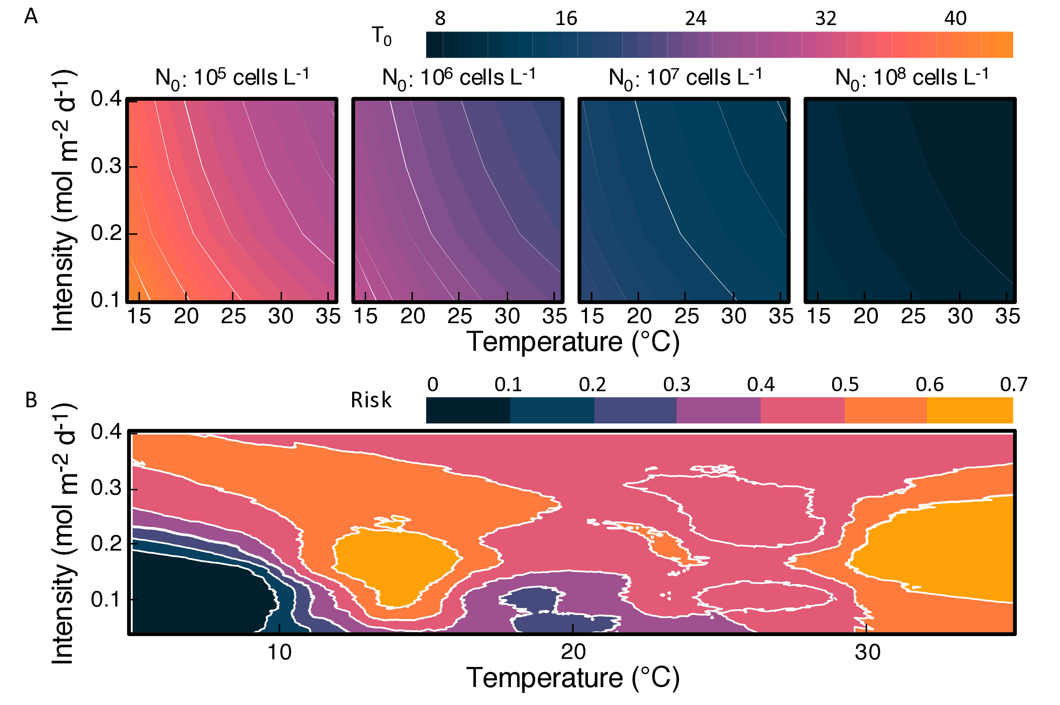

Discussion
2-Methylisoborneol (MIB), produced by filamentous odor-producing cyanobacteria, is one of the most common taste-and-odor compounds found in drinking water sources (Liu et al., 2019; Perkins et al., 2019; Yang et al., 2008). Dissolved MIB (dMIB) in water bodies is particularly challenging to remove using conventional water treatment processes, making it a direct cause of odor issues (Antonopoulou et al., 2014; Wang et al., 2020; Zoschke et al., 2011). Under stable environmental conditions, the cellular MIB yield of odor-producing cyanobacteria remains relatively constant across different growth stages (Wang et al., 2024). However, the intracellular and extracellular distribution of MIB is not fixed; the proportion of dMIB exhibits significant variation across different cultivation periods and environmental conditions (Alghanmi et al., 2018; Oh et al., 2017; Wang et al., 2024; Zhang et al., 2016).
The production and distribution of MIB by cyanobacterial cells are influenced by growth phases and environmental stress. In this study, we propose the f value (dMIB/tMIB) to characterize the distribution pattern of MIB. Field monitoring and laboratory cultivation revealed that f is not a constant value but follows a specific pattern of change. Research indicates that after MIB is synthesized within cells, it primarily binds to cytoplasmic and soluble protein components (Bafford et al., 1993). The primary mechanism of MIB release is through cell lysis and death or cell wall rupture (Alghanmi et al., 2018; Wang et al., 2024; Zhang et al., 2016; Zimba et al., 1999). As the growth phase approaches the stationary phase, increasing cell density in the environment enhances cell crowding effects, leading to more MIB being released due to cell damage and apoptosis (Pavel et al., 2018). Therefore, this study models the relationship between different growth phases and f by using growth stages to represent cell crowding effects and density. On one hand, f serves as an odor indicator, reflecting the ratio of dissolved MIB to total MIB in the environment. On the other hand, changes in f can indicate the proportion of cells in different growth stages. The model results (Fig. 2a, Fig. 2b) show that as the growth phase transitions from the lag phase to the stationary phase, f exhibits a nonlinear trend, first decreasing and then increasing before stabilizing. During the logarithmic phase, when cell growth reaches the inflection point of the Logistic growth curve, the growth rate is at its maximum, and f reaches its minimum. After the inflection point, cell crowding effects intensify, leading to significant MIB release due to cell damage or apoptosis. Towards the end of the logarithmic phase and during the stationary phase, cell density approaches the environmental carrying capacity and gradually stabilizes, with f primarily influenced by cell density, accumulation, and degradation of dMIB in the environment. Similar trends have been observed in other studies (Wang et al., 2024; Zhang et al., 2016). Additionally, modeling different MIB-producing cyanobacteria revealed significant parameter variations (Fig. 3b), likely due to differences in intrinsic growth rates and MIB production efficiencies among species. Studies have shown that Pseudanabaena has a maximum cellular MIB yield of 0.15 ± 0.04 pg cell$​^{−1}$ under a light intensity of 85 μmol photons m$​^{−2}$ s$​^{−1}$ (Cao et al., 2023), while Planktothricoides has a maximum cellular MIB yield of 0.22 ± 0.02 pg cell$​^{−1}$ (Lu et al., 2022).
At the cellular level, the distribution of MIB in Lake Taihu is primarily influenced by cell density and the distribution of cyanobacterial growth stages. Based on the relationship between f and t, we introduce the growth stage index (St) to assess the distribution of MIB-producing cyanobacteria growth phases in Lake Taihu. St ranges from 0 to 1, representing transitions from the lag phase to the stationary phase, where St = 0.5 corresponds to the inflection point of the Logistic growth curve. A higher St indicates a greater proportion of cells in the later growth stages and a higher potential for MIB release. The seasonal variation of St across the lake suggests a slow increase in MIB-producing cyanobacteria during late winter to early spring, which continues into early summer. This is followed by a more rapid growth phase that persists until late autumn. There is a 2-3 month gap between the two odor outbreaks, possibly due to the rapid growth of Microcystis from May to July, which dominates the cyanobacterial community and reduces light availability for filamentous MIB-producing cyanobacteria in the subsurface layer (Su et al., 2022, 2019). Studies indicate that Microcystis begins to grow rapidly and becomes the dominant cyanobacterium in Lake Taihu from May onward (Xuwei et al., 2019). Additionally, research on microcystin in Lake Taihu has shown a significant increase in microcystin concentrations after May (Li et al., 2022). Identifying high-risk odor zones in Lake Taihu further revealed that Meiliang Bay and East Taihu are the areas with the highest risk. Moreover, the odor risk zones exhibit a seasonal north-to-south transition from spring to winter, a pattern not previously reported in MIB-related studies of Lake Taihu.
In this study, the distribution of MIB in Lake Taihu exhibited spatiotemporal heterogeneity. Two distinct MIB outbreaks were observed in April (in the northern Meiliang Bay) and July, with high MIB concentrations primarily occurring in summer and early autumn. Spatially, cluster analysis indicated that East Taihu and Meiliang Bay in the north were the main high-risk MIB outbreak regions. Similarly, previous studies have reported two annual MIB peaks in Lake Taihu. However, in 2019 and 2021, the smaller MIB peak occurred in May, with the highest concentration observed in August, and the May peak was primarily concentrated in East Taihu (Li et al., 2022; Shi et al., 2023). Many studies have identified Pseudanabaena as the primary MIB-producing cyanobacterium in Lake Taihu, with temperature and light being the main environmental factors affecting its growth. Summer conditions typically provide optimal growth conditions for Pseudanabaena (Qi et al., 2020; Rong et al., 2018; Shi et al., 2023; Su et al., 2022). However, during late spring, when the water temperature in Lake Taihu exceeds 20°C, a smaller increase in MIB concentration is often observed, which may be attributed to human activities such as aquaculture (Nan et al., 2021; Wang et al., 2019; Yu et al., 2019).
This study investigates the distribution pattern of MIB-producing cyanobacteria and constructs a model for f based on cell crowding effects and the Logistic growth curve to explain the dynamics of dMIB and pMIB during different growth phases. Furthermore, applying the model to Lake Taihu enables the estimation of annual cyanobacterial growth phase distributions based on MIB distribution patterns and facilitates the prediction of high-risk odor zones, providing guidance for odor management in lakes and reservoirs. However, this study primarily considers MIB release through cell damage and apoptosis, which accounts for the majority of MIB release, while the potential active release of MIB remains unaddressed and requires further investigation.

Conclusion
TBD

Declaration of Competing Interest
The authors declare that they have no known competing financial interests or personal relationships that could have appeared to influence the work reported in this paper.

Acknowledgements
This work was financially supported by the National Natural Science Foundation of China (52030002, 51878649), and Youth Innovation Promotion Association CAS.

References
Alghanmi, H.A., Alkam, F.M., AL-Taee, M.M., 2018. Effect of light and temperature on new cyanobacteria producers for geosmin and 2-methylisoborneol. Journal of Applied Phycology 30, 319–328. https://doi.org/10.1007/s10811-017-1233-0
Andreas, M.P., Giessen, T.W., 2024. The biosynthesis of the odorant 2-methylisoborneol is compartmentalized inside a protein shell. Nature Communications 15. https://doi.org/10.1038/s41467-024-54175-4
Antonopoulou, M., Evgenidou, E., Lambropoulou, D., Konstantinou, I., 2014. A review on advanced oxidation processes for the removal of taste and odor compounds from aqueous media. Water Research 53, 215–234. https://doi.org/10.1016/j.watres.2014.01.028
AWWA, A.W.W.A., 2010. Algae: Source to treatment. American Water Works Association.
Bafford, R.A., Seagull, R.W., Chung, S., Millie, D.F., 1993. INTRACELLULAR LOCALIZATION OF THE TASTE/ODOR METABOLITE 2‐METHYLISOBORNEOL IN OSCILLATORIA LIMOSA (CYANOPHYTA)1. Journal of Phycology 29, 91–95. https://doi.org/10.1111/j.1529-8817.1993.tb00285.x
Bar, J., Cohen-Noyman, E., Geiger, B., Oren, M., 2004. Attenuation of the p53 response to DNA damage by high cell density. Oncogene 23, 2128–2137. https://doi.org/10.1038/sj.onc.1207325
Bentley, R., Meganathan, R., 1981. Geosmin and methylisoborneol biosynthesis in streptomycetes. Evidence for an isoprenoid pathway and its absence in non-differentiating isolates. FEBS Letters 125, 220.
Bermudez, A.G., Latham, Z., Hu, J., Lin, N., 2024. Cell crowding-induced geometric constraint regulates chromatin organizations. Biophysical Journal 123, 407a. https://doi.org/10.1016/j.bpj.2023.11.2493
Cao, T., Fang, J., Jia, Z., Zhu, Y., Su, M., Zhang, Q., Song, Y., Yu, J., Yang, M., 2023. Early warning of MIB episode based on gene abundance and expression in drinking water reservoirs. Water Research 231, 119667. https://doi.org/https://doi.org/10.1016/j.watres.2023.119667
Chaturvedi, K., Basu, S., Singha, S., Das, K., 2023. Predictive microbial growth modelling for an effective shelf-life extension strategy of chhana (indian cottage cheese). Food Control 149, 109697. https://doi.org/10.1016/j.foodcont.2023.109697
Czajkowska, A., Korsak, D., Fiedoruk-Pogrebniak, M., Koncki, R., Strzelak, K., 2024. Turbidimetric flow analysis system for the investigation of microbial growth. Talanta 268, 125303. https://doi.org/10.1016/j.talanta.2023.125303
Devi, A., Chiu, Y.-T., Hsueh, H.-T., Lin, T.-F., 2021. Quantitative PCR based detection system for cyanobacterial geosmin/2-methylisoborneol (2-MIB) events in drinking water sources: Current status and challenges. Water Research 188, 116478. https://doi.org/10.1016/j.watres.2020.116478
Dickschat, Jeroen s., Nawrath, T., Thiel, V., Kunze, B., Müller, R., Schulz, S., 2007. Biosynthesis of the off-flavor 2-methylisoborneol by the myxobacterium nannocystis exedens. Angewandte Chemie International Edition 46, 8287–8290. https://doi.org/10.1002/anie.200702496
Drewinko, B., Yang, L.Y., Barlogie, B., Trujillo, J.M., 1984. Cultured human tumour cells may be arrested in all stages of the cycle during stationary phase: Demonstration of quiescent cells in G1, s and G2 phase. Cell Proliferation 17, 453–463. https://doi.org/10.1111/j.1365-2184.1984.tb00604.x
Eisenhoffer, G.T., Loftus, P.D., Yoshigi, M., Otsuna, H., Chien, C.-B., Morcos, P.A., Rosenblatt, J., 2012. Crowding induces live cell extrusion to maintain homeostatic cell numbers in epithelia. Nature 484, 546–549. https://doi.org/10.1038/nature10999
Eisenhoffer, G.T., Rosenblatt, J., 2013. Bringing balance by force: Live cell extrusion controls epithelial cell numbers. Trends in Cell Biology 23, 185–192. https://doi.org/10.1016/j.tcb.2012.11.006
Gerber, N.N., 1969. A volatile metabolite of actinomycetes, 2-methylisoborneol. Antibiotics 22, 508–509.
Giglio, S., Chou, W.K.W., Ikeda, H., Cane, D.E., Monis, P.T., 2011. Biosynthesis of 2-methylisoborneol in cyanobacteria. Environmental Science & Technology 45, 992–998. https://doi.org/10.1021/es102992p
Gillogly, T.E.T., Snoeyink, V.L., Newcombe, G., Elarde, J.R., 1999. A simplified method to determine the powdered activated carbon dose required to remove methylisoborneol. Water Science and Technology 40, 59–64. https://doi.org/10.1016/S0273-1223(99)00538-7
Izaguirre, G., Jungblut, A., Neilan, B.A., 2007. Benthic cyanobacteria (oscillatoriaceae) that produce microcystin-LR, isolated from four reservoirs in Southern California. Water Research 41, 492–498. https://doi.org/10.1016/j.watres.2006.10.012
Izaguirre, G., Taylor, W.D., 2004. A guide to geosmin- and MIB-producing cyanobacteria in the united states. Water Science and Technology 49, 19–24. https://doi.org/10.2166/wst.2004.0524
Jia, Z., Su, M., Liu, T., Guo, Q., Wang, Q., Burch, M., Yu, J., Yang, M., 2019. Light as a possible regulator of MIB-producing Planktothrix in source water reservoir, mechanism and in-situ verification. Harmful Algae 88, 101658. https://doi.org/10.1016/j.hal.2019.101658
Karim, M.A.U., Aithal, V., Bhowmick, A.R., 2023. Random variation in model parameters: A comprehensive review of stochastic logistic growth equation. Ecological Modelling 484, 110475. https://doi.org/10.1016/j.ecolmodel.2023.110475
Komatsu, M., Tsuda, M., omura, S., Oikawa, H., Ikeda, H., 2008. Identification and functional analysis of genes controlling biosynthesis of 2-methylisoborneol. Proceedings of the National Academy of Sciences 105, 7422–7427. https://doi.org/10.1073/pnas.0802312105
Lawson-Keister, E., Manning, M.L., 2021. Jamming and arrest of cell motion in biological tissues. Current Opinion in Cell Biology 72, 146–155. https://doi.org/10.1016/j.ceb.2021.07.011
Li, H., Gu, X., Chen, H., Mao, Z., Shen, R., Zeng, Q., Ge, Y., 2022. Co-occurrence of multiple cyanotoxins and taste-and-odor compounds in the large eutrophic lake taihu, china: Dynamics, driving factors, and challenges for risk assessment. Environmental Pollution 294, 118594. https://doi.org/10.1016/j.envpol.2021.118594
Li, L., Yang, S., Yu, S., Zhang, Y., 2019. Variation and removal of 2-MIB in full-scale treatment plants with source water from Lake Tai, China. Water Research 162, 180–189. https://doi.org/10.1016/j.watres.2019.06.066
Liu, T., Yu, J., Su, M., Jia, Z., Wang, C., Zhang, Y., Dou, C., Burch, M., Yang, M., 2019. Production and fate of fishy odorants produced by two freshwater chrysophyte species under different temperature and light conditions. Water Research 157, 529–534. https://doi.org/10.1016/j.watres.2019.04.004
Liu, Y., 2007. Overview of some theoretical approaches for derivation of the monod equation. Applied Microbiology and Biotechnology 73, 1241–1250. https://doi.org/10.1007/s00253-006-0717-7
Lu, J., Su, M., Su, Y., Fang, J., Burch, M., Cao, T., Wu, B., Yu, J., Yang, M., 2023. MIB-derived odor management based upon hydraulic regulation in small drinking water reservoirs: Principle and application. Water Research 244, 120485. https://doi.org/10.1016/j.watres.2023.120485
Lu, J., Su, M., Su, Y., Wu, B., Cao, T., Fang, J., Yu, J., Zhang, H., Yang, M., 2022. Driving forces for the growth of MIB-producing Planktothricoides raciborskii in a low-latitude reservoir. Water Research 118670. https://doi.org/10.1016/j.watres.2022.118670
Lv, J., Wang, K., Jiao, J., 2015. Stability of stochastic richards growth model. Applied Mathematical Modelling 39, 4821–4827. https://doi.org/10.1016/j.apm.2015.04.016
Monod, J., 1949. THE GROWTH OF BACTERIAL CULTURES. Annual Review of Microbiology 3, 371–394. https://doi.org/10.1146/annurev.mi.03.100149.002103
Nan, J., Yang, C., Yu, H., Shi, X., Huang, Q., Huang, J., Li, J., 2021. Enclosure culture ban and its effects on water quality and phytoplankton community in a subtropical shallow lake. Aquaculture Research 53, 221–231. https://doi.org/10.1111/are.15568
Nishio, M., Maehama, T., Goto, H., Nakatani, K., Kato, W., Omori, H., Miyachi, Y., Togashi, H., Shimono, Y., Suzuki, A., 2017. Hippo vs. Crab: Tissue‐specific functions of the mammalian hippo pathway. Genes to Cells 22, 6–31. https://doi.org/10.1111/gtc.12461
Oh, H.-S., Lee, C.S., Srivastava, A., Oh, H.-M., Ahn, C.-Y., 2017. Effects of environmental factors on cyanobacterial production of odorous compounds: Geosmin and 2-methylisoborneol. Journal of Microbiology and Biotechnology 27, 1316–1323. https://doi.org/10.4014/jmb.1702.02069
Pavel, M., Renna, M., Park, S.J., Menzies, F.M., Ricketts, T., Füllgrabe, J., Ashkenazi, A., Frake, R.A., Lombarte, A.C., Bento, C.F., Franze, K., Rubinsztein, D.C., 2018. Contact inhibition controls cell survival and proliferation via YAP/TAZ-autophagy axis. Nature Communications 9. https://doi.org/10.1038/s41467-018-05388-x
Peleg, M., Cole, M.B., 1998. Reinterpretation of microbial survival curves. Critical Reviews in Food Science and Nutrition 38, 353–380. https://doi.org/10.1080/10408699891274246
Peleg, M., Corradini, M.G., 2011. Microbial growth curves: What the models tell us and what they cannot. Critical Reviews in Food Science and Nutrition 51, 917–945. https://doi.org/10.1080/10408398.2011.570463
Perkins, R.G., Slavin, E.I., Andrade, T.M.C., Blenkinsopp, C., Pearson, P., Froggatt, T., Godwin, G., Parslow, J., Hurley, S., Luckwell, R., Wain, D.J., 2019. Managing taste and odour metabolite production in drinking water reservoirs: The importance of ammonium as a key nutrient trigger. Journal of Environmental Management 244, 276–284. https://doi.org/10.1016/j.jenvman.2019.04.123
Qi, C., Fang, J., Wang, G., Huang, H., Wang, Z., Si, Z., Zhang, L., 2020. Characterization of odorants in contrasting ecotypes of lake taihu: Algae-dominated versus macrophyte-dominated zones. Environmental Science and Pollution Research 27, 42221–42229. https://doi.org/10.1007/s11356-020-07896-0
Rashash, D.m.C., Dietrich, A.m., Hoehn, R.c., Parker, B.c., 1995. The influence of growth conditions on odor-compound production by two chrysophytes and two cyanobacteria. Water Science and Technology 31, 165–172. https://doi.org/10.1016/0273-1223(95)00472-y
Rong, C., Liu, D., Li, Y., Yang, K., Han, X., Yu, J., Pan, B., Zhang, J., Yang, M., 2018. Source water odor in one reservoir in hot and humid areas of southern China: Occurrence, diagnosis and possible mitigation measures. Environmental Sciences Europe 30. https://doi.org/10.1186/s12302-018-0175-8
Sheridan, J.W., Simmons, R.J., 1981. Studies on a human melanoma cell line: Effect of cell crowding and nutrient depletion on the biophysical and kinetic characteristics of the cells. Journal of Cellular Physiology 107, 85–100. https://doi.org/10.1002/jcp.1041070111
Shi, X., Huang, Q., Shen, X., Wu, J., Nan, J., Li, J., Lu, H., Yang, C., 2023. Distribution, driving forces, and risk assessment of 2-MIB and its producer in a drinking water source-oriented shallow lake. Environmental Science and Pollution Research 30, 71194–71208. https://doi.org/10.1007/s11356-023-27506-z
Su, M., Andersen, T., Burch, M., Jia, Z., An, W., Yu, J., Yang, M., 2019. Succession and interaction of surface and subsurface cyanobacterial blooms in oligotrophic/mesotrophic reservoirs: A case study in Miyun Reservoir. Science of the Total Environment 649, 1553–1562. https://doi.org/J.scitotenv.2018.08.307
Su, M., Suruzzaman, MD., Zhu, Y., Lu, J., Yu, J., Zhang, Y., Yang, M., 2021. Ecological niche and in-situ control of MIB producers in source water. Journal of Environmental Sciences 110, 119–128. https://doi.org/10.1016/j.jes.2021.03.026
Su, M., Yu, J., Zhang, J., Chen, H., An, W., Vogt, R.D., Andersen, T., Jia, D., Wang, J., Yang, M., 2015. MIB-producing cyanobacteria (Planktothrix sp.) in a drinking water reservoir: Distribution and odor producing potential. Water Research 68, 444–453. https://doi.org/10.1016/j.watres.2014.09.038
Su, M., Zhu, Y., Andersen, T., Wang, X., Yu, Z., Lu, J., Song, Y., Cao, T., Yu, J., Zhang, Y., Yang, M., 2022. Light-dominated selection shaping filamentous cyanobacterial assemblages drives odor problem in a drinking water reservoir. npj Clean Water 5, 37. https://doi.org/10.1038/s41545-022-00181-2
Suffet, I.h. (mel), Khiari, D., Bruchet, A., 1999. The drinking water taste and odor wheel for the millennium: Beyond geosmin and 2-methylisoborneol. Water Science and Technology 40, 1–13. https://doi.org/10.1016/s0273-1223(99)00531-4
Suurnäkki, S., Gomez-saez, G.V., Rantala-ylinen, A., Jokela, J., Fewer, D.P., Sivonen, K., 2015. Identification of geosmin and 2-methylisoborneol in cyanobacteria and molecular detection methods for the producers of these compounds. Water Research 68, 56–66. https://doi.org/10.1016/j.watres.2014.09.037
Tabachek, J.L., Yurkowski, M., 1976. Isolation and identification of blue-green algae producing muddy odor metabolites, geosmin, and 2-methylisoborneol, in saline lakes in Manitoba. Journal of the Fisheries Research Board of Canada 33, 25–35. https://doi.org/10.1139/f76-004
Tjørve, K.M.C., Tjørve, E., 2017. The use of gompertz models in growth analyses, and new gompertz-model approach: An addition to the unified-richards family. PLOS ONE 12, e0178691. https://doi.org/10.1371/journal.pone.0178691
Van Der Ploeg, M., Dennis, M., De Regt, M., 1995. Biology of Oscillatoria chalybea, a 2-methylisoborneol producing blue-green alga of Mississippi Catfish Ponds. Water Science and Technology 31, 173–180. https://doi.org/10.1016/0273-1223(95)00473-Z
Wang, C., An, W., Zhao, Y., Dietrich, A.M., Gallagher, D.L., Zhang, Y., Qian, Y., Yu, J., Yang, M., 2023. Risk assessment for 2-MIB odor complaint in drinking water based on zero-inflated log-normal model. ACS ES&T Water 4, 146–154. https://doi.org/10.1021/acsestwater.3c00477
Wang, H., Li, L., Cheng, S., Chen, L., Zhang, H., Zhang, X., 2024. Production and release of 2-MIB in pseudanabaena: Effects of growth phases on cell characteristics and 2-MIB yield. Ecotoxicology and Environmental Safety 274, 116198. https://doi.org/10.1016/j.ecoenv.2024.116198
Wang, M., Yoshimura, C., Allam, A., Kimura, F., Honma, T., 2019. Causality analysis and prediction of 2-methylisoborneol production in a reservoir using empirical dynamic modeling. Water Research 163, 114864. https://doi.org/10.1016/j.watres.2019.114864
Wang, Q., Zietzschmann, F., Yu, J., Hofman, R., An, W., Yang, M., Rietveld, L.C., 2020. Projecting competition between 2-methylisoborneol and natural organic matter in adsorption onto activated carbon from ozonated source waters. Water Research 173, 115574. https://doi.org/10.1016/j.watres.2020.115574
Wang, Y., Zhou, J.X., Pedrini, E., Rubin, I., Khalil, M., Taramelli, R., Qian, H., Huang, S., 2023. Cell population growth kinetics in the presence of stochastic heterogeneity of cell phenotype. Journal of Theoretical Biology 575, 111645. https://doi.org/10.1016/j.jtbi.2023.111645
Wang, Z., Li, R., 2015. Effects of light and temperature on the odor production of 2-methylisoborneol-producing Pseudanabaena sp. and geosmin-producing Anabaena ucrainica (cyanobacteria). Biochemical Systematics and Ecology 58, 219–226. https://doi.org/10.1016/j.bse.2014.12.013
Wang, Z., Xu, Y., Shao, J., Wang, J., Li, R., 2011. Genes associated with 2-methylisoborneol biosynthesis in cyanobacteria: Isolation, characterization, and expression in response to light. Plos One 6, E18665. https://doi.org/10.1371/journal.pone.0018665
WHO, W.H.O., 2011. Guidelines for Drinking-Water Quality. World Health Organization, Geneva, Switzerland.
Wu, J., Jüttner, F., 1988. Differential partitioning of geosmin and 2-methylisoborneol between cellular constituents in Oscillatoria tenuis. Archives of Microbiology 150, 580–583. https://doi.org/10.1007/bf00408253
Xuwei, D., Min, Q., ren, R., Jiarui, L., Xiaoxue, S., Ping, X., Jun, C., 2019. The relationships between odors and environmental factors at bloom and non-bloom area in lake taihu, china. Chemosphere 218, 569–576. https://doi.org/10.1016/j.chemosphere.2018.11.121
Yamada, Y., Kuzuyama, T., Komatsu, M., Shin-ya, K., Omura, S., Cane, D.E., Ikeda, H., 2014. Terpene synthases are widely distributed in bacteria. Proceedings of the National Academy of Sciences 112, 857–862. https://doi.org/10.1073/pnas.1422108112
Yang, M., Yu, J., Li, Z., Guo, Z., Burch, M., Lin, T., 2008. Taihu Lake not to blame for Wuxi’s Woes. Science 319, 158. https://doi.org/10.1126/science.319.5860.158a
Yang, S., Golkaram, M., Oh, S., Oh, Y., Cho, Y., Yoe, J., Ju, S., Lalli, M.A., Park, S.-Y., Lee, Y., Jang, J., 2024. ETV4 is a mechanical transducer linking cell crowding dynamics to lineage specification. Nature Cell Biology 26, 903–916. https://doi.org/10.1038/s41556-024-01415-w
Yu, C., Shi, C., Ji, M., Xu, X., Zhang, Z., Ma, J., Wang, G., 2019. Taste and odor compounds associated with aquatic plants in taihu lake: Distribution and producing potential. Environmental Science and Pollution Research 26, 34510–34520. https://doi.org/10.1007/s11356-019-06188-6
Zhang, T., Li, L., Song, L., Chen, W., 2009. Effects of temperature and light on the growth and geosmin production of Lyngbya kuetzingii (cyanophyta). Journal of Applied Phycology 21, 279–285. https://doi.org/10.1007/s10811-008-9363-z
Zhang, T., Zheng, L., Li, L., Song, L., 2016. 2-methylisoborneol production characteristics of Pseudanabaena sp. FACHB 1277 isolated from Xionghe Reservoir, China. Journal of Applied Phycology 1–10. https://doi.org/10.1007/s10811-016-0864-x
Zimba, P.V., Dionigi, C.P., Millie, D.F., 1999. Evaluating the relationship between photopigment synthesis and 2-methylisoborneol accumulation in cyanobacteria. Journal of Phycology 35, 1422–1429. https://doi.org/10.1046/j.1529-8817.1999.3561422.x
Zoschke, K., Engel, C., Börnick, H., Worch, E., 2011. Adsorption of geosmin and 2-methylisoborneol onto powdered activated carbon at non-equilibrium conditions: Influence of NOM and process modelling. Water Research 45, 4544–4550. https://doi.org/10.1016/j.watres.2011.06.006

