Construction and Application of an 2-Methylisoborneol Intracellular and Extracellular Distribution Model Based on Cellular Crowding Effects
Ming Su^{1,2}, and Min Yang^{1,2,✉}
2025-05-04
Abstract
2-Methylisoborneol (MIB) is a potent odorant produced by cyanobacteria that severely impairs drinking water quality even at trace levels, yet its intracellular dynamics and release mechanisms remain largely unresolved, hindering effective prediction and control of odor events. Field surveys and laboratory cultures revealed that the ratio of dissolved to total MIB ($f$ = dMIB/tMIB) varies systematically during cyanobacterial growth due to cell crowding effects. We developed a model linking the growth stage ($St$) of cyanobacteria to MIB distribution. During the log phase, $f$ decreases and reaches a minimum at the logistic growth inflection point ($T_{0}$, $St$ = 0.5), after which it rises slightly due to increased extracellular release. In the stationary phase, $f$ stabilizes between 0.4 and 0.6, mainly influenced by cell density and carrying capacity. Applying this model to Lake Taihu, we not only reproduced two odor events in 2022–2023 but also revealed growth-phase–dependent MIB release dynamics and risk peaks at ~15 °C and > 30 °C under moderate light doses (0.1–0.4 mol m⁻² d⁻¹), insights not captured by conventional monitoring. The model supports early warning and guides utility responses by linking cellular physiology to odor risk.
¹ State Key Laboratory of Environmental Aquatic Chemistry, Research Center for Eco-Environmental Sciences, Chinese Academy of Sciences
² University of Chinese Academy of Sciences
✉ Correspondence: Min Yang <yangmin@rcees.ac.cn>

Introduction
The issue of taste and odor (T&O) in drinking water sources is one of the most prominent water quality concerns, with earthy-musty odors caused by 2-methylisoborneol (MIB) being a major type of T&O problem (Devi et al., 2021; Suurnäkki et al., 2015; WHO, 2011). MIB is an odorous terpenoid derivative that has become a persistent and problematic contaminant in drinking water due to its extremely low odor threshold concentration (OTC) of 10 ng L⁻¹ and its resistance to conventional water treatment processes (AWWA, 2010; Gillogly et al., 1999; Izaguirre and Taylor, 2004; Li et al., 2019; Suffet et al., 1999; C. Wang et al., 2023; Wang et al., 2020). MIB can be produced by actinomycetes (Gerber, 1969), cyanobacteria (Tabachek and Yurkowski, 1976), fungi (Yamada et al., 2014), and myxobacteria (Dickschat et al., 2007). However, in drinking water sources, filamentous cyanobacteria are the primary producers, including Pseudanabaena, Planktothrix, Phormidium, Oscillatoria, Lyngbya, and Planktothricoides (Cao et al., 2023; Izaguirre et al., 2007; Lu et al., 2023; Su et al., 2021, 2015; Van Der Ploeg et al., 1995; Zhang et al., 2009). MIB is a secondary metabolite of odor-producing cyanobacteria, existing in a bound form within the cells by associating with intracellular proteins, which is known as intracellular MIB (iMIB) (Bentley and Meganathan, 1981; Wu and Jüttner, 1988). When the cell wall ruptures or cells undergo lysis upon death, the intracellular MIB is released into the surrounding water, becoming extracellular MIB (eMIB), and the sum of intracellular and extracellular MIB constitutes the total MIB concentration (tMIB) (Rashash et al., 1995; Zhang et al., 2016).
The intracellular and extracellular distribution of MIB is not constant, which may be related to its biosynthesis and release mechanisms (Alghanmi et al., 2018; Oh et al., 2017; Wang et al., 2024; Zhang et al., 2016). The biosynthetic pathway of MIB in cyanobacteria primarily involves the methylation of the precursor geranyl diphosphate (GPP) and the subsequent cyclization of methyl-GPP (Giglio et al., 2011; Komatsu et al., 2008; Wang et al., 2011). During the cyclization process, 2-methylisoborneol synthase (2-MIBS) is encapsulated within the Sg Enc protein shell, where it catalyzes the formation of MIB (Andreas and Giessen, 2024). However, as the Sg Enc protein shell lacks obvious pores and the direct observation of MIB migration remains challenging, the mechanisms governing MIB release and its intracellular-extracellular distribution patterns are not yet well understood.
The MIB production capacity of odor-producing cyanobacteria is a complex phenomenon that varies significantly with growth stages and environmental stressors (Lu et al., 2022; Wang et al., 2024; Zhang et al., 2016). TMIB concentrations increase during the exponential phase and decline in the decline phase, consistent with changes in cell density (Wang et al., 2024). During the lag phase, MIB remains primarily intracellular, with the highest intracellular MIB concentration observed in the late exponential phase, while its release into the extracellular environment mainly occurs during the stationary and decline phases (Alghanmi et al., 2018). Some studies suggest a negative correlation between MIB production and cell growth rate, as Pseudanabaena sp. accumulates higher intracellular MIB concentrations and secretes more extracellular MIB under growth-inhibiting temperature and light conditions (Jia et al., 2019; Wang and Li, 2015; Zhang et al., 2016). One hypothesis proposes that cyanobacteria increase extracellular geosmin/MIB levels under unfavorable environmental conditions to suppress the growth of competing algal species, thereby maintaining ecological dominance (Wang and Li, 2015). Alternatively, some researchers suggest that extracellular MIB release is merely a consequence of cell damage or death under adverse conditions (Zhang et al., 2016; Zimba et al., 1999).
In high-cell-density environments, due to limited space and resources, cells may experience a crowding effect that inhibits their proliferation, migration, metabolism, and other activities, thereby impacting their growth and death (Bermudez et al., 2024; Eisenhoffer and Rosenblatt, 2013; Lawson-Keister and Manning, 2021; Yang et al., 2024). Under the influence of crowding effects, the main mechanisms that limit cell growth include resource competition, spatial constraints, and cell cycle arrest ($G0$ phase) (Drewinko et al., 1984; Eisenhoffer et al., 2012). Additionally, under crowding effects, cells may undergo death due to mechanisms such as triggering programmed cell death, metabolic stress-induced cell damage, mechanical damage caused by spatial constraints, and cell-to-cell interactions (Bar et al., 2004; Nishio et al., 2017; Sheridan and Simmons, 1981). The crowding effect influences the growth and death of cell populations, which in turn indirectly affects the release of intracellular metabolic products.
The crowding effect on cells can be effectively described using cell growth models, which reflect the influence of limited space and resources on population dynamics. Among these, the Logistic growth model is particularly suitable for characterizing the proliferation of cyanobacteria under nutrient-limited or high-density conditions (Lv et al., 2015; Peleg and Cole, 1998; Tjørve and Tjørve, 2017). This model incorporates two key parameters—intrinsic growth rate ($r$) and carrying capacity ($K$)—to describe the sigmoidal growth pattern commonly observed in microbial systems (Karim et al., 2023; Y. Wang et al., 2023). Its ability to capture growth deceleration and inflection points makes it especially useful for analyzing shifts in metabolic activity and the timing of compound release, such as MIB. Compared to other empirical models, the Logistic model provides a mechanistic basis for understanding population-level regulation and is therefore widely adopted in both theoretical studies and practical applications involving algal bloom dynamics (Peleg and Cole, 1998; Peleg and Corradini, 2011).
Based on the literature description and our previous research, we found that the ratio of eMIB to tMIB ($f=\text{eMIB}/\text{tMIB}$) in odor-producing cyanobacteria during the growth process is not a constant but exhibits a certain pattern of variation. Therefore, we hypothesize that the changes in $f$ may be related to the cell crowding effect. To test this hypothesis, we developed a model describing the variation of $f$ over time based on indoor culture data of odor-producing cyanobacteria and the Logistic growth model. This model was used to explain the release pattern of MIB during the cell growth process and was ultimately applied to describe the growth stage distribution of odor-producing cyanobacteria and predict the odor risk during MIB outbreaks in Taihu Lake. The results of this study provide a new perspective on the release patterns of MIB during the growth stages of odor-producing cyanobacteria, enhancing the understanding of MIB release processes, and offering valuable references for assess the development of odor-producing cyanobacteria as well as MIB episodes in lakes and reservoirs.

Materials and Methods

Study area and sampling
Lake Taihu (30°55’40”-31°32’58”N, 119°52’32”-120°36’10”E), located in the southeastern part of the Yangtze River Delta, is the third largest shallow freshwater lake in China, with a surface area of 2,578 km². In recent years, rapid industrialization and urbanization in the surrounding watershed have led to increasingly frequent outbreaks of algal blooms. Microcystis and Pseudanabaena have become the dominant harmful algal species in the lake, resulting in deteriorating water quality. The presence of microcystins and the odorous compound 2-methylisoborneol (MIB) has further impacted water usage in the surrounding regions. From March 2022 to February 2023, water samples were collected monthly from 31 sampling sites distributed across different regions of the lake (Fig. S2). With an average depth of approximately 2 m and well-mixed conditions, approximately 2 liters of surface water samples were collected from 0.5 m below the water surface using a Kemmerer water sampler.

Phytoplankton identification and physico-chemical analysis
Subsamples (1000 mL) for cell counting were preserved with 5% Lugol’s iodine solution (Sherr and Sherr, 1993) and allowed to settle for 48 hours. The samples were then pre-concentrated 20-fold and stored in the dark until cell enumeration. Cyanobacterial species were identified according to (Komárek and Anagnostidis, 1998), with revisions based on (Komarek et al., 2014). Phytoplankton identification and enumeration were performed using an upright microscope (Olympus BX53, Japan) following the protocol established by (Utermöhl, 1958). Subsamples for MIB analysis were stored in amber glass bottles with airtight seals. The production potential of MIB was calculated by measuring its total concentration. To prevent biodegradation, 10 mg L⁻¹ HgCl₂ was added to the samples (Li et al., 2010), and analysis was conducted within 72 hours using solid-phase microextraction (SPME) coupled with gas chromatography-mass spectrometry (GC-MS) (Agilent 6890/5975, Agilent Tech., USA) following the procedures established by (Liang et al., 2005) and previous studies (Su et al., 2015). In situ measurements of physicochemical variables, including water temperature, pH, dissolved oxygen (DO), turbidity, and conductivity, were performed using a multiparameter probe (EXO2, USA). Water transparency was measured using a 20 cm diameter Secchi disk with alternating black and white quadrants, expressed as Secchi depth (SD). Nutrient concentrations, including nitrate, nitrite, ammonia, total nitrogen (TN), and total phosphorus (TP), were analyzed according to Chinese national standard methods.

Model Development
The Logistic growth model was employed to fit the changes in cell density of cultured Pseudanabaena (Eq. 1).
$$N\left(t\right)=\frac{K}{1+\frac{K−N_{0}}{N_{0}}e^{−rt}} \left(1\right)$$
$$θ=\frac{K−N_{0}}{N_{0}} \left(2\right)$$
The parameter $K$ represents the environmental carrying capacity, which denotes the maximum cell density that algae can reach under specific environmental conditions. $N_{0}$ is the initial cell density at $t$ = 0, while $r$ represents the intrinsic growth rate, indicating the maximum growth rate of cells under ideal conditions (Karim et al., 2023; Peleg and Cole, 1998). $θ$ denotes the initial growth potential.
In aquatic environments, MIB primarily exists in two forms: intracellular MIB (iMIB) and extracellular MIB (eMIB), with their sum constituting the total MIB (tMIB). The eMIB fraction is mainly released into the water due to the lysis of odor-producing cyanobacterial cells. The ratio $f$ (eMIB/tMIB) serves as an odor index, reflecting both the proportion of dissolved MIB in total MIB and the relative abundance of cells at different growth stages. To characterize the temporal variation of eMIB and tMIB produced by Pseudanabaena cinerea FACHB 1277 (obtained from the Freshwater Algae Culture Collection at the Institute of Hydrobiology) during cultivation, a time-dependent model for $f$ was constructed. Since eMIB is associated with cell lysis and death, different approaches were used to describe the variation of $f$ based on cell density. When the cell density was low (less than 80% of $K$), the variation in $f$ was derived based on the cell crowding effect. Specifically, Eq. 3 was obtained by differentiating the logistic growth equation (Eq. 1) with respect to time, which reflects the dynamic change in cell abundance during the early to mid-growth stages (Eq. 3). When the cell density approached the carrying capacity (greater than 80% of $K$), the remaining capacity for growth was used to express the decline phase and corresponding change in $f$ (Eq. 4).
$$f=1−α_{1}T{\left(\frac{N\left(t\right)}{K}\right)}^{′}=1−α_{1}T\frac{θre^{rt}}{e^{2rt}+2θe^{rt}+θ^{2}} \left(3\right)$$
$$f=\frac{1}{2}+\frac{K−N\left(t\right)}{K}α_{2}+β \left(4\right)$$
In this model, $α_{1}$ and $α_{2}$ are variation coefficients, $T$ represents the cell doubling time under cultivation conditions, and $β$ is a correction factor that accounts for the accumulation and volatilization effects of MIB in the cultivation system. Logistic curve fitting was applied to the cell growth data under various environmental conditions using Eq. 1, yielding the initial cell density ($N_{0}$), environmental carrying capacity ($K$), and intrinsic growth rate ($r$). These parameters, along with $f$ and $t$, were then incorporated into Eq. 3 and Eq. 4, and linear regression was employed to estimate the model parameters $α_{1}$, $α_{2}$ and $β$ along with their statistical significance. Furthermore, by adjusting the intrinsic growth rate $r$, this model enables the simulation of potential trends in cell growth and MIB production under different environmental conditions.

MIB risk assessment
Given a known value of $f$, the cyanobacteria growth time $t$ can be determined based on Eq. 3 and Eq. 4. Subsequently, the corresponding growth stage indicator $St$ can be calculated using Eq. 5. By combining the estimated $St$ values with observed tMIB concentrations from field monitoring, a frequency distribution histogram of $St$ versus tMIB is generated (Fig. S9). This distribution characterizes the probability of various tMIB concentrations occurring at different cyanobacterial growth stages, providing a basis for assessing MIB-related odor risk.
$$St=\frac{t}{2T_{0}} \left(5\right)$$
When $t$ = $T_{0}$, $N\left(t\right)$ = $K/2$ (Eq. 1), indicating that $T_{0}$ corresponds to the inflection point of the logistic growth curve.

Statistical analysis and illustration
All data analysis and illustration were performed using R 4.4.2. Data pretreatment and summary were performed using the dplyr package in R, regression analysis including linear and generalized linear models were performed using the stats package, generalized additive modeling was performed using the mgcv package quantile regression analysis was performed using the quantreg package; contour figures were created by the graphics package, other figures were prepared using the ggplot2 package.

Results

Spatiotemporal Distribution Characteristics of MIB in Lake Taihu
Between March 2022 and February 2023, two severe MIB outbreaks were observed in Taihu Lake (Fig. 1A). The high MIB concentration outbreaks primarily occurred in the spring (40.0 ± 77.5 ng L$​^{−1}$) and summer (107 ± 230 ng L$​^{−1}$), with significant peaks in April (66.5 ± 101 ng L$​^{−1}$) and July (232 ± 361 ng L$​^{−1}$), demonstrating a marked seasonality (p < 0.001). Notably, between the two MIB outbreaks, the MIB concentrations in June across the lake were relatively low. In addition to seasonal variation, the distribution of MIB concentrations across the lake also exhibited spatial heterogeneity. The regions with the highest MIB concentrations were mainly concentrated in the northern area and the southeastern area. The April MIB peak was primarily centered around northern area, while the July peak was predominantly observed in both northern area and southeastern area.
A cluster analysis was performed on MIB concentrations from all 31 sampling sites throughout the year, classifying them into four distinct clusters based on concentration levels. These clusters also corresponded spatially to four distinct lake regions (Fig. S2). The highest MIB concentrations during both outbreak periods were primarily located within Northern part and Southeastern part. Furthermore, analysis of the variation in $f$ at different clusters revealed a characteristic trend: during the decline phase of $f$, the lowest values were often followed by an MIB outbreak (Fig. 1C). Concurrent analysis of odor-producing cyanobacteria in water samples using epic-PCR identified Pseudanabaena and Planktothricoides as the dominant MIB-producing genera during the study period. During the sampling period, Microcystis was the dominant cyanobacterial genus for most of the time (Fig. 1D). However, in September, Pseudanabaena, as the primary MIB-producing species reached its highest relative abundance (31.0%). In contrast, Planktothricoides was much lower, accounting for only 1.4%.
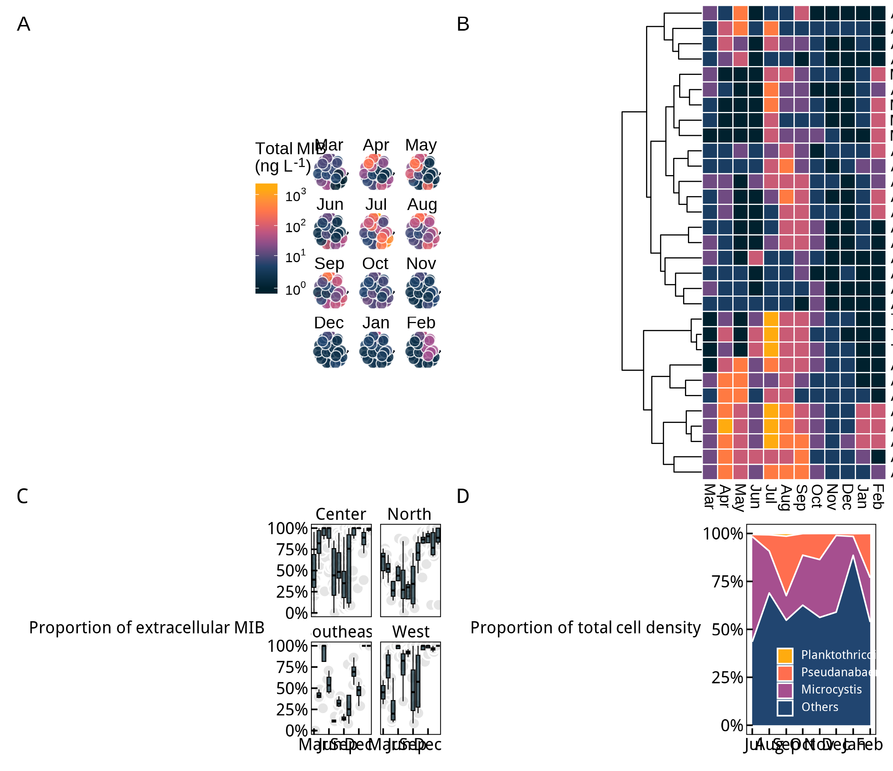
Fig. 1 The distribution of MIB and primary odor-producing cyanobacteria in Lake Taihu: Temporal and spatial distribution of tMIB concentrations in Lake Taihu throughout the year (A), clustering of tMIB concentrations in Lake Taihu (B). Temporal variation in the proportion of dMIB in different lake regions (C) and in the dominant algal species composition (D).

Construction of Model Between the Cultured Cyanobacteria Growth and f Change
In the previous analysis, a distinct pattern in the $f$ was observed in Taihu Lake water samples. Concurrently, pure cultures of the two odor-producing cyanobacteria from Taihu Lake were grown under different light conditions . It was found that during their growth and odor production, the f initially decreased. This ratio reached its lowest point at approximately half of the maximum cell density. During this phase, both dMIB and tMIB concentrations increased slowly. Subsequently, the ratio began to increase gradually and eventually stabilized near 0.5, with dMIB and tMIB concentrations rising rapidly during this period (Fig. 2A, B).
To characterize this pattern, a logistic growth-based model was constructed to express the variations in the $f$. Logistic fitting of the growth of Pseudanabaena and Planktothricoides (Fig. 2C, D) showed good fit results. Based on the f variations during the growth period, the model parameters $α_{1}$, $α_{2}$ and $β$ were derived. The parameter $α_{1}$ for Pseudanabaena was significantly greater than that for Planktothricoides (p < 0.01), while the parameter $β$ showed the opposite trend (p < 0.01)(Fig. 2E). The model exhibited relatively small residuals under most growth conditions, demonstrating a good fitting performance (Fig. 2F).
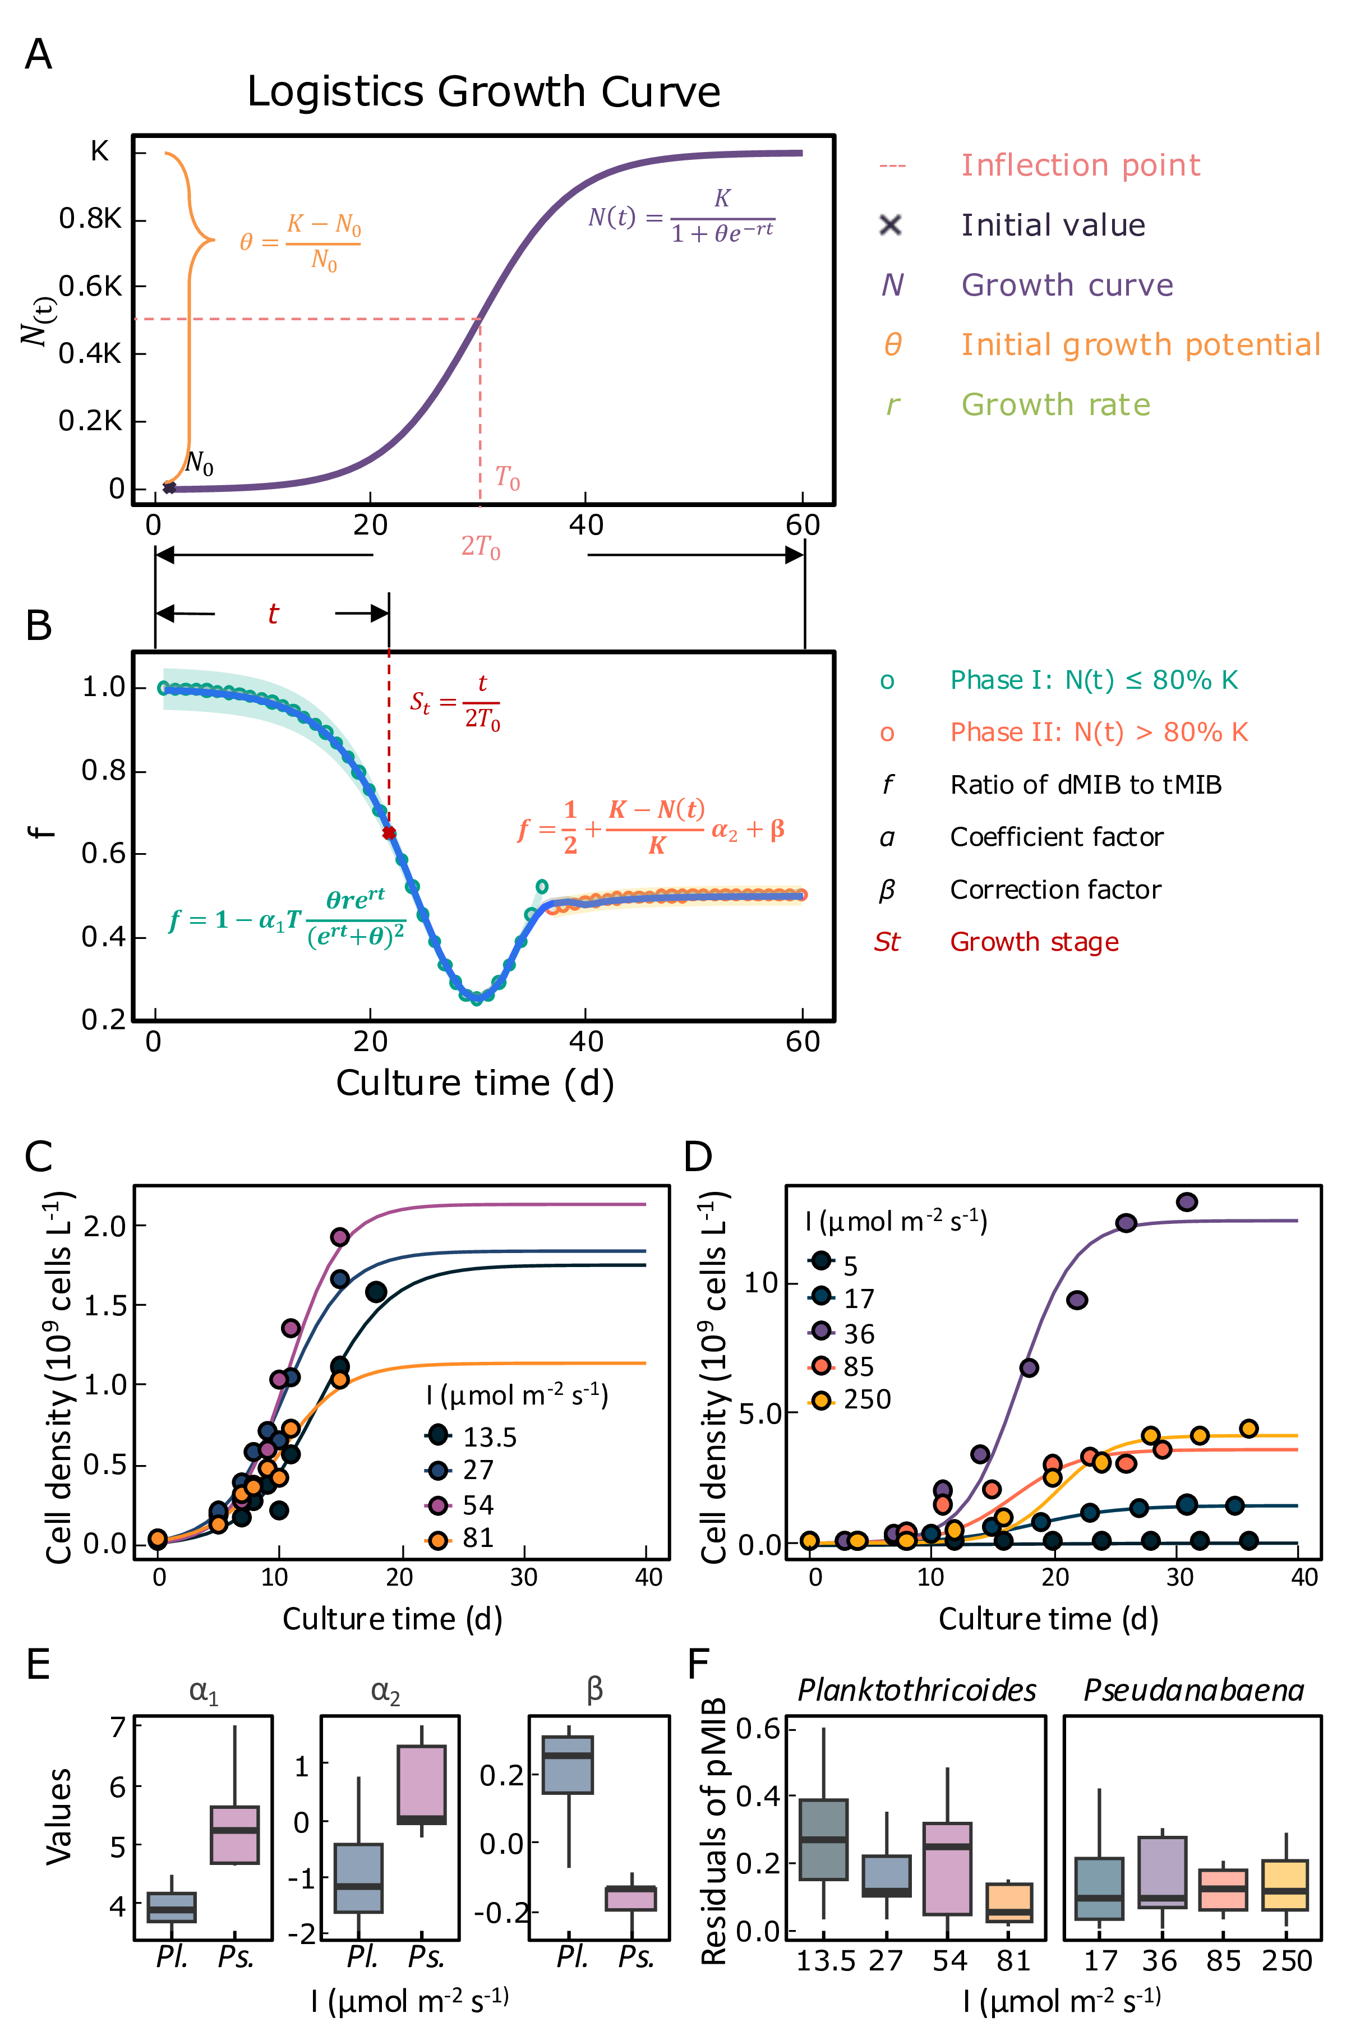
Fig. 2 Concept and performance of $f$ model: Logistic growth curve (A) and conceptual diagram of model (B). logistic growth fitting curves for Planktothricoides (C) and Pseudanabaena (D). Comparison of model parameters between Planktothricoides and Pseudanabaena (E). Comparison of model residuals between Planktothricoides and Pseudanabaena (F). Panel C is replotted using raw data from (Lu et al., 2022), and panel D from (Cao et al., 2023); logistic fitting was performed in this study.

Spatiotemporal Variation of Odor-Producing Cyanobacteria Growth Stage in Taihu Lake
After establishing the model based on the cultivation data, it was applied to the various sampling points in Taihu Lake to calculate the growth information of the odor-producing cyanobacteria at each location and determine the $St$ values. The growth of odor-producing cyanobacteria at different sampling points in Taihu Lake exhibited two distinct growth trends throughout the year. As temperatures increased, a significant growth phase occurred from May to November, followed by a smaller-scale growth $St$ between December and April after the winter production (Fig. 3A). The two distinct cell density growth phases in different seasons led to two separate MIB concentration peaks in Taihu Lake throughout the year. Further analysis of the growth stages of odor-producing algae at different clustering points revealed that the growth stages of the algae and the MIB outbreaks were synchronized at different clustering locations (Fig. 3B). When the $St$ value approaches 0.5, it indicates that the growth stage of the odor-producing algae is near the inflection point of the logarithmic phase, suggesting a high risk of significant MIB release.
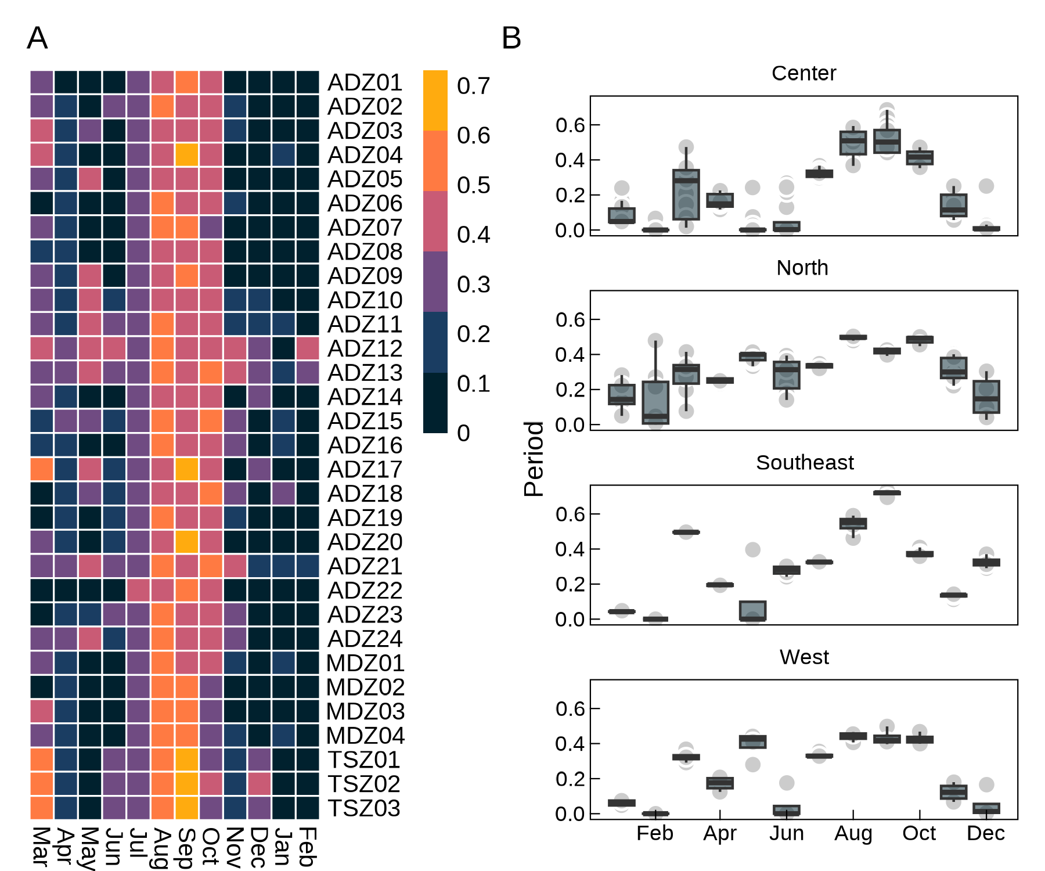
Fig. 3 Growth stage distribution of odor-producing cyanobacteria in the Lake Taihu (A) and different subregions (B)
To extend the model’s application to the entire Taihu Lake, data on water temperature, solar radiation, and odor-producing cyanobacteria growth under different conditions from various sources were collected for different months. Based on temperature and light intensity, a relationship with the intrinsic growth rate ($r$) of the cyanobacteria was established. It was found that the distribution of the growth stages of odor-producing cyanobacteria exhibited seasonal differences (Fig. 4). From spring (starting in March 2022) to winter (ending in February 2023), the growth stages across the lake showed an increasing trend followed by a decrease. Spatially, in different seasons, the northern and southeastern regions exhibited significantly higher growth stages than other areas.
In general, the seasonal pattern was as follows: in early spring, odor-producing cyanobacteria began to grow earliest in the northwest and southeast regions; by summer, most of the lake had growth; in autumn, the northern, southern, and southeastern regions were in the later stages of growth; and in winter, except for a small part of the northern lake region, the growth of odor-producing cyanobacteria was minimal across the lake.
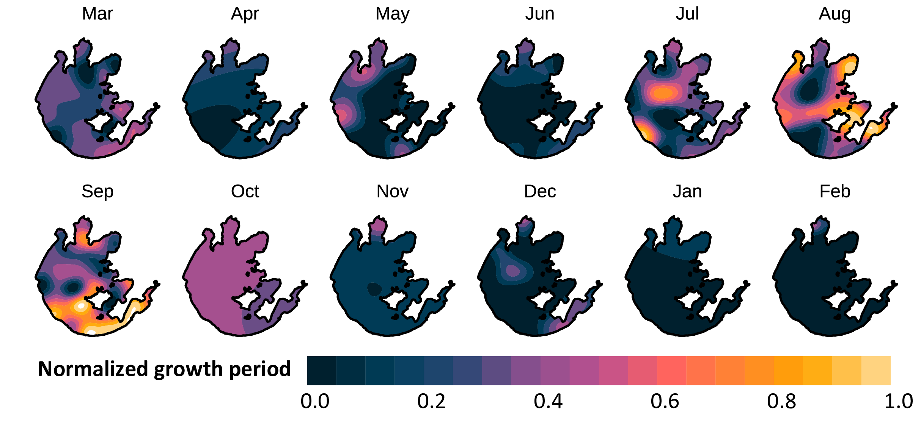
Fig. 4 Growth stage distribution of odor-producing cyanobacteria across the entire Lake Taihu.

MIB Risk Distribution and Seasonal Variation Across Taihu Lake
Further analysis of the relationship between the $St$ and tMIB revealed the distribution of odor risk throughout the year in Taihu Lake (Fig. 5, Fig. S8). The probability of MIB concentrations exceeding 10 ng L$​^{−1}$ was highest in early spring and summer, with lower probabilities of exceeding the threshold in other seasons. The northern and southeastern regions exhibited a higher risk of MIB concentrations exceeding the threshold compared to other areas.
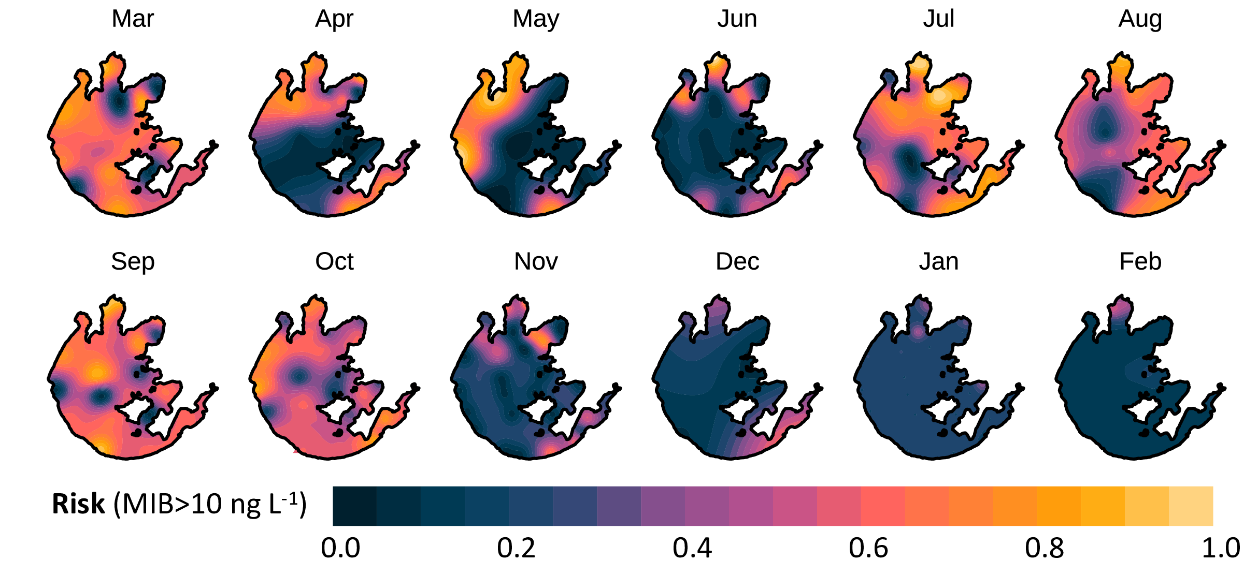
Fig. 5 Odor risk assessment across the entire Lake Taihu (probability of tMIB > 10 ng L$​^{−1}$).

Environmental Influences on Cyanobacteria Growth and Odor Risk
According to various studies, Pseudanabaena exhibits different intrinsic growth rates ($r$) under varying light and temperature conditions. These differences in $r$ can indirectly influence the temporal dynamics of the growth stage indicator ($St$) by affecting the timing of the logistic growth inflection point ($T_{0}$). Within a range of environmental conditions (15–35°C and 0.1–0.4 mol m⁻² d⁻¹), $T_{0}$ is negatively correlated with initial cell density, light dose, and temperature (Fig. 6A).
When these relationships are incorporated into the odor risk prediction framework for Lake Taihu, the model reveals two distinct peaks in odor risk under moderate light conditions—one occurring at approximately 15°C and another above 30°C (Fig. 6B). These two temperature ranges correspond to the observed bimodal pattern of MIB-related odor events in the lake, indicating that there is a risk of odor outbreaks both in spring and summer.
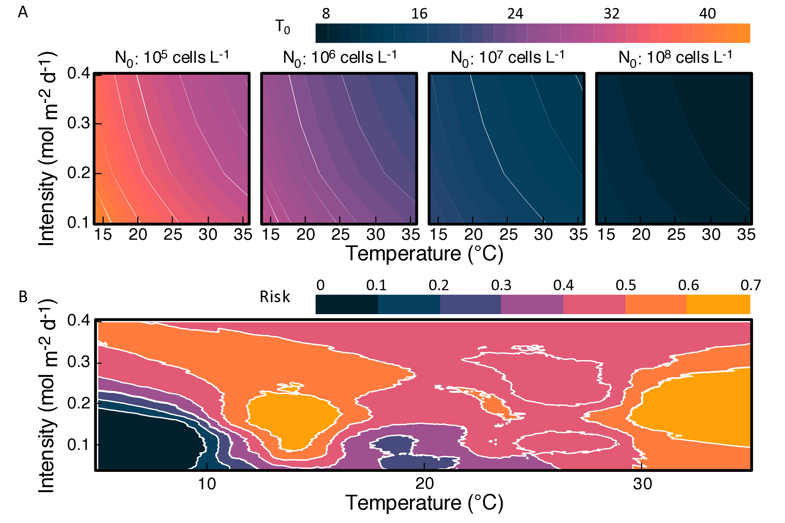
Fig. 6 Effects of Different Light Intensities and Temperatures on the Logistic Growth Inflection Point (A) and Odor Risk (B) of Odor-Producing Cyanobacteria in Lake Taihu (probability of tMIB > 10 ng L$​^{−1}$).

Discussion

Modeling MIB Partitioning Dynamics in Relation to Cyanobacterial Growth Phases
The production and distribution of 2-methylisoborneol (MIB) by odor-producing cyanobacterial cells are influenced by both their growth stage and environmental stressors. Previous studies have rarely focused on the intracellular and extracellular distribution of MIB during the growth of cyanobacteria in both natural aquatic environments and laboratory cultures. Some even suggested that the variation in MIB partitioning lacks a discernible pattern (Liu et al., 2019; Perkins et al., 2019). In this study, we introduce the ratio $f$ ($d_{MIB}/t_{MIB}$) as an indicator to represent the distribution pattern of MIB. Our findings show that $f$ is not a constant, but follows a specific dynamic trend, which may be attributed to cell crowding effects. After synthesis, MIB is primarily bound to cytoplasmic and soluble protein fractions within cyanobacterial cells (Bafford et al., 1993). The major mechanism of MIB release is cell lysis, occurring either through programmed cell death or mechanical rupture of the cell wall (Alghanmi et al., 2018; Wang et al., 2024; Zhang et al., 2016; Zimba et al., 1999). In this study, we established a model describing the relationship between $f$ and growth time $t$, and further proposed a metric—growth stage ($St$)—to evaluate the distribution of cyanobacterial growth stages across the lake (Fig. 7). The $St$ index ranges from 0 to 1, representing the progression of cell growth from the lag phase to the stationary phase, with $St$ = 0.5 corresponding to the inflection point of the logistic growth curve. A higher $St$ indicates a larger proportion of cells in the later stages of growth, implying a greater potential for MIB release. As cell growth progresses toward the stationary phase, environmental cell density increases, leading to intensified crowding effects. These conditions exacerbate cell damage and apoptosis, causing a larger proportion of MIB to be released into the surrounding water (Pavel et al., 2018).
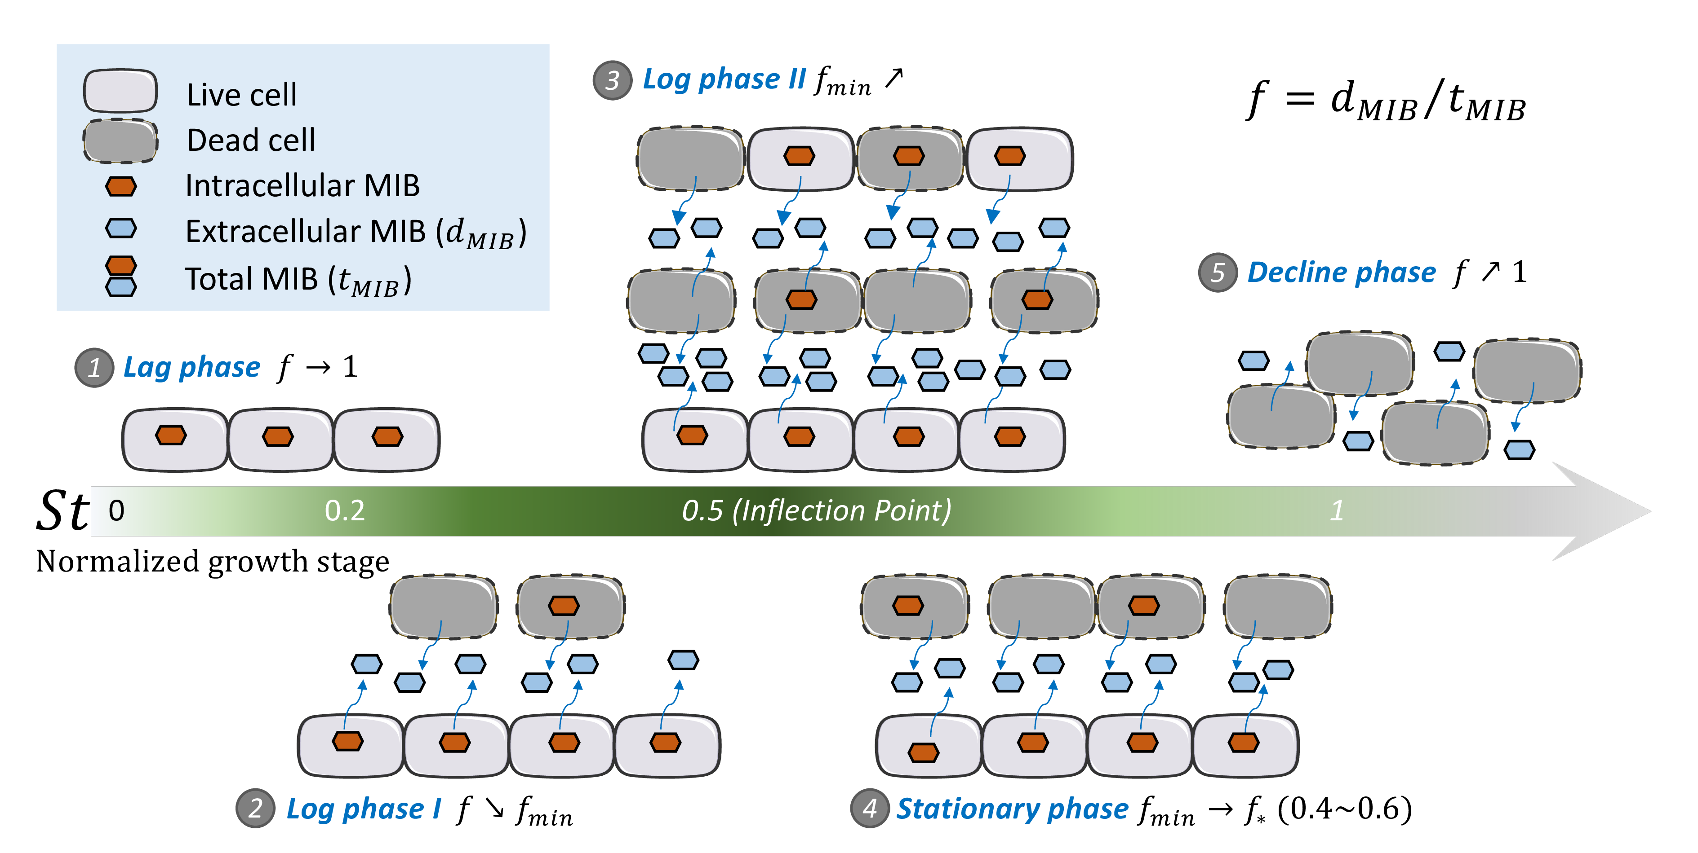
Fig. 7 Schematic representation of MIB allocation dynamics influenced by cell crowding, both intracellularly and extracellularly
In this study, we developed a model linking $f$ to cell growth time $t$, thereby associating the cyanobacterial growth stage with odor production patterns. This model enables the estimation of the growth stage distribution of odor-producing cyanobacteria, offering insights into current odor issues and supporting prediction of future taste and odor (T&O) risks. From a management perspective, $f$ serves dual functions: (1) as a T&O index reflecting the proportion of dissolved MIB (eMIB) to total MIB (tMIB) in the water, and (2) as an ecological indicator of the relative proportions of cells at different growth stages. Model results (Fig. 2A, B) demonstrate that $f$ follows a nonlinear pattern—initially decreasing, then increasing and eventually stabilizing—as the cell population transitions from the lag phase to the stationary phase. During the exponential phase, $f$ reaches its minimum when cell growth rate peaks at the inflection point of the logistic growth curve. After this point, crowding-induced stress increases, leading to significant MIB release due to cell damage and apoptosis. Toward the end of the exponential phase and during the stationary phase, cell density approaches the environmental carrying capacity and enters a state of dynamic equilibrium. At this stage, $f$ is primarily influenced by total cell density and the accumulation and degradation dynamics of eMIB in the environment. This trend is consistent with observations reported in previous studies (Wang et al., 2024; Zhang et al., 2016). By applying the $f$-model, the growth stage distribution of odor-producing cyanobacteria can be inferred based on measured MIB partitioning. This framework enhances our understanding of T&O events in freshwater lakes and reservoirs and provides valuable guidance for implementing more targeted management strategies.

Field-Based Analysis of MIB Dynamics in Relation to Cyanobacterial Growth in Lake Taihu
Based on the intracellular and extracellular MIB distribution patterns caused by the cell crowding effect, the growth and odor-producing processes of MIB-producing cyanobacteria in Lake Taihu can be further analyzed. Field monitoring of MIB in Lake Taihu revealed two major MIB outbreaks: one in April (in the northern region) and another in July, with high concentrations predominantly observed in summer and early autumn. Spatial clustering analysis showed that the northern and southeastern regions were identified as MIB outbreak hotspots. Simultaneously, the lake-wide distribution of $St$ indicated that during the transition from winter to spring, cyanobacteria in certain lake areas began to grow slowly. This early-phase growth persisted until early summer, after which a second, more rapid growth period occurred, continuing until late autumn. Similar dual-peak MIB patterns have been reported in other studies, although with slightly different timing. For instance, in 2019 and 2021, smaller MIB peaks were observed in May, while the major peaks occurred in August in Lake Taihu. Notably, the May MIB outbreaks were predominantly located in the southeastern region (Hongmin Li et al., 2022; Shi et al., 2023). Temperature and light availability are the primary environmental drivers of cyanobacterial growth. During the summer, both factors typically reach optimal levels for the growth of Pseudanabaena, a key MIB-producing filamentous cyanobacterium (Qi et al., 2020; Rong et al., 2018; Shi et al., 2023; Su et al., 2022). From April to May, when the surface water temperature exceeds 20°C, MIB-producing cyanobacteria are already able to grow at a considerable rate (Nan et al., 2021; Wang et al., 2019; Yu et al., 2019). Meanwhile, the lake lacks other dominant cyanobacterial species to compete with them, resulting in a minor peak in MIB concentration during spring. Between May and July, Microcystis undergoes rapid proliferation and becomes the dominant cyanobacterial genus. This dominance reduces light penetration to the subsurface layers, where filamentous MIB-producing cyanobacteria typically reside, thereby inhibiting their growth (Su et al., 2022, 2019). Previous studies also confirm that Microcystis blooms begin around May and subsequently dominate the phytoplankton community (Xuwei et al., 2019). Research on microcystin production in Lake Taihu supports this timeline, with significant increases in microcystin concentrations observed only after May (Hongmin Li et al., 2022).
Further identification of high-risk regions for T&O events indicates that the northern and southeastern areas are the most vulnerable. In the southeastern risk zone, which includes four sampling sites, MIB levels slightly increased in April, declined briefly, and then peaked again in July, remaining elevated through September. In contrast, the northern region exhibited a similar trend, but with a higher April–May peak, and sustained MIB levels >10 ng L⁻¹ between the two major peaks (Fig. 1B). The different odor production dynamics in these two risk zones are attributable to variations in cyanobacterial growth stages. In the southeast, cyanobacteria were in the late growth stage in March, but transitioned to an early growth stage by April, suggesting a mass cell death event between March and April. As a result, cell density did not increase significantly, and MIB production potential was limited. In contrast, cyanobacteria in the northern region remained in the exponential phase from March to April, with continuous growth and higher MIB production potential. At the lake-wide scale, the spatial progression of odor risk zones from north to south from spring through winter was observed—a pattern not previously reported in studies of MIB-related odor problems in Lake Taihu.
Different odor-producing cyanobacteria exhibit distinct growth and odor-production characteristics. Modeling efforts tailored to specific taxa revealed significant differences in fitted parameters (Fig. 2E), likely due to variations in intrinsic growth rates and MIB production efficiencies among species. Studies have shown that Pseudanabaena has a maximum cellular MIB yield of 0.15 ± 0.04 pg cell⁻¹ under a light intensity of 85 μmol photons m⁻² s⁻¹ (Cao et al., 2023), while Planktothricoides exhibits a higher yield of 0.22 ± 0.02 pg cell⁻¹ under similar conditions (Lu et al., 2022). In addition,the inflection point time ($T_{0}$) for these two species also vary significantly across studies (Fig. S10), further contributing to their differential contributions to odor events in aquatic systems.

Environmental significance
By developing a model that links the growth stages of odor-producing cyanobacteria with MIB release and its intracellular–extracellular distribution, this study offers important insights into the ecological dynamics of odor events in freshwater systems. First, it enhances our understanding of the growth behavior of odor-producing cyanobacteria in natural waters. Second, the model provides a tool for forecasting the temporal trends of MIB concentration, thereby improving early-warning capabilities. Third, by quantifying the ratio of intracellular to extracellular MIB, the results can inform water treatment strategies—specifically, whether to target intact cells through coagulation and sedimentation or to apply cell-disruption methods when extracellular MIB dominates. This integrated approach supports more effective and condition-specific odor mitigation in drinking water treatment (Drikas et al., 2009; Huixian Li et al., 2022; Li et al., 2019; Zamyadi et al., 2015).
This study investigates the distribution pattern of MIB-producing cyanobacteria and constructs a model for f based on cell crowding effects and the Logistic growth curve to explain the dynamics of eMIB and pMIB during different growth phases. Furthermore, applying the model to Lake Taihu enables the estimation of annual cyanobacterial growth phase distributions based on MIB distribution patterns and facilitates the prediction of high-risk odor zones, providing guidance for odor management in lakes and reservoirs. However, this study primarily considers MIB release through cell damage and apoptosis, which accounts for the majority of MIB release, while the potential active release of MIB remains unaddressed and requires further investigation.

Conclusion
The intracellular and extracellular distribution dynamics of 2-methylisoborneol (MIB), a musty-smelling secondary metabolite produced by cyanobacteria, remain poorly understood, limiting our ability to predict odor events in source waters. This study developed a growth-stage-based model to characterize MIB release patterns and applied it to Lake Taihu, where conventional approaches have struggled to explain complex odor phenomena. Results revealed that odor-producing cyanobacteria in the lake underwent two distinct growth cycles annually, corresponding to dual MIB concentration peaks—in spring and summer. The $f$ model, derived from laboratory-cultured cyanobacteria data, accurately captured these growth trends and was successfully applied to field observations across the lake. By integrating environmental variables such as water temperature and light intensity, the model enabled lake-wide prediction of cyanobacterial growth stages and corresponding MIB risk. Spatially, the northern and southeastern regions of Lake Taihu consistently showed higher growth potential and odor risk. Temporally, high MIB risk was concentrated in early spring and mid-summer, aligning with inflection points in the cyanobacterial growth phase. Further analysis indicated that environmental factors—especially temperature and light dose—significantly influenced the timing of growth phase transitions, thereby affecting odor risk. Notably, the model identified two risk peaks under moderate light conditions, reflecting the dual seasonal odor patterns observed in the lake. These findings demonstrate the applicability of the $f$ model as a predictive tool for early MIB warnings and provide valuable insights for water quality monitoring and lake management.

Declaration of Competing Interest
The authors declare that they have no known competing financial interests or personal relationships that could have appeared to influence the work reported in this paper.

Acknowledgements
This work was financially supported by the National Natural Science Foundation of China (52030002, 51878649), and Youth Innovation Promotion Association CAS.

References
Alghanmi, H.A., Alkam, F.M., AL-Taee, M.M., 2018. Effect of light and temperature on new cyanobacteria producers for geosmin and 2-methylisoborneol. Journal of Applied Phycology 30, 319–328. https://doi.org/10.1007/s10811-017-1233-0
Andreas, M.P., Giessen, T.W., 2024. The biosynthesis of the odorant 2-methylisoborneol is compartmentalized inside a protein shell. Nature Communications 15. https://doi.org/10.1038/s41467-024-54175-4
AWWA, A.W.W.A., 2010. Algae: Source to treatment. American Water Works Association.
Bafford, R.A., Seagull, R.W., Chung, S., Millie, D.F., 1993. INTRACELLULAR LOCALIZATION OF THE TASTE/ODOR METABOLITE 2‐METHYLISOBORNEOL IN OSCILLATORIA LIMOSA (CYANOPHYTA)1. Journal of Phycology 29, 91–95. https://doi.org/10.1111/j.1529-8817.1993.tb00285.x
Bar, J., Cohen-Noyman, E., Geiger, B., Oren, M., 2004. Attenuation of the p53 response to DNA damage by high cell density. Oncogene 23, 2128–2137. https://doi.org/10.1038/sj.onc.1207325
Bentley, R., Meganathan, R., 1981. Geosmin and methylisoborneol biosynthesis in streptomycetes. Evidence for an isoprenoid pathway and its absence in non-differentiating isolates. FEBS Letters 125, 220.
Bermudez, A.G., Latham, Z., Hu, J., Lin, N., 2024. Cell crowding-induced geometric constraint regulates chromatin organizations. Biophysical Journal 123, 407a. https://doi.org/10.1016/j.bpj.2023.11.2493
Cao, T., Fang, J., Jia, Z., Zhu, Y., Su, M., Zhang, Q., Song, Y., Yu, J., Yang, M., 2023. Early warning of MIB episode based on gene abundance and expression in drinking water reservoirs. Water Research 231, 119667. https://doi.org/https://doi.org/10.1016/j.watres.2023.119667
Devi, A., Chiu, Y.-T., Hsueh, H.-T., Lin, T.-F., 2021. Quantitative PCR based detection system for cyanobacterial geosmin/2-methylisoborneol (2-MIB) events in drinking water sources: Current status and challenges. Water Research 188, 116478. https://doi.org/10.1016/j.watres.2020.116478
Dickschat, Jeroen s., Nawrath, T., Thiel, V., Kunze, B., Müller, R., Schulz, S., 2007. Biosynthesis of the off-flavor 2-methylisoborneol by the myxobacterium nannocystis exedens. Angewandte Chemie International Edition 46, 8287–8290. https://doi.org/10.1002/anie.200702496
Drewinko, B., Yang, L.Y., Barlogie, B., Trujillo, J.M., 1984. Cultured human tumour cells may be arrested in all stages of the cycle during stationary phase: Demonstration of quiescent cells in G1, s and G2 phase. Cell Proliferation 17, 453–463. https://doi.org/10.1111/j.1365-2184.1984.tb00604.x
Drikas, M., Dixon, M., Morran, J., 2009. Removal of MIB and geosmin using granular activated carbon with and without MIEX pre-treatment. Water Research 43, 5151–5159. https://doi.org/10.1016/j.watres.2009.08.016
Eisenhoffer, G.T., Loftus, P.D., Yoshigi, M., Otsuna, H., Chien, C.-B., Morcos, P.A., Rosenblatt, J., 2012. Crowding induces live cell extrusion to maintain homeostatic cell numbers in epithelia. Nature 484, 546–549. https://doi.org/10.1038/nature10999
Eisenhoffer, G.T., Rosenblatt, J., 2013. Bringing balance by force: Live cell extrusion controls epithelial cell numbers. Trends in Cell Biology 23, 185–192. https://doi.org/10.1016/j.tcb.2012.11.006
Gerber, N.N., 1969. A volatile metabolite of actinomycetes, 2-methylisoborneol. Antibiotics 22, 508–509.
Giglio, S., Chou, W.K.W., Ikeda, H., Cane, D.E., Monis, P.T., 2011. Biosynthesis of 2-methylisoborneol in cyanobacteria. Environmental Science & Technology 45, 992–998. https://doi.org/10.1021/es102992p
Gillogly, T.E.T., Snoeyink, V.L., Newcombe, G., Elarde, J.R., 1999. A simplified method to determine the powdered activated carbon dose required to remove methylisoborneol. Water Science and Technology 40, 59–64. https://doi.org/10.1016/S0273-1223(99)00538-7
Izaguirre, G., Jungblut, A., Neilan, B.A., 2007. Benthic cyanobacteria (oscillatoriaceae) that produce microcystin-LR, isolated from four reservoirs in Southern California. Water Research 41, 492–498. https://doi.org/10.1016/j.watres.2006.10.012
Izaguirre, G., Taylor, W.D., 2004. A guide to geosmin- and MIB-producing cyanobacteria in the united states. Water Science and Technology 49, 19–24. https://doi.org/10.2166/wst.2004.0524
Jia, Z., Su, M., Liu, T., Guo, Q., Wang, Q., Burch, M., Yu, J., Yang, M., 2019. Light as a possible regulator of MIB-producing Planktothrix in source water reservoir, mechanism and in-situ verification. Harmful Algae 88, 101658. https://doi.org/10.1016/j.hal.2019.101658
Karim, M.A.U., Aithal, V., Bhowmick, A.R., 2023. Random variation in model parameters: A comprehensive review of stochastic logistic growth equation. Ecological Modelling 484, 110475. https://doi.org/10.1016/j.ecolmodel.2023.110475
Komarek, J., Kastovsky, J., Mares, J., Johansen, J.R., 2014. Taxonomic classification of cyanoprokaryotes (cyanobacterial genera) 2014, using a polyphasic approach. Preslia 86, 295–335.
Komárek, J., Anagnostidis, K., 1998. Cyanoprokaryota 1, Susswasserflora Von Mitteleuropa. Deu.
Komatsu, M., Tsuda, M., omura, S., Oikawa, H., Ikeda, H., 2008. Identification and functional analysis of genes controlling biosynthesis of 2-methylisoborneol. Proceedings of the National Academy of Sciences 105, 7422–7427. https://doi.org/10.1073/pnas.0802312105
Lawson-Keister, E., Manning, M.L., 2021. Jamming and arrest of cell motion in biological tissues. Current Opinion in Cell Biology 72, 146–155. https://doi.org/10.1016/j.ceb.2021.07.011
Li, Hongmin, Gu, X., Chen, H., Mao, Z., Shen, R., Zeng, Q., Ge, Y., 2022. Co-occurrence of multiple cyanotoxins and taste-and-odor compounds in the large eutrophic lake taihu, china: Dynamics, driving factors, and challenges for risk assessment. Environmental Pollution 294, 118594. https://doi.org/10.1016/j.envpol.2021.118594
Li, Huixian, Li, L., Yin, Q., Yu, S., Gao, N., Wang, X., Chen, J., 2022. Different drinking water production schemes to treat authentic algae-laden source water: Removal of 2-methylisoborneol in different forms. Chemical Engineering Journal 440, 135962. https://doi.org/10.1016/j.cej.2022.135962
Li, L., Yang, S., Yu, S., Zhang, Y., 2019. Variation and removal of 2-MIB in full-scale treatment plants with source water from Lake Tai, China. Water Research 162, 180–189. https://doi.org/10.1016/j.watres.2019.06.066
Li, Z., Yu, J., Yang, M., Zhang, J., Burch, M.D., Han, W., 2010. Cyanobacterial population and harmful metabolites dynamics during a bloom in yanghe reservoir, north China. Harmful Algae 9, 481–488. https://doi.org/10.1016/j.hal.2010.03.003
Liang, C., Wang, D., Yang, M., Sun, W., Zhang, S., 2005. Removal of eathy-must odorants in drinking water by powdered activated carbon. Journal of Environmental Science and Health 40, 767–778. https://doi.org/10.1081/ese-200048262
Liu, T., Yu, J., Su, M., Jia, Z., Wang, C., Zhang, Y., Dou, C., Burch, M., Yang, M., 2019. Production and fate of fishy odorants produced by two freshwater chrysophyte species under different temperature and light conditions. Water Research 157, 529–534. https://doi.org/10.1016/j.watres.2019.04.004
Lu, J., Su, M., Su, Y., Fang, J., Burch, M., Cao, T., Wu, B., Yu, J., Yang, M., 2023. MIB-derived odor management based upon hydraulic regulation in small drinking water reservoirs: Principle and application. Water Research 244, 120485. https://doi.org/10.1016/j.watres.2023.120485
Lu, J., Su, M., Su, Y., Wu, B., Cao, T., Fang, J., Yu, J., Zhang, H., Yang, M., 2022. Driving forces for the growth of MIB-producing Planktothricoides raciborskii in a low-latitude reservoir. Water Research 118670. https://doi.org/10.1016/j.watres.2022.118670
Lv, J., Wang, K., Jiao, J., 2015. Stability of stochastic richards growth model. Applied Mathematical Modelling 39, 4821–4827. https://doi.org/10.1016/j.apm.2015.04.016
Nan, J., Yang, C., Yu, H., Shi, X., Huang, Q., Huang, J., Li, J., 2021. Enclosure culture ban and its effects on water quality and phytoplankton community in a subtropical shallow lake. Aquaculture Research 53, 221–231. https://doi.org/10.1111/are.15568
Nishio, M., Maehama, T., Goto, H., Nakatani, K., Kato, W., Omori, H., Miyachi, Y., Togashi, H., Shimono, Y., Suzuki, A., 2017. Hippo vs. Crab: Tissue‐specific functions of the mammalian hippo pathway. Genes to Cells 22, 6–31. https://doi.org/10.1111/gtc.12461
Oh, H.-S., Lee, C.S., Srivastava, A., Oh, H.-M., Ahn, C.-Y., 2017. Effects of environmental factors on cyanobacterial production of odorous compounds: Geosmin and 2-methylisoborneol. Journal of Microbiology and Biotechnology 27, 1316–1323. https://doi.org/10.4014/jmb.1702.02069
Pavel, M., Renna, M., Park, S.J., Menzies, F.M., Ricketts, T., Füllgrabe, J., Ashkenazi, A., Frake, R.A., Lombarte, A.C., Bento, C.F., Franze, K., Rubinsztein, D.C., 2018. Contact inhibition controls cell survival and proliferation via YAP/TAZ-autophagy axis. Nature Communications 9. https://doi.org/10.1038/s41467-018-05388-x
Peleg, M., Cole, M.B., 1998. Reinterpretation of microbial survival curves. Critical Reviews in Food Science and Nutrition 38, 353–380. https://doi.org/10.1080/10408699891274246
Peleg, M., Corradini, M.G., 2011. Microbial growth curves: What the models tell us and what they cannot. Critical Reviews in Food Science and Nutrition 51, 917–945. https://doi.org/10.1080/10408398.2011.570463
Perkins, R.G., Slavin, E.I., Andrade, T.M.C., Blenkinsopp, C., Pearson, P., Froggatt, T., Godwin, G., Parslow, J., Hurley, S., Luckwell, R., Wain, D.J., 2019. Managing taste and odour metabolite production in drinking water reservoirs: The importance of ammonium as a key nutrient trigger. Journal of Environmental Management 244, 276–284. https://doi.org/10.1016/j.jenvman.2019.04.123
Qi, C., Fang, J., Wang, G., Huang, H., Wang, Z., Si, Z., Zhang, L., 2020. Characterization of odorants in contrasting ecotypes of lake taihu: Algae-dominated versus macrophyte-dominated zones. Environmental Science and Pollution Research 27, 42221–42229. https://doi.org/10.1007/s11356-020-07896-0
Rashash, D.m.C., Dietrich, A.m., Hoehn, R.c., Parker, B.c., 1995. The influence of growth conditions on odor-compound production by two chrysophytes and two cyanobacteria. Water Science and Technology 31, 165–172. https://doi.org/10.1016/0273-1223(95)00472-y
Rong, C., Liu, D., Li, Y., Yang, K., Han, X., Yu, J., Pan, B., Zhang, J., Yang, M., 2018. Source water odor in one reservoir in hot and humid areas of southern China: Occurrence, diagnosis and possible mitigation measures. Environmental Sciences Europe 30. https://doi.org/10.1186/s12302-018-0175-8
Sheridan, J.W., Simmons, R.J., 1981. Studies on a human melanoma cell line: Effect of cell crowding and nutrient depletion on the biophysical and kinetic characteristics of the cells. Journal of Cellular Physiology 107, 85–100. https://doi.org/10.1002/jcp.1041070111
Sherr, E.B., Sherr, B.F., 1993. Preservation and storage of samples for enumeration of heterotrophic protists. Handbook of Methods in Aquatic Microbial Ecology. Lewis Publishers, Boca Raton 207–212.
Shi, X., Huang, Q., Shen, X., Wu, J., Nan, J., Li, J., Lu, H., Yang, C., 2023. Distribution, driving forces, and risk assessment of 2-MIB and its producer in a drinking water source-oriented shallow lake. Environmental Science and Pollution Research 30, 71194–71208. https://doi.org/10.1007/s11356-023-27506-z
Su, M., Andersen, T., Burch, M., Jia, Z., An, W., Yu, J., Yang, M., 2019. Succession and interaction of surface and subsurface cyanobacterial blooms in oligotrophic/mesotrophic reservoirs: A case study in Miyun Reservoir. Science of the Total Environment 649, 1553–1562. https://doi.org/J.scitotenv.2018.08.307
Su, M., Suruzzaman, MD., Zhu, Y., Lu, J., Yu, J., Zhang, Y., Yang, M., 2021. Ecological niche and in-situ control of MIB producers in source water. Journal of Environmental Sciences 110, 119–128. https://doi.org/10.1016/j.jes.2021.03.026
Su, M., Yu, J., Zhang, J., Chen, H., An, W., Vogt, R.D., Andersen, T., Jia, D., Wang, J., Yang, M., 2015. MIB-producing cyanobacteria (Planktothrix sp.) in a drinking water reservoir: Distribution and odor producing potential. Water Research 68, 444–453. https://doi.org/10.1016/j.watres.2014.09.038
Su, M., Zhu, Y., Andersen, T., Wang, X., Yu, Z., Lu, J., Song, Y., Cao, T., Yu, J., Zhang, Y., Yang, M., 2022. Light-dominated selection shaping filamentous cyanobacterial assemblages drives odor problem in a drinking water reservoir. npj Clean Water 5, 37. https://doi.org/10.1038/s41545-022-00181-2
Suffet, I.h. (mel), Khiari, D., Bruchet, A., 1999. The drinking water taste and odor wheel for the millennium: Beyond geosmin and 2-methylisoborneol. Water Science and Technology 40, 1–13. https://doi.org/10.1016/s0273-1223(99)00531-4
Suurnäkki, S., Gomez-saez, G.V., Rantala-ylinen, A., Jokela, J., Fewer, D.P., Sivonen, K., 2015. Identification of geosmin and 2-methylisoborneol in cyanobacteria and molecular detection methods for the producers of these compounds. Water Research 68, 56–66. https://doi.org/10.1016/j.watres.2014.09.037
Tabachek, J.L., Yurkowski, M., 1976. Isolation and identification of blue-green algae producing muddy odor metabolites, geosmin, and 2-methylisoborneol, in saline lakes in Manitoba. Journal of the Fisheries Research Board of Canada 33, 25–35. https://doi.org/10.1139/f76-004
Tjørve, K.M.C., Tjørve, E., 2017. The use of gompertz models in growth analyses, and new gompertz-model approach: An addition to the unified-richards family. PLOS ONE 12, e0178691. https://doi.org/10.1371/journal.pone.0178691
Utermöhl, H., 1958. Zur vervollkommnung der quantitativen phytoplankton-methodik. Mitteilungen Internationale Vereinigung Für Theoretische Und Angewandte Limnologie 9, 1–38.
Van Der Ploeg, M., Dennis, M., De Regt, M., 1995. Biology of Oscillatoria chalybea, a 2-methylisoborneol producing blue-green alga of Mississippi Catfish Ponds. Water Science and Technology 31, 173–180. https://doi.org/10.1016/0273-1223(95)00473-Z
Wang, C., An, W., Zhao, Y., Dietrich, A.M., Gallagher, D.L., Zhang, Y., Qian, Y., Yu, J., Yang, M., 2023. Risk assessment for 2-MIB odor complaint in drinking water based on zero-inflated log-normal model. ACS ES&T Water 4, 146–154. https://doi.org/10.1021/acsestwater.3c00477
Wang, H., Li, L., Cheng, S., Chen, L., Zhang, H., Zhang, X., 2024. Production and release of 2-MIB in pseudanabaena: Effects of growth phases on cell characteristics and 2-MIB yield. Ecotoxicology and Environmental Safety 274, 116198. https://doi.org/10.1016/j.ecoenv.2024.116198
Wang, M., Yoshimura, C., Allam, A., Kimura, F., Honma, T., 2019. Causality analysis and prediction of 2-methylisoborneol production in a reservoir using empirical dynamic modeling. Water Research 163, 114864. https://doi.org/10.1016/j.watres.2019.114864
Wang, Q., Zietzschmann, F., Yu, J., Hofman, R., An, W., Yang, M., Rietveld, L.C., 2020. Projecting competition between 2-methylisoborneol and natural organic matter in adsorption onto activated carbon from ozonated source waters. Water Research 173, 115574. https://doi.org/10.1016/j.watres.2020.115574
Wang, Y., Zhou, J.X., Pedrini, E., Rubin, I., Khalil, M., Taramelli, R., Qian, H., Huang, S., 2023. Cell population growth kinetics in the presence of stochastic heterogeneity of cell phenotype. Journal of Theoretical Biology 575, 111645. https://doi.org/10.1016/j.jtbi.2023.111645
Wang, Z., Li, R., 2015. Effects of light and temperature on the odor production of 2-methylisoborneol-producing Pseudanabaena sp. and geosmin-producing Anabaena ucrainica (cyanobacteria). Biochemical Systematics and Ecology 58, 219–226. https://doi.org/10.1016/j.bse.2014.12.013
Wang, Z., Xu, Y., Shao, J., Wang, J., Li, R., 2011. Genes associated with 2-methylisoborneol biosynthesis in cyanobacteria: Isolation, characterization, and expression in response to light. Plos One 6, E18665. https://doi.org/10.1371/journal.pone.0018665
WHO, W.H.O., 2011. Guidelines for Drinking-Water Quality. World Health Organization, Geneva, Switzerland.
Wu, J., Jüttner, F., 1988. Differential partitioning of geosmin and 2-methylisoborneol between cellular constituents in Oscillatoria tenuis. Archives of Microbiology 150, 580–583. https://doi.org/10.1007/bf00408253
Xuwei, D., Min, Q., ren, R., Jiarui, L., Xiaoxue, S., Ping, X., Jun, C., 2019. The relationships between odors and environmental factors at bloom and non-bloom area in lake taihu, china. Chemosphere 218, 569–576. https://doi.org/10.1016/j.chemosphere.2018.11.121
Yamada, Y., Kuzuyama, T., Komatsu, M., Shin-ya, K., Omura, S., Cane, D.E., Ikeda, H., 2014. Terpene synthases are widely distributed in bacteria. Proceedings of the National Academy of Sciences 112, 857–862. https://doi.org/10.1073/pnas.1422108112
Yang, S., Golkaram, M., Oh, S., Oh, Y., Cho, Y., Yoe, J., Ju, S., Lalli, M.A., Park, S.-Y., Lee, Y., Jang, J., 2024. ETV4 is a mechanical transducer linking cell crowding dynamics to lineage specification. Nature Cell Biology 26, 903–916. https://doi.org/10.1038/s41556-024-01415-w
Yu, C., Shi, C., Ji, M., Xu, X., Zhang, Z., Ma, J., Wang, G., 2019. Taste and odor compounds associated with aquatic plants in taihu lake: Distribution and producing potential. Environmental Science and Pollution Research 26, 34510–34520. https://doi.org/10.1007/s11356-019-06188-6
Zamyadi, A., Henderson, R., Stuetz, R., Hofmann, R., Ho, L., Newcombe, G., 2015. Fate of geosmin and 2-methylisoborneol in full-scale water treatment plants. Water Research 83, 171–183. https://doi.org/10.1016/j.watres.2015.06.038
Zhang, T., Li, L., Song, L., Chen, W., 2009. Effects of temperature and light on the growth and geosmin production of Lyngbya kuetzingii (cyanophyta). Journal of Applied Phycology 21, 279–285. https://doi.org/10.1007/s10811-008-9363-z
Zhang, T., Zheng, L., Li, L., Song, L., 2016. 2-methylisoborneol production characteristics of Pseudanabaena sp. FACHB 1277 isolated from Xionghe Reservoir, China. Journal of Applied Phycology 1–10. https://doi.org/10.1007/s10811-016-0864-x
Zimba, P.V., Dionigi, C.P., Millie, D.F., 1999. Evaluating the relationship between photopigment synthesis and 2-methylisoborneol accumulation in cyanobacteria. Journal of Phycology 35, 1422–1429. https://doi.org/10.1046/j.1529-8817.1999.3561422.x

