Cyanobacterial crowding-out effects on metabolite partitioning: modeling 2-methylisoborneol (MIB) release dynamics and implications
Yufan Ai^{†,1,4}, Yongnian Wu^{†,2}, Ming Su^{†,1,4,✉}, Yuying Gui^{1,3}, Yifan Du¹, Jiao Fang¹, Tengxin Cao^{1,4}, and Min Yang^{1,4,✉}
† These authors contributed equally to this work.
¹ Key Laboratory of Environmental Aquatic Chemistry, State Key Laboratory of Regional Environment and Sustainability, Research Center for Eco-Environmental Sciences, Chinese Academy of Sciences. No. 18 Shuangqing Road, Haidian, Beijing, 100085, China
² Bureau of Hydrology Information Center of Taihu Basin Authority, Shanghai 200434, China
³ College of Environmental Science and Engineering, Ocean University of China
⁴ University of Chinese Academy of Sciences. No. 19A Yuquan Road, Shijingshan, Beijing, 100049, China
✉ Correspondence: Ming Su <mingsu@rcees.ac.cn>, Min Yang <yangmin@rcees.ac.cn>

TOC OF ART
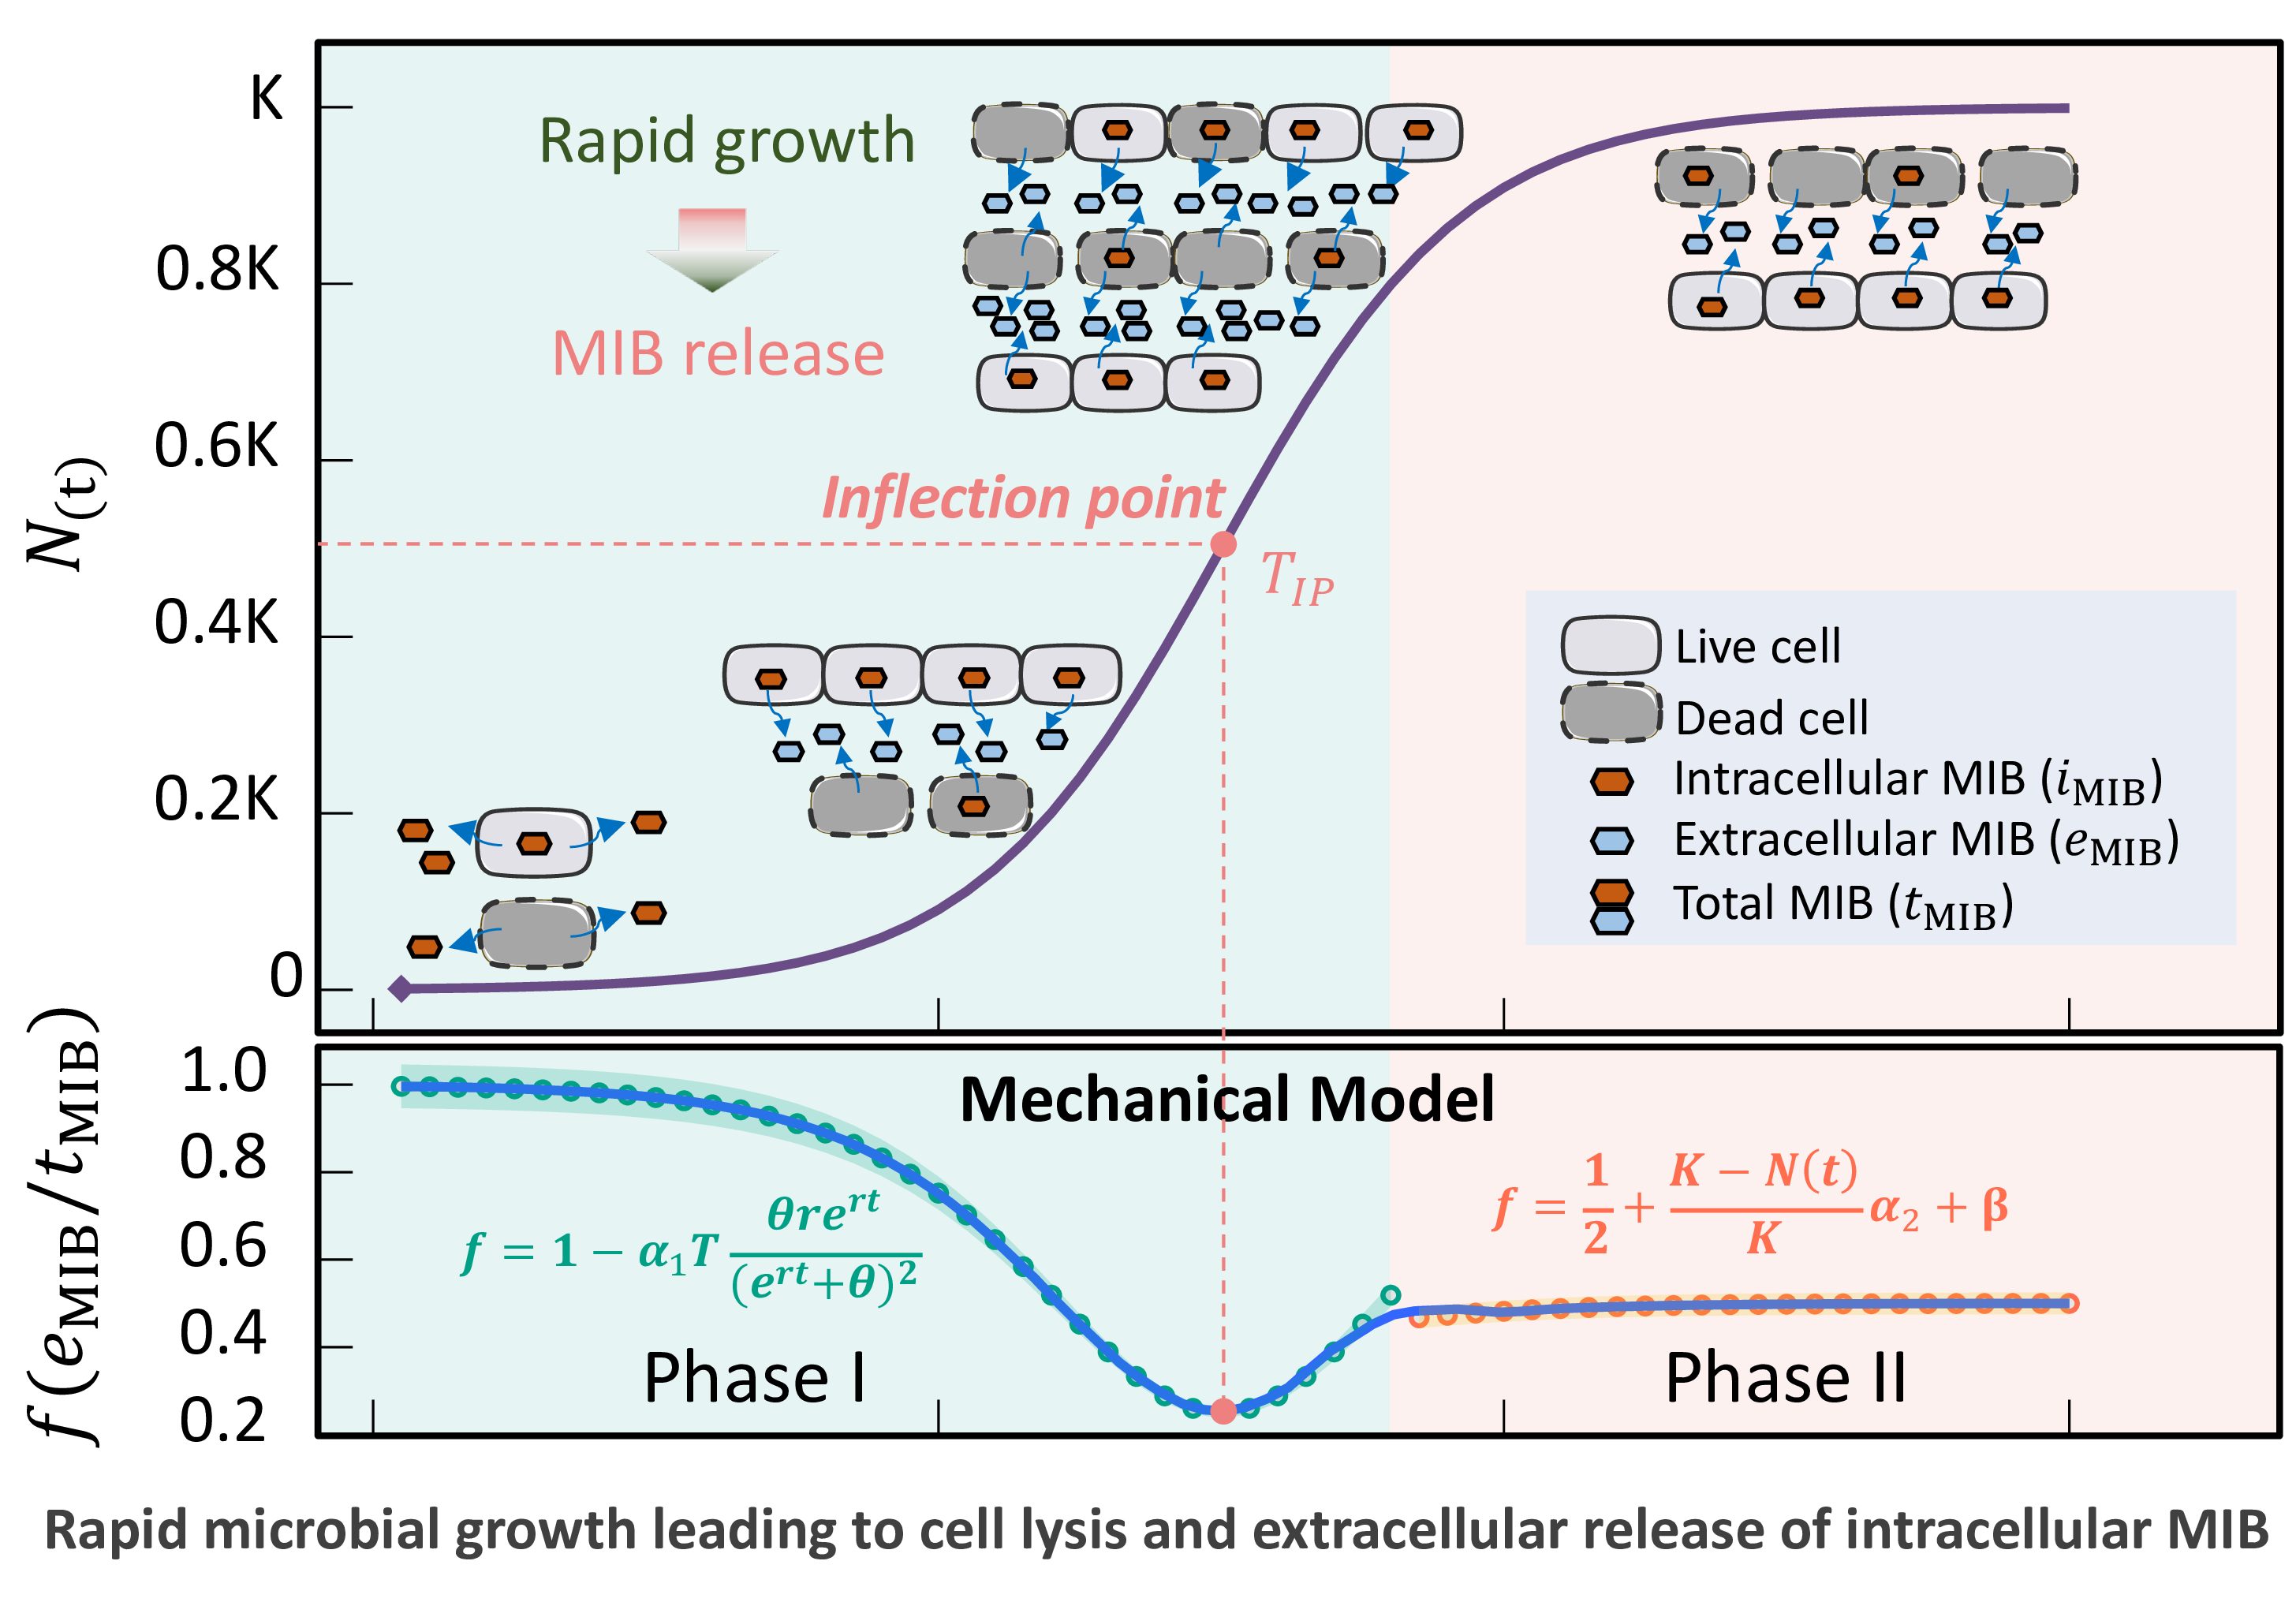

Abstract
2-Methylisoborneol (MIB), a potent cyanobacterial metabolite, impairs drinking water quality through taste-and-odor issues at trace concentrations. Despite its significant impact, the intracellular dynamics and environmental release mechanisms of MIB remain poorly characterized. We developed a mechanistic model of growth-phase dependent MIB release through controlled experiments with two producer strains. The model reveals that the extracellular MIB proportion ($f=e_{\text{MIB}}/t_{\text{MIB}}$) follows a consistent pattern: decreasing to a minimum at mid-log phase before rising and stabilizing ($f$: 0.4 to 0.6) during stationary phase, suggesting crowding-induced cell lysis drives release dynamics. Application to Lake Taihu successfully reconstructed two odor events (2022-2023), elucidating both the spatiotemporal development of MIB producers and identifying critical risk thresholds at ~15°C and >30°C under moderate light (0.1-0.4 mol m⁻² d⁻¹) - patterns undetectable by conventional monitoring. Our findings demonstrate that physiological transitions, rather than just biomass accumulation, control odorant release. This framework may extend to other algal metabolites (e.g., geosmin, cyanotoxins), offering broader predictive capability. By linking cellular processes to water quality risks, our approach enables proactive management of cyanobacterial contaminants, informing both early warning systems and operational guidance for oxidant-type optimization to prevent large-scale release of hazardous compounds from algal cells.

SYNOPSIS
Our mechanistic model shows crowding-induced cyanobacterial lysis drives MIB release, enabling odor outbreak prediction and optimized water treatment strategies

Introduction
The issue of taste and odor (T&O) in drinking water sources is a major water quality concern, with earthy-musty odors caused by 2-methylisoborneol (MIB) being one of the most prevalent problems^{1–3}. MIB, an odorous terpenoid derivative, poses a persistent challenge in drinking water due to its extremely low odor threshold concentration (OTC) of 10 ng L⁻¹ and its resistance to conventional water treatment processes^{4–10}. This compound is produced by various microorganisms, including actinomycetes¹¹, cyanobacteria¹², fungi¹³, and myxobacteria¹⁴. However, in drinking water sources, filamentous cyanobacteria—such as Pseudanabaena, Planktothrix, Phormidium, Oscillatoria, Lyngbya, and Planktothricoides—are the primary producers^{15–21}.
Following biosynthesis, MIB is primarily distributed inside the cells as intracellular MIB ($i_{\text{MIB}}$) or cell-bound MIB^{22,23}. It is then transported to the extracellular environment via cell membrane transporters, forming extracellular MIB ($e_{\text{MIB}}$). Additionally, MIB release can occur during cell wall rupture or lysis upon cell death^{24,25}.
The distribution of MIB between intracellular and extracellular compartments has significant implications for drinking water treatment. If most MIB is already released into the water, advanced treatment processes such as ozone-activated carbon adsorption are required for its removal. Conversely, if MIB remains predominantly intracellular, conventional coagulation and sedimentation processes can effectively remove algal cells, or oxidants that minimize cell damage can be employed to prevent MIB release. Current monitoring practices in water treatment plants typically measure total MIB ($t_{\text{MIB}}$) without distinguishing between intracellular and extracellular fractions, limiting their utility in guiding treatment process selection. Existing studies on MIB distribution are limited and often assume a constant ratio, which fails to provide actionable insights for water treatment optimization.
Our observations from culture experiments suggest that the intracellular and extracellular distribution of MIB is not constant and may be influenced by its biosynthesis and release mechanisms^{25–28}. The biosynthetic pathway of MIB in cyanobacteria involves the methylation of geranyl diphosphate (GPP) followed by cyclization of methyl-GPP, catalyzed by 2-methylisoborneol synthase (2-MIBS) within the Sg Enc protein shell^{29–32}. However, due to the lack of observable pores in the Sg Enc shell and the challenges in directly tracking MIB migration, the mechanisms governing its release and distribution remain poorly understood.
MIB production in cyanobacteria is highly variable and influenced by environmental stressors^{27,33}. While total MIB concentrations typically peak during the log growth phase and decline during the stationary phase, some studies report a negative correlation between MIB production and cell growth rates. For instance, Pseudanabaena sp. accumulates higher intracellular MIB and releases more extracellular MIB under suboptimal temperature and light conditions^{25,34,35}. One hypothesis suggests that cyanobacteria may increase extracellular MIB release under stress to inhibit competing algal species, thereby maintaining ecological dominance³⁵. Alternatively, extracellular MIB may simply result from cell damage or death under adverse conditions^{25,36}.
In high-cell-density environments, crowding effects can restrict cell proliferation, migration, and metabolism, impacting growth and death dynamics^{37–40}. Crowding-induced growth limitation arises from resource competition, spatial constraints, and cell cycle arrest^{41,42}, while cell death may result from programmed cell death, metabolic stress, mechanical damage, or cell-to-cell interactions^{43–45}. These effects indirectly influence the release of intracellular metabolites such as MIB.
The Logistic growth model effectively describes cyanobacterial population dynamics under crowding effects, incorporating intrinsic growth rate ($r$) and carrying capacity ($K$) to capture growth deceleration and inflection points^{46–48}. This model is particularly useful for analyzing shifts in metabolic activity and the timing of metabolite release, making it well-suited for studying MIB dynamics^{49,50}.
Based on these observations, we hypothesize that the ratio of $e_{\text{MIB}}$ to $t_{\text{MIB}}$ ($f$) is not constant but varies predictably over time in response to cell crowding. To test this, we developed a mechanical model describing the temporal variation of $f$ using culture experiments with typical MIB-producing strains. The model was validated to explain MIB release patterns during cell growth and applied to assess growth-stage distributions of odor-producing cyanobacteria in Taihu Lake, predicting odor risk during MIB outbreaks. This study provides new insights into MIB release dynamics, enhances understanding of cyanobacterial odor production, and offers practical guidance for water treatment process selection and bloom management.

Materials and Methods

Study Area and Sampling
Lake Taihu (30°55’40”–31°32’58” N, 119°52’32”–120°36’10” E), located in the southeastern Yangtze River Delta, is China’s third-largest shallow freshwater lake, with a surface area of 2,578 km². The Taihu Lake watershed sustains a densely populated region of over 68 million people (2023 Bulletin on Water Resources in the Taihu Basin and Southeastern Rivers). The lake serves as a critical drinking water source for approximately 17 million residents, including about 20% of Shanghai’s population. Since 2016, the newly constructed Jinze Reservoir has been supplying drinking water sourced from eastern Lake Taihu via the Taipu River (Shanghai Water Authority, 2016). It is also extensively used for irrigation and aquaculture, making water quality a vital concern for local ecosystems and livelihoods.
Lake Taihu is renowned for its recurrent Microcystis blooms, which have drawn significant scientific and policy attention. In response, China has implemented substantial efforts to reduce non-point source pollution, particularly nutrient loading, leading to measurable improvements in water quality in recent years. However, as nutrient concentrations have declined, shifts in algal community composition have occurred: Microcystis blooms have diminished, while filamentous cyanobacteria have proliferated, resulting in elevated 2-methylisoborneol (MIB) levels.
From March 2022 to February 2023, monthly water samples were collected from 31 sampling sites distributed across the lake (Fig. S1). Given the lake’s average depth of ~2 m and well-mixed conditions, surface water samples (2 L) were collected from 0.5 m below the water surface using a Kemmerer water sampler.

Physicochemical Analysis and Phytoplankton Enumeration
In situ measurements of physicochemical parameters—including water temperature, pH, dissolved oxygen (DO), turbidity, and conductivity—were conducted using a multiparameter probe (EXO2, USA). Water transparency was quantified via Secchi depth (SD) measurements using a 20 cm diameter Secchi disk. Nutrient concentrations (nitrate, nitrite, ammonia, total nitrogen [TN], and total phosphorus [TP]) were analyzed following Chinese national standard methods(Ministry of Environmental Protection of PRC 2007, 2009, 2012, 2013).
For odorant analysis, subsamples (100 mL) were collected in amber glass bottles with airtight seals and preserved with 10 mg L⁻¹ ${\text{HgCl}}_{2}$ to inhibit biodegradation⁵¹. Total MIB production potential was determined by measuring its concentration within 72 hours using solid-phase microextraction (SPME) coupled with gas chromatography-mass spectrometry (GC-MS; Agilent 6890/5975, USA), following established protocols^{16,52}.
For phytoplankton enumeration, subsamples (1000 mL) were fixed with 5% Lugol’s iodine solution⁵³, settled for 48 hours, and pre-concentrated 20-fold before analysis. Cyanobacterial species were identified based on morphological criteria⁵⁴, with taxonomic revisions following ref⁵⁵. Cell counts were performed using an upright microscope (Olympus BX53, Japan) following the Utermöhl method⁵⁶.

Model Development
The logistic growth model was applied to describe changes in cell density of cultured strains (Eq. 1):
$$N\left(t\right)=\frac{K}{1+\frac{K−N_{0}}{N_{0}}e^{−rt}} \left(1\right)$$

$$θ=\frac{K−N_{0}}{N_{0}} \left(2\right)$$
Here, $K$ represents the environmental carrying capacity (maximum achievable cell density), $N_{0}$ is the initial cell density ($t$ = 0), $r$ is the intrinsic growth rate (maximum growth rate under ideal conditions)^{48,50}, and $θ$ denotes the initial growth potential.
In aquatic systems, MIB exists in two forms: intracellular ($i_{\text{MIB}}$) and extracellular ($e_{\text{MIB}}$), with their sum constituting total MIB ($t_{\text{MIB}}$). The ratio $f$ ($e_{\text{MIB}}/t_{\text{MIB}}$) serves as an odor index, reflecting the proportion of dissolved $\text{MIB}$ over total MIB.
To model temporal variations in $e_{\text{MIB}}$ and $t_{\text{MIB}}$ produced by Pseudanabaena cinerea FACHB 1277 (obtained from the Freshwater Algae Culture Collection at the Institute of Hydrobiology) and Planktothricoides raciborskii (isolated from the FH Reservoir in Zhuhai, China³³), we developed stage-specific equations for $f$. For cell densities below 80% of $K$ (Phase I), $f$ was derived from the logistic growth equation to capture early- to mid-growth dynamics (Eq. 3). For densities approaching $K$ (>80%, Phase II), $f$ was modeled using residual growth capacity to describe the stationary phase (Eq. 4):
$$f=1−α_{1}T{\left(\frac{N\left(t\right)}{K}\right)}^{′}=1−α_{1}T\frac{θre^{rt}}{e^{2rt}+2θe^{rt}+θ^{2}} \left(3\right)$$

$$f=\frac{1}{2}+\frac{K−N\left(t\right)}{K}α_{2}+β \left(4\right)$$
Here, $α_{1}$ and $α_{2}$ are variation coefficients, $T$ is the cell doubling time, and $β$ is a correction factor for $\text{MIB}$ accumulation/volatilization. Model parameters ($N_{0}$, $K$, $r$) were estimated via logistic curve fitting, while $α_{1}$, $α_{2}$, and $β$ were determined via linear regression. Adjusting $r$ allowed simulation of growth and $\text{MIB}$ production under varying environmental conditions.

MIB Risk Assessment
For a given $f$, the cyanobacterial growth time ($t$) was derived from Eq. 3 and Eq. 4, and the growth stage indicator ($St$) was calculated as:
$$St=\frac{t}{2T_{IP}} \left(5\right)$$
where $T_{IP}$ (time at which $N\left(t\right)$ = $K/2$) marks the logistic curve’s inflection point. A smaller $T_{IP}$ value indicates faster cyanobacterial growth and stronger crowding effects, thereby increasing the likelihood of cell rupture and MIB release. By combining $St$ with field-measured $t_{\text{MIB}}$ concentrations, we generated a frequency distribution histogram (Fig. S11) to quantify the probability of $t_{\text{MIB}}$ occurrence at different growth stages, enabling $\text{MIB}$ risk evaluation.

Statistical Analysis and Visualization
All analyses were conducted in R 4.4.2⁵⁷. Data preprocessing and summarization used dplyr⁵⁸, while regression analyses (linear/generalized linear models) employed the stats package. Generalized additive modeling (mgcv;⁵⁹) and quantile regression (quantreg;⁶⁰) were applied where appropriate. Figures were generated using ggplot2⁶¹, with contour plots produced via the graphics package.

Results

Spatiotemporal Distribution Characteristics of MIB in Lake Taihu
Between March 2022 and February 2023, two severe MIB outbreaks were observed in Lake Taihu (Fig. 1A). The outbreaks exhibited distinct seasonal patterns, with elevated MIB concentrations occurring primarily in spring (40.0 ± 77.5 ng L⁻¹) and summer (107 ± 230 ng L⁻¹). The highest peaks were recorded in April (66.5 ± 101 ng L⁻¹) and July (232 ± 361 ng L⁻¹), demonstrating statistically significant seasonality (p < 0.001). Notably, MIB concentrations across the lake were relatively low in June, between the two outbreak periods.
Spatially, MIB distribution showed clear heterogeneity across the lake (Fig. 1B). The northern and southeastern regions consistently showed the highest concentrations, with the April peak centered in the northern area and the July peak affecting both northern and southeastern areas. Cluster analysis of MIB concentrations from all 31 sampling sites revealed four distinct spatial clusters that corresponded to different lake regions (Fig. S1), with the most severe outbreaks concentrated in the northern and southeastern clusters.
Analysis of the $f$ value variation across clusters revealed an important pattern: the lowest values during the log growth phase of $f$ were typically followed by MIB outbreaks (Fig. 1C). Concurrent 16S RNA gene sequencing identified Pseudanabaena and Planktothricoides as the dominant MIB-producing genera, though their abundances varied significantly (Fig. S4). While Microcystis dominated the cyanobacterial community for most of the study period (Fig. 1D), Pseudanabaena reached its peak relative abundance (31.0%) in September, coinciding with MIB production. In contrast, Planktothricoides remained at much lower levels (1.4%).

Fig. 1: Annual patterns of MIB and odor-producing cyanobacteria in Lake Taihu: (A) Spatiotemporal distribution of total MIB ($t$_{MIB}) concentrations; (B) Spatial clustering of $t$_{MIB} concentrations across the lake; (C) Temporal variation in extracellular MIB proportion ($e$_{MIB}/$t$_{MIB}) by lake region; (D) Seasonal shifts in dominant cyanobacterial genera composition.

Modeling the Relationship Between Cultured Cyanobacteria Growth and Extracellular MIB Ratio (f)
The observed $f$ ratio in Lake Taihu water samples exhibited a characteristic temporal pattern (Fig. 1C). To further elucidate this pattern, we analyzed the growth and odor production dynamics of two laboratory-cultured odor-producing cyanobacteria species (Pseudanabaena and Planktothricoides) under varying light conditions. A logistic growth-based model was developed to characterize the dynamics of the extracellular-to-total MIB ratio ($f$) (Eq. 3, Eq. 4). The model effectively captured the growth trajectories of both Pseudanabaena and Planktothricoides (Fig. 2A, 2B). Under different light regimes, both extracellular MIB ($e_{\text{MIB}}$) and total MIB ($t_{\text{MIB}}$) concentrations increased during the early growth phase (Fig. 2C), in parallel with rising cell densities. MIB production peaked when cell densities approached approximately half of the environmental carrying capacity ($K$), and remained relatively stable thereafter.

Fig. 2: Growth and odor compound production of cultured target odor-producing cyanobacteria: Logistic growth fitting for Pseudanabaena (A) and Planktothricoides (B), and corresponding MIB production patterns (C), with raw data from refs¹⁸ and³³ respectively.
During growth and odor production, both species showed a consistent $f$ ratio pattern: an initial decrease reaching its minimum at approximately half of the maximum cell density, followed by a gradual increase that stabilized near 0.5. Notably, while $e_{\text{MIB}}$ and $t_{\text{MIB}}$ concentrations increased slowly during the initial phase, they rose rapidly during the subsequent phase of $f$ ratio increase. Therefore, we formed this mechanical model as illustrated and represent in Fig. 3A.
Parameter estimation revealed significant interspecies differences: $α_{1}$ was substantially higher for Pseudanabaena than for Planktothricoides (p < 0.01), while $β$ showed the opposite trend (p < 0.01) (Fig. 3B). The model demonstrated good overall performance, with relatively small residuals across most growth conditions (Fig. 3C). Under varying light conditions, the observed changes in the $f$ values of the two cultured odor-producing cyanobacteria were well captured by the model-derived $f$ value curves (Fig. 3D). Moreover, despite differences in species and experimental conditions, the $f$ value trajectories exhibited similar patterns across treatments. Specifically, in the first phase, the $f$ value declined and then increased, while in the second phase, it fluctuated before stabilizing at a relatively constant level. These patterns are consistent with the conceptual results (Fig. 3A).
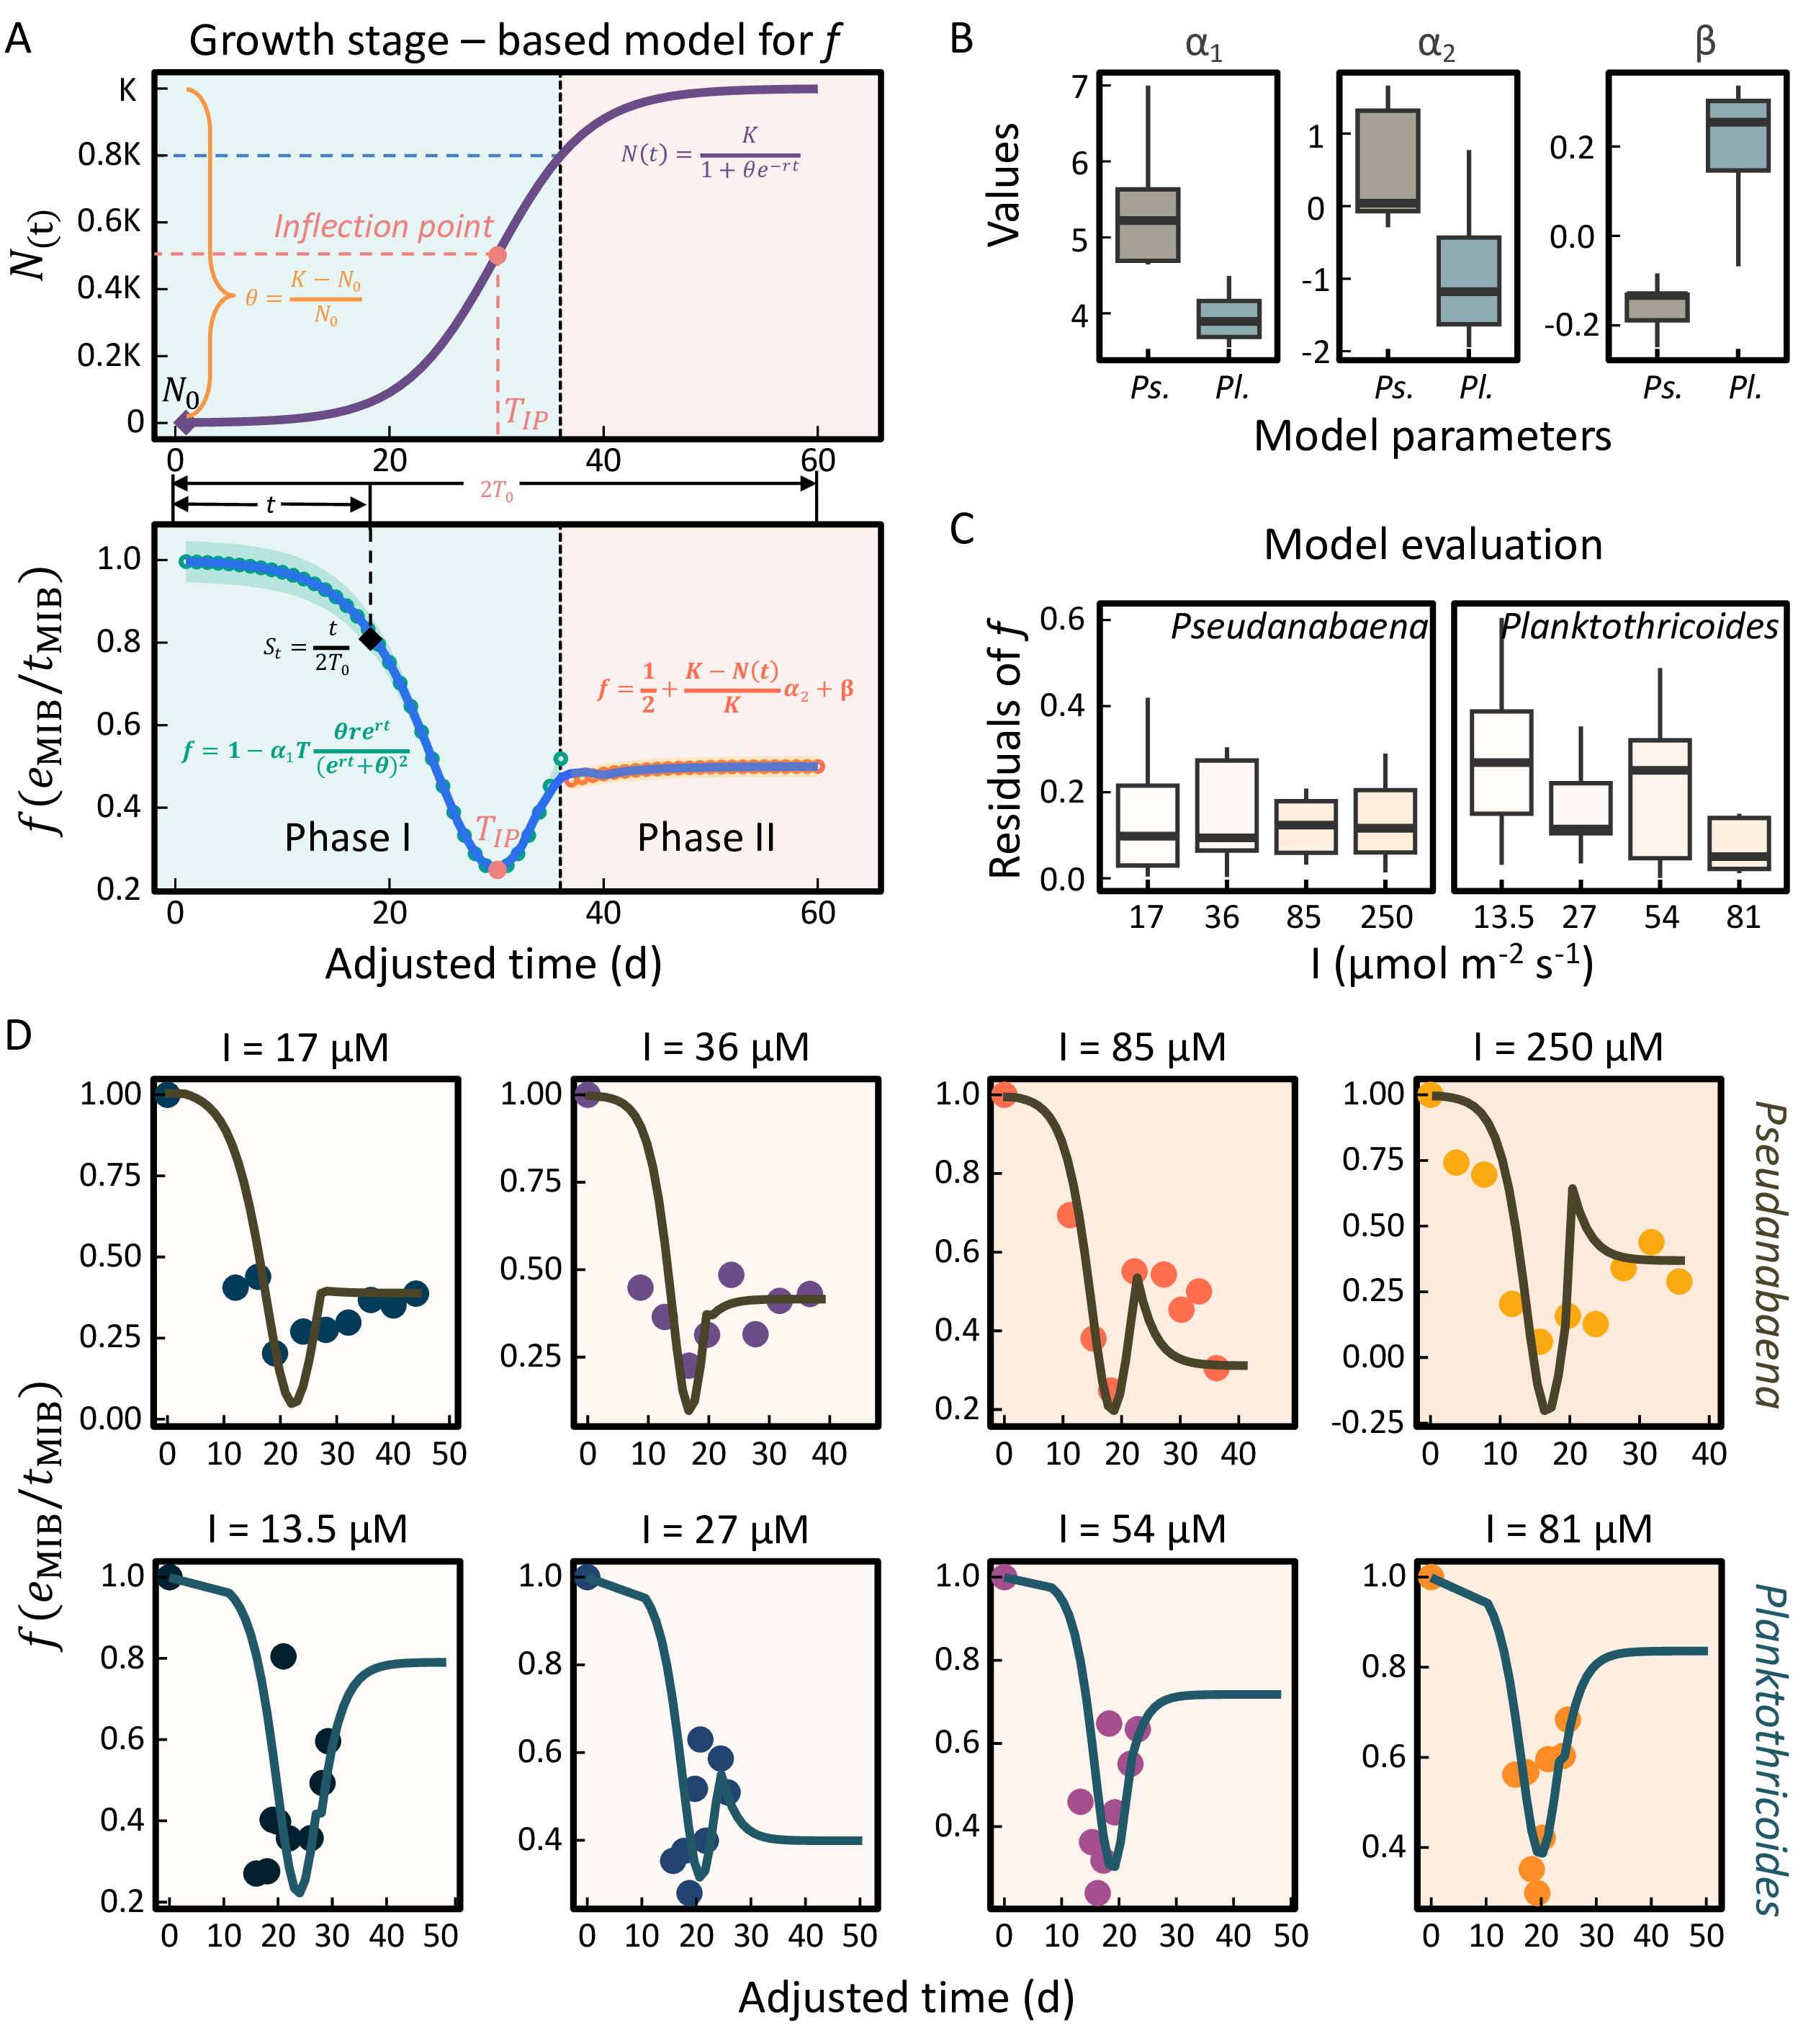
Fig. 3: Model development and performance for extracellular MIB ratio ($f$): (A) Logistic growth curve illustrating key growth phases and conceptual framework of the $f$ ratio model; (B) Inter-species comparison of model parameters ($α_{1}$, $α_{1}$, β); (C) Model residual analysis for both species; (D) Modelled ratio (line) and observed ratio (circle) of extracellular MIB to total MIB ($f$) for cultured Pseudanabaena and Planktothricoides.

Spatiotemporal Variation of Odor-Producing Cyanobacteria Growth Stages in Lake Taihu
The dominant odor-producing cyanobacterium Pseudanabaena in Lake Taihu exhibited high cell densities from July to October, followed by a significant decline starting in November (Fig. S2). Among all regions, the northern and southeastern parts of the lake consistently showed higher Pseudanabaena cell densities. Notably, some sites in the northern region still recorded cell densities exceeding 10⁵ cells L⁻¹ as late as December and the following January.
The cultivation-based model was successfully applied to field data from sampling locations throughout Lake Taihu to characterize growth parameters and determine $St$ values for odor-producing cyanobacteria. Analysis revealed two distinct seasonal growth patterns across the lake. A primary growth phase developed from May through November as water temperatures increased, followed by a secondary, smaller-scale growth phase ($St$) occurring between December and April after winter production (Fig. 4A).
These alternating growth phases directly corresponded with the two annual peaks in MIB concentrations observed in the lake. Examination of algal growth stages across different cluster regions demonstrated strong synchronization between cyanobacterial growth dynamics and MIB outbreak events (Fig. 4B). The $St$ values proved particularly informative, as values approaching 0.5 reliably indicated when populations reached the inflection point of logarithmic growth - a critical threshold associated with elevated risk of substantial MIB release.

Fig. 4: Growth stage of odor-producing cyanobacteria determined by the $f$ model in the Lake Taihu (A) and different subregions (B)
To enable broader application of the model across Lake Taihu, we compiled data on water temperature, solar radiation, and odor-producing cyanobacteria growth patterns under various conditions from multiple sources (Table S2, Fig. S7). By analyzing these monthly variations, we established relationships between environmental factors (temperature and light intensity) and the intrinsic growth rate ($r$) of cyanobacteria. Our analysis revealed clear seasonal differences in the distribution of cyanobacterial growth stages (Fig. 5A). From spring (March 2022) through winter (February 2023), the growth stages followed a consistent pattern of initial increase followed by gradual decline across the entire lake. Spatially, the northern and southeastern regions consistently showed more advanced growth stages compared to other areas throughout all seasons.
The seasonal progression of growth stages exhibited distinct spatial patterns. In early spring, odor-producing cyanobacteria first began growing in the northwest and southeast regions. By summer, active growth had spread to most areas of the lake. During autumn, the northern, southern and southeastern regions reached later growth stages, while in winter, cyanobacterial growth became minimal across nearly the entire lake, with only a small portion of the northern region showing any activity. This spatiotemporal progression of growth stages aligned closely with the observed patterns of MIB production throughout the study period.

Fig. 5: Spatiotemporal distribution of (A) modeled growth stages of odor-producing cyanobacteria and (B) the risk of MIB occurrence (probability of $t_{e}xtMIB$ > 10 ng L$​^{−1}$) in Lake Taihu.
The relationship between odor-producing cyanobacteria growth stage ($St$) and total MIB concentration ($t_{\text{MIB}}$) was further analyzed to assess annual odor risk distribution in Lake Taihu (Fig. 5B, Fig. S10). The analysis revealed similar spatial patterns for the probability of MIB exceeding both 10 ng L⁻¹ and 50 ng L⁻¹ thresholds, with the higher threshold’s probability typically being half that of the lower threshold.
Seasonal risk patterns showed elevated MIB concentrations occurring during two main periods: spring (March-May) and late summer through autumn (July-October). June represented a transitional period between these two risk episodes, while from November to February, most of the lake showed minimal risk except for localized areas in the northern and southeastern regions.
Spatially, spring risks were primarily concentrated in the northern lake region. During late summer and autumn, high-risk areas expanded to encompass nearly the entire lake. Throughout all seasons, the northern and southeastern regions consistently emerged as high-probability hotspots for elevated MIB concentrations.

High-risk conditions for rapid MIB-producer growth and crowding-induced release
Understanding the environmental conditions that promote rapid growth and crowding of odor-producing cyanobacteria is essential for predicting MIB risk dynamics in source waters. Our analysis reveals that the inflection point time ($T_{IP}$) from logistic growth modeling serves as a robust indicator of when cyanobacterial populations reach critical densities associated with elevated MIB release risk. Shorter $T_{IP}$ values indicate faster growth rates and earlier onset of crowding effects, ultimately leading to MIB release and higher extracellular concentrations.
Field observations from Lake Taihu demonstrate that $T_{IP}$ shows consistent negative correlations with three key environmental factors: initial cell density, light availability, and temperature within typical lake conditions (15-35°C; 0.1-0.4 mol m^-2 d^-1 underwater light, Fig. 6A). When carrying capacity remains stable, higher initial cell densities substantially shorten the growth stage duration, accelerating the progression to crowding conditions. Similar acceleration occurs under favorable light and temperature conditions, where increased light intensity and warmer temperatures enhance growth rates, reducing $T_{IP}$ and promoting earlier cell lysis and odor compound release.
These relationships explain the characteristic bimodal pattern of MIB events in Lake Taihu, with risk peaks occurring at approximately 15°C and above 30°C under moderate light conditions (Fig. 6B). The model outputs confirm that temperature-mediated changes in cyanobacterial growth dynamics represent the primary driver of seasonal MIB risk variations, matching historical patterns of spring and summer odor outbreaks in the lake.
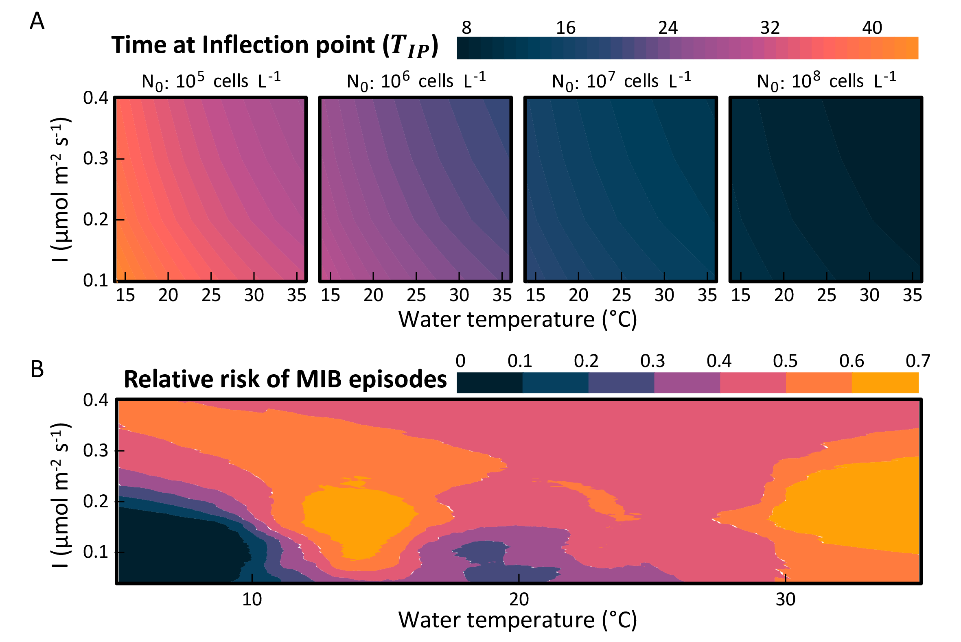
Fig. 6: Modeled relationships between inflection point time ($T_{IP}$), MIB risk, and environmental drivers in Lake Taihu: (A) Mechanistic model outputs showing $T_{IP}$ as a function of water temperature, underwater light dose ($I$), and initial cell density ($N_{0}$); (B) Estimated probability of MIB concentrations exceeding the 10 ng L⁻¹ threshold under identified high-risk conditions.

Discussion

Modeling MIB Partitioning Dynamics in Relation to Cyanobacterial Growth Phases
The production and distribution of 2-methylisoborneol (MIB) by odor-producing cyanobacterial cells are influenced by both their growth stage and environmental stressors. Previous studies have rarely focused on the intracellular and extracellular distribution of MIB during the growth of cyanobacteria in both natural aquatic environments and laboratory cultures. Some even suggested that the variation in MIB partitioning lacks a discernible pattern^{62,63}. In this study, we introduce the ratio $f$ ($e_{MIB}/t_{MIB}$) as an key indicator to represent the distribution pattern of MIB. Our findings show that $f$ is not a constant, but follows a specific dynamic trend, which is mainly attributed to cell crowding effects (Fig. 7). After synthesis, MIB is primarily bound to cytoplasmic and soluble protein fractions within cyanobacterial cells⁶⁴. The major mechanism of MIB release is cell lysis, occurring either through programmed cell death or mechanical rupture of the cell wall^{25,27,28,36}. In this study, we established a model describing the relationship between $f$ and growth time $t$, and further proposed a metric—growth stage ($St$)—to evaluate the distribution of cyanobacterial growth stages across the lake (Fig. 7). The $St$ index ranges from 0 to 1, representing the progression of cell growth from the lag phase to the stationary phase, with $St$ = 0.5 corresponding to the inflection point of the logistic growth curve. A higher $St$ indicates a larger proportion of cells in the later stages of growth, implying a greater potential for MIB release. As cell growth progresses toward the stationary phase, environmental cell density increases, leading to intensified crowding effects. These conditions exacerbate cell damage and apoptosis, causing a larger proportion of MIB to be released into the surrounding water⁶⁵.

Fig. 7: Schematic representation of MIB allocation dynamics influenced by cell crowding, both intracellularly and extracellularly
Our model enables the estimation of the growth stage distribution of odor-producing cyanobacteria, offering insights into current odor issues and supporting prediction of future taste and odor (T&O) risks. From a management perspective, $f$ serves dual functions: (1) as a T&O index reflecting the proportion of dissolved MIB ($e_{\text{MIB}}$) to total MIB ($t_{\text{MIB}}$) in the water, and (2) as an ecological indicator of the relative proportions of cells at different growth stages. Model results (Fig. 2A, B) demonstrate that $f$ follows a nonlinear pattern—initially decreasing, then increasing and eventually stabilizing—as the cell population transitions from the lag phase to the stationary phase. During the log phase, $f$ reaches its minimum when cell growth rate peaks at the inflection point of the logistic growth curve. After this point, crowding-induced stress increases, leading to significant MIB release due to cell damage and apoptosis. Toward the end of the log phase and during the stationary phase, cell density approaches the environmental carrying capacity and enters a state of dynamic equilibrium. At this stage, $f$ is primarily influenced by total cell density and the accumulation and degradation dynamics of $e_{\text{MIB}}$ in the environment. This trend is consistent with observations reported in previous studies^{25,27}. By applying the $f$-model, the growth stage distribution of odor-producing cyanobacteria can be inferred based on measured MIB partitioning. This framework enhances our understanding of T&O events in freshwater lakes and reservoirs and provides valuable guidance for implementing more targeted management strategies.

Field-Based Analysis of MIB Dynamics in Relation to Cyanobacterial Growth in Lake Taihu
Analysis of intracellular and extracellular MIB distribution patterns, influenced by cell crowding effects, provides insights into the growth dynamics and odor production processes of MIB-producing cyanobacteria in Lake Taihu. Lake-wide distribution of $St$ values revealed that cyanobacterial growth initiates during the winter-spring transition in specific areas, beginning with slow early-phase growth that continues until early summer, followed by accelerated growth through late autumn. This bimodal MIB pattern shows temporal variations across years. For example, monitoring data from 2019 and 2021 documented smaller May peaks (predominantly in the southeastern region) alongside major August peaks^{66,67}. Temperature and light availability emerge as the principal environmental regulators of this pattern. Summer conditions typically optimize growth for Pseudanabaena, a key filamentous MIB producer^{67–70}. When surface water temperatures exceed 20°C in April-May, MIB-producing cyanobacteria achieve substantial growth rates^{71–73}, benefiting from minimal competition and resulting in spring MIB peaks. Subsequent Microcystis blooms (May-July) reduce light availability in subsurface layers where filamentous MIB producers reside, temporarily suppressing their growth^{70,74}. This ecological succession aligns with observed microcystin concentration trends⁶⁶ and documented phytoplankton community shifts⁷⁵.
High-risk zone analysis reveals distinct spatiotemporal patterns between northern and southeastern regions. The southeastern zone showed modest April increases followed by July peaks persisting through September, while the northern region exhibited stronger spring peaks with sustained MIB levels (>10 ng L⁻¹) between major outbreaks. These differences reflect contrasting cyanobacterial growth dynamics: southeastern populations transitioned from late-growth phase in March to early growth by April, suggesting significant cell mortality and limited MIB production potential, whereas northern populations maintained log-phase growth through spring with correspondingly higher production potential. The observed north-to-south progression of odor risk zones represents a previously unreported spatial-temporal pattern in Lake Taihu’s MIB dynamics.
Species-specific analyses demonstrate considerable variation in growth and MIB production characteristics. Model parameterization revealed significant interspecies differences (Fig. 2E), attributable to variations in intrinsic growth rates and MIB production efficiencies. Comparative studies show Pseudanabaena achieves maximum cellular MIB yields of 0.15 ± 0.04 pg cell⁻¹ under 85 μmol photons m⁻² s⁻¹¹⁸, while Planktothricoides reaches 0.22 ± 0.02 pg cell⁻¹ under similar conditions³³. These physiological differences, combined with variations in population growth inflection points ($T_{IP}$) across studies (Fig. S12), contribute to species-specific impacts on odor event dynamics.

Environmental significance
The development of a model connecting cyanobacterial growth stages with MIB release dynamics and intracellular-extracellular distribution provides valuable contributions to understanding and managing freshwater odor events. This research advances ecological knowledge of odor-producing cyanobacteria in natural systems while simultaneously creating a practical tool for predicting MIB concentration trends, significantly enhancing early warning capabilities. The model’s ability to quantify intracellular versus extracellular MIB ratios offers direct applications for water treatment optimization, enabling operators to select targeted strategies - focusing either on intact cell removal through coagulation and sedimentation when intracellular MIB dominates, or implementing cell-disruption approaches when extracellular MIB prevails^{9,76–78}.
Application of this modeling framework to Lake Taihu demonstrates its utility for estimating annual cyanobacterial growth phase distributions from MIB patterns and predicting high-risk odor zones, providing actionable guidance for lake management. While the current model effectively addresses the predominant MIB release pathways through cell damage and apoptosis, future research should investigate potential active MIB release mechanisms to complete our understanding of odor compound dynamics in aquatic systems.

Conclusion
The intracellular and extracellular distribution dynamics of 2-methylisoborneol (MIB), a musty-smelling secondary metabolite produced by cyanobacteria, remain poorly understood, limiting our ability to predict odor events in source waters. This study developed a growth-stage-based model to characterize MIB release patterns and applied it to Lake Taihu, where conventional approaches have struggled to explain complex odor phenomena. Results revealed that odor-producing cyanobacteria in the lake underwent two distinct growth cycles annually, corresponding to dual MIB concentration peaks—in spring and summer. The $f$ model, derived from laboratory-cultured cyanobacteria data, accurately captured these growth trends and was successfully applied to field observations across the lake. By integrating environmental variables such as water temperature and light intensity, the model enabled lake-wide prediction of cyanobacterial growth stages and corresponding MIB risk. Spatially, the northern and southeastern regions of Lake Taihu consistently showed higher growth potential and odor risk. Temporally, high MIB risk was concentrated in early spring and mid-summer, aligning with inflection points in the cyanobacterial growth phase. Further analysis indicated that environmental factors—especially temperature and light dose—significantly influenced the timing of growth phase transitions, thereby affecting odor risk. Notably, the model identified two risk peaks under moderate light conditions, reflecting the dual seasonal odor patterns observed in the lake. These findings demonstrate the applicability of the $f$ model as a predictive tool for early MIB warnings and provide valuable insights for water quality monitoring and lake management.

FIGURES
- Fig. 1: Annual patterns of MIB and odor-producing cyanobacteria in Lake Taihu: (A) Spatiotemporal distribution of total MIB ($t$_{MIB}) concentrations; (B) Spatial clustering of $t$_{MIB} concentrations across the lake; (C) Temporal variation in extracellular MIB proportion ($e$_{MIB}/$t$_{MIB}) by lake region; (D) Seasonal shifts in dominant cyanobacterial genera composition.
- Fig. 2: Growth and odor compound production of cultured target odor-producing cyanobacteria: Logistic growth fitting for Pseudanabaena (A) and Planktothricoides (B), and corresponding MIB production patterns (C), with raw data from refs¹⁸ and³³ respectively.
- Fig. 3: Model development and performance for extracellular MIB ratio ($f$): (A) Logistic growth curve illustrating key growth phases and conceptual framework of the $f$ ratio model; (B) Inter-species comparison of model parameters ($α_{1}$, $α_{1}$, β); (C) Model residual analysis for both species; (D) Modelled ratio (line) and observed ratio (circle) of extracellular MIB to total MIB ($f$) for cultured Pseudanabaena and Planktothricoides.
- Fig. 4: Growth stage of odor-producing cyanobacteria determined by the $f$ model in the Lake Taihu (A) and different subregions (B)
- Fig. 5: Spatiotemporal distribution of (A) modeled growth stages of odor-producing cyanobacteria and (B) the risk of MIB occurrence (probability of $t_{\text{MIB}}$ > 10 ng L$​^{−1}$) in Lake Taihu.
- Fig. 6: Modeled relationships between inflection point time ($T_{IP}$), MIB risk, and environmental drivers in Lake Taihu: (A) Mechanistic model outputs showing $T_{IP}$ as a function of water temperature, underwater light dose ($I$), and initial cell density ($N_{0}$); (B) Estimated probability of MIB concentrations exceeding the 10 ng L⁻¹ threshold under identified high-risk conditions.
- Fig. 7: Schematic representation of MIB allocation dynamics influenced by cell crowding, both intracellularly and extracellularly

ASSOCIATED CONTENT

Supporting Information
The Supporting Information is available free of charge at https://.
Spatial clustering map of sampling sites in Lake Taihu used in this study (Fig. S1); Temporal and spatial distribution of Pseudanbaena in Lake Taihu (Fig. S2); Seasonal distribution of total MIB concentration in Lake Taihu (Fig. S3); Concurrent 16S RNA gene sequencing identified Pseudanabaena and Planktothricoides as the dominant MIB-producing genera (Fig. S4); Logistic fit of Pseudanabaena growth under various light conditions (A: 5 mol m⁻² s⁻¹; B: 17 mol m⁻² s⁻¹; C: 36 mol m⁻² s⁻¹; D: 85 mol m⁻² s⁻¹; E: 250 mol m⁻² s⁻¹) (Fig. S5); Logistic fit of Planktothricoides growth under various light conditions (A: 13.5 mol m⁻² s⁻¹; B: 27 mol m⁻² s⁻¹; C: 54 mol m⁻² s⁻¹; D: 81 mol m⁻² s⁻¹) (Fig. S6); Studies in other literature involving the cultivation of Pseudanabaena and Planktothricoides (Fig. S7); Surface Shortwave Downward Irradiance in the Lake Taihu region from March 2022 to February 2023 (Data source: NASA POWER, https://power.larc.nasa.gov/) (Fig. S8); Fitted curves of extracellular MIB to total MIB ratio ($f$) under low, medium, and high cyanobacterial growth rates (Fig. S9); Odor risk assessment across the entire Lake Taihu (probability of $t_{\text{MIB}}$ > 50 ng L⁻¹) (Fig. S10); Frequency distribution of modeled $St$ and $t_{\text{MIB}}$ values for odor-producing cyanobacteria in Lake Taihu (Fig. S11); Boxplot comparison of inflection point times ($T_{IP}$) for Pseudanabaena and Planktothricoides (Fig. S12); Statistical comparisons between seasons for various metrics. $t_{\text{MIB}}$: total MIB; $e_{\text{MIB}}$: extracellular MIB; $i_{\text{MIB}}$: intracellular MIB; $f$: ratio of $e_{\text{MIB}}$ and $t_{\text{MIB}}$ ($f=e_{\text{MIB}}/t_{\text{MIB}}$) (Table S1); Studies in other literature involving the cultivation of Pseudanabaena and Planktothricoides (Table S2); (PDF)

AUTHOR INFORMATION

Corresponding Authors
- Ming Su: Key Laboratory of Environmental Aquatic Chemistry, State Key Laboratory of Regional Environment and Sustainability, Research Center for Eco-Environmental Sciences, Chinese Academy of Sciences, No. 18 Shuangqing Road, Haidian, Beijing 100085, China; University of Chinese Academy of Sciences, No. 19A Yuquan Road, Shijingshan, Beijing 100049, China; ORCID: https://orcid.org/0000-0001-9821-1268; Email: mingsu@rcees.ac.cn
- Min Yang: Key Laboratory of Environmental Aquatic Chemistry, State Key Laboratory of Regional Environment and Sustainability, Research Center for Eco-Environmental Sciences, Chinese Academy of Sciences, No. 18 Shuangqing Road, Haidian, Beijing 100085, China; University of Chinese Academy of Sciences, No. 19A Yuquan Road, Shijingshan, Beijing 100049, China; ORCID: https://orcid.org/0009-0005-4902-7620; Email: yangmin@rcees.ac.cn

Authors
- Yufan Ai: Key Laboratory of Environmental Aquatic Chemistry, State Key Laboratory of Regional Environment and Sustainability, Research Center for Eco-Environmental Sciences, Chinese Academy of Sciences, No. 18 Shuangqing Road, Haidian, Beijing 100085, China; University of Chinese Academy of Sciences, No. 19A Yuquan Road, Shijingshan, Beijing 100049, China
- Yongnian Wu: Bureau of Hydrology Information Center of Taihu Basin Authority, Shanghai 200434, China
- Yuying Gui: Key Laboratory of Environmental Aquatic Chemistry, State Key Laboratory of Regional Environment and Sustainability, Research Center for Eco-Environmental Sciences, Chinese Academy of Sciences, No. 18 Shuangqing Road, Haidian, Beijing 100085, China; College of Environmental Science and Engineering, Ocean University of China, Qingdao 266100, China
- Yifan Du: Key Laboratory of Environmental Aquatic Chemistry, State Key Laboratory of Regional Environment and Sustainability, Research Center for Eco-Environmental Sciences, Chinese Academy of Sciences, No. 18 Shuangqing Road, Haidian, Beijing 100085, China
- Jiao Fang: Key Laboratory of Environmental Aquatic Chemistry, State Key Laboratory of Regional Environment and Sustainability, Research Center for Eco-Environmental Sciences, Chinese Academy of Sciences, No. 18 Shuangqing Road, Haidian, Beijing 100085, China
- Tengxin Cao: Key Laboratory of Environmental Aquatic Chemistry, State Key Laboratory of Regional Environment and Sustainability, Research Center for Eco-Environmental Sciences, Chinese Academy of Sciences, No. 18 Shuangqing Road, Haidian, Beijing 100085, China; University of Chinese Academy of Sciences, No. 19A Yuquan Road, Shijingshan, Beijing 100049, China

Author contributions
Y.A. and Y.W. contributed equally to this work. Y.A. led data curation and methodology, performed formal analysis, and contributed equally to original drafting, writing, and editing. Y.W. took the lead in data curation and methodology. M.S. conceived the study, led formal analysis, project administration, supervision, and visualization, and contributed equally to original drafting, writing, and editing. Y.G., Y.D., J.F., and T.C. provided supporting contributions to methodology and formal analysis. M.Y. led conceptualization, supervision, validation, project administration, and resource provision. All authors reviewed and approved the final manuscript.

Notes
The authors declare no competing financial interest.

References
(1) WHO, W. H. O. Guidelines for Drinking-Water Quality; World Health Organization: Geneva, Switzerland, 2011.
(2) Devi, A.; Chiu, Y.-T.; Hsueh, H.-T.; Lin, T.-F. Quantitative PCR Based Detection System for Cyanobacterial Geosmin/2-Methylisoborneol (2-MIB) Events in Drinking Water Sources: Current Status and Challenges. Water Research 2021, 188, 116478. https://doi.org/10.1016/j.watres.2020.116478.
(3) Suurnäkki, S.; Gomez-saez, G. V.; Rantala-ylinen, A.; Jokela, J.; Fewer, D. P.; Sivonen, K. Identification of Geosmin and 2-Methylisoborneol in Cyanobacteria and Molecular Detection Methods for the Producers of These Compounds. Water Research 2015, 68 (0), 56–66. https://doi.org/10.1016/j.watres.2014.09.037.
(4) Izaguirre, G.; Taylor, W. D. A Guide to Geosmin- and MIB-Producing Cyanobacteria in the United States. Water Science and Technology 2004, 49 (9), 19–24. https://doi.org/10.2166/wst.2004.0524.
(5) Wang, C.; An, W.; Zhao, Y.; Dietrich, A. M.; Gallagher, D. L.; Zhang, Y.; Qian, Y.; Yu, J.; Yang, M. Risk Assessment for 2-MIB Odor Complaint in Drinking Water Based on Zero-Inflated Log-Normal Model. ACS ES&T Water 2023, 4 (1), 146–154. https://doi.org/10.1021/acsestwater.3c00477.
(6) Suffet, I. h. (mel); Khiari, D.; Bruchet, A. The Drinking Water Taste and Odor Wheel for the Millennium: Beyond Geosmin and 2-Methylisoborneol. Water Science and Technology 1999, 40 (6), 1–13. https://doi.org/10.1016/s0273-1223(99)00531-4.
(7) Gillogly, T. E. T.; Snoeyink, V. L.; Newcombe, G.; Elarde, J. R. A Simplified Method to Determine the Powdered Activated Carbon Dose Required to Remove Methylisoborneol. Water Science and Technology 1999, 40 (6), 59–64. https://doi.org/10.1016/S0273-1223(99)00538-7.
(8) Wang, Q.; Zietzschmann, F.; Yu, J.; Hofman, R.; An, W.; Yang, M.; Rietveld, L. C. Projecting Competition Between 2-Methylisoborneol and Natural Organic Matter in Adsorption onto Activated Carbon from Ozonated Source Waters. Water Research 2020, 173, 115574. https://doi.org/10.1016/j.watres.2020.115574.
(9) Li, L.; Yang, S.; Yu, S.; Zhang, Y. Variation and Removal of 2-MIB in Full-Scale Treatment Plants with Source Water from Lake Tai, China. Water Research 2019, 162, 180–189. https://doi.org/10.1016/j.watres.2019.06.066.
(10) AWWA, A. W. W. A. Algae: Source to Treatment; American Water Works Association, 2010.
(11) Gerber, N. N. A Volatile Metabolite of Actinomycetes, 2-Methylisoborneol. Antibiotics 1969, 22 (10), 508–509.
(12) Tabachek, J. L.; Yurkowski, M. Isolation and Identification of Blue-Green Algae Producing Muddy Odor Metabolites, Geosmin, and 2-Methylisoborneol, in Saline Lakes in Manitoba. Journal of the Fisheries Research Board of Canada 1976, 33 (1), 25–35. https://doi.org/10.1139/f76-004.
(13) Yamada, Y.; Kuzuyama, T.; Komatsu, M.; Shin-ya, K.; Omura, S.; Cane, D. E.; Ikeda, H. Terpene Synthases Are Widely Distributed in Bacteria. Proceedings of the National Academy of Sciences 2014, 112 (3), 857–862. https://doi.org/10.1073/pnas.1422108112.
(14) Dickschat, Jeroen s.; Nawrath, T.; Thiel, V.; Kunze, B.; Müller, R.; Schulz, S. Biosynthesis of the Off-Flavor 2-Methylisoborneol by the Myxobacterium Nannocystis Exedens. Angewandte Chemie International Edition 2007, 46 (43), 8287–8290. https://doi.org/10.1002/anie.200702496.
(15) Su, M.; Suruzzaman, MD.; Zhu, Y.; Lu, J.; Yu, J.; Zhang, Y.; Yang, M. Ecological Niche and in-Situ Control of MIB Producers in Source Water. Journal of Environmental Sciences 2021, 110, 119–128. https://doi.org/10.1016/j.jes.2021.03.026.
(16) Su, M.; Yu, J.; Zhang, J.; Chen, H.; An, W.; Vogt, R. D.; Andersen, T.; Jia, D.; Wang, J.; Yang, M. MIB-Producing Cyanobacteria (Planktothrix Sp.) in a Drinking Water Reservoir: Distribution and Odor Producing Potential. Water Research 2015, 68, 444–453. https://doi.org/10.1016/j.watres.2014.09.038.
(17) Lu, J.; Su, M.; Su, Y.; Fang, J.; Burch, M.; Cao, T.; Wu, B.; Yu, J.; Yang, M. MIB-Derived Odor Management Based Upon Hydraulic Regulation in Small Drinking Water Reservoirs: Principle and Application. Water Research 2023, 244, 120485. https://doi.org/10.1016/j.watres.2023.120485.
(18) Cao, T.; Fang, J.; Jia, Z.; Zhu, Y.; Su, M.; Zhang, Q.; Song, Y.; Yu, J.; Yang, M. Early Warning of MIB Episode Based on Gene Abundance and Expression in Drinking Water Reservoirs. Water Research 2023, 231, 119667. https://doi.org/https://doi.org/10.1016/j.watres.2023.119667.
(19) Izaguirre, G.; Jungblut, A.; Neilan, B. A. Benthic Cyanobacteria (Oscillatoriaceae) That Produce Microcystin-LR, Isolated from Four Reservoirs in Southern California. Water Research 2007, 41 (2), 492–498. https://doi.org/10.1016/j.watres.2006.10.012.
(20) Van Der Ploeg, M.; Dennis, M.; De Regt, M. Biology of Oscillatoria Chalybea, a 2-Methylisoborneol Producing Blue-Green Alga of Mississippi Catfish Ponds. Water Science and Technology 1995, 31 (11), 173–180. https://doi.org/10.1016/0273-1223(95)00473-Z.
(21) Zhang, T.; Li, L.; Song, L.; Chen, W. Effects of Temperature and Light on the Growth and Geosmin Production of Lyngbya Kuetzingii (Cyanophyta). Journal of Applied Phycology 2009, 21, 279–285. https://doi.org/10.1007/s10811-008-9363-z.
(22) Bentley, R.; Meganathan, R. Geosmin and Methylisoborneol Biosynthesis in Streptomycetes. Evidence for an Isoprenoid Pathway and Its Absence in Non-Differentiating Isolates. FEBS Letters 1981, 125 (2), 220.
(23) Wu, J.; Jüttner, F. Differential Partitioning of Geosmin and 2-Methylisoborneol Between Cellular Constituents in Oscillatoria Tenuis. Archives of Microbiology 1988, 150, 580–583. https://doi.org/10.1007/bf00408253.
(24) Rashash, D. m. C.; Dietrich, A. m.; Hoehn, R. c.; Parker, B. c. The Influence of Growth Conditions on Odor-Compound Production by Two Chrysophytes and Two Cyanobacteria. Water Science and Technology 1995, 31 (11), 165–172. https://doi.org/10.1016/0273-1223(95)00472-y.
(25) Zhang, T.; Zheng, L.; Li, L.; Song, L. 2-Methylisoborneol Production Characteristics of Pseudanabaena sp. FACHB 1277 Isolated from Xionghe Reservoir, China. Journal of Applied Phycology 2016, 1–10. https://doi.org/10.1007/s10811-016-0864-x.
(26) Oh, H.-S.; Lee, C. S.; Srivastava, A.; Oh, H.-M.; Ahn, C.-Y. Effects of Environmental Factors on Cyanobacterial Production of Odorous Compounds: Geosmin and 2-Methylisoborneol. Journal of Microbiology and Biotechnology 2017, 27 (7), 1316–1323. https://doi.org/10.4014/jmb.1702.02069.
(27) Wang, H.; Li, L.; Cheng, S.; Chen, L.; Zhang, H.; Zhang, X. Production and Release of 2-MIB in Pseudanabaena: Effects of Growth Phases on Cell Characteristics and 2-MIB Yield. Ecotoxicology and Environmental Safety 2024, 274, 116198. https://doi.org/10.1016/j.ecoenv.2024.116198.
(28) Alghanmi, H. A.; Alkam, F. M.; AL-Taee, M. M. Effect of Light and Temperature on New Cyanobacteria Producers for Geosmin and 2-Methylisoborneol. Journal of Applied Phycology 2018, 30 (1), 319–328. https://doi.org/10.1007/s10811-017-1233-0.
(29) Giglio, S.; Chou, W. K. W.; Ikeda, H.; Cane, D. E.; Monis, P. T. Biosynthesis of 2-Methylisoborneol in Cyanobacteria. Environmental Science & Technology 2011, 45 (3), 992–998. https://doi.org/10.1021/es102992p.
(30) Wang, Z.; Xu, Y.; Shao, J.; Wang, J.; Li, R. Genes Associated with 2-Methylisoborneol Biosynthesis in Cyanobacteria: Isolation, Characterization, and Expression in Response to Light. Plos One 2011, 6 (4), E18665. https://doi.org/10.1371/journal.pone.0018665.
(31) Komatsu, M.; Tsuda, M.; omura, S.; Oikawa, H.; Ikeda, H. Identification and Functional Analysis of Genes Controlling Biosynthesis of 2-Methylisoborneol. Proceedings of the National Academy of Sciences 2008, 105 (21), 7422–7427. https://doi.org/10.1073/pnas.0802312105.
(32) Andreas, M. P.; Giessen, T. W. The Biosynthesis of the Odorant 2-Methylisoborneol Is Compartmentalized Inside a Protein Shell. Nature Communications 2024, 15 (1). https://doi.org/10.1038/s41467-024-54175-4.
(33) Lu, J.; Su, M.; Su, Y.; Wu, B.; Cao, T.; Fang, J.; Yu, J.; Zhang, H.; Yang, M. Driving Forces for the Growth of MIB-Producing Planktothricoides Raciborskii in a Low-Latitude Reservoir. Water Research 2022, 118670. https://doi.org/10.1016/j.watres.2022.118670.
(34) Jia, Z.; Su, M.; Liu, T.; Guo, Q.; Wang, Q.; Burch, M.; Yu, J.; Yang, M. Light as a Possible Regulator of MIB-Producing Planktothrix in Source Water Reservoir, Mechanism and in-Situ Verification. Harmful Algae 2019, 88, 101658. https://doi.org/10.1016/j.hal.2019.101658.
(35) Wang, Z.; Li, R. Effects of Light and Temperature on the Odor Production of 2-Methylisoborneol-Producing Pseudanabaena Sp. and Geosmin-Producing Anabaena Ucrainica (Cyanobacteria). Biochemical Systematics and Ecology 2015, 58, 219–226. https://doi.org/10.1016/j.bse.2014.12.013.
(36) Zimba, P. V.; Dionigi, C. P.; Millie, D. F. Evaluating the Relationship Between Photopigment Synthesis and 2-Methylisoborneol Accumulation in Cyanobacteria. Journal of Phycology 1999, 35 (6), 1422–1429. https://doi.org/10.1046/j.1529-8817.1999.3561422.x.
(37) Eisenhoffer, G. T.; Rosenblatt, J. Bringing Balance by Force: Live Cell Extrusion Controls Epithelial Cell Numbers. Trends in Cell Biology 2013, 23 (4), 185–192. https://doi.org/10.1016/j.tcb.2012.11.006.
(38) Bermudez, A. G.; Latham, Z.; Hu, J.; Lin, N. Cell Crowding-Induced Geometric Constraint Regulates Chromatin Organizations. Biophysical Journal 2024, 123 (3), 407a. https://doi.org/10.1016/j.bpj.2023.11.2493.
(39) Yang, S.; Golkaram, M.; Oh, S.; Oh, Y.; Cho, Y.; Yoe, J.; Ju, S.; Lalli, M. A.; Park, S.-Y.; Lee, Y.; Jang, J. ETV4 Is a Mechanical Transducer Linking Cell Crowding Dynamics to Lineage Specification. Nature Cell Biology 2024, 26 (6), 903–916. https://doi.org/10.1038/s41556-024-01415-w.
(40) Lawson-Keister, E.; Manning, M. L. Jamming and Arrest of Cell Motion in Biological Tissues. Current Opinion in Cell Biology 2021, 72, 146–155. https://doi.org/10.1016/j.ceb.2021.07.011.
(41) Drewinko, B.; Yang, L. Y.; Barlogie, B.; Trujillo, J. M. Cultured Human Tumour Cells May Be Arrested in All Stages of the Cycle During Stationary Phase: Demonstration of Quiescent Cells in G1, s and G2 Phase. Cell Proliferation 1984, 17 (5), 453–463. https://doi.org/10.1111/j.1365-2184.1984.tb00604.x.
(42) Eisenhoffer, G. T.; Loftus, P. D.; Yoshigi, M.; Otsuna, H.; Chien, C.-B.; Morcos, P. A.; Rosenblatt, J. Crowding Induces Live Cell Extrusion to Maintain Homeostatic Cell Numbers in Epithelia. Nature 2012, 484 (7395), 546–549. https://doi.org/10.1038/nature10999.
(43) Bar, J.; Cohen-Noyman, E.; Geiger, B.; Oren, M. Attenuation of the P53 Response to DNA Damage by High Cell Density. Oncogene 2004, 23 (12), 2128–2137. https://doi.org/10.1038/sj.onc.1207325.
(44) Nishio, M.; Maehama, T.; Goto, H.; Nakatani, K.; Kato, W.; Omori, H.; Miyachi, Y.; Togashi, H.; Shimono, Y.; Suzuki, A. Hippo Vs. Crab: Tissue‐specific Functions of the Mammalian Hippo Pathway. Genes to Cells 2017, 22 (1), 6–31. https://doi.org/10.1111/gtc.12461.
(45) Sheridan, J. W.; Simmons, R. J. Studies on a Human Melanoma Cell Line: Effect of Cell Crowding and Nutrient Depletion on the Biophysical and Kinetic Characteristics of the Cells. Journal of Cellular Physiology 1981, 107 (1), 85–100. https://doi.org/10.1002/jcp.1041070111.
(46) Tjørve, K. M. C.; Tjørve, E. The Use of Gompertz Models in Growth Analyses, and New Gompertz-Model Approach: An Addition to the Unified-Richards Family. PLOS ONE 2017, 12 (6), e0178691. https://doi.org/10.1371/journal.pone.0178691.
(47) Lv, J.; Wang, K.; Jiao, J. Stability of Stochastic Richards Growth Model. Applied Mathematical Modelling 2015, 39 (16), 4821–4827. https://doi.org/10.1016/j.apm.2015.04.016.
(48) Peleg, M.; Cole, M. B. Reinterpretation of Microbial Survival Curves. Critical Reviews in Food Science and Nutrition 1998, 38 (5), 353–380. https://doi.org/10.1080/10408699891274246.
(49) Wang, Y.; Zhou, J. X.; Pedrini, E.; Rubin, I.; Khalil, M.; Taramelli, R.; Qian, H.; Huang, S. Cell Population Growth Kinetics in the Presence of Stochastic Heterogeneity of Cell Phenotype. Journal of Theoretical Biology 2023, 575, 111645. https://doi.org/10.1016/j.jtbi.2023.111645.
(50) Karim, M. A. U.; Aithal, V.; Bhowmick, A. R. Random Variation in Model Parameters: A Comprehensive Review of Stochastic Logistic Growth Equation. Ecological Modelling 2023, 484, 110475. https://doi.org/10.1016/j.ecolmodel.2023.110475.
(51) Li, Z.; Yu, J.; Yang, M.; Zhang, J.; Burch, M. D.; Han, W. Cyanobacterial Population and Harmful Metabolites Dynamics During a Bloom in Yanghe Reservoir, North China. Harmful Algae 2010, 9 (5), 481–488. https://doi.org/10.1016/j.hal.2010.03.003.
(52) Liang, C.; Wang, D.; Yang, M.; Sun, W.; Zhang, S. Removal of Eathy-Must Odorants in Drinking Water by Powdered Activated Carbon. Journal of Environmental Science and Health 2005, 40 (4), 767–778. https://doi.org/10.1081/ese-200048262.
(53) Sherr, E. B.; Sherr, B. F. Preservation and Storage of Samples for Enumeration of Heterotrophic Protists. Handbook of Methods in Aquatic Microbial Ecology. Lewis Publishers, Boca Raton 1993, 207–212.
(54) Komárek, J.; Anagnostidis, K. Cyanoprokaryota 1; Deu, 1998; Vol. 19(1).
(55) Komarek, J.; Kastovsky, J.; Mares, J.; Johansen, J. R. Taxonomic Classification of Cyanoprokaryotes (Cyanobacterial Genera) 2014, Using a Polyphasic Approach. Preslia 2014, 86, 295–335.
(56) Utermöhl, H. Zur Vervollkommnung Der Quantitativen Phytoplankton-Methodik. Mitteilungen Internationale Vereinigung Für Theoretische Und Angewandte Limnologie 1958, 9, 1–38.
(57) R Core Team. R: A Language and Environment for Statistical Computing; R Foundation for Statistical Computing: Vienna, Austria, 2021.
(58) Timbers, T.; Campbell, T.; Lee, M. R and the Tidyverse. In Data science; Chapman; Hall/CRC, 2022; pp 1–26. https://doi.org/10.1201/9781003080978-1.
(59) Wood, S. N. Generalized Additive Models: An Introduction with R, 2nd ed.; Chapman; Hall/CRC, 2017.
(60) Handbook of Quantile Regression, 1st ed.; Koenker, R., Chernozhukov, V., He, X., Peng, L., Eds.; Chapman; Hall/CRC, 2017. https://doi.org/10.1201/9781315120256.
(61) Wickham, H. Introduction. In ggplot2; Springer New York, 2009; pp 1–7. https://doi.org/10.1007/978-0-387-98141-3_1.
(62) Liu, T.; Yu, J.; Su, M.; Jia, Z.; Wang, C.; Zhang, Y.; Dou, C.; Burch, M.; Yang, M. Production and Fate of Fishy Odorants Produced by Two Freshwater Chrysophyte Species Under Different Temperature and Light Conditions. Water Research 2019, 157, 529–534. https://doi.org/10.1016/j.watres.2019.04.004.
(63) Perkins, R. G.; Slavin, E. I.; Andrade, T. M. C.; Blenkinsopp, C.; Pearson, P.; Froggatt, T.; Godwin, G.; Parslow, J.; Hurley, S.; Luckwell, R.; Wain, D. J. Managing Taste and Odour Metabolite Production in Drinking Water Reservoirs: The Importance of Ammonium as a Key Nutrient Trigger. Journal of Environmental Management 2019, 244, 276–284. https://doi.org/10.1016/j.jenvman.2019.04.123.
(64) Bafford, R. A.; Seagull, R. W.; Chung, S.; Millie, D. F. INTRACELLULAR LOCALIZATION OF THE TASTE/ODOR METABOLITE 2‐METHYLISOBORNEOL IN OSCILLATORIA LIMOSA (CYANOPHYTA)1. Journal of Phycology 1993, 29 (1), 91–95. https://doi.org/10.1111/j.1529-8817.1993.tb00285.x.
(65) Pavel, M.; Renna, M.; Park, S. J.; Menzies, F. M.; Ricketts, T.; Füllgrabe, J.; Ashkenazi, A.; Frake, R. A.; Lombarte, A. C.; Bento, C. F.; Franze, K.; Rubinsztein, D. C. Contact Inhibition Controls Cell Survival and Proliferation via YAP/TAZ-Autophagy Axis. Nature Communications 2018, 9 (1). https://doi.org/10.1038/s41467-018-05388-x.
(66) Li, H.; Gu, X.; Chen, H.; Mao, Z.; Shen, R.; Zeng, Q.; Ge, Y. Co-Occurrence of Multiple Cyanotoxins and Taste-and-Odor Compounds in the Large Eutrophic Lake Taihu, China: Dynamics, Driving Factors, and Challenges for Risk Assessment. Environmental Pollution 2022, 294, 118594. https://doi.org/10.1016/j.envpol.2021.118594.
(67) Shi, X.; Huang, Q.; Shen, X.; Wu, J.; Nan, J.; Li, J.; Lu, H.; Yang, C. Distribution, Driving Forces, and Risk Assessment of 2-MIB and Its Producer in a Drinking Water Source-Oriented Shallow Lake. Environmental Science and Pollution Research 2023, 30 (27), 71194–71208. https://doi.org/10.1007/s11356-023-27506-z.
(68) Qi, C.; Fang, J.; Wang, G.; Huang, H.; Wang, Z.; Si, Z.; Zhang, L. Characterization of Odorants in Contrasting Ecotypes of Lake Taihu: Algae-Dominated Versus Macrophyte-Dominated Zones. Environmental Science and Pollution Research 2020, 27 (34), 42221–42229. https://doi.org/10.1007/s11356-020-07896-0.
(69) Rong, C.; Liu, D.; Li, Y.; Yang, K.; Han, X.; Yu, J.; Pan, B.; Zhang, J.; Yang, M. Source Water Odor in One Reservoir in Hot and Humid Areas of Southern China: Occurrence, Diagnosis and Possible Mitigation Measures. Environmental Sciences Europe 2018, 30 (1). https://doi.org/10.1186/s12302-018-0175-8.
(70) Su, M.; Zhu, Y.; Andersen, T.; Wang, X.; Yu, Z.; Lu, J.; Song, Y.; Cao, T.; Yu, J.; Zhang, Y.; Yang, M. Light-Dominated Selection Shaping Filamentous Cyanobacterial Assemblages Drives Odor Problem in a Drinking Water Reservoir. npj Clean Water 2022, 5 (1), 37. https://doi.org/10.1038/s41545-022-00181-2.
(71) Nan, J.; Yang, C.; Yu, H.; Shi, X.; Huang, Q.; Huang, J.; Li, J. Enclosure Culture Ban and Its Effects on Water Quality and Phytoplankton Community in a Subtropical Shallow Lake. Aquaculture Research 2021, 53 (1), 221–231. https://doi.org/10.1111/are.15568.
(72) Wang, M.; Yoshimura, C.; Allam, A.; Kimura, F.; Honma, T. Causality Analysis and Prediction of 2-Methylisoborneol Production in a Reservoir Using Empirical Dynamic Modeling. Water Research 2019, 163, 114864. https://doi.org/10.1016/j.watres.2019.114864.
(73) Yu, C.; Shi, C.; Ji, M.; Xu, X.; Zhang, Z.; Ma, J.; Wang, G. Taste and Odor Compounds Associated with Aquatic Plants in Taihu Lake: Distribution and Producing Potential. Environmental Science and Pollution Research 2019, 26 (33), 34510–34520. https://doi.org/10.1007/s11356-019-06188-6.
(74) Su, M.; Andersen, T.; Burch, M.; Jia, Z.; An, W.; Yu, J.; Yang, M. Succession and Interaction of Surface and Subsurface Cyanobacterial Blooms in Oligotrophic/Mesotrophic Reservoirs: A Case Study in Miyun Reservoir. Science of the Total Environment 2019, 649, 1553–1562. https://doi.org/J.scitotenv.2018.08.307.
(75) Deng, X.; Qi, M.; Ren, R.; Liu, J.; Sun, X.; Xie, P.; Chen, J. The Relationships Between Odors and Environmental Factors at Bloom and Non-Bloom Area in Lake Taihu, China. Chemosphere 2019, 218, 569–576. https://doi.org/10.1016/j.chemosphere.2018.11.121.
(76) Li, H.; Li, L.; Yin, Q.; Yu, S.; Gao, N.; Wang, X.; Chen, J. Different Drinking Water Production Schemes to Treat Authentic Algae-Laden Source Water: Removal of 2-Methylisoborneol in Different Forms. Chemical Engineering Journal 2022, 440, 135962. https://doi.org/10.1016/j.cej.2022.135962.
(77) Zamyadi, A.; Henderson, R.; Stuetz, R.; Hofmann, R.; Ho, L.; Newcombe, G. Fate of Geosmin and 2-Methylisoborneol in Full-Scale Water Treatment Plants. Water Research 2015, 83, 171–183. https://doi.org/10.1016/j.watres.2015.06.038.
(78) Drikas, M.; Dixon, M.; Morran, J. Removal of MIB and Geosmin Using Granular Activated Carbon with and Without MIEX Pre-Treatment. Water Research 2009, 43 (20), 5151–5159. https://doi.org/10.1016/j.watres.2009.08.016.

