Spatiotemporal dynamics and source–sink processes of geosmin in a drinking water reservoir
Yuying Gui^{b,a,#}, Tengxin Cao^{b,c,#}, Ming Su ^{ID,b,c,*}, Yufan Ai^{b,c}, Yingjie Li^{b,c}, and Min Yang^{b,c}
# These authors contributed equally to this work.
ª College of Environmental Science and Engineering, Ocean University of China, Qingdao 266100, China.
^{b} Key Laboratory of Environmental Aquatic Chemistry, State Key Laboratory of Regional Environment and Sustainability, Research Center for Eco-Environmental Sciences, Chinese Academy of Sciences, Beijing 100085, China.
^{c} University of Chinese Academy of Sciences, Beijing 100049, China.
* Corresponding to: Ming Su (mingsu@rcees.ac.cn)

Abstract
This is the abstract.

Introduction
 引言
3.24 epic 弱化，专注于于桥水库，把于桥水库 geosmin 问题说清楚。 通过测序得到产嗅藻是阿氏浮丝藻， 1.（湖库中 geosmin 危害、重要性。） 2 是有哪些藻产生，原位相关性不强，室内培养的相关性强，原因不明 3 水库环境有区别，深浅、营养盐等，是不是产嗅藻生长和产嗅是区域性的。这对于 gsm 问题的理解重要 4 于桥水库嗅味概况，来源未确定，所以研究该水库 discussion 也按这个思路
4.10 第一段背景意义；第二段主要问题为何（核心科学问题）；第三段根据该问题已有研究，为何难以解决；第四段本文如何研究，怎么做的，提出解决思路，研究意义。 result 代码改一下，支撑材料放 supporting。
人为活动导致世界各地水体的富营养化，这种富营养化促进了蓝藻水华的发生(smayda2008complexity?; shaw2003eutrophication?)。尽管现在中国水体富营养化问题得到了一定程度的缓解，由蓝藻水华带来的环境影响仍然长期存在，其中就包括了产嗅蓝藻带来的嗅味问题(Le et al., 2010; Sun et al., 2014; kapsalis2021eutrophication?)。geosmin 是一种常见的典型的由蓝藻产生的致嗅污染物，其气味阈值极低，仅为 4ng/L，仅依靠絮凝、过滤、曝气、消毒等常规手段无法将其降低至气味阈值内，增加深度处理又会增加能耗与药剂成本，且可能产生有害的副产物(Liang et al., 2006; Wang et al., 2020; watson2019biological?)。虽然从医学角度看，多数嗅味物质没有明确毒性(blaha2004geosmin?)，但饮用水中残留痕量的嗅味物质会引发消费者对饮用水安全的担忧。中国多个湖库都曾经报道过 geosmin 引发的嗅味问题，如秦皇岛洋河水库(Li et al., 2010)、天津于桥水库(Qiu et al., 2023)，因此有必要对 geosmin 问题进行研究和监测，以确保饮用水安全。
已报道的 geosmin 生产者包括蓝藻、放线菌，在湖库型水源地中，geosmin 主要由丝状蓝藻代谢产生。现已查明的土臭素产嗅藻属包括长孢藻、鱼腥藻、鞘丝藻、浮丝藻、念珠藻、颤藻等(Watson et al., 2016)，这些藻种部分形态接近，却能够适应不同的环境条件。位于不同地理位置的湖库环境条件差异较大(Zhang et al., 2019)，同一湖库的不同区域的环境条件也存在差异，这些差异驱动了产嗅藻生态位的分化，而 geosmin 产嗅藻却能适应这些差异，在同一水库的不同部位均能产嗅，但在原位水体中 geosmin 产嗅藻生物量与 geosmin 之间的相关性一般较低，而室内培养实验中 geosmin 往往与其生产者的生物量之间具有很强的相关性。同一水库的不同部位的深度、光照、营养盐条件不同，这些差异是否会导致一种产嗅藻在同一水库的不同部位产嗅规律和停留时间不同对理解 geosmin 问题有较大重要性，原位条件与实验室培养条件的差异是否是导致 geosmin 产嗅藻在两种环境中产嗅规律不同的主要原因尚未确定。
在原位水体中 geosmin 产嗅藻生物量与 geosmin 之间的相关性差异较大，巢湖东部饮用水水源地的 geosmin 与其生产者 dolichospermum 的相关性为 r=0.418（p<0.05）(shang2024temporal?),美国 Eagle Creek Reservoir 中 geosmin 与其潜在生产者之间的相关性为 0.42 至 0.53(Clercin and Druschel, 2019),在天津于桥水库中土臭素产生菌细胞密度与土臭素浓度的变化趋势不同，没有明显相关性(Qiu et al., 2023)。而室内培养实验中 geosmin 往往与其生产者的生物量之间具有很强的相关性，纯培养的Anabaena土臭素产量增加趋势与藻的生物量增加趋势保持一致，r=0.85(p<0.001)(SU20133444?)。浅水区因风浪扰动频繁可能导致营养盐再悬浮，促进底栖蓝藻（如颤藻）的滋生；而深水区分层现象可能利于浮游性鱼腥藻在温跃层聚集，形成产嗅热点区域Jähnichen et al. (2011)。营养盐也是影响湖库中 geosmin 产量的重要环境因子，硝氮（NO_3_⁻-N）较氨氮（NH_4_⁺-N）更显著促进螺旋鱼腥藻（Anabaena spiroides）的 geosmin 合成(yu2011influence?)，浮丝藻（Planktothrix sp.）在低 TN:TP 质量比（<29:1）时，胞外 geosmin 分泌比例增加，可能与磷胁迫诱导的代谢通路（如甲羟戊酸途径）激活相关，低 DIN:SRP 比（4:1）通过改变生物膜中颤藻（Oscillatoria）的氧化还原状态，促进 geosmin 释放(espinosa2021driving?)。因此大型湖库中 geosmin 产嗅藻的生长和产嗅存在一定的区域性特征。中国东太湖取水口附近嗅味浓度和藻密度均高于其他区域(shao2014contribution?)，密云水库的嗅味问题存在明显的分层现象和季节性特征，在营养盐浓度较高，水深较浅的岸边区域产嗅藻密度高，嗅味问题更加严重(Su et al., 2015)，阳澄湖的嗅味问题东部大于中部大于西部(Wu et al., 2021)。
于桥水库是一座大型水库，总库容 1.9 亿立方米，是重要的饮用水水源地，水库流域水质在 1990 年至 2001 年呈波动下降趋势，2001 年后呈缓慢上升趋势，目前处于轻度富营养状态，水质变化的潜在污染源包括营养污染、有机污染、无机污染和自然污染(xu2015spatio?)。据报道，该水库长期存在由藻类引发的 geosmin 问题(li2020analysis?)。于桥水库浮游植物以绿藻门、蓝藻门及硅藻门为主，且蓝藻优势种最多,从时间上看，蓝藻门丰度始终最高，占比为 78。75%-95.17%(gao2024spatiotemporal?)，2016 到 2019 年夏秋季节水库优势藻逐渐由铜绿微囊藻向鱼腥藻到束丝藻-假鱼腥藻过度。尽管已有通过相关性分析结果表明于桥水库的 geosmin 产嗅藻为鱼腥藻，和通过宏基因组手段分析 geosmin synthase genes 的研究表明于桥水库的 geosmin 产嗅藻为 Dolichospermum circinale(Qiu et al., 2023)，但相关性分析结果并不能直接识别 geosmin 生产者，基于功能基因的分子方法可能缺乏确定分类信息和生境特征的能力，且优势产嗅藻种可能发生变化。因此，于桥水库的主要 geosmin 产嗅藻仍有待研究。本文通过 epicPCR 方法识别出于桥水库的 geosmin 产嗅藻，并研究该水库产嗅藻和土臭素的区域性产生和迁移规律，揭示了土臭素产嗅藻的环境互作机制，为土臭素产嗅藻的原位调控提供科学依据。
Anthropogenic activities have led to the eutrophication of water bodies worldwide, promoting the occurrence of cyanobacterial blooms (smayda2008complexity?; shaw2003eutrophication?). Although eutrophication in Chinese water bodies has been partially mitigated, the environmental impacts of cyanobacterial blooms persist, including odor problems caused by geosmin-producing cyanobacteria (Le et al., 2010; Sun et al., 2014; kapsalis2021eutrophication?). Geosmin, a typical odorant produced by cyanobacteria, has an extremely low odor threshold (4 ng/L). Conventional water treatment processes—such as coagulation, filtration, aeration, and disinfection—are insufficient to reduce geosmin below its odor threshold. Advanced treatment methods, while effective, increase energy consumption and chemical costs and may generate harmful byproducts (Liang et al., 2006; Wang et al., 2020; watson2019biological?). Although most odorants, including geosmin, are not considered toxic from a medical perspective (blaha2004geosmin?), trace residues in drinking water can raise public concerns about water safety. Geosmin-related odor issues have been reported in multiple Chinese reservoirs, such as the Yanghe Reservoir in Qinhuangdao (Li et al., 2010) and the Yuqiao Reservoir in Tianjin (Qiu et al., 2023), highlighting the need for further research and monitoring to ensure safe drinking water.
Reported geosmin producers include cyanobacteria and actinobacteria, with filamentous cyanobacteria being the primary contributors in lake and reservoir systems. Identified geosmin-producing genera include Dolichospermum, Anabaena, Lyngbya, Planktothrix, Nostoc, and Oscillatoria (Watson et al., 2016). While some of these taxa share morphological similarities, they thrive under different environmental conditions. Lakes and reservoirs exhibit significant spatial heterogeneity in environmental parameters (Zhang et al., 2019), which drives niche differentiation among odor-producing cyanobacteria. Despite this, geosmin producers can adapt to varying conditions, leading to odor issues in different reservoir regions. However, in situ studies often report weak correlations between geosmin concentrations and cyanobacterial biomass, whereas laboratory cultures typically show strong correlations. Variations in depth, light availability, and nutrient levels across different reservoir zones may influence geosmin production dynamics and persistence. Whether these spatial differences lead to divergent geosmin production patterns in different reservoir regions remains unclear, as does the question of why field and laboratory conditions yield such contrasting results.
Field studies report inconsistent correlations between geosmin and its producers. For example, in the eastern drinking water source of Lake Chaohu, the correlation between geosmin and Dolichospermum was r = 0.418 (p < 0.05) (shang2024temporal?), while in Eagle Creek Reservoir (USA), correlations ranged from 0.42 to 0.53 (Clercin and Druschel, 2019). Similarly, in Tianjin’s Yuqiao Reservoir, geosmin concentrations did not align with the cell density of its putative producers (Qiu et al., 2023). In contrast, laboratory cultures of Anabaena exhibited a strong correlation (r = 0.85, p < 0.001) between biomass growth and geosmin production (SU20133444?).
Environmental heterogeneity in reservoirs further complicates geosmin dynamics. Shallow areas, prone to wind-induced sediment resuspension, may favor benthic cyanobacteria (e.g., Oscillatoria), whereas deeper stratified zones may support planktonic Anabaena aggregating at the thermocline, creating odor hotspots (Jähnichen et al., 2011; dzialowski2008effects?). Nutrient availability also plays a critical role: nitrate (NO₃⁻-N) promotes geosmin synthesis in Anabaena spiroides more effectively than ammonium (NH₄⁺-N) (yu2011influence?), while low TN:TP ratios (<29:1) increase extracellular geosmin release in Planktothrix sp., possibly due to phosphorus limitation activating the mevalonate pathway (espinosa2021driving?). Additionally, low DIN:SRP ratios (4:1) enhance geosmin production in Oscillatoria biofilms by altering redox conditions (espinosa2021driving?). These factors contribute to regional variations in geosmin production. For instance, in Lake Taihu, odor and algal densities were highest near water intake zones (shao2014contribution?), while Miyun Reservoir exhibited pronounced seasonal and spatial stratification, with stronger odor issues in nutrient-rich, shallow littoral areas (Su et al., 2015). Similarly, Yangcheng Lake showed a gradient in odor intensity (eastern > central > western) (Wu et al., 2021).
Yuqiao Reservoir, a large drinking water source (capacity: 190 million m³), has experienced fluctuating water quality trends since the 1990s, currently exhibiting mild eutrophication due to nutrient, organic, and inorganic pollution (xu2015spatio?). Persistent geosmin problems linked to cyanobacteria have been documented (li2020analysis?). Phytoplankton communities are dominated by Chlorophyta, Cyanobacteria, and Bacillariophyta, with Cyanobacteria consistently predominant (78.75–95.17% abundance) (gao2024spatiotemporal?). From 2016 to 2019, summer-autumn dominant species shifted from Microcystis aeruginosa to Anabaena and later to Aphanizomenon-Pseudanabaena. Although correlation analyses and metagenomic studies suggest Dolichospermum circinale as the key geosmin producer (Qiu et al., 2023), correlation-based methods cannot definitively identify producers, and molecular approaches (e.g., geosmin synthase gene detection) often lack taxonomic and habitat resolution. Moreover, dominant odor-producing species may vary over time.
This study employs epicPCR (emulsion, paired isolation, and concatenation PCR) to identify geosmin-producing cyanobacteria in Yuqiao Reservoir, investigating their spatial production and migration patterns. By elucidating the environmental interactions of geosmin producers, this work provides a scientific basis for in situ control strategies to mitigate odor issues.

Materials and methods

Study area and sampling sites
Yuqiao Reservoir is located in the east of the city of Jizhou district in Tianjin, with a total capacity of 1.559 billion cubic metres, making it one of the key large-scale reservoirs in the country and an important urban water source for Tianjin. The reservoir has been experiencing persistent odour problems in recent years. Depending on the geographical location, a total of eight sampling points were selected in this reservoir to investigate the spatial distribution of geosmin concentrations, namely, east of the reservoir, southeast of the reservoir, south of the reservoir, centre of the reservoir, west of the reservoir, water discharge hole, north of the reservoir, and Fengshan. Among them, the water depth in the discharge hole could reach 12 metres, where stratified sampling was conducted. The rest of the sites were sampled at depths of 2 to 4 metres and surface water samples were taken. Sampling is carried out during the annual odour period, two to three times per week, with nutrient measurements and algal counts. All samples were stored at 4°C for 24 hours prior to use. Geomin concentrations were determined using solid phase microextraction (SPME) coupled with gas chromatography-mass spectrometry (GC-MS). Physicochemical properties such as water temperature, ph, dissolved oxygen (DO) and turbidity were measured in situ using a multiprobe instrument (EXO2, Xylem, USA). Ammonia (NH 4-N), total nitrogen (TN), and total phosphorus (TP) were measured according to national water quality standards. Samples for algal counts were preserved in 5% luger iodine, concentrated to 10 mL after 48 h of sedimentation, and cell counts were carried out under a microscope (OLYMPUS BX51, Olympus Optical, Tokyo,Japan) using cell counting plates (S52, 1 mL, Sedgewick-Rafter).

Quantification of geoA gene
Quantitative PCR was employed to determine the absolute abundance of geoA genes,which encode the geosmin syntheses.The amplification of mic genes was carried out using the 173AF(5’-TGTGAGTACCCAAGAGG-3’) and 173AR(5’-CTGCCAATCCTGAAGTCCTTT-3’) primers.The quantitative PCR assays were performed on a LightCycler 96 instrument(Roche, USA) with a 25μL reaction mixture comprising 12.5μLTBGreen®Premix ExTaq™(Takara, Japan), 0.8μL of each primer (173AF and 173AR), 5.9μL deionized water, and 5μL template DNA.
The reaction conditions were as follows: initial pre-incubation at 95°C for 10 min, followed by 35 cycles at 95°C for 20 s, 50°C for 20 s, and 72°C for 20 s. A subsequent DNA melting step ranging from 65°C to 97°C was included.
Absolute abundance was determined based on a standard curve using the formula: Cq = -3.6261lg(cgeoA)+37.70(R2=0.999).All samples were quantified in triplicate, and a negative control was implemented to mitigate the risk of nonspecific amplification.

epicPCR of geoA-16S rRNA Gene Fusion Fragments
epicPCR combines established cell isolation, encapsulation and paired amplification methods. The method is outlined as follows: an initial aqueous oil-in-oil sample emulsion produces approximately 500 million droplets, each with a volume of approximately 1 nanolitre, containing single cells. These cells are loaded and dispersed such that, on average, less than one out of every 100 droplets contains cells. Each of these droplets also contains acrylamide monomers, which encapsulate the cells when a catalyst is added, forming polyacrylamide beads. The polyacrylamide beads provide protection for the bacterial chromosomes and plasmids, preventing them from spreading when used for fusion PCR. Polyacrylamide beads are typically 5 - 30μm in diameter, with most beads being approximately 10μm in diameter, and fusion PCR is performed on hydrogel-captured genomes in a secondary emulsion to ensure that each epicPCR is compartmentalised and performed as a single reaction. （在 2023 年水库 geosmin 爆发期间采集水样进行 GC-MS 检测，结果表明 11 月的样品中采集自 YQ05 的水样、12 月的样品中采集自 YQ03 的水样有着高于同月份其他点位的 tgsm，浓度分别达到了 28.43ng/L 和 29.84ng/L.由于产嗅蓝藻通常在水体中的相对丰度较低，所以用 1.2um 滤膜富集这两个点位的水样以提高产嗅蓝藻的比例。用 Fast DNA试剂盒提取富集在滤膜上的藻类 DNA 进行了 Quantitative PCR 扩增，结果表明这两个点位的 geoA gene 浓度均达到了 10^5copies/L.对这两个点位的水样制备细胞悬浮液，进行 epicPCR 扩增，对巢氏 PCR 扩增产物进行 1% 琼脂糖凝胶电泳，结果如图 x-e 所示。）

Preparation of Polyacrylamide Gel Beads Containing Exposed Genomes:
Sample Collection and Filtration: Water samples were filtered using 1.2μm Isopore™Membrane Filters, and microbial cells within the filters were washed using normal saline(0.85%). 制备环境水样的细胞凝珠：取上述水样、丙烯酰胺溶液和过硫酸铵溶液混匀后加入 STT 乳化油；接着再加入四甲基乙二胺，混匀，静置状态下，进行丙烯酰胺聚合反应，制成包裹水体中藻类细胞的聚丙烯酰胺-细胞凝珠混合液；对聚丙烯酰胺-细胞凝珠混合液依次进行水饱和乙醚清洗、超纯水洗涤后向聚丙烯酰胺-细胞凝珠加入 1×TK 缓冲液，形成聚丙烯酰胺-细胞凝珠 TK 悬液，然后采用细胞过滤器进行过滤，制得纯化聚丙烯酰胺-细胞凝珠 TK 悬液；向纯化聚丙烯酰胺-细胞凝珠 TK 悬液中添加溶菌酶，溶解藻类细胞细胞壁后加入蛋白酶 K 和 TritonX-100，酶解去除与核酸结合的组蛋白，使藻类细胞 DNA 游离，以及破坏藻类细胞细胞膜，使得藻类细胞基因组暴露在聚丙烯酰胺凝珠壳内，获得含有暴露基因组的聚丙烯酰胺-细胞凝珠。 Preparation of environmental water samples of cell beads: take the above water samples, acrylamide solution and ammonium persulfate solution mixed well, then add STT emulsified oil; then add tetramethylethylenediamine, mixing, under the state of static, acrylamide polymerisation reaction, made of polyacrylamide-cell beads wrapped in the algae cells in the water body mixture; polyacrylamide-cell beads mixture in order to carry out water-saturated ethyl ether wash, ultrapure water After washing, 1×TK buffer was added to the polyacrylamide-cell beads to form a polyacrylamide-cell beads TK suspension, which was then filtered using a cell filter to produce a purified polyacrylamide-cell beads TK suspension; lysozyme was added to the purified polyacrylamide-cell beads TK suspension to lyse algal cell cell walls and then proteinase K and TritonX-100 were added to enzymatically digest it. Removing histones bound to nucleic acids, freeing algal cell DNA, as well as destroying the cell membrane of the algal cell, so that the genome of the algal cell is exposed in the shell of the polyacrylamide beads, and obtaining polyacrylamide-cellular gel beads containing the exposed genome.

Results

epic PCR
Functional genes allow the identification of the ecological behaviour of organisms, the gene coding for Geosmin synthase (geoA) can be used to determine whether an organism is capable of producing geosmin or not, whilst highly variable regions of the 16S rRNA gene allow the identification of cyanobacterial species. Thus combining these two parts of the genetic information can identify cyanobacteria that produce geosmin. For this purpose, we screened five gene fusion primers, including fusion PCR, block PCR and nested PCR. primers geo_cya728F (geoA forward primer), 1492R (16S rRNA reverse primer) and 173AR-515F (geoA reverse primer with 16S rRNA forward primer) were used to combine the geoA gene ( 224bp) and 16S rRNA gene (977bp) DNA fragments were fusion PCR ligated to produce the fused fragment (1201bp). This fragment contained both taxonomic and functional information of the cyanobacteria. Subsequently blocking PCR was performed to prevent the influence of the unamplified fragment of the fusion PCR on the nested PCR. Finally, primers 173AF (geoA forward primer) and 806R (16S rRNA reverse primer) were used to shorten the fusion product (465bp) to ensure the amplification efficiency and to reduce the impact of mismatches.
Only if the geoA gene and the 16S rRNA gene in the above process come from the genome of the same organism, can it be proved that its host organism is a positive target. In order to achieve the above PCR process in isolated pure organisms, certain pre-treatment measures were taken, where the environmental samples were thoroughly diluted and mixed with polyacrylamide, and each fine polyacrylamide gel bead contained only one cell or filament. proteinase K was also added to promote efficient cleavage of the cyanobacterial cell wall due to the presence of a cell wall in cyanobacterial cells.
Once single-cell/organism gels are generated within each gel and the PCR process is completed, they can be mixed and subjected to high-throughput sequencing to identify geosmin-producing olfactory algal species based on the 16S rRNA gene sequences trimmed from the epicPCR amplification results.

National investigation
近年来，全国 geosmin 嗅味问题频繁被报道，geosmin 问题可以发生在河流、水库、湖泊等各种水源水体中。随着近年水体富营养化治理的投入，全国水体的富营养化问题得到了一定程度的缓解，但是有关嗅味问题的报道却不减反增。2023 年我们对中国近 30 个湖泊和水库进行了调研，结果表明从全国尺度来看，geosmin 浓度整体呈现东南高西北低的特点，检出 geosmin 浓度超过国家标准(10ng/L)的湖泊和水库主要有长桥海水库、洱海、巢湖、青草沙水库、太湖、于桥水库等;尽管咸水中曾经报道过 geosmin 问题，但是在我们的调研中，西藏的四大咸水湖中均未检出 geosmin，青海的多个咸水湖泊中也仅有小于 2.5ng/L 的微量检出。
我们的调查发现，不同湖泊和水库的 geosmin 嗅味爆发期不同，且 geosmin 事件多为阶段性发生。调查中 geosmin 浓度超标的湖泊和水库都是富营养或者曾经是富营养的水体，嗅味爆发期主要是每年的春夏高温季节，他们主要在中国的东部和南部靠近海洋的地区，这些地区处于中国大河流域的下游，气候湿热，适合产嗅蓝藻的生长。
例外地，于桥水库位于中国北方的天津市，于桥水库的 geosmin 爆发期为每年的 6 月到次年的 1 月，不同于大部分湖泊和水库的爆发期为春夏季节，于桥水库的嗅味爆发期长且爆发浓度高，并且在寒冷的冬天仍然能够保持超过 10ng/L 的 geosmin 浓度。这里 1 月的平均气温低于 0℃，平均水温仅为 4℃左右，他人的研究表明，这样的水温不适宜产嗅藻的生长与产嗅；也有研究表明结冰封冻后的水库中也有藻类可以缓慢繁殖，这些藻类释放的嗅味物质在封冻条件下难以挥发，导致较高的嗅味浓度。

Geosmin problem in Yuqiao Reservoir
于桥水库的 YQ01 至 YQ08 八个点位采集原水样本检测 geosmin。根据历史数据显示Fig. 1，自 2019 年以来，于桥水库的 geosmin 均为季节性发生，通常持续长达 8 个月，发生时间为每年的 6 月到次年的 1 月。于桥水库的 geosmin 每年会经历两次峰值，第一次峰值在 6 到 8 月，从 2019 年至 2023 年平均值分别为 16.9，8.5，10.3，12.8，9.2ng/L，90% 分位数值为 20.5，12.3，16.2，15.8，18.8ng/L；第二次峰值在 10 到 12 月，从 2019 至 2023 年平均值分别为 22.0,15.1,17.6,15.6,21.2ng/L，90% 分位数值为 24.4，21.2,25.1,22.9,29.8ng/L，第一次峰值均低于第二次峰值。从年际分布来看，在 2020 年至 2023 年的 geosmin 发生期间，geosmin 平均浓度分别为 8.33,10.04,11.47,13.25 ng/L ,有逐年增长的趋势(p = 0.001)，嗅味发生期间 geosmin 浓度最高可达 36.4ng/L。在非 geosmin 发生期间，即每年的 2 到 5 月，geosmin 浓度通常在检测限附近（1.9ng/L）。
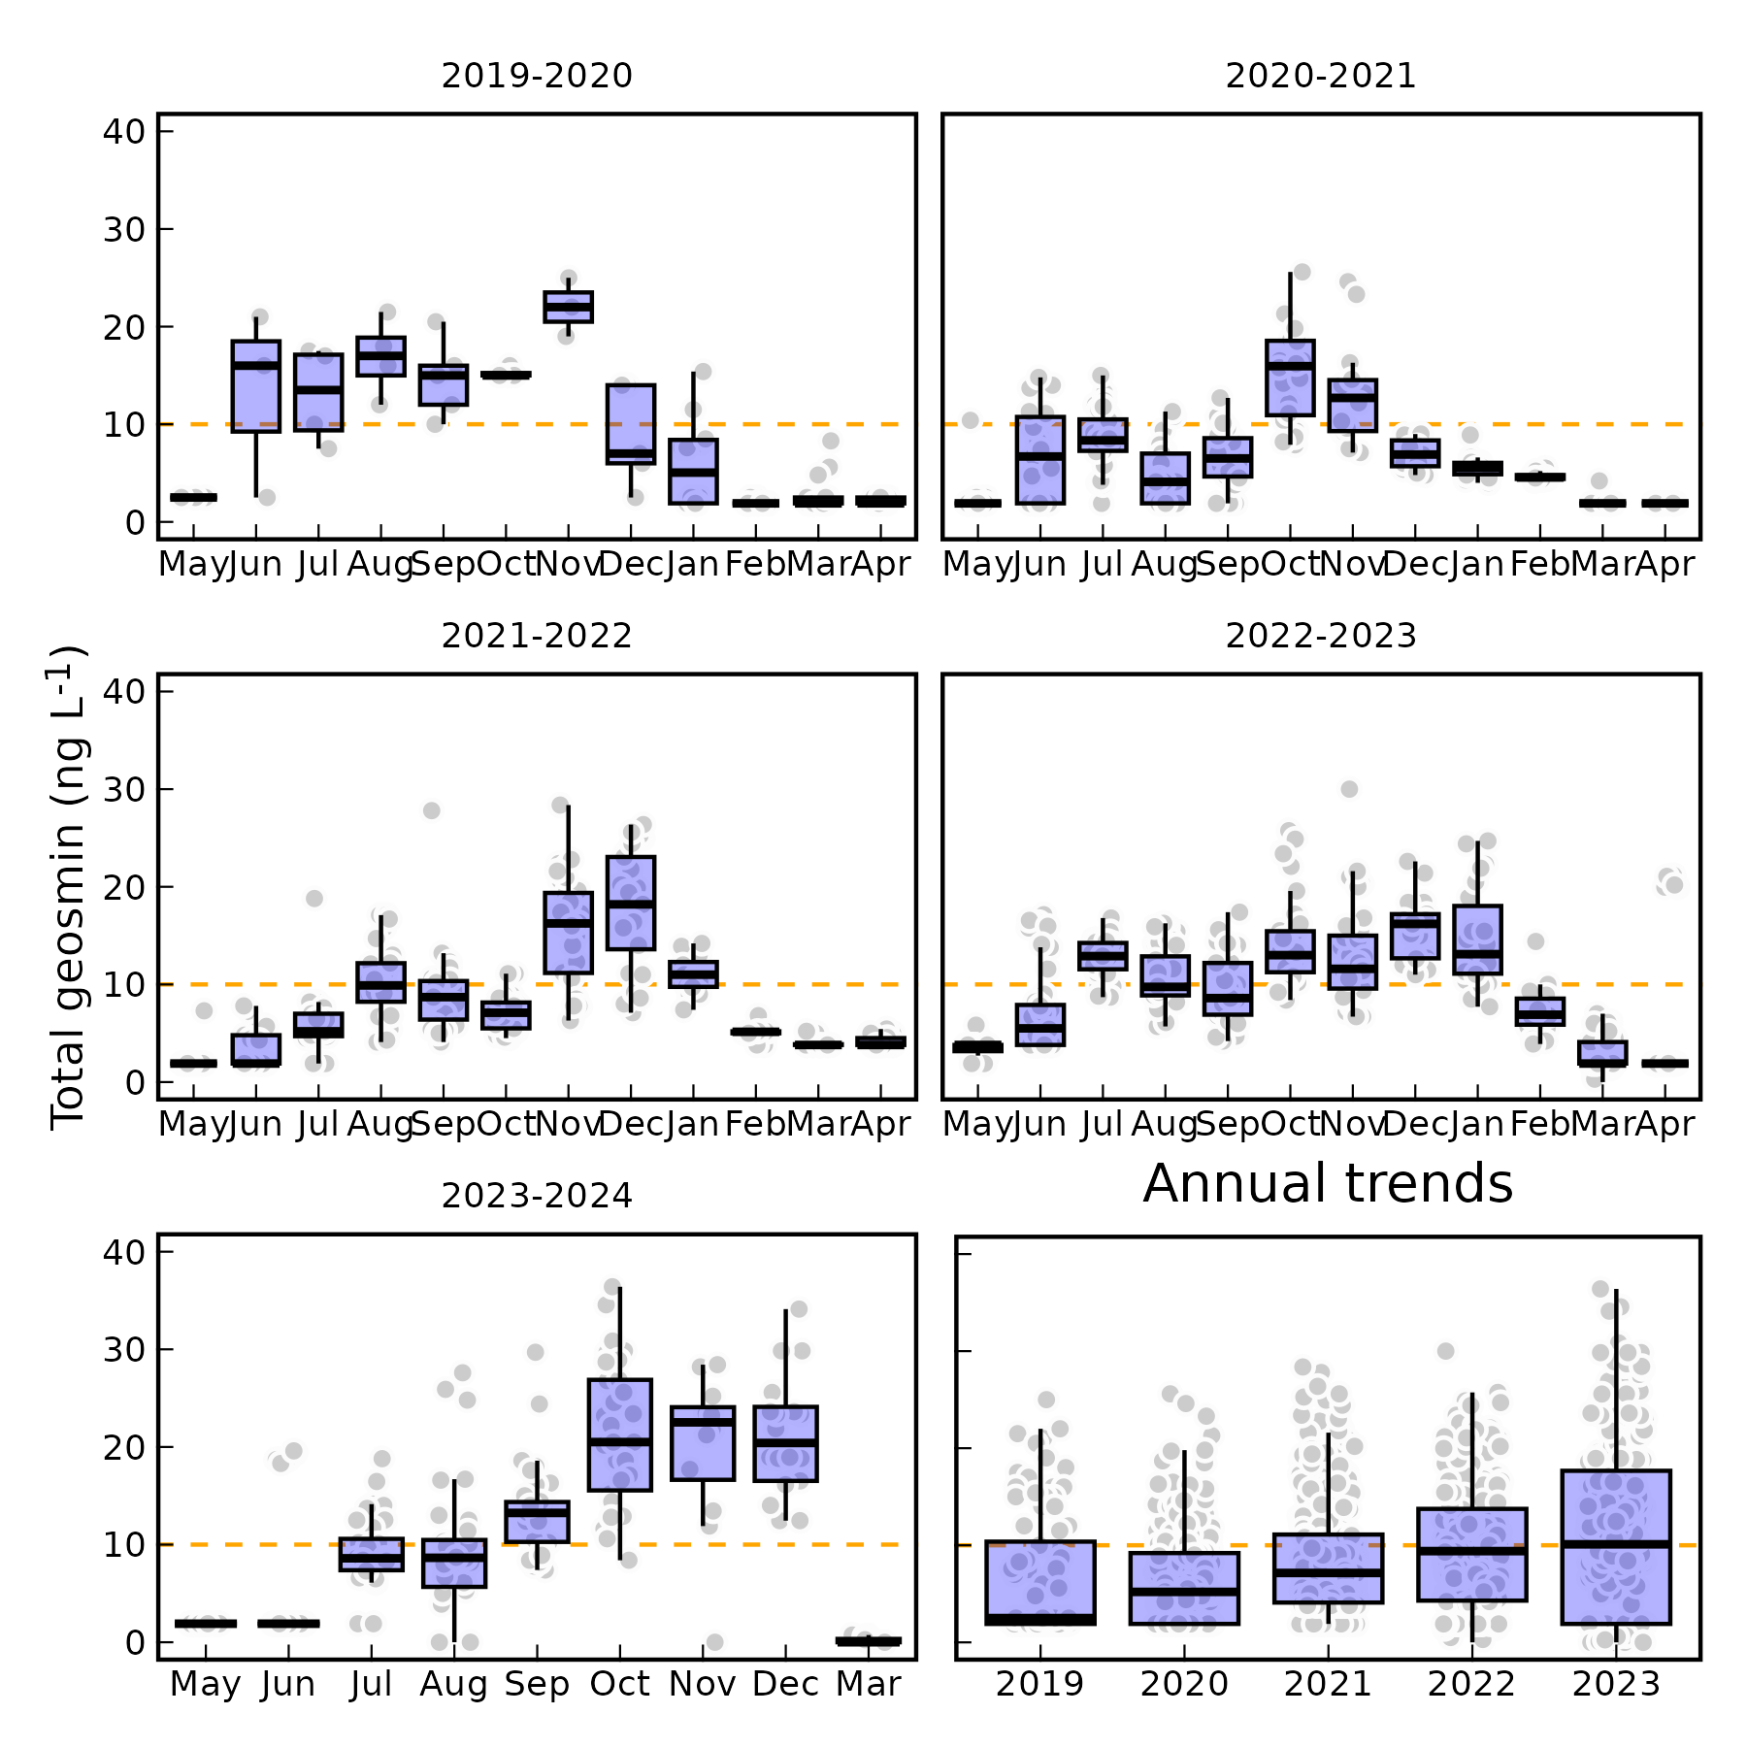
Fig. 1: Seasonal dynamic of geosmin concentration in Yuqiao Reservoir

Distribution of geosmin producer
调查期间，共记录到蓝藻 137 属，蓝藻群落表现出明显的时间和空间差异，蓝藻门为全年的优势门，蓝藻门丰度在每年 5 到 10 月有明显峰值，可达 10^8cells/L。于桥水库已知的潜在 geomsin 产嗅藻表现出与 geosmin 浓度高度相似的时间分布特点（p<0.0001）。对巢氏 PCR 扩增产物进行高通量测序，结果表明在这两个点位的 geosmin 产嗅藻均为 planktothrix。
于桥水库的阿氏浮丝藻每年会爆发两次峰值。第一次峰值发生于 5 月末到 6 月初，阿氏浮丝藻从水库上游的 YQ07、YQ06 点位开始迅速生长，生长速率可达 10⁶cells/(L·d)，阿氏浮丝藻密度峰值达到1.1×10⁷cells/L，并维持该密度水平至8月末开始显著降低，降低速率约为-5×10⁵cells/(L·d)，9月中旬开始，阿氏浮丝藻迎来第二次爆发，并于10月中旬达到峰值，第二次爆发的生长速率和密度峰值高于第一次爆发，分别可达2.5×10⁶cells/(L·d)与2×10⁷cells/L，第二次峰值后密度迅速降低，降低速率可达-2.5×10⁶cells/(L·d)。而中游的YQ03、YQ04、YQ05点位的阿氏浮丝藻第一次爆发晚于上游点位一周左右，爆发后密度起伏变化较大，无明显的变化规律，生长速率在-10⁶cells/(L·d)与10⁶cells/(L·d)之间，但总体保持在高密度水平，最高可达1.1×10⁷cells/L，第二次爆发从9月中旬开始，生长速率和密度峰值也明显高于第一次爆发，分别可达3.7×10⁶cells/(L·d)和2×10⁷cells/L，第二次峰值后密度下降速率也更快，降低速率可达-5×10⁶cells/(L·d)。水库下游的YQ01点位的阿氏浮丝藻密度变化规律比中上游点位更为明显，第一次爆发晚于上游点位两周左右，并且在爆发后呈持续上升的趋势(p=0.0339)，三周后到达峰值，生长速率维持在10⁶cells/(L·d)左右，第一次爆发的密度峰值高于中上游点位，可达1.9×10⁷cells/L，随后持续下降，降低速率可达-1.5×10⁶cells/(L·d)，第二次爆发从10月初开始，同样晚于上游两周，爆发后仍然呈持续上升趋势，第二次爆发的藻密度峰值与中上游相同，即2×10⁷cells/L，生长速率约为1.5×10⁶cells/(L·d)，并于11月初回到爆发前的低密度水平(10⁵cells/L)，降低速率可达-2×10⁶cells/(L·d)，此后藻密度则一直保持在爆发前的低浓度水平(10⁵cells/L)。
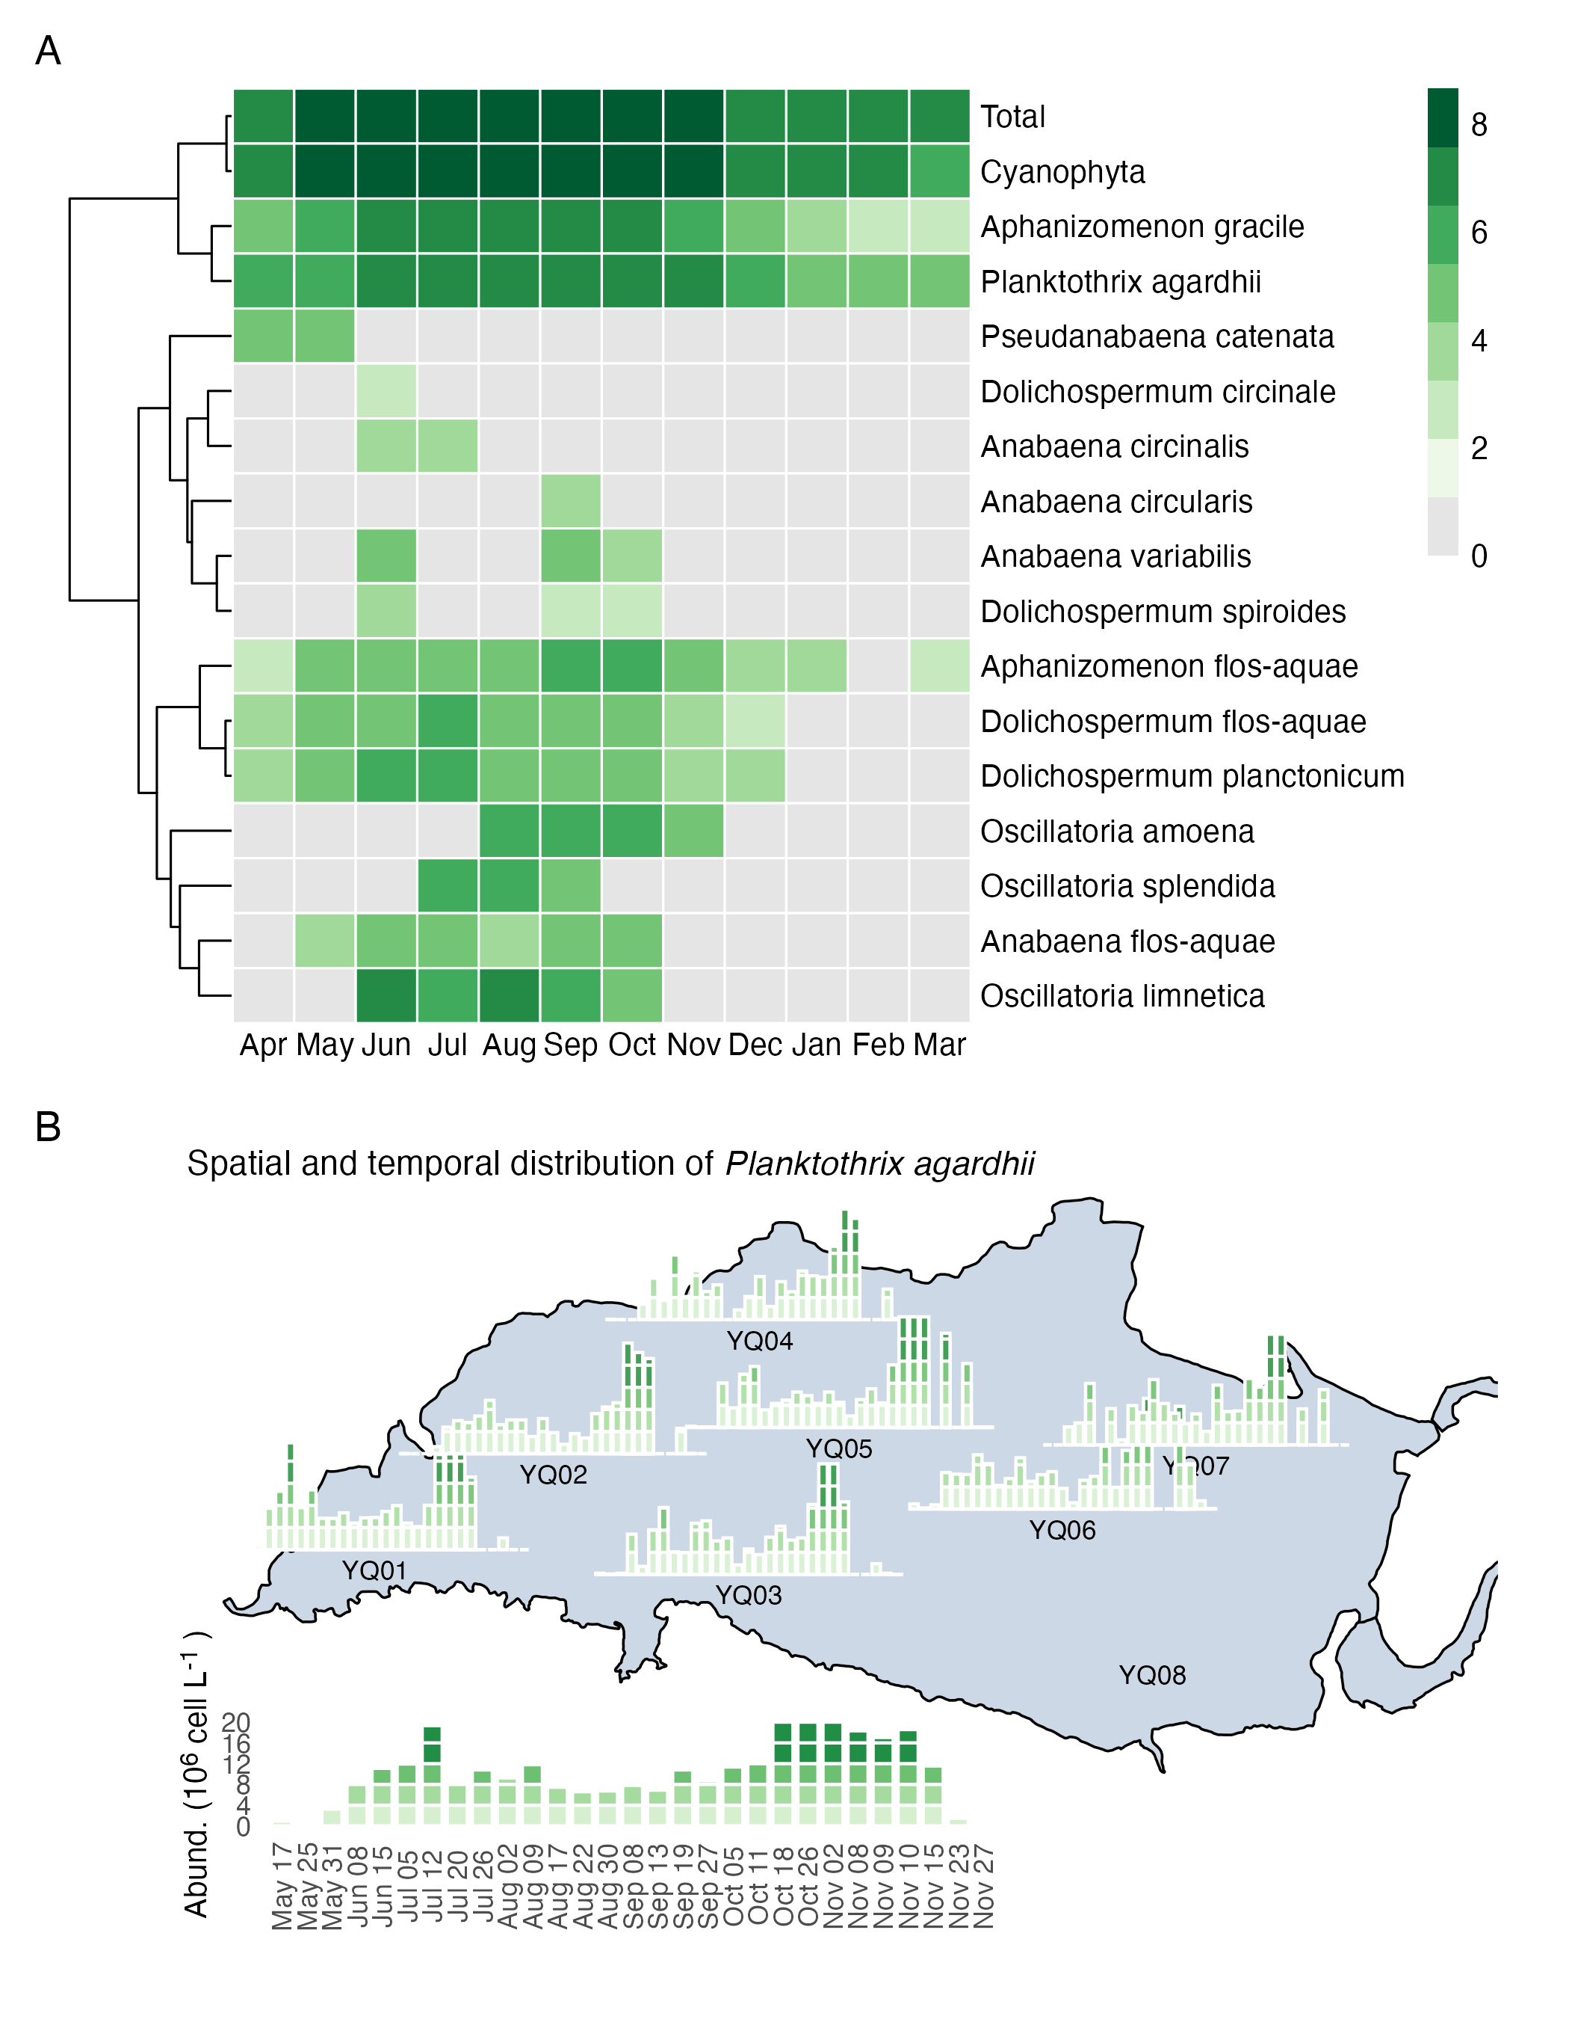
Fig. 2: heatmap of algae in Yuqiao reservoir and geosmin and plaktothrix by site

Distribution of geosmin in Yuqiao Reservoir
于桥水库全年会经历两次 geosmin 爆发事件。第一次爆发为每年的 6 到 8 月，geosmin 从上游较浅的点位开始爆发，在 YQ01 和 YQ05 以外的点位，geosmin 爆发之初的 6 月即达到第一次浓度峰，浓度峰值均在 20ng/L 左右，并在爆发后保持持续下降(p<0.001)，于 8 月降至最低，多数点位在 8 月未检出 geosmin。而 YQ01 和 YQ05 点位 geosmin 浓度变化表现出明显的不同，第一次爆发时，这两个点位的 geosmin 浓度从 4 到 8 月呈持续上升的趋势(p=0.002)，在 4、5 月份，其他点位 geosmin 爆发时，这两个点位的 geosmin 仅为接近检测限的 1.9ng/L，直至 8 月分别上升至 7.71 与 9.33ng/L,geosmin 增长速率分别为 1.11ng/(L·month)与 1.28ng/(L·month)。 第二次 geosmin 爆发事件为每年的 10 到 12 月。此时，水库中上游点位的 geosmin 浓度变化规律接近，均在 8 到 10 月持续上升(p<0.001)，从 8 月的未检出 geosmin 上升至 10 月份全年最高峰值 30ng/L 左右，此后 10 到 12 月则呈持续下降趋势(p=0.017)。不同于其他点位，第二次 geosmin 事件中，水库下游的 YQ01 点位 geosmin 浓度从 8 到 12 月一直呈持续上升的趋势(p=0.007)，geosmin 浓度从 8 月的 7.1ng/L 上升至 12 月的 23.4ng/L，geosmin 增长速率分别为 4.63，8.18，0.87，3.55ng/(L·month)，在其他点位 geosmin 达到浓度峰的 10 月，YQ01 的 geosmin 增长速率也达到最快，但该点位的 geosmin 达峰时间为 12 月，晚于其他点位，并且峰值也低于其他点位.
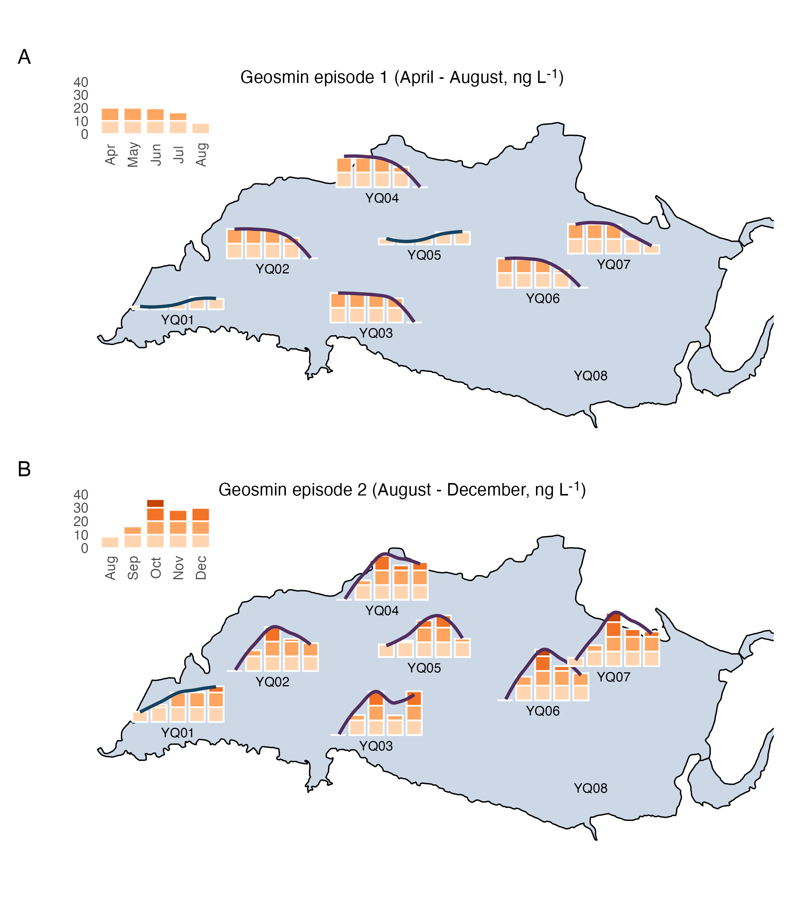
Fig. 3: Spatial distribution of geosmin in Yuqiao Reservoir in 2023-2024

Time Lag Analysis between geosmin and Planktothrix in Yuqiao Reservoir。
通过 YQ01 与 YQ05 点位近四年的 geosmin 与 planktothrix 相关性分析，评价 planktothrix 和 geosmin 之间的滞后时间关系。在 YQ05 点位，geosmin 与阿氏浮丝藻在无滞后时相关性最强，此时 R²为 0.50Fig. 4A，随着滞后周数的增加，YQ05 点位的 geosmin 与阿氏浮丝藻相关性越来越弱。而在 YQ01 点位，geomin 与阿氏浮丝藻从滞后 0 周到滞后 5 周的相关性逐渐增强，并在滞后 5 周时，两者相关性达到最高，R^2 为 0.41Fig. 4A，随着滞后周数继续增加，两者相关性逐渐减弱，在 YQ01 点位两者相关性最强的一组数据中Fig. 4B，可以看到仍然有较多藻密度较高而 geosmin 浓度较低的数据点. 在中游的 YQ05 点位，阿氏浮丝藻和 geosmin 于每年的 6 月初开始爆发Fig. 4C，阿氏浮丝藻在 12 月开始减少，而 geosmin 仍然能够保持高浓度到 2 月左右降低至爆发前的低浓度水平。在下游的 YQ01 点位Fig. 4D，阿氏浮丝藻则早于 geosmin 5 周左右爆发，冬季藻密度降低后，geosmin 浓度仍能保持一到两个月才开始缓慢降低。
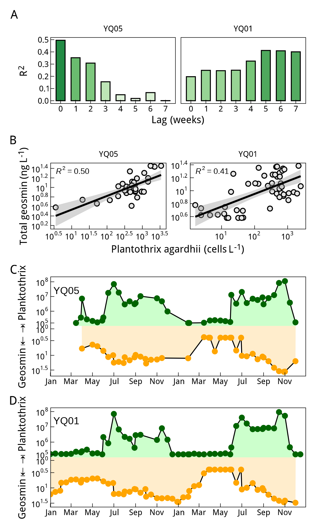
Fig. 4: Time lag between geosmin and Planktothrix in Yuqiao Reservoir

Migration patterns of geosmin and its olfactory producing algae in Yuqiao Reservoir
Total geosmin 的箭头朝向接近右下方，说明 Total geosmin 主要受到 PC1 和 PC2 的负面共同影响。氨氮的箭头与 Total geosmin 几乎平行，说明从全库水平来看两者相关性非常强。TP、COD 和 Chl.a 与 Total geosmin 的夹角也较小，表明它们之间也存在较强的正相关性，充足的营养盐条件是水体富营养化加剧的标志，促进了产嗅藻的生长和产嗅，geosmin 的生物合成与 Chl.a 的生物合成有一定的相关性。透明度和 DO 与 Total geosmin 完全相反，表明水体透明度越低，DO 越低，geosmin 浓度越高，这是由于藻类爆发引起水体浑浊程度增加，同时耗氧速率增加。 从岸边较浅的点位来看，于桥水库的 geosmin 与氨氮相关性极强，R²为 0.35。岸边浅水区域通常受到外界输入的影响较大，比如地表径流带来的养分，使得氨氮浓度较高，同时这些区域因为水体流速缓慢，光照较强，水体混合程度更高，所以更适合藻类生长和产嗅，导致两者相关性强。水库中游的 YQ05 点位，二者的相关性有所下降，R²为 0.19，而水库下游最深的 YQ01 点位，二者相关性非常低，R²仅为 0.03 这是因为水库深处的环境相对稳定，氨氮可能因为沉降或者硝化过程在水体中减少，水库深处的氨氮更多来自内循环，如沉积物释放或分解，且下游 geosmin 的产生可能更多受限于藻类生长条件，如光照和温度等，从而降低了氨氮和 geosmin 的相关性。
结合于桥水库的地形，进一步分析于桥水库 geosmin 与其产嗅藻的分布规律。岸边地区的水深较浅，特别是水库上游的 YQ07 点位，水深仅有 2 到 3 米，此处接近入库河流，是水库水体的主要来源。每年 5 月底至 6 月初，携带者阿氏浮丝藻的水体从上游较浅的点位输入于桥水库。在浅水区及入库口，水流减速易形成沉积，有利于产嗅藻的富集。浅水区水体混合程度高，入库河流携带的营养盐可以快速混合均匀，输入水库的产嗅蓝藻可以即时适应水体环境，在输入水库的同时开始产嗅。浅水区光照充足，水温高，更容易促进蓝藻生长产嗅。上游的水体流动性强于下游，可能促进 geosmin 的挥发和稀释，所以在嗅味事件末期，geosmin 总是从上游和较浅的岸边开始降低。水库整体流速较缓，上游输入的产嗅藻需要经过两周左右的迁移最终汇于水库下游，水深最深的 YQ01 点位，该处水深可达 10 米。深水区水动力较弱，水体交换时间长，不同深度的水体环境差异较大，所以产嗅藻随水体迁移至下游后，需要一定时间的适应才能继续生长产嗅。此处靠近水库的大坝区域，停留时间长于上游点位，更有利于累积更多产嗅藻和 geosmin，所以阿氏浮丝藻和 geosmin 爆发事件时，YQ01 点位的峰值总是达到全库最高。在水库中游的 YQ05 点位水深大约为 5 米，此处在第一次嗅味事件（6 到 8 月）时为 geosmin 的汇，第二次嗅味事件（10 到 12 月）为 geosmin 的源.
Fig. 5A
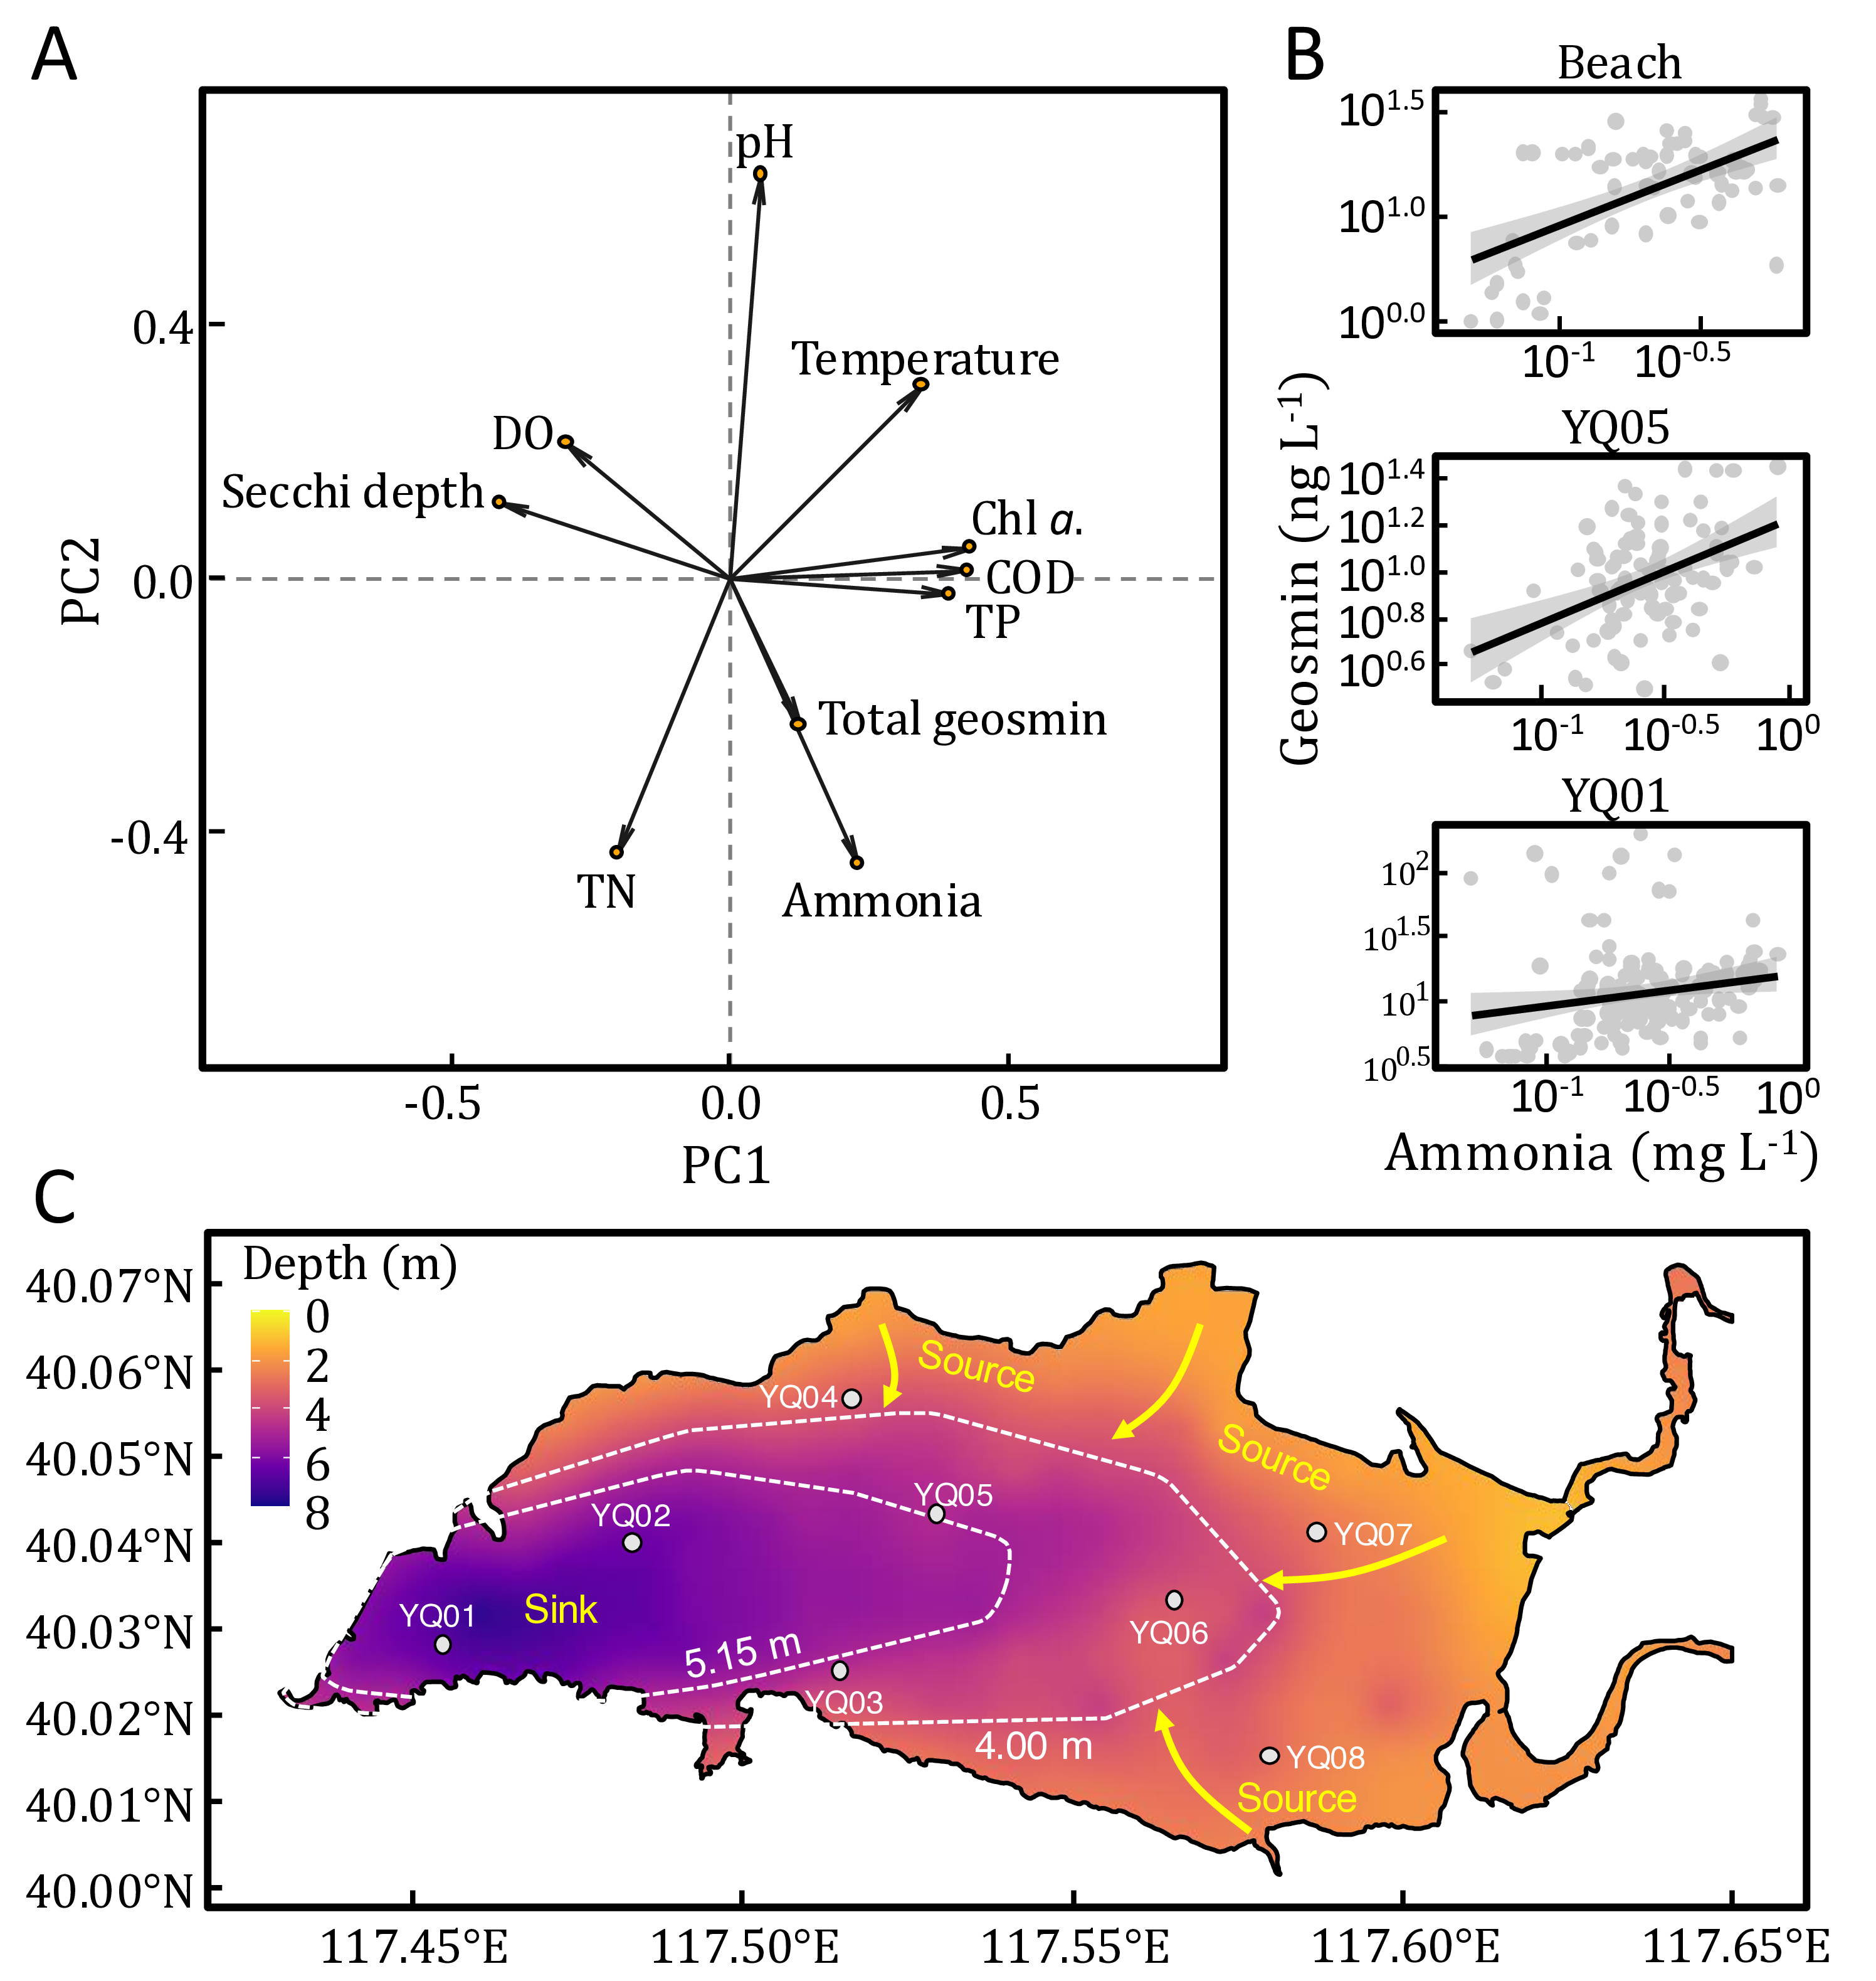
Fig. 5: Mechanism of Planktothrix induced risk in Yuqiao Reservoir

Discussion
geosmin 是饮用水中最常见的致嗅化合物之一,丝状蓝藻和放线菌均为土臭素的生产者，但已有研究表明，在湖库型水体中，geosmin 主要由丝状蓝藻产生(lee2020occurrence?)。中国超过 80% 的地表水源均存在嗅味问题(Sun et al., 2014)，饮用水处理中的 geosmin 难以用传统工艺去除，因此常在饮用水中成为嗅味问题的主要原因。揭示 geosmin 在环境中的产生、分布特征为解决水体嗅味问题提供了科学依据。中国湖库型水源地中，geosmin 问题与富营养化治理成效呈现复杂关联,尽管中国水体富营养化程度有所缓解，但 2023 年调研显示，东南地区 geosmin 超过 10 ng/L国家标准的湖库仍然较多。这一现象可能与营养盐水平变化导致的蓝藻群落演替有关：随着水体富营养化治理，水体营养盐水平整体降低，优势藻种从营养盐限制型的微囊藻向光照限制型产嗅丝状蓝藻（如鱼腥藻、束丝藻）过渡，多种 geosmin 产嗅藻能够在低氮、低磷的条件下通过形成异形胞固定无机氮，通过磷储存机制和胞外碱性磷酸酶利用有机磷，能够在各种生境中广泛存在(wan2019phosphorus?)。因此，geosmin 不仅是水质指标，更是生态系统响应环境压力的重要信号分子。
于桥水库原位监测研究中，geosmin 浓度与其产嗅藻 planktothrix 的相关性整体较低，其 R²最高值仅见于 YQ05 点位的（R²=0.50，p<0.05）Fig. 4B，该结果与多项原位监测研究中产嗅藻生物量与特征嗅味物质浓度间的相关性水平基本一致，表明在复杂水环境条件下藻类生物量与次生代谢产物浓度间可能受到多因素调控(shang2024temporal?)。而实验室纯培养条件下 geosmin 与其产嗅藻相关性极强，R²可达 0.9 以上(SU20133444?)。同时，在纯培养条件下，geosmin 生产者在实验室环境中表现出比原位生长更高的 geosmin 产量(Gerber and Lechevalier, 1965)。导致Geosmin 与其生产者的生物量相关性在两种环境中表现出显著差异的主要原因是纯培养条件下与原位水体环境中的微生物代谢活动不同。在实验室纯培养环境下，geosmin 浓度更多地依赖于特定微生物的基因表达和代谢能力，而在原位水体中，其浓度受到溶解氧、微生物群落动态等多种环境因素影响(Lukassen et al., 2022)。原位水体与纯培养条件下 geosmin 与其生产者生物量的的相关性差异主要源于环境条件和微生物群落结构的不同。因此，原位调查在揭示土臭素产嗅藻的真实生态行为及其环境驱动机制方面具有更重要的研究价值，应注重开展原位调查，以期为水体嗅味问题的精准防控提供科学依据。

Geosmin in Yuqiao Reservoir
本研究揭示于桥水库的 geosmin 污染事呈现独特的时空分布特征，与我国东部及南部湖泊水库典型嗅味事件相比，该水库土臭素污染具有显著差异：时间分布上，污染事件发生于夏季并持续至次年一月，呈现双峰型浓度特征Fig. 1，而中国东部和南部的湖泊和水库的嗅味污染一般发生在春夏季节，而不发生在低温的冬季，且峰值持续时间较短，呈单峰浓度特征(Cao et al., 2023; shang2024temporal?)。空间分布上，下游监测点 YQ01 的 geosmin 与其产嗅藻 planktothrix 生物量峰值较中上游点位滞后 4-5 周，且浓度衰减同步延迟Fig. 3，该滞后周期可能表征 geosmin 在水体中的停留时间。5-6 月支流来水输入了 planktothrix 同步产生了 geosmin，7-8 月二者在中上游形成首个浓度峰值后，由于浅水区 8-10 月的高光强环境促进了表层藻类水华，间接通过遮光效应抑制了 planktothrix 的生长，导致土臭素浓度阶段性下降。(Oberhaus et al., 2007)。值得注意的是，上游点位浮丝藻生物量与土臭素浓度呈现显著同步变化（r=0.82, p<0.01），表明支流输入时浮丝藻已具备原位产嗅能力。至 10-12 月，环境条件改变促使浮丝藻二次增殖，形成冬季次峰，此现象突破了传统认知中低温环境抑制产嗅的理论。该研究揭示了于桥水库土臭素污染的双峰特征及其水动力驱动机制，为建立流域特异性嗅味预警模型、追踪污染源项及评估污染物迁移扩散规律提供了科学依据。

The migration process of geosmin in Yuqiao Reservoir
本研究表明随着滞后周数的增加，YQ05 点位的 geosmin 与阿氏浮丝藻相关性越来越弱，这表明在 YQ05 点位阿氏浮丝藻与 geosmin 同时输入，并不存在明显的滞后关系。在 YQ01 点位两者相关性最强的一组数据中Fig. 4B，可以看到仍然有较多藻密度较高而 geosmin 浓度较低的数据点，这表明水库下游的产嗅藻由中上游输入，并于下游生长 5 周左右开始大量产嗅。在中游的 YQ05 点位，阿氏浮丝藻和 geosmin 于每年的 6 月初开始爆发Fig. 4C，阿氏浮丝藻在 12 月开始减少，而 geosmin 仍然能够保持高浓度到 2 月左右开始降低，这是由于冬季于桥水库经历冰封期，冰盖使 geosmin 难以挥发，保留在水体中，这与 Wang 等在画匠水库的研究相符，冬季富营养化是影响 geosmin 合成和释放的主要因素而不是温度(Wang et al., 2015)。在下游的 YQ01 点位，geosmin 增长时间滞后于阿氏浮丝藻 5 周，冬季藻密度降低后，geosmin 仍能维持峰值 4 到 5 周。在美国 Eagle Creek Reservoir 中也观测到 geosmin 与 Planktothrix 紧密相关，且水库中 geosmin 的最高检出值与产嗅藻峰值之间存在 37 天的滞后期，这一滞后期代表产嗅藻从流域迁移到水库所需的时间(Clercin and Druschel, 2019)。这些信息提供了一种预测 geosmin 事件的线索,使得水库可以在异味变得严重之前阻止产嗅藻生长。

Identification of geosmin-producing algae
目前已有的研究表明，基因组中是否携带 geosmin synthase 是进行 geosmin 产嗅藻识别的关键依据，对功能基因的定量检测可以检出水体中 geosmin 的产生潜力，但是不能识别出 geosmin 产嗅藻的不同物种信息。基于分子生物学的系统发育基因（如 16S rRNA 基因）扩增子测序仅能用于识别藻类群落结构，不能特定地识别出 geosmin 产嗅藻。目前 epicPCR 方法可以高通量精准识别环境中功能基因宿主，并已经成功应用于特异性识别硫酸盐还原菌(Spencer2015massively?)，本研究通过改进 epicPCR 方法，筛选了特异性引物 PCR 完成了对于桥水库 geosmin 产嗅藻的识别，但是该方法还不适用于识别如放线菌等除蓝藻之外的 geosmin producers。 通过 epicPCR 方法我们识别出于桥水库 2023 年的 geosmin producer 是 planktothrix，但 geosmin producer 并不是一直不变的，也可能同时存在多种 geosmin producers，LI 等人的研究表明在 2017 到 2019 年于桥水库的 geosmin 与鱼腥藻具有极显著的正相关性，并且主要嗅味物质从 2017 年的 geosmin 转变为 2018 年后 mib(li2020analysis?)

Conclusions

Acknowledgements
This work was financially supported by the National Natural Science Foundation of China (52030002, 51878649), and Youth Innovation Promotion Association CAS.

References
Cao, T., Fang, J., Jia, Z., Zhu, Y., Su, M., Zhang, Q., Song, Y., Yu, J., Yang, M., 2023. Early warning of MIB episode based on gene abundance and expression in drinking water reservoirs. Water Research 231, 119667. https://doi.org/https://doi.org/10.1016/j.watres.2023.119667
Clercin, N.A., Druschel, G.K., 2019. Influence of environmental factors on the production of MIB and geosmin metabolites by bacteria in a eutrophic reservoir. Water Resources Research 55, 5413–5430. https://doi.org/10.1029/2018wr023651
Gerber, N.N., Lechevalier, H.A., 1965. Geosmin, an earthy-smelling substance isolated from actinomycetes. Applied Microbiology 13, 935–938.
Jähnichen, S., Jäschke, K., Wieland, F., Packroff, G., Benndorf, J., 2011. Spatio-temporal distribution of cell-bound and dissolved geosmin in wahnbach reservoir: Causes and potential odour nuisances in raw water. Water Research 45, 4973–4982. https://doi.org/10.1016/j.watres.2011.06.043
Le, C., Zha, Y., Li, Y., Sun, D., Lu, H., Yin, B., 2010. Eutrophication of lake waters in China: Cost, causes, and control. Environmental Management 45, 662–668. https://doi.org/10.1007/s00267-010-9440-3
Li, Z., Yu, J., Yang, M., Zhang, J., Burch, M.D., Han, W., 2010. Cyanobacterial population and harmful metabolites dynamics during a bloom in yanghe reservoir, north China. Harmful Algae 9, 481–488. https://doi.org/10.1016/j.hal.2010.03.003
Liang, C., Wang, D., Ge, X., Yang, M., Sun, W., 2006. Comparative study on the removal technologies of 2-methylisoborneol (MIB) in drinking water. Journal of Environmental Sciences 18, 47–51.
Lukassen, M.B., Menanteau-Ledouble, S., Jonge, N. de, Schram, E., Nielsen, J.L., 2022. Impact of water quality parameters on geosmin levels and geosmin producers in european recirculating aquaculture systems. Journal of Applied Microbiology 132, 2475–2487. https://doi.org/10.1111/jam.15358
Oberhaus, L., Briand, J.F., Leboulanger, C., Jacquet, S., Humbert, J.F., 2007. Comparative effects of the quality and quantity of light and temperature on the growth of Planktothrix agardhii and P. rubescens. Journal of Phycology 43, 1191–1199. https://doi.org/10.1111/j.1529-8817.2007.00414.x
Qiu, P., Zhang, Y., Mi, W., Song, G., Bi, Y., 2023. Producers and drivers of odor compounds in a large drinking-water source. Frontiers in Ecology and Evolution 11. https://doi.org/10.3389/fevo.2023.1216567
Su, M., Yu, J., Zhang, J., Chen, H., An, W., Vogt, R.D., Andersen, T., Jia, D., Wang, J., Yang, M., 2015. MIB-producing cyanobacteria (Planktothrix sp.) in a drinking water reservoir: Distribution and odor producing potential. Water Research 68, 444–453. https://doi.org/10.1016/j.watres.2014.09.038
Sun, D., Yu, J., Yang, M., An, W., Zhao, Y., Lu, N., Yuan, S., Zhang, D., 2014. Occurrence of odor problems in drinking water of major cities across China. Frontiers of Environmental Science & Engineering 8, 411–416. https://doi.org/10.1007/s11783-013-0577-1
Wang, C., An, W., Guo, Q., Jia, Z., Wang, Q., Yu, J., Yang, M., 2020. Assessing the hidden social risk caused by odor in drinking water through population behavioral responses using economic burden. Water Research 172, 115507. https://doi.org/10.1016/j.watres.2020.115507
Wang, R., Li, D., Jin, C.X., Yang, B.W., 2015. Seasonal occurrence and species specificity of fishy and musty odor in huajiang reservoir in winter, china. Water Resources and Industry 11, 13–26. https://doi.org/10.1016/j.wri.2015.04.002
Watson, S.B., Monis, P., Baker, P., Giglio, S., 2016. Biochemistry and genetics of taste- and odor-producing cyanobacteria. Harmful Algae 54, 112–127. https://doi.org/10.1016/j.hal.2015.11.008
Wu, A., Wang, Y., Friese, K., Zhang, L., Han, C., Kang, D., Shen, Q., 2021. Spatial and seasonal distribution of 2-methylisoborneol in a large eutrophic shallow lake, china. Water, Air, & Soil Pollution 232. https://doi.org/10.1007/s11270-021-05340-8
Zhang, R., Qi, F., Liu, C., Zhang, Y., Wang, Y., Song, Z., Kumirska, J., Sun, D., 2019. Cyanobacteria derived taste and odor characteristics in various lakes in china: Songhua lake, chaohu lake and taihu lake. Ecotoxicology and Environmental Safety 181, 499–507. https://doi.org/10.1016/j.ecoenv.2019.06.046

