Integrating littoral zone odor dynamics into early warning and intervention systems for drinking water reservoirs
Yuying Gui^{b,a,#}, Tengxin Cao^{b,c,#}, Ming Su ^{ID,b,c,*}, Yufan Ai^{b,c}, Yingjie Li^{b,c}, and Min Yang^{b,c}
# These authors contributed equally to this work.
ª College of Environmental Science and Engineering, Ocean University of China, Qingdao 266100, China.
^{b} Key Laboratory of Environmental Aquatic Chemistry, State Key Laboratory of Regional Environment and Sustainability, Research Center for Eco-Environmental Sciences, Chinese Academy of Sciences, Beijing 100085, China.
^{c} University of Chinese Academy of Sciences, Beijing 100049, China.
* Corresponding to: Ming Su (mingsu@rcees.ac.cn)

Abstract
This is the abstract.

Introduction
The increasing frequency and intensity of harmful cyanobacterial blooms (CyanoHABs) in surface waters, driven by climate change and intensified anthropogenic pressures, pose a critical and escalating global threat to water security (Feng et al., 2021; Heisler et al., 2008; Huisman et al., 2018; O’neil et al., 2012; Paerl et al., 2001; Paerl and Paul, 2012; Woolway et al., 2020). While substantial research has focused on eutrophication-driven bloom mechanisms and risk assessment in shallow lakes (Kosten et al., 2011; Martinez i Quer et al., 2024; Paerl et al., 2011; Reinl et al., 2022; Rousso et al., 2020; Xu et al., 2009; Zhang et al., 2023), studies on reservoir systems—which constitute a primary source of global drinking water—remain disproportionately scarce. This significant knowledge gap carries critical implications, as CyanoHABs directly threaten drinking water safety through the production of toxins (Carmichael et al., 2001; LEFLAIVE and TEN‐HAGE, 2007; Merel et al., 2013; Plaas and Paerl, 2020) and taste-and-odor (T&O) compounds (Burlingame et al., 2017; Lin et al., 2018; Su et al., 2015; Yang et al., 2008), impacting both human health and water utility. For example, nearly half of China’s source-water reservoirs experience recurrent algal-derived T&O episodes (Sun et al., 2014). Unlike chemical contaminants, cyanobacterial populations can undergo exponential growth under suitable conditions (Asato, 2003; Mehnert et al., 2010), rapidly releasing metabolites (Ai et al., 2025; LEFLAIVE and TEN‐HAGE, 2007; Singh et al., 2005) that often exceed the response capacity of conventional water treatment facilities (Cerón-Vivas et al., 2022; Mustapha et al., 2021; Srinivasan and Sorial, 2011), leading to widespread drinking water quality incidents (Li et al., 2010; Yang et al., 2008).
Effectively managing CyanoHABs in reservoirs presents distinct and formidable challenges. Compared to natural lakes, reservoirs display greater spatial and hydraulic complexity, resulting in less stable and predictable ecological regimes (Dordoni et al., 2023; Thornton, 1984). Conventional reservoir monitoring strategies, typically confined to sampling near dam intakes, fail to capture the spatially heterogeneous distribution of algal biomass and metabolites. Furthermore, the short flow time from intake to drinking water treatment plant—often on the scale of minutes to hours—provides an inadequate operational window for timely intervention. In contrast, littoral zones in reservoirs are characterized by markedly different environmental conditions, such as enhanced nutrient availability and light penetration (Cefalì et al., 2016; Zohary and Gasith, 2014), which may promote early cyanobacterial proliferation. Despite their potential significance as critical sentinel sites, these areas remain critically under-monitored. Consequently, the mechanistic linkages between littoral zone CyanoHAB dynamics and downstream water quality at intakes are poorly understood and quantified.
Geosmin (GSM) and 2-methylisoborneol (MIB) are among the most concerning terpenoid T&O compounds produced by cyanobacteria (Jüttner and Watson, 2007; Watson, 2003). Their low molecular weight and chemical nature allow them to penetrate conventional water treatment barriers and persist into tap water (Lin et al., 2018; Zamyadi et al., 2015), directly impairing drinking water quality and consumer acceptance. In China, MIB-related episodes have been widely reported and studied, with corresponding mitigation strategies developed (Su et al., 2021, 2015). In contrast, GSM incidents have historically been more prevalent in the Southern Hemisphere (Bowmer et al., 1992; Uwins et al., 2007) but are increasingly reported across Northern Hemisphere water bodies (Qiu et al., 2023; Wu et al., 2022). Notably, GSM-producing cyanobacterial taxa are phylogenetically more diverse than those associated with MIB (AWWA, 2010), complicating source-tracking and management efforts. To address these emerging challenges, we conducted a multi-year, spatially resolved monitoring study in Yuqiao Reservoir—a major drinking water source for Tianjin, China, with a documented history of GSM episodes. Integrating water quality analysis, molecular sequencing of algal communities, and advanced statistical modeling, we demonstrate significant spatial decoupling of cyanobacterial assemblages and T&O compounds between littoral zones and the dam area. We further identify key odor-producing taxa and establish that littoral zone cyanobacterial dynamics exert a decisive influence on T&O levels at the intake. These findings position the littoral zone as a critical sentinel for early warning and a strategic target for proactive intervention. This study advances a scientifically informed monitoring framework, shifting the paradigm from reactive response to preventive management of CyanoHAB-derived T&O risks in reservoir-based water supplies.

Materials and methods

Study area and sampling sites
Yuqiao Reservoir is located in the east of the city of Jizhou district in Tianjin, with a total capacity of 1.559 billion cubic metres, making it one of the key large-scale reservoirs in the country and an important urban water source for Tianjin. The reservoir has been experiencing persistent odour problems in recent years. Depending on the geographical location, a total of eight sampling points were selected in this reservoir to investigate the spatial distribution of geosmin concentrations, namely, east of the reservoir, southeast of the reservoir, south of the reservoir, centre of the reservoir, west of the reservoir, water discharge hole, north of the reservoir, and Fengshan. Among them, the water depth in the discharge hole could reach 12 metres, where stratified sampling was conducted. The rest of the sites were sampled at depths of 2 to 4 metres and surface water samples were taken. Sampling is carried out during the annual odour period, two to three times per week, with nutrient measurements and algal counts. All samples were stored at 4°C for 24 hours prior to use. Geomin concentrations were determined using solid phase microextraction (SPME) coupled with gas chromatography-mass spectrometry (GC-MS). Physicochemical properties such as water temperature, ph, dissolved oxygen (DO) and turbidity were measured in situ using a multiprobe instrument (EXO2, Xylem, USA). Ammonia (NH 4-N), total nitrogen (TN), and total phosphorus (TP) were measured according to national water quality standards. Samples for algal counts were preserved in 5% luger iodine, concentrated to 10 mL after 48 h of sedimentation, and cell counts were carried out under a microscope (OLYMPUS BX51, Olympus Optical, Tokyo,Japan) using cell counting plates (S52, 1 mL, Sedgewick-Rafter).

Quantification of geoA gene
Quantitative PCR was employed to determine the absolute abundance of geoA genes,which encode the geosmin syntheses.The amplification of mic genes was carried out using the 173AF(5’-TGTGAGTACCCAAGAGG-3’) and 173AR(5’-CTGCCAATCCTGAAGTCCTTT-3’) primers.The quantitative PCR assays were performed on a LightCycler 96 instrument(Roche, USA) with a 25μL reaction mixture comprising 12.5μLTBGreen®Premix ExTaq™(Takara, Japan), 0.8μL of each primer (173AF and 173AR), 5.9μL deionized water, and 5μL template DNA.
The reaction conditions were as follows: initial pre-incubation at 95°C for 10 min, followed by 35 cycles at 95°C for 20 s, 50°C for 20 s, and 72°C for 20 s. A subsequent DNA melting step ranging from 65°C to 97°C was included.
Absolute abundance was determined based on a standard curve using the formula: Cq = -3.6261lg(cgeoA)+37.70(R2=0.999).All samples were quantified in triplicate, and a negative control was implemented to mitigate the risk of nonspecific amplification.

epicPCR of geoA-16S rRNA Gene Fusion Fragments
epicPCR combines established cell isolation, encapsulation and paired amplification methods. The method is outlined as follows: an initial aqueous oil-in-oil sample emulsion produces approximately 500 million droplets, each with a volume of approximately 1 nanolitre, containing single cells. These cells are loaded and dispersed such that, on average, less than one out of every 100 droplets contains cells. Each of these droplets also contains acrylamide monomers, which encapsulate the cells when a catalyst is added, forming polyacrylamide beads. The polyacrylamide beads provide protection for the bacterial chromosomes and plasmids, preventing them from spreading when used for fusion PCR. Polyacrylamide beads are typically 5 - 30μm in diameter, with most beads being approximately 10μm in diameter, and fusion PCR is performed on hydrogel-captured genomes in a secondary emulsion to ensure that each epicPCR is compartmentalised and performed as a single reaction. （在2023年水库geosmin爆发期间采集水样进行GC-MS检测，结果表明11月的样品中采集自YQ05的水样、12月的样品中采集自YQ03的水样有着高于同月份其他点位的tgsm，浓度分别达到了28.43ng/L和29.84ng/L.由于产嗅蓝藻通常在水体中的相对丰度较低，所以用1.2um滤膜富集这两个点位的水样以提高产嗅蓝藻的比例。用Fast DNA试剂盒提取富集在滤膜上的藻类DNA进行了Quantitative PCR扩增，结果表明这两个点位的geoA gene浓度均达到了10^5copies/L.对这两个点位的水样制备细胞悬浮液，进行epicPCR扩增，对巢氏PCR扩增产物进行1%琼脂糖凝胶电泳，结果如图x-e所示。）

Preparation of Polyacrylamide Gel Beads Containing Exposed Genomes:
Sample Collection and Filtration: Water samples were filtered using 1.2μm Isopore™Membrane Filters, and microbial cells within the filters were washed using normal saline(0.85%). 制备环境水样的细胞凝珠：取上述水样、丙烯酰胺溶液和过硫酸铵溶液混匀后加入STT乳化油；接着再加入四甲基乙二胺，混匀，静置状态下，进行丙烯酰胺聚合反应，制成包裹水体中藻类细胞的聚丙烯酰胺-细胞凝珠混合液；对聚丙烯酰胺-细胞凝珠混合液依次进行水饱和乙醚清洗、超纯水洗涤后向聚丙烯酰胺-细胞凝珠加入1×TK缓冲液，形成聚丙烯酰胺-细胞凝珠TK悬液，然后采用细胞过滤器进行过滤，制得纯化聚丙烯酰胺-细胞凝珠TK悬液；向纯化聚丙烯酰胺-细胞凝珠TK悬液中添加溶菌酶，溶解藻类细胞细胞壁后加入蛋白酶K和TritonX-100，酶解去除与核酸结合的组蛋白，使藻类细胞DNA游离，以及破坏藻类细胞细胞膜，使得藻类细胞基因组暴露在聚丙烯酰胺凝珠壳内，获得含有暴露基因组的聚丙烯酰胺-细胞凝珠。 Preparation of environmental water samples of cell beads: take the above water samples, acrylamide solution and ammonium persulfate solution mixed well, then add STT emulsified oil; then add tetramethylethylenediamine, mixing, under the state of static, acrylamide polymerisation reaction, made of polyacrylamide-cell beads wrapped in the algae cells in the water body mixture; polyacrylamide-cell beads mixture in order to carry out water-saturated ethyl ether wash, ultrapure water After washing, 1×TK buffer was added to the polyacrylamide-cell beads to form a polyacrylamide-cell beads TK suspension, which was then filtered using a cell filter to produce a purified polyacrylamide-cell beads TK suspension; lysozyme was added to the purified polyacrylamide-cell beads TK suspension to lyse algal cell cell walls and then proteinase K and TritonX-100 were added to enzymatically digest it. Removing histones bound to nucleic acids, freeing algal cell DNA, as well as destroying the cell membrane of the algal cell, so that the genome of the algal cell is exposed in the shell of the polyacrylamide beads, and obtaining polyacrylamide-cellular gel beads containing the exposed genome.

Results
Fig. 1 ?@fig-yqgsmtime ?@fig-heatmap Fig. 3 Fig. 4 Fig. 5

National investigation
近年来，全国geosmin嗅味问题频繁被报道，geosmin问题可以发生在河流、水库、湖泊等各种水源水体中。随着近年水体富营养化治理的投入，全国水体的富营养化问题得到了一定程度的缓解，但是有关嗅味问题的报道却不减反增。2023年我们对中国近30个湖泊和水库进行了调研，结果表明从全国尺度来看，geosmin浓度整体呈现东南高西北低的特点，检出geosmin浓度超过国家标准(10ng/L)的湖泊和水库主要有长桥海水库、洱海、巢湖、青草沙水库、太湖、于桥水库等;尽管咸水中曾经报道过geosmin问题，但是在我们的调研中，西藏的四大咸水湖中均未检出geosmin，青海的多个咸水湖泊中也仅有小于2.5ng/L的微量检出。
我们的调查发现，不同湖泊和水库的geosmin嗅味爆发期不同，且geosmin事件多为阶段性发生。调查中geosmin浓度超标的湖泊和水库都是富营养或者曾经是富营养的水体，嗅味爆发期主要是每年的春夏高温季节，他们主要在中国的东部和南部靠近海洋的地区，这些地区处于中国大河流域的下游，气候湿热，适合产嗅蓝藻的生长。
例外地，于桥水库位于中国北方的天津市，于桥水库的geosmin爆发期为每年的6月到次年的1月，不同于大部分湖泊和水库的爆发期为春夏季节，于桥水库的嗅味爆发期长且爆发浓度高，并且在寒冷的冬天仍然能够保持超过10ng/L的geosmin浓度。这里1月的平均气温低于0℃，平均水温仅为4℃左右，他人的研究表明，这样的水温不适宜产嗅藻的生长与产嗅；也有研究表明结冰封冻后的水库中也有藻类可以缓慢繁殖，这些藻类释放的嗅味物质在封冻条件下难以挥发，导致较高的嗅味浓度。
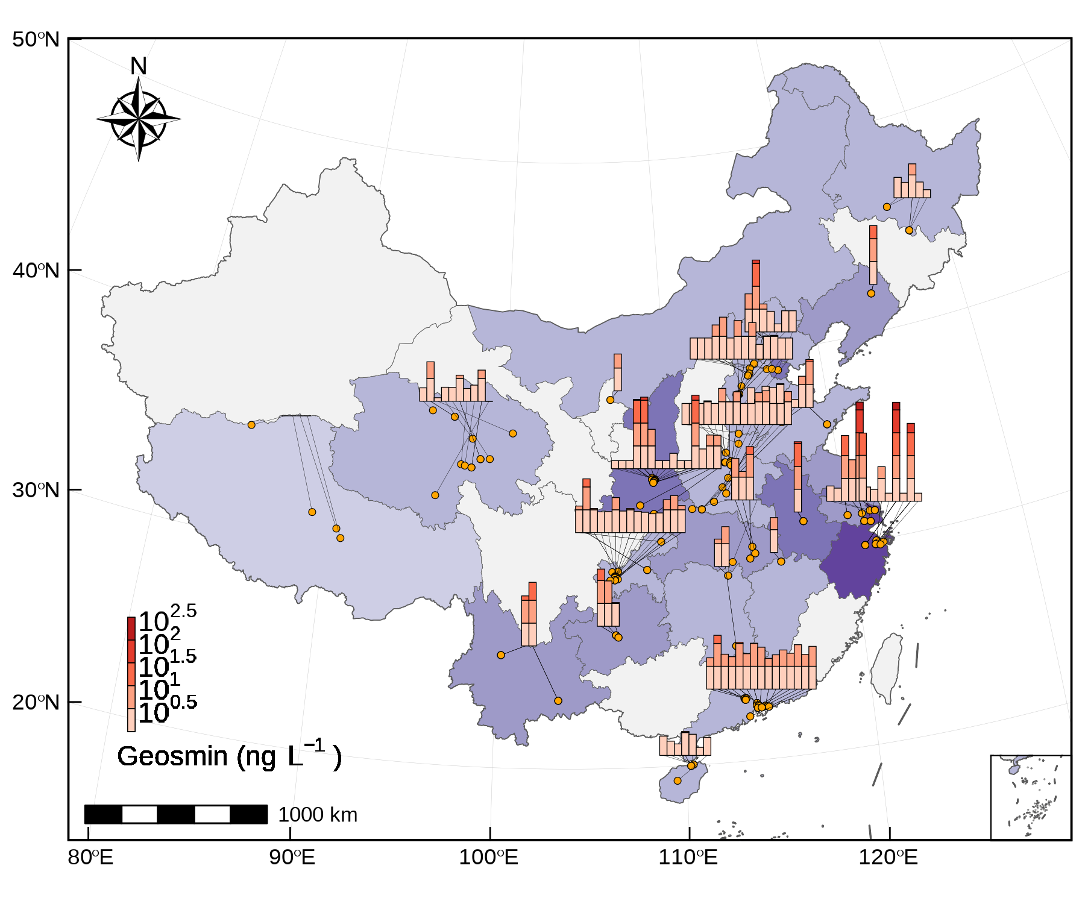
Fig. 1: Distribution of geosmin in China

Geosmin problem in Yuqiao Reservoir
于桥水库的YQ01至YQ08八个点位采集原水样本检测geosmin。根据历史数据显示?@fig-yqgsmtime，自2019年以来，于桥水库的geosmin均为季节性发生，通常持续长达8个月，发生时间为每年的6月到次年的1月。于桥水库的geosmin每年会经历两次峰值，第一次峰值在6到8月，从2019年至2023年平均值分别为16.9，8.5，10.3，12.8，9.2ng/L，90%分位数值为20.5，12.3，16.2，15.8，18.8ng/L；第二次峰值在10到12月，从2019至2023年平均值分别为22.0,15.1,17.6,15.6,21.2ng/L，90%分位数值为24.4，21.2,25.1,22.9,29.8ng/L，第一次峰值均低于第二次峰值。从年际分布来看，在2020年至2023年的geosmin发生期间，geosmin平均浓度分别为8.33,10.04,11.47,13.25 ng/L ,有逐年增长的趋势(p = 0.001)，嗅味发生期间geosmin浓度最高可达36.4ng/L。在非geosmin发生期间，即每年的2到5月，geosmin浓度通常在检测限附近（1.9ng/L）。
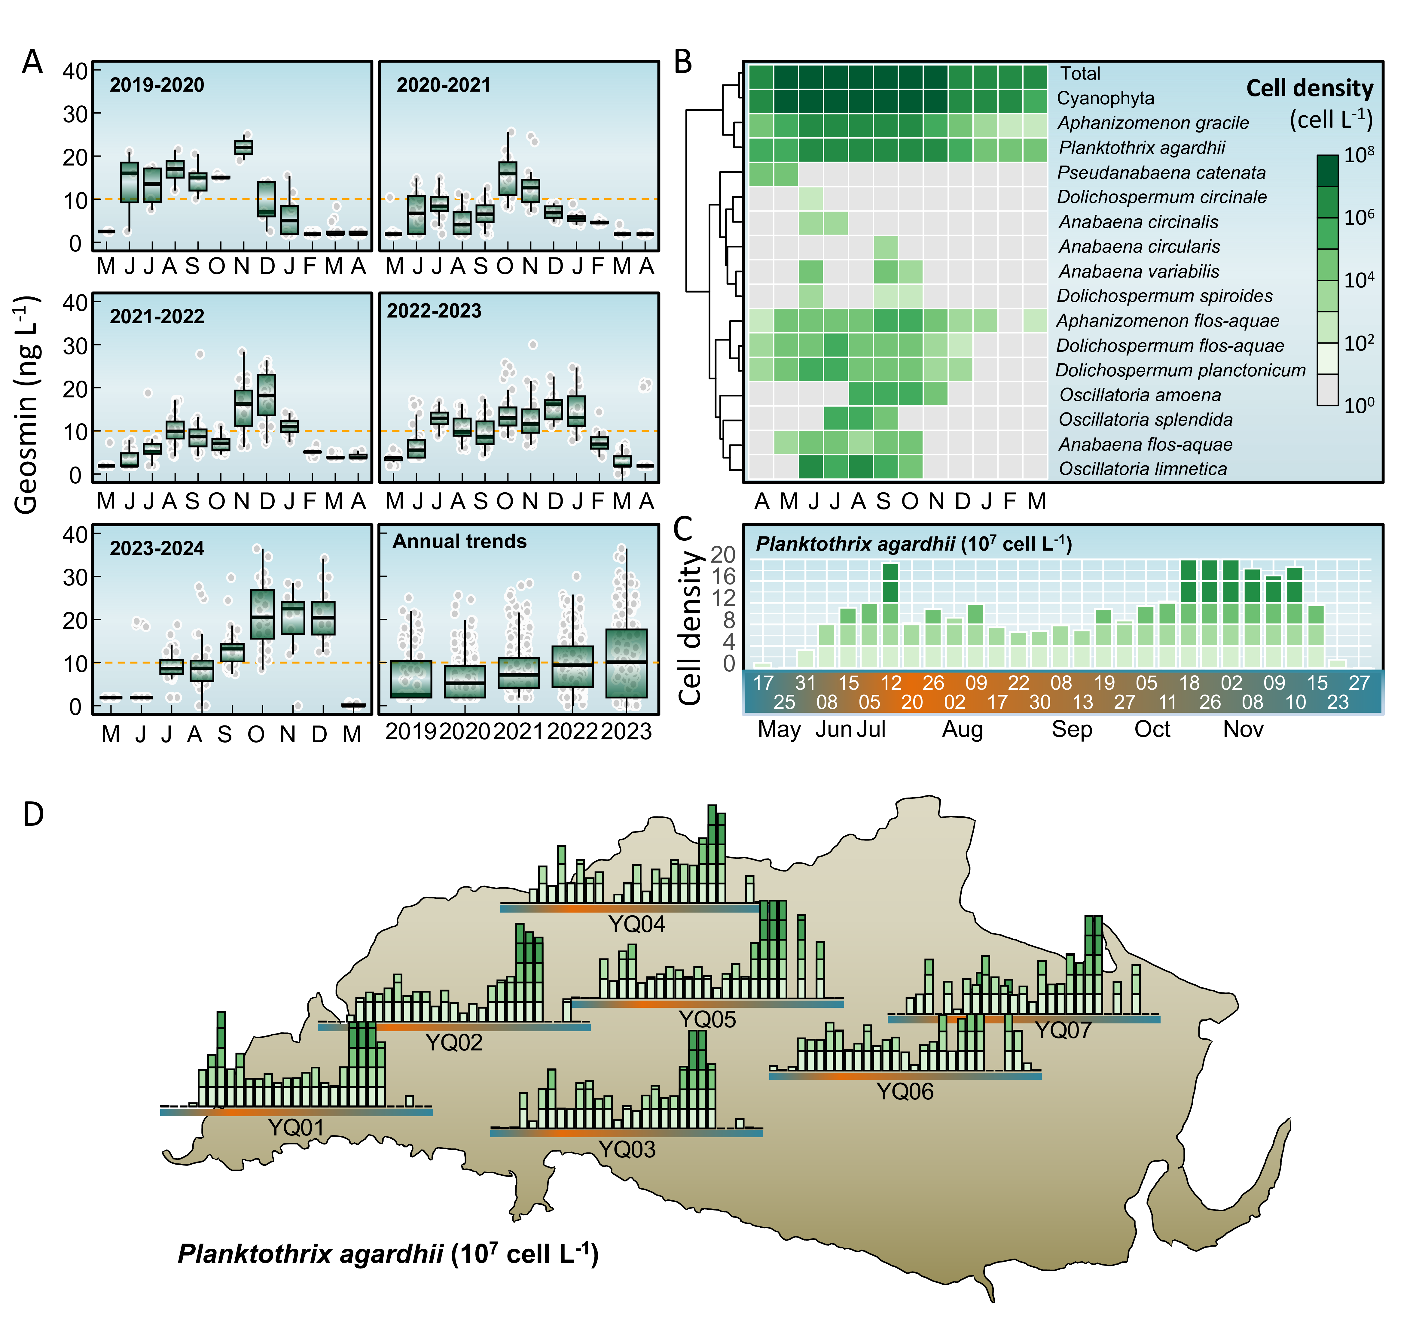
Fig. 2: Geosmin derived odor problems in Yuqiao Reservoir

Distribution of geosmin producer
调查期间，共记录到蓝藻137属，蓝藻群落表现出明显的时间和空间差异，蓝藻门为全年的优势门，蓝藻门丰度在每年5到10月有明显峰值，可达10^8cells/L。于桥水库已知的潜在geomsin产嗅藻表现出与geosmin浓度高度相似的时间分布特点（p<0.0001）。对巢氏PCR扩增产物进行高通量测序，结果表明在这两个点位的geosmin产嗅藻均为planktothrix。
于桥水库的阿氏浮丝藻每年会爆发两次峰值。第一次峰值发生于5月末到6月初，阿氏浮丝藻从水库上游的YQ07、YQ06点位开始迅速生长，生长速率可达10⁶cells/(L·d)，阿氏浮丝藻密度峰值达到1.1×10⁷cells/L，并维持该密度水平至8月末开始显著降低，降低速率约为-5×10⁵cells/(L·d)，9月中旬开始，阿氏浮丝藻迎来第二次爆发，并于10月中旬达到峰值，第二次爆发的生长速率和密度峰值高于第一次爆发，分别可达2.5×10⁶cells/(L·d)与2×10⁷cells/L，第二次峰值后密度迅速降低，降低速率可达-2.5×10⁶cells/(L·d)。而中游的YQ03、YQ04、YQ05点位的阿氏浮丝藻第一次爆发晚于上游点位一周左右，爆发后密度起伏变化较大，无明显的变化规律，生长速率在-10⁶cells/(L·d)与10⁶cells/(L·d)之间，但总体保持在高密度水平，最高可达1.1×10⁷cells/L，第二次爆发从9月中旬开始，生长速率和密度峰值也明显高于第一次爆发，分别可达3.7×10⁶cells/(L·d)和2×10⁷cells/L，第二次峰值后密度下降速率也更快，降低速率可达-5×10⁶cells/(L·d)。水库下游的YQ01点位的阿氏浮丝藻密度变化规律比中上游点位更为明显，第一次爆发晚于上游点位两周左右，并且在爆发后呈持续上升的趋势(p=0.0339)，三周后到达峰值，生长速率维持在10⁶cells/(L·d)左右，第一次爆发的密度峰值高于中上游点位，可达1.9×10⁷cells/L，随后持续下降，降低速率可达-1.5×10⁶cells/(L·d)，第二次爆发从10月初开始，同样晚于上游两周，爆发后仍然呈持续上升趋势，第二次爆发的藻密度峰值与中上游相同，即2×10⁷cells/L，生长速率约为1.5×10⁶cells/(L·d)，并于11月初回到爆发前的低密度水平(10⁵cells/L)，降低速率可达-2×10⁶cells/(L·d)，此后藻密度则一直保持在爆发前的低浓度水平(10⁵cells/L)。

Distribution of geosmin in Yuqiao Reservoir
于桥水库全年会经历两次geosmin爆发事件。第一次爆发为每年的6到8月，geosmin从上游较浅的点位开始爆发，在YQ01和YQ05以外的点位，geosmin爆发之初的6月即达到第一次浓度峰，浓度峰值均在20ng/L左右，并在爆发后保持持续下降(p<0.001)，于8月降至最低，多数点位在8月未检出geosmin。而YQ01和YQ05点位geosmin浓度变化表现出明显的不同，第一次爆发时，这两个点位的geosmin浓度从4到8月呈持续上升的趋势(p=0.002)，在4、5月份，其他点位geosmin爆发时，这两个点位的geosmin仅为接近检测限的1.9ng/L，直至8月分别上升至7.71与9.33ng/L,geosmin增长速率分别为1.11ng/(L·month)与1.28ng/(L·month)。 第二次geosmin爆发事件为每年的10到12月。此时，水库中上游点位的geosmin浓度变化规律接近，均在8到10月持续上升(p<0.001)，从8月的未检出geosmin上升至10月份全年最高峰值30ng/L左右，此后10到12月则呈持续下降趋势(p=0.017)。不同于其他点位，第二次geosmin事件中，水库下游的YQ01点位geosmin浓度从8到12月一直呈持续上升的趋势(p=0.007)，geosmin浓度从8月的7.1ng/L上升至12月的23.4ng/L，geosmin增长速率分别为4.63，8.18，0.87，3.55ng/(L·month)，在其他点位geosmin达到浓度峰的10月，YQ01的geosmin增长速率也达到最快，但该点位的geosmin达峰时间为12月，晚于其他点位，并且峰值也低于其他点位.
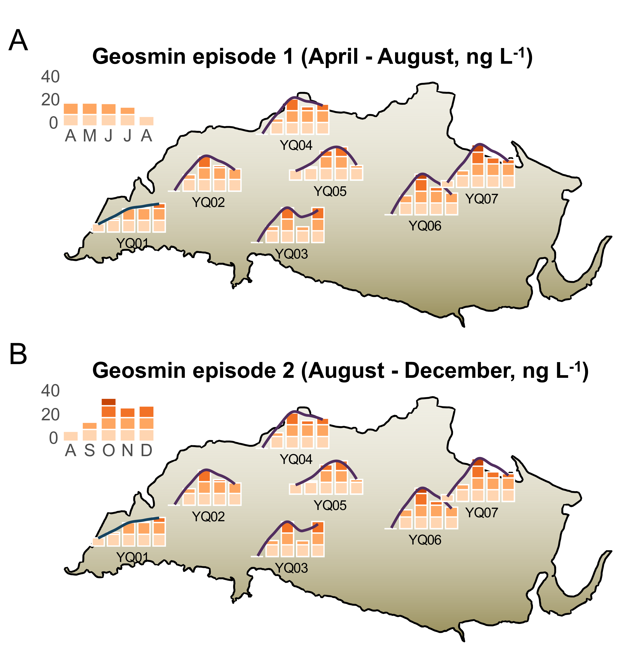
Fig. 3: Spatial distribution of geosmin in Yuqiao Reservoir in 2023-2024

Time Lag Analysis between geosmin and Planktothrix in Yuqiao Reservoir。
通过YQ01与YQ05点位近四年的geosmin与planktothrix相关性分析，评价planktothrix和geosmin之间的滞后时间关系。在YQ05点位，geosmin与阿氏浮丝藻在无滞后时相关性最强，此时R²为0.50Fig. 4A，随着滞后周数的增加，YQ05点位的geosmin与阿氏浮丝藻相关性越来越弱。而在YQ01点位，geomin与阿氏浮丝藻从滞后0周到滞后5周的相关性逐渐增强，并在滞后5周时，两者相关性达到最高，R^2为0.41Fig. 4A，随着滞后周数继续增加，两者相关性逐渐减弱，在YQ01点位两者相关性最强的一组数据中Fig. 4B，可以看到仍然有较多藻密度较高而geosmin浓度较低的数据点. 在中游的YQ05点位，阿氏浮丝藻和geosmin于每年的6月初开始爆发Fig. 4C，阿氏浮丝藻在12月开始减少，而geosmin仍然能够保持高浓度到2月左右降低至爆发前的低浓度水平。在下游的YQ01点位Fig. 4D，阿氏浮丝藻则早于geosmin 5周左右爆发，冬季藻密度降低后，geosmin浓度仍能保持一到两个月才开始缓慢降低。
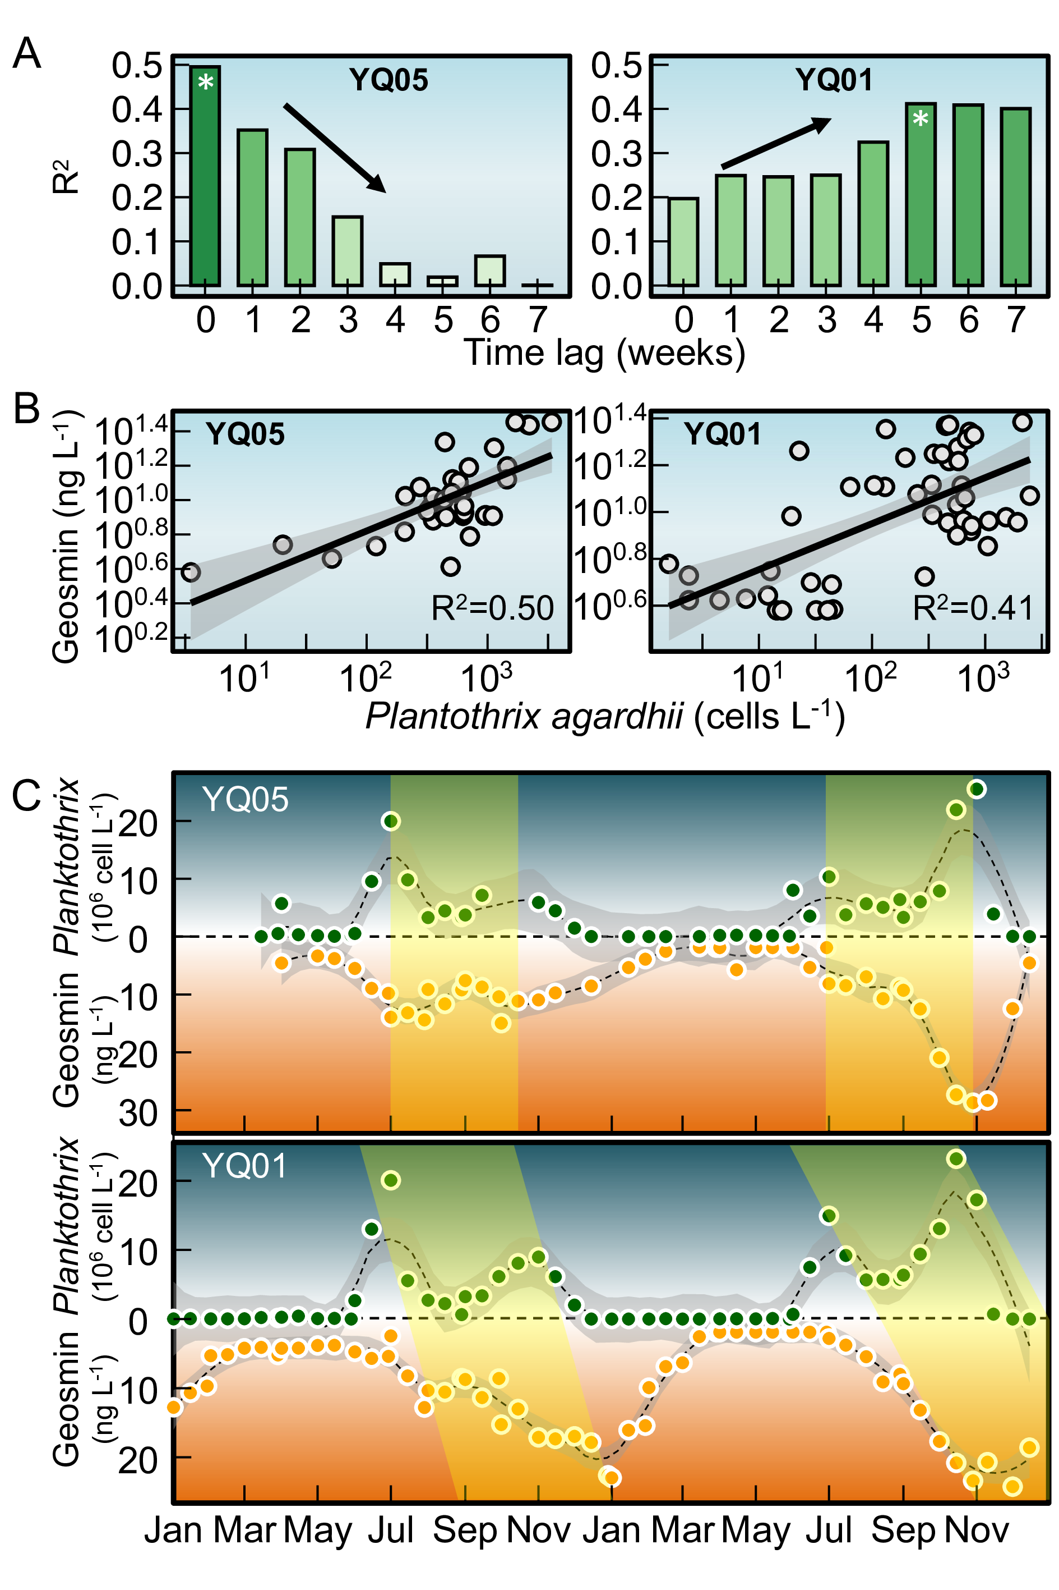
Fig. 4: Time lag between geosmin and Planktothrix in Yuqiao Reservoir

Migration patterns of geosmin and its olfactory producing algae in Yuqiao Reservoir
Total geosmin的箭头朝向接近右下方，说明Total geosmin主要受到PC1和PC2的负面共同影响。氨氮的箭头与Total geosmin几乎平行，说明从全库水平来看两者相关性非常强。TP、COD和Chl.a与Total geosmin的夹角也较小，表明它们之间也存在较强的正相关性，充足的营养盐条件是水体富营养化加剧的标志，促进了产嗅藻的生长和产嗅，geosmin的生物合成与Chl.a的生物合成有一定的相关性。透明度和DO与Total geosmin完全相反，表明水体透明度越低，DO越低，geosmin浓度越高，这是由于藻类爆发引起水体浑浊程度增加，同时耗氧速率增加。 从岸边较浅的点位来看，于桥水库的geosmin与氨氮相关性极强，R²为0.35。岸边浅水区域通常受到外界输入的影响较大，比如地表径流带来的养分，使得氨氮浓度较高，同时这些区域因为水体流速缓慢，光照较强，水体混合程度更高，所以更适合藻类生长和产嗅，导致两者相关性强。水库中游的YQ05点位，二者的相关性有所下降，R²为0.19，而水库下游最深的YQ01点位，二者相关性非常低，R²仅为0.03这是因为水库深处的环境相对稳定，氨氮可能因为沉降或者硝化过程在水体中减少，水库深处的氨氮更多来自内循环，如沉积物释放或分解，且下游geosmin的产生可能更多受限于藻类生长条件，如光照和温度等，从而降低了氨氮和geosmin的相关性。
结合于桥水库的地形，进一步分析于桥水库geosmin与其产嗅藻的分布规律。岸边地区的水深较浅，特别是水库上游的YQ07点位，水深仅有2到3米，此处接近入库河流，是水库水体的主要来源。每年5月底至6月初，携带者阿氏浮丝藻的水体从上游较浅的点位输入于桥水库。在浅水区及入库口，水流减速易形成沉积，有利于产嗅藻的富集。浅水区水体混合程度高，入库河流携带的营养盐可以快速混合均匀，输入水库的产嗅蓝藻可以即时适应水体环境，在输入水库的同时开始产嗅。浅水区光照充足，水温高，更容易促进蓝藻生长产嗅。上游的水体流动性强于下游，可能促进geosmin的挥发和稀释，所以在嗅味事件末期，geosmin总是从上游和较浅的岸边开始降低。水库整体流速较缓，上游输入的产嗅藻需要经过两周左右的迁移最终汇于水库下游，水深最深的YQ01点位，该处水深可达10米。深水区水动力较弱，水体交换时间长，不同深度的水体环境差异较大，所以产嗅藻随水体迁移至下游后，需要一定时间的适应才能继续生长产嗅。此处靠近水库的大坝区域，停留时间长于上游点位，更有利于累积更多产嗅藻和geosmin，所以阿氏浮丝藻和geosmin爆发事件时，YQ01点位的峰值总是达到全库最高。在水库中游的YQ05点位水深大约为5米，此处在第一次嗅味事件（6到8月）时为geosmin的汇，第二次嗅味事件（10到12月）为geosmin的源.
Fig. 5A
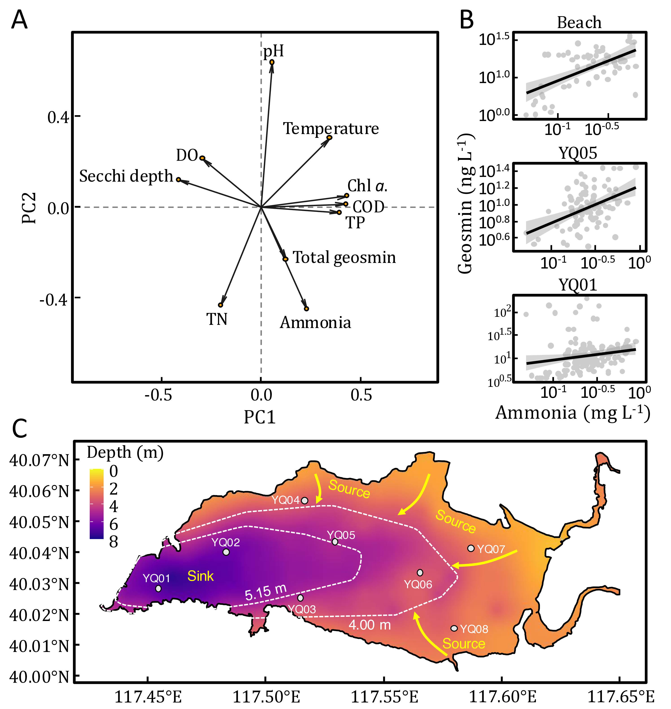
Fig. 5: Mechanism of Planktothrix induced risk in Yuqiao Reservoir

Discussion
geosmin是饮用水中最常见的致嗅化合物之一,丝状蓝藻和放线菌均为土臭素的生产者，但已有研究表明，在湖库型水体中，geosmin主要由丝状蓝藻产生(lee2020occurrence?)。中国超过80%的地表水源均存在嗅味问题(Sun et al., 2014)，饮用水处理中的geosmin难以用传统工艺去除，因此常在饮用水中成为嗅味问题的主要原因。揭示geosmin在环境中的产生、分布特征为解决水体嗅味问题提供了科学依据。中国湖库型水源地中，geosmin问题与富营养化治理成效呈现复杂关联,尽管中国水体富营养化程度有所缓解，但2023年调研显示，东南地区geosmin超过10 ng/L国家标准的湖库仍然较多。这一现象可能与营养盐水平变化导致的蓝藻群落演替有关：随着水体富营养化治理，水体营养盐水平整体降低，优势藻种从营养盐限制型的微囊藻向光照限制型产嗅丝状蓝藻（如鱼腥藻、束丝藻）过渡，多种 geosmin产嗅藻能够在低氮、低磷的条件下通过形成异形胞固定无机氮，通过磷储存机制和胞外碱性磷酸酶利用有机磷，能够在各种生境中广泛存在(wan2019phosphorus?)。因此，geosmin不仅是水质指标，更是生态系统响应环境压力的重要信号分子。
于桥水库原位监测研究中，geosmin浓度与其产嗅藻planktothrix的相关性整体较低，其R²最高值仅见于YQ05点位的（R²=0.50，p<0.05）Fig. 4B，该结果与多项原位监测研究中产嗅藻生物量与特征嗅味物质浓度间的相关性水平基本一致，表明在复杂水环境条件下藻类生物量与次生代谢产物浓度间可能受到多因素调控(shang2024temporal?)。而实验室纯培养条件下geosmin与其产嗅藻相关性极强，R²可达0.9以上(SU20133444?)。同时，在纯培养条件下，geosmin生产者在实验室环境中表现出比原位生长更高的geosmin产量(Gerber and Lechevalier, 1965)。导致Geosmin与其生产者的生物量相关性在两种环境中表现出显著差异的主要原因是纯培养条件下与原位水体环境中的微生物代谢活动不同。在实验室纯培养环境下，geosmin浓度更多地依赖于特定微生物的基因表达和代谢能力，而在原位水体中，其浓度受到溶解氧、微生物群落动态等多种环境因素影响(Lukassen et al., 2022)。原位水体与纯培养条件下geosmin与其生产者生物量的的相关性差异主要源于环境条件和微生物群落结构的不同。因此，原位调查在揭示土臭素产嗅藻的真实生态行为及其环境驱动机制方面具有更重要的研究价值，应注重开展原位调查，以期为水体嗅味问题的精准防控提供科学依据。

Geosmin in Yuqiao Reservoir
本研究揭示于桥水库的geosmin污染事呈现独特的时空分布特征，与我国东部及南部湖泊水库典型嗅味事件相比，该水库土臭素污染具有显著差异：时间分布上，污染事件发生于夏季并持续至次年一月，呈现双峰型浓度特征?@fig-yqgsmtime，而中国东部和南部的湖泊和水库的嗅味污染一般发生在春夏季节，而不发生在低温的冬季，且峰值持续时间较短，呈单峰浓度特征(Cao et al., 2023; shang2024temporal?)。空间分布上，下游监测点YQ01的geosmin与其产嗅藻planktothrix生物量峰值较中上游点位滞后4-5周，且浓度衰减同步延迟Fig. 3，该滞后周期可能表征geosmin在水体中的停留时间。5-6月支流来水输入了planktothrix同步产生了geosmin，7-8月二者在中上游形成首个浓度峰值后，由于浅水区8-10月的高光强环境促进了表层藻类水华，间接通过遮光效应抑制了planktothrix的生长，导致土臭素浓度阶段性下降。(Oberhaus et al., 2007)。值得注意的是，上游点位浮丝藻生物量与土臭素浓度呈现显著同步变化（r=0.82, p<0.01），表明支流输入时浮丝藻已具备原位产嗅能力。至10-12月，环境条件改变促使浮丝藻二次增殖，形成冬季次峰，此现象突破了传统认知中低温环境抑制产嗅的理论。该研究揭示了于桥水库土臭素污染的双峰特征及其水动力驱动机制，为建立流域特异性嗅味预警模型、追踪污染源项及评估污染物迁移扩散规律提供了科学依据。

The migration process of geosmin in Yuqiao Reservoir
本研究表明随着滞后周数的增加，YQ05点位的geosmin与阿氏浮丝藻相关性越来越弱，这表明在YQ05点位阿氏浮丝藻与geosmin同时输入，并不存在明显的滞后关系。在YQ01点位两者相关性最强的一组数据中Fig. 4B，可以看到仍然有较多藻密度较高而geosmin浓度较低的数据点，这表明水库下游的产嗅藻由中上游输入，并于下游生长5周左右开始大量产嗅。在中游的YQ05点位，阿氏浮丝藻和geosmin于每年的6月初开始爆发Fig. 4C，阿氏浮丝藻在12月开始减少，而geosmin仍然能够保持高浓度到2月左右开始降低，这是由于冬季于桥水库经历冰封期，冰盖使geosmin难以挥发，保留在水体中，这与Wang等在画匠水库的研究相符，冬季富营养化是影响geosmin合成和释放的主要因素而不是温度(Wang et al., 2015)。在下游的YQ01点位，geosmin增长时间滞后于阿氏浮丝藻5周，冬季藻密度降低后，geosmin仍能维持峰值4到5周。在美国Eagle Creek Reservoir中也观测到geosmin与Planktothrix紧密相关，且水库中geosmin的最高检出值与产嗅藻峰值之间存在37天的滞后期，这一滞后期代表产嗅藻从流域迁移到水库所需的时间(Clercin and Druschel, 2019)。这些信息提供了一种预测geosmin事件的线索,使得水库可以在异味变得严重之前阻止产嗅藻生长。

Identification of geosmin-producing algae
目前已有的研究表明，基因组中是否携带geosmin synthase是进行geosmin产嗅藻识别的关键依据，对功能基因的定量检测可以检出水体中geosmin的产生潜力，但是不能识别出geosmin产嗅藻的不同物种信息。基于分子生物学的系统发育基因（如16S rRNA基因）扩增子测序仅能用于识别藻类群落结构，不能特定地识别出geosmin产嗅藻。目前epicPCR方法可以高通量精准识别环境中功能基因宿主，并已经成功应用于特异性识别硫酸盐还原菌(Spencer2015massively?)，本研究通过改进epicPCR方法，筛选了特异性引物PCR完成了对于桥水库geosmin产嗅藻的识别，但是该方法还不适用于识别如放线菌等除蓝藻之外的geosmin producers。 通过epicPCR方法我们识别出于桥水库2023年的geosmin producer是planktothrix，但geosmin producer并不是一直不变的，也可能同时存在多种geosmin producers，LI等人的研究表明在2017到2019年于桥水库的geosmin与鱼腥藻具有极显著的正相关性，并且主要嗅味物质从2017年的geosmin转变为2018年后mib(li2020analysis?)
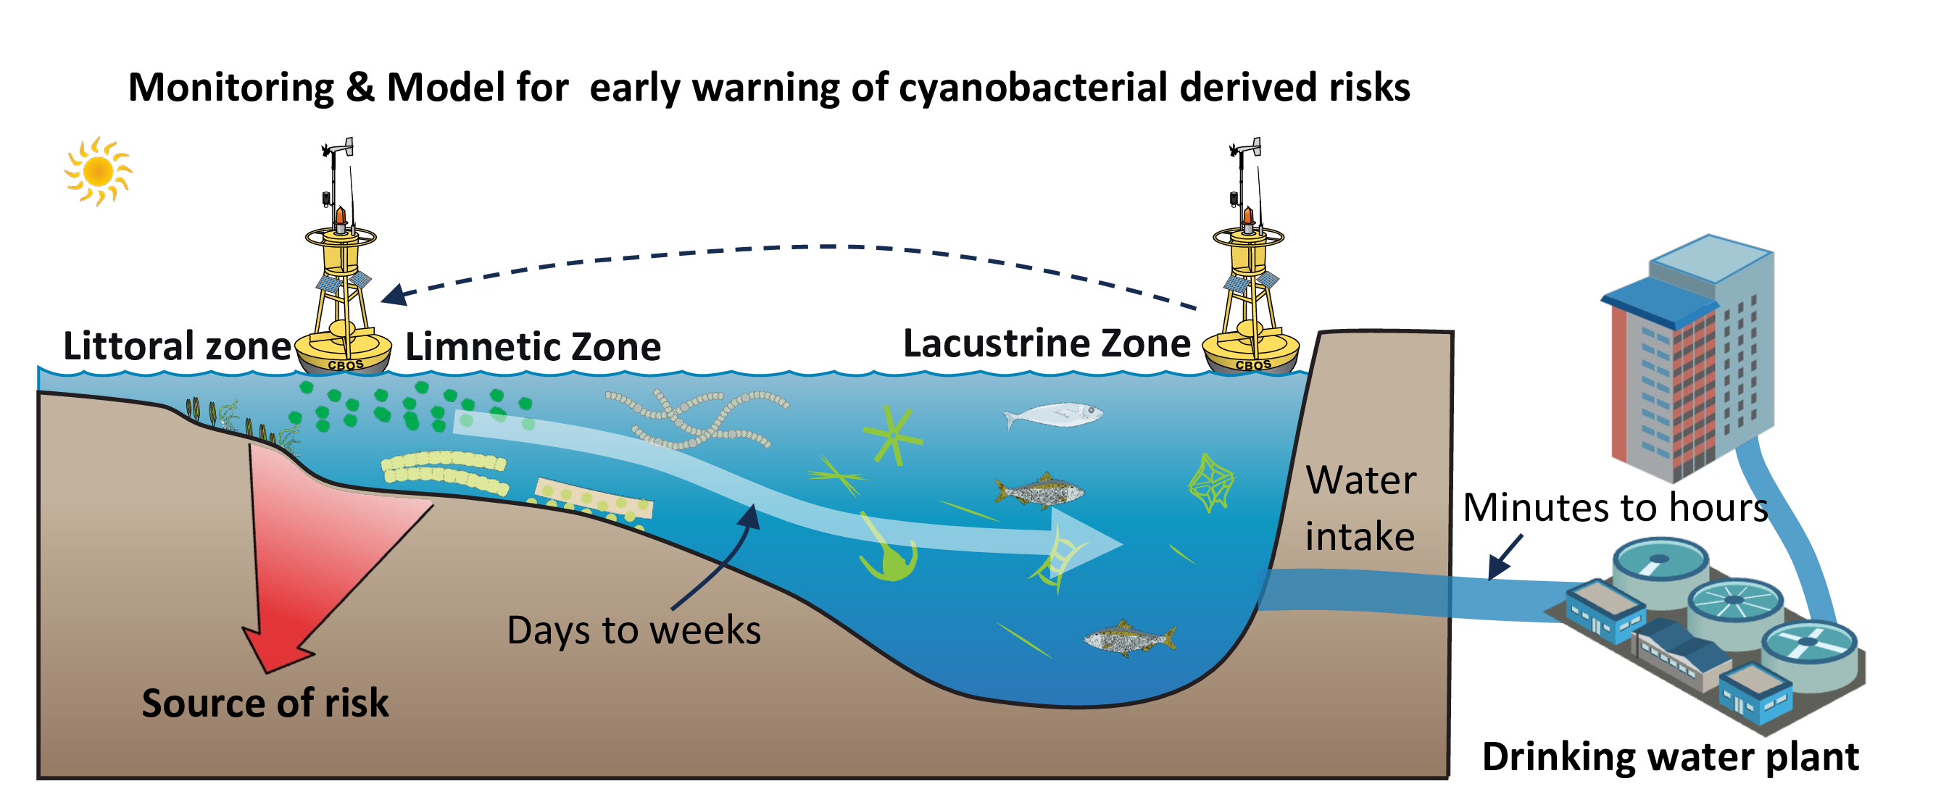
Fig. 6: sketch of geosmin producer

Conclusions

Acknowledgements
This work was financially supported by the National Natural Science Foundation of China (52030002, 51878649), and Youth Innovation Promotion Association CAS.

References
Ai, Y., Wu, Y., Su, M., Gui, Y., Du, Y., Fang, J., Cao, T., Yang, M., 2025. Cyanobacterial crowding-out effects on metabolite partitioning: Modeling 2-methylisoborneol (MIB) release dynamics and implications. Journal of Hazardous Materials 140118. https://doi.org/https://doi.org/10.1016/j.jhazmat.2025.140118
Asato, Y., 2003. Toward an understanding of cell growth and the cell division cycle of unicellular photoautotrophic cyanobacteria. Cellular and Molecular Life Sciences (CMLS) 60, 663–687. https://doi.org/10.1007/s00018-003-2079-y
AWWA, A.W.W.A., 2010. Algae: Source to treatment. American Water Works Association.
Bowmer, K.H., Padovan, A., Oliver, R.L., Korth, W., Ganf, G.G., 1992. Physiology of geosmin production by Anabaena Circinalis isolated from the murrumbidgee river, australia. Water Science and Technology 25, 259–267. https://doi.org/10.2166/wst.1992.0060
Burlingame, G.A., Doty, R.L., Dietrich, A.M., 2017. Humans as sensors to evaluate drinking water taste and odor: A review. Journal AWWA 109, 13–24. https://doi.org/10.5942/jawwa.2017.109.0118
Cao, T., Fang, J., Jia, Z., Zhu, Y., Su, M., Zhang, Q., Song, Y., Yu, J., Yang, M., 2023. Early warning of MIB episode based on gene abundance and expression in drinking water reservoirs. Water Research 231, 119667. https://doi.org/https://doi.org/10.1016/j.watres.2023.119667
Carmichael, W.W., Azevedo, S.M., An, J.S., Molica, R.J., Jochimsen, E.M., Lau, S., Rinehart, K.L., Shaw, G.R., Eaglesham, G.K., 2001. Human fatalities from cyanobacteria: Chemical and biological evidence for cyanotoxins. Environmental Health Perspectives 109, 663–668. https://doi.org/10.1289/ehp.01109663
Cefalì, M.E., Cebrian, E., Chappuis, E., Pinedo, S., Terradas, M., Mariani, S., Ballesteros, E., 2016. Life on the boundary: Environmental factors as drivers of habitat distribution in the littoral zone. Estuarine, Coastal and Shelf Science 172, 81–92. https://doi.org/10.1016/j.ecss.2016.01.043
Cerón-Vivas, A., Villamizar León, M.P., Cajigas, Á.A., 2022. Geosmin and 2-methylisoborneol removal in drinking water treatment. Water Practice and Technology 18, 159–167. https://doi.org/10.2166/wpt.2022.167
Clercin, N.A., Druschel, G.K., 2019. Influence of environmental factors on the production of MIB and geosmin metabolites by bacteria in a eutrophic reservoir. Water Resources Research 55, 5413–5430. https://doi.org/10.1029/2018wr023651
Dordoni, M., Zappalà, P., Barth, J.A.C., 2023. A preliminary global hydrochemical comparison of lakes and reservoirs. Frontiers in Water 5. https://doi.org/10.3389/frwa.2023.1084050
Feng, L., Dai, Y., Hou, X., Xu, Y., Liu, J., Zheng, C., 2021. Concerns about phytoplankton bloom trends in global lakes. Nature 590, E35–E47. https://doi.org/10.1038/s41586-021-03254-3
Gerber, N.N., Lechevalier, H.A., 1965. Geosmin, an earthy-smelling substance isolated from actinomycetes. Applied Microbiology 13, 935–938.
Heisler, J., Glibert, P.M., Burkholder, J.M., Anderson, D.M., Cochlan, W., Dennison, W.C., Dortch, Q., Gobler, C.J., Heil, C.A., Humphries, E., Lewitus, A., Magnien, R., Marshall, H.G., Sellner, K., Stockwell, D.A., Stoecker, D.K., Suddleson, M., 2008. Eutrophication and harmful algal blooms: A scientific consensus. Harmful Algae 8, 3–13. https://doi.org/10.1016/j.hal.2008.08.006
Huisman, J., Codd, G.A., Paerl, H.W., Ibelings, B.W., Verspagen, J.M.H., Visser, P.M., 2018. Cyanobacterial blooms. Nature Reviews Microbiology 16, 471–483. https://doi.org/10.1038/s41579-018-0040-1
Jüttner, F., Watson, S.B., 2007. Biochemical and ecological control of geosmin and 2-methylisoborneol in source waters. Applied and Environmental Microbiology 73, 4395–4406. https://doi.org/10.1128/aem.02250-06
Kosten, S., Huszar, V.L.M., Bécares, E., Costa, L.S., Donk, E. van, Hansson, L., Jeppesen, E., Kruk, C., Lacerot, G., Mazzeo, N., De Meester, L., Moss, B., Lürling, M., Nõges, T., Romo, S., Scheffer, M., 2011. Warmer climates boost cyanobacterial dominance in shallow lakes. Global Change Biology 18, 118–126. https://doi.org/10.1111/j.1365-2486.2011.02488.x
LEFLAIVE, J., TEN‐HAGE, L., 2007. Algal and cyanobacterial secondary metabolites in freshwaters: A comparison of allelopathic compounds and toxins. Freshwater Biology 52, 199–214. https://doi.org/10.1111/j.1365-2427.2006.01689.x
Li, Z., Yu, J., Yang, M., Zhang, J., Burch, M.D., Han, W., 2010. Cyanobacterial population and harmful metabolites dynamics during a bloom in yanghe reservoir, north China. Harmful Algae 9, 481–488. https://doi.org/10.1016/j.hal.2010.03.003
Lin, T.-F., Watson, S., Suffet, I.H.M., 2018. Taste and odour in source and drinking water: Causes, controls, and consequences. IWA Publishing.
Lukassen, M.B., Menanteau-Ledouble, S., Jonge, N. de, Schram, E., Nielsen, J.L., 2022. Impact of water quality parameters on geosmin levels and geosmin producers in european recirculating aquaculture systems. Journal of Applied Microbiology 132, 2475–2487. https://doi.org/10.1111/jam.15358
Martinez i Quer, A., Larsson, Y., Johansen, A., Arias, C.A., Carvalho, P.N., 2024. Cyanobacterial blooms in surface waters – nature-based solutions, cyanotoxins and their biotransformation products. Water Research 251, 121122. https://doi.org/10.1016/j.watres.2024.121122
Mehnert, G., Leunert, F., Cires, S., Johnk, K.D., Rucker, J., Nixdorf, B., Wiedner, C., 2010. Competitiveness of invasive and native cyanobacteria from temperate freshwaters under various light and temperature conditions. Journal of Plankton Research 32, 1009–1021. https://doi.org/10.1093/plankt/fbq033
Merel, S., Walker, D., Chicana, R., Snyder, S., Baurès, E., Thomas, O., 2013. State of knowledge and concerns on cyanobacterial blooms and cyanotoxins. Environment International 59, 303–327. https://doi.org/10.1016/j.envint.2013.06.013
Mustapha, S., Tijani, J.O., Ndamitso, M.M., Abdulkareem, A.S., Shuaib, D.T., Mohammed, A.K., 2021. A critical review on geosmin and 2-methylisoborneol in water: Sources, effects, detection, and removal techniques. Environmental Monitoring and Assessment 193, 204. https://doi.org/10.1007/s10661-021-08980-9
O’neil, J.m., Davis, T.w., Burford, M.a., Gobler, C.j., 2012. The rise of harmful cyanobacteria blooms: The potential roles of eutrophication and climate change. Harmful Algae 14, 313–334. https://doi.org/10.1016/j.hal.2011.10.027
Oberhaus, L., Briand, J.F., Leboulanger, C., Jacquet, S., Humbert, J.F., 2007. Comparative effects of the quality and quantity of light and temperature on the growth of Planktothrix agardhii and P. rubescens. Journal of Phycology 43, 1191–1199. https://doi.org/10.1111/j.1529-8817.2007.00414.x
Paerl, H.W., Fulton, R.S., Moisander, P.H., Dyble, J., 2001. Harmful freshwater algal blooms, with an emphasis on cyanobacteria. The Scientific World Journal 1, 76–113. https://doi.org/10.1100/tsw.2001.16
Paerl, H.W., Paul, V.J., 2012. Climate change: Links to global expansion of harmful cyanobacteria. Water Research 46, 1349–1363. https://doi.org/10.1016/j.watres.2011.08.002
Paerl, H.W., Xu, H., Mccarthy, M.J., Zhu, G., Qin, B., Li, Y., Gardner, W.S., 2011. Controlling harmful cyanobacterial blooms in a hyper-eutrophic lake (lake taihu, China): The need for a dual nutrient (n & p) management strategy. Water Research 45, 1973–1983. https://doi.org/10.1016/j.watres.2010.09.018
Plaas, H.E., Paerl, H.W., 2020. Toxic cyanobacteria: A growing threat to water and air quality. Environmental Science &amp; Technology 55, 44–64. https://doi.org/10.1021/acs.est.0c06653
Qiu, P., Zhang, Y., Mi, W., Song, G., Bi, Y., 2023. Producers and drivers of odor compounds in a large drinking-water source. Frontiers in Ecology and Evolution 11. https://doi.org/10.3389/fevo.2023.1216567
Reinl, K.L., Harris, T.D., Elfferich, I., Coker, A., Zhan, Q., Domis, L.N.D.S., Morales-Williams, A.M., Bhattacharya, R., Grossart, H.-P., North, R.L., Sweetman, J.N., 2022. The role of organic nutrients in structuring freshwater phytoplankton communities in a rapidly changing world. Water Research 219, 118573. https://doi.org/10.1016/j.watres.2022.118573
Rousso, B.Z., Bertone, E., Stewart, R., Hamilton, D.P., 2020. A systematic literature review of forecasting and predictive models for cyanobacteria blooms in freshwater lakes. Water Research 182, 115959. https://doi.org/10.1016/j.watres.2020.115959
Singh, S., Kate, B.N., Banerjee, U.C., 2005. Bioactive compounds from cyanobacteria and microalgae: An overview. Critical Reviews in Biotechnology 25, 73–95. https://doi.org/10.1080/07388550500248498
Srinivasan, R., Sorial, G.A., 2011. Treatment of taste and odor causing compounds 2-methyl isoborneol and geosmin in drinking water: A critical review. Journal of Environmental Sciences 23, 1–13. https://doi.org/10.1016/s1001-0742(10)60367-1
Su, M., Yu, J., Zhang, J., Chen, H., An, W., Vogt, R.D., Andersen, T., Jia, D., Wang, J., Yang, M., 2015. MIB-producing cyanobacteria (Planktothrix sp.) in a drinking water reservoir: Distribution and odor producing potential. Water Research 68, 444–453. https://doi.org/10.1016/j.watres.2014.09.038
Su, M., Zhu, Y., Jia, Z., Liu, T., Yu, J., Burch, M., Yang, M., 2021. Identification of MIB producers and odor risk assessment using routine data: A case study of an estuary drinking water reservoir. Water Research 192, 116848. https://doi.org/10.1016/j.watres.2021.116848
Sun, D., Yu, J., Yang, M., An, W., Zhao, Y., Lu, N., Yuan, S., Zhang, D., 2014. Occurrence of odor problems in drinking water of major cities across China. Frontiers of Environmental Science & Engineering 8, 411–416. https://doi.org/10.1007/s11783-013-0577-1
Thornton, K.W., 1984. REGIONAL COMPARISONS OF LAKES AND RESERVOIRS: GEOLOGY, CLIMATOLOGY, AND MORPHOLOGY. Lake and Reservoir Management 1, 261–265. https://doi.org/10.1080/07438148409354521
Uwins, H.K., Teasdale, P., Stratton, H., 2007. A case study investigating the occurrence of geosmin and 2-methylisoborneol (MIB) in the surface waters of the hinze dam, gold coast, australia. Water Science and Technology 55, 231–238. https://doi.org/10.2166/wst.2007.184
Wang, R., Li, D., Jin, C.X., Yang, B.W., 2015. Seasonal occurrence and species specificity of fishy and musty odor in huajiang reservoir in winter, china. Water Resources and Industry 11, 13–26. https://doi.org/10.1016/j.wri.2015.04.002
Watson, S.B., 2003. Cyanobacterial and eukaryotic algal odour compounds: Signals or by-products? A review of their biological activity. Phycologia 42, 332–350. https://doi.org/10.2216/i0031-8884-42-4-332.1
Woolway, R.I., Kraemer, B.M., Lenters, J.D., Merchant, C.J., O’Reilly, C.M., Sharma, S., 2020. Global lake responses to climate change. Nature Reviews Earth &amp; Environment 1, 388–403. https://doi.org/10.1038/s43017-020-0067-5
Wu, T., Zhu, G., Wang, Z., Zhu, M., Xu, H., 2022. Seasonal dynamics of odor compounds concentration driven by phytoplankton succession in a subtropical drinking water reservoir, southeast China. Journal of Hazardous Materials 425, 128056. https://doi.org/10.1016/j.jhazmat.2021.128056
Xu, H., Paerl, H.W., Qin, B., Zhu, G., Gaoa, G., 2009. Nitrogen and phosphorus inputs control phytoplankton growth in eutrophic Lake Taihu, China. Limnology and Oceanography 55, 420–432. https://doi.org/10.4319/lo.2010.55.1.0420
Yang, M., Yu, J., Li, Z., Guo, Z., Burch, M., Lin, T., 2008. Taihu Lake not to blame for Wuxi’s Woes. Science 319, 158. https://doi.org/10.1126/science.319.5860.158a
Zamyadi, A., Henderson, R., Stuetz, R., Hofmann, R., Ho, L., Newcombe, G., 2015. Fate of geosmin and 2-methylisoborneol in full-scale water treatment plants. Water Research 83, 171–183. https://doi.org/10.1016/j.watres.2015.06.038
Zhang, Y., Whalen, J.K., Cai, C., Shan, K., Zhou, H., 2023. Harmful cyanobacteria-diatom/dinoflagellate blooms and their cyanotoxins in freshwaters: A nonnegligible chronic health and ecological hazard. Water Research 233, 119807. https://doi.org/10.1016/j.watres.2023.119807
Zohary, T., Gasith, A., 2014. The littoral zone, in: Lake Kinneret. Springer Netherlands, pp. 517–532. https://doi.org/10.1007/978-94-017-8944-8_29

