Integrating littoral zone odor dynamics into early warning and intervention systems for drinking water reservoirs
Yuying Gui^{b,a,#}, Tengxin Cao^{b,c,#}, Ming Su ^{ID,b,c,*}, Yufan Ai^{b,c}, Yingjie Li^{b,c}, and Min Yang^{b,c}
# These authors contributed equally to this work.
ª College of Environmental Science and Engineering, Ocean University of China, Qingdao 266100, China.
^{b} Key Laboratory of Environmental Aquatic Chemistry, State Key Laboratory of Regional Environment and Sustainability, Research Center for Eco-Environmental Sciences, Chinese Academy of Sciences, Beijing 100085, China.
^{c} University of Chinese Academy of Sciences, Beijing 100049, China.
* Corresponding to: Ming Su (mingsu@rcees.ac.cn)

Abstract
This is the abstract.

Introduction
The increasing frequency and intensity of harmful cyanobacterial blooms (CyanoHABs) in surface waters, driven by climate change and intensified anthropogenic pressures, pose a critical and escalating global threat to water security (Feng et al., 2021; Heisler et al., 2008; Huisman et al., 2018; O’neil et al., 2012; Paerl et al., 2001; Paerl and Paul, 2012; Woolway et al., 2020). While substantial research has focused on eutrophication-driven bloom mechanisms and risk assessment in shallow lakes (Kosten et al., 2011; Martinez i Quer et al., 2024; Paerl et al., 2011; Reinl et al., 2022; Rousso et al., 2020; Xu et al., 2009; Zhang et al., 2023), studies on reservoir systems—which constitute a primary source of global drinking water—remain disproportionately scarce. This significant knowledge gap carries critical implications, as CyanoHABs directly threaten drinking water safety through the production of toxins (Carmichael et al., 2001; LEFLAIVE and TEN‐HAGE, 2007; Merel et al., 2013; Plaas and Paerl, 2020) and taste-and-odor (T&O) compounds (Burlingame et al., 2017; Lin et al., 2018; Su et al., 2015; Yang et al., 2008), impacting both human health and water utility. For example, nearly half of China’s source-water reservoirs experience recurrent algal-derived T&O episodes (Sun et al., 2014). Unlike chemical contaminants, cyanobacterial populations can undergo exponential growth under suitable conditions (Asato, 2003; Mehnert et al., 2010), rapidly releasing metabolites (Ai et al., 2025; LEFLAIVE and TEN‐HAGE, 2007; Singh et al., 2005) that often exceed the response capacity of conventional water treatment facilities (Cerón-Vivas et al., 2022; Mustapha et al., 2021; Srinivasan and Sorial, 2011), leading to widespread drinking water quality incidents (Li et al., 2010; Yang et al., 2008).
Effectively managing CyanoHABs in reservoirs presents distinct and formidable challenges. Compared to natural lakes, reservoirs display greater spatial and hydraulic complexity, resulting in less stable and predictable ecological regimes (Dordoni et al., 2023; Thornton, 1984). Conventional reservoir monitoring strategies, typically confined to sampling near dam intakes, fail to capture the spatially heterogeneous distribution of algal biomass and metabolites. Furthermore, the short flow time from intake to drinking water treatment plant—often on the scale of minutes to hours—provides an inadequate operational window for timely intervention. In contrast, littoral zones in reservoirs are characterized by markedly different environmental conditions, such as enhanced nutrient availability and light penetration (Cefalì et al., 2016; Zohary and Gasith, 2014), which may promote early cyanobacterial proliferation. Despite their potential significance as critical sentinel sites, these areas remain critically under-monitored. Consequently, the mechanistic linkages between littoral zone CyanoHAB dynamics and downstream water quality at intakes are poorly understood and quantified.
Geosmin (GSM) and 2-methylisoborneol (MIB) are among the most concerning terpenoid T&O compounds produced by cyanobacteria (Jüttner and Watson, 2007; Watson, 2003). Their low molecular weight and chemical nature allow them to penetrate conventional water treatment barriers and persist into tap water (Lin et al., 2018; Zamyadi et al., 2015), directly impairing drinking water quality and consumer acceptance. In China, MIB-related episodes have been widely reported and studied, with corresponding mitigation strategies developed (Su et al., 2021, 2015). In contrast, GSM incidents have historically been more prevalent in the Southern Hemisphere (Bowmer et al., 1992; Uwins et al., 2007) but are increasingly reported across Northern Hemisphere water bodies (Qiu et al., 2023; Wu et al., 2022). Notably, GSM-producing cyanobacterial taxa are phylogenetically more diverse than those associated with MIB (AWWA, 2010), complicating source-tracking and management efforts. To address these emerging challenges, we conducted a multi-year, spatially resolved monitoring study in Yuqiao Reservoir—a major drinking water source for Tianjin, China, with a documented history of GSM episodes. Integrating water quality analysis, molecular sequencing of algal communities, and advanced statistical modeling, we demonstrate significant spatial decoupling of cyanobacterial assemblages and T&O compounds between littoral zones and the dam area. We further identify key odor-producing taxa and establish that littoral zone cyanobacterial dynamics exert a decisive influence on T&O levels at the intake. These findings position the littoral zone as a critical sentinel for early warning and a strategic target for proactive intervention. This study advances a scientifically informed monitoring framework, shifting the paradigm from reactive response to preventive management of CyanoHAB-derived T&O risks in reservoir-based water supplies.

Materials and methods

Study area and sampling sites
Yuqiao Reservoir is located in the east of the city of Jizhou district in Tianjin, with a total capacity of 1.559 billion cubic metres, making it one of the key large-scale reservoirs in the country and an important urban water source for Tianjin. The reservoir has been experiencing persistent odour problems in recent years. Depending on the geographical location, a total of eight sampling points were selected in this reservoir to investigate the spatial distribution of geosmin concentrations, namely, east of the reservoir, southeast of the reservoir, south of the reservoir, centre of the reservoir, west of the reservoir, water discharge hole, north of the reservoir, and Fengshan. Among them, the water depth in the discharge hole could reach 12 metres, where stratified sampling was conducted. The rest of the sites were sampled at depths of 2 to 4 metres and surface water samples were taken. Sampling is carried out during the annual odour period, two to three times per week, with nutrient measurements and algal counts. All samples were stored at 4°C for 24 hours prior to use. Geomin concentrations were determined using solid phase microextraction (SPME) coupled with gas chromatography-mass spectrometry (GC-MS). Physicochemical properties such as water temperature, ph, dissolved oxygen (DO) and turbidity were measured in situ using a multiprobe instrument (EXO2, Xylem, USA). Ammonia (NH 4-N), total nitrogen (TN), and total phosphorus (TP) were measured according to national water quality standards. Samples for algal counts were preserved in 5% luger iodine, concentrated to 10 mL after 48 h of sedimentation, and cell counts were carried out under a microscope (OLYMPUS BX51, Olympus Optical, Tokyo,Japan) using cell counting plates (S52, 1 mL, Sedgewick-Rafter).

Quantification of geoA gene
Quantitative PCR was employed to determine the absolute abundance of geoA genes,which encode the geosmin syntheses.The amplification of mic genes was carried out using the 173AF(5’-TGTGAGTACCCAAGAGG-3’) and 173AR(5’-CTGCCAATCCTGAAGTCCTTT-3’) primers.The quantitative PCR assays were performed on a LightCycler 96 instrument(Roche, USA) with a 25μL reaction mixture comprising 12.5μLTBGreen®Premix ExTaq™(Takara, Japan), 0.8μL of each primer (173AF and 173AR), 5.9μL deionized water, and 5μL template DNA.
The reaction conditions were as follows: initial pre-incubation at 95°C for 10 min, followed by 35 cycles at 95°C for 20 s, 50°C for 20 s, and 72°C for 20 s. A subsequent DNA melting step ranging from 65°C to 97°C was included.
Absolute abundance was determined based on a standard curve using the formula: Cq = -3.6261lg(cgeoA)+37.70(R2=0.999).All samples were quantified in triplicate, and a negative control was implemented to mitigate the risk of nonspecific amplification.

epicPCR of geoA-16S rRNA Gene Fusion Fragments
epicPCR combines established cell isolation, encapsulation and paired amplification methods. The method is outlined as follows: an initial aqueous oil-in-oil sample emulsion produces approximately 500 million droplets, each with a volume of approximately 1 nanolitre, containing single cells. These cells are loaded and dispersed such that, on average, less than one out of every 100 droplets contains cells. Each of these droplets also contains acrylamide monomers, which encapsulate the cells when a catalyst is added, forming polyacrylamide beads. The polyacrylamide beads provide protection for the bacterial chromosomes and plasmids, preventing them from spreading when used for fusion PCR. Polyacrylamide beads are typically 5 - 30μm in diameter, with most beads being approximately 10μm in diameter, and fusion PCR is performed on hydrogel-captured genomes in a secondary emulsion to ensure that each epicPCR is compartmentalised and performed as a single reaction. （在2023年水库geosmin爆发期间采集水样进行GC-MS检测，结果表明11月的样品中采集自YQ05的水样、12月的样品中采集自YQ03的水样有着高于同月份其他点位的tgsm，浓度分别达到了28.43ng/L和29.84ng/L.由于产嗅蓝藻通常在水体中的相对丰度较低，所以用1.2um滤膜富集这两个点位的水样以提高产嗅蓝藻的比例。用Fast DNA试剂盒提取富集在滤膜上的藻类DNA进行了Quantitative PCR扩增，结果表明这两个点位的geoA gene浓度均达到了10^5copies/L.对这两个点位的水样制备细胞悬浮液，进行epicPCR扩增，对巢氏PCR扩增产物进行1%琼脂糖凝胶电泳，结果如图x-e所示。）

Preparation of Polyacrylamide Gel Beads Containing Exposed Genomes:
Sample Collection and Filtration: Water samples were filtered using 1.2μm Isopore™Membrane Filters, and microbial cells within the filters were washed using normal saline(0.85%). 制备环境水样的细胞凝珠：取上述水样、丙烯酰胺溶液和过硫酸铵溶液混匀后加入STT乳化油；接着再加入四甲基乙二胺，混匀，静置状态下，进行丙烯酰胺聚合反应，制成包裹水体中藻类细胞的聚丙烯酰胺-细胞凝珠混合液；对聚丙烯酰胺-细胞凝珠混合液依次进行水饱和乙醚清洗、超纯水洗涤后向聚丙烯酰胺-细胞凝珠加入1×TK缓冲液，形成聚丙烯酰胺-细胞凝珠TK悬液，然后采用细胞过滤器进行过滤，制得纯化聚丙烯酰胺-细胞凝珠TK悬液；向纯化聚丙烯酰胺-细胞凝珠TK悬液中添加溶菌酶，溶解藻类细胞细胞壁后加入蛋白酶K和TritonX-100，酶解去除与核酸结合的组蛋白，使藻类细胞DNA游离，以及破坏藻类细胞细胞膜，使得藻类细胞基因组暴露在聚丙烯酰胺凝珠壳内，获得含有暴露基因组的聚丙烯酰胺-细胞凝珠。 Preparation of environmental water samples of cell beads: take the above water samples, acrylamide solution and ammonium persulfate solution mixed well, then add STT emulsified oil; then add tetramethylethylenediamine, mixing, under the state of static, acrylamide polymerisation reaction, made of polyacrylamide-cell beads wrapped in the algae cells in the water body mixture; polyacrylamide-cell beads mixture in order to carry out water-saturated ethyl ether wash, ultrapure water After washing, 1×TK buffer was added to the polyacrylamide-cell beads to form a polyacrylamide-cell beads TK suspension, which was then filtered using a cell filter to produce a purified polyacrylamide-cell beads TK suspension; lysozyme was added to the purified polyacrylamide-cell beads TK suspension to lyse algal cell cell walls and then proteinase K and TritonX-100 were added to enzymatically digest it. Removing histones bound to nucleic acids, freeing algal cell DNA, as well as destroying the cell membrane of the algal cell, so that the genome of the algal cell is exposed in the shell of the polyacrylamide beads, and obtaining polyacrylamide-cellular gel beads containing the exposed genome.

Results

National Survey of Geosmin Occurrence in Drinking Water Sources
A national-scale survey of geosmin (GSM) concentrations across China’s major drinking water sources revealed its widespread occurrence and pronounced spatial heterogeneity. The measured GSM concentrations ranged from 0 ng L⁻¹ to 150 ng L⁻¹. The median concentration was 2.2 ng L⁻¹, significantly lower than the arithmetic mean of 7.2 ng L⁻¹, with a standard deviation of 18 ng L⁻¹, confirming a strong positive skew. A total of 12.3% of the sampling sites exceeded the common odor threshold of 10 ng L⁻¹. Geospatial analysis identified clear regional patterns, with a distinct high-concentration cluster in the Yangtze River Delta and eastern coastal regions, while water sources in the arid northwest and the Tibetan Plateau consistently exhibited low GSM levels.
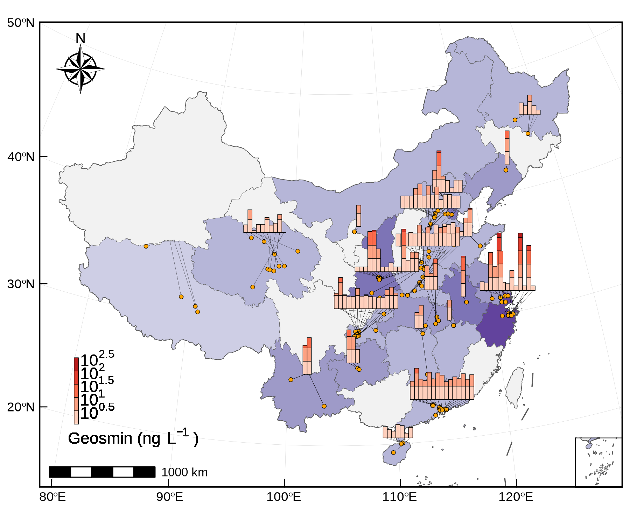
Fig. 1: Distribution of geosmin in China

Seasonal and Interannual Dynamics in Yuqiao Reservoir
Sustained monitoring at the primary water intake (YQ01) revealed a recurrent bimodal annual pattern in GSM occurrence. GSM concentrations were consistently lowest during spring (April-May), with a primary peak in summer (July-August) and a secondary, more prolonged peak throughout autumn and early winter (October-December). Median July concentrations ranged from 5.2 to 12.9 ng L⁻¹ across the study period. Annual median values stabilized between 5.2 and 10.1 ng L⁻¹ from 2020-2024, significantly lower than the outlier year 2019-2020 (median = 2.5 ng L⁻¹). Statistical comparison confirmed a significant difference among years (χ²(4) = 64.3, p < 0.001).
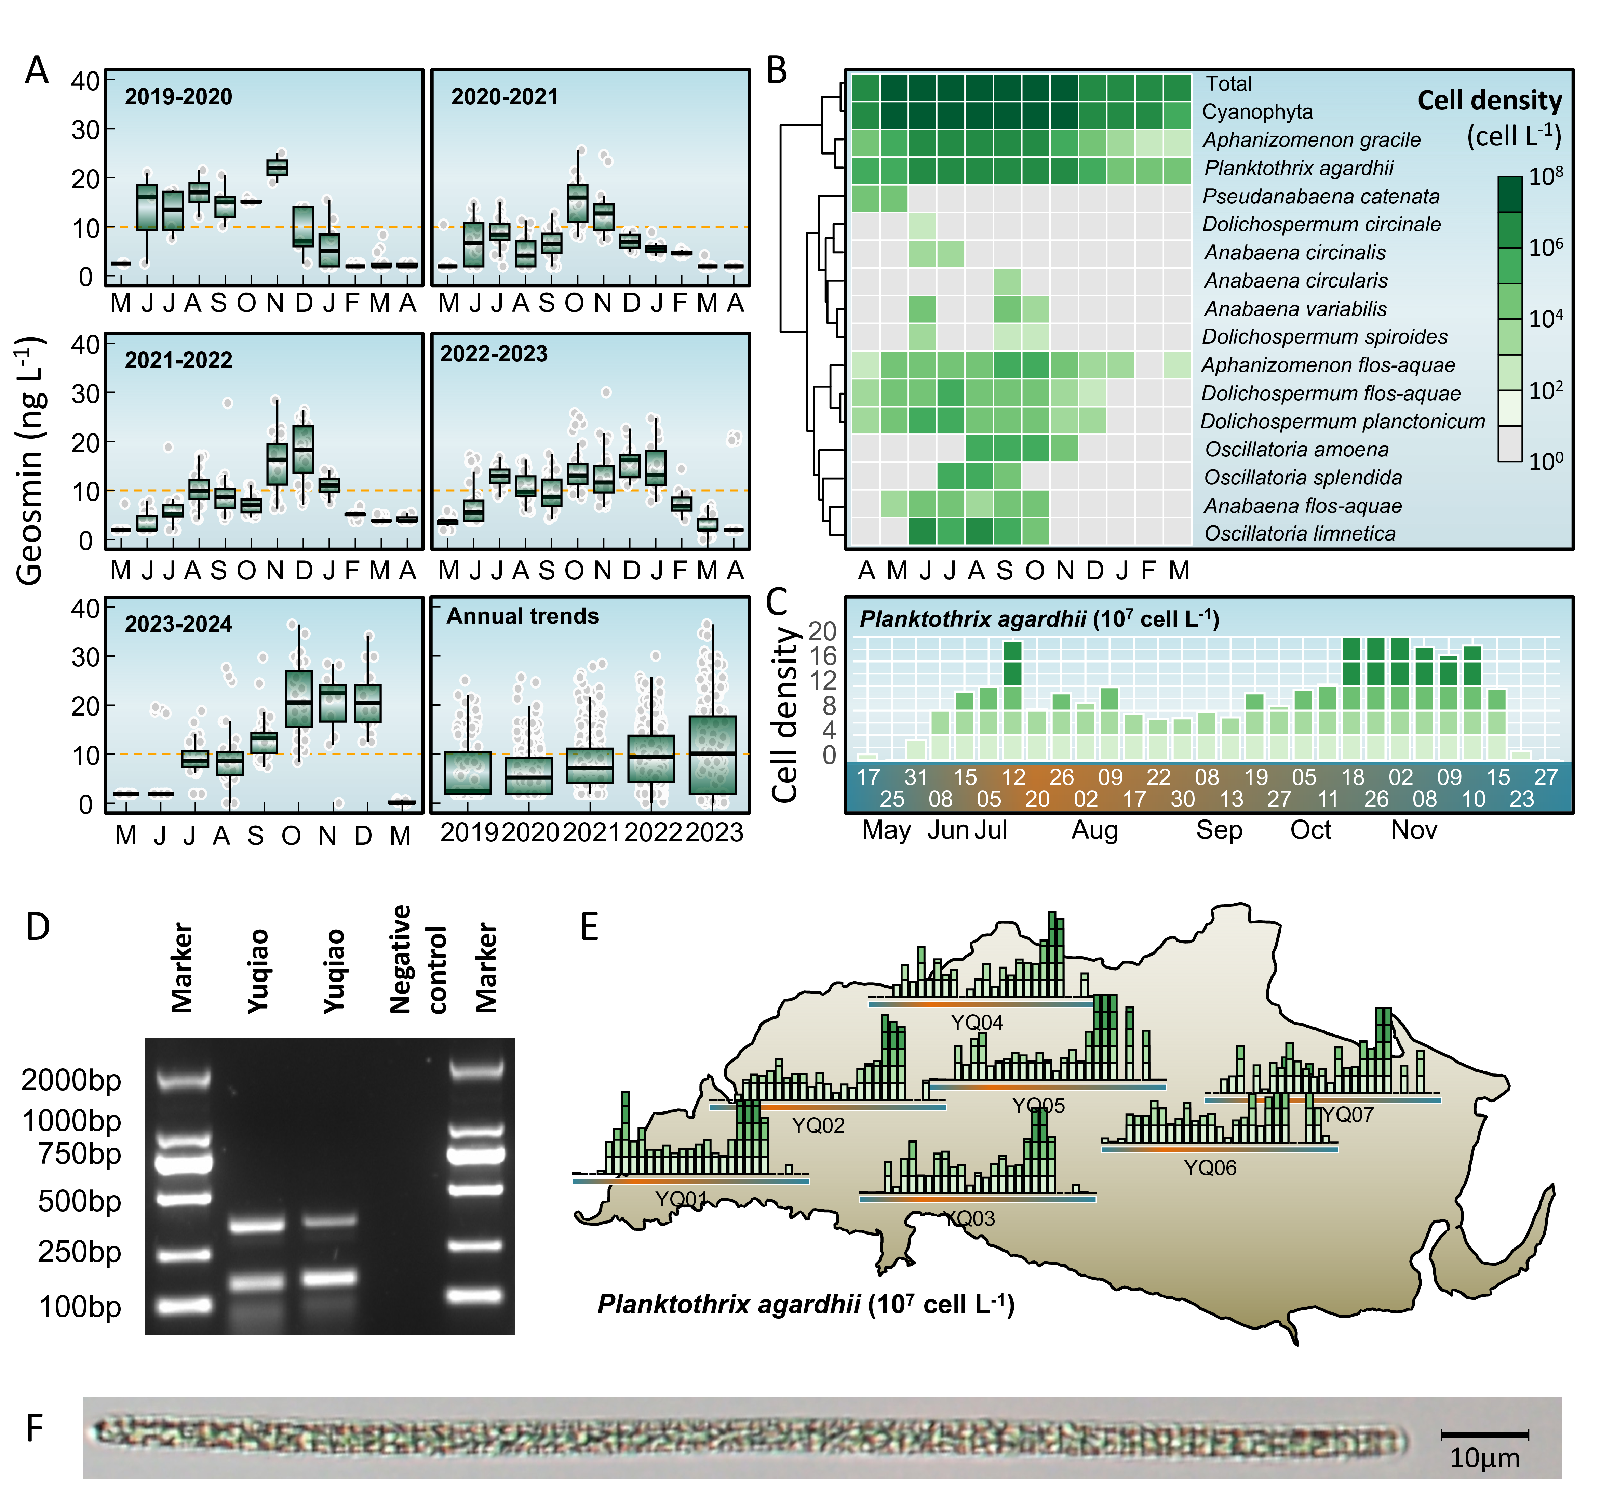
Fig. 2: Ecological mechanisms linking littoral zone dynamics to geosmin risk at the intake. (B) Heatmap showing monthly log10-transformed biomass (cells L⁻¹) of total phytoplankton, total cyanobacteria, and key geosmin-producing cyanobacterial taxa aggregated across the study period. The color gradient from white to dark green indicates increasing biomass. Hierarchical clustering of taxa (rows) reveals groups with similar seasonal patterns. Note the early appearance and sustained presence of several producers (e.g., Planktothrix agardhii, Aphanizomenon spp.) from spring onward. (b) Structural equation model (SEM) depicting the direct and indirect pathways influencing geosmin concentration at the main intake (YQ01). Arrows represent significant standardized path coefficients (p < 0.05; solid: positive, dashed: negative). The width of the arrow is proportional to the coefficient’s strength. The model highlights the central role of littoral cyanobacterial biomass as a direct driver. R² values indicate the variance explained for each endogenous variable.

Spatiotemporal Dynamics of Cyanobacterial Communities and GSM Producers
Comparative analysis revealed significant spatial decoupling in the development of potential GSM-producing cyanobacteria between littoral (YQ05) and dam (YQ01) sites. Planktothrix agardhii maintained consistently elevated biomass at YQ05, with log10-transformed monthly means reaching 7.07 during peak summer months, compared to delayed and lower abundance at YQ01. Aphanizomenon gracile exhibited early establishment at YQ05 (log10 mean = 5.34 in April), while remaining negligible at YQ01 during the same period.
High-frequency spatial monitoring during 2023 revealed that littoral sites consistently exhibited higher P. agardhii biomass compared to the dam intake. The maximum recorded biomass at littoral sites reached 40×10⁴ cells L⁻¹, while YQ01 peaked at only 29.2×10⁴ cells L⁻¹. At littoral sites, P. agardhii biomass exceeded 4×10⁴ cells L⁻¹ in 58.7% of samples and 8×10⁴ cells L⁻¹ in 29.7% of samples, compared to only 61.6% and 29.3% at YQ01, respectively.
Analysis of major biomass peaks (≥20×10⁴ cells L⁻¹) revealed a consistent spatiotemporal progression, with littoral sites reaching this threshold earlier than the dam intake. Site YQ05 first exceeded 20×10⁴ cells L⁻¹ approximately 8 days before YQ01 reached comparable levels.
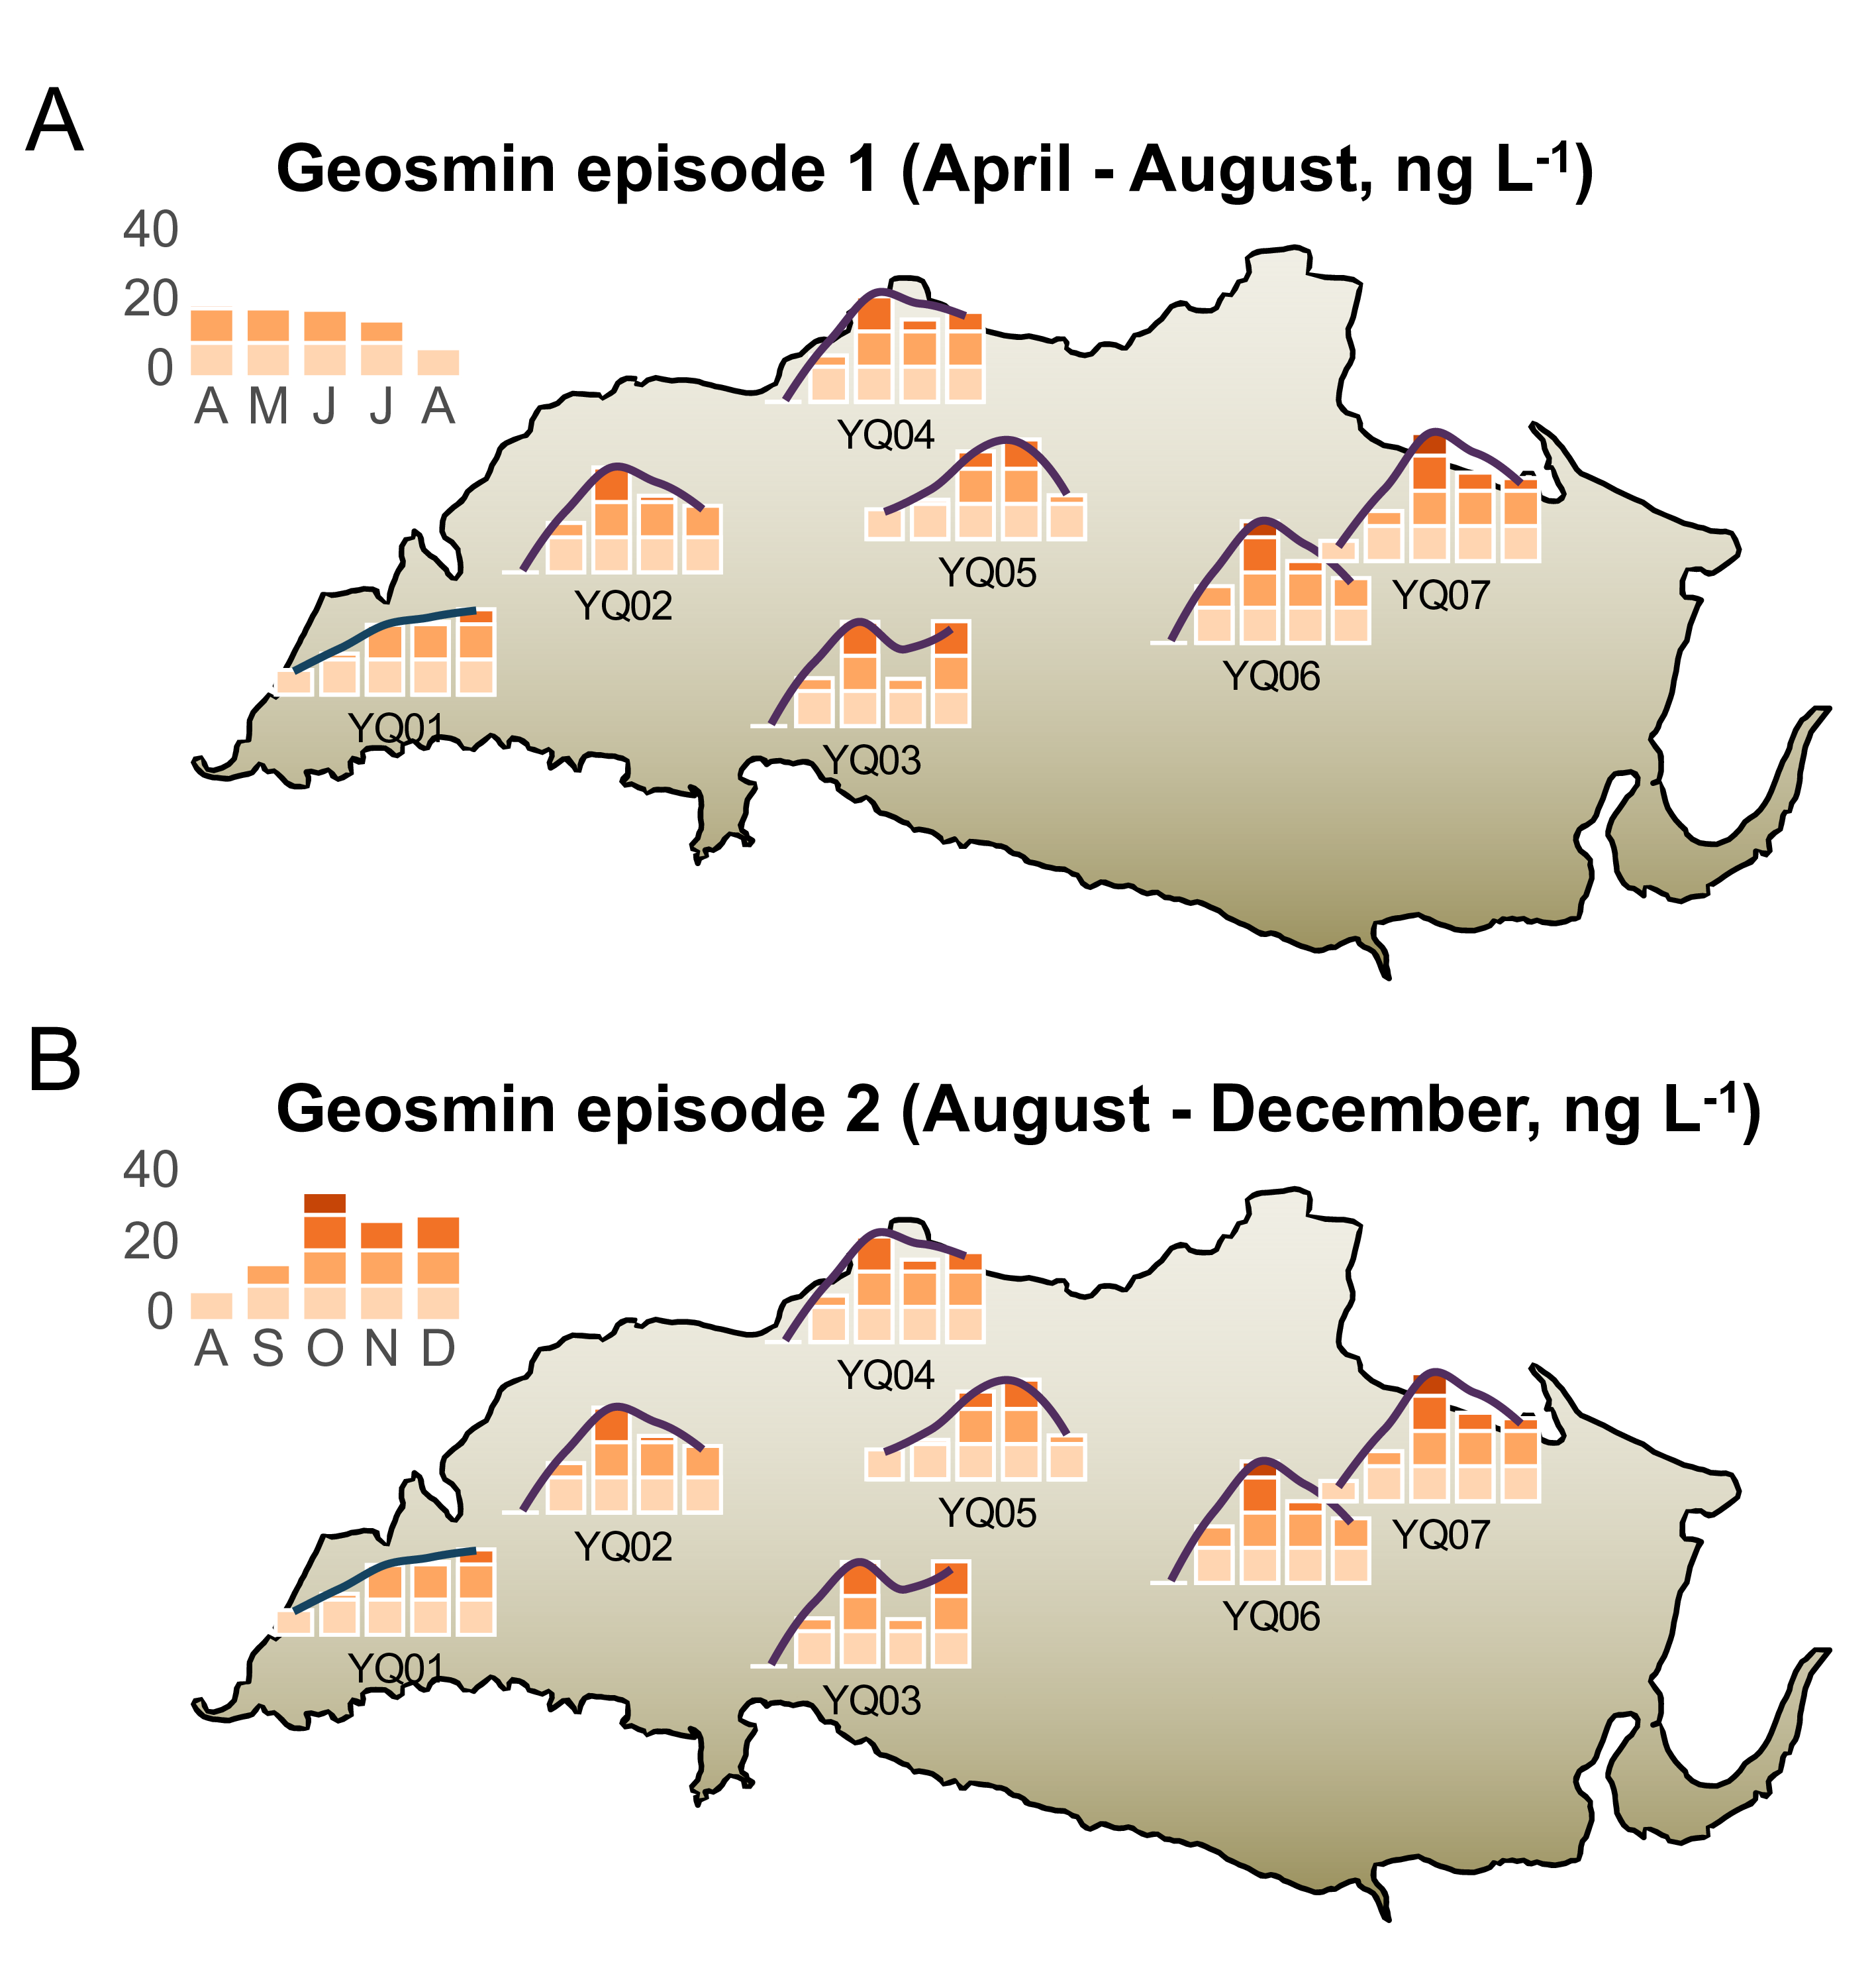
Fig. 3: Ecological mechanisms linking littoral zone dynamics to geosmin risk at the intake. (B) Heatmap showing monthly log10-transformed biomass (cells L⁻¹) of total phytoplankton, total cyanobacteria, and key geosmin-producing cyanobacterial taxa aggregated across the study period. The color gradient from white to dark green indicates increasing biomass. Hierarchical clustering of taxa (rows) reveals groups with similar seasonal patterns. Note the early appearance and sustained presence of several producers (e.g., Planktothrix agardhii, Aphanizomenon spp.) from spring onward. (b) Structural equation model (SEM) depicting the direct and indirect pathways influencing geosmin concentration at the main intake (YQ01). Arrows represent significant standardized path coefficients (p < 0.05; solid: positive, dashed: negative). The width of the arrow is proportional to the coefficient’s strength. The model highlights the central role of littoral cyanobacterial biomass as a direct driver. R² values indicate the variance explained for each endogenous variable.

Predictive Relationships and Early-Warning Lead Times
Time-lagged correlation analysis revealed distinct optimal lag periods between P. agardhii biomass and GSM concentrations. For the littoral site YQ05, the strongest correlation occurred at zero lag (R² = 0.495, p = <0.001). In contrast, for the dam intake YQ01, the optimal predictive relationship showed a 4-6 week lag, with maximum R² values at 5 weeks (R² = 0.412, p = <0.001).
Regression analysis at these optimal lags revealed distinct quantitative relationships. For YQ05 at zero lag: log₁₀(GSM) = 0.24 + 0.29×log₁₀(P. agardhii biomass) (R² = 0.495). For YQ01 at 5-week lag: log₁₀(GSM) = 0.56 + 0.2×log₁₀(P. agardhii biomass) (R² = 0.412).
The predictive power was strongest at specific biomass thresholds. When P. agardhii biomass at YQ05 exceeded 500 cells L⁻¹, the probability of GSM exceeding 10 ng L⁻¹ at YQ01 within 5 weeks was 61.9%, increasing to 87.5% when biomass exceeded 1000 cells L⁻¹.
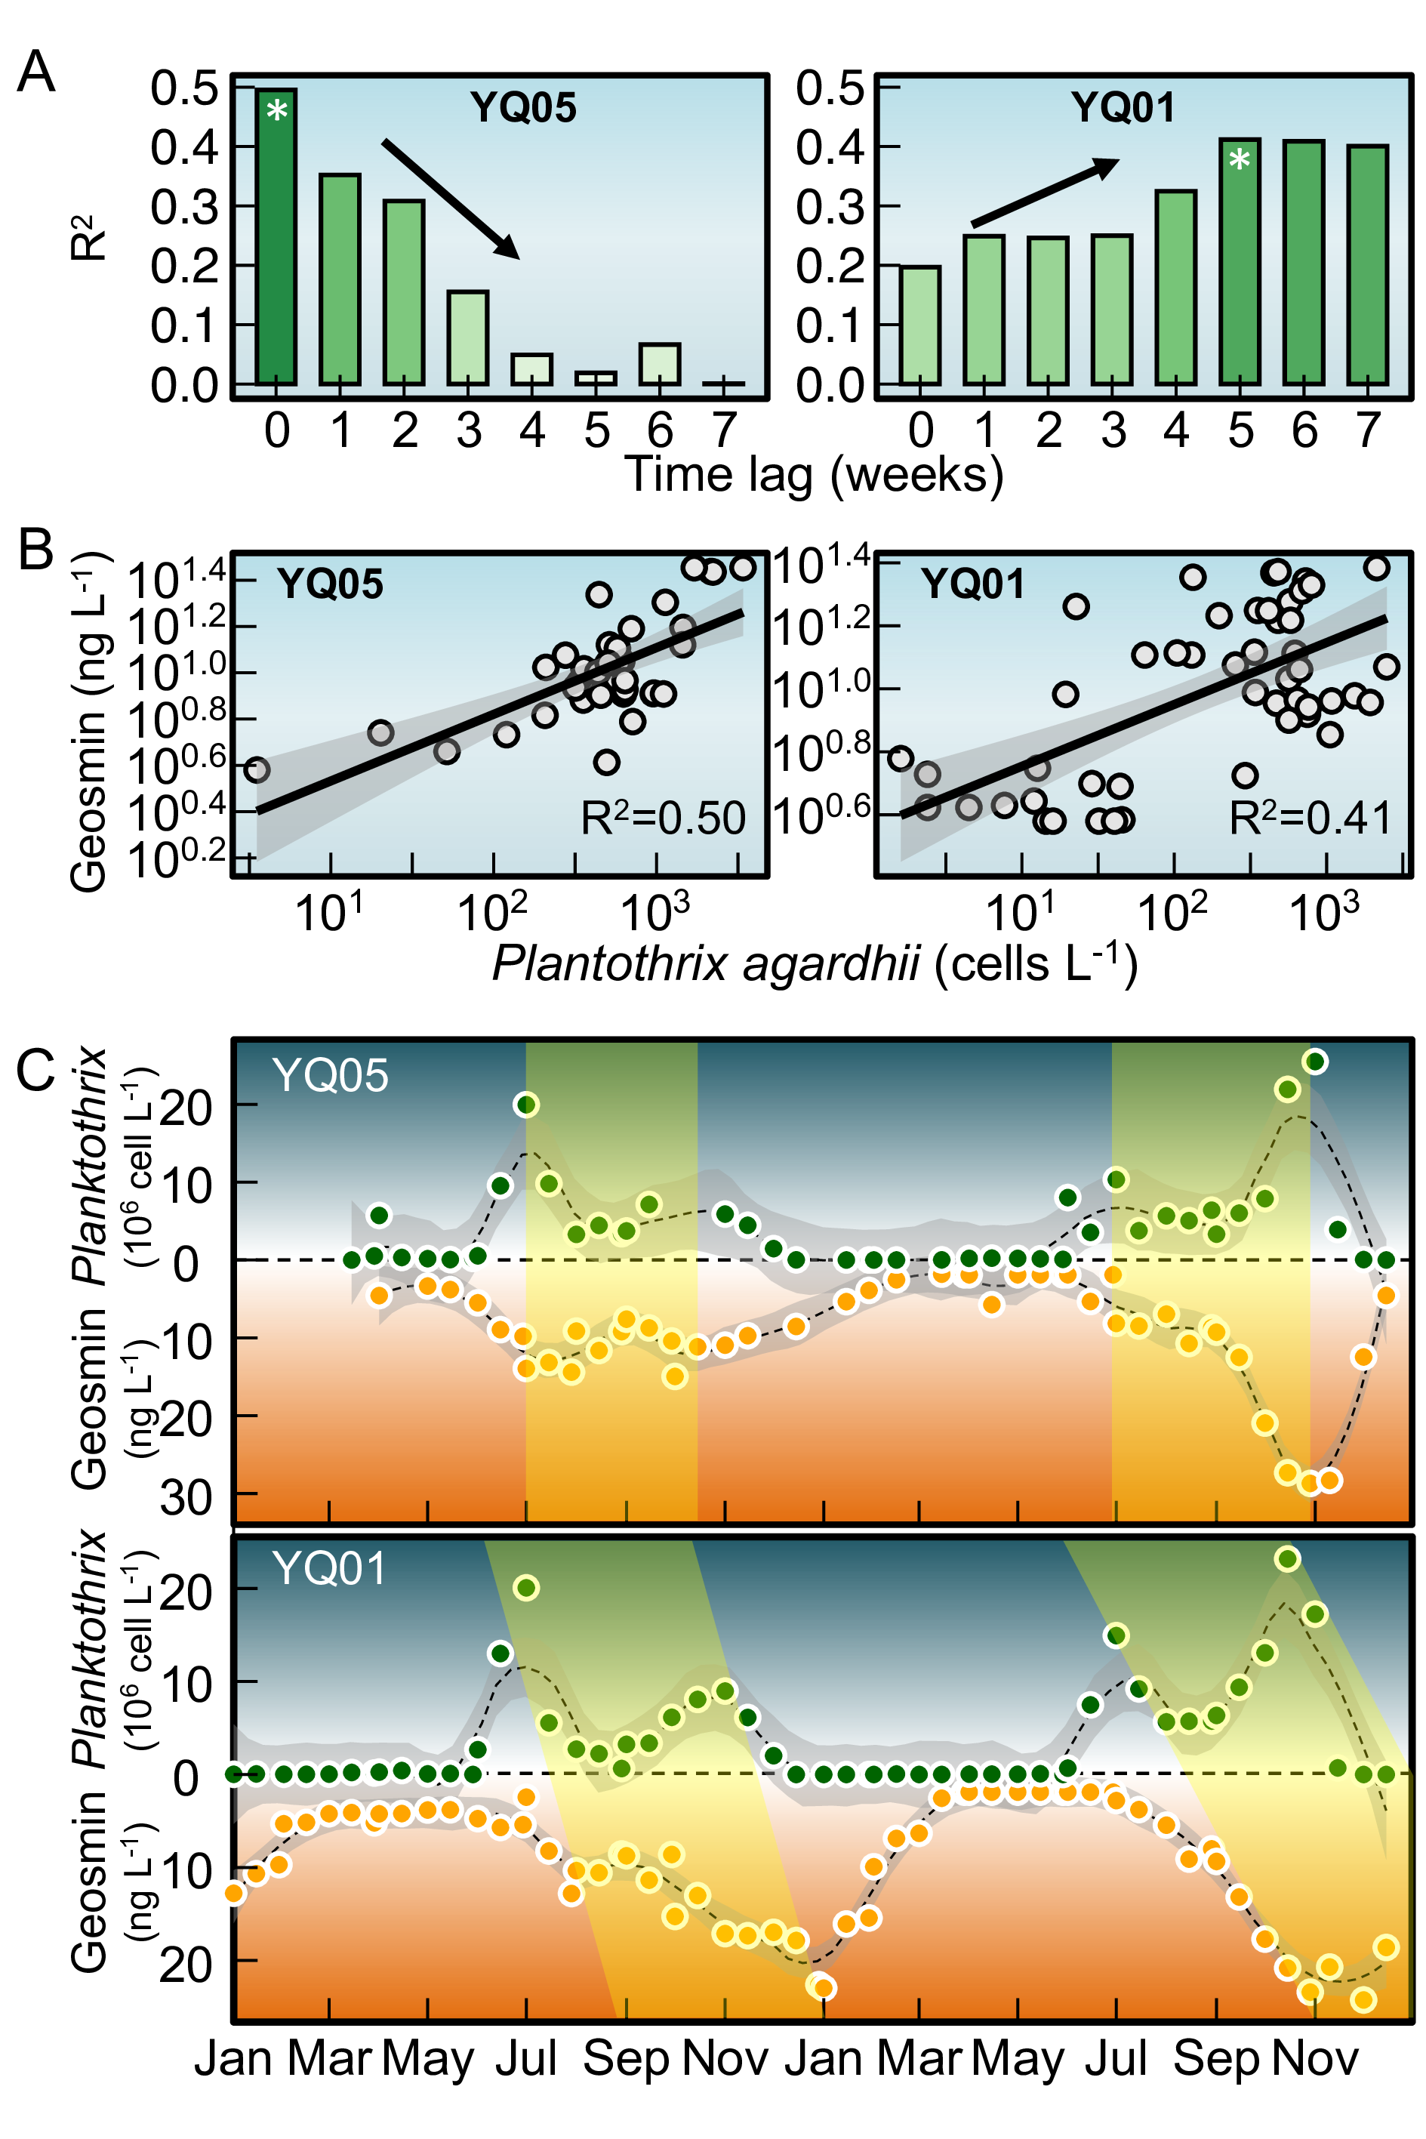
Fig. 4: Time lag between geosmin and Planktothrix in Yuqiao Reservoir

Environmental Drivers of GSM Variability
Principal component analysis revealed that the first two principal components explained 60.6% of total variance. PC1 represented a thermal-nutrient productivity axis associated with temperature (loading = 0.342), TP (0.39), and Chl-a (0.428). PC2 represented a nitrogen availability axis correlated with ammonia (loading = -0.449) and TN (0.432). GSM showed moderate positive loadings on both PC1 (0.122) and PC2 (0.229).
Site-specific analysis showed that at YQ01, GSM had a strong positive correlation with ammonia (R² = 0.035, p < 0.001), while at YQ05 the relationship was weaker (R² = 0.203). At YQ01, 90% of samples with ammonia > 0.4 mg L⁻¹ had GSM > 10 ng L⁻¹, compared to 75% at YQ05. During peak GSM events (> 30 ng L⁻¹), median ammonia concentrations were 0.19 mg L⁻¹ at YQ01 and NA mg L⁻¹ at YQ05.

Discussion

Widespread Occurrence of Geosmin as a Global Water Quality Challenge
The national-scale survey demonstrates that geosmin (GSM) contamination is a pervasive issue across China’s drinking water sources, with 12.3% of sampling sites exceeding the common odor threshold of 10 ng L⁻¹. This widespread occurrence aligns with growing global reports of GSM episodes in both temperate and subtropical regions [cite]. The spatial heterogeneity observed, with distinct high-concentration clusters in the Yangtze River Delta and eastern coastal regions, suggests regional environmental drivers—potentially including climatic conditions, land use patterns, and watershed characteristics—that warrant further investigation. GSM’s persistence through conventional water treatment processes and its extremely low odor threshold (as low as 4 ng L⁻¹for sensitive individuals) pose significant challenges to drinking water safety and consumer acceptance. These challenges directly undermine Sustainable Development Goal 6 (Clean Water and Sanitation), particularly target 6.1 focused on achieving universal access to safe and affordable drinking water. The economic implications are substantial, with water utilities worldwide investing significant resources in advanced treatment technologies and management strategies to address GSM-related consumer complaints and non-compliance incidents [cite].

Littoral Zones as Ecological Hotspots for GSM Production: The Critical Role of Filamentous Cyanobacteria
Our multi-year monitoring in Yuqiao Reservoir provides compelling evidence that littoral zones function as critical “incubation hotspots” for GSM-producing cyanobacteria, with filamentous taxa—particularly Planktothrix agardhii—demonstrating specific adaptations to littoral environments that favor their proliferation and GSM production. The ecological niche of Planktothrix and related filamentous cyanobacteria is characterized by several key traits that explain their affinity for littoral zones. First, their filamentous morphology provides competitive advantages in shallow, intermittently mixed waters by facilitating buoyancy regulation and resistance to sedimentation [cite]. This allows them to maintain optimal positioning in the water column for light harvesting, a critical factor in nutrient-rich littoral zones where light attenuation can be rapid.
Second, the low-light adaptation strategy of P. agardhii, enabled by specific pigment complexes (phycobiliproteins), allows this taxon to thrive under the variable light conditions characteristic of littoral zones, where shading from shoreline vegetation and sediment resuspension create heterogeneous light fields [cite]. This adaptation is particularly relevant given our observation that P. agardhii maintained detectable biomass in littoral zones as early as April, when light conditions are suboptimal for many phytoplankton groups.
Third, nutrient acquisition strategies of filamentous cyanobacteria, including the ability to store phosphorus and fix atmospheric nitrogen (in some taxa), provide competitive advantages in littoral environments where nutrient fluxes are dynamic and often pulsed [cite]. The stronger correlation between ammonia and GSM in littoral zones (R²= 0.365 at beach sites) versus the dam intake suggests that nitrogen availability—potentially from shoreline runoff—may be a key regulator of GSM production in these environments.
The observed spatial decoupling—with littoral sites exhibiting earlier seasonal establishment and higher biomass of GSM producers compared to the dam intake—reflects these ecological specializations. The 5-6 week lag between P. agardhii biomass peaks in littoral zones and subsequent GSM elevations at the dam intake represents not merely hydrodynamic transport, but potentially includes continued metabolic activity during transit and accumulation processes in transitional zones. This mechanistic understanding challenges conventional reservoir management paradigms that primarily focus on pelagic zones and dam areas. Our findings align with emerging literature emphasizing the disproportionate role of nearshore environments in cyanobacterial bloom initiation and metabolite production, particularly for filamentous taxa with specific adaptations to littoral conditions [cite].

Paradigm Shift in Monitoring Strategy: From Reactive to Proactive Management
Current reservoir monitoring practices, predominantly focused on dam intakes, provide insufficient warning for timely intervention against GSM episodes. Our quantitative analysis demonstrates that littoral zone monitoring offers a critical 4-6 week early-warning window—a substantial operational advantage for water utilities. The predictive relationship established between littoral P. agardhii biomass and downstream GSM concentrations (R²= 0.412 at 5-week lag) provides a scientifically robust basis for operational decision-making. When P. agardhii biomass at YQ05 exceeded 500 cells L⁻¹, the probability of GSM exceeding 10 ng L⁻¹at YQ01 within 5 weeks was 61.9%, offering clear thresholds for action. This temporal lead enables implementation of preventive measures—such as optimized reservoir operation, selective withdrawal, or targeted pre-treatment—before GSM reaches problematic levels at the intake. We propose a tiered monitoring framework integrating: (1) sentinel stations in representative littoral zones for early detection, (2) spatial gradient stations tracking cyanobacterial transport pathways, and (3) intake stations for final water quality verification. This approach represents a fundamental shift from reactive response to proactive, risk-based management, potentially reducing treatment costs and minimizing service disruptions [cite].

Study Implications and Limitations
This research provides both mechanistic insights and practical tools for managing GSM risks in reservoir-based water supplies. The identification of specific predictive relationships (e.g., the 5-week lag between littoral P. agardhii biomass and intake GSM) and quantitative thresholds offers directly applicable guidance for water utilities. The demonstrated spatial heterogeneity in cyanobacterial succession patterns underscores the need for reservoir-specific management strategies rather than one-size-fits-all approaches.
Several limitations warrant consideration. First, while the 4-6 year monitoring period captures interannual variability, longer-term data would strengthen confidence in the observed patterns, particularly in light of climate change impacts on cyanobacterial dynamics. Second, the study focused primarily on P. agardhii as the dominant GSM producer in Yuqiao Reservoir; in other systems with different cyanobacterial assemblages, the specific producer taxa and their ecological preferences may vary. Third, the predictive models, while statistically robust within the study reservoir, require validation across different reservoir types and geographical regions to assess their broader applicability. Future research should integrate molecular techniques to better characterize the diversity and metabolic potential of GSM-producing communities, incorporate high-resolution hydrodynamic modeling to elucidate transport pathways, and explore climate change scenarios to anticipate future risk patterns. Additionally, economic analyses comparing the costs of expanded monitoring against potential savings from reduced treatment interventions would strengthen the case for operational implementation.
Despite these limitations, this study advances the scientific foundation for evidence-based management of taste-and-odor episodes in drinking water reservoirs. By elucidating the critical role of littoral zones in GSM production and establishing quantitative early-warning relationships, we provide water utilities with practical tools to enhance water security and service reliability in the face of increasing cyanobacterial challenges.
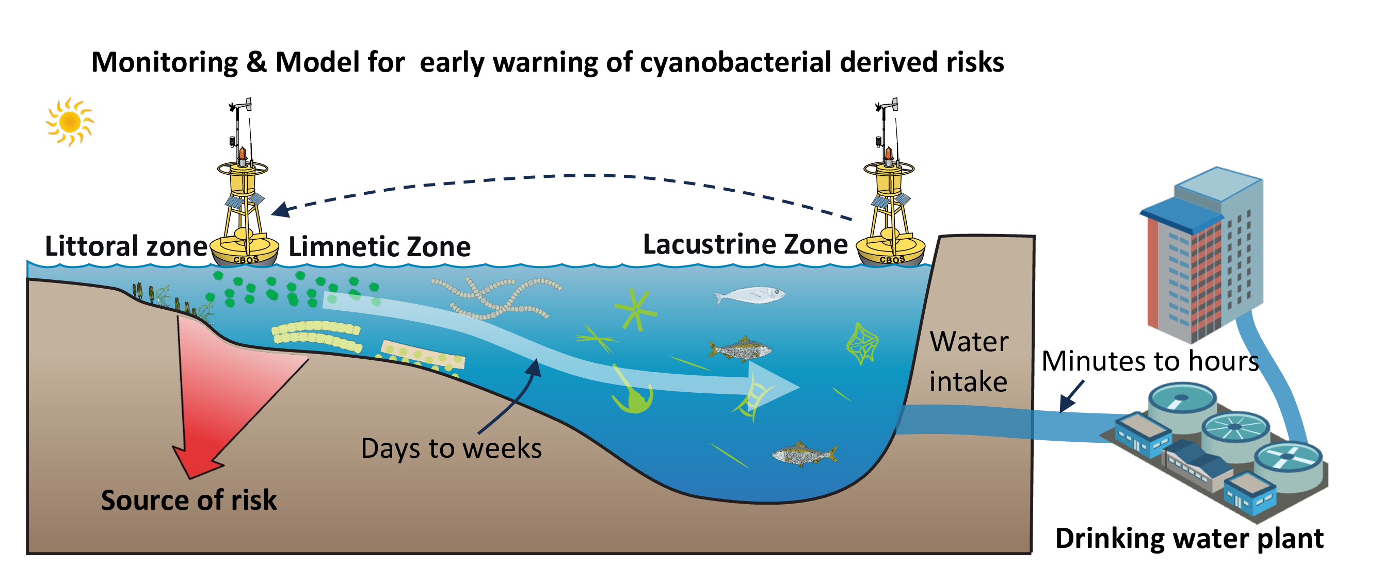
Fig. 5: sketch of geosmin producer

Conclusions

Acknowledgements
This work was financially supported by the National Natural Science Foundation of China (52030002, 51878649), and Youth Innovation Promotion Association CAS.

References
Ai, Y., Wu, Y., Su, M., Gui, Y., Du, Y., Fang, J., Cao, T., Yang, M., 2025. Cyanobacterial crowding-out effects on metabolite partitioning: Modeling 2-methylisoborneol (MIB) release dynamics and implications. Journal of Hazardous Materials 140118. https://doi.org/https://doi.org/10.1016/j.jhazmat.2025.140118
Asato, Y., 2003. Toward an understanding of cell growth and the cell division cycle of unicellular photoautotrophic cyanobacteria. Cellular and Molecular Life Sciences (CMLS) 60, 663–687. https://doi.org/10.1007/s00018-003-2079-y
AWWA, A.W.W.A., 2010. Algae: Source to treatment. American Water Works Association.
Bowmer, K.H., Padovan, A., Oliver, R.L., Korth, W., Ganf, G.G., 1992. Physiology of geosmin production by Anabaena Circinalis isolated from the murrumbidgee river, australia. Water Science and Technology 25, 259–267. https://doi.org/10.2166/wst.1992.0060
Burlingame, G.A., Doty, R.L., Dietrich, A.M., 2017. Humans as sensors to evaluate drinking water taste and odor: A review. Journal AWWA 109, 13–24. https://doi.org/10.5942/jawwa.2017.109.0118
Carmichael, W.W., Azevedo, S.M., An, J.S., Molica, R.J., Jochimsen, E.M., Lau, S., Rinehart, K.L., Shaw, G.R., Eaglesham, G.K., 2001. Human fatalities from cyanobacteria: Chemical and biological evidence for cyanotoxins. Environmental Health Perspectives 109, 663–668. https://doi.org/10.1289/ehp.01109663
Cefalì, M.E., Cebrian, E., Chappuis, E., Pinedo, S., Terradas, M., Mariani, S., Ballesteros, E., 2016. Life on the boundary: Environmental factors as drivers of habitat distribution in the littoral zone. Estuarine, Coastal and Shelf Science 172, 81–92. https://doi.org/10.1016/j.ecss.2016.01.043
Cerón-Vivas, A., Villamizar León, M.P., Cajigas, Á.A., 2022. Geosmin and 2-methylisoborneol removal in drinking water treatment. Water Practice and Technology 18, 159–167. https://doi.org/10.2166/wpt.2022.167
Dordoni, M., Zappalà, P., Barth, J.A.C., 2023. A preliminary global hydrochemical comparison of lakes and reservoirs. Frontiers in Water 5. https://doi.org/10.3389/frwa.2023.1084050
Feng, L., Dai, Y., Hou, X., Xu, Y., Liu, J., Zheng, C., 2021. Concerns about phytoplankton bloom trends in global lakes. Nature 590, E35–E47. https://doi.org/10.1038/s41586-021-03254-3
Heisler, J., Glibert, P.M., Burkholder, J.M., Anderson, D.M., Cochlan, W., Dennison, W.C., Dortch, Q., Gobler, C.J., Heil, C.A., Humphries, E., Lewitus, A., Magnien, R., Marshall, H.G., Sellner, K., Stockwell, D.A., Stoecker, D.K., Suddleson, M., 2008. Eutrophication and harmful algal blooms: A scientific consensus. Harmful Algae 8, 3–13. https://doi.org/10.1016/j.hal.2008.08.006
Huisman, J., Codd, G.A., Paerl, H.W., Ibelings, B.W., Verspagen, J.M.H., Visser, P.M., 2018. Cyanobacterial blooms. Nature Reviews Microbiology 16, 471–483. https://doi.org/10.1038/s41579-018-0040-1
Jüttner, F., Watson, S.B., 2007. Biochemical and ecological control of geosmin and 2-methylisoborneol in source waters. Applied and Environmental Microbiology 73, 4395–4406. https://doi.org/10.1128/aem.02250-06
Kosten, S., Huszar, V.L.M., Bécares, E., Costa, L.S., Donk, E. van, Hansson, L., Jeppesen, E., Kruk, C., Lacerot, G., Mazzeo, N., De Meester, L., Moss, B., Lürling, M., Nõges, T., Romo, S., Scheffer, M., 2011. Warmer climates boost cyanobacterial dominance in shallow lakes. Global Change Biology 18, 118–126. https://doi.org/10.1111/j.1365-2486.2011.02488.x
LEFLAIVE, J., TEN‐HAGE, L., 2007. Algal and cyanobacterial secondary metabolites in freshwaters: A comparison of allelopathic compounds and toxins. Freshwater Biology 52, 199–214. https://doi.org/10.1111/j.1365-2427.2006.01689.x
Li, Z., Yu, J., Yang, M., Zhang, J., Burch, M.D., Han, W., 2010. Cyanobacterial population and harmful metabolites dynamics during a bloom in yanghe reservoir, north China. Harmful Algae 9, 481–488. https://doi.org/10.1016/j.hal.2010.03.003
Lin, T.-F., Watson, S., Suffet, I.H.M., 2018. Taste and odour in source and drinking water: Causes, controls, and consequences. IWA Publishing.
Martinez i Quer, A., Larsson, Y., Johansen, A., Arias, C.A., Carvalho, P.N., 2024. Cyanobacterial blooms in surface waters – nature-based solutions, cyanotoxins and their biotransformation products. Water Research 251, 121122. https://doi.org/10.1016/j.watres.2024.121122
Mehnert, G., Leunert, F., Cires, S., Johnk, K.D., Rucker, J., Nixdorf, B., Wiedner, C., 2010. Competitiveness of invasive and native cyanobacteria from temperate freshwaters under various light and temperature conditions. Journal of Plankton Research 32, 1009–1021. https://doi.org/10.1093/plankt/fbq033
Merel, S., Walker, D., Chicana, R., Snyder, S., Baurès, E., Thomas, O., 2013. State of knowledge and concerns on cyanobacterial blooms and cyanotoxins. Environment International 59, 303–327. https://doi.org/10.1016/j.envint.2013.06.013
Mustapha, S., Tijani, J.O., Ndamitso, M.M., Abdulkareem, A.S., Shuaib, D.T., Mohammed, A.K., 2021. A critical review on geosmin and 2-methylisoborneol in water: Sources, effects, detection, and removal techniques. Environmental Monitoring and Assessment 193, 204. https://doi.org/10.1007/s10661-021-08980-9
O’neil, J.m., Davis, T.w., Burford, M.a., Gobler, C.j., 2012. The rise of harmful cyanobacteria blooms: The potential roles of eutrophication and climate change. Harmful Algae 14, 313–334. https://doi.org/10.1016/j.hal.2011.10.027
Paerl, H.W., Fulton, R.S., Moisander, P.H., Dyble, J., 2001. Harmful freshwater algal blooms, with an emphasis on cyanobacteria. The Scientific World Journal 1, 76–113. https://doi.org/10.1100/tsw.2001.16
Paerl, H.W., Paul, V.J., 2012. Climate change: Links to global expansion of harmful cyanobacteria. Water Research 46, 1349–1363. https://doi.org/10.1016/j.watres.2011.08.002
Paerl, H.W., Xu, H., Mccarthy, M.J., Zhu, G., Qin, B., Li, Y., Gardner, W.S., 2011. Controlling harmful cyanobacterial blooms in a hyper-eutrophic lake (lake taihu, China): The need for a dual nutrient (n & p) management strategy. Water Research 45, 1973–1983. https://doi.org/10.1016/j.watres.2010.09.018
Plaas, H.E., Paerl, H.W., 2020. Toxic cyanobacteria: A growing threat to water and air quality. Environmental Science &amp; Technology 55, 44–64. https://doi.org/10.1021/acs.est.0c06653
Qiu, P., Zhang, Y., Mi, W., Song, G., Bi, Y., 2023. Producers and drivers of odor compounds in a large drinking-water source. Frontiers in Ecology and Evolution 11. https://doi.org/10.3389/fevo.2023.1216567
Reinl, K.L., Harris, T.D., Elfferich, I., Coker, A., Zhan, Q., Domis, L.N.D.S., Morales-Williams, A.M., Bhattacharya, R., Grossart, H.-P., North, R.L., Sweetman, J.N., 2022. The role of organic nutrients in structuring freshwater phytoplankton communities in a rapidly changing world. Water Research 219, 118573. https://doi.org/10.1016/j.watres.2022.118573
Rousso, B.Z., Bertone, E., Stewart, R., Hamilton, D.P., 2020. A systematic literature review of forecasting and predictive models for cyanobacteria blooms in freshwater lakes. Water Research 182, 115959. https://doi.org/10.1016/j.watres.2020.115959
Singh, S., Kate, B.N., Banerjee, U.C., 2005. Bioactive compounds from cyanobacteria and microalgae: An overview. Critical Reviews in Biotechnology 25, 73–95. https://doi.org/10.1080/07388550500248498
Srinivasan, R., Sorial, G.A., 2011. Treatment of taste and odor causing compounds 2-methyl isoborneol and geosmin in drinking water: A critical review. Journal of Environmental Sciences 23, 1–13. https://doi.org/10.1016/s1001-0742(10)60367-1
Su, M., Yu, J., Zhang, J., Chen, H., An, W., Vogt, R.D., Andersen, T., Jia, D., Wang, J., Yang, M., 2015. MIB-producing cyanobacteria (Planktothrix sp.) in a drinking water reservoir: Distribution and odor producing potential. Water Research 68, 444–453. https://doi.org/10.1016/j.watres.2014.09.038
Su, M., Zhu, Y., Jia, Z., Liu, T., Yu, J., Burch, M., Yang, M., 2021. Identification of MIB producers and odor risk assessment using routine data: A case study of an estuary drinking water reservoir. Water Research 192, 116848. https://doi.org/10.1016/j.watres.2021.116848
Sun, D., Yu, J., Yang, M., An, W., Zhao, Y., Lu, N., Yuan, S., Zhang, D., 2014. Occurrence of odor problems in drinking water of major cities across China. Frontiers of Environmental Science & Engineering 8, 411–416. https://doi.org/10.1007/s11783-013-0577-1
Thornton, K.W., 1984. REGIONAL COMPARISONS OF LAKES AND RESERVOIRS: GEOLOGY, CLIMATOLOGY, AND MORPHOLOGY. Lake and Reservoir Management 1, 261–265. https://doi.org/10.1080/07438148409354521
Uwins, H.K., Teasdale, P., Stratton, H., 2007. A case study investigating the occurrence of geosmin and 2-methylisoborneol (MIB) in the surface waters of the hinze dam, gold coast, australia. Water Science and Technology 55, 231–238. https://doi.org/10.2166/wst.2007.184
Watson, S.B., 2003. Cyanobacterial and eukaryotic algal odour compounds: Signals or by-products? A review of their biological activity. Phycologia 42, 332–350. https://doi.org/10.2216/i0031-8884-42-4-332.1
Woolway, R.I., Kraemer, B.M., Lenters, J.D., Merchant, C.J., O’Reilly, C.M., Sharma, S., 2020. Global lake responses to climate change. Nature Reviews Earth &amp; Environment 1, 388–403. https://doi.org/10.1038/s43017-020-0067-5
Wu, T., Zhu, G., Wang, Z., Zhu, M., Xu, H., 2022. Seasonal dynamics of odor compounds concentration driven by phytoplankton succession in a subtropical drinking water reservoir, southeast China. Journal of Hazardous Materials 425, 128056. https://doi.org/10.1016/j.jhazmat.2021.128056
Xu, H., Paerl, H.W., Qin, B., Zhu, G., Gaoa, G., 2009. Nitrogen and phosphorus inputs control phytoplankton growth in eutrophic Lake Taihu, China. Limnology and Oceanography 55, 420–432. https://doi.org/10.4319/lo.2010.55.1.0420
Yang, M., Yu, J., Li, Z., Guo, Z., Burch, M., Lin, T., 2008. Taihu Lake not to blame for Wuxi’s Woes. Science 319, 158. https://doi.org/10.1126/science.319.5860.158a
Zamyadi, A., Henderson, R., Stuetz, R., Hofmann, R., Ho, L., Newcombe, G., 2015. Fate of geosmin and 2-methylisoborneol in full-scale water treatment plants. Water Research 83, 171–183. https://doi.org/10.1016/j.watres.2015.06.038
Zhang, Y., Whalen, J.K., Cai, C., Shan, K., Zhou, H., 2023. Harmful cyanobacteria-diatom/dinoflagellate blooms and their cyanotoxins in freshwaters: A nonnegligible chronic health and ecological hazard. Water Research 233, 119807. https://doi.org/10.1016/j.watres.2023.119807
Zohary, T., Gasith, A., 2014. The littoral zone, in: Lake Kinneret. Springer Netherlands, pp. 517–532. https://doi.org/10.1007/978-94-017-8944-8_29

