Integrating littoral zone odor dynamics into early warning and intervention systems for drinking water reservoirs
Yuying Gui^{b,a,#}, Tengxin Cao^{b,c,#}, Ming Su ^{ID,b,c,*}, Yufan Ai^{b,c}, Yingjie Li^{b,c}, and Min Yang^{b,c}
# These authors contributed equally to this work.
ª College of Environmental Science and Engineering, Ocean University of China, Qingdao 266100, China.
^{b} Key Laboratory of Environmental Aquatic Chemistry, State Key Laboratory of Regional Environment and Sustainability, Research Center for Eco-Environmental Sciences, Chinese Academy of Sciences, Beijing 100085, China.
^{c} University of Chinese Academy of Sciences, Beijing 100049, China.
* Corresponding to: Ming Su (mingsu@rcees.ac.cn)

Abstract
Cyanobacterial blooms threaten drinking water safety through the production of taste-and-odor compounds such as geosmin. However, the spatiotemporal mechanisms linking bloom dynamics to odor episodes in reservoirs—critical drinking water sources—remain poorly quantified, hindering effective management. This study integrated a national-scale survey with a five-year, high-frequency monitoring program in Yuqiao Reservoir, a major water source in northern China. Nationally, geosmin was detected in 188 of 214 sites, with 14% exceeding the 10 ng L⁻¹odor threshold, confirming its widespread occurrence. In Yuqiao Reservoir, Planktothrix agardhii was identified as the dominant geosmin producer. A pronounced spatiotemporal decoupling was observed: littoral zones acted as production hotspots, with P. agardhii biomass peaking 8 days earlier than at the dam intake. Time-lagged correlation revealed that littoral biomass predicted intake geosmin with a 5-week lead time (R²= 0.412). Ammonia was a key driver, showing the strongest correlation with geosmin in littoral zones (R²= 0.365). We propose a conceptual transport model and a tiered monitoring framework that shifts focus from reactive intake sampling to proactive sentinel stations in littoral zones. This approach provides a critical early-warning window, enabling preventive measures to safeguard drinking water quality against geosmin episodes.

Introduction
The increasing frequency and intensity of harmful cyanobacterial blooms (CyanoHABs) in surface waters, driven by climate change and intensified anthropogenic pressures, pose a critical and escalating global threat to water security (Feng et al., 2021; Heisler et al., 2008; Huisman et al., 2018; O’neil et al., 2012; Paerl et al., 2001; Paerl and Paul, 2012; Woolway et al., 2020). While substantial research has focused on eutrophication-driven bloom mechanisms and risk assessment in shallow lakes (Kosten et al., 2011; Martinez i Quer et al., 2024; Paerl et al., 2011; Reinl et al., 2022; Rousso et al., 2020; Xu et al., 2009; Zhang et al., 2023), studies on reservoir systems—which constitute a primary source of global drinking water—remain disproportionately scarce. This significant knowledge gap carries critical implications, as CyanoHABs directly threaten drinking water safety through the production of toxins (Carmichael et al., 2001; LEFLAIVE and TEN‐HAGE, 2007; Merel et al., 2013; Plaas and Paerl, 2020) and taste-and-odor (T&O) compounds (Burlingame et al., 2017; Lin et al., 2018; Su et al., 2015; Yang et al., 2008), impacting both human health and water utility. For example, nearly half of China’s source-water reservoirs experience recurrent algal-derived T&O episodes (Sun et al., 2014). Unlike chemical contaminants, cyanobacterial populations can undergo exponential growth under suitable conditions (Asato, 2003; Mehnert et al., 2010), rapidly releasing metabolites (Ai et al., 2025; LEFLAIVE and TEN‐HAGE, 2007; Singh et al., 2005) that often exceed the response capacity of conventional water treatment facilities (Cerón-Vivas et al., 2022; Mustapha et al., 2021; Srinivasan and Sorial, 2011), leading to widespread drinking water quality incidents (Li et al., 2010; Yang et al., 2008).
Effectively managing CyanoHABs in reservoirs presents distinct and formidable challenges. Compared to natural lakes, reservoirs display greater spatial and hydraulic complexity, resulting in less stable and predictable ecological regimes (Dordoni et al., 2023; Thornton, 1984). Conventional reservoir monitoring strategies, typically confined to sampling near dam intakes, fail to capture the spatially heterogeneous distribution of algal biomass and metabolites. Furthermore, the short flow time from intake to drinking water treatment plant—often on the scale of minutes to hours—provides an inadequate operational window for timely intervention. In contrast, littoral zones in reservoirs are characterized by markedly different environmental conditions, such as enhanced nutrient availability and light penetration (Cefalì et al., 2016; Zohary and Gasith, 2014), which may promote early cyanobacterial proliferation. Despite their potential significance as critical sentinel sites, these areas remain critically under-monitored. Consequently, the mechanistic linkages between littoral zone CyanoHAB dynamics and downstream water quality at intakes are poorly understood and quantified.
Geosmin and 2-methylisoborneol (MIB) are among the most concerning terpenoid T&O compounds produced by cyanobacteria (Jüttner and Watson, 2007; Watson, 2003). Their low molecular weight and chemical nature allow them to penetrate conventional water treatment barriers and persist into tap water (Lin et al., 2018; Zamyadi et al., 2015), directly impairing drinking water quality and consumer acceptance. In China, MIB-related episodes have been widely reported and studied, with corresponding mitigation strategies developed (Su et al., 2021, 2015). In contrast, geosmin incidents have historically been more prevalent in the Southern Hemisphere (Bowmer et al., 1992; Uwins et al., 2007) but are increasingly reported across Northern Hemisphere water bodies (Qiu et al., 2023; Wu et al., 2022). Notably, geosmin-producing cyanobacterial taxa are phylogenetically more diverse than those associated with MIB (AWWA, 2010), complicating source-tracking and management efforts. A national survey conducted as part of this study confirms that geosmin is a widespread contaminant across China’s drinking water sources, establishing the broad relevance of the reservoir-specific mechanisms investigated here.
To address these emerging challenges, we conducted a multi-year, spatially resolved monitoring study in Yuqiao Reservoir—a major drinking water source for Tianjin, China, with a documented history of geosmin episodes. Integrating water quality analysis, molecular sequencing of algal communities, and advanced statistical modeling, we demonstrate significant spatial decoupling of cyanobacterial assemblages and T&O compounds between littoral zones and the dam area. We further identify key odor-producing taxa and establish that littoral zone cyanobacterial dynamics exert a decisive influence on T&O levels at the intake. These findings position the littoral zone as a critical sentinel for early warning and a strategic target for proactive intervention. This study advances a scientifically informed monitoring framework, shifting the paradigm from reactive response to preventive management of CyanoHAB-derived T&O risks in reservoir-based water supplies.

Materials and methods

Study area and sampling design
National-scale geosmin survey. This study compiles geosmin concentration data from drinking water sources across China, representing one of the most extensive national surveys of this odorant to date. The dataset integrates our own multi-year monitoring results with high-quality geosmin measurements. Besides, we have also included a study with 33 reservoirs in Guangdong province (Zhou et al., 2024). In total, geosmin data from 214 distinct sampling sites across multiple provinces were analyzed to characterize its nationwide occurrence and spatial heterogeneity.
zhai2017disinfection
Intensive monitoring at Yuqiao Reservoir. Yuqiao Reservoir (40°00′30″–40°05′30″N, 117°22′30″–117°27′30″E) is a large, river-type reservoir (total capacity: 1.559 billion m³) and a critical drinking water source for Tianjin, China (Xu et al., 2014; Zhai et al., 2017). It has experienced persistent seasonal taste-and-odor episodes in recent years (Cai et al., 2017; Qiu et al., 2021). Reflecting its distinct bathymetry and hydrodynamic gradients, seven sampling sites (YQ01–YQ07) were established along a littoral-to-dam transect. Site YQ01, located in the deep lacustrine zone near the dam (max depth ~12 m), was sampled vertically (integrated water column). The remaining sites (YQ02–YQ07) were situated in shallower littoral and transitional zones (depth 2–4 m), where only surface water samples were collected. During the annual odor season, high-frequency sampling was conducted 2–3 times per week from 2019 to 2024. Samples for geosmin analysis, water chemistry, and phytoplankton were collected concurrently. All samples were stored at 4°C in the dark and processed within 24 hours.

Analytical methods
Geosmin analysis. Geosmin concentrations were determined using headspace solid-phase microextraction (HS-SPME) coupled with gas chromatography-mass spectrometry (GC-MS; Agilent 6890GC-5973MSD) following a well-established protocol (Su et al., 2015). The method detection limit for geosmin was 1 ng L⁻¹.
Water quality parameters. In-situ measurements of water temperature, pH, dissolved oxygen (DO), and turbidity were performed using a multiparameter sonde (EXO2, Xylem, USA). Ammonium (NH₄⁺-N), total nitrogen (TN), and total phosphorus (TP) were analyzed according to Chinese national standard methods for water quality.
Phytoplankton analysis. Phytoplankton samples were fixed with Lugol’s iodine solution (final concentration 5%). After 48-h sedimentation, samples were concentrated to 10 mL. Cell identification and enumeration were performed under an inverted microscope (Olympus BX51) using a Sedgewick–Rafter counting chamber. Biomass was expressed as cell density.

Molecular identification of geosmin-producing cyanobacteria
Water samples for molecular analysis were collected concurrently with geosmin samples. Biomass was collected on 1.2-μm polycarbonate filters (Millipore) and stored at–80°C. Total genomic DNA was extracted using the FastDNA™Spin Kit for Soil (MP Biomedicals). The geosmin synthase gene (geoA) was amplified using cyanobacterium-specific primers (Giglio et al., 2008; Su et al., 2013). Amplicons were visualized via agarose gel electrophoresis, and positive products were subjected to high-throughput sequencing. After quality filtering and primer removal, sequences were clustered into operational taxonomic units (OTUs) at 97% similarity. Representative sequences were taxonomically assigned via BLAST against public geoA databases, and a maximum-likelihood phylogenetic tree was constructed to confirm the identity of the dominant geosmin producer.

Data processing and statistical analysis
Temporal aggregation and lagged correlation. To reduce noise from irregular sampling and align different time series, all data were aggregated to weekly means. For each sampling date, the corresponding week was defined from the preceding Monday. To investigate time-lagged relationships, weekly geosmin concentrations were shifted forward by i weeks (i = 0–7) and paired with concurrent weekly mean Planktothrix agardhii biomass. For each site and lag period, a log–log linear model was fitted:
$$\log_{10}\left(G\right)=α+β\log_{10}\left(P\right)+ε \left(1\right)$$
where G is geosmin concentration (ng L⁻¹) and P is P. agardhii cell density (cells L⁻¹). To minimize the influence of background low values, only paired observations with geosmin > 2 ng L⁻¹ and positive biomass were included. A site was included in the lag analysis only if it contained≥20 valid weekly observations. The coefficient of determination (R²) was used to assess model fit. The lag period yielding the maximum R² was defined as the optimal early-warning window for that site. The significance of the regression slope was evaluated using a t-test.
Multivariate and spatial analysis. Principal component analysis (PCA) was performed on standardized geosmin and environmental variables to explore their multivariate relationships. Zone-specific regression analyses (littoral, transitional, dam) were conducted to compare the strength of the ammonia–geosmin relationship across reservoir zones. Bathymetric data from field surveys were spatially interpolated using ordinary kriging to create a continuous depth map, illustrating the gradient from shallow littoral to deep lacustrine zones.
Software. All statistical analyses and visualizations were performed in R (version 4.4.2) using packages including dplyr, lubridate, stats, and ggplot2.

Results

National survey of geosmin occurrence in drinking water sources
A nationwide survey was conducted to assess geosmin (geosmin) concentrations across China’s major drinking water sources, encompassing a total of 214 sampling sites from reservoirs and key surface water bodies in 26 provinces. geosmin was detected in 188 locations. Measured concentrations spanned over four orders of magnitude, ranging from below detection limits to a maximum of 150 ng L⁻¹, recorded at a site in Zhejiang Province. Overall, 14% of sampling sites exceeded the common odor threshold of 10 ng L⁻¹. Geospatial analysis revealed pronounced heterogeneity. Elevated geosmin levels were broadly clustered in the eastern and southern regions, including the Yangtze River Delta, Pearl River Delta, and parts of North China. In contrast, concentrations in northwestern China (e.g., Tibet, Xinjiang, Qinghai) and certain central provinces were consistently low or below detection limits, corroborating a general east-high, west-low spatial pattern. This comprehensive dataset demonstrates that geosmin is a widespread odorant affecting drinking water sources across diverse climatic and geographical zones in China.
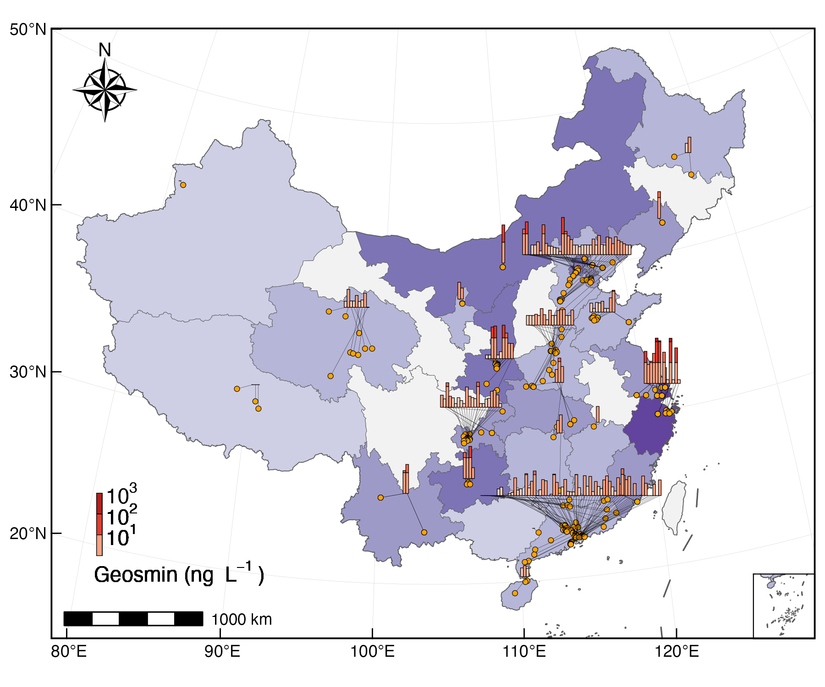
Fig. 1: A multi-scale visualization of geosmin occurrence: linking individual sampling sites to provincial-level aggregates (Provincial/regional aggregate bars (log-scale binned) connected to individual sampling sites. Beijing-Tianjin-Hebei and Jiangsu-Shanghai-Zhejiang are treated as single units to avoid spatial overlap).

Seasonal and interannual dynamics in Yuqiao Reservoir
To elucidate the temporal dynamics of geosmin occurrence, Yuqiao Reservoir (YQ, a key drinking water source in the Beijing-Tianjin-Hebei region) was selected for sustained, high-frequency monitoring at its primary water intake (site YQ01) from 2019 to 2024. The long-term record revealed a recurrent and pronounced seasonal cycle (Fig. 2A). Concentrations were consistently low (<5 ng L⁻¹) during spring (April–May), followed by a rapid increase in early summer (June) culminating in a primary peak during the warmest months (July–August). A second, broader peak persisted throughout autumn and early winter (October–December), after which levels gradually declined. The odor threshold of 10 ng L⁻¹ was frequently exceeded. Analysis of the monthly median concentrations across water years (May to April) showed that the threshold was surpassed during at least 40%* of the summer months (July–September) and 100% of the autumn/early winter months (October–December) during the monitoring period, highlighting a persistent odor risk in the warmer half of the year.
At the interannual scale (Fig. 2B, annual boxplots), geosmin concentrations exhibited a notable decreasing trend following an exceptionally high initial year. The median concentration in the 2019–2020 water year was 2.5 ng L⁻¹, substantially exceeding the threshold. Subsequently, from 2020 to 2024, annual median concentrations stabilized within a lower range of 5.2–10 ng L⁻¹. A Kruskal-Wallis test confirmed statistically significant differences among the annual datasets (χ²(4) = 64.3, p < 0.001). This trend suggests a potential shift in baseline conditions or source inputs after the initial monitoring year, though seasonal peaks remained a consistent feature of the reservoir’s annual cycle.
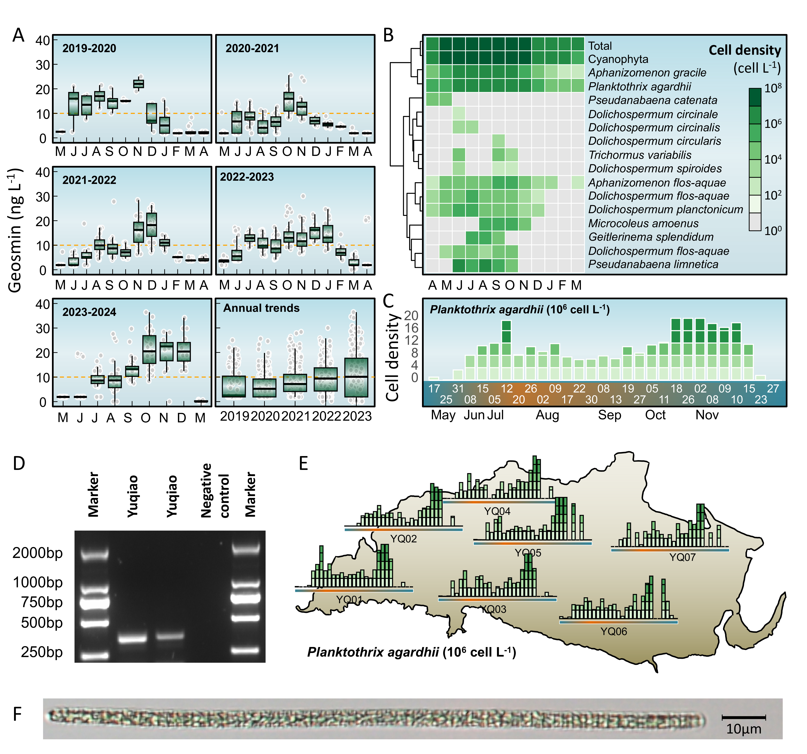
Fig. 2: Long-term dynamics of geosmin and phytoplankton community in Yuqiao Reservoir (2019–2024). (A) Seasonal and interannual variations in geosmin concentrations at the main water intake (site YQ01). (B) Heatmap showing monthly log10-transformed biomass of total phytoplankton, total cyanobacteria, and key geosmin-producing cyanobacterial genera. (C) Temporal patterns of Planktothrix agardhii biomass across sampling sites. (D) Agarose gel electrophoresis confirming the molecular identification of P. agardhii. (E) Spatial mapping of seasonal P. agardhii biomass variations at representative sampling sites overlaid on the reservoir map. (F) Microscopic image of P. agardhii filaments.

Phytoplankton community dynamics and key cyanobacterial genera
To investigate the relationship between geosmin occurrence and phytoplankton dynamics, high-resolution phytoplankton composition data from Yuqiao Reservoir (site YQ01, 2019–2024) were analyzed (Fig. 2B). The total phytoplankton biomass (expressed as log₁₀-transformed cell density) exhibited a clear seasonal pattern, with the lowest levels observed in winter (January–March, ~10⁷ cells L⁻¹) and a rapid increase beginning in spring (April). Biomass peaked during the summer months (July–September, >10⁸ cells L⁻¹), remained elevated through autumn (October–December), and then declined sharply in late winter, mirroring the general temporal trend of geosmin concentrations.
Cyanobacteria dominated the phytoplankton community throughout most of the year, contributing substantially to total biomass. Their seasonal trajectory closely followed that of total phytoplankton, with the highest cyanobacterial biomass recorded from June to October. Within the cyanobacterial assemblage, several filamentous genera known for potential geosmin production exhibited distinct seasonal successions. Planktothrix agardhii and Aphanizomenon gracile were perennial but showed clear seasonality, with biomass maxima in summer and autumn. Pseudanabaena catenata was primarily a spring (April–May) taxon. Several Dolichospermum species (including D. circinale, D. circinalis, D. flos-aquae, D. planctonicum, and D. spiroides) and Aphanizomenon flos-aquae typically emerged in late spring or early summer, proliferated during summer, and declined by late autumn. Other taxa, such as Trichormus variabilis, Dolichospermum circularis, Microcoleus amoenus, Geitlerinema splendidum, and Pseudanabaena limnetica, displayed more sporadic occurrences, often with pronounced peaks limited to specific months within the warm season (e.g., June–August).
The co-occurrence of elevated geosmin concentrations with periods of high cyanobacterial biomass, particularly during summer and autumn blooms dominated by known or putative geosmin-producing genera (e.g., Planktothrix, Aphanizomenon, Dolichospermum), suggests a strong biotic source for the observed odor episodes. The temporal succession of different cyanobacterial taxa may contribute to the characteristic bimodal (summer and autumn) geosmin peak observed in the reservoir.

Identification and spatiotemporal distribution of the primary geosmin producer
Planktothrix agardhii was identified as the dominant geosmin-producing cyanobacterium based on gene sequencing in Yuqiao Reservoir (Fig. 2D, 2F). Spatial monitoring during 2023 revealed a pronounced biomass gradient, with littoral sites (YQ03, YQ04, YQ06, YQ07) sustaining significantly higher cell densities than the central dam intake (YQ01). The maximum observed biomass reached 5.1×10⁷ cells L⁻¹ at a littoral site, compared to 2.9×10⁷ cells L⁻¹ at the dam. Elevated biomass thresholds (>2×10⁷ cells L⁻¹) were exceeded in 7% of littoral samples, respectively, but in 4% of dam samples. Temporally, P. agardhii exhibited a perennial presence with sustained warm-season biomass, contrasting with the ephemeral peaks of other cyanobacteria (Fig. 2C). Major bloom events (≥2×10⁷ cells L⁻¹) propagated from littoral zones to the dam (Fig. 2E), with sites such as YQ05 exceeding the threshold approximately 8 days before YQ01. This spatiotemporal pattern indicates littoral zones as initiation hotspots for P. agardhii proliferation, with subsequent advection likely driving geosmin peaks at the drinking water intake.
The temporal progression of major bloom events (biomass≥2×10⁷ cells L⁻¹) followed a clear spatial sequence from the littoral zone towards the dam. For instance, site YQ05 first exceeded this threshold in mid-October, approximately -8 days before the dam site (YQ01) reached comparable levels in late October. This spatiotemporal decoupling highlights the littoral zones as probable initiation hotspots for P. agardhii proliferation, with subsequent advection contributing to the geosmin peaks observed at the central water intake.

Distinct spatiotemporal patterns of two geosmin episodes
To further elucidate the spatiotemporal dynamics of geosmin (geosmin), we identified two distinct odor episodes in Yuqiao Reservoir (April–August and August–December 2023). Spatial mapping of monthly averaged geosmin concentrations at seven representative sites revealed contrasting patterns between the littoral and dam regions (Fig. 3).
During the first episode (April–August), littoral sites (YQ02, YQ03, YQ04, YQ06, YQ07) exhibited elevated concentrations in spring (April–June), with values ranging from 0 to 21.2 ng L⁻¹. These concentrations then declined by August to between 0.6 and 5.8 ng L⁻¹. In contrast, the central dam site (YQ01) and the nearby YQ05 (located close to littoral zones) showed a delayed response. Their concentrations started low in April (0 ng L⁻¹) and increased steadily, peaking in August at 8.5 ng L⁻¹.
The second episode (August–December) exhibited a reversed spatiotemporal pattern. Littoral sites experienced a sharp peak in October, with concentrations reaching 0 to 36.4 ng L⁻¹, followed by a decline to 0–29.8 ng L⁻¹ by December. Conversely, the dam site (YQ01) showed a sustained, monotonic increase from August (0 ng L⁻¹) to December (24.2 ng L⁻¹). Site YQ05, located between littoral and dam zones, exhibited an intermediate transitional pattern, with its decline beginning in November rather than October, further illustrating the spatiotemporal gradient from littoral production zones to the central reservoir.
These divergent spatiotemporal trajectories (Fig. 3) highlight a systematic decoupling: littoral zones consistently experience an earlier onset and subsequent decline during both odor episodes, while the dam region exhibits a delayed and prolonged response. This pattern likely reflects the integrated effects of initial production hotspots in the littoral zone and subsequent advective transport toward the central reservoir.
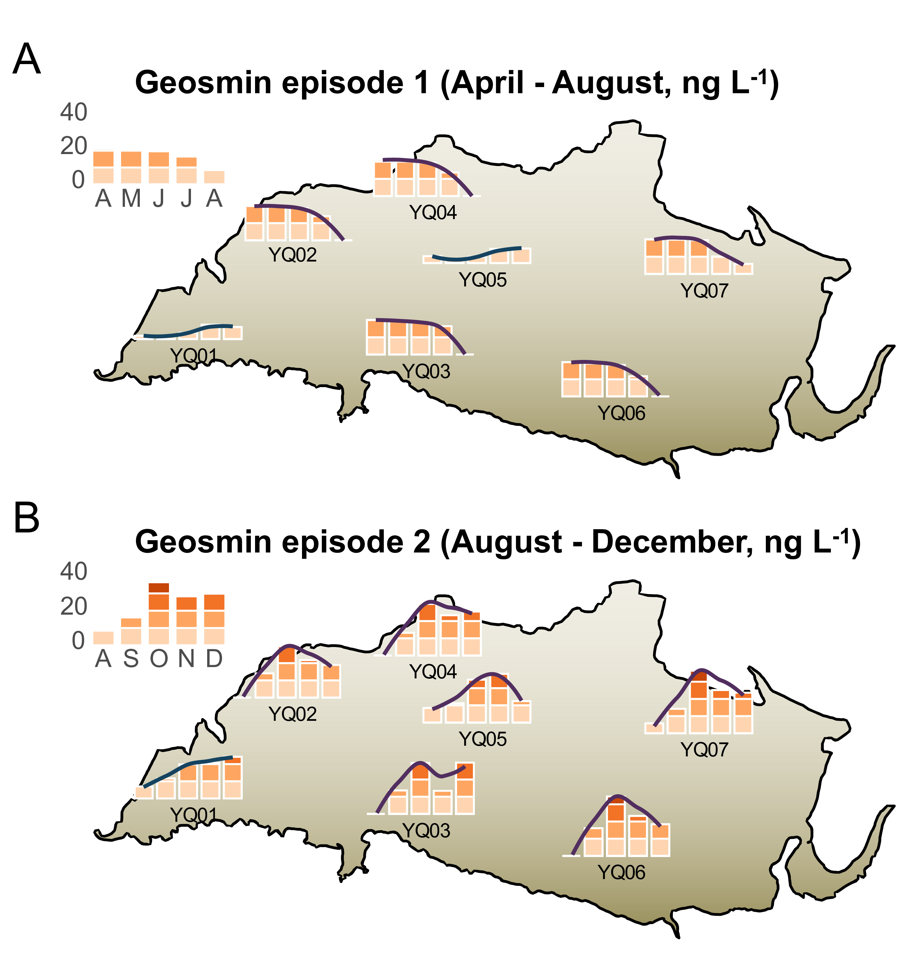
Fig. 3: Spatial mapping of monthly mean geosmin concentrations during Episode 1 (April–August, A) and Episode 2 (August–December, B) in Yuqiao Reservoir.

Predictive relationship between Planktothrix agardhii dynamics and geosmin episodes
To quantify the causal linkage between the primary producer and odor events, we performed time-lagged correlation analyses between Planktothrix agardhii biomass and geosmin (geosmin) concentrations at the near-littoral site YQ05 and the dam intake YQ01 (Fig. 4A). These sites were selected for their continuous long-term monitoring data. The analysis revealed fundamentally distinct temporal coupling patterns.
At the near-littoral site YQ05, the strongest correlation (R² = 0.5, p < 0.001) occurred at zero lag, indicating near-instantaneous geosmin production associated with local P. agardhii proliferation. The correlation coefficient decreased progressively as the lag period increased. Conversely, at the downstream dam site YQ01, the correlation was weakest at zero lag but strengthened with increasing lag time, reaching a maximum at a 5-week lag (R² = 0.41, p < 0.001). This opposite pattern demonstrates that P. agardhii biomass serves as a concurrent indicator at its production zone (YQ05) but as a leading indicator for geosmin risk at the distal water intake (YQ01).
Regression models were established at the respective optimal lag periods (Fig. 4B). For YQ05 (zero lag), the relationship was log₁₀(geosmin) = 0.24 + 0.29×log₁₀(P. agardhii biomass). For YQ01 (5-week lag), the model was log₁₀(geosmin) = 0.56 + 0.2×log₁₀(P. agardhii biomass). The steeper slope for YQ01 suggests a potential amplification effect during the transport and transformation processes from the littoral production zone to the central reservoir.
The distinct temporal phasing is visually evident in the bi-weekly time series (Fig. 4C). At YQ05, peaks in P. agardhii biomass and geosmin concentrations were closely synchronized. In contrast, at YQ01, biomass peaks consistently preceded major geosmin episodes by several weeks. For instance, the autumn biomass peak preceded the highest geosmin concentration by approximately 6.7 weeks. This consistent lag provides a critical early-warning window. When P. agardhii biomass at YQ05 exceeded 5.0×10⁷ cells L⁻¹, geosmin at YQ01 subsequently exceeded the 10 ng L⁻¹ odor threshold within 4-6 weeks in 61.9% of cases. These quantified relationships underscore the utility of near-littoral cyanobacterial monitoring for forecasting odor risks at the drinking water intake.
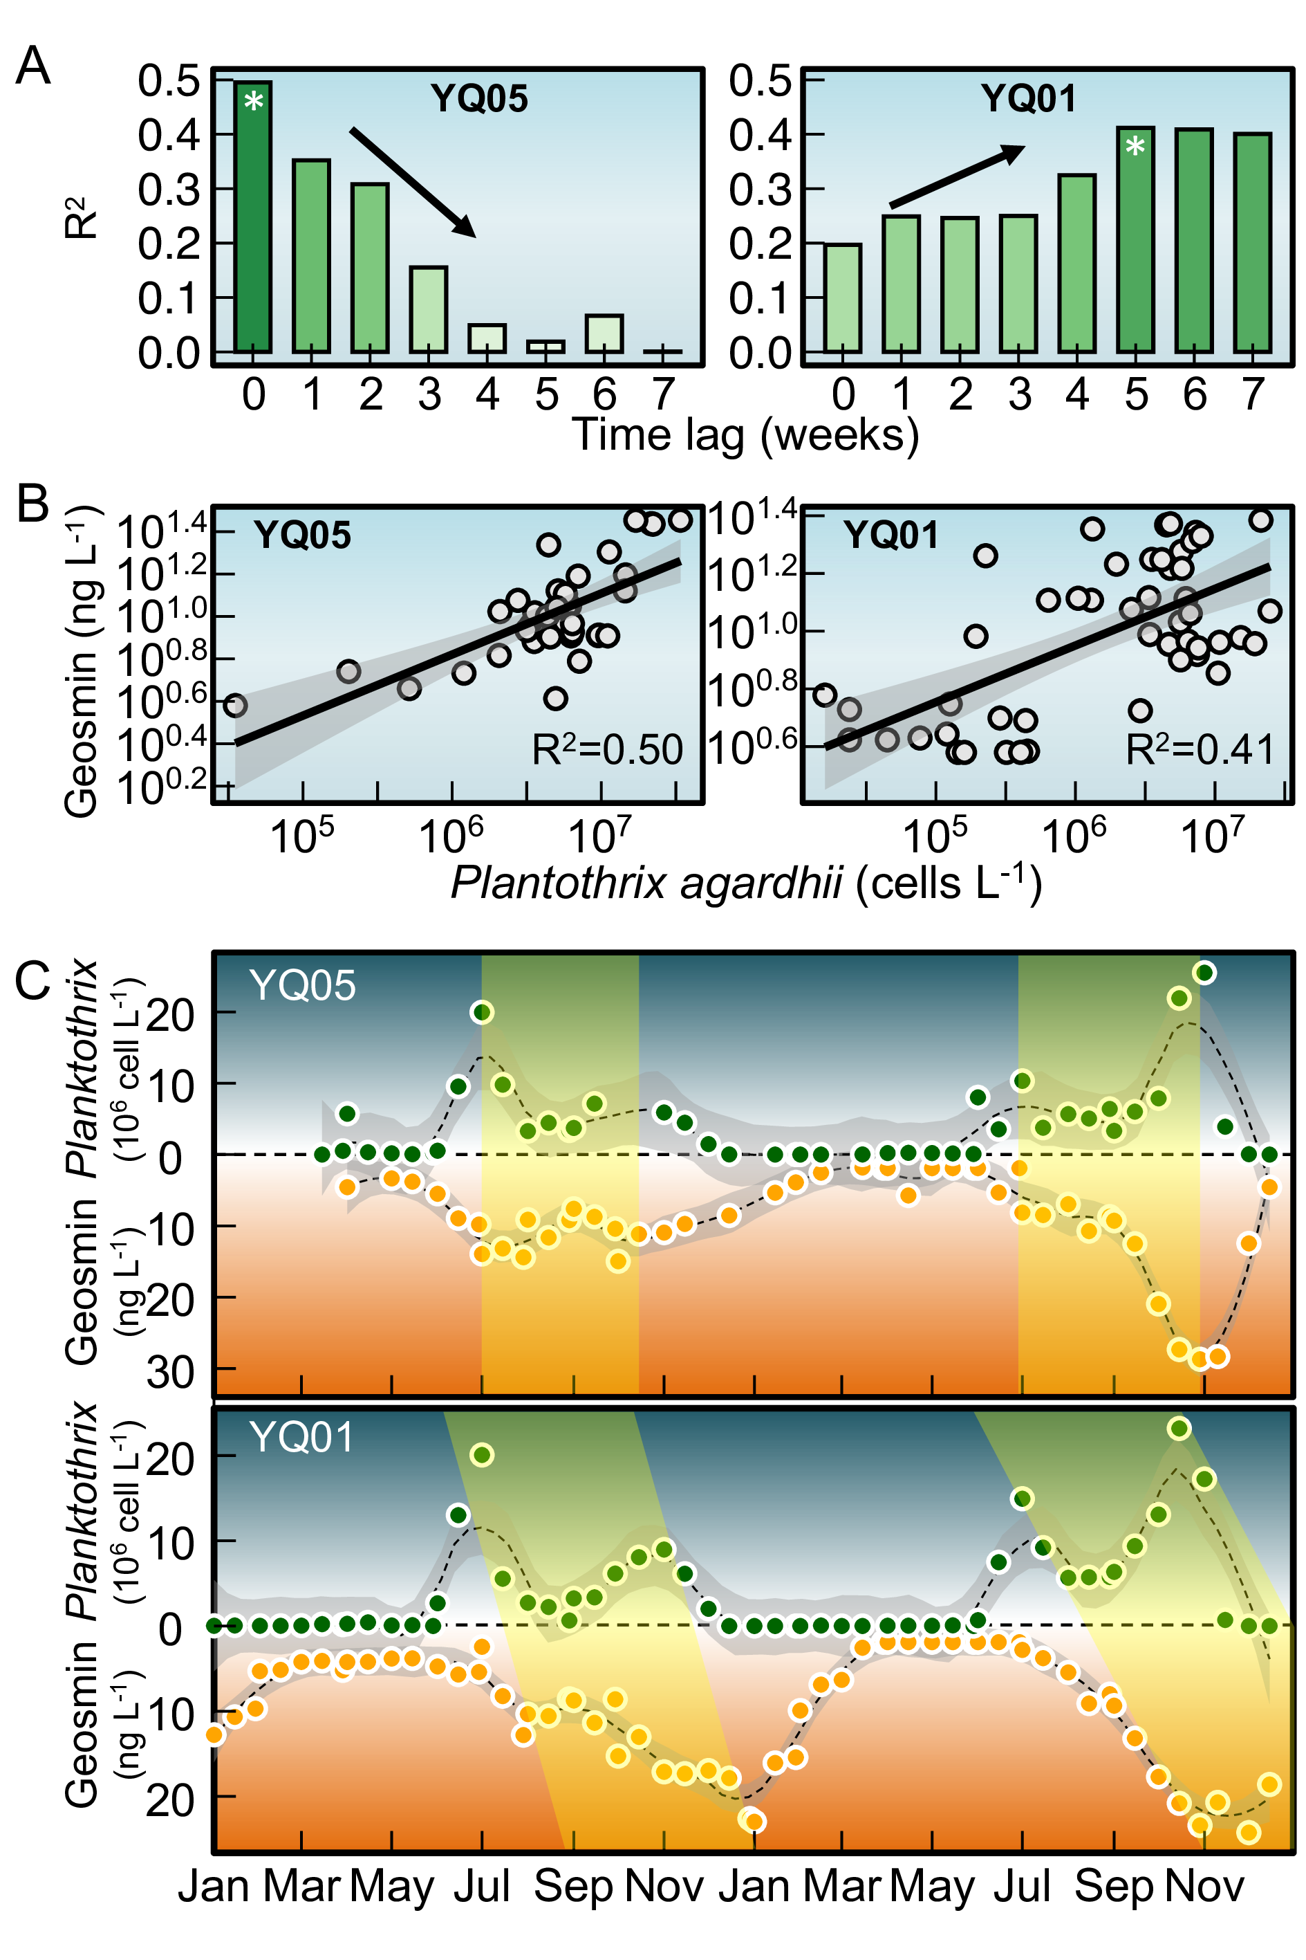
Fig. 4: Time-lagged relationships between Planktothrix agardhii biomass and geosmin concentrations at near-littoral and dam sites. (A) Correlation coefficients (R²) between P. agardhii biomass and geosmin at different lag periods (0–5 weeks) for site YQ05 (near-littoral) and YQ01 (dam intake). (B) Linear regression models at optimal lag periods: zero lag for YQ05 and 5-week lag for YQ01. (C) Scatter plots with fitted regression lines showing the quantitative relationships between P. agardhii biomass and geosmin at each site.

Environmental drivers of geosmin and proposed transport pathway
Principal component analysis (PCA) of key environmental variables identified ammonia (NH₄⁺-N) as the most strongly correlated factor with geosmin (geosmin) variation in the PC1–PC2 plane (Fig. 5A). The first two principal components explained 60.6% of the total variance. PC1 (explaining 43.5%) represented a thermal‑nutrient productivity axis, with high loadings from temperature (0.342), total phosphorus (TP, 0.39), and chlorophyll‑a (Chl‑a, 0.428). PC2 (explaining 17.1%) represented a nitrogen availability axis, dominated by ammonia (-0.449) and total nitrogen (TN, 0.432). geosmin exhibited moderate positive loadings on both PC1 (0.122) and PC2 (0.229), indicating that its variability was jointly influenced by thermal‑nutrient conditions and nitrogen availability.
To examine this relationship spatially, we performed log‑log regressions between ammonia and geosmin across three reservoir zones: littoral sites (YQ02–YQ04, YQ06–YQ07), the transitional near‑littoral site (YQ05), and the central dam intake (YQ01) (Fig. 5B). The correlation strength followed a distinct gradient, with the highest R² at littoral sites (0.365), intermediate at YQ05 (0.203), and lowest at YQ01 (0.035). This pattern indicates that the linkage between ammonia and geosmin is most direct within littoral production zones and becomes progressively decoupled along the transport pathway toward the dam.
Integrating these findings with the spatiotemporal dynamics of Planktothrix agardhii and geosmin, we propose a conceptual transport pathway for odor episodes (Fig. 5C). High‑resolution bathymetric mapping shows that shallow littoral areas (depths < 4–5 m) correspond to zones of elevated ammonia and serve as initiation hotspots for P. agardhii proliferation and geosmin production. Subsequent advective transport, guided by the reservoir’s hydrodynamic circulation, gradually propagates cells and dissolved geosmin from littoral zones through the transitional region (YQ05) to the central dam area (YQ01). This conceptual model synthesizes three key observations: (1) the spatial gradient in ammonia‑geosmin coupling, (2) the consistent temporal lags in cyanobacterial biomass and geosmin peaks between littoral and dam sites, and (3) the influence of bathymetry on water residence times. Together, these elements provide a mechanistic framework for understanding the origin, transport, and delayed manifestation of geosmin episodes at the drinking‑water intake of Yuqiao Reservoir.
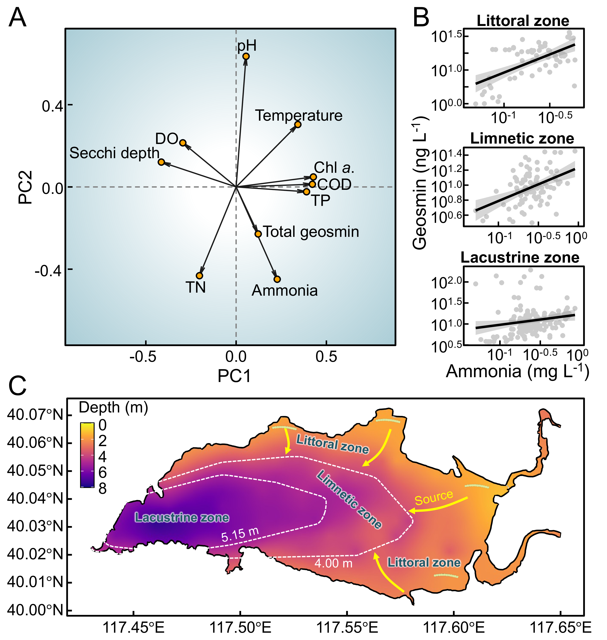
Fig. 5: Environmental drivers and conceptual transport pathway of geosmin in Yuqiao Reservoir. (A) Principal component analysis (PCA) biplot showing relationships between geosmin and key environmental variables. (B) Log-log regressions between ammonia concentration and geosmin across littoral, transitional (YQ05), and dam (YQ01) zones. (C) Bathymetric map of Yuqiao Reservoir depicting the proposed transport pathway from littoral production zones to the central water intake.

Discussion

Geosmin as a prevalent challenge for drinking water security in China
Our nationwide survey reveals that geosmin contamination is widespread across China’s major drinking water sources, with 14% of the surveyed sites exceeding the common odor threshold of 10 ng L⁻¹ ((AWWA, 2010)). This finding underscores geosmin as a significant and pervasive water quality issue, corroborating similar reports from diverse climatic regions globally (Devi et al., 2021; Lin et al., 2018). The pronounced spatial heterogeneity—marked by elevated concentrations in eastern and southern regions such as the Yangtze River Delta and Pearl River Delta—suggests that regional factors, including climate, watershed land use, and nutrient loading patterns, are critical drivers of geosmin risk. The compound’s low odor threshold and resistance to conventional treatment (Cook et al., 2001; Mustapha et al., 2021; Zamyadi et al., 2015) pose substantial challenges for water utilities (Srinivasan and Sorial, 2011), directly impacting consumer acceptance and compliance with water safety objectives linked to Sustainable Development Goal 6 (Arora and Mishra, 2022). The economic ramifications are considerable, driving investments in advanced treatment technologies and proactive management strategies worldwide (Yuan and Hofmann, 2022).

Littoral zones as production hotspots: ecological mechanisms and spatiotemporal decoupling
Actinomycetes are recognized as major biotic sources of taste-and-odor compounds, including geosmin and 2‑MIB, in soils and freshwater sediments (Gerber, 1979; Gerber and Lechevalier, 1965; Guo et al., 2024; Jensen et al., 1994). In the present study, however, synchronous peaks of Planktothrix agardhii biomass and geosmin concentrations—particularly at littoral sites with zero‑lag correlation (R² = 0.5)—together with the molecular identification of P. agardhii as the dominant geosmin producer via gene sequencing of GeoA gene and isolation (Fig. 2D, Fig. 2F), strongly indicate cyanobacterial origin. This aligns with a growing body of evidence that cyanobacteria constitute the primary biotic source of such odorants in many freshwater systems (Chislock et al., 2021; Hooper et al., 2023; Izaguirre, 1992; Pham et al., 2020; Su et al., 2013; Suurnäkki et al., 2015). While actinomycetes in sediments are known geosmin producers, their contribution in well‑oxygenated water columns of managed reservoirs like Yuqiao is likely secondary. We argue that detection of geoA‑harboring cyanobacteria (Giglio et al., 2011; Giglio et al., 2008; Kutovaya and Watson, 2014) in a well‑oxygenated water body provides compelling evidence that geosmin is primarily derived from cyanobacterial activity. This view is consistent with studies linking specific cyanobacterial blooms to geosmin episodes in drinking‑water reservoirs worldwide (Churro et al., 2020; Hayashi et al., 2019; John et al., 2018).
The sustained monitoring in Yuqiao Reservoir elucidates littoral zones as critical ecological niches for the proliferation of geosmin-producing cyanobacteria, particularly Planktothrix agardhii. The distinct spatiotemporal patterns—earlier onset, higher biomass, and stronger correlation with ammonia in littoral areas—highlight a production-transport decoupling central to reservoir-wide odor episodes. The affinity of filamentous cyanobacteria like P. agardhii for littoral environments can be attributed to several adaptive traits. Their filamentous morphology confers advantages in shallow, intermittently mixed waters through regulated buoyancy and reduced sedimentation losses, enabling optimal positioning for light harvesting (Jia et al., 2019; Su et al., 2019). This is complemented by low-light adaptations via phycobiliprotein pigments (Cao et al., 2025; Komárek and Johansen, 2015), allowing persistence under the variable light regimes typical of littoral zones (Scott and Marcarelli, 2012; Zohary and Gasith, 2014). Furthermore, the strong correlation observed between ammonia and geosmin specifically in littoral sites (R² = 0.37) suggests that nitrogen availability, likely influenced by shoreline inputs, is a key regulatory factor for production in these zones. In contrast, the weakened correlation at the dam intake (R² = 0.03) reflects the integration and modification of signals during transport.
The systematic spatial decoupling is evidenced by the consistent 8-day lag in major bloom events between littoral sites and the dam. This lag represents not merely physical advection but may also involve continued metabolic activity and potential accumulation in transitional zones. These findings challenge conventional reservoir management focused predominantly on pelagic or intake monitoring and align with growing recognition of nearshore areas as initiation sites for cyanobacterial metabolites.

Towards a proactive monitoring paradigm: quantitative predictive tools
The conceptual model depicted in Fig. 6 synthesizes the spatiotemporal mechanism underpinning our proposed management shift. It illustrates that the highest metabolic activity of geosmin-producing cyanobacteria is concentrated in littoral zones, driven by localized nutrient inputs and favorable physical conditions (Zohary and Gasith, 2014). The geosmin produced in these hotspots is subsequently advected through the limnetic zone, resulting in a distinct transport lag before it accumulates in the lacustrine zone and reaches the dam intake. This hydro-ecological sequence reveals a critical flaw in conventional, intake-centric monitoring (Mohanty et al., 2024): by the time geosmin is detected at the dam, its impact on treatment is immediate, leaving minimal time for preventive intervention (Zamyadi et al., 2015). This flaw is particularly acute for cyanobacteria, which can undergo rapid exponential growth, leading to sudden, log‑phase surges in metabolite concentrations that overwhelm conventional response protocols (Oliver and Ganf, 2000).
To capitalize on the inherent early-warning signal embedded within this process, we propose a tiered monitoring framework comprising: (1) sentinel stations in representative littoral zones for early detection of producer biomass, (2) gradient stations along the main transport pathway to track bloom progression, and (3) final verification at the intake. By shifting the primary monitoring focus upstream to the production source, utilities gain the crucial 4–6 week lead time—quantified by our lagged correlation analysis (R² = 0.41 at 5 weeks)—necessary to detect incipient risk during the early growth phase, well before the problematic log‑phase surge. This lead time enables the implementation of preventive measures—such as optimized reservoir operation (Fang et al., 2024; Lu et al., 2023; Su et al., 2017), selective withdrawal, or pre‑emptive treatment adjustments—that can effectively disrupt the progression from initial proliferation to full‑blown water quality crisis. Thereby, the majority of algal‑derived contamination events, which are characterized by their sudden onset, can be anticipated and mitigated at source, rather than reacted to after the fact. This concept aligns with the growing emphasis on source water protection and early-warning systems in water security management (Recknagel et al., 2017).
This transformation from a reactive to a predictive paradigm fundamentally redefines resilience. It moves beyond merely coping with crises to preventing them, which can significantly reduce treatment costs, minimize service disruptions, and safeguard public trust in the water supply. Proactive monitoring of littoral sentinel sites is not merely an added layer of surveillance; it is a strategic re‑allocation of resources to intercept algal‑derived risks at their earliest, most manageable stage.
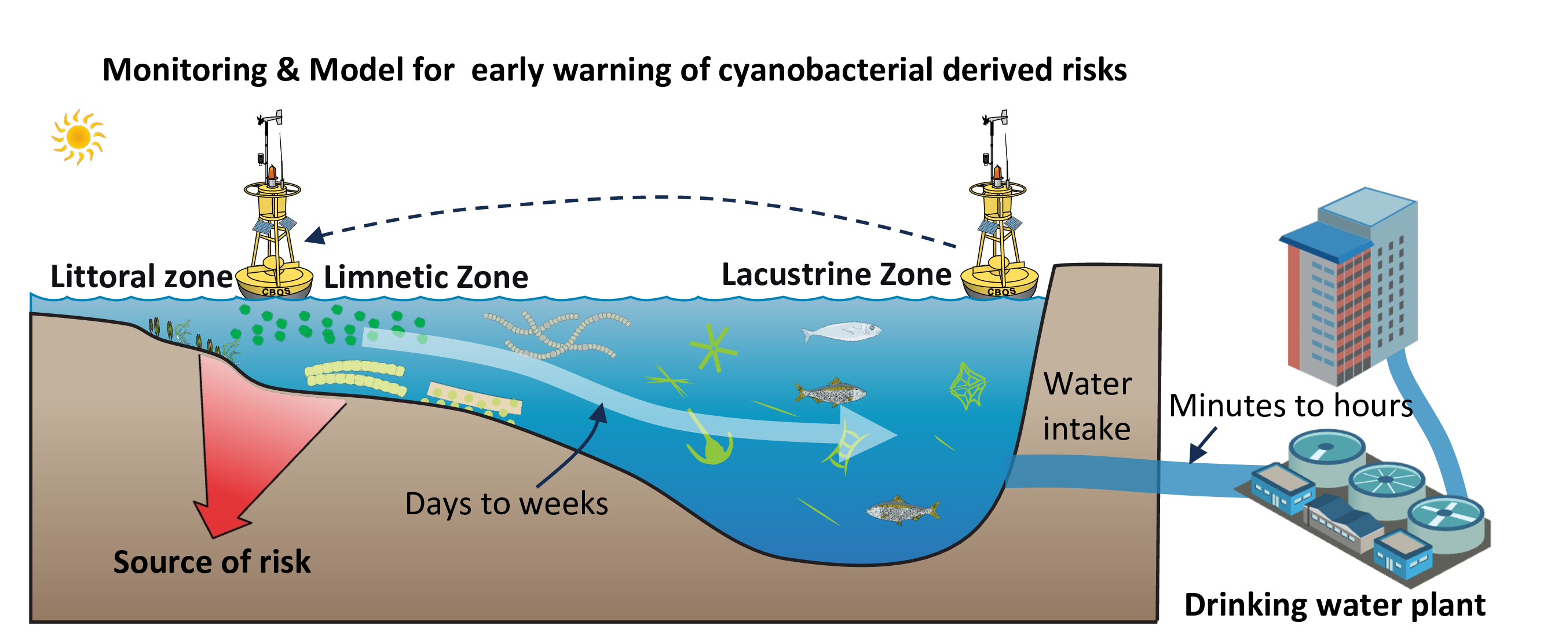
Fig. 6: Conceptual model of littoral-initiated geosmin transport and its implications for monitoring strategy. A sketch illustrating the spatiotemporal progression of geosmin episodes: (1) high metabolic activity of cyanobacteria (e.g., Planktothrix agardhii) in the littoral zone, driven by nutrient inputs and favorable light conditions; (2) advection of produced geosmin and biomass into the limnetic zone, resulting in a transport lag; (3) accumulation of geosmin in the lacustrine zone (dam intake), posing an immediate treatment challenge; and (4) the proposed monitoring shift from conventional reactive intake-focused sampling to proactive early detection in littoral zones, providing critical warning time for preventive measures.

Implications, limitations, and future perspectives
This study provides mechanistic insights into geosmin dynamics in a drinking water reservoir and translates them into practical monitoring tools. The identification of littoral zones as production hotspots and the quantification of time-lagged predictive relationships offer a blueprint for evidence-based management.
Several limitations should be acknowledged. First, while the 4–6 year dataset captures clear seasonal and interannual patterns, longer-term monitoring would strengthen the understanding of trends, particularly under climate change scenarios. Second, the dominant role of P. agardhii is specific to Yuqiao Reservoir; other systems may harbor different producer taxa (e.g., Dolichospermum, Aphanizomenon) with distinct ecological drivers (Choo et al., 2025; Izaguirre and Taylor, 2004; Su et al., 2013). Third, the predictive models require validation across diverse reservoir types and geographical settings to assess their broader applicability.
Future research should focus on: (1) integrating molecular tools to characterize the diversity and expression of geosmin synthesis genes within cyanobacterial communities, (2) coupling ecological monitoring with high-resolution hydrodynamic modeling to precisely quantify transport pathways and residence times, and (3) conducting cost-benefit analyses to evaluate the economic viability of implementing expanded littoral monitoring programs. Furthermore, investigating the interactions between climate variables (e.g., warming, extreme precipitation) and the identified production-transport mechanisms will be crucial for forecasting future risk scenarios. By unraveling the spatiotemporal mechanisms of geosmin production and transport, and by establishing quantifiable early-warning indicators, this work provides a scientific foundation for moving beyond reactive response. It equips water managers with a proactive strategy to safeguard drinking water quality against this persistent olfactory challenge.

Conclusions
This study delineates a coherent spatiotemporal mechanism for geosmin episodes in Yuqiao Reservoir, integrating landscape-scale drivers, in-reservoir ecological processes, and predictive management tools. The nationwide survey confirms geosmin as a pervasive challenge across China’s drinking water sources, establishing a critical context for reservoir-specific management. Within Yuqiao, littoral zones function as critical production hotspots, where Planktothrix agardhii—identified as the dominant producer—proliferates in response to local nutrient conditions, particularly ammonia. The subsequent advective transport of biomass and metabolite creates a systematic spatiotemporal decoupling, manifested as a consistent 4–6 week lag between littoral proliferation and geosmin peaks at the dam intake. This mechanistic understanding enables a paradigm shift from reactive to proactive management. The established quantitative relationship, where littoral P. agardhii biomass serves as a leading indicator, provides an operational early-warning window. By shifting the monitoring focus upstream to littoral sentinel sites, water utilities can implement timely interventions, thereby enhancing the security and reliability of drinking water supplies against this persistent olfactory threat.

Acknowledgements
This work was financially supported by the National Natural Science Foundation of China (52030002, 51878649), and Youth Innovation Promotion Association CAS.

References
Ai, Y., Wu, Y., Su, M., Gui, Y., Du, Y., Fang, J., Cao, T., Yang, M., 2025. Cyanobacterial crowding-out effects on metabolite partitioning: Modeling 2-methylisoborneol (MIB) release dynamics and implications. Journal of Hazardous Materials 140118. https://doi.org/https://doi.org/10.1016/j.jhazmat.2025.140118
Arora, N.K., Mishra, I., 2022. Sustainable development goal 6: Global water security. Environmental Sustainability 5, 271–275. https://doi.org/10.1007/s42398-022-00246-5
Asato, Y., 2003. Toward an understanding of cell growth and the cell division cycle of unicellular photoautotrophic cyanobacteria. Cellular and Molecular Life Sciences (CMLS) 60, 663–687. https://doi.org/10.1007/s00018-003-2079-y
AWWA, A.W.W.A., 2010. Algae: Source to treatment. American Water Works Association.
Bowmer, K.H., Padovan, A., Oliver, R.L., Korth, W., Ganf, G.G., 1992. Physiology of geosmin production by Anabaena Circinalis isolated from the murrumbidgee river, australia. Water Science and Technology 25, 259–267. https://doi.org/10.2166/wst.1992.0060
Burlingame, G.A., Doty, R.L., Dietrich, A.M., 2017. Humans as sensors to evaluate drinking water taste and odor: A review. Journal AWWA 109, 13–24. https://doi.org/10.5942/jawwa.2017.109.0118
Cai, F., Yu, G., Zhang, K., Chen, Y., Li, Q., Yang, Y., Xie, J., Wang, Y., Li, R., 2017. Geosmin production and polyphasic characterization of Oscillatoria limosa agardh ex gomont isolated from the open canal of a large drinking water system in tianjin city, china. Harmful Algae 69, 28–37. https://doi.org/10.1016/j.hal.2017.09.006
Cao, T., Su, M., Ai, Y., Yang, Z., Zhao, J., Yang, M., 2025. Green light suppresses cell growth but enhances photosynthetic rate and MIB biosynthesis in PE-containing pseudanabaena. Water Research 123336. https://doi.org/10.1016/j.watres.2025.123336
Carmichael, W.W., Azevedo, S.M., An, J.S., Molica, R.J., Jochimsen, E.M., Lau, S., Rinehart, K.L., Shaw, G.R., Eaglesham, G.K., 2001. Human fatalities from cyanobacteria: Chemical and biological evidence for cyanotoxins. Environmental Health Perspectives 109, 663–668. https://doi.org/10.1289/ehp.01109663
Cefalì, M.E., Cebrian, E., Chappuis, E., Pinedo, S., Terradas, M., Mariani, S., Ballesteros, E., 2016. Life on the boundary: Environmental factors as drivers of habitat distribution in the littoral zone. Estuarine, Coastal and Shelf Science 172, 81–92. https://doi.org/10.1016/j.ecss.2016.01.043
Cerón-Vivas, A., Villamizar León, M.P., Cajigas, Á.A., 2022. Geosmin and 2-methylisoborneol removal in drinking water treatment. Water Practice and Technology 18, 159–167. https://doi.org/10.2166/wpt.2022.167
Chislock, M.F., Olsen, B.K., Choi, J., Abebe, A., Bleier, T.L., Wilson, A.E., 2021. Contrasting patterns of 2-methylisoborneol (MIB) vs. Geosmin across depth in a drinking water reservoir are mediated by cyanobacteria and actinobacteria. Environmental Science and Pollution Research. https://doi.org/10.1007/s11356-021-12973-z
Choo, F., Cook, D., Hobson, P., 2025. Investigating the physicochemical parameters that drive geosmin production in benthic cyanobacterial systems. Water Research 287, 124388. https://doi.org/10.1016/j.watres.2025.124388
Churro, C., Semedo-Aguiar, A.P., Silva, A.D., Pereira-Leal, J.B., Leite, R.B., 2020. A novel cyanobacterial geosmin producer, revising GeoA distribution and dispersion patterns in bacteria. Scientific Reports 10. https://doi.org/10.1038/s41598-020-64774-y
Cook, D., Newcombe, G., Sztajnbok, P., 2001. The application of powdered activated carbon for MIB and geosmin removal: Predicting PAC doses in four raw waters. Water Research 35, 1325–1333. https://doi.org/10.1016/S0043-1354(00)00363-8
Devi, A., Chiu, Y.-T., Hsueh, H.-T., Lin, T.-F., 2021. Quantitative PCR based detection system for cyanobacterial geosmin/2-methylisoborneol (2-MIB) events in drinking water sources: Current status and challenges. Water Research 188, 116478. https://doi.org/10.1016/j.watres.2020.116478
Dordoni, M., Zappalà, P., Barth, J.A.C., 2023. A preliminary global hydrochemical comparison of lakes and reservoirs. Frontiers in Water 5. https://doi.org/10.3389/frwa.2023.1084050
Fang, J., Li, Y., Su, M., Cao, T., Sun, X., Ai, Y., Qin, J., Yu, J., Yang, M., 2024. Mitigating harmful cyanobacterial blooms in drinking water reservoirs through in-situ sediment resuspension. Water Research 267, 122509. https://doi.org/10.1016/j.watres.2024.122509
Feng, L., Dai, Y., Hou, X., Xu, Y., Liu, J., Zheng, C., 2021. Concerns about phytoplankton bloom trends in global lakes. Nature 590, E35–E47. https://doi.org/10.1038/s41586-021-03254-3
Gerber, N.N., 1979. Volatile Substances from Actinomycetes: Their Role in the Odor Pollution of Water. CRC Critical Reviews in Microbiology 7, 191–214. https://doi.org/10.3109/10408417909082014
Gerber, N.N., Lechevalier, H.A., 1965. Geosmin, an earthy-smelling substance isolated from actinomycetes. Applied Microbiology 13, 935–938.
Giglio, S., Chou, W.K.W., Ikeda, H., Cane, D.E., Monis, P.T., 2011. Biosynthesis of 2-methylisoborneol in cyanobacteria. Environmental Science & Technology 45, 992–998. https://doi.org/10.1021/es102992p
Giglio, S., Jiang, J., Saint, C.P.S., Cane, D.E., Monis, P.T., 2008. Isolation and characterization of the gene associated with geosmin production in cyanobacteria. Environmental Science & Technology 42, 8027–8032. https://doi.org/10.1021/es801465w
Guo, H., Li, R., Xue, S., Zhangsun, X., Huang, D., Li, Y., Li, N., Su, Y., Zhang, H., Huang, T., 2024. Considerable declines in odor in a drinking water reservoir: Variations of odorous community, precursor enzymes abundance, distribution, and environmental dominant factors. Water Research 122767. https://doi.org/10.1016/j.watres.2024.122767
Hayashi, S., Ohtani, S., Godo, T., Nojiri, Y., Saki, Y., Esumi, T., Kamiya, H., 2019. Identification of geosmin biosynthetic gene in geosmin-producing colonial cyanobacteria coelosphaerium sp. And isolation of geosmin non-producing coelosphaerium sp. From brackish lake shinji in japan. Harmful Algae 84, 19–26. https://doi.org/10.1016/j.hal.2019.01.010
Heisler, J., Glibert, P.M., Burkholder, J.M., Anderson, D.M., Cochlan, W., Dennison, W.C., Dortch, Q., Gobler, C.J., Heil, C.A., Humphries, E., Lewitus, A., Magnien, R., Marshall, H.G., Sellner, K., Stockwell, D.A., Stoecker, D.K., Suddleson, M., 2008. Eutrophication and harmful algal blooms: A scientific consensus. Harmful Algae 8, 3–13. https://doi.org/10.1016/j.hal.2008.08.006
Hooper, A.S., Kille, P., Watson, S.E., Christofides, S.R., Perkins, R.G., 2023. The importance of nutrient ratios in determining elevations in geosmin synthase (geoA) and 2-MIB cyclase (mic) resulting in taste and odour events. Water Research 119693. https://doi.org/10.1016/j.watres.2023.119693
Huisman, J., Codd, G.A., Paerl, H.W., Ibelings, B.W., Verspagen, J.M.H., Visser, P.M., 2018. Cyanobacterial blooms. Nature Reviews Microbiology 16, 471–483. https://doi.org/10.1038/s41579-018-0040-1
Izaguirre, G., 1992. A copper-tolerant phormidium species from lake mathews, california, that produces 2-methylisoborneol and geosmin. Water Science and Technology 25, 217–223. https://doi.org/10.2166/wst.1992.0055
Izaguirre, G., Taylor, W.D., 2004. A guide to geosmin- and MIB-producing cyanobacteria in the united states. Water Science and Technology 49, 19–24. https://doi.org/10.2166/wst.2004.0524
Jensen, S., Anders, C., Goatcher, L., Perley, T., Kenefick, S., Hrudey, S., 1994. Actinomycetes as a factor in odour problems affecting drinking water from the north saskatchewan river. Water Research 28, 1393–1401. https://doi.org/0043-1354(94)90306-9
Jia, Z., Su, M., Liu, T., Guo, Q., Wang, Q., Burch, M., Yu, J., Yang, M., 2019. Light as a possible regulator of MIB-producing Planktothrix in source water reservoir, mechanism and in-situ verification. Harmful Algae 88, 101658. https://doi.org/10.1016/j.hal.2019.101658
John, N., Koehler, A.V., Ansell, B.R.E., Baker, L., Crosbie, N.D., Jex, A.R., 2018. An improved method for PCR-based detection and routine monitoring of geosmin-producing cyanobacterial blooms. Water Research 136, 34–40. https://doi.org/10.1016/j.watres.2018.02.041
Jüttner, F., Watson, S.B., 2007. Biochemical and ecological control of geosmin and 2-methylisoborneol in source waters. Applied and Environmental Microbiology 73, 4395–4406. https://doi.org/10.1128/aem.02250-06
Komárek, J., Johansen, J.R., 2015. Chapter 4 - filamentous cyanobacteria, in: Freshwater Algae of North America (Second Edition). Academic Press, Boston, pp. 135–235. https://doi.org/10.1016/b978-0-12-385876-4.00004-9
Kosten, S., Huszar, V.L.M., Bécares, E., Costa, L.S., Donk, E. van, Hansson, L., Jeppesen, E., Kruk, C., Lacerot, G., Mazzeo, N., De Meester, L., Moss, B., Lürling, M., Nõges, T., Romo, S., Scheffer, M., 2011. Warmer climates boost cyanobacterial dominance in shallow lakes. Global Change Biology 18, 118–126. https://doi.org/10.1111/j.1365-2486.2011.02488.x
Kutovaya, O.A., Watson, S.B., 2014. Development and application of a molecular assay to detect and monitor geosmin-producing cyanobacteria and actinomycetes in the great lakes. Journal of Great Lakes Research 40, 404–414. https://doi.org/10.1016/j.jglr.2014.03.016
LEFLAIVE, J., TEN‐HAGE, L., 2007. Algal and cyanobacterial secondary metabolites in freshwaters: A comparison of allelopathic compounds and toxins. Freshwater Biology 52, 199–214. https://doi.org/10.1111/j.1365-2427.2006.01689.x
Li, Z., Yu, J., Yang, M., Zhang, J., Burch, M.D., Han, W., 2010. Cyanobacterial population and harmful metabolites dynamics during a bloom in yanghe reservoir, north China. Harmful Algae 9, 481–488. https://doi.org/10.1016/j.hal.2010.03.003
Lin, T.-F., Watson, S., Suffet, I.H.M., 2018. Taste and odour in source and drinking water: Causes, controls, and consequences. IWA Publishing.
Lu, J., Su, M., Su, Y., Fang, J., Burch, M., Cao, T., Wu, B., Yu, J., Yang, M., 2023. MIB-derived odor management based upon hydraulic regulation in small drinking water reservoirs: Principle and application. Water Research 244, 120485. https://doi.org/10.1016/j.watres.2023.120485
Martinez i Quer, A., Larsson, Y., Johansen, A., Arias, C.A., Carvalho, P.N., 2024. Cyanobacterial blooms in surface waters – nature-based solutions, cyanotoxins and their biotransformation products. Water Research 251, 121122. https://doi.org/10.1016/j.watres.2024.121122
Mehnert, G., Leunert, F., Cires, S., Johnk, K.D., Rucker, J., Nixdorf, B., Wiedner, C., 2010. Competitiveness of invasive and native cyanobacteria from temperate freshwaters under various light and temperature conditions. Journal of Plankton Research 32, 1009–1021. https://doi.org/10.1093/plankt/fbq033
Merel, S., Walker, D., Chicana, R., Snyder, S., Baurès, E., Thomas, O., 2013. State of knowledge and concerns on cyanobacterial blooms and cyanotoxins. Environment International 59, 303–327. https://doi.org/10.1016/j.envint.2013.06.013
Mohanty, S., Pandey, P.C., Srivastava, P.K., Srivastava, S.K., 2024. Challenges and future implications in monitoring and assessment of aquatic ecosystems, in: Aquatic Ecosystems Monitoring. CRC Press, pp. 297–318.
Mustapha, S., Tijani, J.O., Ndamitso, M.M., Abdulkareem, A.S., Shuaib, D.T., Mohammed, A.K., 2021. A critical review on geosmin and 2-methylisoborneol in water: Sources, effects, detection, and removal techniques. Environmental Monitoring and Assessment 193, 204. https://doi.org/10.1007/s10661-021-08980-9
O’neil, J.m., Davis, T.w., Burford, M.a., Gobler, C.j., 2012. The rise of harmful cyanobacteria blooms: The potential roles of eutrophication and climate change. Harmful Algae 14, 313–334. https://doi.org/10.1016/j.hal.2011.10.027
Oliver, R.L., Ganf, G.G., 2000. Freshwater blooms, in: The Ecology of Cyanobacteria: Their Diversity in Time and Space. Springer, pp. 149–194.
Paerl, H.W., Fulton, R.S., Moisander, P.H., Dyble, J., 2001. Harmful freshwater algal blooms, with an emphasis on cyanobacteria. The Scientific World Journal 1, 76–113. https://doi.org/10.1100/tsw.2001.16
Paerl, H.W., Paul, V.J., 2012. Climate change: Links to global expansion of harmful cyanobacteria. Water Research 46, 1349–1363. https://doi.org/10.1016/j.watres.2011.08.002
Paerl, H.W., Xu, H., Mccarthy, M.J., Zhu, G., Qin, B., Li, Y., Gardner, W.S., 2011. Controlling harmful cyanobacterial blooms in a hyper-eutrophic lake (lake taihu, China): The need for a dual nutrient (n & p) management strategy. Water Research 45, 1973–1983. https://doi.org/10.1016/j.watres.2010.09.018
Pham, T.-L., Bui, M.H., Driscoll, M., Shimizu, K., Motoo, U., 2020. First report of geosmin and 2-methylisoborneol (2-MIB) in Dolichospermum and Oscillatoria from vietnam. Limnology 22, 43–56. https://doi.org/10.1007/s10201-020-00630-2
Plaas, H.E., Paerl, H.W., 2020. Toxic cyanobacteria: A growing threat to water and air quality. Environmental Science &amp; Technology 55, 44–64. https://doi.org/10.1021/acs.est.0c06653
Qiu, P., Chen, Y., Li, C., Huo, D., Bi, Y., Wang, J., Li, Y., Li, R., Yu, G., 2021. Using molecular detection for the diversity and occurrence of cyanobacteria and 2-methylisoborneol-producing cyanobacteria in an eutrophicated reservoir in Northern China. Environmental Pollution 288, 117772. https://doi.org/10.1016/j.envpol.2021.117772
Qiu, P., Zhang, Y., Mi, W., Song, G., Bi, Y., 2023. Producers and drivers of odor compounds in a large drinking-water source. Frontiers in Ecology and Evolution 11. https://doi.org/10.3389/fevo.2023.1216567
Recknagel, F., Orr, P.T., Bartkow, M., Swanepoel, A., Cao, H., 2017. Early warning of limit-exceeding concentrations of cyanobacteria and cyanotoxins in drinking water reservoirs by inferential modelling. Harmful Algae 69, 18–27. https://doi.org/10.1016/j.hal.2017.09.003
Reinl, K.L., Harris, T.D., Elfferich, I., Coker, A., Zhan, Q., Domis, L.N.D.S., Morales-Williams, A.M., Bhattacharya, R., Grossart, H.-P., North, R.L., Sweetman, J.N., 2022. The role of organic nutrients in structuring freshwater phytoplankton communities in a rapidly changing world. Water Research 219, 118573. https://doi.org/10.1016/j.watres.2022.118573
Rousso, B.Z., Bertone, E., Stewart, R., Hamilton, D.P., 2020. A systematic literature review of forecasting and predictive models for cyanobacteria blooms in freshwater lakes. Water Research 182, 115959. https://doi.org/10.1016/j.watres.2020.115959
Scott, J.T., Marcarelli, A.M., 2012. Cyanobacteria in freshwater benthic environments, in: Ecology of Cyanobacteria Ii. Springer Netherlands, pp. 271–289. https://doi.org/10.1007/978-94-007-3855-3_9
Singh, S., Kate, B.N., Banerjee, U.C., 2005. Bioactive compounds from cyanobacteria and microalgae: An overview. Critical Reviews in Biotechnology 25, 73–95. https://doi.org/10.1080/07388550500248498
Srinivasan, R., Sorial, G.A., 2011. Treatment of taste and odor causing compounds 2-methyl isoborneol and geosmin in drinking water: A critical review. Journal of Environmental Sciences 23, 1–13. https://doi.org/10.1016/s1001-0742(10)60367-1
Su, M., Andersen, T., Burch, M., Jia, Z., An, W., Yu, J., Yang, M., 2019. Succession and interaction of surface and subsurface cyanobacterial blooms in oligotrophic/mesotrophic reservoirs: A case study in Miyun Reservoir. Science of the Total Environment 649, 1553–1562. https://doi.org/J.scitotenv.2018.08.307
Su, M., Gaget, V., Giglio, S., Burch, M., An, W., Yang, M., 2013. Establishment of quantitative PCR methods for the quantification of geosmin-producing potential and Anabaena sp. In freshwater systems. Water Research 47, 3444–3454. https://doi.org/10.1016/j.watres.2013.03.043
Su, M., Jia, D., Yu, J., Vogt, R.D., Wang, J., An, W., Yang, M., 2017. Reducing production of taste and odor by deep-living cyanobacteria in drinking water reservoirs by regulation of water level. Science of the Total Environment 574, 1477–1483. https://doi.org/10.1016/j.scitotenv.2016.08.134
Su, M., Yu, J., Zhang, J., Chen, H., An, W., Vogt, R.D., Andersen, T., Jia, D., Wang, J., Yang, M., 2015. MIB-producing cyanobacteria (Planktothrix sp.) in a drinking water reservoir: Distribution and odor producing potential. Water Research 68, 444–453. https://doi.org/10.1016/j.watres.2014.09.038
Su, M., Zhu, Y., Jia, Z., Liu, T., Yu, J., Burch, M., Yang, M., 2021. Identification of MIB producers and odor risk assessment using routine data: A case study of an estuary drinking water reservoir. Water Research 192, 116848. https://doi.org/10.1016/j.watres.2021.116848
Sun, D., Yu, J., Yang, M., An, W., Zhao, Y., Lu, N., Yuan, S., Zhang, D., 2014. Occurrence of odor problems in drinking water of major cities across China. Frontiers of Environmental Science & Engineering 8, 411–416. https://doi.org/10.1007/s11783-013-0577-1
Suurnäkki, S., Gomez-saez, G.V., Rantala-ylinen, A., Jokela, J., Fewer, D.P., Sivonen, K., 2015. Identification of geosmin and 2-methylisoborneol in cyanobacteria and molecular detection methods for the producers of these compounds. Water Research 68, 56–66. https://doi.org/10.1016/j.watres.2014.09.037
Thornton, K.W., 1984. REGIONAL COMPARISONS OF LAKES AND RESERVOIRS: GEOLOGY, CLIMATOLOGY, AND MORPHOLOGY. Lake and Reservoir Management 1, 261–265. https://doi.org/10.1080/07438148409354521
Uwins, H.K., Teasdale, P., Stratton, H., 2007. A case study investigating the occurrence of geosmin and 2-methylisoborneol (MIB) in the surface waters of the hinze dam, gold coast, australia. Water Science and Technology 55, 231–238. https://doi.org/10.2166/wst.2007.184
Watson, S.B., 2003. Cyanobacterial and eukaryotic algal odour compounds: Signals or by-products? A review of their biological activity. Phycologia 42, 332–350. https://doi.org/10.2216/i0031-8884-42-4-332.1
Woolway, R.I., Kraemer, B.M., Lenters, J.D., Merchant, C.J., O’Reilly, C.M., Sharma, S., 2020. Global lake responses to climate change. Nature Reviews Earth &amp; Environment 1, 388–403. https://doi.org/10.1038/s43017-020-0067-5
Wu, T., Zhu, G., Wang, Z., Zhu, M., Xu, H., 2022. Seasonal dynamics of odor compounds concentration driven by phytoplankton succession in a subtropical drinking water reservoir, southeast China. Journal of Hazardous Materials 425, 128056. https://doi.org/10.1016/j.jhazmat.2021.128056
Xu, H., Paerl, H.W., Qin, B., Zhu, G., Gaoa, G., 2009. Nitrogen and phosphorus inputs control phytoplankton growth in eutrophic Lake Taihu, China. Limnology and Oceanography 55, 420–432. https://doi.org/10.4319/lo.2010.55.1.0420
Xu, Y., Xie, R., Wang, Y., Sha, J., 2014. Spatio-temporal variations of water quality in yuqiao reservoir basin, north china. Frontiers of Environmental Science &amp; Engineering 9, 649–664. https://doi.org/10.1007/s11783-014-0702-9
Yang, M., Yu, J., Li, Z., Guo, Z., Burch, M., Lin, T., 2008. Taihu Lake not to blame for Wuxi’s Woes. Science 319, 158. https://doi.org/10.1126/science.319.5860.158a
Yuan, J., Hofmann, R., 2022. Adsorption and biodegradation of 2-methylisoborneol and geosmin in drinking water granular activated carbon filters: A review and meta-analysis. Journal of Hazardous Materials 440, 129838. https://doi.org/10.1016/j.jhazmat.2022.129838
Zamyadi, A., Henderson, R., Stuetz, R., Hofmann, R., Ho, L., Newcombe, G., 2015. Fate of geosmin and 2-methylisoborneol in full-scale water treatment plants. Water Research 83, 171–183. https://doi.org/10.1016/j.watres.2015.06.038
Zhai, H., He, X., Zhang, Y., Du, T., Adeleye, A.S., Li, Y., 2017. Disinfection byproduct formation in drinking water sources: A case study of yuqiao reservoir. Chemosphere 181, 224–231. https://doi.org/10.1016/j.chemosphere.2017.04.028
Zhang, Y., Whalen, J.K., Cai, C., Shan, K., Zhou, H., 2023. Harmful cyanobacteria-diatom/dinoflagellate blooms and their cyanotoxins in freshwaters: A nonnegligible chronic health and ecological hazard. Water Research 233, 119807. https://doi.org/10.1016/j.watres.2023.119807
Zhou, S., Qiu, D., Xiao, L., 2024. Spatial distribution and influencing factors of organic odorants 2-methylisoborneol and geosmin in reservoirs of guangdong province. Guangdong Chemical Industry (In Chinese) 51, 117–119, 122.
Zohary, T., Gasith, A., 2014. The littoral zone, in: Lake Kinneret. Springer Netherlands, pp. 517–532. https://doi.org/10.1007/978-94-017-8944-8_29

