Integrating littoral zone odor dynamics into early warning and intervention systems for drinking water reservoirs
Yuying Gui^{a,b,#}, Tengxin Cao^{b,f,#}, Ming Su ^{ID,b,f,*}, Jie Yang^{c}, Ziyi Yang^{b,f}, Qi Zhang^{e}, Lin Sun^{d}, Yufan Ai^{b,f}, Jiao Fang^{b}, Yingjie Li^{b,f}, and Min Yang^{b,f}
# These authors contributed equally to this work.
ª College of Environmental Science and Engineering, Ocean University of China, Qingdao 266100, China.
^{b} Key Laboratory of Environmental Aquatic Chemistry, State Key Laboratory of Regional Environment and Sustainability, Research Center for Eco-Environmental Sciences, Chinese Academy of Sciences, Beijing 100085, China.
^{c} Tianjin Hydraulic Research Institute, Tianjin 300061, China.
^{d} Tianjin Key Laboratory of Animal and Plant Resistance, College of Life Sciences, Tianjin Normal University, Tianjin 300387, China.
^{e} Institute of Hydrobiology, Chinese Academy of Sciences, Wuhan 430070, China.
^{f} University of Chinese Academy of Sciences, Beijing 100049, China.
* Corresponding to: Ming Su (mingsu@rcees.ac.cn)

Abstract
Cyanobacterial blooms threaten drinking water safety through the production of taste-and-odor compounds such as geosmin. However, the spatiotemporal mechanisms linking bloom dynamics to odor episodes in reservoirs—critical drinking water sources—remain poorly quantified, hindering effective management. This study integrated a national-scale survey with a five-year, high-frequency monitoring program in Yuqiao Reservoir, a major water source in northern China. Nationally, geosmin was detected in 188 of 214 sites, with 14% exceeding the 10 ng L⁻¹ odor threshold, confirming its widespread occurrence. In Yuqiao Reservoir, Planktothrix agardhii was identified as the dominant geosmin producer. A pronounced spatiotemporal decoupling was observed: littoral zones acted as production hotspots, with P. agardhii biomass peaking 8 days earlier than at the dam intake. Time-lagged correlation revealed that littoral biomass predicted intake geosmin with a 5-week lead time (R² = 0.41). Ammonia was a key driver, showing the strongest correlation with geosmin in littoral zones (R² = 0.37). We propose a conceptual transport model and a tiered monitoring framework that shifts focus from reactive intake sampling to proactive sentinel stations in littoral zones. This approach provides a critical early-warning window, enabling preventive measures to safeguard drinking water quality against geosmin episodes.

Synopsis
This study pioneers an early-warning framework by identifying the littoral zone as the critical hotspot for reservoir odor outbreaks and integrating real-time monitoring with predictive modeling for targeted intervention.

Introduction
The increasing frequency and intensity of harmful cyanobacterial blooms (CyanoHABs) in surface waters, driven by climate change and intensified anthropogenic activities, represent a critical and elevated global threat to water security^{1–7}. CyanoHABs in eutrophic shallow lakes have been extensively investigated^{8–14}, while studies in reservoir systems remain insufficient. As the most important resource for drinking water, CyanoHABs in these reservoirs directly threaten drinking water safety through the production of toxins^{15–18} and taste-and-odor (T&O) compounds^{19–22}, therefore impacts both human health and water utility. For example, nearly half of China’s source-water reservoirs experience recurrent algal-derived T&O episodes²³. Unlike chemical contaminants, cyanobacterial populations can undergo exponential growth under favored aquatic conditions^{24,25}, rapidly releasing metabolites with substantial concentrations^{17,26,27}, that often exceeds the response capacity of conventional water treatment facilities^{28–30}, therefore leading to widespread drinking water quality incidents^{22,31}.
Effectively managing CyanoHABs in reservoirs presents distinct and formidable challenges. Compared to natural lakes, reservoirs display greater spatial and hydraulic complexity, resulting in less stable and predictable ecological regimes^{32,33}. Conventional reservoir monitoring strategies, typically confined to sampling at water intakes that usully closed to the dam, fail to capture the spatially heterogeneous distribution of algal biomass and metabolites. Furthermore, the short flow time from intake to drinking water treatment plant—often on the scale of minutes to hours—provides an inadequate operational window for timely intervention. In contrast, we hypothesis that, the littoral zones in reservoirs are characterized by markedly different environmental conditions, such as enhanced nutrient availability and light penetration^{34,35}, which may promote early cyanobacterial proliferation. Despite their potential significance as critical sentinel sites, these areas remain critically under-monitored. Consequently, the mechanistic linkages between littoral zone CyanoHAB dynamics and downstream water quality at intakes are poorly understood and quantified.
Geosmin and 2-methylisoborneol (MIB) are among the most concerning terpenoid T&O compounds produced by cyanobacteria^{36,37}. Their low molecular weight and chemical properties allow them to penetrate conventional water treatment barriers and persist into tap water^{21,38}, therefore impairing drinking water quality and consumer acceptance. In China, MIB-related events have been extensively documented, and site-specific control strategies—such as managing reservoir water levels²⁰ or reducing hydraulic retention time³⁹—have been developed in response. Geosmin, however, presents a different spatial and historical pattern. While traditionally more common in Southern Hemisphere waters^{40,41}, geosmin episodes are now being reported with growing frequency across Northern Hemisphere lakes and reservoirs^{42,43}. Complicating matters further, the cyanobacterial taxa capable of producing geosmin are phylogenetically more diverse than those linked to MIB⁴⁴. This diversity makes it harder to find out the producing organisms and develop targeted management approaches, underscoring the need for more comprehensive study—particularly regarding the ecological niches and growth dynamics of these organisms in littoral zones.
To bridge these knowledge gaps, we first analyzed recent national survey data to map the occurrence of geosmin across China’s drinking water sources. Building on this broader picture, we then selected a representative reservoir with a known history of geosmin episodes for detailed investigation. Through a five-year, spatially resolved monitoring program, we integrated water chemistry measurements, molecular profiling of algal communities, and advanced statistical models. Our results reveal a clear spatial decoupling between cyanobacterial communities and T&O compound concentrations in littoral zones compared to the dam area. We further identify the key cyanobacterial taxa responsible for odor production and demonstrate that population dynamics in the littoral zone decisively shape T&O levels at the drinking water intake. These findings reposition the littoral zone not merely as a peripheral area, but as a critical sentinel for early warning and a strategic leverage point for proactive intervention. By establishing this spatial and ecological link, our work supports a shift from reactive treatment toward preventive, risk-based management of cyanobacterial T&O threats in reservoir-dependent water supplies.

Materials and methods

Study area and sampling design
National-scale geosmin survey. This study compiles geosmin concentration data from drinking water sources across China, representing one of the most extensive national surveys of this odorant to date. The dataset integrates our own multi-year monitoring results with high-quality geosmin measurements. Besides, we have also included a study with 33 reservoirs in Guangdong province⁴⁵. In total, geosmin data from 214 distinct sampling sites across multiple provinces were analyzed to characterize its nationwide occurrence and spatial heterogeneity.
Intensive monitoring at Yuqiao Reservoir. Yuqiao Reservoir (40°00′30″–40°05′30″N, 117°22′30″–117°27′30″E) is a large, river-type reservoir (total capacity: 1.559 billion m³) and a critical drinking water source for Tianjin, China^{46,47}. It has experienced persistent seasonal taste-and-odor episodes in recent years^{48,49}. Reflecting its distinct bathymetry and hydrodynamic gradients, seven sampling sites (YQ01–YQ07) were established along a littoral-to-dam transect. Site YQ01, located in the deep lacustrine zone near the dam (max depth ~12 m), was sampled vertically (integrated water column). The remaining sites (YQ02–YQ07) were situated in shallower littoral and transitional zones (depth 2–4 m), where only surface water samples were collected. During the annual odor season, high-frequency sampling was conducted 2–3 times per week from 2019 to 2024. Samples for geosmin analysis, water chemistry, and phytoplankton were collected concurrently. All samples were stored at 4°C in the dark and processed within 24 hours.

Analytical methods
Geosmin analysis. Geosmin concentrations were determined using headspace solid-phase microextraction (HS-SPME) coupled with gas chromatography-mass spectrometry (GC-MS; Agilent 6890GC-5973MSD) following a well-established protocol²⁰. The method detection limit for geosmin was 1 ng L⁻¹.
Water quality parameters. In-situ measurements of water temperature, pH, dissolved oxygen (DO), and turbidity were performed using a multiparameter sonde (EXO2, Xylem, USA). Ammonium (NH₄⁺-N), total nitrogen (TN), and total phosphorus (TP) were analyzed according to Chinese national standard methods for water quality.
Phytoplankton analysis. Phytoplankton samples were fixed with Lugol’s iodine solution (final concentration 5%). After 48-h sedimentation, samples were concentrated to 10 mL. Cell identification and enumeration were performed under an inverted microscope (Olympus BX51) using a Sedgewick–Rafter counting chamber. Biomass was expressed as cell density.

Molecular identification of geosmin-producing cyanobacteria
Water samples for molecular analysis were collected concurrently with geosmin samples. Biomass was collected on 1.2-μm polycarbonate filters (Millipore) and stored at–80°C. Total genomic DNA was extracted using the FastDNA™Spin Kit for Soil (MP Biomedicals). The geosmin synthase gene (geoA) was amplified using cyanobacterium-specific primers^{50,51}. Amplicons were visualized via agarose gel electrophoresis, and positive products were subjected to high-throughput sequencing. After quality filtering and primer removal, sequences were clustered into operational taxonomic units (OTUs) at 97% similarity. Representative sequences were taxonomically assigned via BLAST against public geoA databases, and a maximum-likelihood phylogenetic tree was constructed to confirm the identity of the dominant geosmin producer.

Data processing and statistical analysis
Temporal aggregation and lagged correlation. To reduce noise from irregular sampling and align different time series, all data were aggregated to weekly means. For each sampling date, the corresponding week was defined from the preceding Monday. To investigate time-lagged relationships, weekly geosmin concentrations were shifted forward by i weeks (i = 0–7) and paired with concurrent weekly mean Planktothrix agardhii biomass. For each site and lag period, a log–log linear model was fitted:
$$\log_{10}\left(G\right)=α+β\log_{10}\left(P\right)+ε \left(1\right)$$
where G is geosmin concentration (ng L⁻¹) and P is P. agardhii cell density (cells L⁻¹). To minimize the influence of background low values, only paired observations with geosmin > 2 ng L⁻¹ and positive biomass were included. A site was included in the lag analysis only if it contained≥20 valid weekly observations. The coefficient of determination (R²) was used to assess model fit. The lag period yielding the maximum R² was defined as the optimal early-warning window for that site. The significance of the regression slope was evaluated using a t-test.
Multivariate and spatial analysis. Principal component analysis (PCA) was performed on standardized geosmin and environmental variables to explore their multivariate relationships. Zone-specific regression analyses (littoral, transitional, dam) were conducted to compare the strength of the ammonia–geosmin relationship across reservoir zones. Bathymetric data from field surveys were spatially interpolated using ordinary kriging to create a continuous depth map, illustrating the gradient from shallow littoral to deep lacustrine zones.
Software. All statistical analyses and visualizations were performed in R (version 4.4.2) using packages including dplyr, lubridate, stats, and ggplot2.

Results

National survey of geosmin occurrence in drinking water sources
A nationwide survey was conducted to assess geosmin (geosmin) concentrations across China’s major drinking water sources, encompassing a total of 214 sampling sites from reservoirs and key surface water bodies in 26 provinces. geosmin was detected in 188 locations. Measured concentrations spanned over four orders of magnitude, ranging from below detection limits to a maximum of 150 ng L⁻¹, recorded at a site in Zhejiang Province. Overall, 14% of sampling sites exceeded the common odor threshold of 10 ng L⁻¹. Geospatial analysis revealed pronounced heterogeneity. Elevated geosmin levels were broadly clustered in the eastern and southern regions, including the Yangtze River Delta, Pearl River Delta, and parts of North China. In contrast, concentrations in northwestern China (e.g., Tibet, Xinjiang, Qinghai) and certain central provinces were consistently low or below detection limits, corroborating a general east-high, west-low spatial pattern. This comprehensive dataset demonstrates that geosmin is a widespread odorant affecting drinking water sources across diverse climatic and geographical zones in China.
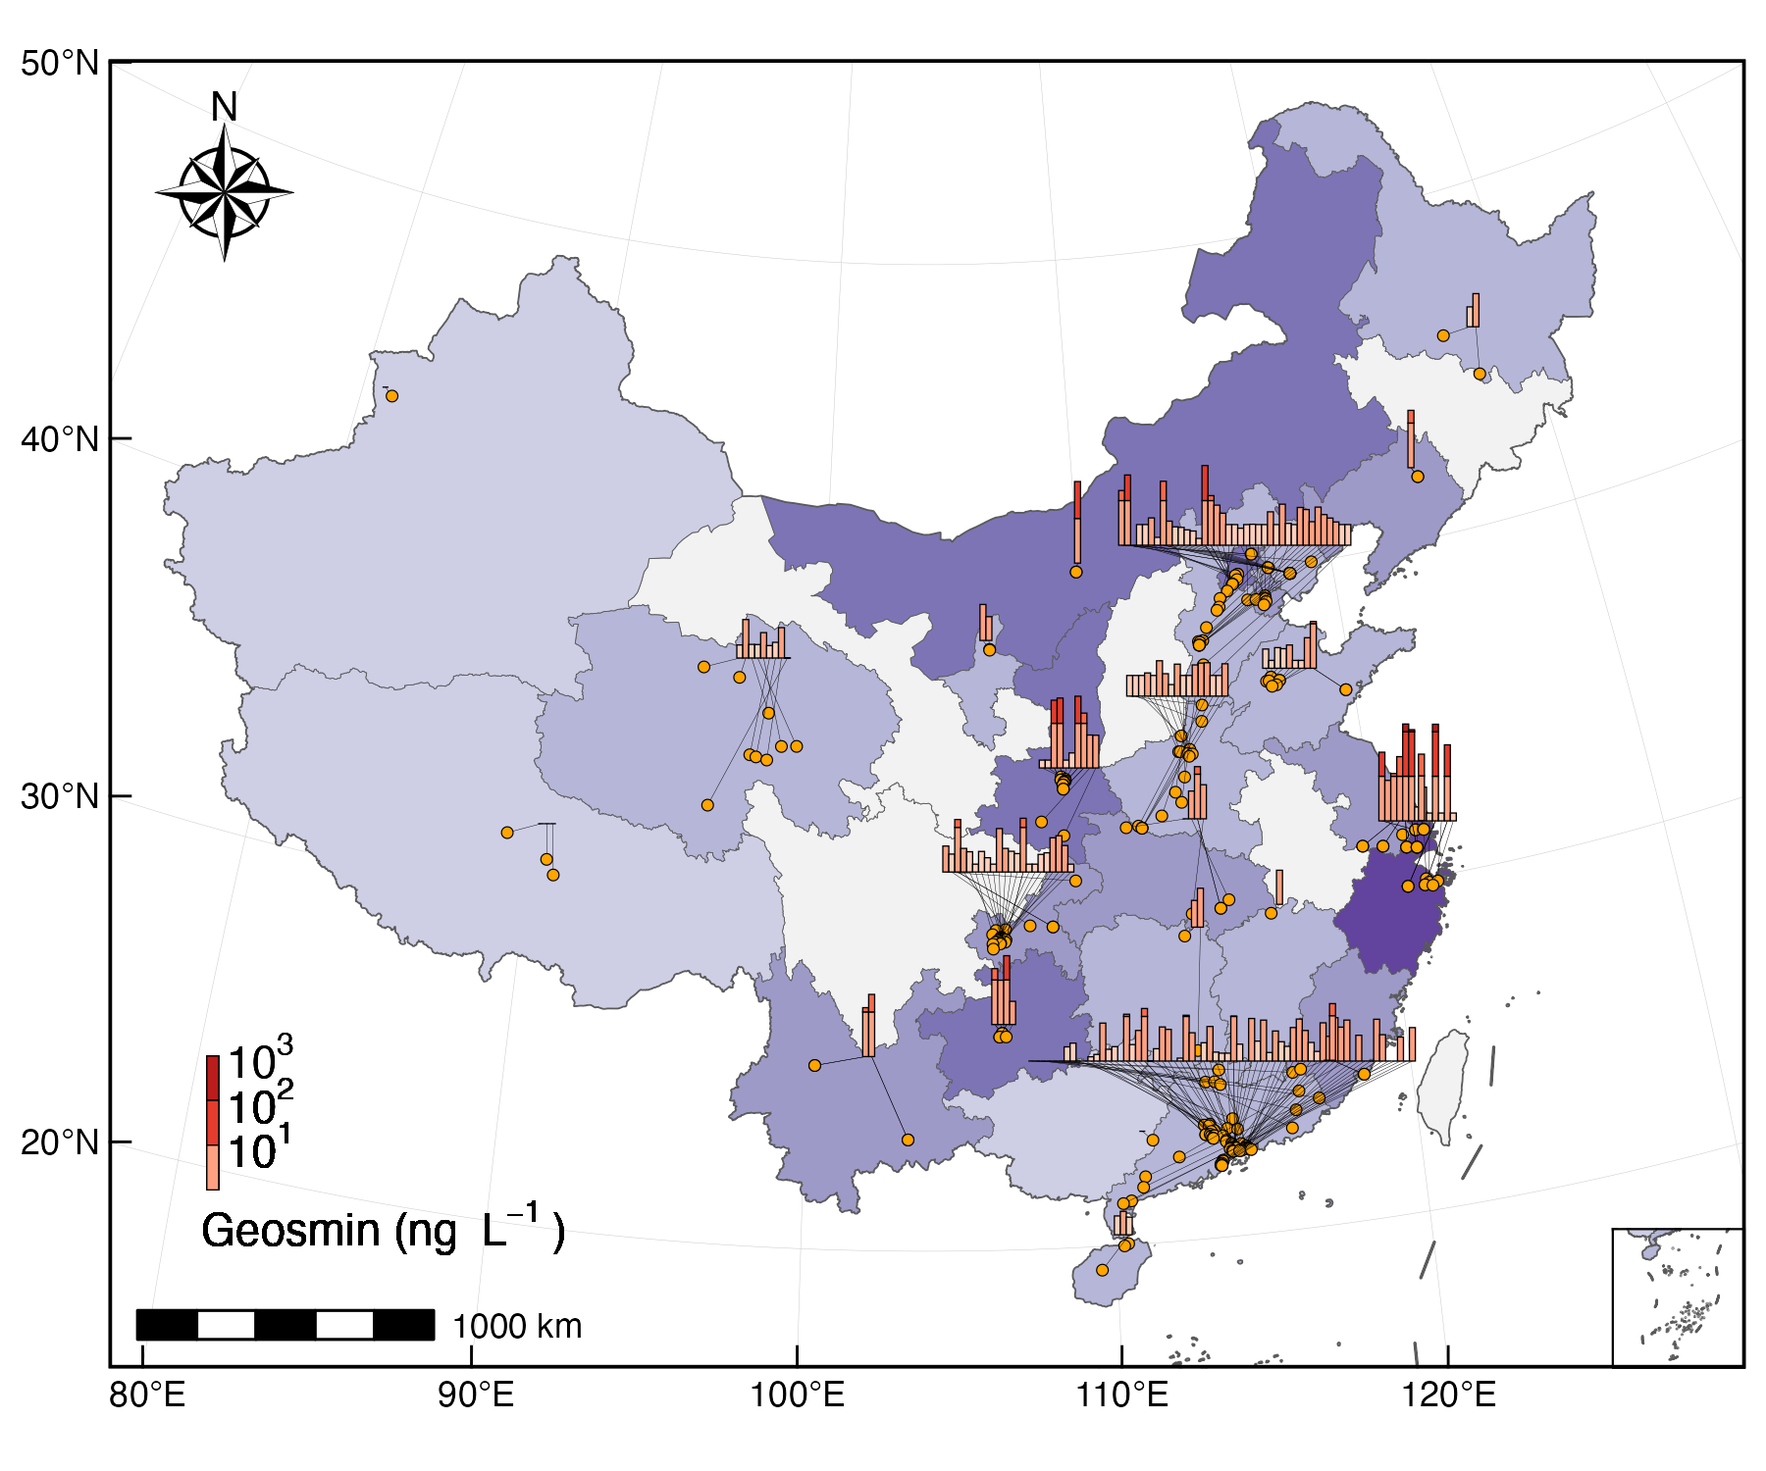
Fig. 1: A multi-scale visualization of geosmin occurrence: linking individual sampling sites to provincial-level aggregates (Provincial/regional aggregate bars (log-scale binned) connected to individual sampling sites. Beijing-Tianjin-Hebei and Jiangsu-Shanghai-Zhejiang are treated as single units to avoid spatial overlap).

Seasonal and interannual dynamics in Yuqiao Reservoir
To elucidate the temporal dynamics of geosmin occurrence, Yuqiao Reservoir (YQ, a key drinking water source in the Beijing-Tianjin-Hebei region) was selected for sustained, high-frequency monitoring at its primary water intake (site YQ01) from 2019 to 2024. The long-term record revealed a recurrent and pronounced seasonal cycle (Fig. 2A). Concentrations were consistently low (<5 ng L⁻¹) during spring (April–May), followed by a rapid increase in early summer (June) culminating in a primary peak during the warmest months (July–August). A second, broader peak persisted throughout autumn and early winter (October–December), after which levels gradually declined. The odor threshold of 10 ng L⁻¹ was frequently exceeded. Analysis of the monthly median concentrations across water years (May to April) showed that the threshold was surpassed during at least 40%* of the summer months (July–September) and 100% of the autumn/early winter months (October–December) during the monitoring period, highlighting a persistent odor risk in the warmer half of the year.
At the interannual scale (Fig. 2B, annual boxplots), geosmin concentrations exhibited a notable decreasing trend following an exceptionally high initial year. The median concentration in the 2019–2020 water year was 2.5 ng L⁻¹, substantially exceeding the threshold. Subsequently, from 2020 to 2024, annual median concentrations stabilized within a lower range of 5.2–10 ng L⁻¹. A Kruskal-Wallis test confirmed statistically significant differences among the annual datasets (χ²(4) = 64.3, p < 0.001). This trend suggests a potential shift in baseline conditions or source inputs after the initial monitoring year, though seasonal peaks remained a consistent feature of the reservoir’s annual cycle.
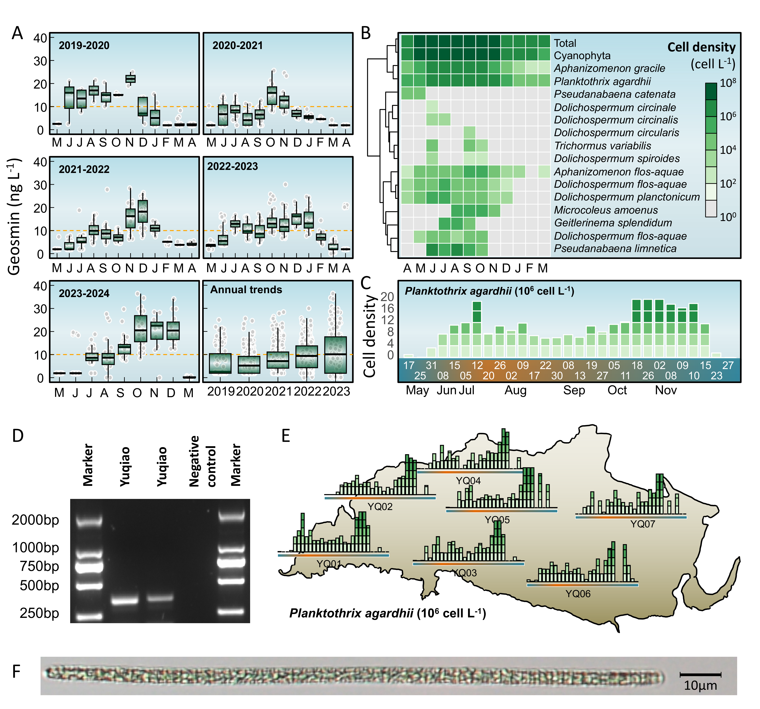
Fig. 2: Long-term dynamics of geosmin and phytoplankton community in Yuqiao Reservoir (2019–2024). (A) Seasonal and interannual variations in geosmin concentrations at the main water intake (site YQ01). (B) Heatmap showing monthly log10-transformed biomass of total phytoplankton, total cyanobacteria, and key geosmin-producing cyanobacterial genera. (C) Temporal patterns of Planktothrix agardhii biomass across sampling sites. (D) Agarose gel electrophoresis confirming the molecular identification of P. agardhii. (E) Spatial mapping of seasonal P. agardhii biomass variations at representative sampling sites overlaid on the reservoir map. (F) Microscopic image of P. agardhii filaments.

Phytoplankton community dynamics and key cyanobacterial genera
To investigate the relationship between geosmin occurrence and phytoplankton dynamics, high-resolution phytoplankton composition data from Yuqiao Reservoir (site YQ01, 2019–2024) were analyzed (Fig. 2B). The total phytoplankton biomass (expressed as log₁₀-transformed cell density) exhibited a clear seasonal pattern, with the lowest levels observed in winter (January–March, ~10⁷ cells L⁻¹) and a rapid increase beginning in spring (April). Biomass peaked during the summer months (July–September, >10⁸ cells L⁻¹), remained elevated through autumn (October–December), and then declined sharply in late winter, mirroring the general temporal trend of geosmin concentrations.
Cyanobacteria dominated the phytoplankton community throughout most of the year, contributing substantially to total biomass. Their seasonal trajectory closely followed that of total phytoplankton, with the highest cyanobacterial biomass recorded from June to October. Within the cyanobacterial assemblage, several filamentous genera known for potential geosmin production exhibited distinct seasonal successions. Planktothrix agardhii and Aphanizomenon gracile were perennial but showed clear seasonality, with biomass maxima in summer and autumn. Pseudanabaena catenata was primarily a spring (April–May) taxon. Several Dolichospermum species (including D. circinale, D. circinalis, D. flos-aquae, D. planctonicum, and D. spiroides) and Aphanizomenon flos-aquae typically emerged in late spring or early summer, proliferated during summer, and declined by late autumn. Other taxa, such as Trichormus variabilis, Dolichospermum circularis, Microcoleus amoenus, Geitlerinema splendidum, and Pseudanabaena limnetica, displayed more sporadic occurrences, often with pronounced peaks limited to specific months within the warm season (e.g., June–August).
The co-occurrence of elevated geosmin concentrations with periods of high cyanobacterial biomass, particularly during summer and autumn blooms dominated by known or putative geosmin-producing genera (e.g., Planktothrix, Aphanizomenon, Dolichospermum), suggests a strong biotic source for the observed odor episodes. The temporal succession of different cyanobacterial taxa may contribute to the characteristic bimodal (summer and autumn) geosmin peak observed in the reservoir.

Identification and spatiotemporal distribution of the primary geosmin producer
Planktothrix agardhii was identified as the dominant geosmin-producing cyanobacterium based on gene sequencing in Yuqiao Reservoir (Fig. 2D, 2F). Spatial monitoring during 2023 revealed a pronounced biomass gradient, with littoral sites (YQ03, YQ04, YQ06, YQ07) sustaining significantly higher cell densities than the central dam intake (YQ01). The maximum observed biomass reached 5.1×10⁷ cells L⁻¹ at a littoral site, compared to 2.9×10⁷ cells L⁻¹ at the dam. Elevated biomass thresholds (>2×10⁷ cells L⁻¹) were exceeded in 7% of littoral samples, respectively, but in 4% of dam samples. Temporally, P. agardhii exhibited a perennial presence with sustained warm-season biomass, contrasting with the ephemeral peaks of other cyanobacteria (Fig. 2C). Major bloom events (≥2×10⁷ cells L⁻¹) propagated from littoral zones to the dam (Fig. 2E), with sites such as YQ05 exceeding the threshold approximately 8 days before YQ01. This spatiotemporal pattern indicates littoral zones as initiation hotspots for P. agardhii proliferation, with subsequent advection likely driving geosmin peaks at the drinking water intake.
The temporal progression of major bloom events (biomass≥2×10⁷ cells L⁻¹) followed a clear spatial sequence from the littoral zone towards the dam. For instance, site YQ05 first exceeded this threshold in mid-October, approximately -8 days before the dam site (YQ01) reached comparable levels in late October. This spatiotemporal decoupling highlights the littoral zones as probable initiation hotspots for P. agardhii proliferation, with subsequent advection contributing to the geosmin peaks observed at the central water intake.

Distinct spatiotemporal patterns of two geosmin episodes
To further elucidate the spatiotemporal dynamics of geosmin (geosmin), we identified two distinct odor episodes in Yuqiao Reservoir (April–August and August–December 2023). Spatial mapping of monthly averaged geosmin concentrations at seven representative sites revealed contrasting patterns between the littoral and dam regions (Fig. 3).
During the first episode (April–August), littoral sites (YQ02, YQ03, YQ04, YQ06, YQ07) exhibited elevated concentrations in spring (April–June), with values ranging from 0 to 21.2 ng L⁻¹. These concentrations then declined by August to between 0.6 and 5.8 ng L⁻¹. In contrast, the central dam site (YQ01) and the nearby YQ05 (located close to littoral zones) showed a delayed response. Their concentrations started low in April (0 ng L⁻¹) and increased steadily, peaking in August at 8.5 ng L⁻¹.
The second episode (August–December) exhibited a reversed spatiotemporal pattern. Littoral sites experienced a sharp peak in October, with concentrations reaching 0 to 36.4 ng L⁻¹, followed by a decline to 0–29.8 ng L⁻¹ by December. Conversely, the dam site (YQ01) showed a sustained, monotonic increase from August (0 ng L⁻¹) to December (24.2 ng L⁻¹). Site YQ05, located between littoral and dam zones, exhibited an intermediate transitional pattern, with its decline beginning in November rather than October, further illustrating the spatiotemporal gradient from littoral production zones to the central reservoir.
These divergent spatiotemporal trajectories (Fig. 3) highlight a systematic decoupling: littoral zones consistently experience an earlier onset and subsequent decline during both odor episodes, while the dam region exhibits a delayed and prolonged response. This pattern likely reflects the integrated effects of initial production hotspots in the littoral zone and subsequent advective transport toward the central reservoir.
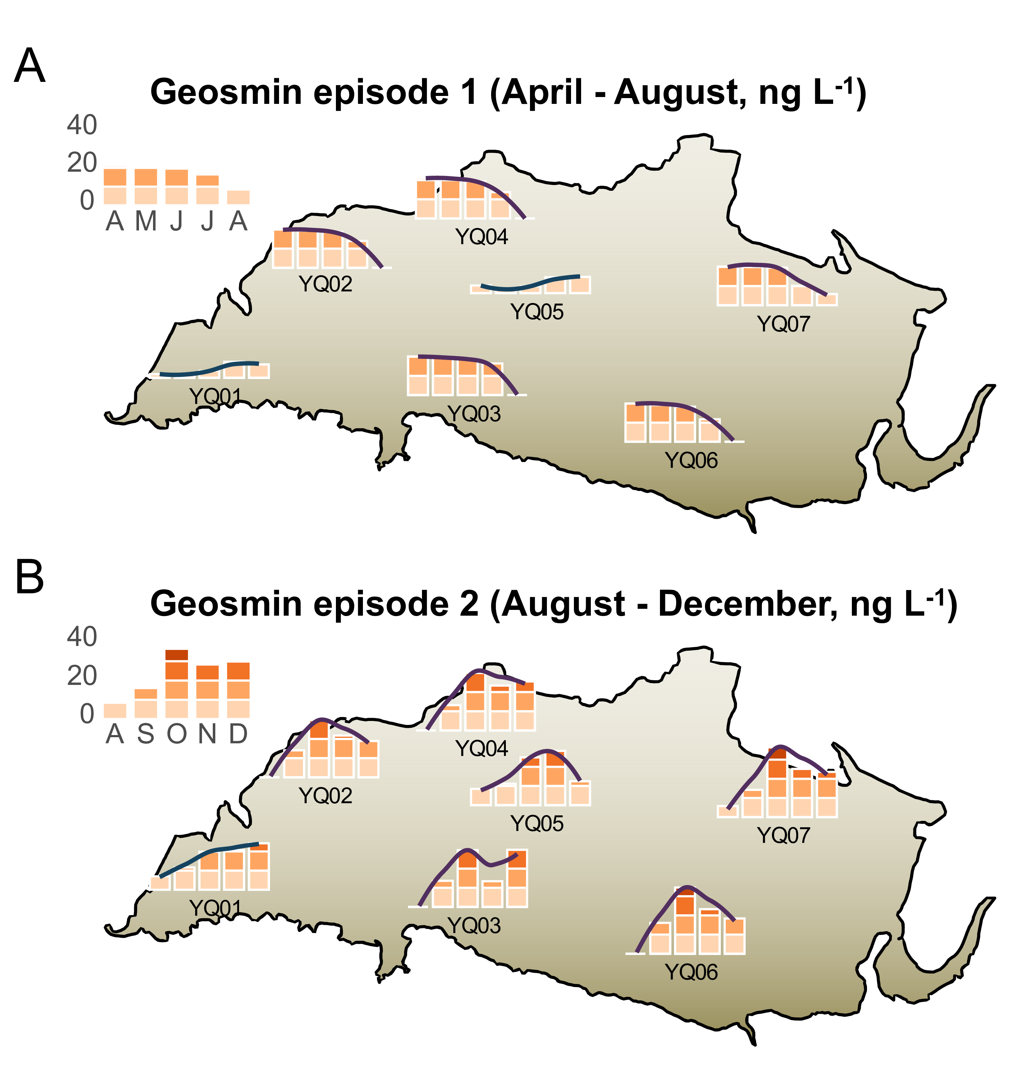
Fig. 3: Spatial mapping of monthly mean geosmin concentrations during Episode 1 (April–August, A) and Episode 2 (August–December, B) in Yuqiao Reservoir.

Predictive relationship between Planktothrix agardhii dynamics and geosmin episodes
To quantify the causal linkage between the primary producer and odor events, we performed time-lagged correlation analyses between Planktothrix agardhii biomass and geosmin (geosmin) concentrations at the near-littoral site YQ05 and the dam intake YQ01 (Fig. 4A). These sites were selected for their continuous long-term monitoring data. The analysis revealed fundamentally distinct temporal coupling patterns.
At the near-littoral site YQ05, the strongest correlation (R² = 0.5, p < 0.001) occurred at zero lag, indicating near-instantaneous geosmin production associated with local P. agardhii proliferation. The correlation coefficient decreased progressively as the lag period increased. Conversely, at the downstream dam site YQ01, the correlation was weakest at zero lag but strengthened with increasing lag time, reaching a maximum at a 5-week lag (R² = 0.41, p < 0.001). This opposite pattern demonstrates that P. agardhii biomass serves as a concurrent indicator at its production zone (YQ05) but as a leading indicator for geosmin risk at the distal water intake (YQ01).
Regression models were established at the respective optimal lag periods (Fig. 4B). For YQ05 (zero lag), the relationship was log₁₀(geosmin) = 0.24 + 0.29×log₁₀(P. agardhii biomass). For YQ01 (5-week lag), the model was log₁₀(geosmin) = 0.56 + 0.2×log₁₀(P. agardhii biomass). The steeper slope for YQ01 suggests a potential amplification effect during the transport and transformation processes from the littoral production zone to the central reservoir.
The distinct temporal phasing is visually evident in the bi-weekly time series (Fig. 4C). At YQ05, peaks in P. agardhii biomass and geosmin concentrations were closely synchronized. In contrast, at YQ01, biomass peaks consistently preceded major geosmin episodes by several weeks. For instance, the autumn biomass peak preceded the highest geosmin concentration by approximately 6.7 weeks. This consistent lag provides a critical early-warning window. When P. agardhii biomass at YQ05 exceeded 5.0×10⁷ cells L⁻¹, geosmin at YQ01 subsequently exceeded the 10 ng L⁻¹ odor threshold within 4-6 weeks in 61.9% of cases. These quantified relationships underscore the utility of near-littoral cyanobacterial monitoring for forecasting odor risks at the drinking water intake.
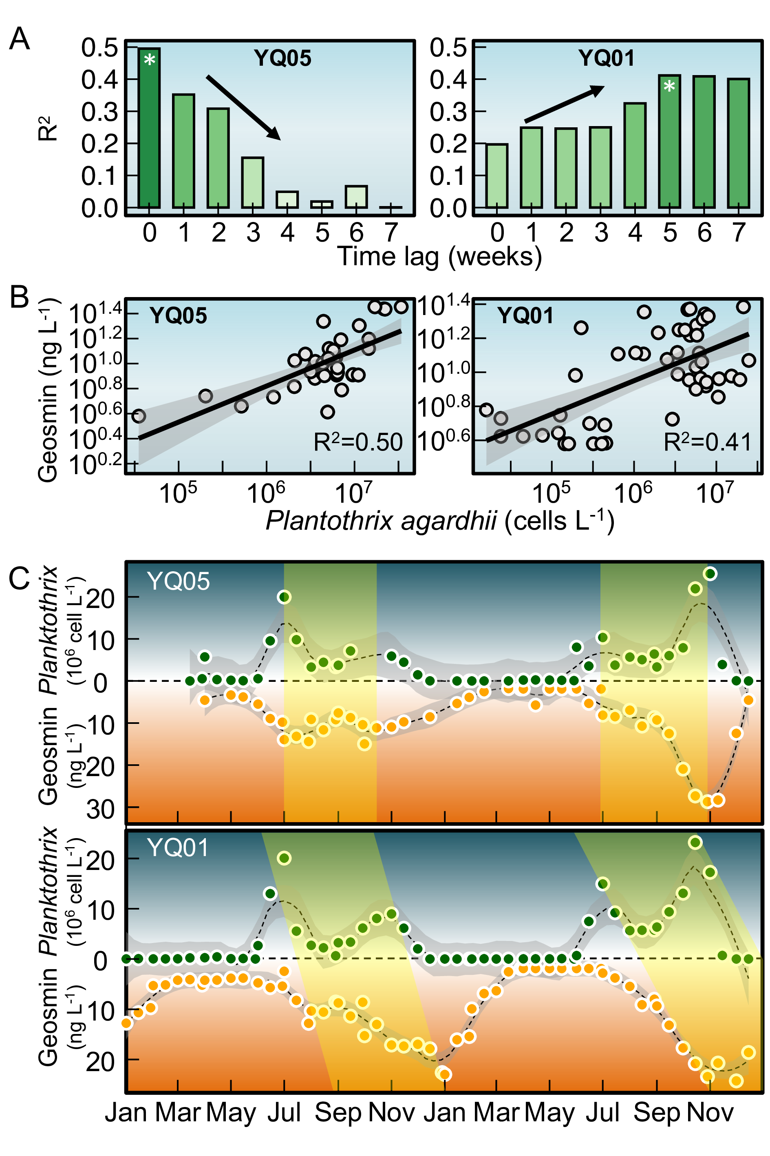
Fig. 4: Time-lagged relationships between Planktothrix agardhii biomass and geosmin concentrations at near-littoral and dam sites. (A) Correlation coefficients (R²) between P. agardhii biomass and geosmin at different lag periods (0–5 weeks) for site YQ05 (near-littoral) and YQ01 (dam intake). (B) Linear regression models at optimal lag periods: zero lag for YQ05 and 5-week lag for YQ01. (C) Scatter plots with fitted regression lines showing the quantitative relationships between P. agardhii biomass and geosmin at each site.

Environmental drivers of geosmin and proposed transport pathway
Principal component analysis (PCA) of key environmental variables identified ammonia (NH₄⁺-N) as the most strongly correlated factor with geosmin (geosmin) variation in the PC1–PC2 plane (Fig. 5A). The first two principal components explained 60.6% of the total variance. PC1 (explaining 43.5%) represented a thermal‑nutrient productivity axis, with high loadings from temperature (0.342), total phosphorus (TP, 0.39), and chlorophyll‑a (Chl‑a, 0.428). PC2 (explaining 17.1%) represented a nitrogen availability axis, dominated by ammonia (-0.449) and total nitrogen (TN, 0.432). geosmin exhibited moderate positive loadings on both PC1 (0.122) and PC2 (0.229), indicating that its variability was jointly influenced by thermal‑nutrient conditions and nitrogen availability.
To examine this relationship spatially, we performed log‑log regressions between ammonia and geosmin across three reservoir zones: littoral sites (YQ02–YQ04, YQ06–YQ07), the transitional near‑littoral site (YQ05), and the central dam intake (YQ01) (Fig. 5B). The correlation strength followed a distinct gradient, with the highest R² at littoral sites (0.365), intermediate at YQ05 (0.203), and lowest at YQ01 (0.035). This pattern indicates that the linkage between ammonia and geosmin is most direct within littoral production zones and becomes progressively decoupled along the transport pathway toward the dam.
Integrating these findings with the spatiotemporal dynamics of Planktothrix agardhii and geosmin, we propose a conceptual transport pathway for odor episodes (Fig. 5C). High‑resolution bathymetric mapping shows that shallow littoral areas (depths < 4–5 m) correspond to zones of elevated ammonia and serve as initiation hotspots for P. agardhii proliferation and geosmin production. Subsequent advective transport, guided by the reservoir’s hydrodynamic circulation, gradually propagates cells and dissolved geosmin from littoral zones through the transitional region (YQ05) to the central dam area (YQ01). This conceptual model synthesizes three key observations: (1) the spatial gradient in ammonia‑geosmin coupling, (2) the consistent temporal lags in cyanobacterial biomass and geosmin peaks between littoral and dam sites, and (3) the influence of bathymetry on water residence times. Together, these elements provide a mechanistic framework for understanding the origin, transport, and delayed manifestation of geosmin episodes at the drinking‑water intake of Yuqiao Reservoir.
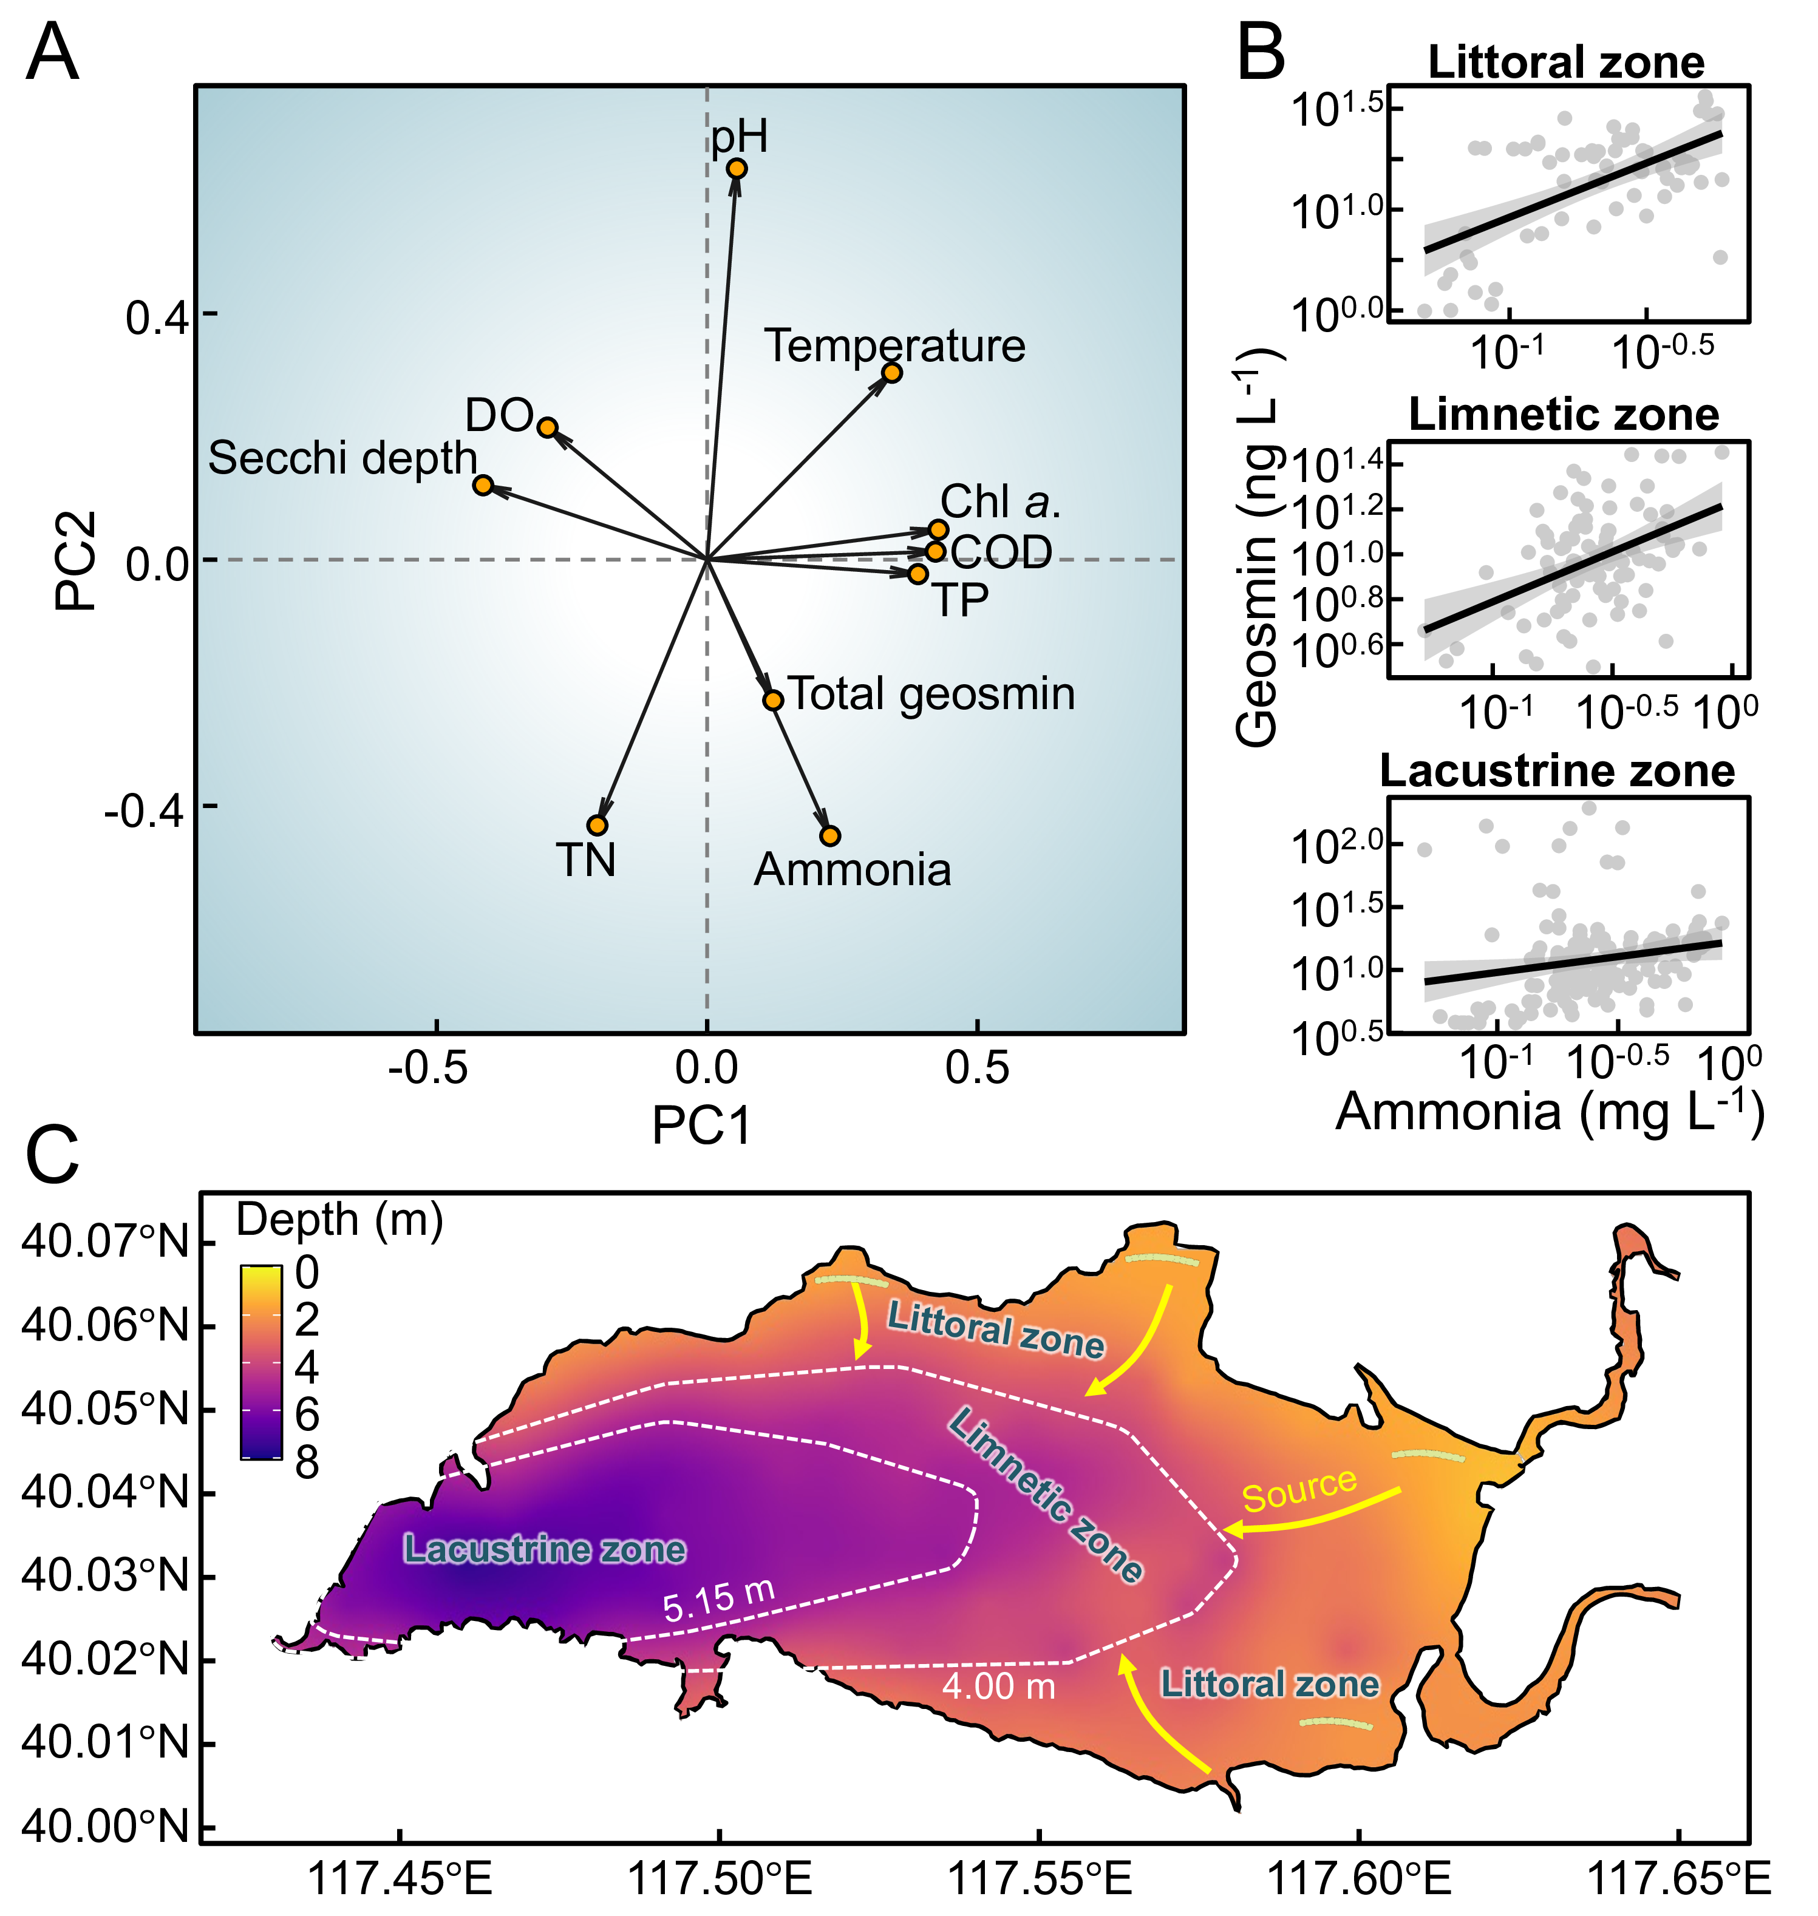
Fig. 5: Environmental drivers and conceptual transport pathway of geosmin in Yuqiao Reservoir. (A) Principal component analysis (PCA) biplot showing relationships between geosmin and key environmental variables. (B) Log-log regressions between ammonia concentration and geosmin across littoral, transitional (YQ05), and dam (YQ01) zones. (C) Bathymetric map of Yuqiao Reservoir depicting the proposed transport pathway from littoral production zones to the central water intake.

Discussion

Geosmin as a prevalent challenge for drinking water security in China
Our nationwide survey reveals that geosmin contamination is widespread across China’s major drinking water sources, with 14% of the surveyed sites exceeding the common odor threshold of 10 ng L⁻¹ (⁴⁴). This finding underscores geosmin as a significant and pervasive water quality issue, corroborating similar reports from diverse climatic regions globally^{21,52}. The pronounced spatial heterogeneity—marked by elevated concentrations in eastern and southern regions such as the Yangtze River Delta and Pearl River Delta—suggests that regional factors, including climate, watershed land use, and nutrient loading patterns, are critical drivers of geosmin risk. The compound’s low odor threshold and resistance to conventional treatment^{29,38,53} pose substantial challenges for water utilities²⁸, directly impacting consumer acceptance and compliance with water safety objectives linked to Sustainable Development Goal 6⁵⁴. The economic ramifications are considerable, driving investments in advanced treatment technologies and proactive management strategies worldwide⁵⁵.

Littoral zones as production hotspots: ecological mechanisms and spatiotemporal decoupling
Actinomycetes are recognized as major biotic sources of taste-and-odor compounds, including geosmin and 2‑MIB, in soils and freshwater sediments^{56–59}. In the present study, however, synchronous peaks of Planktothrix agardhii biomass and geosmin concentrations—particularly at littoral sites with zero‑lag correlation (R² = 0.5)—together with the molecular identification of P. agardhii as the dominant geosmin producer via gene sequencing of GeoA gene and isolation (Fig. 2D, Fig. 2F), strongly indicate cyanobacterial origin. This aligns with a growing body of evidence that cyanobacteria constitute the primary biotic source of such odorants in many freshwater systems^{50,60–64}. While actinomycetes in sediments are known geosmin producers, their contribution in well‑oxygenated water columns of managed reservoirs like Yuqiao is likely secondary. We argue that detection of geoA‑harboring cyanobacteria^{51,65,66} in a well‑oxygenated water body provides compelling evidence that geosmin is primarily derived from cyanobacterial activity. This view is consistent with studies linking specific cyanobacterial blooms to geosmin episodes in drinking‑water reservoirs worldwide^{67–69}.
The sustained monitoring in Yuqiao Reservoir elucidates littoral zones as critical ecological niches for the proliferation of geosmin-producing cyanobacteria, particularly Planktothrix agardhii. The distinct spatiotemporal patterns—earlier onset, higher biomass, and stronger correlation with ammonia in littoral areas—highlight a production-transport decoupling central to reservoir-wide odor episodes. The affinity of filamentous cyanobacteria like P. agardhii for littoral environments can be attributed to several adaptive traits. Their filamentous morphology confers advantages in shallow, intermittently mixed waters through regulated buoyancy and reduced sedimentation losses, enabling optimal positioning for light harvesting^{70,71}. This is complemented by low-light adaptations via phycobiliprotein pigments^{72,73}, allowing persistence under the variable light regimes typical of littoral zones^{35,74}. Furthermore, the strong correlation observed between ammonia and geosmin specifically in littoral sites (R² = 0.37) suggests that nitrogen availability, likely influenced by shoreline inputs, is a key regulatory factor for production in these zones. In contrast, the weakened correlation at the dam intake (R² = 0.03) reflects the integration and modification of signals during transport.
The systematic spatial decoupling is evidenced by the consistent 8-day lag in major bloom events between littoral sites and the dam. This lag represents not merely physical advection but may also involve continued metabolic activity and potential accumulation in transitional zones. These findings challenge conventional reservoir management focused predominantly on pelagic or intake monitoring and align with growing recognition of nearshore areas as initiation sites for cyanobacterial metabolites.

Towards a proactive monitoring paradigm: quantitative predictive tools
The conceptual model depicted in Fig. 6 synthesizes the spatiotemporal mechanism underpinning our proposed management shift. It illustrates that the highest metabolic activity of geosmin-producing cyanobacteria is concentrated in littoral zones, driven by localized nutrient inputs and favorable physical conditions³⁵. The geosmin produced in these hotspots is subsequently advected through the limnetic zone, resulting in a distinct transport lag before it accumulates in the lacustrine zone and reaches the dam intake. This hydro-ecological sequence reveals a critical flaw in conventional, intake-centric monitoring⁷⁵: by the time geosmin is detected at the dam, its impact on treatment is immediate, leaving minimal time for preventive intervention³⁸. This flaw is particularly acute for cyanobacteria, which can undergo rapid exponential growth, leading to sudden, log‑phase surges in metabolite concentrations that overwhelm conventional response protocols⁷⁶.
To capitalize on the inherent early-warning signal embedded within this process, we propose a tiered monitoring framework comprising: (1) sentinel stations in representative littoral zones for early detection of producer biomass, (2) gradient stations along the main transport pathway to track bloom progression, and (3) final verification at the intake. By shifting the primary monitoring focus upstream to the production source, utilities gain the crucial 4–6 week lead time—quantified by our lagged correlation analysis (R² = 0.41 at 5 weeks)—necessary to detect incipient risk during the early growth phase, well before the problematic log‑phase surge. This lead time enables the implementation of preventive measures—such as optimized reservoir operation^{39,77,78}, selective withdrawal, or pre‑emptive treatment adjustments—that can effectively disrupt the progression from initial proliferation to full‑blown water quality crisis. Thereby, the majority of algal‑derived contamination events, which are characterized by their sudden onset, can be anticipated and mitigated at source, rather than reacted to after the fact. This concept aligns with the growing emphasis on source water protection and early-warning systems in water security management⁷⁹.
This transformation from a reactive to a predictive paradigm fundamentally redefines resilience. It moves beyond merely coping with crises to preventing them, which can significantly reduce treatment costs, minimize service disruptions, and safeguard public trust in the water supply. Proactive monitoring of littoral sentinel sites is not merely an added layer of surveillance; it is a strategic re‑allocation of resources to intercept algal‑derived risks at their earliest, most manageable stage.
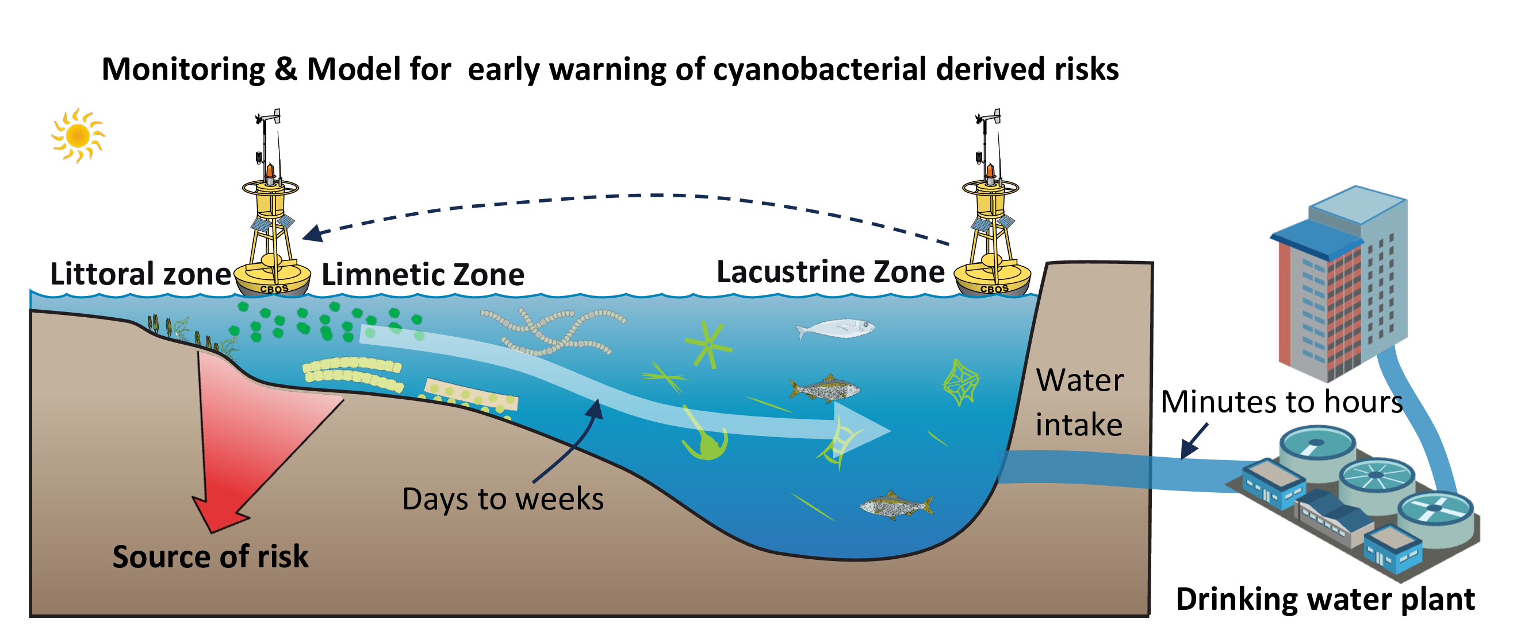
Fig. 6: Conceptual model of littoral-initiated geosmin transport and its implications for monitoring strategy. A sketch illustrating the spatiotemporal progression of geosmin episodes: (1) high metabolic activity of cyanobacteria (e.g., Planktothrix agardhii) in the littoral zone, driven by nutrient inputs and favorable light conditions; (2) advection of produced geosmin and biomass into the limnetic zone, resulting in a transport lag; (3) accumulation of geosmin in the lacustrine zone (dam intake), posing an immediate treatment challenge; and (4) the proposed monitoring shift from conventional reactive intake-focused sampling to proactive early detection in littoral zones, providing critical warning time for preventive measures.

Implications, limitations, and future perspectives
This study provides mechanistic insights into geosmin dynamics in a drinking water reservoir and translates them into practical monitoring tools. The identification of littoral zones as production hotspots and the quantification of time-lagged predictive relationships offer a blueprint for evidence-based management.
Several limitations should be acknowledged. First, while the 4–6 year dataset captures clear seasonal and interannual patterns, longer-term monitoring would strengthen the understanding of trends, particularly under climate change scenarios. Second, the dominant role of P. agardhii is specific to Yuqiao Reservoir; other systems may harbor different producer taxa (e.g., Dolichospermum, Aphanizomenon) with distinct ecological drivers^{50,80,81}. Third, the predictive models require validation across diverse reservoir types and geographical settings to assess their broader applicability.
Future research should focus on: (1) integrating molecular tools to characterize the diversity and expression of geosmin synthesis genes within cyanobacterial communities, (2) coupling ecological monitoring with high-resolution hydrodynamic modeling to precisely quantify transport pathways and residence times, and (3) conducting cost-benefit analyses to evaluate the economic viability of implementing expanded littoral monitoring programs. Furthermore, investigating the interactions between climate variables (e.g., warming, extreme precipitation) and the identified production-transport mechanisms will be crucial for forecasting future risk scenarios. By unraveling the spatiotemporal mechanisms of geosmin production and transport, and by establishing quantifiable early-warning indicators, this work provides a scientific foundation for moving beyond reactive response. It equips water managers with a proactive strategy to safeguard drinking water quality against this persistent olfactory challenge.

Conclusions
This study delineates a coherent spatiotemporal mechanism for geosmin episodes in Yuqiao Reservoir, integrating landscape-scale drivers, in-reservoir ecological processes, and predictive management tools. The nationwide survey confirms geosmin as a pervasive challenge across China’s drinking water sources, establishing a critical context for reservoir-specific management. Within Yuqiao, littoral zones function as critical production hotspots, where Planktothrix agardhii—identified as the dominant producer—proliferates in response to local nutrient conditions, particularly ammonia. The subsequent advective transport of biomass and metabolite creates a systematic spatiotemporal decoupling, manifested as a consistent 4–6 week lag between littoral proliferation and geosmin peaks at the dam intake. This mechanistic understanding enables a paradigm shift from reactive to proactive management. The established quantitative relationship, where littoral P. agardhii biomass serves as a leading indicator, provides an operational early-warning window. By shifting the monitoring focus upstream to littoral sentinel sites, water utilities can implement timely interventions, thereby enhancing the security and reliability of drinking water supplies against this persistent olfactory threat.

FIGURES
- Fig. 1: A multi-scale visualization of geosmin occurrence: linking individual sampling sites to provincial-level aggregates (Provincial/regional aggregate bars (log-scale binned) connected to individual sampling sites. Beijing-Tianjin-Hebei and Jiangsu-Shanghai-Zhejiang are treated as single units to avoid spatial overlap).
- Fig. 2: Long-term dynamics of geosmin and phytoplankton community in Yuqiao Reservoir (2019–2024). (A) Seasonal and interannual variations in geosmin concentrations at the main water intake (site YQ01). (B) Heatmap showing monthly log10-transformed biomass of total phytoplankton, total cyanobacteria, and key geosmin-producing cyanobacterial genera. (C) Temporal patterns of Planktothrix agardhii biomass across sampling sites. (D) Agarose gel electrophoresis confirming the molecular identification of P. agardhii. (E) Spatial mapping of seasonal P. agardhii biomass variations at representative sampling sites overlaid on the reservoir map. (F) Microscopic image of P. agardhii filaments.
- Fig. 3: Spatial mapping of monthly mean geosmin concentrations during Episode 1 (April–August, A) and Episode 2 (August–December, B) in Yuqiao Reservoir.
- Fig. 4: Time-lagged relationships between Planktothrix agardhii biomass and geosmin concentrations at near-littoral and dam sites. (A) Correlation coefficients (R²) between P. agardhii biomass and geosmin at different lag periods (0–5 weeks) for site YQ05 (near-littoral) and YQ01 (dam intake). (B) Linear regression models at optimal lag periods: zero lag for YQ05 and 5-week lag for YQ01. (C) Scatter plots with fitted regression lines showing the quantitative relationships between P. agardhii biomass and geosmin at each site.
- Fig. 5: Environmental drivers and conceptual transport pathway of geosmin in Yuqiao Reservoir. (A) Principal component analysis (PCA) biplot showing relationships between geosmin and key environmental variables. (B) Log-log regressions between ammonia concentration and geosmin across littoral, transitional (YQ05), and dam (YQ01) zones. (C) Bathymetric map of Yuqiao Reservoir depicting the proposed transport pathway from littoral production zones to the central water intake.
- Fig. 6: Conceptual model of littoral-initiated geosmin transport and its implications for monitoring strategy. A sketch illustrating the spatiotemporal progression of geosmin episodes: (1) high metabolic activity of cyanobacteria (e.g., Planktothrix agardhii) in the littoral zone, driven by nutrient inputs and favorable light conditions; (2) advection of produced geosmin and biomass into the limnetic zone, resulting in a transport lag; (3) accumulation of geosmin in the lacustrine zone (dam intake), posing an immediate treatment challenge; and (4) the proposed monitoring shift from conventional reactive intake-focused sampling to proactive early detection in littoral zones, providing critical warning time for preventive measures.

ASSOCIATED CONTENT

Supporting Information
The Supporting Information is available free of charge at https://.
The Supporting Information provides comprehensive datasets, experimental details, and supplementary analyses supporting the main text, including: The nutrient concentrations difference in surveyed 43 reservoirs (Fig. S1); The phytoplankton composition and basic sediment characteristics in ten representative reservoirs (Figs. S2-S3); Temporal dynamics of Microcystis density and dissolved metals during formal sediment resuspension (SR) experiments (Figs. S4-S8); Predictive modeling of SR performance across reservoirs with varying sediment reactivity and particle size structures (Fig. S9); Temporal dynamics of dissolved metals during in-situ SR operation (Fig. S10); Relationships between physicochemical properties and algal removal performance of air‐dried sediments during 72‐h settling pre-experiments (Fig. S11); Sediment physicochemical properties, Microcystis removal efficiency, and dissolved heavy metals dynamics during the second preliminary SR experiments (Tables S1–S2; Figs. S12-S13); Scanning electron microscopy (SEM) images and real image illustrating Microcystis–sediment floc formation (Figs. S14-S15); and references (PDF).

AUTHOR INFORMATION

Corresponding Authors
- Ming Su: 1. Key Laboratory of Environmental Aquatic Chemistry, State Key Laboratory of Regional Environment and Sustainability, Research Center for Eco-Environmental Sciences, Chinese Academy of Sciences, Beijing 100085, China; 2. University of Chinese Academy of Sciences, Beijing 100049, China ORCID: 0000-0001-9821-1268; URL: https://drwater.net/team/ming-su/; Email: mingsu@rcees.ac.cn

Authors
- Yuying Gui: 1. College of Environmental Science and Engineering, Ocean University of China, No. 238 Songling Road, Qingdao, 266100, China; 2. Key Laboratory of Environmental Aquatic Chemistry, State Key Laboratory of Regional Environment and Sustainability, Research Center for Eco-Environmental Sciences, Chinese Academy of Sciences, Beijing 100085, China
- Tengxin Cao: 1. Key Laboratory of Environmental Aquatic Chemistry, State Key Laboratory of Regional Environment and Sustainability, Research Center for Eco-Environmental Sciences, Chinese Academy of Sciences, Beijing 100085, China; 2. University of Chinese Academy of Sciences, Beijing 100049, China
- Jie Yang: Tianjin Hydraulic Research Institute, No. 60 Youyi Road, Hexi District, Tianjin, 300061, China
- Ziyi Yang: 1. Key Laboratory of Environmental Aquatic Chemistry, State Key Laboratory of Regional Environment and Sustainability, Research Center for Eco-Environmental Sciences, Chinese Academy of Sciences, Beijing 100085, China; 2. University of Chinese Academy of Sciences, Beijing 100049, China
- Qi Zhang: Institute of Hydrobiology, Chinese Academy of Sciences, 7 Donghu South Road, Wuchang District, Wuhan, 430070, China
- Lin Sun: Tianjin Key Laboratory of Animal and Plant Resistance, College of Life Sciences, Tianjin Normal University, Binshui West Road 393, Xiqing District, Tianjin, 300387, China
- Yufan Ai: 1. Key Laboratory of Environmental Aquatic Chemistry, State Key Laboratory of Regional Environment and Sustainability, Research Center for Eco-Environmental Sciences, Chinese Academy of Sciences, Beijing 100085, China; 2. University of Chinese Academy of Sciences, Beijing 100049, China
- Jiao Fang: 1. School of Environment and Spatial Informatics, China University of Mining and Technology, No. 1 Daxue Road, Xuzhou, 221116, China; 2. Key Laboratory of Environmental Aquatic Chemistry, State Key Laboratory of Regional Environment and Sustainability, Research Center for Eco-Environmental Sciences, Chinese Academy of Sciences, Beijing 100085, China
- Yingjie Li: 1. Key Laboratory of Environmental Aquatic Chemistry, State Key Laboratory of Regional Environment and Sustainability, Research Center for Eco-Environmental Sciences, Chinese Academy of Sciences, Beijing 100085, China; 2. University of Chinese Academy of Sciences, Beijing 100049, China

Author contributions
Yuying Gui (Equal contributor) and Tengxin Cao (Equal contributor) jointly contributed to methodology design and formal analysis. Yuying Gui also provided support from Ocean University of China. Jie Yang contributed to conceptualization and methodology. Ming Su (Corresponding Author) led conceptualization, formal analysis, and visualization, and was responsible for original draft writing, manuscript editing, project administration, and supervision. Ziyi Yang, Qi Zhang and Lin Sun provided methodology support from their respective institutes. Yufan Ai and Yingjie Li assisted in methodology and formal analysis. Min Yang provided supervision and supported the project coordination from the Research Center for Eco-Environmental Sciences.

Notes
The authors declare no competing financial interest.

Acknowledgements
This work was financially supported by the National Natural Science Foundation of China (52030002, 51878649), and Youth Innovation Promotion Association CAS.

References
(1) Huisman, J.; Codd, G. A.; Paerl, H. W.; Ibelings, B. W.; Verspagen, J. M. H.; Visser, P. M. Cyanobacterial Blooms. Nature Reviews Microbiology 2018, 16 (8), 471–483. https://doi.org/10.1038/s41579-018-0040-1.
(2) Paerl, H. W.; Fulton, R. S.; Moisander, P. H.; Dyble, J. Harmful Freshwater Algal Blooms, with an Emphasis on Cyanobacteria. The Scientific World Journal 2001, 1, 76–113. https://doi.org/10.1100/tsw.2001.16.
(3) Heisler, J.; Glibert, P. M.; Burkholder, J. M.; Anderson, D. M.; Cochlan, W.; Dennison, W. C.; Dortch, Q.; Gobler, C. J.; Heil, C. A.; Humphries, E.; Lewitus, A.; Magnien, R.; Marshall, H. G.; Sellner, K.; Stockwell, D. A.; Stoecker, D. K.; Suddleson, M. Eutrophication and Harmful Algal Blooms: A Scientific Consensus. Harmful Algae 2008, 8 (1), 3–13. https://doi.org/10.1016/j.hal.2008.08.006.
(4) Feng, L.; Dai, Y.; Hou, X.; Xu, Y.; Liu, J.; Zheng, C. Concerns about Phytoplankton Bloom Trends in Global Lakes. Nature 2021, 590 (7846), E35–E47. https://doi.org/10.1038/s41586-021-03254-3.
(5) Woolway, R. I.; Kraemer, B. M.; Lenters, J. D.; Merchant, C. J.; O’Reilly, C. M.; Sharma, S. Global Lake Responses to Climate Change. Nature Reviews Earth &amp; Environment 2020, 1 (8), 388–403. https://doi.org/10.1038/s43017-020-0067-5.
(6) Paerl, H. W.; Paul, V. J. Climate Change: Links to Global Expansion of Harmful Cyanobacteria. Water Research 2012, 46 (5), 1349–1363. https://doi.org/10.1016/j.watres.2011.08.002.
(7) O’neil, J. m.; Davis, T. w.; Burford, M. a.; Gobler, C. j. The Rise of Harmful Cyanobacteria Blooms: The Potential Roles of Eutrophication and Climate Change. Harmful Algae 2012, 14 (0), 313–334. https://doi.org/10.1016/j.hal.2011.10.027.
(8) Rousso, B. Z.; Bertone, E.; Stewart, R.; Hamilton, D. P. A Systematic Literature Review of Forecasting and Predictive Models for Cyanobacteria Blooms in Freshwater Lakes. Water Research 2020, 182, 115959. https://doi.org/10.1016/j.watres.2020.115959.
(9) Zhang, Y.; Whalen, J. K.; Cai, C.; Shan, K.; Zhou, H. Harmful Cyanobacteria-Diatom/Dinoflagellate Blooms and Their Cyanotoxins in Freshwaters: A Nonnegligible Chronic Health and Ecological Hazard. Water Research 2023, 233, 119807. https://doi.org/10.1016/j.watres.2023.119807.
(10) Martinez i Quer, A.; Larsson, Y.; Johansen, A.; Arias, C. A.; Carvalho, P. N. Cyanobacterial Blooms in Surface Waters – Nature-Based Solutions, Cyanotoxins and Their Biotransformation Products. Water Research 2024, 251, 121122. https://doi.org/10.1016/j.watres.2024.121122.
(11) Reinl, K. L.; Harris, T. D.; Elfferich, I.; Coker, A.; Zhan, Q.; Domis, L. N. D. S.; Morales-Williams, A. M.; Bhattacharya, R.; Grossart, H.-P.; North, R. L.; Sweetman, J. N. The Role of Organic Nutrients in Structuring Freshwater Phytoplankton Communities in a Rapidly Changing World. Water Research 2022, 219, 118573. https://doi.org/10.1016/j.watres.2022.118573.
(12) Xu, H.; Paerl, H. W.; Qin, B.; Zhu, G.; Gaoa, G. Nitrogen and Phosphorus Inputs Control Phytoplankton Growth in Eutrophic Lake Taihu, China. Limnology and Oceanography 2009, 55 (1), 420–432. https://doi.org/10.4319/lo.2010.55.1.0420.
(13) Paerl, H. W.; Xu, H.; Mccarthy, M. J.; Zhu, G.; Qin, B.; Li, Y.; Gardner, W. S. Controlling Harmful Cyanobacterial Blooms in a Hyper-Eutrophic Lake (Lake Taihu, China): The Need for a Dual Nutrient (n & p) Management Strategy. Water Research 2011, 45 (5), 1973–1983. https://doi.org/10.1016/j.watres.2010.09.018.
(14) Kosten, S.; Huszar, V. L. M.; Bécares, E.; Costa, L. S.; Donk, E. van; Hansson, L.; Jeppesen, E.; Kruk, C.; Lacerot, G.; Mazzeo, N.; De Meester, L.; Moss, B.; Lürling, M.; Nõges, T.; Romo, S.; Scheffer, M. Warmer Climates Boost Cyanobacterial Dominance in Shallow Lakes. Global Change Biology 2011, 18 (1), 118–126. https://doi.org/10.1111/j.1365-2486.2011.02488.x.
(15) Plaas, H. E.; Paerl, H. W. Toxic Cyanobacteria: A Growing Threat to Water and Air Quality. Environmental Science &amp; Technology 2020, 55 (1), 44–64. https://doi.org/10.1021/acs.est.0c06653.
(16) Carmichael, W. W.; Azevedo, S. M.; An, J. S.; Molica, R. J.; Jochimsen, E. M.; Lau, S.; Rinehart, K. L.; Shaw, G. R.; Eaglesham, G. K. Human Fatalities from Cyanobacteria: Chemical and Biological Evidence for Cyanotoxins. Environmental Health Perspectives 2001, 109 (7), 663–668. https://doi.org/10.1289/ehp.01109663.
(17) LEFLAIVE, J.; TEN‐HAGE, L. Algal and Cyanobacterial Secondary Metabolites in Freshwaters: A Comparison of Allelopathic Compounds and Toxins. Freshwater Biology 2007, 52 (2), 199–214. https://doi.org/10.1111/j.1365-2427.2006.01689.x.
(18) Merel, S.; Walker, D.; Chicana, R.; Snyder, S.; Baurès, E.; Thomas, O. State of Knowledge and Concerns on Cyanobacterial Blooms and Cyanotoxins. Environment International 2013, 59, 303–327. https://doi.org/10.1016/j.envint.2013.06.013.
(19) Burlingame, G. A.; Doty, R. L.; Dietrich, A. M. Humans as Sensors to Evaluate Drinking Water Taste and Odor: A Review. Journal AWWA 2017, 109 (11), 13–24. https://doi.org/10.5942/jawwa.2017.109.0118.
(20) Su, M.; Yu, J.; Zhang, J.; Chen, H.; An, W.; Vogt, R. D.; Andersen, T.; Jia, D.; Wang, J.; Yang, M. MIB-Producing Cyanobacteria (Planktothrix Sp.) in a Drinking Water Reservoir: Distribution and Odor Producing Potential. Water Research 2015, 68, 444–453. https://doi.org/10.1016/j.watres.2014.09.038.
(21) Lin, T.-F.; Watson, S.; Suffet, I. H. M. Taste and Odour in Source and Drinking Water: Causes, Controls, and Consequences; IWA Publishing, 2018.
(22) Yang, M.; Yu, J.; Li, Z.; Guo, Z.; Burch, M.; Lin, T. Taihu Lake Not to Blame for Wuxi’s Woes. Science 2008, 319 (5860), 158. https://doi.org/10.1126/science.319.5860.158a.
(23) Sun, D.; Yu, J.; Yang, M.; An, W.; Zhao, Y.; Lu, N.; Yuan, S.; Zhang, D. Occurrence of Odor Problems in Drinking Water of Major Cities Across China. Frontiers of Environmental Science & Engineering 2014, 8 (3), 411–416. https://doi.org/10.1007/s11783-013-0577-1.
(24) Mehnert, G.; Leunert, F.; Cires, S.; Johnk, K. D.; Rucker, J.; Nixdorf, B.; Wiedner, C. Competitiveness of Invasive and Native Cyanobacteria from Temperate Freshwaters Under Various Light and Temperature Conditions. Journal of Plankton Research 2010, 32 (7), 1009–1021. https://doi.org/10.1093/plankt/fbq033.
(25) Asato, Y. Toward an Understanding of Cell Growth and the Cell Division Cycle of Unicellular Photoautotrophic Cyanobacteria. Cellular and Molecular Life Sciences (CMLS) 2003, 60 (4), 663–687. https://doi.org/10.1007/s00018-003-2079-y.
(26) Ai, Y.; Wu, Y.; Su, M.; Gui, Y.; Du, Y.; Fang, J.; Cao, T.; Yang, M. Cyanobacterial Crowding-Out Effects on Metabolite Partitioning: Modeling 2-Methylisoborneol (MIB) Release Dynamics and Implications. Journal of Hazardous Materials 2025, 140118. https://doi.org/https://doi.org/10.1016/j.jhazmat.2025.140118.
(27) Singh, S.; Kate, B. N.; Banerjee, U. C. Bioactive Compounds from Cyanobacteria and Microalgae: An Overview. Critical Reviews in Biotechnology 2005, 25 (3), 73–95. https://doi.org/10.1080/07388550500248498.
(28) Srinivasan, R.; Sorial, G. A. Treatment of Taste and Odor Causing Compounds 2-Methyl Isoborneol and Geosmin in Drinking Water: A Critical Review. Journal of Environmental Sciences 2011, 23 (1), 1–13. https://doi.org/10.1016/s1001-0742(10)60367-1.
(29) Mustapha, S.; Tijani, J. O.; Ndamitso, M. M.; Abdulkareem, A. S.; Shuaib, D. T.; Mohammed, A. K. A Critical Review on Geosmin and 2-Methylisoborneol in Water: Sources, Effects, Detection, and Removal Techniques. Environmental Monitoring and Assessment 2021, 193 (4), 204. https://doi.org/10.1007/s10661-021-08980-9.
(30) Cerón-Vivas, A.; Villamizar León, M. P.; Cajigas, Á. A. Geosmin and 2-Methylisoborneol Removal in Drinking Water Treatment. Water Practice and Technology 2022, 18 (1), 159–167. https://doi.org/10.2166/wpt.2022.167.
(31) Li, Z.; Yu, J.; Yang, M.; Zhang, J.; Burch, M. D.; Han, W. Cyanobacterial Population and Harmful Metabolites Dynamics During a Bloom in Yanghe Reservoir, North China. Harmful Algae 2010, 9 (5), 481–488. https://doi.org/10.1016/j.hal.2010.03.003.
(32) Thornton, K. W. REGIONAL COMPARISONS OF LAKES AND RESERVOIRS: GEOLOGY, CLIMATOLOGY, AND MORPHOLOGY. Lake and Reservoir Management 1984, 1 (1), 261–265. https://doi.org/10.1080/07438148409354521.
(33) Dordoni, M.; Zappalà, P.; Barth, J. A. C. A Preliminary Global Hydrochemical Comparison of Lakes and Reservoirs. Frontiers in Water 2023, 5. https://doi.org/10.3389/frwa.2023.1084050.
(34) Cefalì, M. E.; Cebrian, E.; Chappuis, E.; Pinedo, S.; Terradas, M.; Mariani, S.; Ballesteros, E. Life on the Boundary: Environmental Factors as Drivers of Habitat Distribution in the Littoral Zone. Estuarine, Coastal and Shelf Science 2016, 172, 81–92. https://doi.org/10.1016/j.ecss.2016.01.043.
(35) Zohary, T.; Gasith, A. The Littoral Zone. In Lake kinneret; Springer Netherlands, 2014; pp 517–532. https://doi.org/10.1007/978-94-017-8944-8_29.
(36) Jüttner, F.; Watson, S. B. Biochemical and Ecological Control of Geosmin and 2-Methylisoborneol in Source Waters. Applied and Environmental Microbiology 2007, 73 (14), 4395–4406. https://doi.org/10.1128/aem.02250-06.
(37) Watson, S. B. Cyanobacterial and Eukaryotic Algal Odour Compounds: Signals or by-Products? A Review of Their Biological Activity. Phycologia 2003, 42 (4), 332–350. https://doi.org/10.2216/i0031-8884-42-4-332.1.
(38) Zamyadi, A.; Henderson, R.; Stuetz, R.; Hofmann, R.; Ho, L.; Newcombe, G. Fate of Geosmin and 2-Methylisoborneol in Full-Scale Water Treatment Plants. Water Research 2015, 83, 171–183. https://doi.org/10.1016/j.watres.2015.06.038.
(39) Lu, J.; Su, M.; Su, Y.; Fang, J.; Burch, M.; Cao, T.; Wu, B.; Yu, J.; Yang, M. MIB-Derived Odor Management Based Upon Hydraulic Regulation in Small Drinking Water Reservoirs: Principle and Application. Water Research 2023, 244, 120485. https://doi.org/10.1016/j.watres.2023.120485.
(40) Bowmer, K. H.; Padovan, A.; Oliver, R. L.; Korth, W.; Ganf, G. G. Physiology of Geosmin Production by Anabaena Circinalis Isolated from the Murrumbidgee River, Australia. Water Science and Technology 1992, 25 (2), 259–267. https://doi.org/10.2166/wst.1992.0060.
(41) Uwins, H. K.; Teasdale, P.; Stratton, H. A Case Study Investigating the Occurrence of Geosmin and 2-Methylisoborneol (MIB) in the Surface Waters of the Hinze Dam, Gold Coast, Australia. Water Science and Technology 2007, 55 (5), 231–238. https://doi.org/10.2166/wst.2007.184.
(42) Qiu, P.; Zhang, Y.; Mi, W.; Song, G.; Bi, Y. Producers and Drivers of Odor Compounds in a Large Drinking-Water Source. Frontiers in Ecology and Evolution 2023, 11. https://doi.org/10.3389/fevo.2023.1216567.
(43) Wu, T.; Zhu, G.; Wang, Z.; Zhu, M.; Xu, H. Seasonal Dynamics of Odor Compounds Concentration Driven by Phytoplankton Succession in a Subtropical Drinking Water Reservoir, Southeast China. Journal of Hazardous Materials 2022, 425, 128056. https://doi.org/10.1016/j.jhazmat.2021.128056.
(44) AWWA, A. W. W. A. Algae: Source to Treatment; American Water Works Association, 2010.
(45) Zhou, S.; Qiu, D.; Xiao, L. Spatial Distribution and Influencing Factors of Organic Odorants 2-Methylisoborneol and Geosmin in Reservoirs of Guangdong Province. Guangdong Chemical Industry (In Chinese) 2024, 51 (22), 117–119, 122.
(46) Zhai, H.; He, X.; Zhang, Y.; Du, T.; Adeleye, A. S.; Li, Y. Disinfection Byproduct Formation in Drinking Water Sources: A Case Study of Yuqiao Reservoir. Chemosphere 2017, 181, 224–231. https://doi.org/10.1016/j.chemosphere.2017.04.028.
(47) Xu, Y.; Xie, R.; Wang, Y.; Sha, J. Spatio-Temporal Variations of Water Quality in Yuqiao Reservoir Basin, North China. Frontiers of Environmental Science &amp; Engineering 2014, 9 (4), 649–664. https://doi.org/10.1007/s11783-014-0702-9.
(48) Qiu, P.; Chen, Y.; Li, C.; Huo, D.; Bi, Y.; Wang, J.; Li, Y.; Li, R.; Yu, G. Using Molecular Detection for the Diversity and Occurrence of Cyanobacteria and 2-Methylisoborneol-Producing Cyanobacteria in an Eutrophicated Reservoir in Northern China. Environmental Pollution 2021, 288, 117772. https://doi.org/10.1016/j.envpol.2021.117772.
(49) Cai, F.; Yu, G.; Zhang, K.; Chen, Y.; Li, Q.; Yang, Y.; Xie, J.; Wang, Y.; Li, R. Geosmin Production and Polyphasic Characterization of Oscillatoria Limosa Agardh Ex Gomont Isolated from the Open Canal of a Large Drinking Water System in Tianjin City, China. Harmful Algae 2017, 69, 28–37. https://doi.org/10.1016/j.hal.2017.09.006.
(50) Su, M.; Gaget, V.; Giglio, S.; Burch, M.; An, W.; Yang, M. Establishment of Quantitative PCR Methods for the Quantification of Geosmin-Producing Potential and Anabaena Sp. In Freshwater Systems. Water Research 2013, 47 (10), 3444–3454. https://doi.org/10.1016/j.watres.2013.03.043.
(51) Giglio, S.; Jiang, J.; Saint, C. P. S.; Cane, D. E.; Monis, P. T. Isolation and Characterization of the Gene Associated with Geosmin Production in Cyanobacteria. Environmental Science & Technology 2008, 42 (21), 8027–8032. https://doi.org/10.1021/es801465w.
(52) Devi, A.; Chiu, Y.-T.; Hsueh, H.-T.; Lin, T.-F. Quantitative PCR Based Detection System for Cyanobacterial Geosmin/2-Methylisoborneol (2-MIB) Events in Drinking Water Sources: Current Status and Challenges. Water Research 2021, 188, 116478. https://doi.org/10.1016/j.watres.2020.116478.
(53) Cook, D.; Newcombe, G.; Sztajnbok, P. The Application of Powdered Activated Carbon for MIB and Geosmin Removal: Predicting PAC Doses in Four Raw Waters. Water Research 2001, 35 (5), 1325–1333. https://doi.org/10.1016/S0043-1354(00)00363-8.
(54) Arora, N. K.; Mishra, I. Sustainable Development Goal 6: Global Water Security. Environmental Sustainability 2022, 5 (3), 271–275. https://doi.org/10.1007/s42398-022-00246-5.
(55) Yuan, J.; Hofmann, R. Adsorption and Biodegradation of 2-Methylisoborneol and Geosmin in Drinking Water Granular Activated Carbon Filters: A Review and Meta-Analysis. Journal of Hazardous Materials 2022, 440, 129838. https://doi.org/10.1016/j.jhazmat.2022.129838.
(56) Guo, H.; Li, R.; Xue, S.; Zhangsun, X.; Huang, D.; Li, Y.; Li, N.; Su, Y.; Zhang, H.; Huang, T. Considerable Declines in Odor in a Drinking Water Reservoir: Variations of Odorous Community, Precursor Enzymes Abundance, Distribution, and Environmental Dominant Factors. Water Research 2024, 122767. https://doi.org/10.1016/j.watres.2024.122767.
(57) Gerber, N. N.; Lechevalier, H. A. Geosmin, an Earthy-Smelling Substance Isolated from Actinomycetes. Applied Microbiology 1965, 13 (6), 935–938.
(58) Gerber, N. N. Volatile Substances from Actinomycetes: Their Role in the Odor Pollution of Water. CRC Critical Reviews in Microbiology 1979, 7 (3), 191–214. https://doi.org/10.3109/10408417909082014.
(59) Jensen, S.; Anders, C.; Goatcher, L.; Perley, T.; Kenefick, S.; Hrudey, S. Actinomycetes as a Factor in Odour Problems Affecting Drinking Water from the North Saskatchewan River. Water Research 1994, 28 (6), 1393–1401. https://doi.org/0043-1354(94)90306-9.
(60) Chislock, M. F.; Olsen, B. K.; Choi, J.; Abebe, A.; Bleier, T. L.; Wilson, A. E. Contrasting Patterns of 2-Methylisoborneol (MIB) Vs. Geosmin Across Depth in a Drinking Water Reservoir Are Mediated by Cyanobacteria and Actinobacteria. Environmental Science and Pollution Research 2021. https://doi.org/10.1007/s11356-021-12973-z.
(61) Pham, T.-L.; Bui, M. H.; Driscoll, M.; Shimizu, K.; Motoo, U. First Report of Geosmin and 2-Methylisoborneol (2-MIB) in Dolichospermum and Oscillatoria from Vietnam. Limnology 2020, 22 (1), 43–56. https://doi.org/10.1007/s10201-020-00630-2.
(62) Izaguirre, G. A Copper-Tolerant Phormidium Species from Lake Mathews, California, That Produces 2-Methylisoborneol and Geosmin. Water Science and Technology 1992, 25 (2), 217–223. https://doi.org/10.2166/wst.1992.0055.
(63) Hooper, A. S.; Kille, P.; Watson, S. E.; Christofides, S. R.; Perkins, R. G. The Importance of Nutrient Ratios in Determining Elevations in Geosmin Synthase (geoA) and 2-MIB Cyclase (Mic) Resulting in Taste and Odour Events. Water Research 2023, 119693. https://doi.org/10.1016/j.watres.2023.119693.
(64) Suurnäkki, S.; Gomez-saez, G. V.; Rantala-ylinen, A.; Jokela, J.; Fewer, D. P.; Sivonen, K. Identification of Geosmin and 2-Methylisoborneol in Cyanobacteria and Molecular Detection Methods for the Producers of These Compounds. Water Research 2015, 68 (0), 56–66. https://doi.org/10.1016/j.watres.2014.09.037.
(65) Giglio, S.; Chou, W. K. W.; Ikeda, H.; Cane, D. E.; Monis, P. T. Biosynthesis of 2-Methylisoborneol in Cyanobacteria. Environmental Science & Technology 2011, 45 (3), 992–998. https://doi.org/10.1021/es102992p.
(66) Kutovaya, O. A.; Watson, S. B. Development and Application of a Molecular Assay to Detect and Monitor Geosmin-Producing Cyanobacteria and Actinomycetes in the Great Lakes. Journal of Great Lakes Research 2014, 40 (2), 404–414. https://doi.org/10.1016/j.jglr.2014.03.016.
(67) Hayashi, S.; Ohtani, S.; Godo, T.; Nojiri, Y.; Saki, Y.; Esumi, T.; Kamiya, H. Identification of Geosmin Biosynthetic Gene in Geosmin-Producing Colonial Cyanobacteria Coelosphaerium Sp. And Isolation of Geosmin Non-Producing Coelosphaerium Sp. From Brackish Lake Shinji in Japan. Harmful Algae 2019, 84, 19–26. https://doi.org/10.1016/j.hal.2019.01.010.
(68) John, N.; Koehler, A. V.; Ansell, B. R. E.; Baker, L.; Crosbie, N. D.; Jex, A. R. An Improved Method for PCR-Based Detection and Routine Monitoring of Geosmin-Producing Cyanobacterial Blooms. Water Research 2018, 136, 34–40. https://doi.org/10.1016/j.watres.2018.02.041.
(69) Churro, C.; Semedo-Aguiar, A. P.; Silva, A. D.; Pereira-Leal, J. B.; Leite, R. B. A Novel Cyanobacterial Geosmin Producer, Revising GeoA Distribution and Dispersion Patterns in Bacteria. Scientific Reports 2020, 10 (1). https://doi.org/10.1038/s41598-020-64774-y.
(70) Su, M.; Andersen, T.; Burch, M.; Jia, Z.; An, W.; Yu, J.; Yang, M. Succession and Interaction of Surface and Subsurface Cyanobacterial Blooms in Oligotrophic/Mesotrophic Reservoirs: A Case Study in Miyun Reservoir. Science of the Total Environment 2019, 649, 1553–1562. https://doi.org/J.scitotenv.2018.08.307.
(71) Jia, Z.; Su, M.; Liu, T.; Guo, Q.; Wang, Q.; Burch, M.; Yu, J.; Yang, M. Light as a Possible Regulator of MIB-Producing Planktothrix in Source Water Reservoir, Mechanism and in-Situ Verification. Harmful Algae 2019, 88, 101658. https://doi.org/10.1016/j.hal.2019.101658.
(72) Cao, T.; Su, M.; Ai, Y.; Yang, Z.; Zhao, J.; Yang, M. Green Light Suppresses Cell Growth but Enhances Photosynthetic Rate and MIB Biosynthesis in PE-Containing Pseudanabaena. Water Research 2025, 123336. https://doi.org/10.1016/j.watres.2025.123336.
(73) Komárek, J.; Johansen, J. R. Chapter 4 - Filamentous Cyanobacteria. In Freshwater algae of north america (second edition); Academic Press: Boston, 2015; pp 135–235. https://doi.org/10.1016/b978-0-12-385876-4.00004-9.
(74) Scott, J. T.; Marcarelli, A. M. Cyanobacteria in Freshwater Benthic Environments. In Ecology of cyanobacteria ii; Springer Netherlands, 2012; pp 271–289. https://doi.org/10.1007/978-94-007-3855-3_9.
(75) Mohanty, S.; Pandey, P. C.; Srivastava, P. K.; Srivastava, S. K. Challenges and Future Implications in Monitoring and Assessment of Aquatic Ecosystems. In Aquatic ecosystems monitoring; CRC Press, 2024; pp 297–318.
(76) Oliver, R. L.; Ganf, G. G. Freshwater Blooms. In The ecology of cyanobacteria: Their diversity in time and space; Springer, 2000; pp 149–194.
(77) Su, M.; Jia, D.; Yu, J.; Vogt, R. D.; Wang, J.; An, W.; Yang, M. Reducing Production of Taste and Odor by Deep-Living Cyanobacteria in Drinking Water Reservoirs by Regulation of Water Level. Science of the Total Environment 2017, 574, 1477–1483. https://doi.org/10.1016/j.scitotenv.2016.08.134.
(78) Fang, J.; Li, Y.; Su, M.; Cao, T.; Sun, X.; Ai, Y.; Qin, J.; Yu, J.; Yang, M. Mitigating Harmful Cyanobacterial Blooms in Drinking Water Reservoirs Through in-Situ Sediment Resuspension. Water Research 2024, 267, 122509. https://doi.org/10.1016/j.watres.2024.122509.
(79) Recknagel, F.; Orr, P. T.; Bartkow, M.; Swanepoel, A.; Cao, H. Early Warning of Limit-Exceeding Concentrations of Cyanobacteria and Cyanotoxins in Drinking Water Reservoirs by Inferential Modelling. Harmful Algae 2017, 69, 18–27. https://doi.org/10.1016/j.hal.2017.09.003.
(80) Izaguirre, G.; Taylor, W. D. A Guide to Geosmin- and MIB-Producing Cyanobacteria in the United States. Water Science and Technology 2004, 49 (9), 19–24. https://doi.org/10.2166/wst.2004.0524.
(81) Choo, F.; Cook, D.; Hobson, P. Investigating the Physicochemical Parameters That Drive Geosmin Production in Benthic Cyanobacterial Systems. Water Research 2025, 287, 124388. https://doi.org/10.1016/j.watres.2025.124388.

