Spatiotemporal decoupling of littoral and lacustrine geosmin dynamics: Implications for early warning in drinking water reservoirs
Yuying Gui^{a,b,#}, Tengxin Cao^{b,f,#}, Jie Yang^{c}, Jihui Qin^{d}, Ming Su ^{ID,b,f,*}, Yuanhong Xiao^{d}, Zhixiang Hao^{c}, Ziyi Yang^{b,f}, Qi Zhang^{e}, Yufan Ai^{b,f}, Jiao Fang^{b}, Yingjie Li^{b,f}, Zhengyan Liª, and Min Yang^{b,f}
# These authors contributed equally to this work.
ª College of Environmental Science and Engineering, Ocean University of China, Qingdao 266100, China.
^{b} Key Laboratory of Environmental Aquatic Chemistry, State Key Laboratory of Regional Environment and Sustainability, Research Center for Eco-Environmental Sciences, Chinese Academy of Sciences, Beijing 100085, China.
^{c} Tianjin Hydraulic Research Institute, Tianjin 300061, China.
^{d} Tianjin Yuqiao Reservoir Authority, Tianjin 301900, China.
^{e} Institute of Hydrobiology, Chinese Academy of Sciences, Wuhan 430070, China.
^{f} University of Chinese Academy of Sciences, Beijing 100049, China.
* Corresponding to: Ming Su (mingsu@rcees.ac.cn)

Abstract
The relationship between cyanobacterial niche characteristics and the transport dynamics of harmful metabolites to drinking water intakes remains poorly understood. This study integrated a national survey with a five-year high-frequency monitoring program to characterize these dynamics, focusing on the potent odorant geosmin. The national investigation revealed that 14% of surveyed sites exceeded the odor threshold of 10 ng L⁻¹, indicating a non-negligible risk. In the YQ Reservoir, Planktothrix agardhii was identified as a primary producer. Monitoring revealed a distinct spatiotemporal decoupling: shallow littoral zones functioned as production centers where P. agardhii biomass peaked 8 days prior to the lacustrine intake. Time-lagged correlation analysis indicated that littoral biomass predicts intake geosmin concentrations with a 5-week lead time (R² = 0.41). Ammonium (R² = 0.37) was identified as the key regulatory factor, exhibiting its strongest correlation with geosmin in littoral zones (R² = 0.37), though this linkage attenuated during transport. This proposed mechanistic transport model and tiered framework shift surveillance from reactive intake sampling to proactive littoral sentinel stations, establishing a critical predictive window for preventive intervention in reservoir-dependent water supplies.

Synopsis
This study pioneers an early-warning framework by identifying the littoral zone as the critical hotspot for reservoir odor outbreaks and integrating real-time monitoring with predictive modeling for targeted intervention.

Introduction
The increasing frequency and intensity of harmful cyanobacterial blooms (CyanoHABs) in surface waters, driven by climate change and intensified anthropogenic activities, represent a significant global threat to water security^{1–7}. While CyanoHABs in eutrophic shallow lakes have been extensively characterized^{8–13}, research in reservoir systems remains comparatively limited. In these critical drinking water resources, CyanoHABs directly jeopardize water safety through the production of toxins^{14–16} and taste-and-odor (T&O) compounds^{17–20}. Approximately half of China’s source-water reservoirs experience recurrent algal-derived T&O episodes²¹. Unlike chemical contaminants, cyanobacterial populations exhibit exponential growth under favorable conditions^{22,23}, resulting in rapid metabolite release^{24,25} that often exceeds the treatment capacity of conventional water utilities^{26–28}.
Managing CyanoHABs in reservoirs involves distinct challenges due to spatial and hydraulic complexity, which results in less predictable ecological regimes than those in natural lakes^{29,30}. Conventional monitoring strategies, typically concentrated at lacustrine intakes near dams, often fail to capture the heterogeneous distribution of algal biomass and metabolites. Furthermore, the limited hydraulic residence time between the intake and the treatment plant provides an insufficient operational window for intervention. Littoral zones in reservoirs are characterized by enhanced nutrient availability and light penetration^{31,32}, which may facilitate early cyanobacterial proliferation. Despite their potential as sentinel sites, these areas are frequently under-monitored, and the mechanistic linkages between littoral zone dynamics and downstream water quality at intakes remain insufficiently quantified.
Geosmin and 2-methylisoborneol (MIB) are the primary terpenoid T&O compounds synthesized by cyanobacteria^{33,34}. Their low molecular weight and chemical stability allow them to penetrate conventional treatment barriers and persist in distribution networks^{19,35}. While MIB episodes in China have been well studied and managed through hydraulic controls^{18,36}, geosmin episodes are increasing in frequency across Northern Hemisphere reservoirs^{37,38}. The high phylogenetic diversity of geosmin-producing taxa³⁹ complicates the identification of biological sources and the development of targeted management strategies, emphasizing the need for research into the ecological niches and growth dynamics of these organisms in littoral zones.
This study analyzes recent national survey data to characterize the occurrence of geosmin across China’s drinking water sources and presents a five-year, spatially resolved investigation of a representative reservoir. By integrating water chemistry, molecular profiling, and statistical modeling, this research examines the spatiotemporal decoupling between cyanobacterial communities in littoral zones and concentrations at the lacustrine intake. The objectives are to identify the primary cyanobacterial taxa responsible for geosmin production and to demonstrate how population dynamics within littoral hotspots determine downstream odor levels. This work provides an evidence-based framework for shifting from reactive treatment toward proactive, risk-based management of cyanobacterial T&O threats.

Materials and methods

Study area and sampling design
National-scale geosmin survey. This study compiles geosmin concentration data from drinking water sources across China, representing an extensive national assessment of this odorant. The dataset integrates long-term monitoring results with high-quality measurements from established literature, including a survey of 33 reservoirs in Guangdong province⁴⁰. In total, geosmin data from 214 distinct sampling sites were analyzed to characterize spatial heterogeneity and nationwide occurrence patterns.
Intensive monitoring at a reservoir in northern China. YQ reservoir is a large, river-type reservoir located in northern China, with a total storage capacity of approximately 1.559 billion m³, and serves as an important drinking water source for a major metropolitan area in northern China.^{41,42}. In recent years, the reservoir has experienced recurrent seasonal taste-and-odor episodes^{43,44}. Based on bathymetric and hydrodynamic gradients, seven sampling sites (YQ01–YQ07) were established along a littoral-to-lacustrine transect. Site YQ01, located in the deep lacustrine zone (maximum depth of approximately 12 m), was monitored using integrated water column sampling. Sites YQ02–YQ07 were situated in shallower littoral and transitional zones (water depth 2–4 m), where surface water samples were collected. High-frequency sampling (2–3 times per week) was conducted during the annual odor season from 2019 to 2024. Samples for geosmin analysis, water chemistry, and phytoplankton assessment were collected concurrently, stored at 4°C in the dark, and processed within 24 hours.

Analytical methods
Geosmin analysis. Geosmin concentrations were determined via headspace solid-phase microextraction (HS-SPME) coupled with gas chromatography–mass spectrometry (GC-MS; Agilent 6890GC-5973MSD) following established protocols¹⁸. The method detection limit (MDL) for geosmin was 1 ng L⁻¹.
Water quality parameters. In-situ measurements of water temperature, pH, dissolved oxygen (DO), and turbidity were recorded using a multiparameter sonde (EXO2, Xylem, USA). Ammonium (NH₄⁺-N), total nitrogen (TN), and total phosphorus (TP) were quantified according to Chinese national standard methods.
Phytoplankton analysis. Samples were fixed with 5% Lugol’s iodine solution and concentrated to 10 mL after 48-h sedimentation. Cell identification and enumeration were performed using an inverted microscope (Olympus BX51) and a Sedgewick–Rafter counting chamber. Biomass is reported as cell density.

Molecular identification of geosmin-producing cyanobacteria
Biomass for molecular analysis was collected on 1.2-μm polycarbonate filters (Millipore) and stored at–80°C. Genomic DNA was extracted using the FastDNATM Spin Kit for Soil (MP Biomedicals). The geosmin synthase gene (geoA) was amplified with cyanobacterium-specific primers (173AF/173AR)^{45,46}, and taxonomic identification was analyzed via PCR amplification of the 16S rRNA gene V4 region (primers 515F/806R). Gene fusion was performed to combine the geosmin synthase and 16S rRNA gene amplicons using primers (173AF/806R). Amplicons were verified via agarose gel electrophoresis and subjected to high-throughput sequencing. Representative sequences were taxonomically assigned via BLAST searches, and a maximum-likelihood phylogenetic tree was constructed to confirm the identity of the dominant producer.

Data processing and statistical analysis
Temporal aggregation and lagged correlation. Data were aggregated to weekly means to align time series and reduce noise. To investigate time-lagged relationships, weekly geosmin concentrations were shifted forward by i weeks (i = 0–7) and paired with concurrent Planktothrix agardhii biomass. A log–log linear model was applied:
$$\log_{10}\left(G\right)=α+β\log_{10}\left(P\right)+ε \left(1\right)$$
where $G$ is the geosmin concentration (ng L⁻¹) and $P$ is $P.agardhii$ cell density (cells L⁻¹). To minimize low-value interference, only paired observations with geosmin > 2 ng L⁻¹ and positive biomass were included. Analysis was restricted to sites with≥20 valid weekly observations. The coefficient of determination ($R^{2}$) identified the optimal lag period (early-warning window), and slope significance was evaluated via t-test.
Multivariate and spatial analysis. Principal component analysis (PCA) was performed on standardized variables to explore multivariate relationships. Zone-specific regressions (littoral, transitional, lacustrine) compared the strength of the ammonium–geosmin linkage. Bathymetric data were spatially interpolated via ordinary kriging to illustrate the reservoir’s depth gradient. All analyses were conducted in R (version 4.4.2) using the dplyr, lubridate, stats, and ggplot2 packages.

Results

National survey of geosmin occurrence in drinking water sources
We conducted a nationwide survey of 214 sites across 26 provinces to assess geosmin levels in China’s major drinking water sources, including reservoirs and key surface water bodies. Risk potential at each site was evaluated using peak recorded concentrations (Fig. S1). Values varied by more than four orders of magnitude, ranging from non-detectable levels to a maximum of 150 ng L⁻¹ in East Coastal China. Across the study area, 14% of sites exceeded the 10 ng L⁻¹ odor threshold (Fig. S2). The geospatial distribution showed marked spatial variability; elevated geosmin levels were primarily concentrated in eastern and southern China—specifically the Yangtze and Pearl River Deltas and parts of North China. In contrast, concentrations remained low or below detection limits throughout the northwest (e.g., Tibet, Xinjiang, and Qinghai) and certain central provinces, indicating a clear longitudinal gradient. These results identify geosmin as a pervasive odorant affecting drinking water quality across diverse climatic and geographic zones in China.
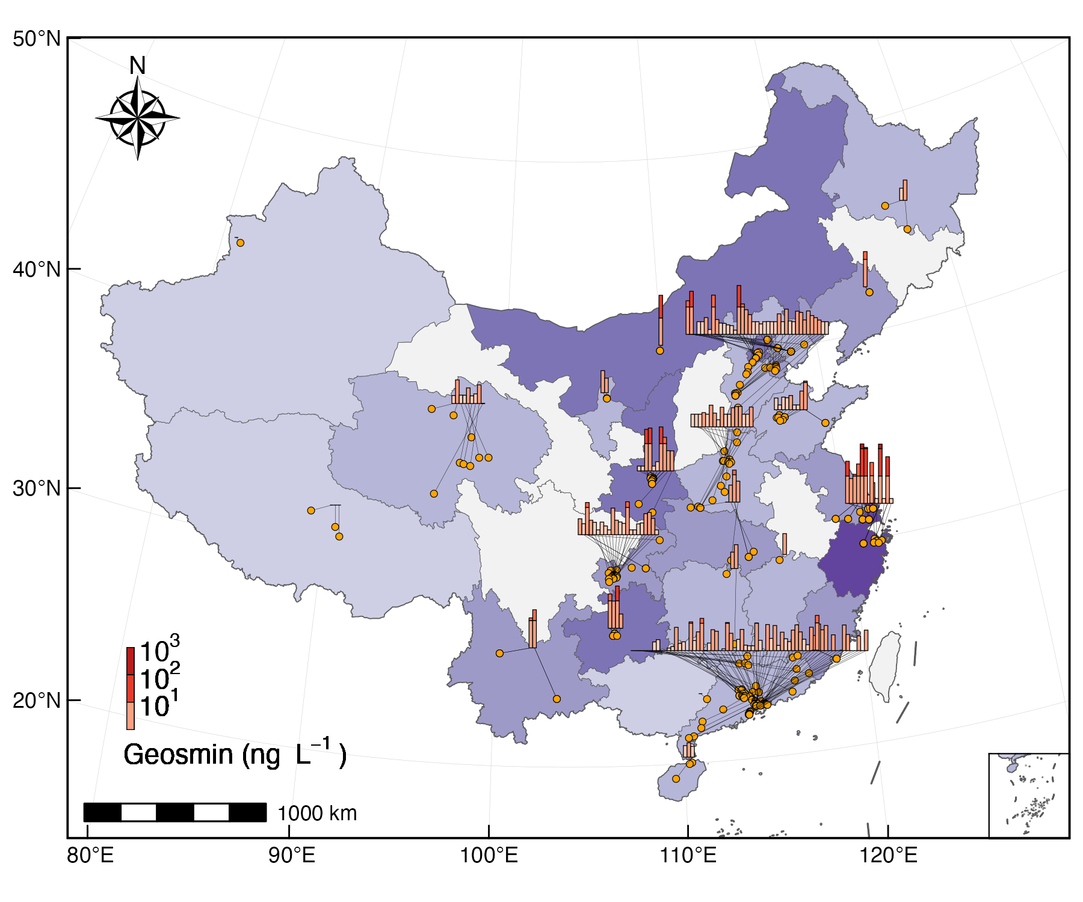
Fig. 1: A multi-scale visualization of geosmin occurrence: linking individual sampling sites to provincial-level aggregates (Provincial/regional aggregate bars (log-scale binned) connected to individual sampling sites. Beijing-Tianjin-Hebei and Jiangsu-Shanghai-Zhejiang are treated as single units to avoid spatial overlap).

Seasonal and interannual dynamics in YQ Reservoir
High-frequency monitoring was conducted at the primary intake (site YQ01) of YQ Reservoir from 2019 to 2024 to characterize temporal geosmin variability (Fig. S3). The longitudinal record demonstrates a recurrent seasonal pattern (Fig. 2A, Fig. S4A). Concentrations typically remained below 5 ng L⁻¹ during the spring (April–May), followed by an abrupt increase in June. Primary peaks occurred during the July–August period, with secondary elevations persisting through autumn and early winter (October–December) before a gradual decline. The 10 ng L⁻¹ odor threshold was frequently exceeded during the study period. Monthly median values surpassed this threshold in 40% of summer months (July–September) and 100% of autumn/early winter months (October–December), indicating a recurrent odor risk during the warmer half of the year.
Interannual analysis (Fig. 2B) revealed a reduction in geosmin levels following the 2019–2020 monitoring period, which recorded a median concentration of 2.5 ng L⁻¹. Between 2020 and 2024, annual medians stabilized within a range of 5.2 to 10 ng L⁻¹. Statistical differences between years were confirmed by a Kruskal-Wallis test (χ²(4) = 64.3, p < 0.001). These data suggest a shift in baseline conditions or source inputs after the initial year, although seasonal periodicity remained a consistent feature.
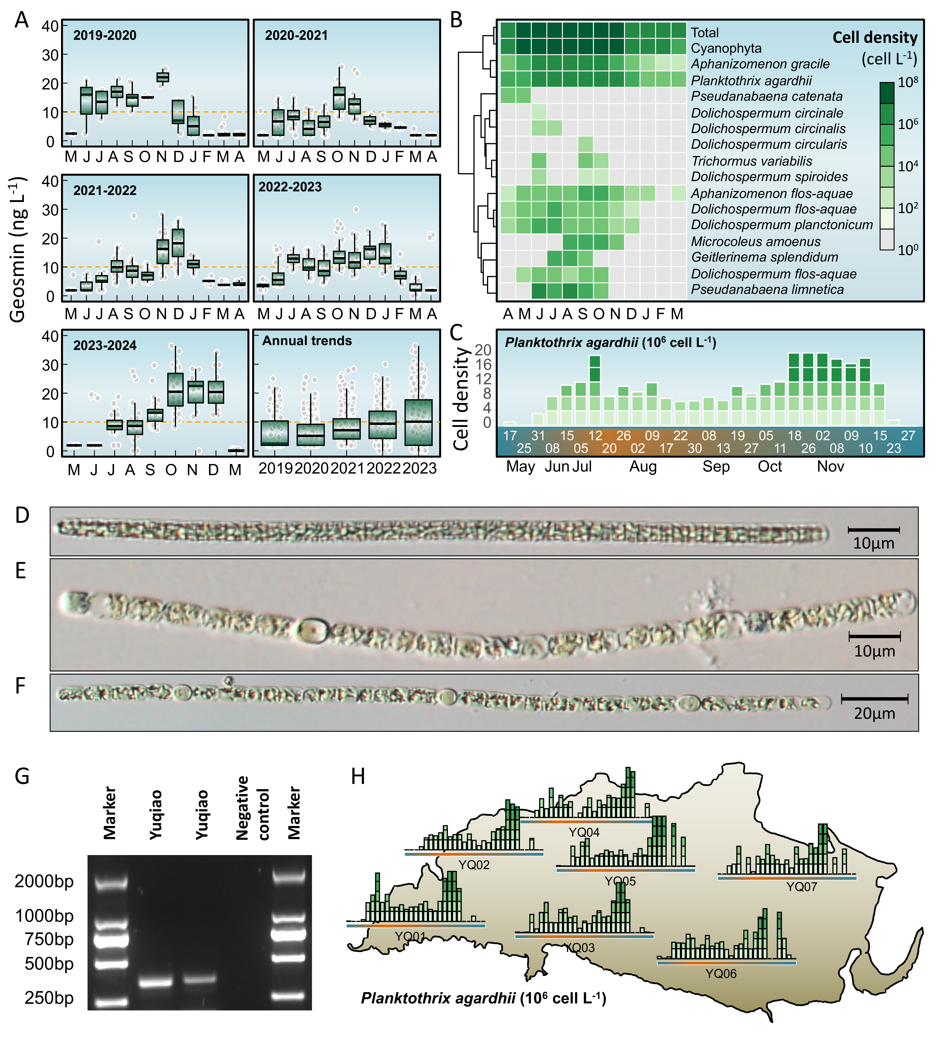
Fig. 2: Long-term dynamics of geosmin and phytoplankton community in YQ Reservoir (2019–2024). (A) Seasonal and interannual variations in geosmin concentrations at the main water intake (site YQ01). (B) Heatmap showing monthly log10-transformed biomass of total phytoplankton, total cyanobacteria, and key geosmin-producing cyanobacterial genera. (C) Temporal patterns of Planktothrix agardhii biomass across sampling sites. (D-F) Microscopic image of primary geosmin producers (P. agardhii, Dolichospermum and Aphanizomenon) . (G) Agarose gel electrophoresis image for the molecular identification of geosmin producers. (H) Spatial mapping of seasonal P. agardhii biomass variations at representative sampling sites overlaid on the reservoir map.

Phytoplankton community dynamics and key cyanobacterial genera
Phytoplankton composition data from YQ Reservoir (site YQ01, 2019–2024) were analyzed to assess the relationship between community dynamics and geosmin occurrence (Fig. 2B). Total phytoplankton biomass (log₁₀-transformed cell density) demonstrated seasonal variability, with minimum values in winter (January–March, ~10⁷ cells L⁻¹) followed by an increase starting in April. Biomass peaked during summer (July–September, >10⁸ cells L⁻¹) and remained elevated through autumn (October–December) before declining in late winter, a trajectory consistent with observed geosmin fluctuations.
Cyanobacteria dominated the assemblage throughout most of the monitoring period, with peak biomass recorded from June to October. Within this group, filamentous genera associated with geosmin production followed distinct successional patterns. Planktothrix agardhii and Aphanizomenon gracile were present year-round but reached maxima in summer and autumn. In contrast, Pseudanabaena catenata was primarily restricted to spring (April–May). Several Dolichospermum species (e.g., D. circinale, D. flos-aquae, D. planctonicum) and Aphanizomenon flos-aquae emerged in late spring, proliferated during summer, and declined by late autumn. Other taxa, including Trichormus variabilis, Microcoleus amoenus, and Pseudanabaena limnetica, occurred sporadically, with peaks confined to specific intervals between June and August.
The synchronization of elevated geosmin concentrations with high cyanobacterial biomass—particularly during blooms of Planktothrix, Dolichospermum and Aphanizomenon—points to a biological origin for the odor episodes. The temporal succession of these specific taxa likely drives the characteristic bimodal geosmin peaks observed during the summer and autumn months.

Identification and spatiotemporal distribution of the primary geosmin producer
Screening of 16S rRNA and geoA gene sequences identified the genera Planktothrix, Dolichospermum, and Aphanizomenon as the primary geosmin producers in YQ Reservoir (Fig. 2D-2G). Due to the high diversity and dynamic succession of filamentous cyanobacteria observed over the five-year monitoring period, taxonomic identification at the species level remains inconclusive based on current evidence. However, P. agardhii was selected as the representative taxon for subsequent analysis, as this genus exhibited the highest correlation with geosmin concentrations (Fig. S4B).
Spatial monitoring in 2023 demonstrated a clear biomass gradient; littoral sites (YQ03, YQ04, YQ06, and YQ07, Fig. S3) maintained significantly higher cell densities than the lacustrine site (YQ01). Maximum biomass reached 5.1×10⁷ cells L⁻¹ at littoral locations, nearly double the peak of 2.9×10⁷ cells L⁻¹ recorded at the lacustrine abstraction point. Biomass exceeded the 2×10⁷ cells L⁻¹ threshold in 7% of littoral samples, compared to 4% at YQ01. Unlike the ephemeral peaks of other cyanobacteria, P. agardhii persisted throughout the warm season (Fig. 2C).
The progression of bloom events (≥2×10⁷ cells L⁻¹) followed a spatial sequence from the littoral zone toward the dam (Fig. 2H). For example, YQ05 reached this threshold 8 days before YQ01. This temporal lag suggests that littoral zones function as primary proliferation centers, with subsequent advection driving the geosmin peaks observed at the lacustrine intake.

Distinct spatiotemporal patterns of two geosmin episodes
Two distinct odor episodes were identified in YQ Reservoir during 2023 (April–August and August–December). Spatial mapping of monthly average geosmin concentrations at seven representative sites revealed contrasting trajectories between littoral and lacustrine regions (Fig. 3).
During the first episode (April–August), littoral sites (YQ02, YQ03, YQ04, YQ06, and YQ07) recorded elevated concentrations in spring (April–June), ranging from 0 to 21.2 ng L⁻¹. These values declined by August to between 0.6 and 5.8 ng L⁻¹. In contrast, the lacustrine site (YQ01) and the transitional site (YQ05) exhibited a delayed response; concentrations increased progressively from April minima to reach a peak in August at 8.5 ng L⁻¹.
The second episode (August–December) showed a reversed spatiotemporal gradient. Littoral sites reached peak concentrations in October, ranging from 0 to 36.4 ng L⁻¹, before decreasing by December. Conversely, the lacustrine site (YQ01) exhibited a monotonic increase throughout the period, reaching 24.2 ng L⁻¹ in December. Site YQ05 demonstrated an intermediate transition, with concentrations declining in November.
These divergent trajectories (Fig. 3) indicate a systematic spatiotemporal decoupling: littoral zones demonstrate earlier onset and decline during both episodes, while the lacustrine region shows delayed and prolonged elevations. This pattern reflects the integrated effects of initial production in littoral hotspots and subsequent advective transport toward the central reservoir.
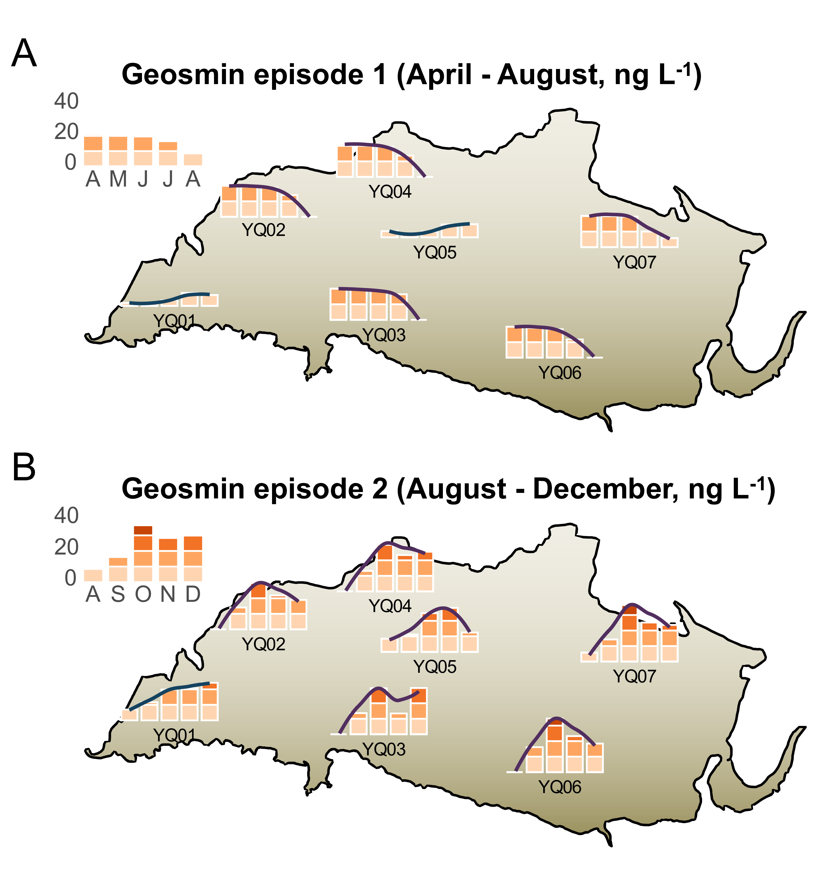
Fig. 3: Spatial mapping of monthly mean geosmin concentrations during Episode 1 (April–August, A) and Episode 2 (August–December, B) in YQ Reservoir.

Predictive relationship between Planktothrix agardhii dynamics and geosmin episodes
Time-lagged correlation analyses were performed between Planktothrix agardhii biomass and geosmin concentrations at the near-littoral site YQ05 and the lacustrine site YQ01 (Fig. 4A, Fig. S8). The analysis demonstrated divergent temporal coupling between the two locations. At YQ05, the strongest correlation (R² = 0.5, p < 0.001) occurred at zero lag, indicating that geosmin levels fluctuated synchronously with local P. agardhii density. In contrast, the correlation at the lacustrine site YQ01 was weakest at zero lag but increased with time, peaking at a 5-week lag (R² = 0.41, p < 0.001). This offset indicates that P. agardhii biomass functions as a concurrent indicator in the littoral production zone but acts as a leading indicator for geosmin risk at the distal lacustrine intake.
Regression models were established using the optimal lag periods for each site (Fig. 4B). For YQ05 (zero lag), the relationship followed the equation: log₁₀(geosmin) = 0.24 0.29×log₁₀(P. agardhii biomass). For YQ01 (5-week lag), the model was: log₁₀(geosmin) = 0.56 0.2×log₁₀(P. agardhii biomass). The higher slope observed at YQ01 suggests a potential amplification of geosmin concentrations during transport from littoral zones to the reservoir center.
Bi-weekly time series further illustrate this temporal phasing (Fig. 4C). At YQ05, P. agardhii and geosmin peaks were closely aligned, whereas at YQ01, biomass peaks preceded major odor episodes by approximately 6.7 weeks. This consistent lag serves as a predictive window; when P. agardhii biomass at YQ05 exceeded 5.0×10⁷ cells L⁻¹, geosmin at the lacustrine intake surpassed the 10 ng L⁻¹ threshold within 4–6 weeks in 61.9% of observations. These results support the use of near-littoral monitoring for forecasting odor risks at central abstraction points.
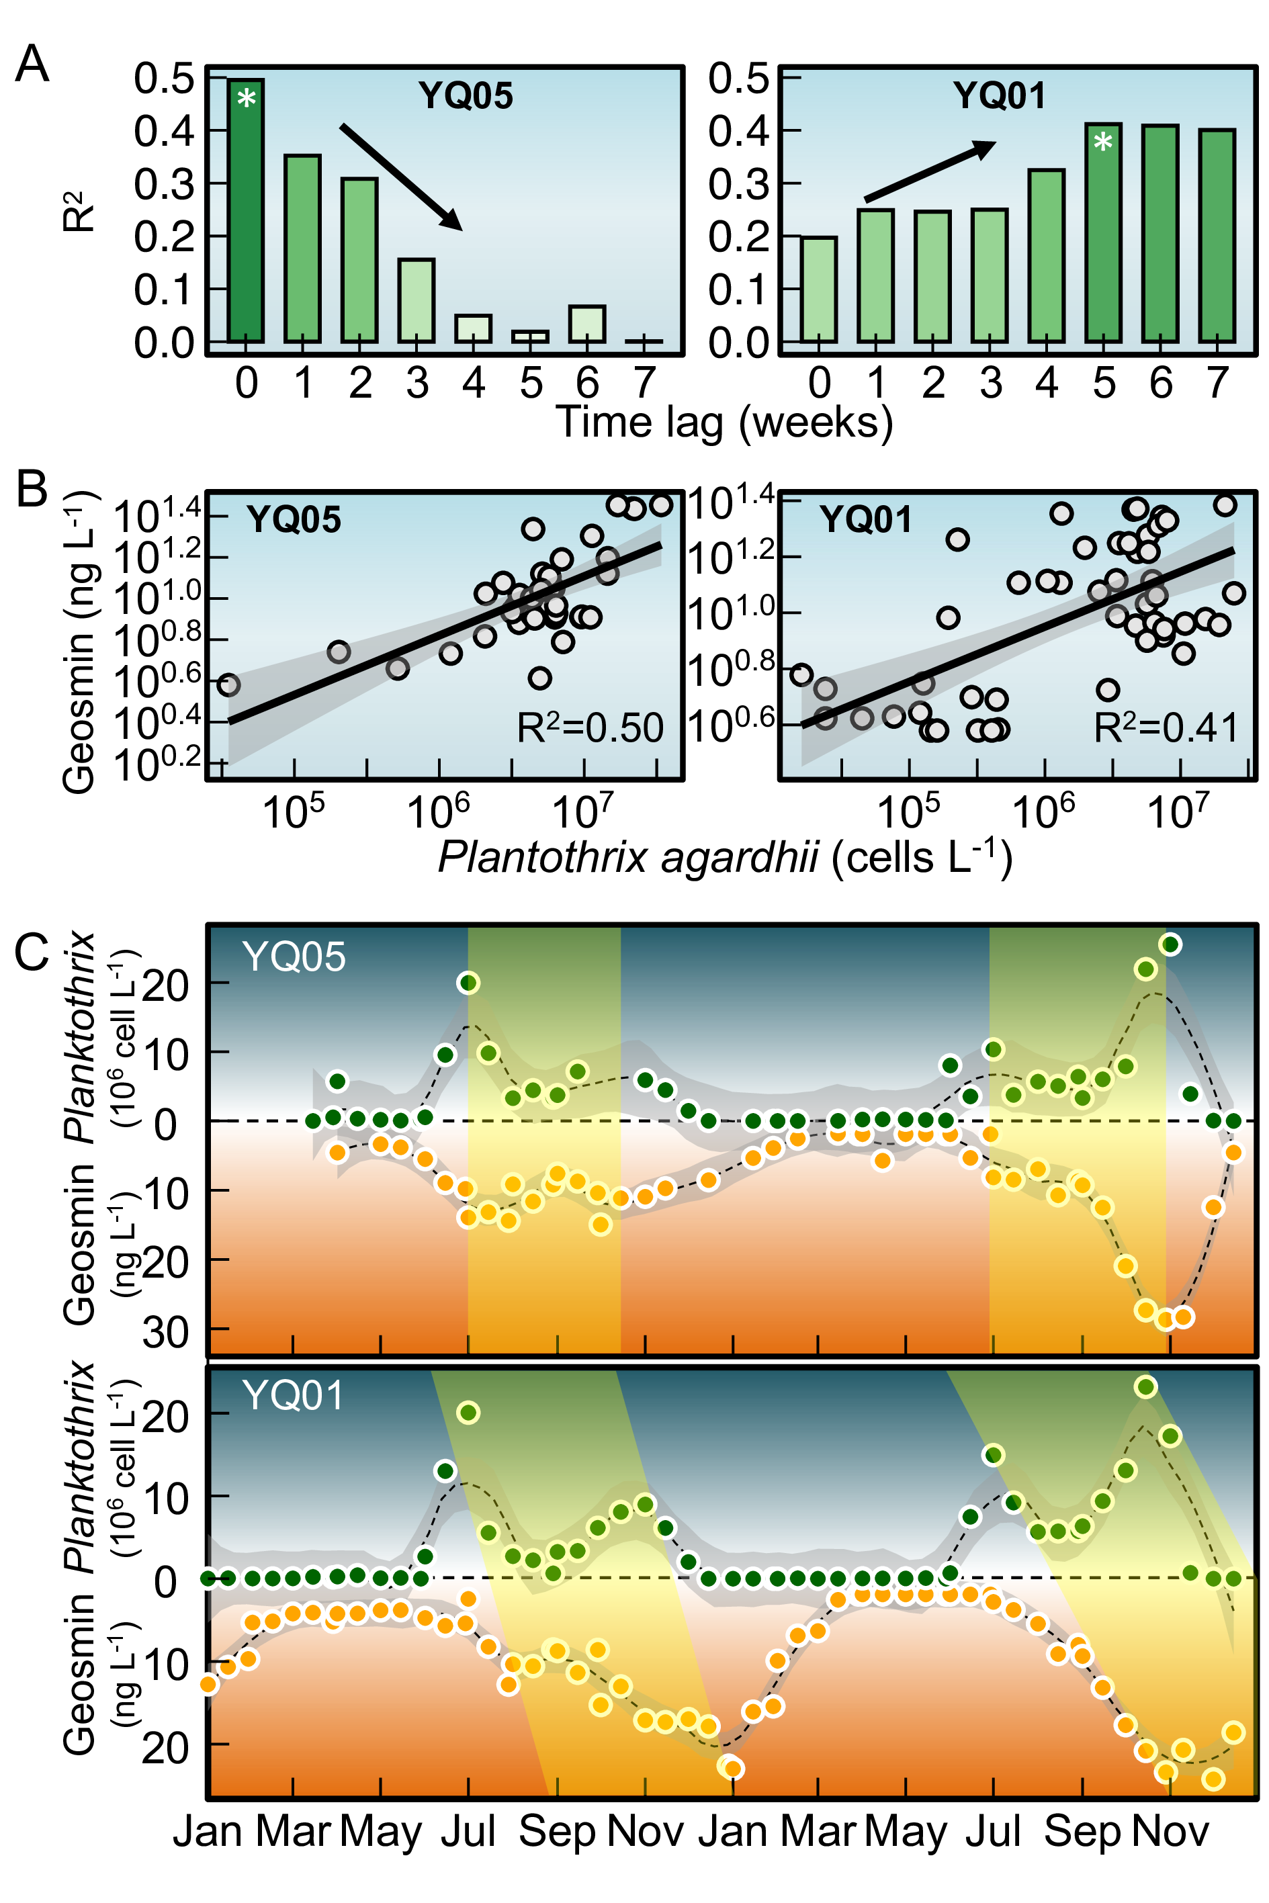
Fig. 4: Time-lagged relationships between Planktothrix agardhii biomass and geosmin concentrations at near-littoral and dam sites. (A) Correlation coefficients (R²) between P. agardhii biomass and geosmin at different lag periods (0–5 weeks) for site YQ05 (near-littoral) and YQ01 (dam intake). (B) Linear regression models at optimal lag periods: zero lag for YQ05 and 5-week lag for YQ01. (C) Scatter plots with fitted regression lines showing the quantitative relationships between P. agardhii biomass and geosmin at each site.

Environmental drivers of geosmin and proposed transport pathway
Clear spatial gradient in nutrient loading and algal response was observed in YQ Reservoir (Fig. S9). The littoral sites exhibit the highest vulnerability to organic enrichment, particularly during the summer. In this period, the littoral zone reaches a peak mean Chl-a of 0.072 mg L⁻¹, which is significantly higher than the 0.061 mg L⁻¹ observed in the lacustrine zone. This spatial disparity is mirrored in the Chemical Oxygen Demand (COD) and turbidity levels, with littoral sites showing higher COD (5.87 mg L⁻¹) and lower Secchi Disk transparency (50.6 cm) than the deeper water sites. In contrast, the lacustrine zone displays higher stability regarding immediate organic surges but acts as a major sink for nitrogen. During winter, the Total Nitrogen (TN) in the lacustrine zone reaches a maximum of 3.56 mg L⁻¹, a level higher than those found in the littoral or transitional areas during the same season. The transitional sites serve as a buffer, with water chemistry parameters like pH and TP typically falling between the littoral peaks and the lacustrine lows.
Principal component analysis (PCA) identified ammonium (NH₄⁺-N) as the variable most strongly associated with geosmin variability in the PC1–PC2 plane (Fig. 5A). The first two principal components accounted for 60.6% of total variance. PC1 (43.5%) represented a thermal-nutrient productivity axis, characterized by high loadings for temperature (0.342), total phosphorus (TP, 0.39), and chlorophyll-a (Chl-a, 0.428). PC2 (17.1%) represented a nitrogen availability axis, dominated by ammonium (-0.449) and total nitrogen (TN, 0.432). Geosmin exhibited moderate positive loadings on both PC1 (0.122) and PC2 (0.229), suggesting that variability is driven by a combination of thermal-nutrient status and nitrogen availability.
Log-log regressions between ammonium and geosmin were performed across three reservoir zones: littoral (YQ02–YQ04, YQ06–YQ07), transitional (YQ05), and lacustrine (YQ01) (Fig. 5B). A clear spatial gradient in correlation strength was observed, with the highest R² at littoral sites (0.365), followed by YQ05 (0.203), and the lacustrine site YQ01 (0.035). This attenuation suggests that the ammonium-geosmin linkage is most direct in production zones and undergoes progressive decoupling during transport toward the lacustrine intake.
Based on these results and the observed spatiotemporal dynamics of Planktothrix agardhii, a transport pathway for odor episodes is proposed (Fig. 5C). Shallow littoral areas (depths < 4–5 m) serve as primary sites for ammonium accumulation, P. agardhii proliferation, and geosmin production. Advective transport then moves cells and dissolved geosmin from these littoral zones through the transitional region (YQ05) to the lacustrine intake (YQ01). This framework integrates the spatial gradient in nutrient-geosmin coupling, the observed temporal lags between zones, and the bathymetric influence on water residence times. These elements provide a mechanistic basis for the origin and delayed manifestation of geosmin episodes at the reservoir’s primary abstraction point.
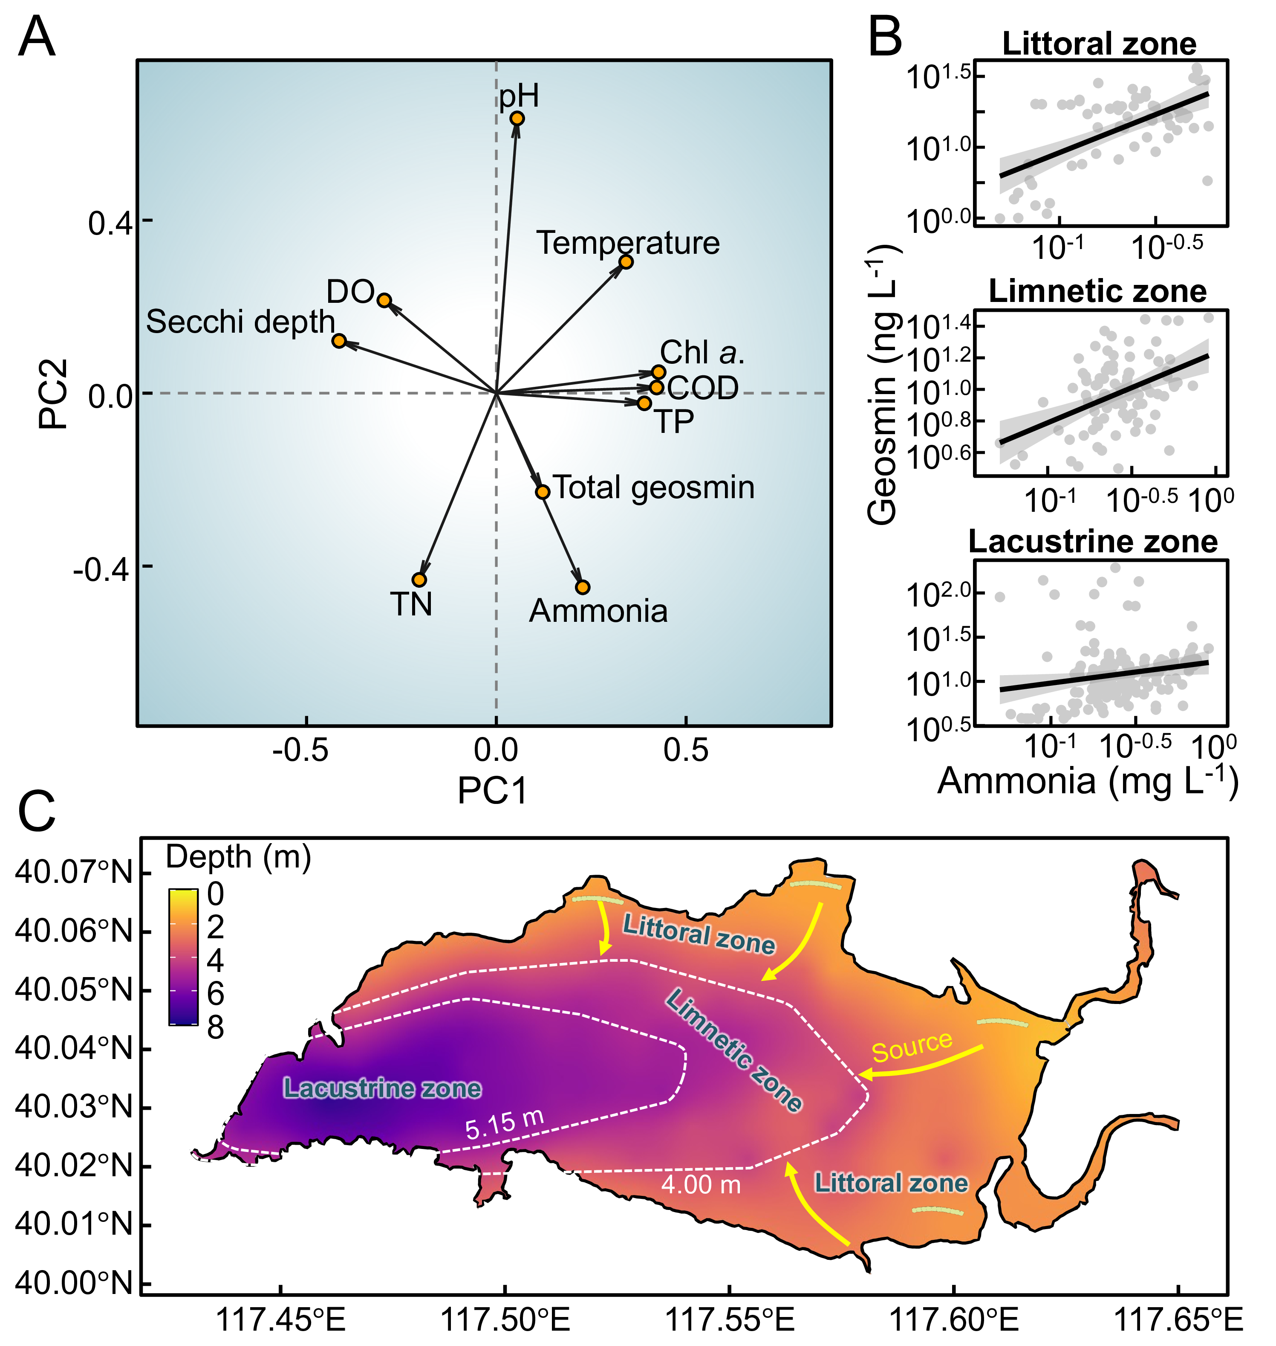
Fig. 5: Environmental drivers and conceptual transport pathway of geosmin in YQ Reservoir. (A) Principal component analysis (PCA) biplot showing relationships between geosmin and key environmental variables. (B) Log-log regressions between ammonia concentration and geosmin across littoral, transitional (YQ05), and dam (YQ01) zones. (C) Bathymetric map of YQ Reservoir depicting the proposed transport pathway from littoral production zones to the central water intake.

Discussion

Geosmin prevalence in Chinese drinking water sources
National survey data indicate that geosmin contamination is widespread across China’s primary drinking water sources, with 14% of sites exceeding the 10 ng L⁻¹ odor threshold (³⁹). These results identify geosmin as a pervasive water quality challenge, consistent with observations in other climatological regions^{19,47}. The observed spatial heterogeneity—specifically the higher concentrations within the Yangtze and Pearl River Deltas—suggests that regional climatic conditions, watershed land use, and nutrient loading are primary determinants of geosmin risk. Given its low odor threshold and resistance to conventional treatment processes^{27,35,48}, geosmin poses significant operational challenges for water utilities²⁶ and impacts compliance with water safety objectives such as Sustainable Development Goal 6⁴⁹. Consequently, these risks drive substantial investment in advanced treatment technologies and proactive source management⁵⁰.

Littoral zones as production centers and spatiotemporal decoupling
While actinomycetes are established sources of geosmin in freshwater sediments^{51–54}, the synchronous peaks of Planktothrix agardhii biomass and geosmin at littoral sites (R² = 0.5), combined with the molecular identification of the geoA gene (Fig. 2D, F), confirm a cyanobacterial origin in YQ Reservoir. This supports the consensus that cyanobacteria are the primary biotic source of odorants in well-oxygenated reservoir water columns^{45,55–59}. Detection of geoA-harboring cyanobacteria^{46,60,61} in this oxygenated environment indicates that geosmin is primarily derived from cyanobacterial activity, aligning with studies linking specific blooms to odor episodes globally^{62–64}.
Monitoring data identify littoral zones as critical ecological niches for P. agardhii proliferation. The filamentous morphology and low-light adaptation of P. agardhii facilitate its dominance in shallow, intermittently mixed littoral environments^{65–68}. These traits allow for optimal light harvesting under the variable regimes typical of nearshore areas^{32,69}. The high correlation between ammonium and geosmin specifically in littoral zones (R² = 0.37) points to nitrogen availability from shoreline inputs as a key regulator. The subsequent weakening of this correlation at the lacustrine intake (R² = 0.03) reflects the decoupling of biological production from observed concentrations during transport. This spatial decoupling is quantified by the 8-day lag in bloom development between littoral sites and the dam, representing a period of physical advection and continued metabolic accumulation.

Implications for proactive monitoring and risk management
The conceptual mechanism depicted in Fig. 6 illustrates that maximum geosmin production is localized in littoral zones before advective transport through the limnetic zone. This sequence demonstrates a limitation in intake-centric monitoring: by the time geosmin reaches the lacustrine zone, the window for preventive intervention is minimal^{35,70}. The identified 4–6 week lag between littoral proliferation and lacustrine contamination establishes a quantifiable window for risk mitigation. By deploying littoral sentinel sites, utilities can move beyond reactive crisis management—such as emergency high-dose activated carbon application—toward preventive catchment-based strategies.
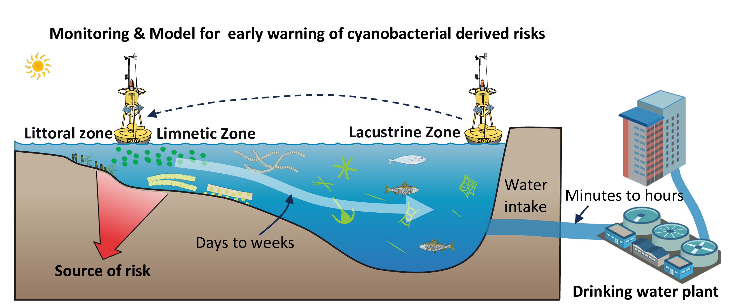
Fig. 6: Conceptual model of littoral-initiated geosmin transport and its implications for monitoring strategy. A sketch illustrating the spatiotemporal progression of geosmin episodes: (1) high metabolic activity of cyanobacteria (e.g., Planktothrix agardhii) in the littoral zone, driven by nutrient inputs and favorable light conditions; (2) advection of produced geosmin and biomass into the limnetic zone, resulting in a transport lag; (3) accumulation of geosmin in the lacustrine zone (dam intake), posing an immediate treatment challenge; and (4) the proposed monitoring shift from conventional reactive intake-focused sampling to proactive early detection in littoral zones, providing critical warning time for preventive measures.
For example, reservoir operations, including selective withdrawal or hydrodynamic controls, can be adjusted to disrupt the transport of geosmin-rich water masses before they reach critical intake depths^{36,71,72}. Focusing surveillance on littoral production zones provides a 4–6 week lead time—supported by the lagged correlation at YQ01 (R² = 0.41 at 5 weeks). This interval allows for optimized treatment costs and proactive resource allocation to intercept risks during the incipient growth phase, aligning with modern water safety frameworks⁷³.
While the current dataset captures robust seasonal and interannual trends, longer-term observations are required to evaluate these dynamics under shifting climate scenarios. Furthermore, while P. agardhii is the dominant producer in this system, other reservoirs may be driven by different taxa, such as Dolichospermum or Aphanizomenon^{45,74,75}.
Future research should focus on: (1) integrating molecular tools to characterize the diversity and expression of geosmin synthesis genes, (2) coupling ecological monitoring with high-resolution hydrodynamic modeling to refine transport time estimates, and (3) conducting cost-benefit analyses to evaluate the economic feasibility of expanded littoral monitoring. By establishing quantifiable early-warning indicators based on the littoral-to-lacustrine transport mechanism, this work provides a technical foundation for improving drinking water security.

FIGURES
- Fig. 1: A multi-scale visualization of geosmin occurrence: linking individual sampling sites to provincial-level aggregates (Provincial/regional aggregate bars (log-scale binned) connected to individual sampling sites. Beijing-Tianjin-Hebei and Jiangsu-Shanghai-Zhejiang are treated as single units to avoid spatial overlap).
- Fig. 2: Long-term dynamics of geosmin and phytoplankton community in YQ Reservoir (2019–2024). (A) Seasonal and interannual variations in geosmin concentrations at the main water intake (site YQ01). (B) Heatmap showing monthly log10-transformed biomass of total phytoplankton, total cyanobacteria, and key geosmin-producing cyanobacterial genera. (C) Temporal patterns of Planktothrix agardhii biomass across sampling sites. (D-F) Microscopic image of primary geosmin producers (P. agardhii, Dolichospermum and Aphanizomenon) . (G) Agarose gel electrophoresis image for the molecular identification of geosmin producers. (H) Spatial mapping of seasonal P. agardhii biomass variations at representative sampling sites overlaid on the reservoir map.
- Fig. 3: Spatial mapping of monthly mean geosmin concentrations during Episode 1 (April–August, A) and Episode 2 (August–December, B) in YQ Reservoir.
- Fig. 4: Time-lagged relationships between Planktothrix agardhii biomass and geosmin concentrations at near-littoral and dam sites. (A) Correlation coefficients (R²) between P. agardhii biomass and geosmin at different lag periods (0–5 weeks) for site YQ05 (near-littoral) and YQ01 (dam intake). (B) Linear regression models at optimal lag periods: zero lag for YQ05 and 5-week lag for YQ01. (C) Scatter plots with fitted regression lines showing the quantitative relationships between P. agardhii biomass and geosmin at each site.
- Fig. 5: Environmental drivers and conceptual transport pathway of geosmin in YQ Reservoir. (A) Principal component analysis (PCA) biplot showing relationships between geosmin and key environmental variables. (B) Log-log regressions between ammonia concentration and geosmin across littoral, transitional (YQ05), and dam (YQ01) zones. (C) Bathymetric map of YQ Reservoir depicting the proposed transport pathway from littoral production zones to the central water intake.
- Fig. 6: Conceptual model of littoral-initiated geosmin transport and its implications for monitoring strategy. A sketch illustrating the spatiotemporal progression of geosmin episodes: (1) high metabolic activity of cyanobacteria (e.g., Planktothrix agardhii) in the littoral zone, driven by nutrient inputs and favorable light conditions; (2) advection of produced geosmin and biomass into the limnetic zone, resulting in a transport lag; (3) accumulation of geosmin in the lacustrine zone (dam intake), posing an immediate treatment challenge; and (4) the proposed monitoring shift from conventional reactive intake-focused sampling to proactive early detection in littoral zones, providing critical warning time for preventive measures.

ASSOCIATED CONTENT

Supporting Information
The Supporting Information is available free of charge at https://.
The Supporting Information provides comprehensive datasets, experimental details, and supplementary analyses supporting the main text, including: Geographic distribution of sampling sites for the national geosmin survey in China (Fig. S1); Frequency distribution of geosmin concentrations from the national survey (Fig. S2); Study site overview of Yuqiao Reservoir, featuring satellite imagery and a bathymetric map (Fig. S3); Temporal dynamics of geosmin concentration and Planktothrix agardhii abundance in Yuqiao Reservoir (Fig. S4); Comparative limnochemical characteristics of the littoral, transitional, and lacustrine zones within Yuqiao Reservoir (Figs. S5-S7); Site-specific relationship between Planktothrix agardhii abundance and geosmin concentration at transitional (YQ05) and lacustrine (YQ01) sites (Fig. S8); The spatiotemporal variation of physicochemical parameters across reservoir zones and seasons (Fig. S9); and a table for the identification of geosmin producers based on gene sequencing (Table S1) (PDF).

AUTHOR INFORMATION

Corresponding Authors
- Ming Su: 1. Key Laboratory of Environmental Aquatic Chemistry, State Key Laboratory of Regional Environment and Sustainability, Research Center for Eco-Environmental Sciences, Chinese Academy of Sciences, Beijing 100085, China; 2. University of Chinese Academy of Sciences, Beijing 100049, China ORCID: 0000-0001-9821-1268; URL: https://drwater.net/team/ming-su/; Email: mingsu@rcees.ac.cn

Authors
- Yuying Gui 1. College of Environmental Science and Engineering, Ocean University of China, No. 238 Songling Road, Qingdao, 266100, China; 2. Key Laboratory of Environmental Aquatic Chemistry, State Key Laboratory of Regional Environment and Sustainability, Research Center for Eco-Environmental Sciences, Chinese Academy of Sciences, Beijing 100085, China
- Tengxin Cao 1. Key Laboratory of Environmental Aquatic Chemistry, State Key Laboratory of Regional Environment and Sustainability, Research Center for Eco-Environmental Sciences, Chinese Academy of Sciences, Beijing 100085, China; 2. University of Chinese Academy of Sciences, Beijing 100049, China
- Jie Yang: Tianjin Hydraulic Research Institute, No. 60 Youyi Road, Hexi District, Tianjin, 300061, China
- Jihui Qin: Tianjin Yuqiao Reservoir Authority, No. 13, South Dongwuhuan Road, Jizhou District, Tianjin, 301900, China
- Ming Su (Corresponding author): 1. Key Laboratory of Environmental Aquatic Chemistry, State Key Laboratory of Regional Environment and Sustainability, Research Center for Eco-Environmental Sciences, Chinese Academy of Sciences, Beijing 100085, China; 2. University of Chinese Academy of Sciences, Beijing 100049, China
- Yuanhong Xiao: Tianjin Yuqiao Reservoir Authority, No. 13, South Dongwuhuan Road, Jizhou District, Tianjin, 301900, China
- Zhixiang Hao: Tianjin Hydraulic Research Institute, No. 60 Youyi Road, Hexi District, Tianjin, 300061, China
- Ziyi Yang: 1. Key Laboratory of Environmental Aquatic Chemistry, State Key Laboratory of Regional Environment and Sustainability, Research Center for Eco-Environmental Sciences, Chinese Academy of Sciences, Beijing 100085, China; 2. University of Chinese Academy of Sciences, Beijing 100049, China
- Qi Zhang: Institute of Hydrobiology, Chinese Academy of Sciences, 7 Donghu South Road, Wuchang District, Wuhan, 430070, China
- Yufan Ai: 1. Key Laboratory of Environmental Aquatic Chemistry, State Key Laboratory of Regional Environment and Sustainability, Research Center for Eco-Environmental Sciences, Chinese Academy of Sciences, Beijing 100085, China; 2. University of Chinese Academy of Sciences, Beijing 100049, China
- Jiao Fang: Key Laboratory of Environmental Aquatic Chemistry, State Key Laboratory of Regional Environment and Sustainability, Research Center for Eco-Environmental Sciences, Chinese Academy of Sciences, Beijing 100085, China
- Yingjie Li: 1. Key Laboratory of Environmental Aquatic Chemistry, State Key Laboratory of Regional Environment and Sustainability, Research Center for Eco-Environmental Sciences, Chinese Academy of Sciences, Beijing 100085, China; 2. University of Chinese Academy of Sciences, Beijing 100049, China
- Zhengyan Li: College of Environmental Science and Engineering, Ocean University of China, No. 238 Songling Road, Qingdao, 266100, China
- Min Yang: 1. Key Laboratory of Environmental Aquatic Chemistry, State Key Laboratory of Regional Environment and Sustainability, Research Center for Eco-Environmental Sciences, Chinese Academy of Sciences, Beijing 100085, China; 2. University of Chinese Academy of Sciences, Beijing 100049, China

Author contributions
Yuying Gui and Tengxin Cao jointly contributed to methodology design and formal analysis. Jie Yang contributed to methodology and conceptualization. Jihui Qin and Yuanhong Xiao provided methodology support. Ming Su led conceptualization and formal analysis, wrote and edited the original draft, led visualization and project administration, and supervised the work. Zhixiang Hao contributed to methodology. Ziyi Yang, Qi Zhang, Yufan Ai, Jiao Fang, Yingjie Li, and Zhengyan Li provided methodology and/or formal analysis support. Min Yang provided supervision and project coordination support.

Notes
The authors declare no competing financial interest.

Acknowledgements
This work was financially supported by the National Natural Science Foundation of China (52030002, 51878649), and Youth Innovation Promotion Association CAS.

References
(1) Huisman, J.; Codd, G. A.; Paerl, H. W.; Ibelings, B. W.; Verspagen, J. M. H.; Visser, P. M. Cyanobacterial Blooms. Nature Reviews Microbiology 2018, 16 (8), 471–483. https://doi.org/10.1038/s41579-018-0040-1.
(2) Paerl, H. W.; Fulton, R. S.; Moisander, P. H.; Dyble, J. Harmful Freshwater Algal Blooms, with an Emphasis on Cyanobacteria. The Scientific World Journal 2001, 1, 76–113. https://doi.org/10.1100/tsw.2001.16.
(3) Heisler, J.; Glibert, P. M.; Burkholder, J. M.; Anderson, D. M.; Cochlan, W.; Dennison, W. C.; Dortch, Q.; Gobler, C. J.; Heil, C. A.; Humphries, E.; Lewitus, A.; Magnien, R.; Marshall, H. G.; Sellner, K.; Stockwell, D. A.; Stoecker, D. K.; Suddleson, M. Eutrophication and Harmful Algal Blooms: A Scientific Consensus. Harmful Algae 2008, 8 (1), 3–13. https://doi.org/10.1016/j.hal.2008.08.006.
(4) Feng, L.; Dai, Y.; Hou, X.; Xu, Y.; Liu, J.; Zheng, C. Concerns about Phytoplankton Bloom Trends in Global Lakes. Nature 2021, 590 (7846), E35–E47. https://doi.org/10.1038/s41586-021-03254-3.
(5) Woolway, R. I.; Kraemer, B. M.; Lenters, J. D.; Merchant, C. J.; O’Reilly, C. M.; Sharma, S. Global Lake Responses to Climate Change. Nature Reviews Earth &amp; Environment 2020, 1 (8), 388–403. https://doi.org/10.1038/s43017-020-0067-5.
(6) Paerl, H. W.; Paul, V. J. Climate Change: Links to Global Expansion of Harmful Cyanobacteria. Water Research 2012, 46 (5), 1349–1363. https://doi.org/10.1016/j.watres.2011.08.002.
(7) O’neil, J. m.; Davis, T. w.; Burford, M. a.; Gobler, C. j. The Rise of Harmful Cyanobacteria Blooms: The Potential Roles of Eutrophication and Climate Change. Harmful Algae 2012, 14 (0), 313–334. https://doi.org/10.1016/j.hal.2011.10.027.
(8) Rousso, B. Z.; Bertone, E.; Stewart, R.; Hamilton, D. P. A Systematic Literature Review of Forecasting and Predictive Models for Cyanobacteria Blooms in Freshwater Lakes. Water Research 2020, 182, 115959. https://doi.org/10.1016/j.watres.2020.115959.
(9) Zhang, Y.; Whalen, J. K.; Cai, C.; Shan, K.; Zhou, H. Harmful Cyanobacteria-Diatom/Dinoflagellate Blooms and Their Cyanotoxins in Freshwaters: A Nonnegligible Chronic Health and Ecological Hazard. Water Research 2023, 233, 119807. https://doi.org/10.1016/j.watres.2023.119807.
(10) Reinl, K. L.; Harris, T. D.; Elfferich, I.; Coker, A.; Zhan, Q.; Domis, L. N. D. S.; Morales-Williams, A. M.; Bhattacharya, R.; Grossart, H.-P.; North, R. L.; Sweetman, J. N. The Role of Organic Nutrients in Structuring Freshwater Phytoplankton Communities in a Rapidly Changing World. Water Research 2022, 219, 118573. https://doi.org/10.1016/j.watres.2022.118573.
(11) Xu, H.; Paerl, H. W.; Qin, B.; Zhu, G.; Gaoa, G. Nitrogen and Phosphorus Inputs Control Phytoplankton Growth in Eutrophic Lake Taihu, China. Limnology and Oceanography 2009, 55 (1), 420–432. https://doi.org/10.4319/lo.2010.55.1.0420.
(12) Paerl, H. W.; Xu, H.; Mccarthy, M. J.; Zhu, G.; Qin, B.; Li, Y.; Gardner, W. S. Controlling Harmful Cyanobacterial Blooms in a Hyper-Eutrophic Lake (Lake Taihu, China): The Need for a Dual Nutrient (n & p) Management Strategy. Water Research 2011, 45 (5), 1973–1983. https://doi.org/10.1016/j.watres.2010.09.018.
(13) Kosten, S.; Huszar, V. L. M.; Bécares, E.; Costa, L. S.; Donk, E. van; Hansson, L.; Jeppesen, E.; Kruk, C.; Lacerot, G.; Mazzeo, N.; De Meester, L.; Moss, B.; Lürling, M.; Nõges, T.; Romo, S.; Scheffer, M. Warmer Climates Boost Cyanobacterial Dominance in Shallow Lakes. Global Change Biology 2011, 18 (1), 118–126. https://doi.org/10.1111/j.1365-2486.2011.02488.x.
(14) Plaas, H. E.; Paerl, H. W. Toxic Cyanobacteria: A Growing Threat to Water and Air Quality. Environmental Science &amp; Technology 2020, 55 (1), 44–64. https://doi.org/10.1021/acs.est.0c06653.
(15) Carmichael, W. W.; Azevedo, S. M.; An, J. S.; Molica, R. J.; Jochimsen, E. M.; Lau, S.; Rinehart, K. L.; Shaw, G. R.; Eaglesham, G. K. Human Fatalities from Cyanobacteria: Chemical and Biological Evidence for Cyanotoxins. Environmental Health Perspectives 2001, 109 (7), 663–668. https://doi.org/10.1289/ehp.01109663.
(16) Merel, S.; Walker, D.; Chicana, R.; Snyder, S.; Baurès, E.; Thomas, O. State of Knowledge and Concerns on Cyanobacterial Blooms and Cyanotoxins. Environment International 2013, 59, 303–327. https://doi.org/10.1016/j.envint.2013.06.013.
(17) Burlingame, G. A.; Doty, R. L.; Dietrich, A. M. Humans as Sensors to Evaluate Drinking Water Taste and Odor: A Review. Journal AWWA 2017, 109 (11), 13–24. https://doi.org/10.5942/jawwa.2017.109.0118.
(18) Su, M.; Yu, J.; Zhang, J.; Chen, H.; An, W.; Vogt, R. D.; Andersen, T.; Jia, D.; Wang, J.; Yang, M. MIB-Producing Cyanobacteria (Planktothrix Sp.) in a Drinking Water Reservoir: Distribution and Odor Producing Potential. Water Research 2015, 68, 444–453. https://doi.org/10.1016/j.watres.2014.09.038.
(19) Lin, T.-F.; Watson, S.; Suffet, I. H. M. Taste and Odour in Source and Drinking Water: Causes, Controls, and Consequences; IWA Publishing, 2018.
(20) Yang, M.; Yu, J.; Li, Z.; Guo, Z.; Burch, M.; Lin, T. Taihu Lake Not to Blame for Wuxi’s Woes. Science 2008, 319 (5860), 158. https://doi.org/10.1126/science.319.5860.158a.
(21) Sun, D.; Yu, J.; Yang, M.; An, W.; Zhao, Y.; Lu, N.; Yuan, S.; Zhang, D. Occurrence of Odor Problems in Drinking Water of Major Cities Across China. Frontiers of Environmental Science & Engineering 2014, 8 (3), 411–416. https://doi.org/10.1007/s11783-013-0577-1.
(22) Mehnert, G.; Leunert, F.; Cires, S.; Johnk, K. D.; Rucker, J.; Nixdorf, B.; Wiedner, C. Competitiveness of Invasive and Native Cyanobacteria from Temperate Freshwaters Under Various Light and Temperature Conditions. Journal of Plankton Research 2010, 32 (7), 1009–1021. https://doi.org/10.1093/plankt/fbq033.
(23) Asato, Y. Toward an Understanding of Cell Growth and the Cell Division Cycle of Unicellular Photoautotrophic Cyanobacteria. Cellular and Molecular Life Sciences (CMLS) 2003, 60 (4), 663–687. https://doi.org/10.1007/s00018-003-2079-y.
(24) Ai, Y.; Wu, Y.; Su, M.; Gui, Y.; Du, Y.; Fang, J.; Cao, T.; Yang, M. Cyanobacterial Crowding-Out Effects on Metabolite Partitioning: Modeling 2-Methylisoborneol (MIB) Release Dynamics and Implications. Journal of Hazardous Materials 2025, 140118. https://doi.org/https://doi.org/10.1016/j.jhazmat.2025.140118.
(25) Singh, S.; Kate, B. N.; Banerjee, U. C. Bioactive Compounds from Cyanobacteria and Microalgae: An Overview. Critical Reviews in Biotechnology 2005, 25 (3), 73–95. https://doi.org/10.1080/07388550500248498.
(26) Srinivasan, R.; Sorial, G. A. Treatment of Taste and Odor Causing Compounds 2-Methyl Isoborneol and Geosmin in Drinking Water: A Critical Review. Journal of Environmental Sciences 2011, 23 (1), 1–13. https://doi.org/10.1016/s1001-0742(10)60367-1.
(27) Mustapha, S.; Tijani, J. O.; Ndamitso, M. M.; Abdulkareem, A. S.; Shuaib, D. T.; Mohammed, A. K. A Critical Review on Geosmin and 2-Methylisoborneol in Water: Sources, Effects, Detection, and Removal Techniques. Environmental Monitoring and Assessment 2021, 193 (4), 204. https://doi.org/10.1007/s10661-021-08980-9.
(28) Cerón-Vivas, A.; Villamizar León, M. P.; Cajigas, Á. A. Geosmin and 2-Methylisoborneol Removal in Drinking Water Treatment. Water Practice and Technology 2022, 18 (1), 159–167. https://doi.org/10.2166/wpt.2022.167.
(29) Thornton, K. W. REGIONAL COMPARISONS OF LAKES AND RESERVOIRS: GEOLOGY, CLIMATOLOGY, AND MORPHOLOGY. Lake and Reservoir Management 1984, 1 (1), 261–265. https://doi.org/10.1080/07438148409354521.
(30) Dordoni, M.; Zappalà, P.; Barth, J. A. C. A Preliminary Global Hydrochemical Comparison of Lakes and Reservoirs. Frontiers in Water 2023, 5. https://doi.org/10.3389/frwa.2023.1084050.
(31) Cefalì, M. E.; Cebrian, E.; Chappuis, E.; Pinedo, S.; Terradas, M.; Mariani, S.; Ballesteros, E. Life on the Boundary: Environmental Factors as Drivers of Habitat Distribution in the Littoral Zone. Estuarine, Coastal and Shelf Science 2016, 172, 81–92. https://doi.org/10.1016/j.ecss.2016.01.043.
(32) Zohary, T.; Gasith, A. The Littoral Zone. In Lake kinneret; Springer Netherlands, 2014; pp 517–532. https://doi.org/10.1007/978-94-017-8944-8_29.
(33) Jüttner, F.; Watson, S. B. Biochemical and Ecological Control of Geosmin and 2-Methylisoborneol in Source Waters. Applied and Environmental Microbiology 2007, 73 (14), 4395–4406. https://doi.org/10.1128/aem.02250-06.
(34) Watson, S. B. Cyanobacterial and Eukaryotic Algal Odour Compounds: Signals or by-Products? A Review of Their Biological Activity. Phycologia 2003, 42 (4), 332–350. https://doi.org/10.2216/i0031-8884-42-4-332.1.
(35) Zamyadi, A.; Henderson, R.; Stuetz, R.; Hofmann, R.; Ho, L.; Newcombe, G. Fate of Geosmin and 2-Methylisoborneol in Full-Scale Water Treatment Plants. Water Research 2015, 83, 171–183. https://doi.org/10.1016/j.watres.2015.06.038.
(36) Lu, J.; Su, M.; Su, Y.; Fang, J.; Burch, M.; Cao, T.; Wu, B.; Yu, J.; Yang, M. MIB-Derived Odor Management Based Upon Hydraulic Regulation in Small Drinking Water Reservoirs: Principle and Application. Water Research 2023, 244, 120485. https://doi.org/10.1016/j.watres.2023.120485.
(37) Qiu, P.; Zhang, Y.; Mi, W.; Song, G.; Bi, Y. Producers and Drivers of Odor Compounds in a Large Drinking-Water Source. Frontiers in Ecology and Evolution 2023, 11. https://doi.org/10.3389/fevo.2023.1216567.
(38) Wu, T.; Zhu, G.; Wang, Z.; Zhu, M.; Xu, H. Seasonal Dynamics of Odor Compounds Concentration Driven by Phytoplankton Succession in a Subtropical Drinking Water Reservoir, Southeast China. Journal of Hazardous Materials 2022, 425, 128056. https://doi.org/10.1016/j.jhazmat.2021.128056.
(39) AWWA, A. W. W. A. Algae: Source to Treatment; American Water Works Association, 2010.
(40) Zhou, S.; Qiu, D.; Xiao, L. Spatial Distribution and Influencing Factors of Organic Odorants 2-Methylisoborneol and Geosmin in Reservoirs of Guangdong Province. Guangdong Chemical Industry (In Chinese) 2024, 51 (22), 117–119, 122.
(41) Zhai, H.; He, X.; Zhang, Y.; Du, T.; Adeleye, A. S.; Li, Y. Disinfection Byproduct Formation in Drinking Water Sources: A Case Study of Yuqiao Reservoir. Chemosphere 2017, 181, 224–231. https://doi.org/10.1016/j.chemosphere.2017.04.028.
(42) Xu, Y.; Xie, R.; Wang, Y.; Sha, J. Spatio-Temporal Variations of Water Quality in Yuqiao Reservoir Basin, North China. Frontiers of Environmental Science &amp; Engineering 2014, 9 (4), 649–664. https://doi.org/10.1007/s11783-014-0702-9.
(43) Qiu, P.; Chen, Y.; Li, C.; Huo, D.; Bi, Y.; Wang, J.; Li, Y.; Li, R.; Yu, G. Using Molecular Detection for the Diversity and Occurrence of Cyanobacteria and 2-Methylisoborneol-Producing Cyanobacteria in an Eutrophicated Reservoir in Northern China. Environmental Pollution 2021, 288, 117772. https://doi.org/10.1016/j.envpol.2021.117772.
(44) Cai, F.; Yu, G.; Zhang, K.; Chen, Y.; Li, Q.; Yang, Y.; Xie, J.; Wang, Y.; Li, R. Geosmin Production and Polyphasic Characterization of Oscillatoria Limosa Agardh Ex Gomont Isolated from the Open Canal of a Large Drinking Water System in Tianjin City, China. Harmful Algae 2017, 69, 28–37. https://doi.org/10.1016/j.hal.2017.09.006.
(45) Su, M.; Gaget, V.; Giglio, S.; Burch, M.; An, W.; Yang, M. Establishment of Quantitative PCR Methods for the Quantification of Geosmin-Producing Potential and Anabaena Sp. In Freshwater Systems. Water Research 2013, 47 (10), 3444–3454. https://doi.org/10.1016/j.watres.2013.03.043.
(46) Giglio, S.; Jiang, J.; Saint, C. P. S.; Cane, D. E.; Monis, P. T. Isolation and Characterization of the Gene Associated with Geosmin Production in Cyanobacteria. Environmental Science & Technology 2008, 42 (21), 8027–8032. https://doi.org/10.1021/es801465w.
(47) Devi, A.; Chiu, Y.-T.; Hsueh, H.-T.; Lin, T.-F. Quantitative PCR Based Detection System for Cyanobacterial Geosmin/2-Methylisoborneol (2-MIB) Events in Drinking Water Sources: Current Status and Challenges. Water Research 2021, 188, 116478. https://doi.org/10.1016/j.watres.2020.116478.
(48) Cook, D.; Newcombe, G.; Sztajnbok, P. The Application of Powdered Activated Carbon for MIB and Geosmin Removal: Predicting PAC Doses in Four Raw Waters. Water Research 2001, 35 (5), 1325–1333. https://doi.org/10.1016/S0043-1354(00)00363-8.
(49) Arora, N. K.; Mishra, I. Sustainable Development Goal 6: Global Water Security. Environmental Sustainability 2022, 5 (3), 271–275. https://doi.org/10.1007/s42398-022-00246-5.
(50) Yuan, J.; Hofmann, R. Adsorption and Biodegradation of 2-Methylisoborneol and Geosmin in Drinking Water Granular Activated Carbon Filters: A Review and Meta-Analysis. Journal of Hazardous Materials 2022, 440, 129838. https://doi.org/10.1016/j.jhazmat.2022.129838.
(51) Guo, H.; Li, R.; Xue, S.; Zhangsun, X.; Huang, D.; Li, Y.; Li, N.; Su, Y.; Zhang, H.; Huang, T. Considerable Declines in Odor in a Drinking Water Reservoir: Variations of Odorous Community, Precursor Enzymes Abundance, Distribution, and Environmental Dominant Factors. Water Research 2024, 122767. https://doi.org/10.1016/j.watres.2024.122767.
(52) Gerber, N. N.; Lechevalier, H. A. Geosmin, an Earthy-Smelling Substance Isolated from Actinomycetes. Applied Microbiology 1965, 13 (6), 935–938.
(53) Gerber, N. N. Volatile Substances from Actinomycetes: Their Role in the Odor Pollution of Water. CRC Critical Reviews in Microbiology 1979, 7 (3), 191–214. https://doi.org/10.3109/10408417909082014.
(54) Jensen, S.; Anders, C.; Goatcher, L.; Perley, T.; Kenefick, S.; Hrudey, S. Actinomycetes as a Factor in Odour Problems Affecting Drinking Water from the North Saskatchewan River. Water Research 1994, 28 (6), 1393–1401. https://doi.org/0043-1354(94)90306-9.
(55) Chislock, M. F.; Olsen, B. K.; Choi, J.; Abebe, A.; Bleier, T. L.; Wilson, A. E. Contrasting Patterns of 2-Methylisoborneol (MIB) Vs. Geosmin Across Depth in a Drinking Water Reservoir Are Mediated by Cyanobacteria and Actinobacteria. Environmental Science and Pollution Research 2021. https://doi.org/10.1007/s11356-021-12973-z.
(56) Pham, T.-L.; Bui, M. H.; Driscoll, M.; Shimizu, K.; Motoo, U. First Report of Geosmin and 2-Methylisoborneol (2-MIB) in Dolichospermum and Oscillatoria from Vietnam. Limnology 2020, 22 (1), 43–56. https://doi.org/10.1007/s10201-020-00630-2.
(57) Izaguirre, G. A Copper-Tolerant Phormidium Species from Lake Mathews, California, That Produces 2-Methylisoborneol and Geosmin. Water Science and Technology 1992, 25 (2), 217–223. https://doi.org/10.2166/wst.1992.0055.
(58) Hooper, A. S.; Kille, P.; Watson, S. E.; Christofides, S. R.; Perkins, R. G. The Importance of Nutrient Ratios in Determining Elevations in Geosmin Synthase (geoA) and 2-MIB Cyclase (Mic) Resulting in Taste and Odour Events. Water Research 2023, 119693. https://doi.org/10.1016/j.watres.2023.119693.
(59) Suurnäkki, S.; Gomez-saez, G. V.; Rantala-ylinen, A.; Jokela, J.; Fewer, D. P.; Sivonen, K. Identification of Geosmin and 2-Methylisoborneol in Cyanobacteria and Molecular Detection Methods for the Producers of These Compounds. Water Research 2015, 68 (0), 56–66. https://doi.org/10.1016/j.watres.2014.09.037.
(60) Giglio, S.; Chou, W. K. W.; Ikeda, H.; Cane, D. E.; Monis, P. T. Biosynthesis of 2-Methylisoborneol in Cyanobacteria. Environmental Science & Technology 2011, 45 (3), 992–998. https://doi.org/10.1021/es102992p.
(61) Kutovaya, O. A.; Watson, S. B. Development and Application of a Molecular Assay to Detect and Monitor Geosmin-Producing Cyanobacteria and Actinomycetes in the Great Lakes. Journal of Great Lakes Research 2014, 40 (2), 404–414. https://doi.org/10.1016/j.jglr.2014.03.016.
(62) Hayashi, S.; Ohtani, S.; Godo, T.; Nojiri, Y.; Saki, Y.; Esumi, T.; Kamiya, H. Identification of Geosmin Biosynthetic Gene in Geosmin-Producing Colonial Cyanobacteria Coelosphaerium Sp. And Isolation of Geosmin Non-Producing Coelosphaerium Sp. From Brackish Lake Shinji in Japan. Harmful Algae 2019, 84, 19–26. https://doi.org/10.1016/j.hal.2019.01.010.
(63) John, N.; Koehler, A. V.; Ansell, B. R. E.; Baker, L.; Crosbie, N. D.; Jex, A. R. An Improved Method for PCR-Based Detection and Routine Monitoring of Geosmin-Producing Cyanobacterial Blooms. Water Research 2018, 136, 34–40. https://doi.org/10.1016/j.watres.2018.02.041.
(64) Churro, C.; Semedo-Aguiar, A. P.; Silva, A. D.; Pereira-Leal, J. B.; Leite, R. B. A Novel Cyanobacterial Geosmin Producer, Revising GeoA Distribution and Dispersion Patterns in Bacteria. Scientific Reports 2020, 10 (1). https://doi.org/10.1038/s41598-020-64774-y.
(65) Su, M.; Andersen, T.; Burch, M.; Jia, Z.; An, W.; Yu, J.; Yang, M. Succession and Interaction of Surface and Subsurface Cyanobacterial Blooms in Oligotrophic/Mesotrophic Reservoirs: A Case Study in Miyun Reservoir. Science of the Total Environment 2019, 649, 1553–1562. https://doi.org/J.scitotenv.2018.08.307.
(66) Jia, Z.; Su, M.; Liu, T.; Guo, Q.; Wang, Q.; Burch, M.; Yu, J.; Yang, M. Light as a Possible Regulator of MIB-Producing Planktothrix in Source Water Reservoir, Mechanism and in-Situ Verification. Harmful Algae 2019, 88, 101658. https://doi.org/10.1016/j.hal.2019.101658.
(67) Cao, T.; Su, M.; Ai, Y.; Yang, Z.; Zhao, J.; Yang, M. Green Light Suppresses Cell Growth but Enhances Photosynthetic Rate and MIB Biosynthesis in PE-Containing Pseudanabaena. Water Research 2025, 123336. https://doi.org/10.1016/j.watres.2025.123336.
(68) Komárek, J.; Johansen, J. R. Chapter 4 - Filamentous Cyanobacteria. In Freshwater algae of north america (second edition); Academic Press: Boston, 2015; pp 135–235. https://doi.org/10.1016/b978-0-12-385876-4.00004-9.
(69) Scott, J. T.; Marcarelli, A. M. Cyanobacteria in Freshwater Benthic Environments. In Ecology of cyanobacteria ii; Springer Netherlands, 2012; pp 271–289. https://doi.org/10.1007/978-94-007-3855-3_9.
(70) Mohanty, S.; Pandey, P. C.; Srivastava, P. K.; Srivastava, S. K. Challenges and Future Implications in Monitoring and Assessment of Aquatic Ecosystems. In Aquatic ecosystems monitoring; CRC Press, 2024; pp 297–318.
(71) Su, M.; Jia, D.; Yu, J.; Vogt, R. D.; Wang, J.; An, W.; Yang, M. Reducing Production of Taste and Odor by Deep-Living Cyanobacteria in Drinking Water Reservoirs by Regulation of Water Level. Science of the Total Environment 2017, 574, 1477–1483. https://doi.org/10.1016/j.scitotenv.2016.08.134.
(72) Fang, J.; Li, Y.; Su, M.; Cao, T.; Sun, X.; Ai, Y.; Qin, J.; Yu, J.; Yang, M. Mitigating Harmful Cyanobacterial Blooms in Drinking Water Reservoirs Through in-Situ Sediment Resuspension. Water Research 2024, 267, 122509. https://doi.org/10.1016/j.watres.2024.122509.
(73) Recknagel, F.; Orr, P. T.; Bartkow, M.; Swanepoel, A.; Cao, H. Early Warning of Limit-Exceeding Concentrations of Cyanobacteria and Cyanotoxins in Drinking Water Reservoirs by Inferential Modelling. Harmful Algae 2017, 69, 18–27. https://doi.org/10.1016/j.hal.2017.09.003.
(74) Izaguirre, G.; Taylor, W. D. A Guide to Geosmin- and MIB-Producing Cyanobacteria in the United States. Water Science and Technology 2004, 49 (9), 19–24. https://doi.org/10.2166/wst.2004.0524.
(75) Choo, F.; Cook, D.; Hobson, P. Investigating the Physicochemical Parameters That Drive Geosmin Production in Benthic Cyanobacterial Systems. Water Research 2025, 287, 124388. https://doi.org/10.1016/j.watres.2025.124388.

