MIB-derived odor management based upon hydraulic regulation in small drinking water reservoirs: principle and application
2024-12-19
Jinping Lu^{1,4}, Ming Su^{1,4,*}, Yuliang Su², Jiao Fang¹, Michael Burch³, Tengxin Cao^{1,4}, Bin Wu², Jianwei Yu^{1,4}, Min Yang^{1,4,*}
1. State Key Laboratory of Environmental Aquatic Chemistry, Research Center for Eco-Environmental Sciences, Chinese Academy of Sciences, P.O. Box 2871, Beijing, 100085.
2. Zhuhai Water Environment Holdings Group Ltd., Zhuhai, 519020.
3. School of Biological Sciences, The University of Adelaide, SA, 5005.
4. University of Chinese Academy of Sciences, Beijing, 100049.
* Corresponding Author: Min Yang (yangmin@rcees.ac.cn)

Abstract
The musty odorant (2-methylisoborneol, MIB) is prevalent in source water reservoirs and has become one of the major challenges for drinking water quality. This study proposes an approach to control the growth of MIB-producing cyanobacteria in a small reservoir based on hydraulic regulation, according to the results of long-term field investigations, laboratory culture experiments, model construction, and field application. Field investigations found that longer hydraulic retention time (HRT) is a factor that triggers MIB episodes. The culture study revealed that the maximum cell density, growth rate of MIB-producing Planktothricoides raciborskii, and MIB concentration are determined by the HRT (R²= 0.94, p-value < 0.001) and can be minimized by decreasing the HRT to less than 10 $d$. On this basis, an HRT regulation model was constructed and validated by field investigation, and critical HRT values were evaluated for 14 cyanobacteria genera. By decreasing the HRT to 5.4 ± 0.8 $d$, which is lower than the critical value of 7.5 ~ 15.0 $d$, an MIB episode was successfully terminated in ZXD Reservoir in 2021. The results suggest that the proposed principle can provide a scientific basis for HRT regulation, which has been proved to be effective and feasible. This approach avoids negative impacts on water quality, does not require extra investment in engineering infrastructure, and in some cases may be applied readily by changing existing operational procedures. Therefore, HRT-based regulation is a promising strategy targeting MIB control and possibly for other cyanobacterial-derived water quality problems in small reservoirs.
Keywords: 2-methylisoborneol; cyanobacterial control; HRT; drinking water; hydraulic regulation; odor.

Introduction
Earthy/musty odor episodes in source water reservoirs caused by 2-methylisoborneol (MIB), a terpene derivative with an odor threshold concentration (OTC) as low as 10 ng L⁻¹, are often a major concern for the drinking water industry (Izaguirre and Taylor, 2004; Jüttner and Watson, 2007; Watson, 2004). Activated carbon adsorption has been widely used for MIB removal (Li et al., 2019; Zamyadi et al., 2015). However, it does not perform well when the MIB concentration in source water exceeds 200 ng L⁻¹ (Gillogly et al., 1999), particularly when natural organic material (NOM) is abundant and competes for adsorption sites on activated carbon (Wang et al., 2020). In addition, it substantially increases the operating cost for water treatment plants and produces large amounts of sludge requiring disposal (Huang et al., 2020; Li et al., 2019). Therefore, it is highly desirable to find options to control the growth of MIB-producing cyanobacteria in source water.
Though MIB was first identified as the volatile secondary metabolite produced by actinomycetes, some fungi and symbiotic bacteria, filamentous cyanobacteria have been identified as the major sources of MIB in drinking water reservoirs (Cao et al., 2023; Gerber, 1983; Jüttner and Watson, 2007). More than 20 cyanobacterial strains of genera including Pseudanabaena (Su et al., 2021a; Zhang et al., 2016), Planktothrix (Su et al., 2015), Phormidium (Izaguirre et al., 2007), Oscillatoria (Van Der Ploeg et al., 1995) and Planktothricoides (Lu et al., 2022; Te et al., 2017) have been reported to be the main MIB producers as summarized by Su et al. (2021a). In comparison with the more prevalent surface bloom-forming genus Microcystis with small spherical cells (diameter: 3 ~ 9 μm), most of MIB-producing strains are filamentous cyanobacteria (length: 1.3 ~ 12 μm, width: 0.8 ~ 15 μm) (Xu et al., 2020). Larger cellular planar surface area enables them to capture more irradiance to operate under lower light conditions (Su et al., 2014). In addition, they often possess more accessory photosynthetic pigments (e.g. phycoerythrin) that broaden their capacity to absorb irradiance across the visible spectrum through chromatic acclimation (Su et al., 2023; Wiltbank and Kehoe, 2019). These characteristics allow them to grow in subsurface/deep layers where light intensity is often relatively low (Halstvedt et al., 2007; Su et al., 2019) and green light and nutrients (Dokulil and Teubner, 2012; Su et al., 2015) are more abundant (Wiltbank and Kehoe, 2019). Consequently, they also tend grow slower than the surface bloom-forming cyanobacteria (Anunciação Gomes et al., 2015; Araujo Torres et al., 2015).
Several strategies have been developed to prevent or suppress cyanobacterial blooms, including reduction of nutrient loads, chemical algaecides, physical removal, artificial mixing and bio-manipulation (Everall and Lees, 1997; Fastner et al., 2015; Greenfield et al., 2014; Huisman et al., 2018; Newcombe, 2012). However, the effects are not guaranteed although they have been successfully in at least some lakes. Nutrients management requires long term and basin scale actions (Jeppesen et al., 2005). The use of algicides in natural water bodies and drinking water reservoirs is not desirable due to potential adverse ecological impacts (Kibuye et al., 2021). Artificial mixing of lakes is an effective hydraulic approach to prevent blooms of buoyant cyanobacteria but very costly (Visser et al., 1996; Visser et al., 2016). More specifically, the MIB-producing cyanobacteria are usually not the dominant species (Su et al., 2019), leading to low control efficiencies for these traditional approaches.
The control of subsurface/deep-living cyanobacteria in source water is not often discussed. The important issues in this context are: 1) chemicals are undesirable or are restricted for application in source water, and 2) most MIB-producers grow at subsurface layer with relatively low abundances. In view of their unique niche characteristics, water level and turbidity regulation-based strategies for cyanobacteria have been developed and verified in Miyun Reservoir and for Qingcaosha (QCS) Reservoir (both in China) in our previous studies (Jia et al., 2019; Su et al., 2022, 2017). These verified applications suggest that it is feasible to minimize the growth of MIB-producers in source water by reducing the underwater light intensity to below their minimal requirements. However, these approaches require abundant water and capacity to adjust the water level or sufficient highly turbid inflow to regulate the water turbidity, which are not available for many reservoirs. In addition, the results of field monitoring in East Taihu Lake and cultural experiment confirmed that submerged macrophytes can significantly inhibit the growth of MIB-producing cyanobacteria through nutrient depletion, increasing water transparency, shading and allelopathic effects, but it is more applicable to shallow lakes (Yang et al., 2023).
Hydrodynamics has been verified as a key factor influencing cyanobacterial blooms in several riverine ecosystems (Cha et al., 2017; Mitrovic et al., 2011; Mitrovic et al., 2003; Romo et al., 2012; Verspagen et al., 2006). A mechanical model predicted that flushing with fresh water will suppress Microcystis populations when the current flushing rate is sufficiently increased (Verspagen et al., 2006). On the contrary, rapid flow rates may prevent the formation of cyanobacterial blooms by disturbing and diluting cyanobacterial populations and/or by increasing turbidity, weakening thermal stratification in the water column, thereby reducing light exposure to cyanobacteria (Cha et al., 2017). A discharge of 300 ML d⁻¹ (0.03 m s⁻¹) are found to be sufficient to suppress the development of Dolichospermum circinalis (formerly named as Anabaena circinalis), and discharge of 3000 ML d⁻¹ (0.3 m s⁻¹) can effectively remove an established bloom (Mitrovic et al., 2011). These studies have demonstrated the control effect of bloom-forming cyanobacteria based on large-scale flowrate increases in river system. Except a case study in a shallow Mediterranean lake (Romo et al., 2012), that attributed the increase of Microcystis aeruginosa biomass and microcystin concentration by 1-2 orders of magnitude to the flowrate decrease during the dry season. No study has explored the effect of hydraulic regulation in reservoir and lake systems, which have much lower flowrates. Besides, two aspects of hydrodynamic including in-situ flow velocity and physical dilution may affect the growth and control of cyanobacteria, the corresponding causal mechanisms, however, have not been elucidated.
According to our previous studies (Jia et al., 2019; Lu et al., 2022) and other publications (Table 10, Table 10, Table 10, Table 10, Table 10, Table 10, Table 10, Table 10, Table 10, Table 10, Table 10, Table 10, Table 10, Table 10, Table 10, Table 10, Table 10, Table 10, Table 10, Table 10, Table 10, Table 10, Table 10, Table 10, Table 10, Table 10, Table 10, Table 10, Table 10, Table 10, Table 10, Table 10, Table 10, Table 10, Table 10, Table 10, Table 10, Table 10, Table 10, Table 10, Table 10, Table 10, Table 10, Table 10, Table 10, Table 10, Table 10, Table 10, Table 10, Table 10, Table 10, Table 10, Table 10, Table 10, Table 10, Table 10, Table 10, Table 10, Table 10, Table 10, Table 10, Table 10, Table 10, Table 10, Table 10, Table 10, Table 10, Table 10, Table 10, Table 10, Table 10, Table 10, Table 10, Table 10, Table 10, Table 10, Table 10, Table 10, Table 10, Table 10, Table 10, Table 10, Table 10, Table 10, Table 10, Table 10, Table 10, Table 10, Table 10, Table 10, Table 10, Table 10, Table 10, Table 10, Table 10, Table 10, Table 10, Table 10, Table 10, Table 10, Table 10, Table 10, Table 10, Table 10, Table 10, Table 10, Table 10, Table 10, Table 10), the growth rates of filamentous producers are relatively lower than bloom-forming cyanobacteria. Since MIB is mainly produced by filamentous cyanobacteria, we proposed the hypothesis here: the growth of MIB-producers with relatively low growth rates, can be suppressed by hydraulic regulation in reservoir systems, although their flowrates are much lower than river systems. In this study, the effects of HRT on the production of MIB were first investigated in a small reservoir in Zhuhai City, China, and verified in a culture experiment using an MIB-producing Planktothricoides raciborskii (P. raciborskii) strain. Subsequently, a mechanical model was developed to evaluate the critical HRT values for limiting the growth of filamentous cyanobacteria genera and validated in another small reservoir in Zhuhai that supplies source water to Macao. The result of this study may provide a new approach and principle for controlling the MIB problems in source water, particularly for small reservoirs where regulation of HRT can be achieved relatively easily.

Materials and Methods

Study sites
Two subtropical mesotrophic reservoirs, Nanping Reservoir (NP, 22°13’N, 113°29’E) and Zhuxiandong Reservoir (ZXD, 22°12’N,113°31’E), were selected and investigated in this study. Both reservoirs are located in Zhuhai city, China (Fig. 1), and are charged from Xijiang River. NP Reservoir is used as the drinking water resources for Zhuhai and sometimes for Macao, while ZXD Reservoir is mainly used as the drinking water resource for Macao. The mean water depths are 15.80 ± 12.77 m (mean ± sd) for NP Reservoir and 6.72 ± 2.29 m for ZXD Reservoir. The dynamics of water temperature followed the same seasonal pattern, with the annual mean temperature of 24 °C. Weak stratification were observed with 3~5 °C temperature differences between surface water and bottom water for both reservoirs (Fig. 2). The effective volumes of the two reservoirs are 5.74 × 10⁶ m³ (NP) and 2.61 × 10⁶ m³ (ZXD), and the hydraulic residence times (HRTs) are in the ranges of 10 ~ 55 $d$ (NP) and 5 ~ 23 $d$ (ZXD), respectively. NP Reservoir has suffered from MIB-derived musty odor problems every spring and summer since 2017, and an MIB episode was observed in ZXD Reservoir during March and April of 2021.

Sampling procedure
Since thermal stratification was weak, the samples were mainly collected from surface layer (0.5 m). Long-term routine monitoring of NP Reservoir was conducted every month from 2017 to 2020. Water samples (1 L) were collected from the surface layer (0.5 m depth) of NP03 (near the outlet), and the temperature was measured using a mercury thermometer in-situ. In addition, two intensive investigations were performed during the two MIB episodes (July 2017 and April 2018) in NP Reservoir, with surface water samples (0.5 L) taken from 6 sampling sites (NP01 ~ NP06) every day for odorant analysis. During the MIB episode in ZXD Reservoir (March ~ April 2021), an intensive investigation was performed, and 0.5 L surface water samples were collected every day at 6 sampling sites (ZXD01 ~ ZXD06) for quantification of phytoplankton and odorants. In addition, to characterize the overall water quality of ZXD Reservoir, 0.5 × 3 L water samples for the nutrients and odorants quantification were collected from three layers (surface, half depth, bottom) at each site once a week in April 2021. Detailed sampling description is summarized in Table 1.
The water samples were sealed in brown narrow-mouth sampling bottles and taken to the laboratory for pretreatment within four hours. The water depth (Depth) was measured using an ultrasonic sounder (SM-5, Japan), and the water transparency (SD) was determined using a standard Secchi disk. A multiparameter water quality probe (YSI6600, US) was used to measure water temperature (Temp.), dissolved oxygen (DO), pH, turbidity (Turb.), salinity, conductivity (Cond.), total dissolved solids (TDS), chlorophyll a (Chl a), phycocyanin (PC), and redox potential (ORP), all parameters were calibrated in the laboratory or in the field before use according to the instrument manual.

Laboratory water quality analysis
Water samples were kept in refrigerated (4 °C) in the dark before analysis and all water quality indicators were analyzed quantified within 48 hours. Raw and filtered (0.7 μm, Whatman, UK) water samples for odorants (MIB and geosmin) analysis were preserved by adding NaClO (2 mg L⁻¹) to inhibit biodegradation (Fan et al., 2018). The total MIB (tMIB) and geosmin (tGSM) concentration were estimated using the raw water samples, while the dissolved MIB (dMIB) and geosmin (dGSM) were measured using the filtered samples. The odor compounds (MIB, geosmin) were analyzed using solid phase microextraction (SPME) combined with gas chromatography-mass spectrometer (GC-MS, Agilent 7890, US) (Su et al., 2015). The total nutrients including total nitrogen (TN), total phosphorus (TP), ammonia (NH₄-N) and nitrate (NO₃-N) were analyzed according to the national standard methods (Ministry of Environmental Protection of PRC 2007, 2009, 2012, 2013).

Phytoplankton quantification
Raw ZXD Reservoir subsamples (100 mL) were preserved with 5% Lugol’s iodine and allowed to settle for 72 hours. The top 90 mL solution was then removed to achieve a 10× concentration solution. Phytoplankton cell counting was performed using a microscope (Olympus, BX51, Japan) under bright field with a counting tool (CCT V1.4, China, https://drwater.rcees.ac.cn). The specific quantification method was consistent with our previous reports (Jia et al., 2019; Su et al., 2015). Chl a concentration of the long-term routine monitoring samples from NP Reservoir was measured with raw water using AlgaeLabAnalyser (BBE, German).

The growth of Planktothricoides raciborskii under different HRTs
Planktothricoides raciborskii (P. raciborskii), the most abundant MIB-producing cyanobacteria genus in Zhuhai Reservoirs (Fig. 10), was isolated from FH Reservoir in Zhuhai in our previous study (Lu et al., 2022), and used in the culture experiment in this study. A pure P. raciborskii strain was first cultured until the logarithmic phase in BG11 medium (30 °C, 54 μmol photon m⁻² s⁻¹), then filtered using a 1.2 μm membrane (Millipore, USA), and washed three times with ultrapure water for later inoculation. The experiments were performed at 6 HRT levels (2, 5, 10, 20, 40, 80 $d$) with three replicates, and named as RT02, RT05, RT10, RT020, RT40 and RT80. Filtered (0.7 µm, Waterman, UK) and sterilized (121°C, 30 minutes) raw water from NP Reservoir was used as the culture medium (TDN: 860 μg L⁻¹, TDP: 21 μg L⁻¹). The culture experiment lasted for 18 $d$ under the optimal temperature and light intensity (30 °C, 54 μmol photon m⁻² s⁻¹) (Lu et al., 2022), which closed to the mean light intensity at 0.9 m depth in NP Reservoir during the MIB episode. Since the cell densities of culture samples are relatively high, no enrichment is required for optimized cell counting. In order to minimize the effect of sampling on culture system, only 20 mL culture samples were taken every two days for cell enumeration and odorant analysis. More detail of the experiment design is provided in Fig. 3 and Table 2.

Data analysis
The mean actual reservoir HRT ($τ$, $d$) and specific growth rate of P. raciborskii from culture experiments were calculated using the following equations:
τ=V​​Qi 1
$$μ=\frac{lny_{t_{2}}−lny_{t_{1}}}{t_{2}−t_{1}} \left(2\right)$$
Where $V$ is the volume of the actual reservoir, $Q_{i}$ is the inflow. $y_{t_{2}}$ and $y_{t_{1}}$ are the P. raciborskii cell densities of culture experiment at the beginning ($t_{1}$) and end ($t_{2}$) of the logarithmic growth phase.
The growth rates of 14 typical cyanobacterial genera were determined by culture experiments from published papers. In total of 1,480 records were validated and used to evaluate the statistical distributions of their growth rates. Note that Pseudanabaena was identified as the main MIB producer in ZXD Reservoir, where the field application was performed. The median growth rate of Pseudanabaena based on the records from literatures (including our previous studies) was used.
All data analysis and visualization in this investigation were based on R Language (R Core Team, 2021). Data statistics, statistical tests, linear modeling, and multivariate nonlinear regression were completed using base packages (R Core Team, 2021). More specifically, two strategies were performed for statistical tests, including variance analysis (ANOVA) for data meeting multivariate normality and variance chi-squared, and wilcoxon test for the remaining data. The description of statistical test is given in the tables in the Supplementary Material. The correlation coefficient’s calculation and significance test were completed using the Hmisc package (Harrell Jr, 2022). The graphs were drawn using the ggplot2 package (Wickham, 2016). Values are expressed as mean values ± standard deviations.

Results

Correlation between HRT and MIB concentration in NP reservoir
In total, four significant MIB episodes (peak cMIB > 30 ng L⁻¹) were observed in NP Reservoir over the period from 2017 to 2020 (Fig. 4). High MIB concentrations were recorded mainly in spring (27.1 ± 25.9 ng L⁻¹) and summer (35.5 ± 36.1 ng L⁻¹), particularly in April (48.4 ± 35.5 ng L⁻¹) and August (51.3 ± 55.9 ng L⁻¹), indicating significant seasonality (p-value = 0.0334). The geosmin concentrations remained below the OTC (10 ng L⁻¹) over the entire study period.
Limnological characteristics were investigated to explore the potential drivers of MIB episodes, as summarized in Table 3. The mean HRT of NP Reservoir was 19.7 ± 8.6 $d$, with higher values in spring (25.8 ± 13.8 $d$), particularly in March (35.0 ± 14.0 $d$) and May (22.5 ± 14.1 $d$), showing significant seasonal variation (p-value = 0.0092). The mean annual water temperature was high and in the range 23.5 ± 3.3 °C, with a relatively low temperature difference (5.7 °C) between summer (26.5 ± 1.3 °C) and winter (20.8 ± 3.7 °C). Nutrients including total nitrogen (TN), total phosphorus (TP), and ammonia (NH₄-N) exhibited no significant seasonal variances (p-values > 0.1), with mean values of 1,502 ± 401 μg L⁻¹, 36 ± 30 μg L⁻¹, and 152 ± 107 μg L⁻¹, respectively.
The concentrations of total organic carbon (TOC) were slightly higher in spring (1.65 ± 0.16 mg L⁻¹) and summer (1.76 ± 0.49 mg L⁻¹), showing weak seasonal variance (p-value = 0.0565). The mean annual dissolved oxygen (DO) was 6.9 ± 1.4 mg L⁻¹, exhibiting no seasonal difference (p-value = 0.4690). The phytoplankton abundances were significantly higher (p-value = 0.0084) in spring (39.7 ± 38.2 × 10⁶ cell L⁻¹) and summer (54.1 ± 48.8 × 10⁶ cell L⁻¹), resulting in higher pH values (p-value = 0.0023) of 8.5 ± 0.4 and 8.6 ± 0.5, respectively.
Correlation analysis was performed between the MIB concentration and limnological parameters, with only the phytoplankton abundance exhibiting a significantly positive correlation (r = 0.40, p-value = 0.0115, Fig. 5). The highest phytoplankton abundance ((63.6 ± 49.7) × 10⁶ cell L⁻¹) occurred in July when the MIB concentration was 38.6 ± 28.0 ng L⁻¹. Moreover, Pseudanabaena and Planktothricoides were identified as the major MIB-producing cyanobacteria according to the mic gene sequences (Table 4).
It should be noted that the MIB concentration and HRT exhibited a similar variation trend (Fig. 4), while the change in MIB lagged behind that for HRT by a period of 1 ~ 4 weeks. There was a unimodal distribution between MIB episode probability and HRT, showing that the episode probability was approximately 40% when the HRT was over 17 ~ 20 $d$ (Fig. 6). No significant difference in other major limnological parameters, including temperature, nutrients (TN, TP, NH₄-N, NO₃-N), pH, etc., was observed between the MIB episodes and the other periods (Table 5).

The effect of HRT on the growth and MIB production of P. raciborskii via culture experiment
The culture experiment indicated that HRT exhibited a significant impact on the cell growth of the MIB-producing P. raciborskii, (p-value < 0.001, Fig. 1A). Growth was inhibited in low HRT treatments (RT02, RT05), exhibiting significantly lower biomass concentrations in comparison with the other HRT treatments (p-value < 0.0001). Significant differences in growth between moderate (RT10 and RT20) and high HRT treatments (RT40 and RT80) were also observed (p-value < 0.0001). Cell increase lasted for 2 $d$ and 4 $d$ for RT02 and RT05, respectively, and the highest values of (1.03 ± 0.49) ×10⁷ cell L⁻¹ and (2.02 ± 0.29) × 10⁷ cell L⁻¹ were obtained on day 3 (RT02) and 5 (RT05), respectively, followed by rapid declines to very low abundance (RT02: 0 cell L⁻¹; RT05: (7.05 ± 2.44) ×10⁵ cell L⁻¹) on day 13. Cell increase lasted for 9 $d$ in the RT20 treatment, which was 4 $d$ longer than that in the RT10 treatment.
MIB concentrations exhibited a similar pattern to the abundance of P. raciborskii (Fig. 1B, 1C). The initial MIB concentration was 3,501.0 ± 295.4 ng L⁻¹. The MIB concentrations exhibited a clear decreasing trend in RT02 and RT05, which might be associated with evaporation and biodegradation (Li et al., 2012). For RT10 and RT20, the production of MIB during the cell growth period (day 5 ~ 10) could compensate for losses of MIB, and MIB concentrations began to decrease in the cell decay period. Net increase in MIB concentration was observed only in the RT40 and RT80 treatments. The MIB concentrations in the RT40 and RT80 treatments increased from 3,784.7 ± 472.2 and 3,691.7 ± 343.9 ng L⁻¹ to 6,838.5 ± 783.7 and 15,852.7 ± 2,644.4 ng L⁻¹ (day 19), respectively. In general, the maximum MIB increase ratio was significantly positively correlated with HRT (r = 0.76, p-value = 0.0001).
The growth rates (ρ) and maximum cell densities (N*) were evaluated according to Eq. 3, as summarized in Table 1. Negative growth rate was obtained in RT02 (-0.26 ± 0.14 $d^{−1}$), while near-zero growth rate was obtained in RT05 (0.02 ± 0.05 $d^{−1}$). Positive growth rates of 0.19 ± 0.02 $d^{−1}$ to 0.33 ± 0.11 $d^{−1}$ were obtained for the moderate/high HRT treatments, showing a positive correlation with HRT (r = 0.65, p-value = 0.0021). Accordingly, the maximum cell density and MIB concentration were also significantly correlated with HRT (r = 0.91, p-value = 0.0107; r = 0.97, p-value = 0.0011).
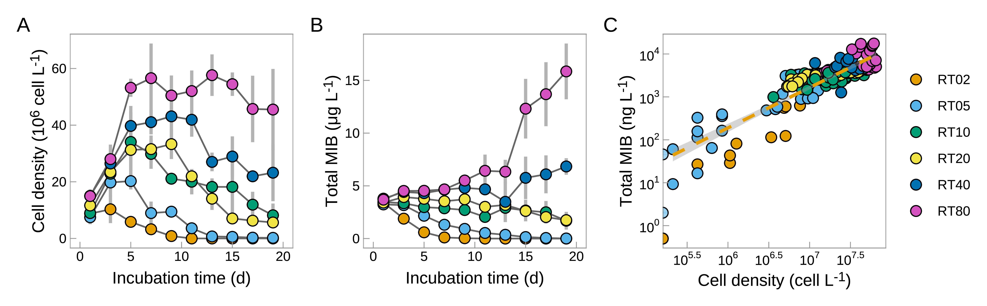
Fig. 1 Cell growth and MIB production of P. raciborskii under different HRTs (A: Cell density; B: MIB concentration; C: Correlation between cell density and MIB concentration) (culture condition: temperature: 30 °C, light intensity, 54 μmol m⁻² s⁻¹; values are present as mean ± sd)
Table 1 Summary of the P. raciborskii culture experiment results ($τ$ (d): the duration of cell number increases; $N^{*}$: the maximum cell density; $c_{MIB}^{*}$: the maximum MIB concentration; $k_{MIB}$: the decay rates of MIB under different HRT conditions, all values are expressed as mean values ± standard deviations.)
HRT (d) | $τ$ (d) | $ρ$ (d⁻¹) | $N^{*}$ (×10⁷ cell L⁻¹) | $c_{MIB}^{*}$ (ng L⁻¹) | $k_{MIB}^{*}$ (ng L⁻¹ d⁻¹)
2 | 3 | -0.26 ± 0.14 | 1.03 ± 0.48 | 1,888.7 ± 96.3 | 341.1 ± 19.9
5 | 5 | 0.02 ± 0.05 | 2.02 ± 0.29 | 3,172.1 ± 197.8 | 179.4 ± 7.4
10 | 5 | 0.19 ± 0.02 | 3.41 ± 1.04 | 3,347.8 ± 334.7 | 98.6 ± 45.1
20 | 9 | 0.13 ± 0.10 | 3.33 ± 0.52 | 3,936.9 ± 82.5 | 92.3 ± 5.2
40 | 9 | 0.20 ± 0.11 | 4.31 ± 0.75 | 6,838.5 ± 783.7 | -(178.4 ± 43.7)
80 | 13 | 0.33 ± 0.11 | 5.76 ± 0.73 | 15,853 ± 2,644.4 | -(675.6 ± 129.6)

The MIB decay rates were 92.3 ± 5.2 ng L⁻¹ d⁻¹, 98.6 ± 45.1 ng L⁻¹ d⁻¹, 179.4 ± 7.4 ng L⁻¹ d⁻¹, and 341.1 ± 19.9 ng L⁻¹ d⁻¹ for RT20, RT10, RT05 and RT02, respectively. It required 10 $d$ for MIB to decrease from the initial concentration of 3,410.9 ± 198.6 ng L⁻¹ (day 1) to 0.5 ± 0.0 ng L⁻¹ (day 11) in RT02; and 18 $d$ from 3,238.2 ± 132.9 ng L⁻¹ (day 1) to 9.3 ± 7.3 ng L⁻¹ (day 19) in RT05. By comparison, the time required for MIB removal was significantly longer for RT10 (35 $d$) and RT020 (37 $d$).

HRT regulation model
The goal of HRT regulation is to reduce the cell increase rate of the targeted cyanobacteria to less than 0. Here, we propose a model to describe the correlation between the observed cell increase rate ($ν, d^{−1}$) and HRT ($τ, d$), as shown in Eq. 3.
$$ν=μ_{s}−\frac{k}{τ} \left(3\right)$$
Where $μ_{s}$ ($d^{−1}$) and $k$ are undetermined coefficients, defined as the static growth rate and the hydraulic impact coefficient, respectively. This model indicates that the observed cell increase rate ($ν, d^{−1}$) equal to the static growth rate ($μ_{s}, d^{−1}$) minus the loss rate caused by the hydraulic effects ($k/τ$). By feeding the culture experiment result of P. raciborskii, the model was determined as $ν=\left(0.259±0.0316\right)−\left(1.05±0.141\right)/τ$ ($R^{2}=0.777$, p-value < 0.0001, Fig. 2A). Accordingly, the critical HRT ($τ_{L}^{*}, d$) for zero growth ($ν=0$) was determined to be $4.1±1.2 d$ for P. raciborskii using $k/μ_{s}$. At the same time, the critical HRT values ($τ_{F}^{*}, d$) for zero MIB increase in two actual MIB episodes were determined to be 7.6 $d$ and 6.7 $d$, respectively (Fig. 2B, Fig. 2C). Assuming that the static growth rate $μ_{s}$ was the same for both the laboratory experiment and the field survey, the hydraulic impact coefficient in the field ($k_{F}$) was determined as $k_{F}=τ_{F}^{*}/τ_{L}^{*}⋅k_{L}$. The critical HRT of two actual MIB episodes were 1.74 ~ 1.97 times higher than the critical HRT determined by the culture experiment ($4.1±1.2 d)$, implying that the hydraulic impact coefficient in the field situation ($k_{F}$) is 1.83 ~ 2.07.
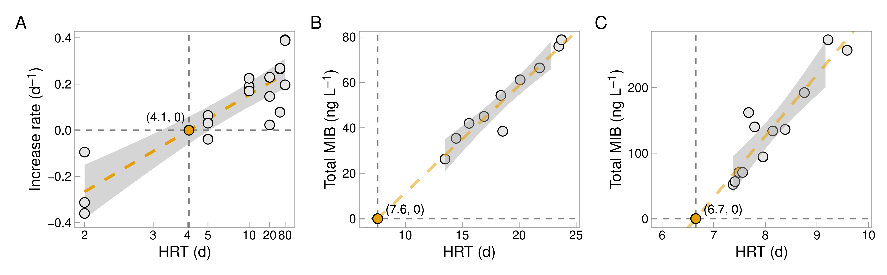
Fig. 2 MIB concentrations are highly correlated to hydraulic retention time according to a culture experiment (A) and two actual MIB episodes occurred in NP reservoir in Zhuhai (B, C)
The critical HRT ($τ_{F}^{*}$) determined by $k_{F}/μ_{s}$ is the key parameter that can be used to guide the reservoir operation. The growth rates of 14 cyanobacterial genera based on 1,480 records determined by culture experiments from references have been summarized in Table 6, and the relationship between the growth rates and critical HRTs for these 14 genera is shown in Fig. 3. Assuming the hydraulic impact coefficient in the field situation ($k_{F}$) is in the range of 1.5 ~ 3.0, the values of $τ_{F}^{*}$ were determined based on their median static growth rates ($μ_{s}$). Higher $μ_{s}$ requires smaller HRT. For example, the control of Synechoccus requires an HRT shorter than 2.1 ~ 4.2 $d$, while Phormidium can be well controlled with an HRT shorter than 7.7 ~ 15.4 $d$. The critical HRT values for frequently reported MIB-producers including Planktothrix, Planktothricoides, Oscillatoria, Pseudanabaena, Phormidium and Lyngbya (Izaguirre and Taylor, 2004; Watson, 2003) were determined as 3.4 ~ 6.8 $d$; 4.6 ~ 9.1 $d$; 5.8 ~ 11.6 $d$; 7.5 ~ 15.0 $d$; 7.7 ~ 15.4 $d$; and 10.3 ~ 20.7 $d$, respectively (Fig. 3).
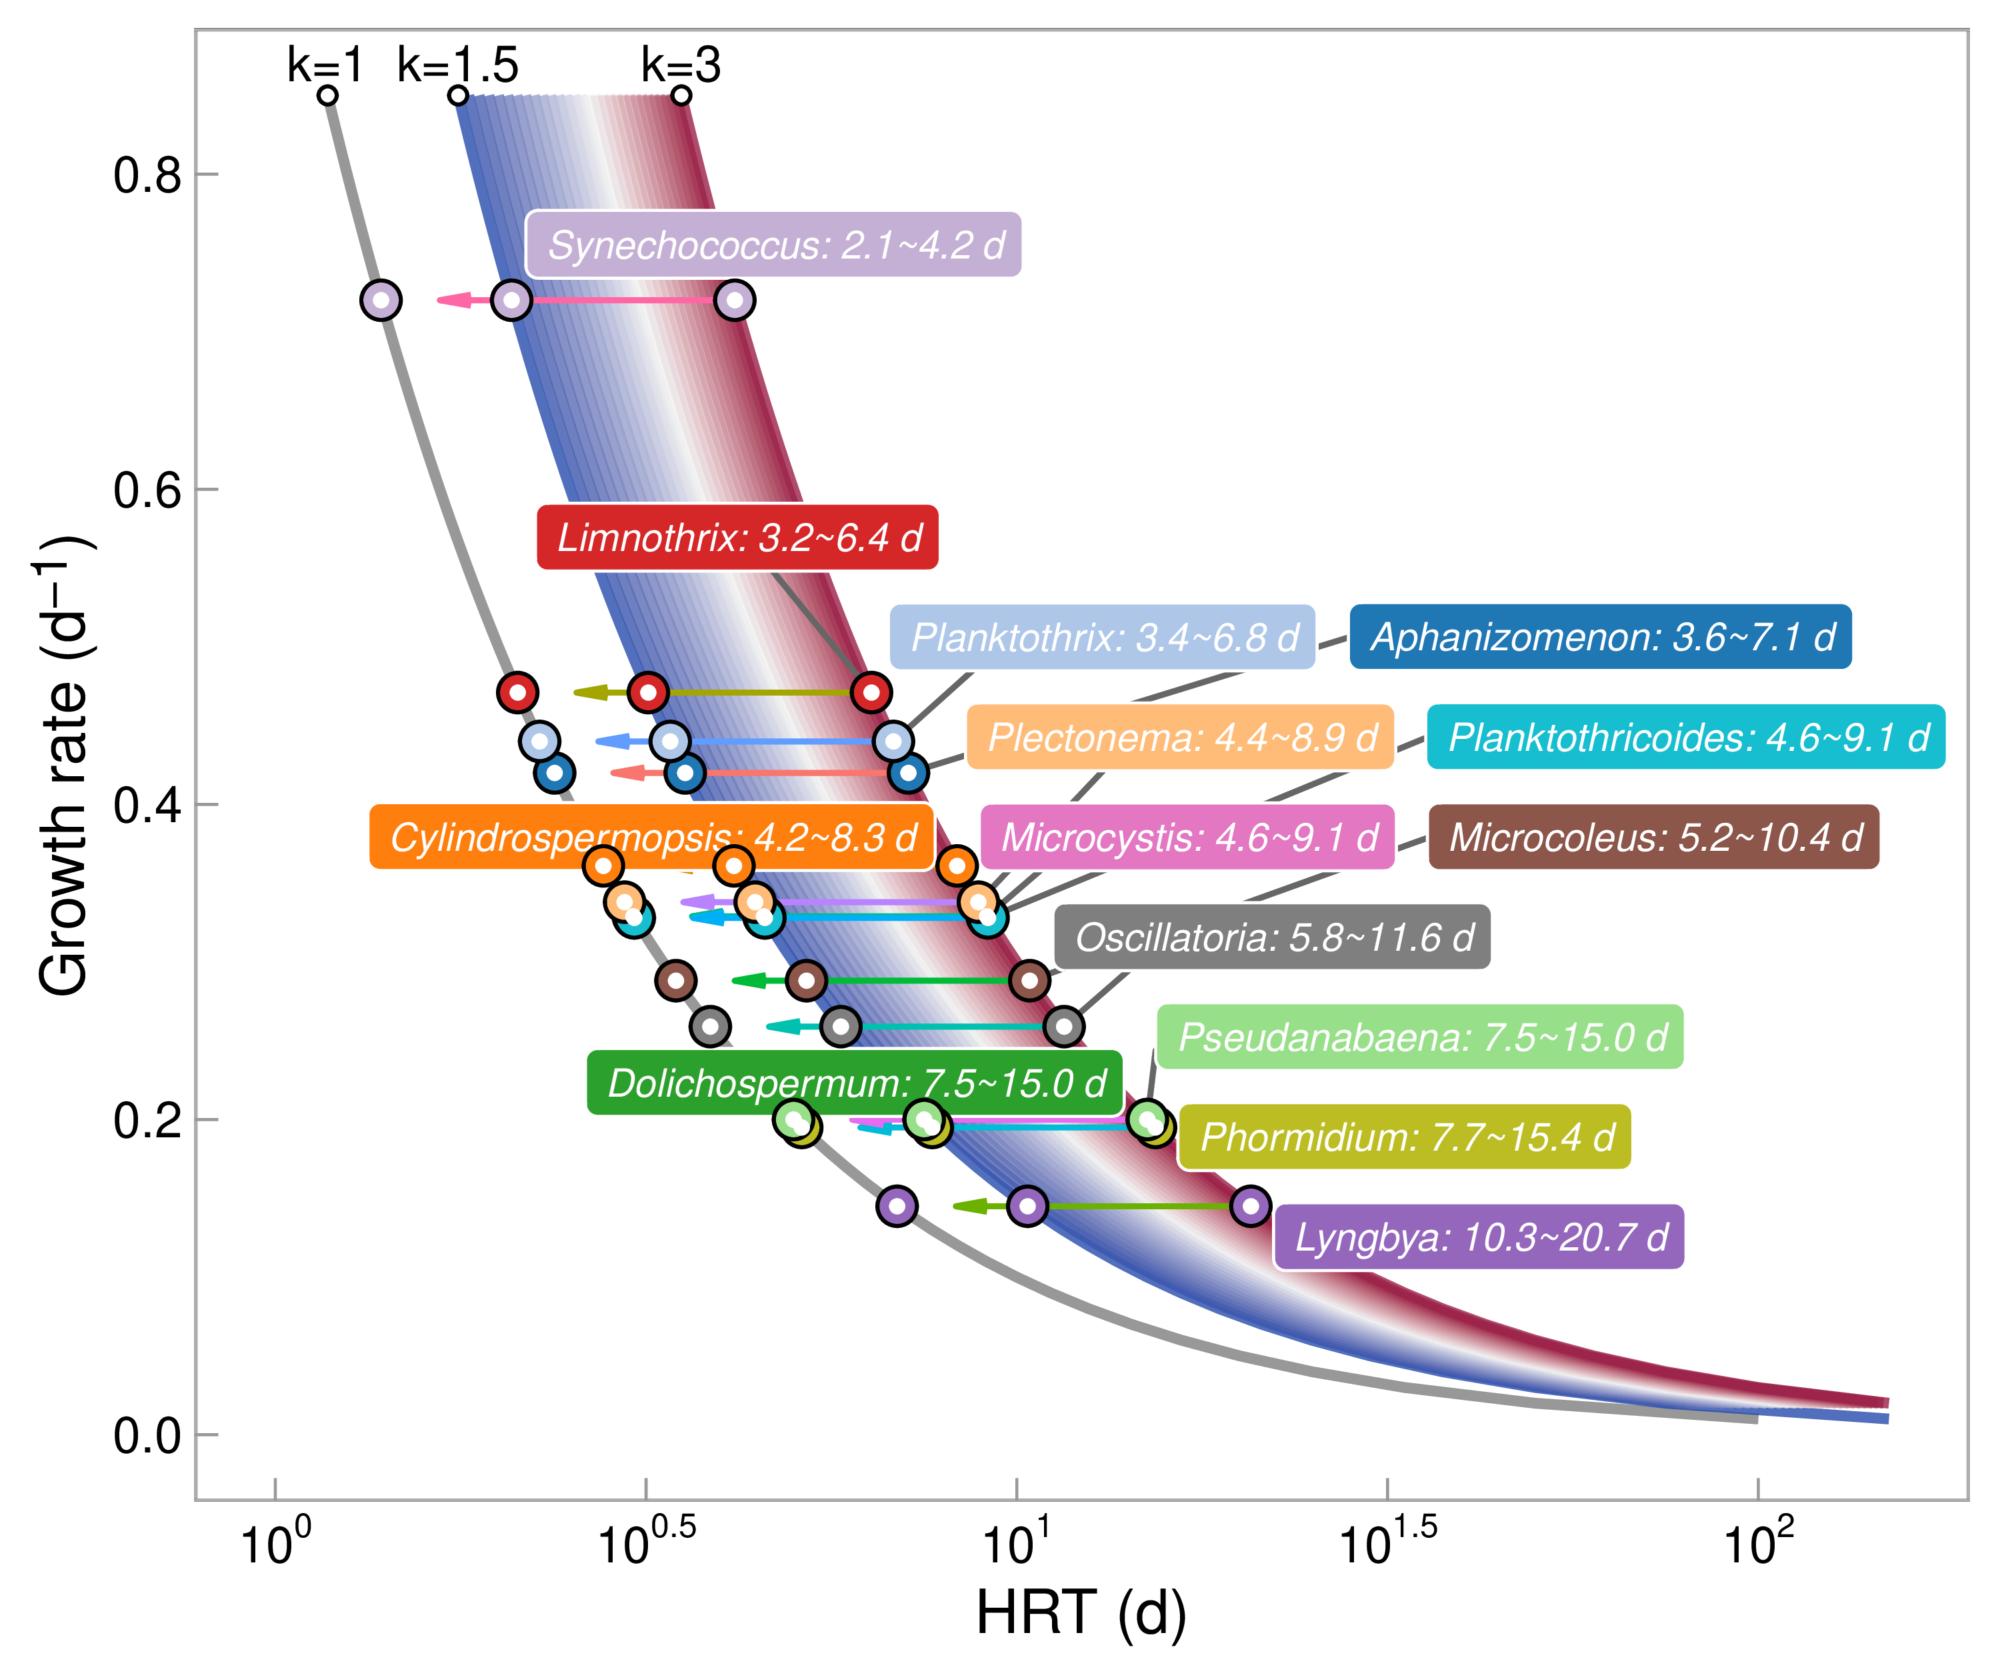
Fig. 3 The critical HRT values $τ_{F}^{*}$ for 14 typical cyanobacteria genera determined by the empirical $k_{F}$ value and their median static growth rates ($μ_{s}$)

Field application of HRT regulation for MIB control
HRT regulation to impact cyanobacterial growth was applied to ZXD Reservoir in April 2021. The mean HRT of this reservoir is 12.3 ± 7.3 $d$, MIB concentration (4.2 ng L⁻¹) and phytoplankton density (chl a, 2.5 μg L⁻¹) are relatively low. Nevertheless, it experienced an MIB episode starting on 20 March, 2021, resulting from the suspension of all inflow for 6 $d$ from 13 ~ 18 March due to the construction of an upstream pump station. Although the HRT was shortened to 18.0 ± 2.2 $d$ from 19 March, the MIB concentration continued to increase, with the maximum concentration of 51.7 ± 12.8 ng L⁻¹ observed on 15 April (Fig. 4A). The other main water quality parameters did not exhibit significant variations during this period (Table 7, Table 8). The mean nutrient concentrations were 1,615 ± 143 μg L⁻¹ (TN), 15 ± 3 μg L⁻¹ (TP), 73 ± 59 μg L⁻¹ (NH₄-N) and 1,438 ± 141 μg L⁻¹ (NO₃-N), respectively.
Cyanobacteria accounted for 91.5% of the phytoplankton community, mainly consisting of filamentous genera including Pseudanabaena (19.8%), Limnothrix (29.7%), Aphanizomenon (12.9%), Cylindrospermopsis (6.2%), Dolichospermum (5.7%) and Planktothrix (5.1%), as illustrated in Fig. 4B. The Planktothrix and Pseudanabaena were both potential MIB producers in reservoirs. Planktothrix was mostly absent and showed no obvious correlation with MIB (r = -0.58, p-value = 0.128). Nevertheless, Pseudanabaena exhibited a synchronized increase along with MIB dynamics from 6.36 × 10⁴ cell L⁻¹ (0.53%, 8 March) to 9.98 × 10⁶ cell L⁻¹ (25.2%, 17 April) (r = 0.79, p-value = 0.028, Fig. 7). It was thus confirmed to be the main MIB producer in ZXD Reservoir.
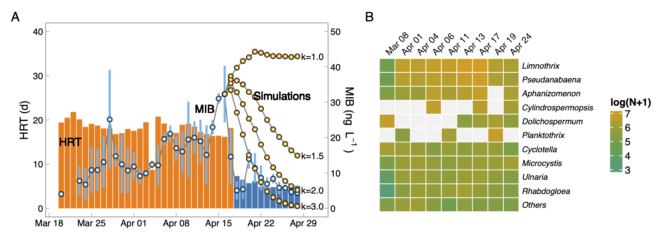
Fig. 4 Variations of MIB concentrations (A) and typical cyanobacterial genera (B) in association with HRT of ZXD Reservoir (the simulated MIB concentrations at different $k$-values are illustrated using black lines with orange circles)
On 18 April, HRT regulation was applied by raising the inflow and outflow rates from 10.07 × 10⁴ to 33.96 × 10⁴ m³ d⁻¹. This resulted in a significant reduction in HRT to 5.4 ± 0.8 $d$, which was below the critical HRT value ($τ_{F}^{*}$) for Pseudanabaena (7.5 ~ 15 $d$, Fig. 4). The k-value was about 2.03 (p-value < 0.001) obtained by performing a non-linear regression based on routing data using the nls function in R (Fig. 5A). The whole phytoplankton community structure exhibited no significant difference before or after HRT regulation (p-value = 0.072), and was dominated by cyanobacteria with a relative abundance of 93.8 % (Fig. 9). Since the application of HRT regulation, the growth of phytoplankton was inhibited, exhibiting a significant reduction from the maximum observed cell density of 39.61 × 10⁶ cell L⁻¹ (17 April) to 8.86 × 10⁶ cell L⁻¹ (24 April). The mean cell density of dominant genera including Limnothrix、Aphanizomenon and Cylindrospermopsis decreased significantly from (6.98 ± 4.65) × 10⁶, (2.66 ± 2.61) × 10⁶, (1.22 ± 2.21) × 10⁶ cell L⁻¹ to (2.41 ± 1.03) × 10⁶, (1.12 ± 1.59) × 10⁶, (0.75 ± 1.06) × 10⁶ cell L⁻¹ after HRT regulation, respectively. In particular, the MIB producer Pseudanabaena exhibited significant reduction in both abundance (from 9.98 × 10⁶ cell L⁻¹ on 17 April to 1.12 × 10⁶ cell L⁻¹ on 24 April) and proportion (from 25.2% to 12.7%). Meanwhile, continuous decrease of MIB was observed from 22.34 ± 4.4 ng L⁻¹ on day 3 of HRT regulation (20 April) to 9.3 ± 2.3 ng L⁻¹ on day 8 (25 April), and remained lower than 10 ng L⁻¹ afterward.
Both the phytoplankton abundance and MIB concentration exhibited significant differences between before- and after-HRT regulation. Chl-a decreased from an average of 11.3 ± 14.5 μg L⁻¹ before to 3.7 ± 6.5 μg L⁻¹ after (p-value = 0.005), particularly for surface and middle layers (p-value < 0.001, Fig. 5A, Fig. 8B). The reduction in MIB concentration between the two periods was also significant (from 22.2 ± 8.7 ng L⁻¹ to 8.6 ± 3.7 ng L⁻¹, p-value < 0.05, Fig. 5B). Simultaneously, several water quality parameters exhibited significant decreases including ammonia, pH, salinity, conductivity, phycocyanin content (PC, Fig. 8C), and ORP (p-values < 0.001, Table 9). The thermal stratification was weakened (Fig. 8A), and TN exhibited a slight increase from 1,563 ± 97 μg L⁻¹ to 1,664 ± 163 μg L⁻¹ (p-value = 0.0020).
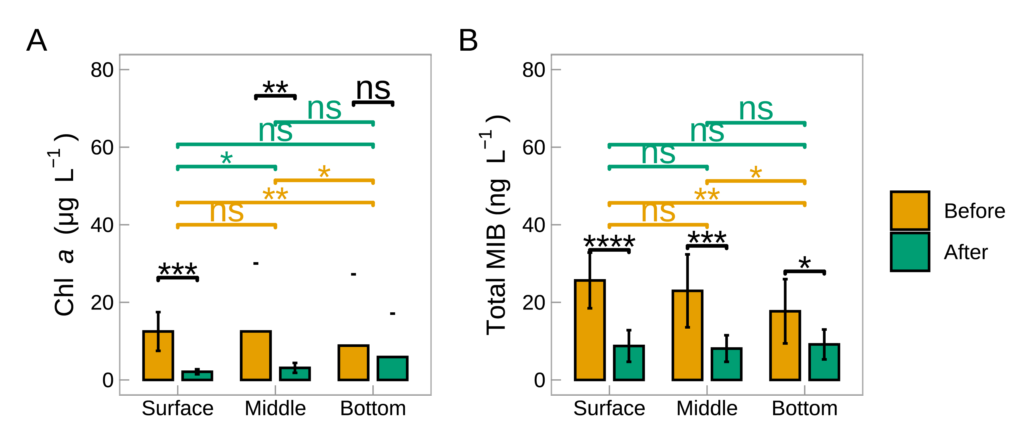
Fig. 5 The variation of Chl-a (A) and MIB (B) in different layers before-and-after HRT regulation (ns, not significant, p-value > 0.05; *, p-value < 0.05; **, p-value < 0.01; ***, p-value < 0.001; ****, p-value < 0.0001)

Discussion

The critical HRT for MIB control in reservoirs
By reducing the rate of cell increase ($υ$) to less than 0, the nuisance cyanobacterial population and their associated water quality problems can be controlled and prevented. Thus, $τ_{F}^{*}$ can be defined as $k_{F}/μ_{s}$ by setting $υ$ to 0 (Eq. 3), which is determined by the specific growth rate of the selected cyanobacterial genera ($μ_{s}$) and the hydrodynamic regulation coefficient ($k_{F}$). The basis of cyanobacterial control via HRT regulation includes two elements: 1) physical dilution to prevent cell accumulation or growth, and 2) other physical impacts associated with the side-effects of hydraulic change. Investigations on river systems have found that shorter HRT can effectively weaken water thermal stratification, resulting in enhanced vertical mixing and higher water turbidity (Cha et al., 2017; Mitrovic et al., 2011). This side effect is potentially helpful for cyanobacterial control, since a well-mixed water column eliminates the cyanobacterial competitive advantage – vertical movement aided by their gas vesicles, over other algae (Huisman et al., 2018; Walsby et al., 1997; Whitton and Potts, 2007). Moreover, the loss of MIB due to volatilization may also affect. These additive effects can be represented by the hydraulic impact coefficient ($k_{F}$). The coefficient contributed by physical dilution equals $1$ according to the theoretical derivation, while the rest ($k_{F}−1$) is contributed by other effects.
In this study, the value of $k$ determined in the culture experiment is 1.05 ± 0.141, suggesting that the control of P. raciborskii is dominated by physical dilution. This is also supported by another study that reports the effects of disturbance on Pseudanabaena growth are limited (Gao et al., 2018). Nevertheless, the hydraulic impact coefficient in the natural system should be higher than 1 because the aquatic environment is very complex, and many factors are highly correlated to hydraulic conditions (e.g., MIB loss). The hydraulic impact coefficient in NP and ZXD Reservoir ($k_{F}$) was 1.83 ~ 2.07, indicating that the removal rate is also contributed by the side effect of HRT regulation (45.3 % ~ 51.7 %) in addition to physical dilution (48.3 % ~ 54.7 %).
Considering that $k_{F}$ is a parameter involving the physical dilution rate ($k_{D}=1$) and the side effects of hydraulic change ($k_{S}=k_{F}−k_{D}$), including weakening thermal stratification and increasing turbidity, among others, these side effects are also dependent upon reservoir characteristics such as water depth (Yang et al., 2020), water temperature (Wang et al., 2021), inflow characteristics (Sun et al., 2022), and reservoir morphology (Van Breeman and Ketelaars, 1995). Yang et al. (2020) concluded that thermal stratification could be affected by HRT and water depth, according to an investigation of eight karst hydropower reservoirs in Wujiang River basin in China. The turbidity in reservoir water is also affected by water temperature and inflow characteristics (Sun et al., 2022; Wang et al., 2021). Moreover, Van Breeman and Ketelaars (1995) declared that the mixing characteristics in reservoirs depend upon their morphology, which determines the effectiveness of cyanobacterial control. Thus, we believe that $k_{F}$ is almost a constant for a specific reservoir and suggest that $k_{F}$ should be adjusted when applied to actual reservoirs. In this study, it was estimated from the MIB episodes in the NP and ZXD Reservoirs, and we empirically propose that $k_{F}$ can be given a value in the range of 1.5 ~ 3.0 if no specific evidence is available.
The specific growth rate ($μ_{s}$) varies among different cyanobacterial genera (Jia et al., 2019; Lu et al., 2022; Wang and Li, 2015), and genera with higher $μ_{s}$ require a shorter critical HRT ($τ_{F}^{*}$) to limit their cell increase (Fig. 3). Nevertheless, the growth rate of cyanobacterial cells is also a function of environmental factors such as light intensity, temperature, nutrients, etc. (Jia et al., 2019; Lu et al., 2022; Su et al., 2021b), so the critical HRT is different in different seasons and/or different reservoirs. This is most likely the reason for the 0.9-day difference in critical HRT values (6.7 $d$ and 7.6 $d$) between the two MIB episodes in NP Reservoir. To simplify model Eq. 3, the median values of the cyanobacterial genera growth rates reported in literature were used in this study to calculate critical HRTs ($τ_{F}^{*}$) with different $k_{F}$ values (Fig. 3). These values can provide a grounded basis for HRT regulation for MIB control in drinking water reservoirs, and they can also help understand phytoplankton community composition in various water bodies with different HRTs. Nevertheless, although we have tried our best to review all available literature regarding the growth rates of typical cyanobacteria, the growth rates are not necessarily accurate enough and may result in imprecise critical HRT values.

Application of HRT regulation in drinking water reservoirs
It is useful to compare the growth potential of more widespread and typical surface bloom-forming cyanobacteria genera such as Microcystis, Aphanizomenon, Cylindrospermopsis, etc., to the MIB-producing genera. The latter tend to have relatively lower specific growth rates (0.09 ~ 0.39 d⁻¹, Table 6), which suggests that regulation based upon shorter HRT is potentially more effective for controlling these MIB-producing genera. In the case reported here, HRT regulation applied in ZXD Reservoir successfully controlled the MIB problems in 2021 (Fig. 4). During the MIB episode, the HRT threshold of the MIB producer Pseudanabaena was determined as 7.5 ~ 15.0 $d$ based on 69 records from literatures (Fig. 3), which was shorter than the HRT of ZXD Reservoir (18.0 ± 2.2 $d$) before the application of HRT regulation. In comparison, the HRT was lowered to 5.4 ± 0.8 $d$ by raising the flow rate after 18 April, resulting in significant decreases in Pseudanabaena abundance and MIB concentration. The fitted k-value in ZXD Reservoir was about 2.03 (Fig. 4A), indicating that the critical HRT was 10 ~ 15 $d$ and consistent with our empirically proposed $k_{F}$ value (1.5 ~ 3.0). Besides, both Chl-a concentration and phytoplankton cell density were markedly decreased after regulation (Fig. 5A, Fig. 4B). These results support that HRT regulation can be used to control this type of nuisance cyanobacteria and their related water quality problems. Nevertheless, the growth rate of Pseudanabaena, that was not determined by specialized culture experiment, may result in imprecise evaluation of HRT threshold.
Investigations into other strategies to control harmful cyanobacteria in reservoirs have shown clear evidence of influence on the structure of phytoplankton communities (Burford and O’donohue, 2006; Moustaka-Gouni et al., 2022; Wan et al., 2021). Wan et al. (2021) found a distinct variation in bacterioplankton community composition caused by changes in total phosphorus after dredging. Lusty and Gobler (2020) found a significant reduction in cyanobacteria biomass after hydrogen peroxide was added, but the sensitivity of different genera varied. Burford and O’donohue (2006) declared that artificial mixing was more effective in controlling colonial versus solitary filamentous species and promoted the growth of species with low phosphorus tolerance. By contrast, in this study, the phytoplankton community structure was not significantly affect by HRT regulation (p-value = 0.072, Fig. 4B). The HRT regulation principle includes physical dilution ($1/τ$), which was consistent for the effect on all genera; while specific growth rates varied among different genera, and typical bloom-forming cyanobacteria genera with higher growth rates and lower critical HRTs could gain growth advantages over others under shorter HRT conditions, as also suggested by Robarts and Zohary (1987). In ZXD Reservoir, the mean Pseudanabaena cell abundance was drastically reduced by 65.4% after HRT regulation, whereas some bloom-forming genera with higher growth rates, including Aphanizomenon and Cylindrospermopsis, descended to relatively lower values at about 57.8% and 38.7%, respectively (Fig. 4B). Therefore, by adjusting the HRT the phytoplankton structure can potentially be modified towards a preferred community structure with less abundant harmful algae. It is worth noting that HRT-based regulation to control MIB-producing cyanobacteria is more suitable for small drinking water reservoirs, especially in areas with well-developed water systems but cyanobacteria-derived MIB problems are frequent including South China and South East Asia, etc. (Lu et al., 2022). In these areas, large number of small reservoirs have been built for flood control, drought, water supply and irrigation, making it easier to control odor by reducing HRT through mutual water transfers. Nevertheless, shortening HRT in medium/large reservoirs can cause significant water and energy consumption. Additionally, this strategy is also limited by the fact that the odor compounds or other contaminants (nutrient, phytoplankton, etc.) in inflow water should be at low level. Besides, the higher flushing rates associated with shorter HRTs are more suitable for those planktonic cyanobacterial genera control, while other strategies (water level and turbidity regulation, etc.) are more effective for reservoirs with benthic/deep-living genera (Jia et al., 2019; Su et al., 2017). The hydraulic regulation may not able to deal with the MIB problem caused by actinomycetes and other microorganisms in source water reservoirs, and therefore further investigations are required.

Conclusion
This study carried out field investigations, laboratory culture experiments, and field applications in response to frequently observed MIB episodes in drinking water reservoirs in China. The following conclusions could be drawn: 1) Increases in HRT can trigger MIB-derived odor problems in reservoirs; 2) The maximum cell density, growth rate, and MIB concentration exhibited significant positive correlations with HRT according to the culture experiment of MIB-producing P. raciborskii, and growth was greatly inhibited when HRT was less than 5 $d$; 3) A HRT regulation model that aims to control harmful cyanobacteria and associated water quality problems was developed, and the critical HRT values for controlling typical cyanobacterial genera were evaluated; 4) HRT regulation was successfully applied by decreasing the HRT to lower than the critical value in ZXD Reservoir, resulting in a significant decrease of MIB concentration. The proposed principle provides a scientific basis for HRT regulation strategy and can be used to control MIB-derived odor problems, and this should also work for the control of other MIB-producing cyanobacteria.

Declaration of Competing Interest
The authors declare that they have no known competing financial interests or personal relationships that could have appeared to influence the work reported in this paper.

Acknowledgement
This work was financially supported by the National Natural Science Foundation of China (52030002, 51878649), China Key Research and Development Program (2022YFC3203603) and Youth Innovation Promotion Association CAS.

References
Anunciação Gomes, A.M. da, Oliveira e Azevedo, S.M.F. de, Lürling, M., 2015. Temperature effect on exploitation and interference competition among Microcystis aeruginosa, Planktothrix agardhii and, Cyclotella meneghiniana. The Scientific World Journal 2015, 1–10. https://doi.org/10.1155/2015/834197
Araujo Torres, C. de, Lürling, M., Marinho, M.M., 2015. Assessment of the effects of light availability on growth and competition between strains of Planktothrix agardhii and Microcystis aeruginosa. Microbial Ecology 71, 802–813. https://doi.org/10.1007/s00248-015-0719-z
Burford, M.A., O’donohue, M.J., 2006. A comparison of phytoplankton community assemblages in artificially and naturally mixed subtropical water reservoirs. Freshwater Biology 51, 973–982. https://doi.org/10.1111/j.1365-2427.2006.01536.x
Cao, T., Fang, J., Jia, Z., Zhu, Y., Su, M., Zhang, Q., Song, Y., Yu, J., Yang, M., 2023. Early warning of MIB episode based on gene abundance and expression in drinking water reservoirs. Water Research 231, 119667. https://doi.org/https://doi.org/10.1016/j.watres.2023.119667
Cha, Y., Cho, K.H., Lee, H., Kang, T., Kim, J.H., 2017. The relative importance of water temperature and residence time in predicting cyanobacteria abundance in regulated rivers. Water Research 124, 11–19. https://doi.org/10.1016/j.watres.2017.07.040
Dokulil, Martint., Teubner, K., 2012. Deep living Planktothrix rubescens modulated by environmental constraints and climate forcing. Hydrobiologia 698, 29–46. https://doi.org/10.1007/s10750-012-1020-5
Everall, N.c., Lees, D.r., 1997. The identification and significance of chemicals released from decomposing barley straw during reservoir algal control. Water Research 31, 614–620. https://doi.org/10.1016/s0043-1354(96)00291-6
Fan, C.-C., Chiu, Y.-T., Lin, T.-F., 2018. A simple alternative method for preservation of 2-methylisoborneol in water samples. International Journal of Environmental Research and Public Health 15, 1015. https://doi.org/10.3390/ijerph15051015
Fastner, J., Abella, S., Litt, A., Morabito, G., Vörös, L., Pálffy, K., Straile, D., Kümmerlin, R., Matthews, D., Phillips, M.G., Chorus, I., 2015. Combating cyanobacterial proliferation by avoiding or treating inflows with high p load experiences from eight case studies. Aquatic Ecology 50, 367–383. https://doi.org/10.1007/s10452-015-9558-8
Gao, J., Zhu, J., Wang, M., Dong, W., 2018. Dominance and growth factors of Pseudanabaena sp. In drinking water source reservoirs, southern china. Sustainability 10, 3936. https://doi.org/10.3390/su10113936
Gerber, N.N., 1983. Volatile substances from actinomycetes: Their role in the odor pollution of water. Water Science and Technology 15, 115–125. https://doi.org/10.2166/wst.1983.0136
Gillogly, T.E.T., Snoeyink, V.L., Newcombe, G., Elarde, J.R., 1999. A simplified method to determine the powdered activated carbon dose required to remove methylisoborneol. Water Science and Technology 40, 59–64. https://doi.org/10.1016/S0273-1223(99)00538-7
Greenfield, D.I., Duquette, A., Goodson, A., Keppler, C.J., Williams, S.H., Brock, L.M., Stackley, K.D., White, D., Wilde, S.B., 2014. The effects of three chemical algaecides on cell numbers and toxin content of the cyanobacteria Microcystis aeruginosa and Anabaenopsis sp. Environmental Management 54, 1110–1120. https://doi.org/10.1007/s00267-014-0339-2
Halstvedt, C.B., Rohrlack, T., Andersen, T., Skulberg, O., Edvardsen, B., 2007. Seasonal dynamics and depth distribution of Planktothrix spp. In Lake Steinsfjorden (Norway) related to environmental factors. Journal of Plankton Research 29, 471–482. https://doi.org/10.1093/plankt/fbm036
Harrell Jr, F.E., 2022. Hmisc: Harrell Miscellaneous.
Huang, X., Shi, B., Hao, H., Su, Y., Wu, B., Jia, Z., Wang, C., Wang, Q., Yang, M., Yu, J., 2020. Identifying the function of activated carbon surface chemical properties in the removability of two common odor compounds. Water Research 178, 115797. https://doi.org/10.1016/j.watres.2020.115797
Huisman, J., Codd, G.A., Paerl, H.W., Ibelings, B.W., Verspagen, J.M.H., Visser, P.M., 2018. Cyanobacterial blooms. Nature Reviews Microbiology 16, 471–483. https://doi.org/10.1038/s41579-018-0040-1
Izaguirre, G., Jungblut, A., Neilan, B.A., 2007. Benthic cyanobacteria (oscillatoriaceae) that produce microcystin-LR, isolated from four reservoirs in Southern California. Water Research 41, 492–498. https://doi.org/10.1016/j.watres.2006.10.012
Izaguirre, G., Taylor, W.d., 2004. A guide to geosmin- and MIB-producing cyanobacteria in the United States. Water Science and Technology 49, 19–24.
Jeppesen, E., Søndergaard, M., Jensen, J.P., Havens, K.E., Anneville, O., Carvalho, L., Coveney, M.F., Deneke, R., Dokulil, M.T., Foy, B., others, 2005. Lake responses to reduced nutrient loading–an analysis of contemporary long-term data from 35 case studies. Freshwater biology 50, 1747–1771. https://doi.org/https://doi.org/10.1111/j.1365-2427.2005.01415.x
Jia, Z., Su, M., Liu, T., Guo, Q., Wang, Q., Burch, M., Yu, J., Yang, M., 2019. Light as a possible regulator of MIB-producing Planktothrix in source water reservoir, mechanism and in-situ verification. Harmful Algae 88, 101658. https://doi.org/10.1016/j.hal.2019.101658
Jüttner, F., Watson, S.B., 2007. Biochemical and ecological control of geosmin and 2-methylisoborneol in source waters. Applied and Environmental Microbiology 73, 4395–4406. https://doi.org/10.1128/aem.02250-06
Kibuye, F.A., Zamyadi, A., Wert, E.C., 2021. A critical review on operation and performance of source water control strategies for cyanobacterial blooms: Part i-chemical control methods. Harmful Algae 109, 102099. https://doi.org/10.1016/j.hal.2021.102099
Li, L., Yang, S., Yu, S., Zhang, Y., 2019. Variation and removal of 2-MIB in full-scale treatment plants with source water from Lake Tai, China. Water Research 162, 180–189. https://doi.org/10.1016/j.watres.2019.06.066
Li, Z., Hobson, P., An, W., Burch, M.D., House, J., Yang, M., 2012. Earthy odor compounds production and loss in three cyanobacterial cultures. Water Research 46, 5165–5173. https://doi.org/10.1016/j.watres.2012.06.008
Lu, J., Su, M., Su, Y., Wu, B., Cao, T., Fang, J., Yu, J., Zhang, H., Yang, M., 2022. Driving forces for the growth of MIB-producing Planktothricoides raciborskii in a low-latitude reservoir. Water Research 118670. https://doi.org/10.1016/j.watres.2022.118670
Lusty, M.W., Gobler, C.J., 2020. The efficacy of hydrogen peroxide in mitigating cyanobacterial blooms and altering microbial communities across four lakes in NY, USA. Toxins 12, 428. https://doi.org/10.3390/toxins12070428
Mitrovic, S.M., Hardwick, L., Dorani, F., 2011. Use of flow management to mitigate cyanobacterial blooms in the Lower Darling River, Australia. Journal of Plankton Research 33, 229–241. https://doi.org/10.1093/plankt/fbq094
Mitrovic, S.M., Oliver, R.L., Rees, C., Bowling, L.C., Buckney, R.T., 2003. Critical flow velocities for the growth and dominance of Anabaena circinalis in some turbid freshwater rivers. Freshwater Biology 48, 164–174. https://doi.org/10.1046/j.1365-2427.2003.00957.x
Moustaka-Gouni, M., Poulimenakou, V., Papadimitriou, T., Paxinou, A., Stefanidou, N., Laspidou, C.S., Kormas, K.A., Katsiapi, M., 2022. Differential effect of hydroxen peroxide on toxic cyanobacteria of hypertrophic mediterranean waterbodies. Sustainability.
Newcombe, G., 2012. International guidance manual for the management of toxic cyanobacteria. IWA Publishing.
R Core Team, 2021. R: A language and environment for statistical computing. R Foundation for Statistical Computing, Vienna, Austria.
Robarts, R.D., Zohary, T., 1987. Temperature effects on photosynthetic capacity, respiration, and growth rates of bloom‐forming cyanobacteria. New Zealand Journal of Marine and Freshwater Research 21, 391–399. https://doi.org/10.1080/00288330.1987.9516235
Romo, S., Soria, J., Fernández, F., Ouahid, Y., Barón-Solá, Ángel, 2012. Water residence time and the dynamics of toxic cyanobacteria. Freshwater Biology 58, 513–522. https://doi.org/10.1111/j.1365-2427.2012.02734.x
Su, M., An, W., Yu, J., Pan, S., Yang, M., 2014. Importance of underwater light field in selecting phytoplankton morphology in a eutrophic reservoir. Hydrobiologia 724, 203–216. https://doi.org/10.1007/s10750-013-1734-z
Su, M., Andersen, T., Burch, M., Jia, Z., An, W., Yu, J., Yang, M., 2019. Succession and interaction of surface and subsurface cyanobacterial blooms in oligotrophic/mesotrophic reservoirs: A case study in Miyun Reservoir. Science of the Total Environment 649, 1553–1562. https://doi.org/J.scitotenv.2018.08.307
Su, M., Fang, J., Jia, Z., Su, Y., Zhu, Y., Wu, B., Little, J.C., Yu, J., Yang, M., 2023. Biosynthesis of 2-methylisoborneol is regulated by chromatic acclimation of Pseudanabaena. Environmental Research 221, 115260. https://doi.org/10.1016/j.envres.2023.115260
Su, M., Jia, D., Yu, J., Vogt, R.D., Wang, J., An, W., Yang, M., 2017. Reducing production of taste and odor by deep-living cyanobacteria in drinking water reservoirs by regulation of water level. Science of the Total Environment 574, 1477–1483. https://doi.org/10.1016/j.scitotenv.2016.08.134
Su, M., Suruzzaman, MD., Zhu, Y., Lu, J., Yu, J., Zhang, Y., Yang, M., 2021a. Ecological niche and in-situ control of MIB producers in source water. Journal of Environmental Sciences 110, 119–128. https://doi.org/10.1016/j.jes.2021.03.026
Su, M., Yu, J., Zhang, J., Chen, H., An, W., Vogt, R.D., Andersen, T., Jia, D., Wang, J., Yang, M., 2015. MIB-producing cyanobacteria (Planktothrix sp.) in a drinking water reservoir: Distribution and odor producing potential. Water Research 68, 444–453. https://doi.org/10.1016/j.watres.2014.09.038
Su, M., Zhu, Y., Andersen, T., Wang, X., Yu, Z., Lu, J., Song, Y., Cao, T., Yu, J., Zhang, Y., Yang, M., 2022. Light-dominated selection shaping filamentous cyanobacterial assemblages drives odor problem in a drinking water reservoir. npj Clean Water 5, 37. https://doi.org/10.1038/s41545-022-00181-2
Su, M., Zhu, Y., Jia, Z., Liu, T., Yu, J., Burch, M., Yang, M., 2021b. Identification of MIB producers and odor risk assessment using routine data: A case study of an estuary drinking water reservoir. Water Research 192, 116848. https://doi.org/10.1016/j.watres.2021.116848
Sun, Y., Li, J., Cao, Z., Borthwick, A.G.L., Józsa, J., 2022. Effect of tributary inflow on reservoir turbidity current. Environmental Fluid Mechanics. https://doi.org/10.1007/s10652-022-09856-3
Te, S.H., Tan, B.F., Thompson, J.R., Gin, K.Y.-H., 2017. Relationship of microbiota and cyanobacterial secondary metabolites in Planktothricoides-dominated bloom. Environmental Science & Technology 51, 4199–4209. https://doi.org/10.1021/acs.est.6b05767
Van Breeman, L., Ketelaars, H., 1995. The influence of artificial mixing and other factors on algal biomass in the biesbosch reservoirs. Aqua- Journal of Water Supply: Research and Technology[AQUA J. WATER SUPPLY TECHNOL.]. 44.
Van Der Ploeg, M., Dennis, M., De Regt, M., 1995. Biology of Oscillatoria chalybea, a 2-methylisoborneol producing blue-green alga of Mississippi Catfish Ponds. Water Science and Technology 31, 173–180. https://doi.org/10.1016/0273-1223(95)00473-Z
Verspagen, J.M.H., Passarge, J., Jöhnk, K.D., Visser, P.M., Peperzak, L., Boers, P., Laanbroek, H.J., Huisman, J., 2006. Water management strategies against toxic Microcystis blooms in the Dutch Delta. Ecological Applications 16, 313–327. https://doi.org/10.1890/04-1953
Visser, P., Ibelings, B., Van Der Veer, B., Koedood, J., Mur, R., 1996. Artificial mixing prevents nuisance blooms of the cyanobacterium Microcystis in Lake Nieuwe Meer, the Netherlands. Freshwater Biology 36, 435–450. https://doi.org/10.1046/j.1365-2427.1996.00093.x
Visser, P.M., Ibelings, B.W., Bormans, M., Huisman, J., 2016. Artificial mixing to control cyanobacterial blooms: A review. Aquatic Ecology 50, 423–441. https://doi.org/10.1007/s10452-015-9537-0
Walsby, A.E., Hayes, P.K., Boje, R., Stal, L.J., 1997. The selective advantage of buoyancy provided by gas vesicles for planktonic cyanobacteria in the Baltic Sea. New Phytologist 136, 407–417. https://doi.org/10.1046/j.1469-8137.1997.00754.x
Wan, W., Gadd, G.M., Gu, J.-D., He, D., Liu, W., Yuan, W., Ye, L., Yang, Y., 2021. Dredging alleviates cyanobacterial blooms by weakening diversity maintenance of bacterioplankton community. Water Research 202, 117449. https://doi.org/10.1016/j.watres.2021.117449
Wang, Q., Zietzschmann, F., Yu, J., Hofman, R., An, W., Yang, M., Rietveld, L.C., 2020. Projecting competition between 2-methylisoborneol and natural organic matter in adsorption onto activated carbon from ozonated source waters. Water Research 173, 115574. https://doi.org/10.1016/j.watres.2020.115574
Wang, R., Mao, X., Gao, L., Qi, L., Lu, X., Wang, Y., Li, J., Xie, C., Yuan, H., Yan, Z., others, 2021. An experimental and numerical study of turbidity currents entering a stratified reservoir. FRESENIUS ENVIRONMENTAL BULLETIN 30, 5108–5118.
Wang, Z., Li, R., 2015. Effects of light and temperature on the odor production of 2-methylisoborneol-producing Pseudanabaena sp. and geosmin-producing Anabaena ucrainica (cyanobacteria). Biochemical Systematics and Ecology 58, 219–226. https://doi.org/10.1016/j.bse.2014.12.013
Watson, S.B., 2004. Aquatic taste and odor: A primary signal of drinking-water integrity. Journal of Toxicology and Environmental Health, Part A 67, 1779–1795. https://doi.org/10.1080/15287390490492377
Watson, S.B., 2003. Cyanobacterial and eukaryotic algal odour compounds: Signals or by-products? A review of their biological activity. Phycologia 42, 332–350. https://doi.org/10.2216/i0031-8884-42-4-332.1
Whitton, B.A., Potts, M., 2007. The ecology of cyanobacteria: Their diversity in time and space. Springer Science & Business Media.
Wickham, H., 2016. ggplot2: Elegant graphics for data analysis. Springer-verlag New York.
Wiltbank, L.B., Kehoe, D.M., 2019. Diverse light responses of cyanobacteria mediated by phytochrome superfamily photoreceptors. Nature Reviews Microbiology 17, 37–50. https://doi.org/10.1038/s41579-018-0110-4
Xu, Y., Xiao, L., Yang, Y., 2020. Common phytoplankton species in Zhuhai Reservoirs. Jinan University Press.
Yang, C., Shen, X., Shi, X., Cui, Z., Nan, J., Lu, H., Li, J., Huang, Q., 2023. Impact of submerged macrophytes on growth and 2-MIB release risk of Pseudanabaena sp.: From field monitoringa to cultural experiments. Journal of Hazardous Materials 442, 130052. https://doi.org/10.1016/j.jhazmat.2022.130052
Yang, X., Li, Y., Wang, B., Xiao, J., Yang, M., Liu, C.-Q., 2020. Effect of hydraulic load on thermal stratification in karst cascade hydropower reservoirs, Southwest China. Journal of Hydrology: Regional Studies 32, 100748. https://doi.org/10.1016/j.ejrh.2020.100748
Zamyadi, A., Henderson, R., Stuetz, R., Hofmann, R., Ho, L., Newcombe, G., 2015. Fate of geosmin and 2-methylisoborneol in full-scale water treatment plants. Water Research 83, 171–183. https://doi.org/10.1016/j.watres.2015.06.038
Zhang, T., Zheng, L., Li, L., Song, L., 2016. 2-methylisoborneol production characteristics of Pseudanabaena sp. FACHB 1277 isolated from Xionghe Reservoir, China. Journal of Applied Phycology 1–10. https://doi.org/10.1007/s10811-016-0864-x

