Light-dominated selection shaping filamentous cyanobacterial assemblages drives odor problem in a drinking water reservoir
Supplementary Material
Ming Su^{1,5}, Yiping Zhu², Tom Andersen³, Xianyun Wang⁴, Zhiyong Yu^{1,5}, Jinping Lu^{1,5}, Yichao Song², Tengxin Cao^{1,5}, Jianwei Yu^{1,5}, Yu Zhang^{1,5}, and Min Yang^{1,5,✉}
2025-01-09
¹ Key Laboratory of Drinking Water Science and Technology, Research Center for Eco-Environmental Sciences, Chinese Academy of Sciences
² Shanghai Chengtou Raw Water Co. Ltd
³ Department of Biosciences, University of Oslo
⁴ National Engineering Research Center of China (South) for Urban Water
⁵ University of Chinese Academy of Sciences
✉ Correspondence: Min Yang <yangmin@rcees.ac.cn>

Supplementary Material
All data analysis and illustration were performed using R 4.0¹. Data pretreatment and summary were performed using the dplyr² and base packages in R, regression analysis including linear and generalized linear models were performed using the stats package¹, generalized additive modelling was performed using the mgcv package^{3,4} quantile regression analysis was performed using the quantreg package⁵; contour figures were created by the graphics package¹, other figures were prepared using the ggplot2 package⁶.
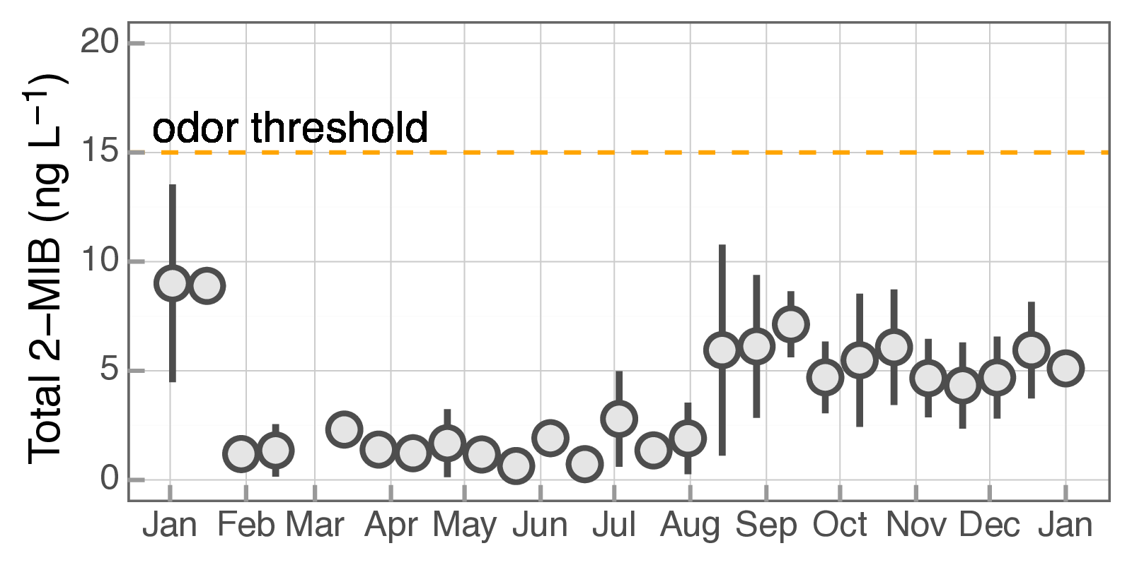
Fig. S1 Seasonal dynamics of MIB of Yangtze River water (inlet) from 2011 to 2015”

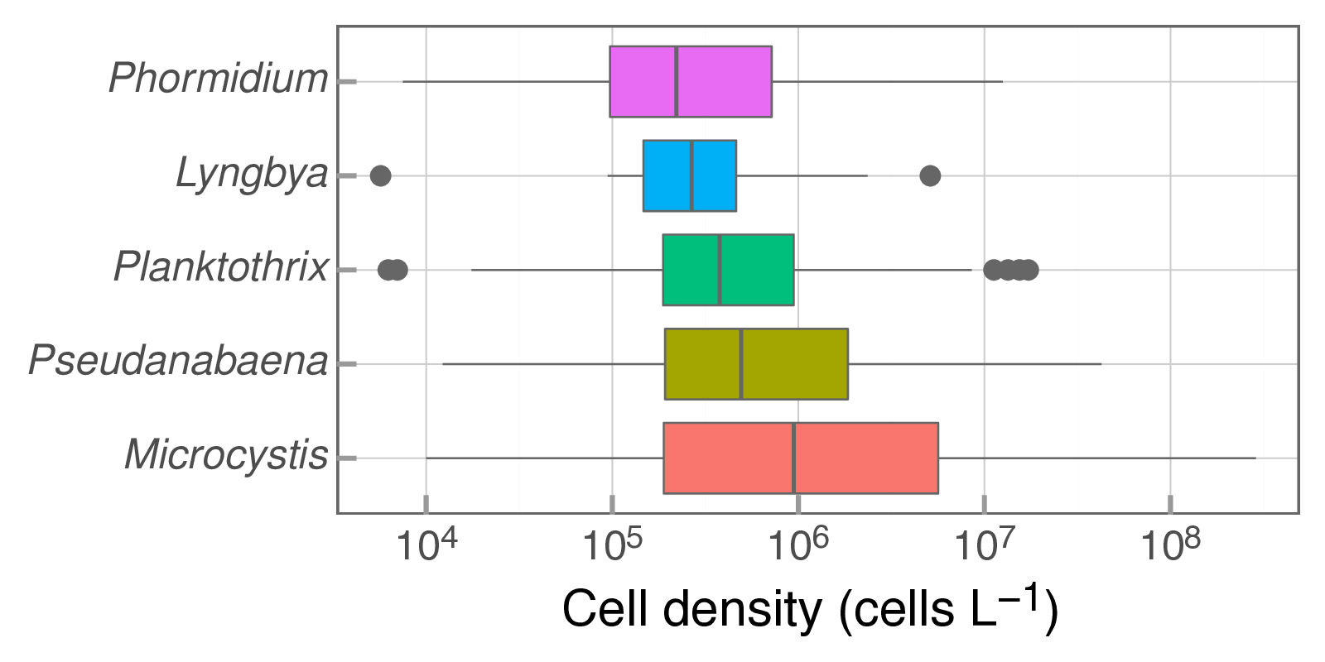
Fig. S2 Composition of filamentous cyanobacteria and Microcystis in QCS Reservoir

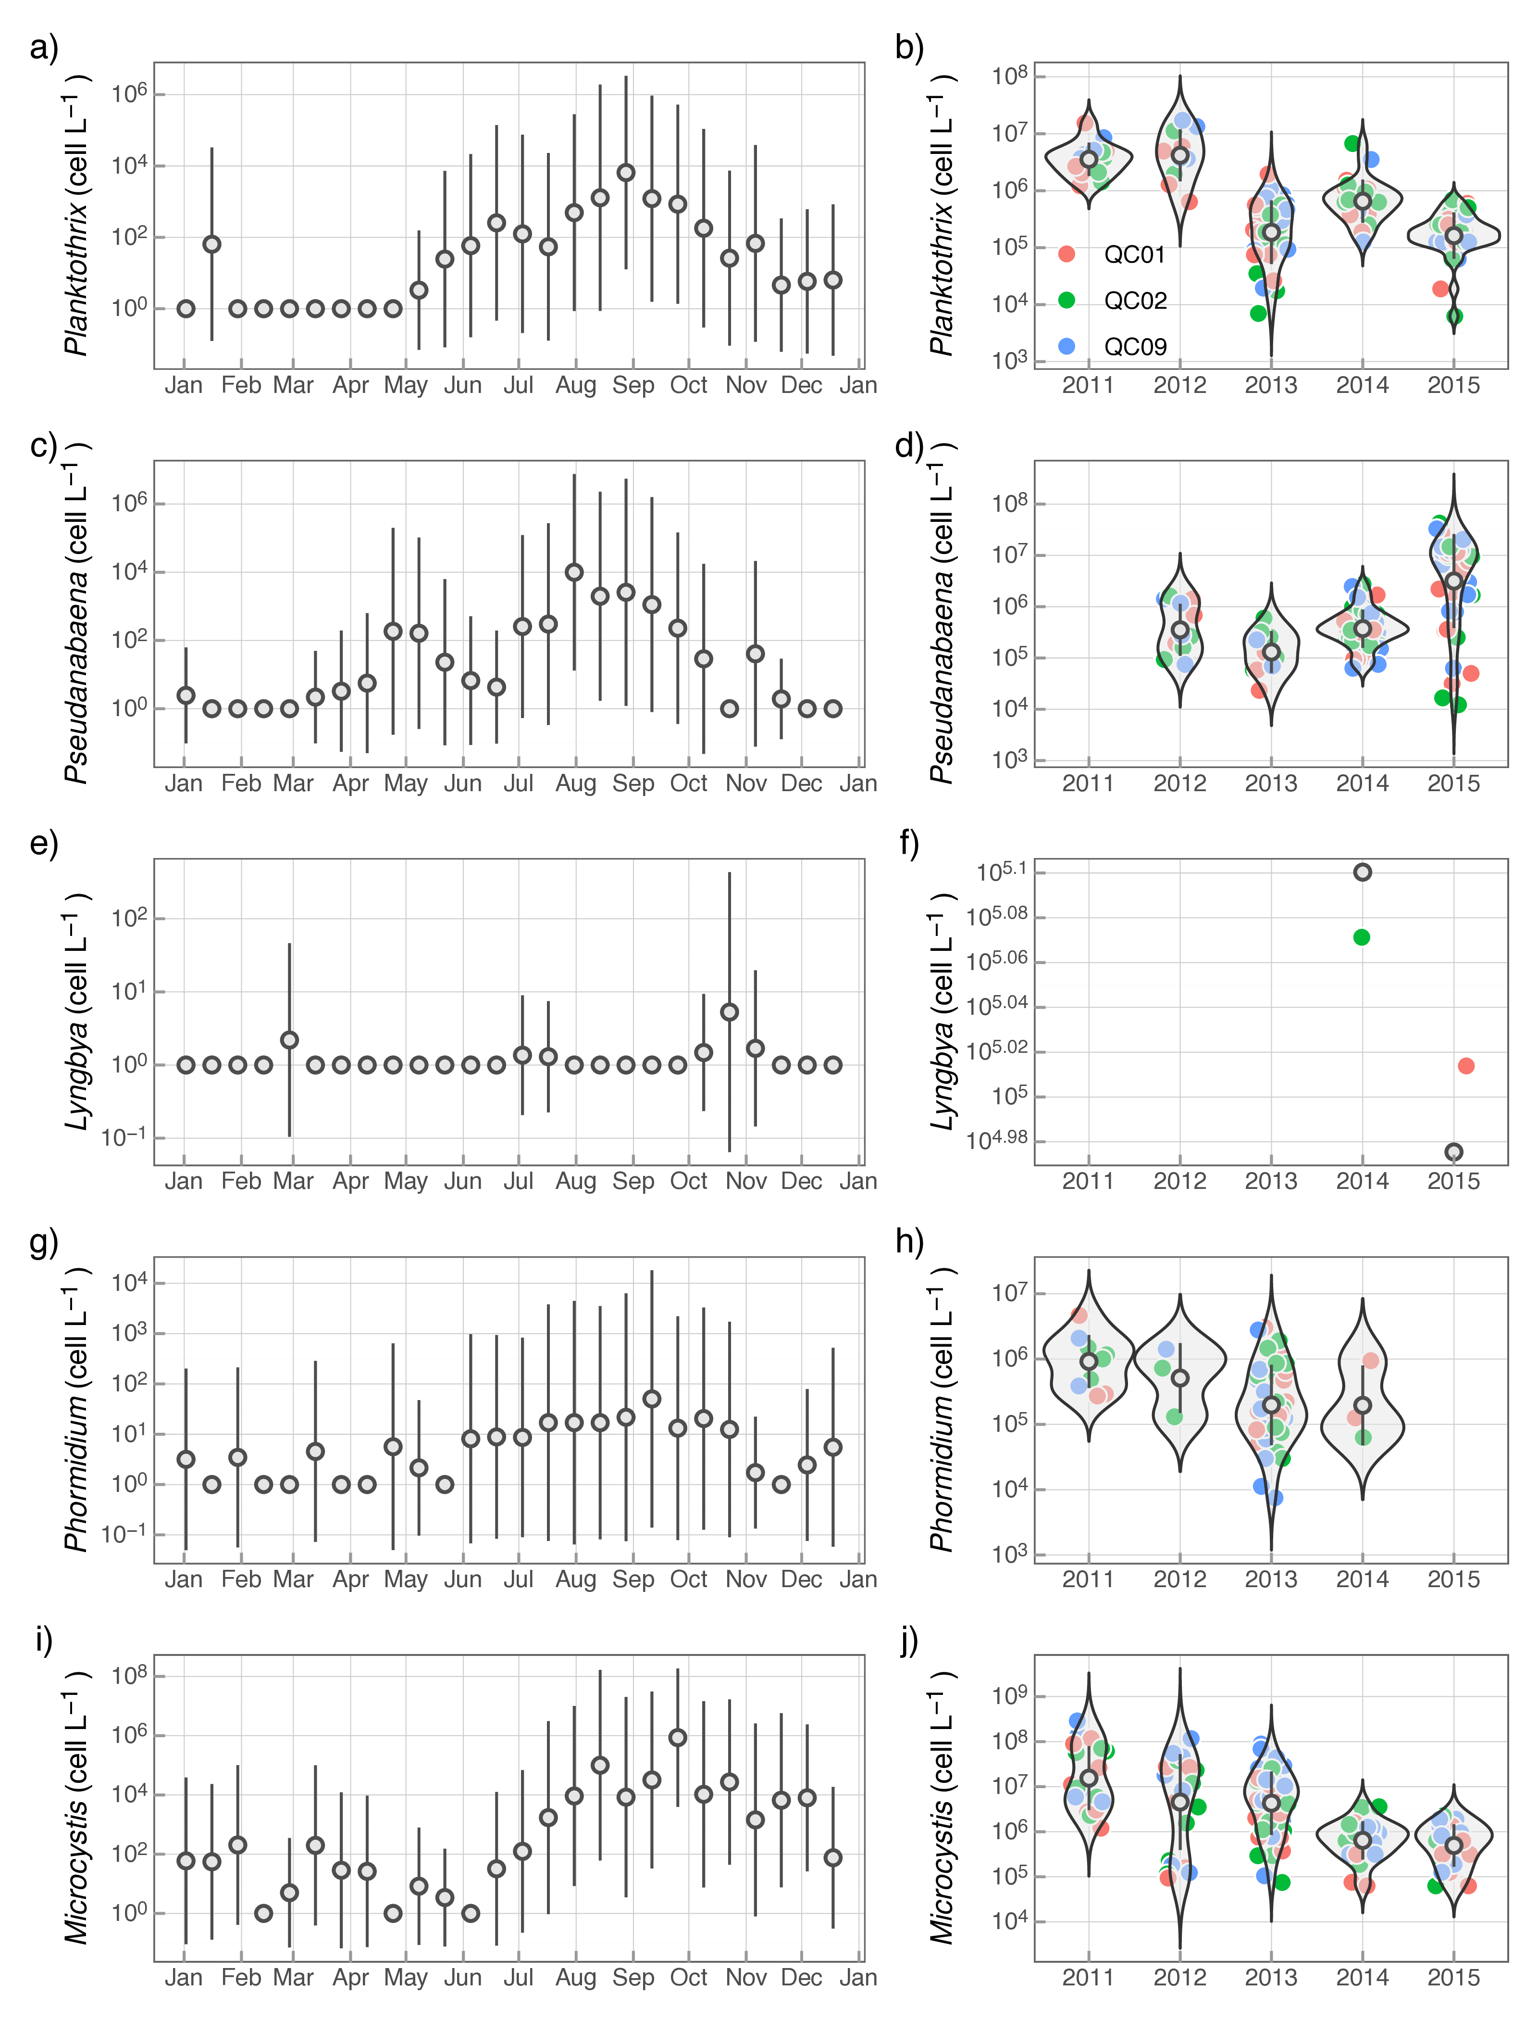
Fig. S3 Seasonal dynamics and long-term trends of Planktothrix, Pseudanabaena, Lyngbya, Phormidium and Microcystis in QCS Reservoir

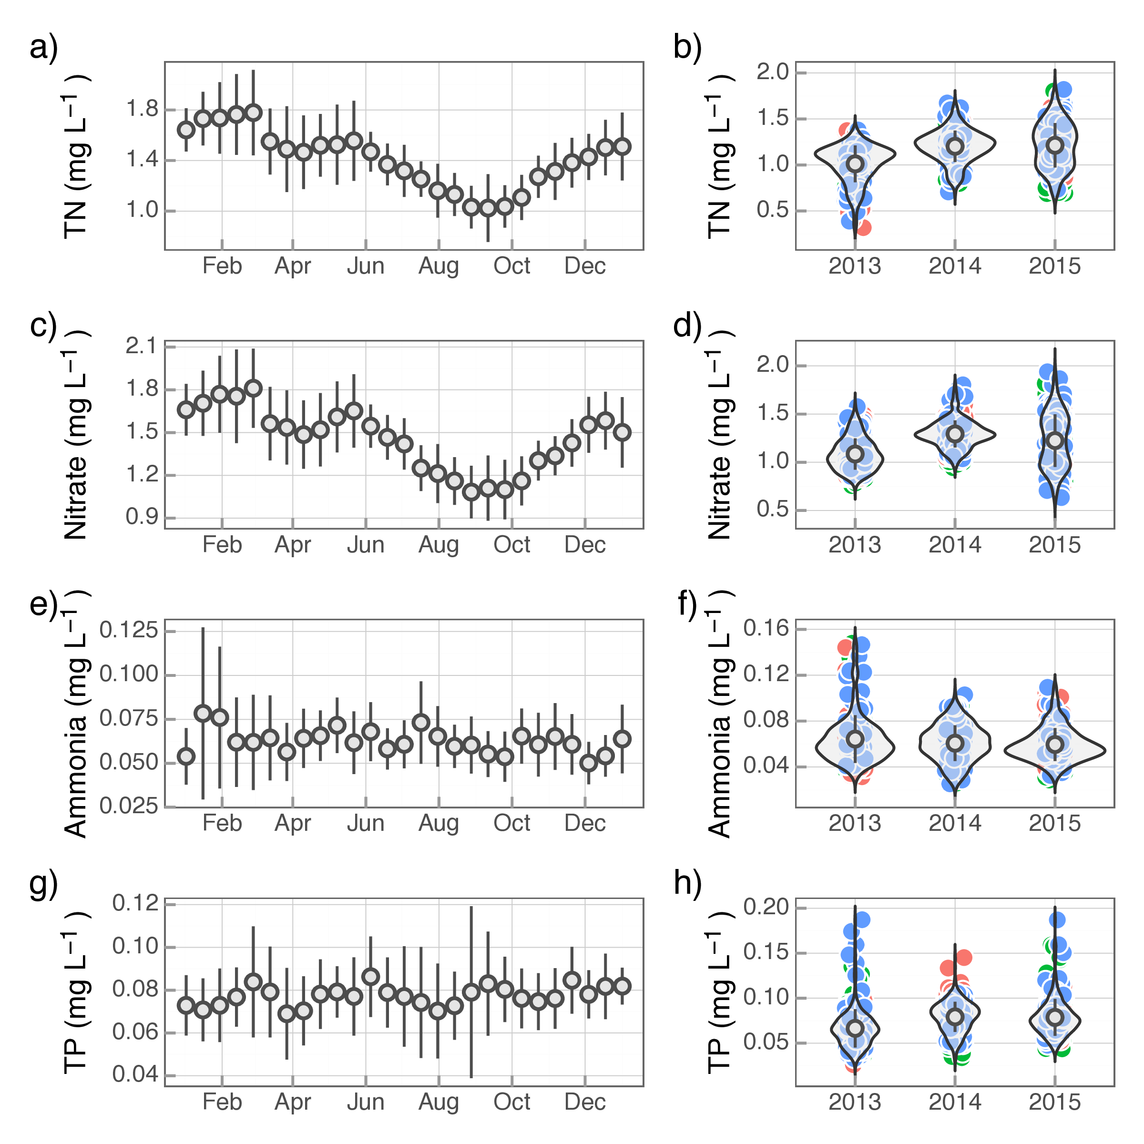
Fig. S4 Seasonal dynamics and long-term trends of nutrients (total nitrogen, nitrate, ammonia and total phosphorus) in QCS Reservoir

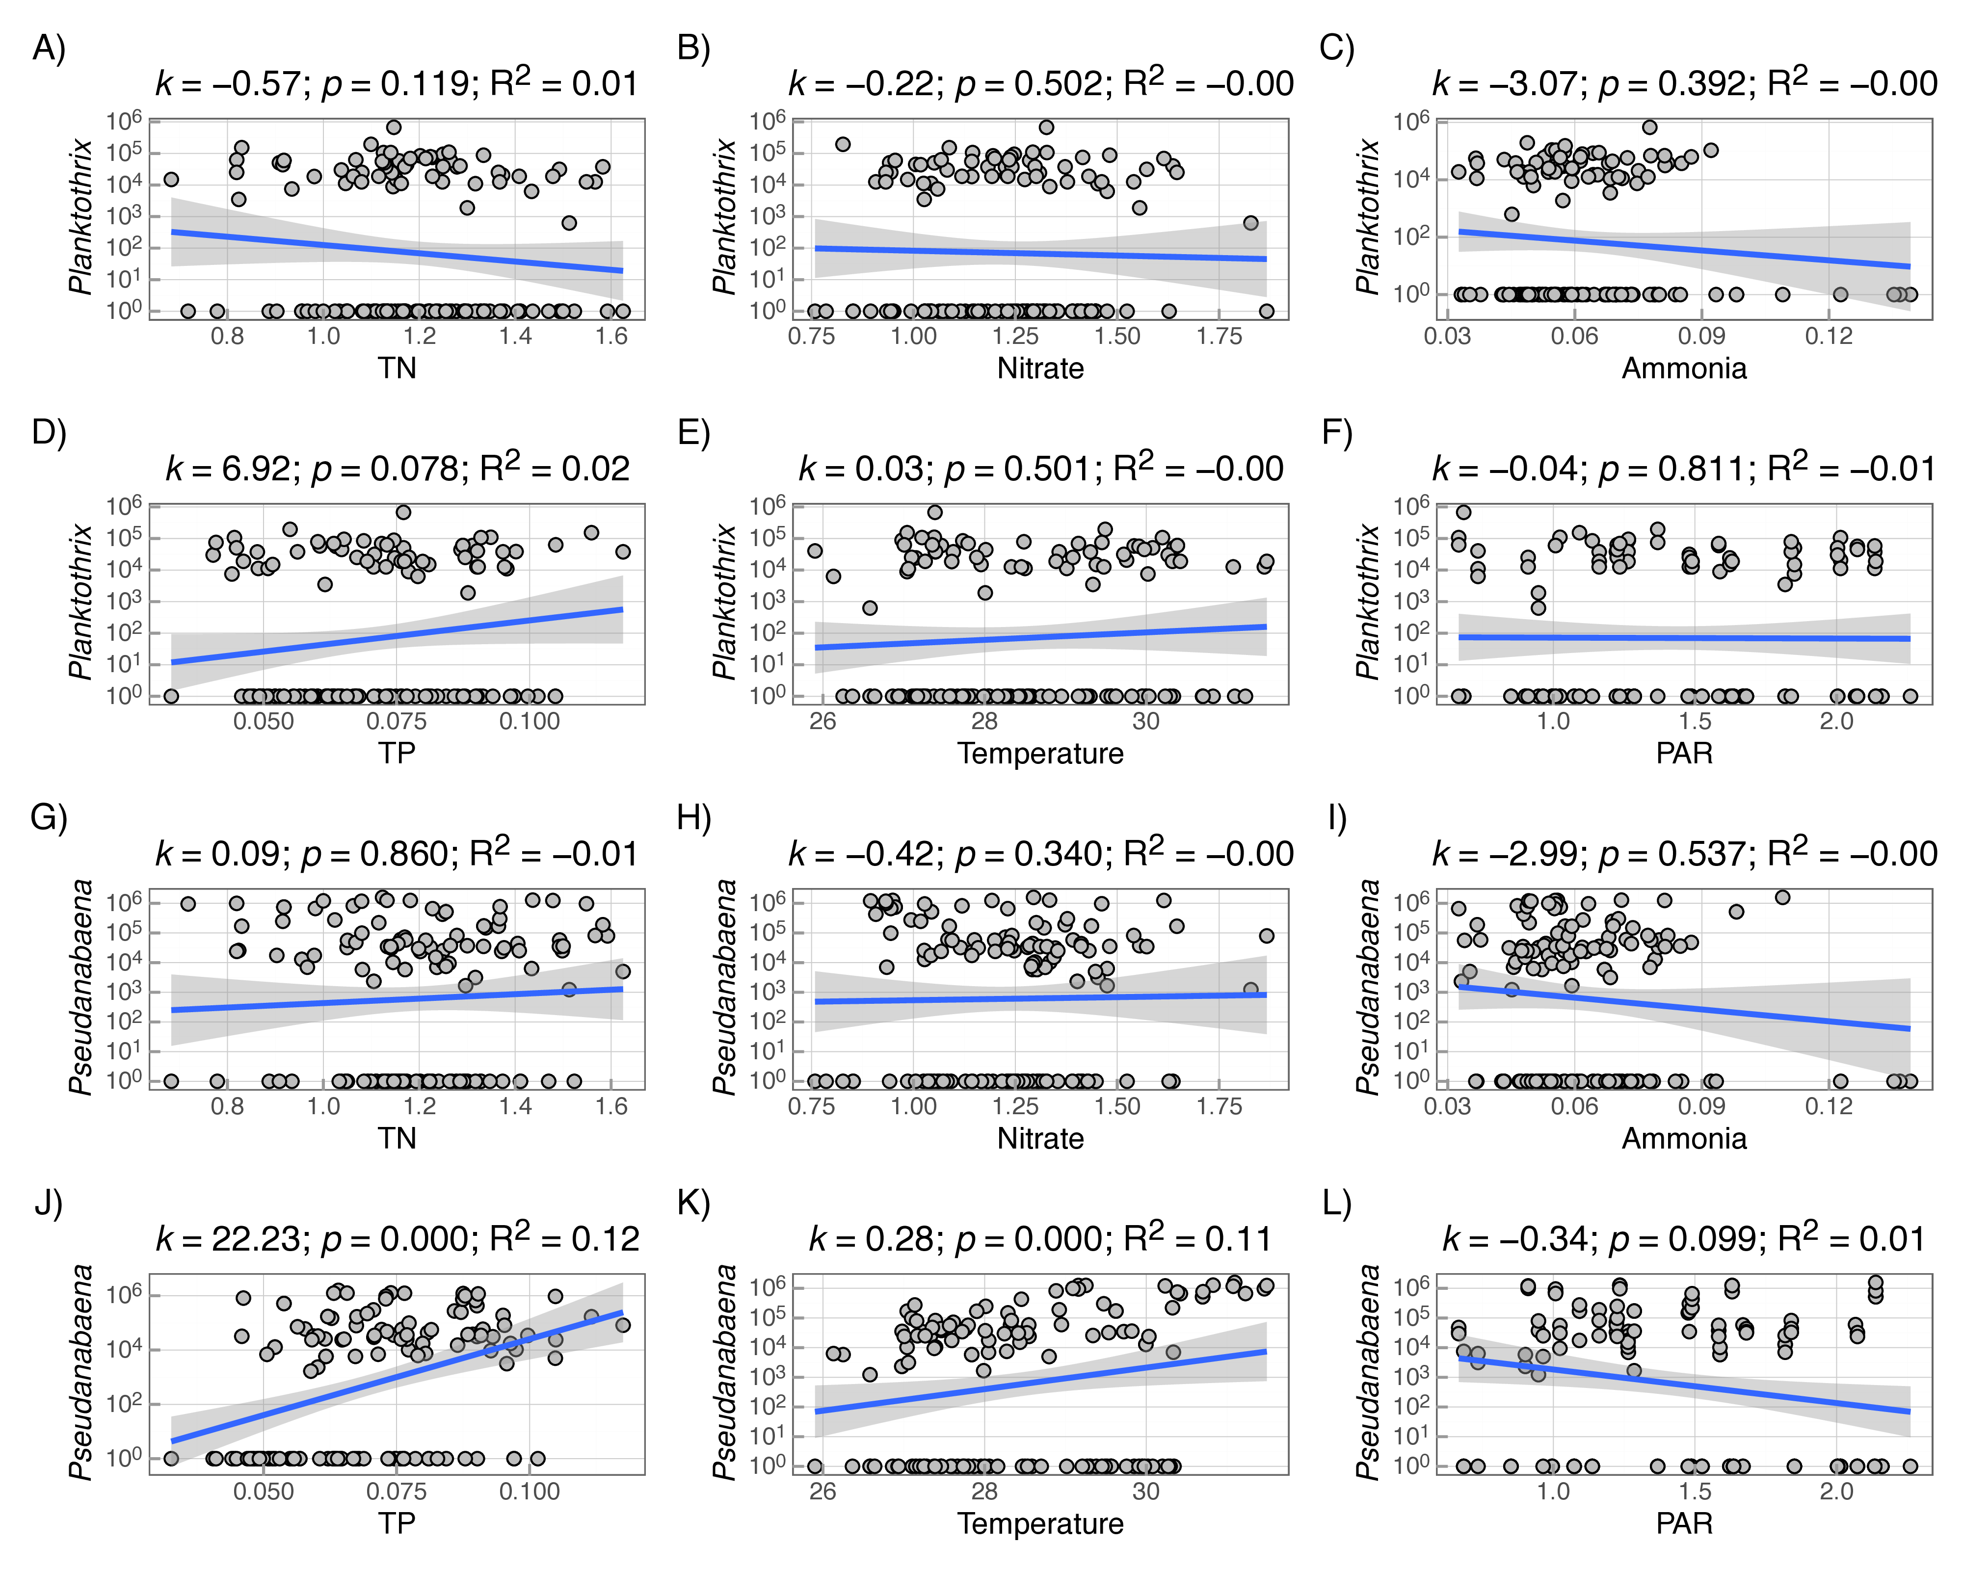
Fig. S5 Correlation between factors and filamentous abundances

Year | Season | Min | Max | Median | IQR | Mean | SD | SE | CI
2013 | Spring | 0.037 | 0.078 | 0.055 | 0.013 | 0.055 | 0.010 | 0.002 | 0.004
2013 | Summer | 0.033 | 0.139 | 0.058 | 0.018 | 0.063 | 0.023 | 0.003 | 0.006
2013 | Autumn | 0.035 | 0.127 | 0.067 | 0.027 | 0.065 | 0.021 | 0.004 | 0.007
2013 | Winter | 0.028 | 0.201 | 0.053 | 0.089 | 0.088 | 0.064 | 0.021 | 0.050
2014 | Spring | 0.045 | 0.107 | 0.071 | 0.019 | 0.074 | 0.016 | 0.002 | 0.005
2014 | Summer | 0.032 | 0.093 | 0.059 | 0.016 | 0.061 | 0.013 | 0.001 | 0.003
2014 | Autumn | 0.024 | 0.105 | 0.044 | 0.027 | 0.051 | 0.019 | 0.003 | 0.007
2014 | Winter | 0.034 | 0.183 | 0.067 | 0.024 | 0.078 | 0.034 | 0.007 | 0.015
2015 | Spring | 0.034 | 0.104 | 0.069 | 0.019 | 0.068 | 0.016 | 0.003 | 0.006
2015 | Summer | 0.033 | 0.109 | 0.058 | 0.022 | 0.062 | 0.016 | 0.002 | 0.005
2015 | Autumn | 0.039 | 0.077 | 0.054 | 0.008 | 0.056 | 0.011 | 0.003 | 0.007
2015 | Winter | 0.022 | 0.081 | 0.053 | 0.028 | 0.052 | 0.022 | 0.009 | 0.023
Table S1 Descriptive statistics of ammonia nitrogen in QCS Reservoir (unit: mg L⁻¹)

Year | Season | Min | Max | Median | IQR | Mean | SD | SE | CI
2013 | Spring | 1.213 | 1.702 | 1.415 | 0.179 | 1.431 | 0.118 | 0.024 | 0.05
2013 | Summer | 0.759 | 1.665 | 1.110 | 0.269 | 1.137 | 0.194 | 0.025 | 0.05
2013 | Autumn | 0.843 | 1.71 | 1.029 | 0.445 | 1.140 | 0.281 | 0.047 | 0.095
2013 | Winter | 1.390 | 1.828 | 1.557 | 0.167 | 1.600 | 0.136 | 0.045 | 0.105
2014 | Spring | 1.578 | 2.162 | 1.796 | 0.121 | 1.800 | 0.130 | 0.019 | 0.038
2014 | Summer | 0.944 | 1.737 | 1.293 | 0.176 | 1.306 | 0.163 | 0.019 | 0.038
2014 | Autumn | 1.159 | 1.707 | 1.309 | 0.119 | 1.352 | 0.129 | 0.023 | 0.047
2014 | Winter | 1.561 | 2.362 | 2.008 | 0.196 | 2.008 | 0.189 | 0.039 | 0.082
2015 | Spring | 1.157 | 1.793 | 1.485 | 0.271 | 1.474 | 0.186 | 0.033 | 0.068
2015 | Summer | 0.895 | 1.867 | 1.411 | 0.414 | 1.333 | 0.264 | 0.037 | 0.074
2015 | Autumn | 0.729 | 1.365 | 1.145 | 0.234 | 1.092 | 0.189 | 0.052 | 0.114
2015 | Winter | 1.595 | 1.774 | 1.708 | 0.131 | 1.694 | 0.078 | 0.032 | 0.082
Table S2 Descriptive statistics of nitrate nitrogen in QCS Reservoir (unit: mg L⁻¹)

Year | Season | Min | Max | Median | IQR | Mean | SD | SE | CI
2013 | Spring | 1.008 | 1.469 | 1.326 | 0.156 | 1.313 | 0.113 | 0.023 | 0.048
2013 | Summer | 0.683 | 1.411 | 1.126 | 0.150 | 1.094 | 0.153 | 0.020 | 0.040
2013 | Autumn | 0.319 | 1.592 | 1.006 | 0.583 | 1.052 | 0.351 | 0.059 | 0.119
2013 | Winter | 1.367 | 1.735 | 1.543 | 0.161 | 1.542 | 0.132 | 0.044 | 0.101
2014 | Spring | 1.478 | 2.265 | 1.808 | 0.217 | 1.795 | 0.164 | 0.024 | 0.048
2014 | Summer | 0.808 | 1.705 | 1.237 | 0.192 | 1.228 | 0.195 | 0.023 | 0.045
2014 | Autumn | 0.959 | 1.601 | 1.236 | 0.125 | 1.250 | 0.142 | 0.025 | 0.052
2014 | Winter | 1.361 | 2.429 | 2.073 | 0.337 | 1.974 | 0.259 | 0.054 | 0.112
2015 | Spring | 1.234 | 1.875 | 1.419 | 0.191 | 1.450 | 0.154 | 0.028 | 0.056
2015 | Summer | 0.718 | 1.654 | 1.317 | 0.355 | 1.292 | 0.223 | 0.031 | 0.063
2015 | Autumn | 0.726 | 1.348 | 1.013 | 0.135 | 1.017 | 0.156 | 0.043 | 0.094
2015 | Winter | 1.348 | 1.75 | 1.59 | 0.279 | 1.581 | 0.177 | 0.072 | 0.186
Table S3 Descriptive statistics of total nitrogen (TN) in QCS Reservoir (unit: mg L⁻¹)

Year | Season | Min | Max | Median | IQR | Mean | SD | SE | CI
2013 | Spring | 0.053 | 0.095 | 0.077 | 0.016 | 0.078 | 0.012 | 0.003 | 0.005
2013 | Summer | 0.033 | 0.25 | 0.064 | 0.023 | 0.07 | 0.036 | 0.005 | 0.009
2013 | Autumn | 0.046 | 0.121 | 0.070 | 0.017 | 0.072 | 0.015 | 0.003 | 0.005
2013 | Winter | 0.055 | 0.095 | 0.060 | 0.018 | 0.067 | 0.013 | 0.004 | 0.010
2014 | Spring | 0.050 | 0.133 | 0.089 | 0.022 | 0.089 | 0.019 | 0.003 | 0.005
2014 | Summer | 0.047 | 0.118 | 0.081 | 0.024 | 0.079 | 0.017 | 0.002 | 0.004
2014 | Autumn | 0.056 | 0.126 | 0.084 | 0.011 | 0.088 | 0.013 | 0.002 | 0.005
2014 | Winter | 0.058 | 0.133 | 0.092 | 0.037 | 0.091 | 0.021 | 0.004 | 0.009
2015 | Spring | 0.042 | 0.115 | 0.073 | 0.023 | 0.073 | 0.019 | 0.003 | 0.007
2015 | Summer | 0.046 | 0.222 | 0.077 | 0.022 | 0.083 | 0.027 | 0.004 | 0.007
2015 | Autumn | 0.065 | 0.092 | 0.072 | 0.012 | 0.075 | 0.008 | 0.002 | 0.005
2015 | Winter | 0.069 | 0.096 | 0.075 | 0.006 | 0.078 | 0.010 | 0.004 | 0.010
Table S4 Descriptive statistics of total phosphrus (TP) in QCS Reservoir (unit: mg L⁻¹)

Year | Season | Min | Max | Median | IQR | Mean | SD | SE | CI
2013 | Spring | 11.208 | 24.642 | 19.468 | 5.594 | 19.475 | 4.088 | 0.834 | 1.726
2013 | Summer | 24.563 | 30.343 | 28.701 | 1.977 | 28.348 | 1.609 | 0.208 | 0.416
2013 | Autumn | 11.564 | 27.028 | 21.502 | 7.032 | 20.788 | 5.019 | 0.836 | 1.698
2013 | Winter | 3.927 | 9.514 | 5.846 | 4.501 | 6.853 | 2.403 | 0.801 | 1.847
2014 | Spring | 12.100 | 25.821 | 20.99 | 6.767 | 20.322 | 4.091 | 0.591 | 1.188
2014 | Summer | 25.688 | 28.549 | 27.386 | 0.832 | 27.367 | 0.691 | 0.08 | 0.159
2014 | Autumn | 12.874 | 26.943 | 21.812 | 7.086 | 21.447 | 4.271 | 0.767 | 1.567
2014 | Winter | 7.19 | 11.001 | 8.403 | 1.759 | 8.637 | 1.168 | 0.244 | 0.505
2015 | Spring | 11.17 | 25.049 | 22.13 | 3.92 | 20.856 | 4.131 | 0.742 | 1.515
2015 | Summer | 24.69 | 31.491 | 28.798 | 2.92 | 28.475 | 1.953 | 0.273 | 0.549
2015 | Autumn | 16.102 | 28.22 | 26.413 | 5.503 | 23.534 | 4.587 | 1.272 | 2.772
2015 | Winter | 7.861 | 8.981 | 8.092 | 0.554 | 8.278 | 0.447 | 0.182 | 0.469
Table S5 Descriptive statistics of water temperature in QCS Reservoir (unit: °C)

Year | Season | Min | Max | Median | IQR | Mean | SD | SE | CI
2013 | Spring | 0.815 | 1.879 | 1.273 | 0.410 | 1.322 | 0.314 | 0.064 | 0.133
2013 | Summer | 0.901 | 2.261 | 1.638 | 0.810 | 1.621 | 0.416 | 0.054 | 0.107
2013 | Autumn | 0.701 | 1.468 | 1.152 | 0.409 | 1.110 | 0.247 | 0.041 | 0.084
2013 | Winter | 0.483 | 1.311 | 0.798 | 0.139 | 0.873 | 0.298 | 0.099 | 0.229
2014 | Spring | 0.854 | 1.977 | 1.552 | 0.395 | 1.528 | 0.284 | 0.041 | 0.083
2014 | Summer | 0.666 | 1.840 | 1.226 | 0.453 | 1.235 | 0.316 | 0.036 | 0.073
2014 | Autumn | 0.643 | 1.487 | 0.957 | 0.368 | 0.999 | 0.254 | 0.046 | 0.093
2014 | Winter | 0.461 | 1.254 | 0.938 | 0.241 | 0.857 | 0.248 | 0.052 | 0.107
2015 | Spring | 0.870 | 2.033 | 1.462 | 0.572 | 1.418 | 0.355 | 0.064 | 0.130
2015 | Summer | 0.734 | 2.138 | 1.235 | 0.482 | 1.293 | 0.352 | 0.049 | 0.099
2015 | Autumn | 0.638 | 1.460 | 1.253 | 0.185 | 1.195 | 0.329 | 0.091 | 0.199
2015 | Winter | 0.415 | 0.994 | 0.598 | 0.297 | 0.700 | 0.239 | 0.097 | 0.251
Table S6 Descriptive statistics of pre-week PAR in QCS Reservoir (unit: mol m⁻² d⁻¹)

Term | EDF | Ref.DF | Statistic | P.Value
s(nweek) | 5.293509 | 8.000000 | 21.395662 | 0.000000
s(ndate) | 1.757591 | 1.757591 | 3.755324 | 0.091522
Table S7 Summary of time series analysis for Planktothrix; s(nweek) denotes the seasonal pattern, and s(ndate) denotes the long-term pattern

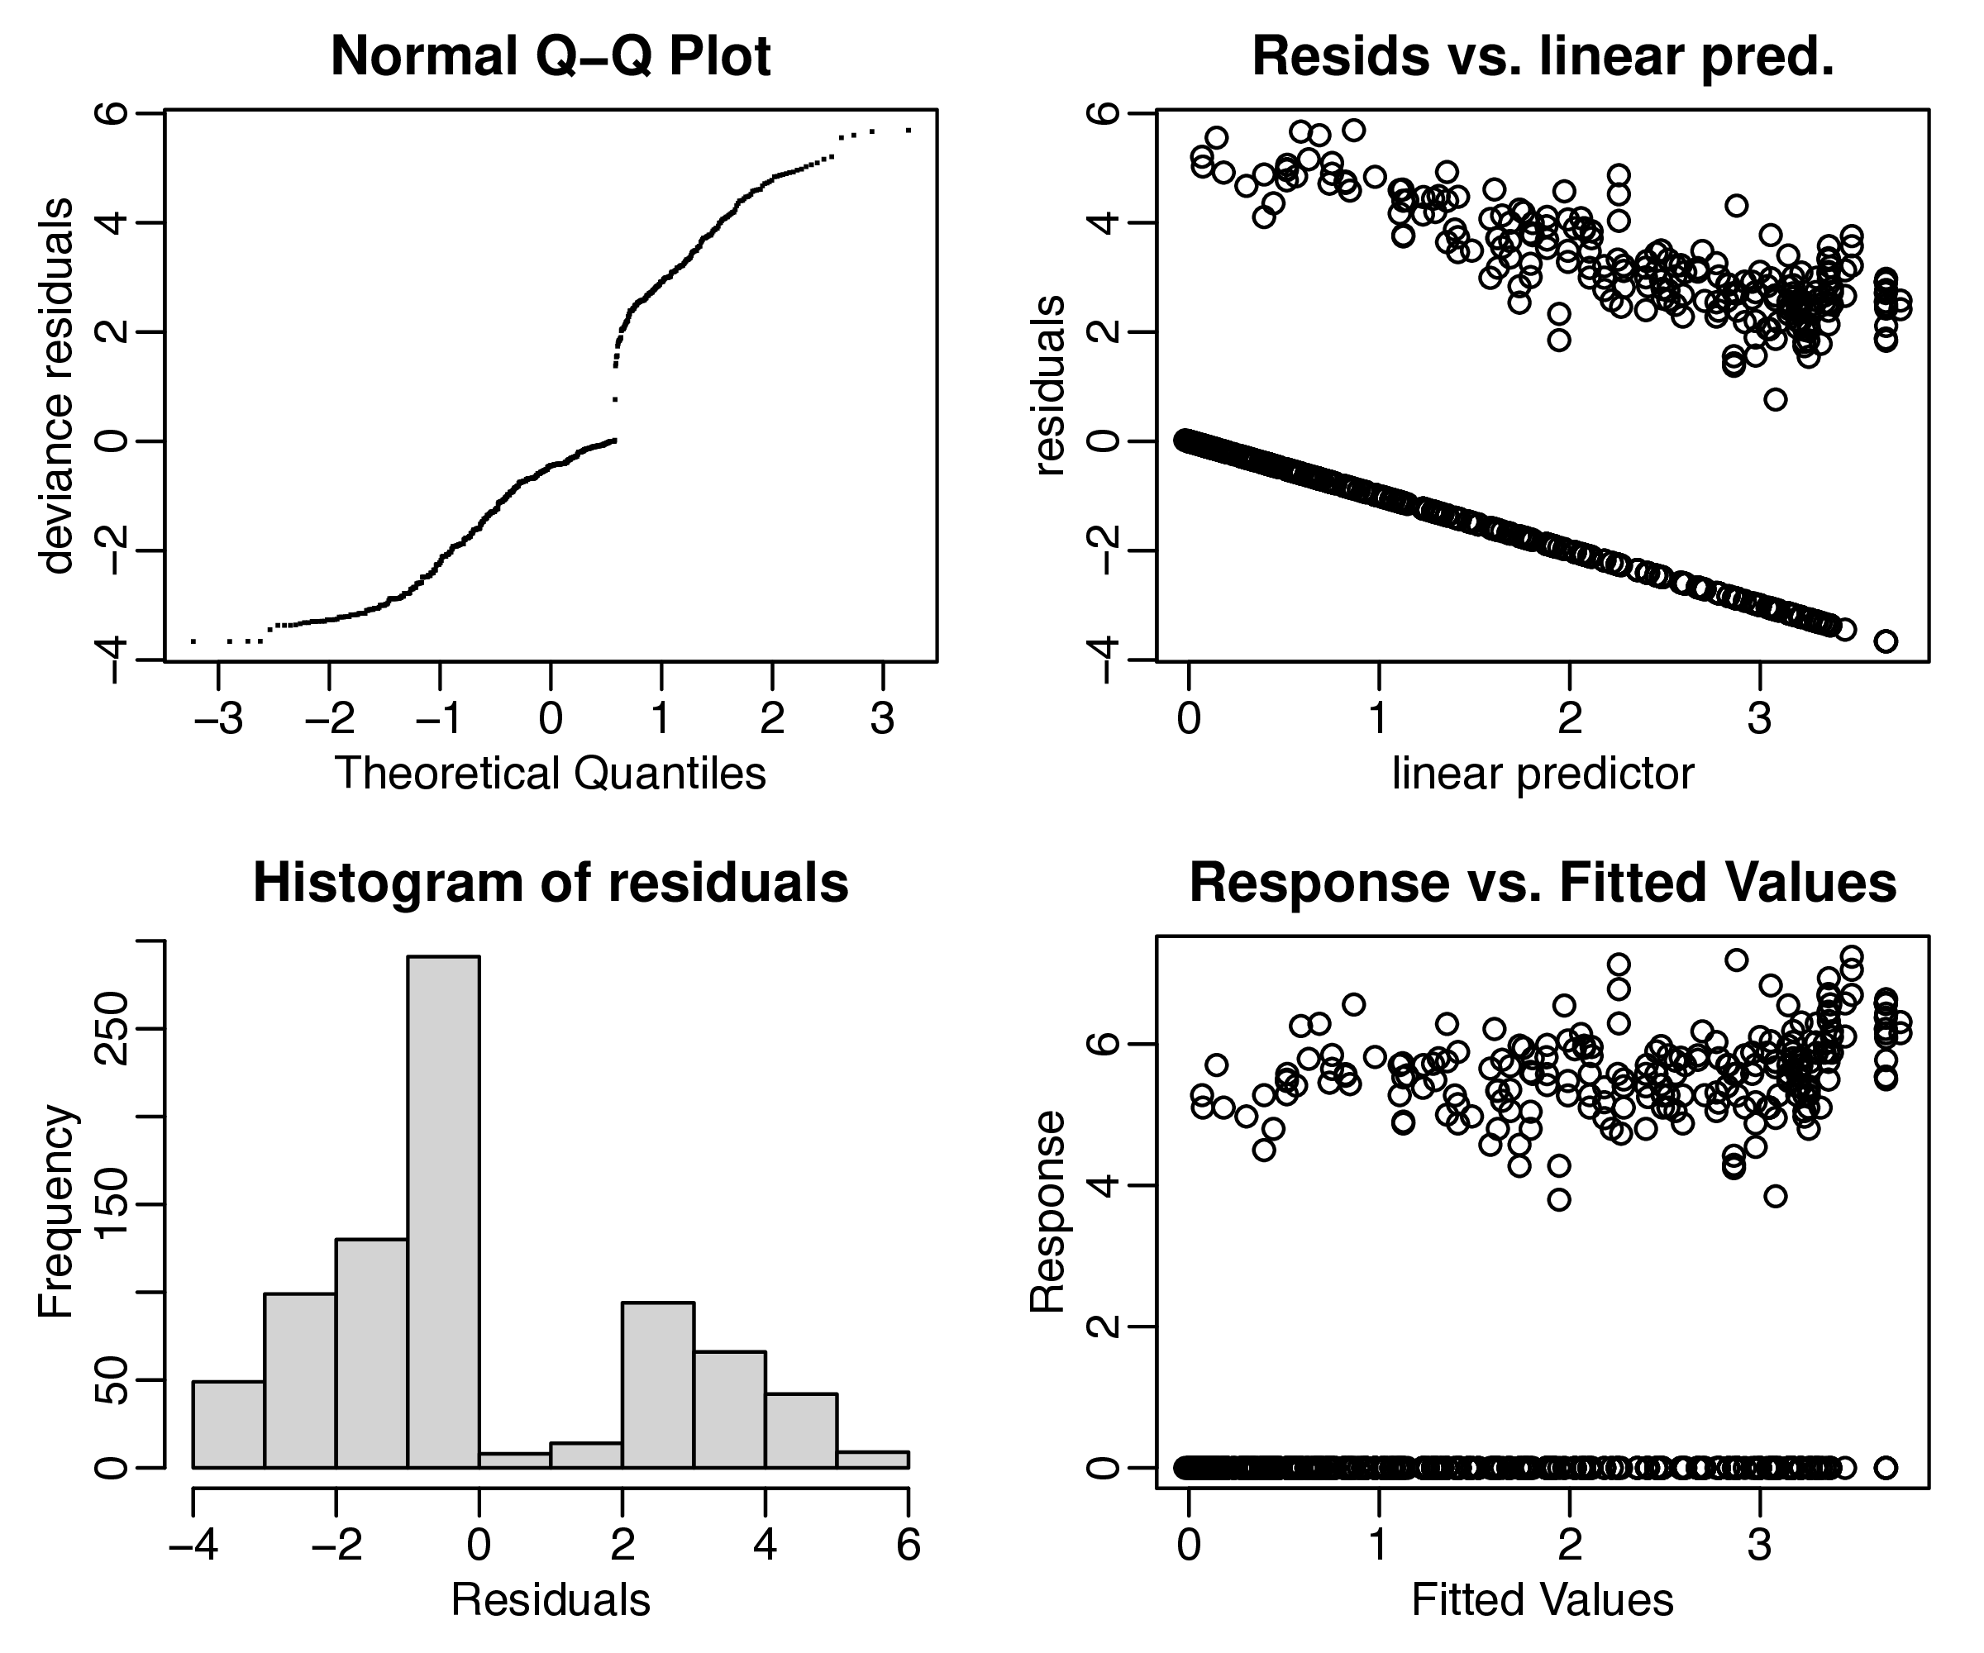
Fig. S6 Time series analysis of Planktothrix based on seasonal and long-term trend smooth functions
Seasonal and long-term trends of Planktothrix and Pseudanabaena were evaluated using time series analysis, as illustrated in Table S7, Fig. S6, Table S8 and Fig. S7.
Term | EDF | Ref.DF | Statistic | P.Value
s(nweek) | 6.246786 | 8.000000 | 11.302972 | 0.000000
s(ndate) | 1.943873 | 1.943873 | 82.456653 | 0.000000
Table S8 Summary of time series analysis for Pseudanabaena; s(nweek) denotes the seasonal pattern, and s(ndate) denotes the long-term pattern

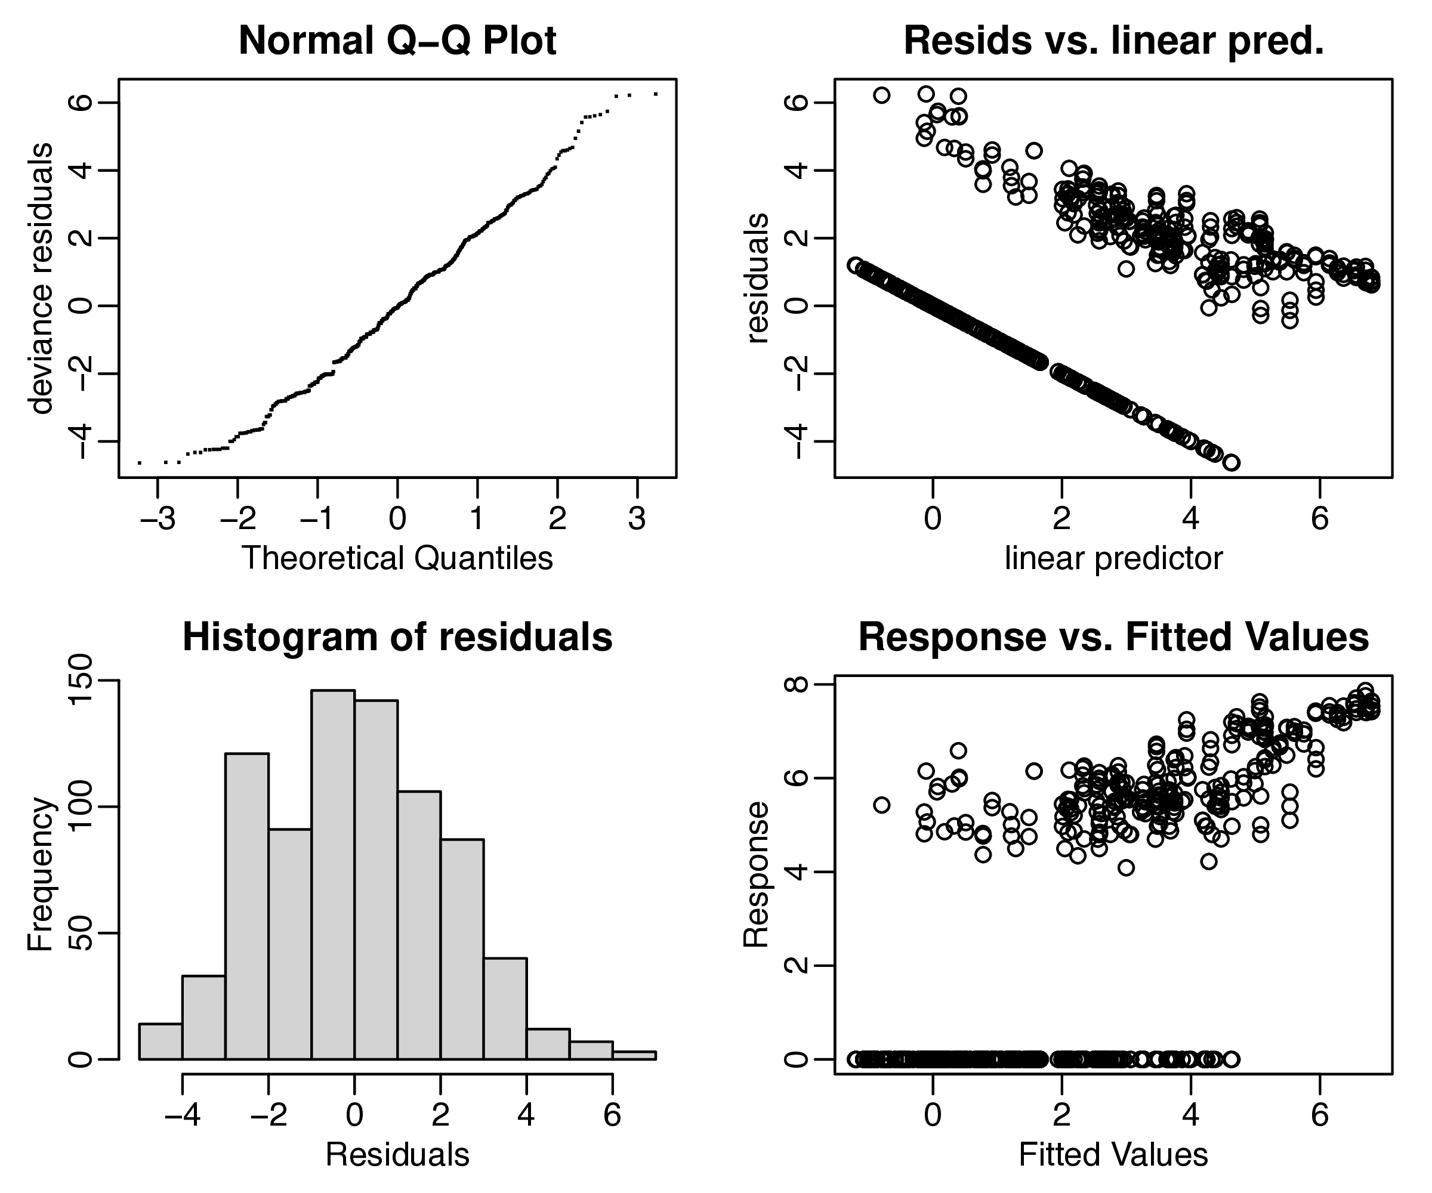
Fig. S7 Time series analysis for Pseudanabaena based on seasonal and long-term trend smooth functions
We select water temperature (temp), pre-week photosynthetically active radiation (weekPAR), total nitrogen (TN), nitrate (NO3), total phosphate (TP), ammonia (NH4), wind speed (wind) and maximum daily air temperature (maxtemp) as the potential predictors for abundances of Planktothrix (Table S9) and Pseudanabaena (Table S10). Linear model ($Y=∑β_{i}X_{i}+β_{0}+ϵ$, $ϵ∈N\left(0,1\right),i=1,2,...$) between these predictors ($X_{i}$, i = 1, 2, …) and logarithm transformed abundances ($Y=log_{10}\left(1+N\right)$).
Term | Estimate | Std.Error | Statistic | P.Value
(Intercept) | 0.055381 | 0.204114 | 0.271325 | 0.786326
temp | 0.020686 | 0.006190 | 3.342053 | 0.000936
weekPAR | -0.043151 | 0.062931 | -0.685693 | 0.493431
TN | -0.125703 | 0.134448 | -0.934960 | 0.350554
NO3 | -0.110292 | 0.143055 | -0.770975 | 0.441323
TP | 0.915797 | 1.105912 | 0.828092 | 0.408270
NH4 | -0.721135 | 0.911296 | -0.791330 | 0.429371
wind | 0.085435 | 0.042653 | 2.003032 | 0.046064
maxtemp | -0.003568 | 0.005304 | -0.672707 | 0.501646
Table S9 Correlation analysis between Planktothrix and environmental factors (named as LM1)

Term | Estimate | Std.Error | Statistic | P.Value
(Intercept) | -0.249268 | 0.208706 | -1.194353 | 0.233274
temp | 0.041253 | 0.006329 | 6.518053 | 2.97e-10
weekPAR | -0.119826 | 0.064347 | -1.862196 | 0.063543
TN | 0.189667 | 0.137473 | 1.379667 | 0.168707
NO3 | -0.068600 | 0.146274 | -0.468984 | 0.639418
TP | 0.202906 | 1.130792 | 0.179437 | 0.857715
NH4 | -0.737178 | 0.931798 | -0.791136 | 0.429484
wind | -0.034087 | 0.043612 | -0.781579 | 0.435072
maxtemp | -0.012824 | 0.005423 | -2.364817 | 0.018669
Table S10 Correlation analysis between Pseudanabaena and environmental factors (named as LM2)
We performed Backward Stepwise Regressions to identify the significant variables responsible for the abundances of Planktothrix and Pseudanabaena. The regression started with a model that contains all variables, and then removing the least significant variables one by one, until a pre-specified stopping rule (here we use AIC rule) is reached.
Below is the Backward Stepwise Regressions of linear model for Planktothrix, the water temperature (temp), pre-week PAR (weekPAR), total nitrogen (TN) and wind speed (wind) were considered as effect predictors for Planktothrix.
Term | Estimate | Std.Error | Statistic | P.Value
(Intercept) | 0.029206 | 0.183201 | 0.159421 | 0.873442
temp | 0.018787 | 0.003960 | 4.744185 | 3.21e-06
weekPAR | -0.066606 | 0.057760 | -1.153142 | 0.249749
TN | -0.194775 | 0.073604 | -2.646272 | 0.008558
wind | 0.075903 | 0.040487 | 1.874726 | 0.061780
Table S11 Backward Stepwise Regression of linear models for Planktothrix
Below is the Backward Stepwise Regressions of linear model for Pseudanabaena, the water temperature (temp), pre-week PAR (weekPAR), total nitrogen (TN), ammonia (NH4) and maximum daily air temperature (maxtemp) were considered as effect predictors for Pseudanabaena.
Term | Estimate | Std.Error | Statistic | P.Value
(Intercept) | -0.351 | 0.162542 | -2.159404 | 0.031596
temp | 0.043007 | 0.005947 | 7.231744 | 3.84e-12
weekPAR | -0.118911 | 0.063542 | -1.871372 | 0.062248
TN | 0.142841 | 0.078959 | 1.809052 | 0.071424
NH4 | -0.888384 | 0.900174 | -0.986903 | 0.324470
maxtemp | -0.013610 | 0.005303 | -2.566502 | 0.010749
Table S12 Backward Stepwise Regression of linear models for Pseudanabaena
Backward Stepwise Regression approaches were performed for the two linear models to find out the optimum selections of predictors, as summarize in Table S11 (Planktothrix) and Table S12 (Pseudanabaena), respectively. Water temperature (temp), pre-week PAR (weekPAR), total nitrogen (TN), wind speed (wind) and maximum daily air temperature (maxtemp) were sorted out.
Parameter | VIF
temp | 2.025278
weekPAR | 1.449414
TN | 1.734340
TP | 1.148326
NH4 | 1.179282
wind | 1.119961
Table S13 VIF analysis of selected predictors of Planktothrix and Pseudanabaena models
According to the Backward Stepwise Regressions, water temperature (temp), pre-week PAR (weekPAR), total nitrogen (TN), total phosphate (TP), ammonia (NH4) and wind speed (wind) were selected as the valid predictors and used for following general additive models (GAMs). Variance inflation factors (VIF) were calculated and validated the rationality (<5) for these predictors , as summarized in Table S13.
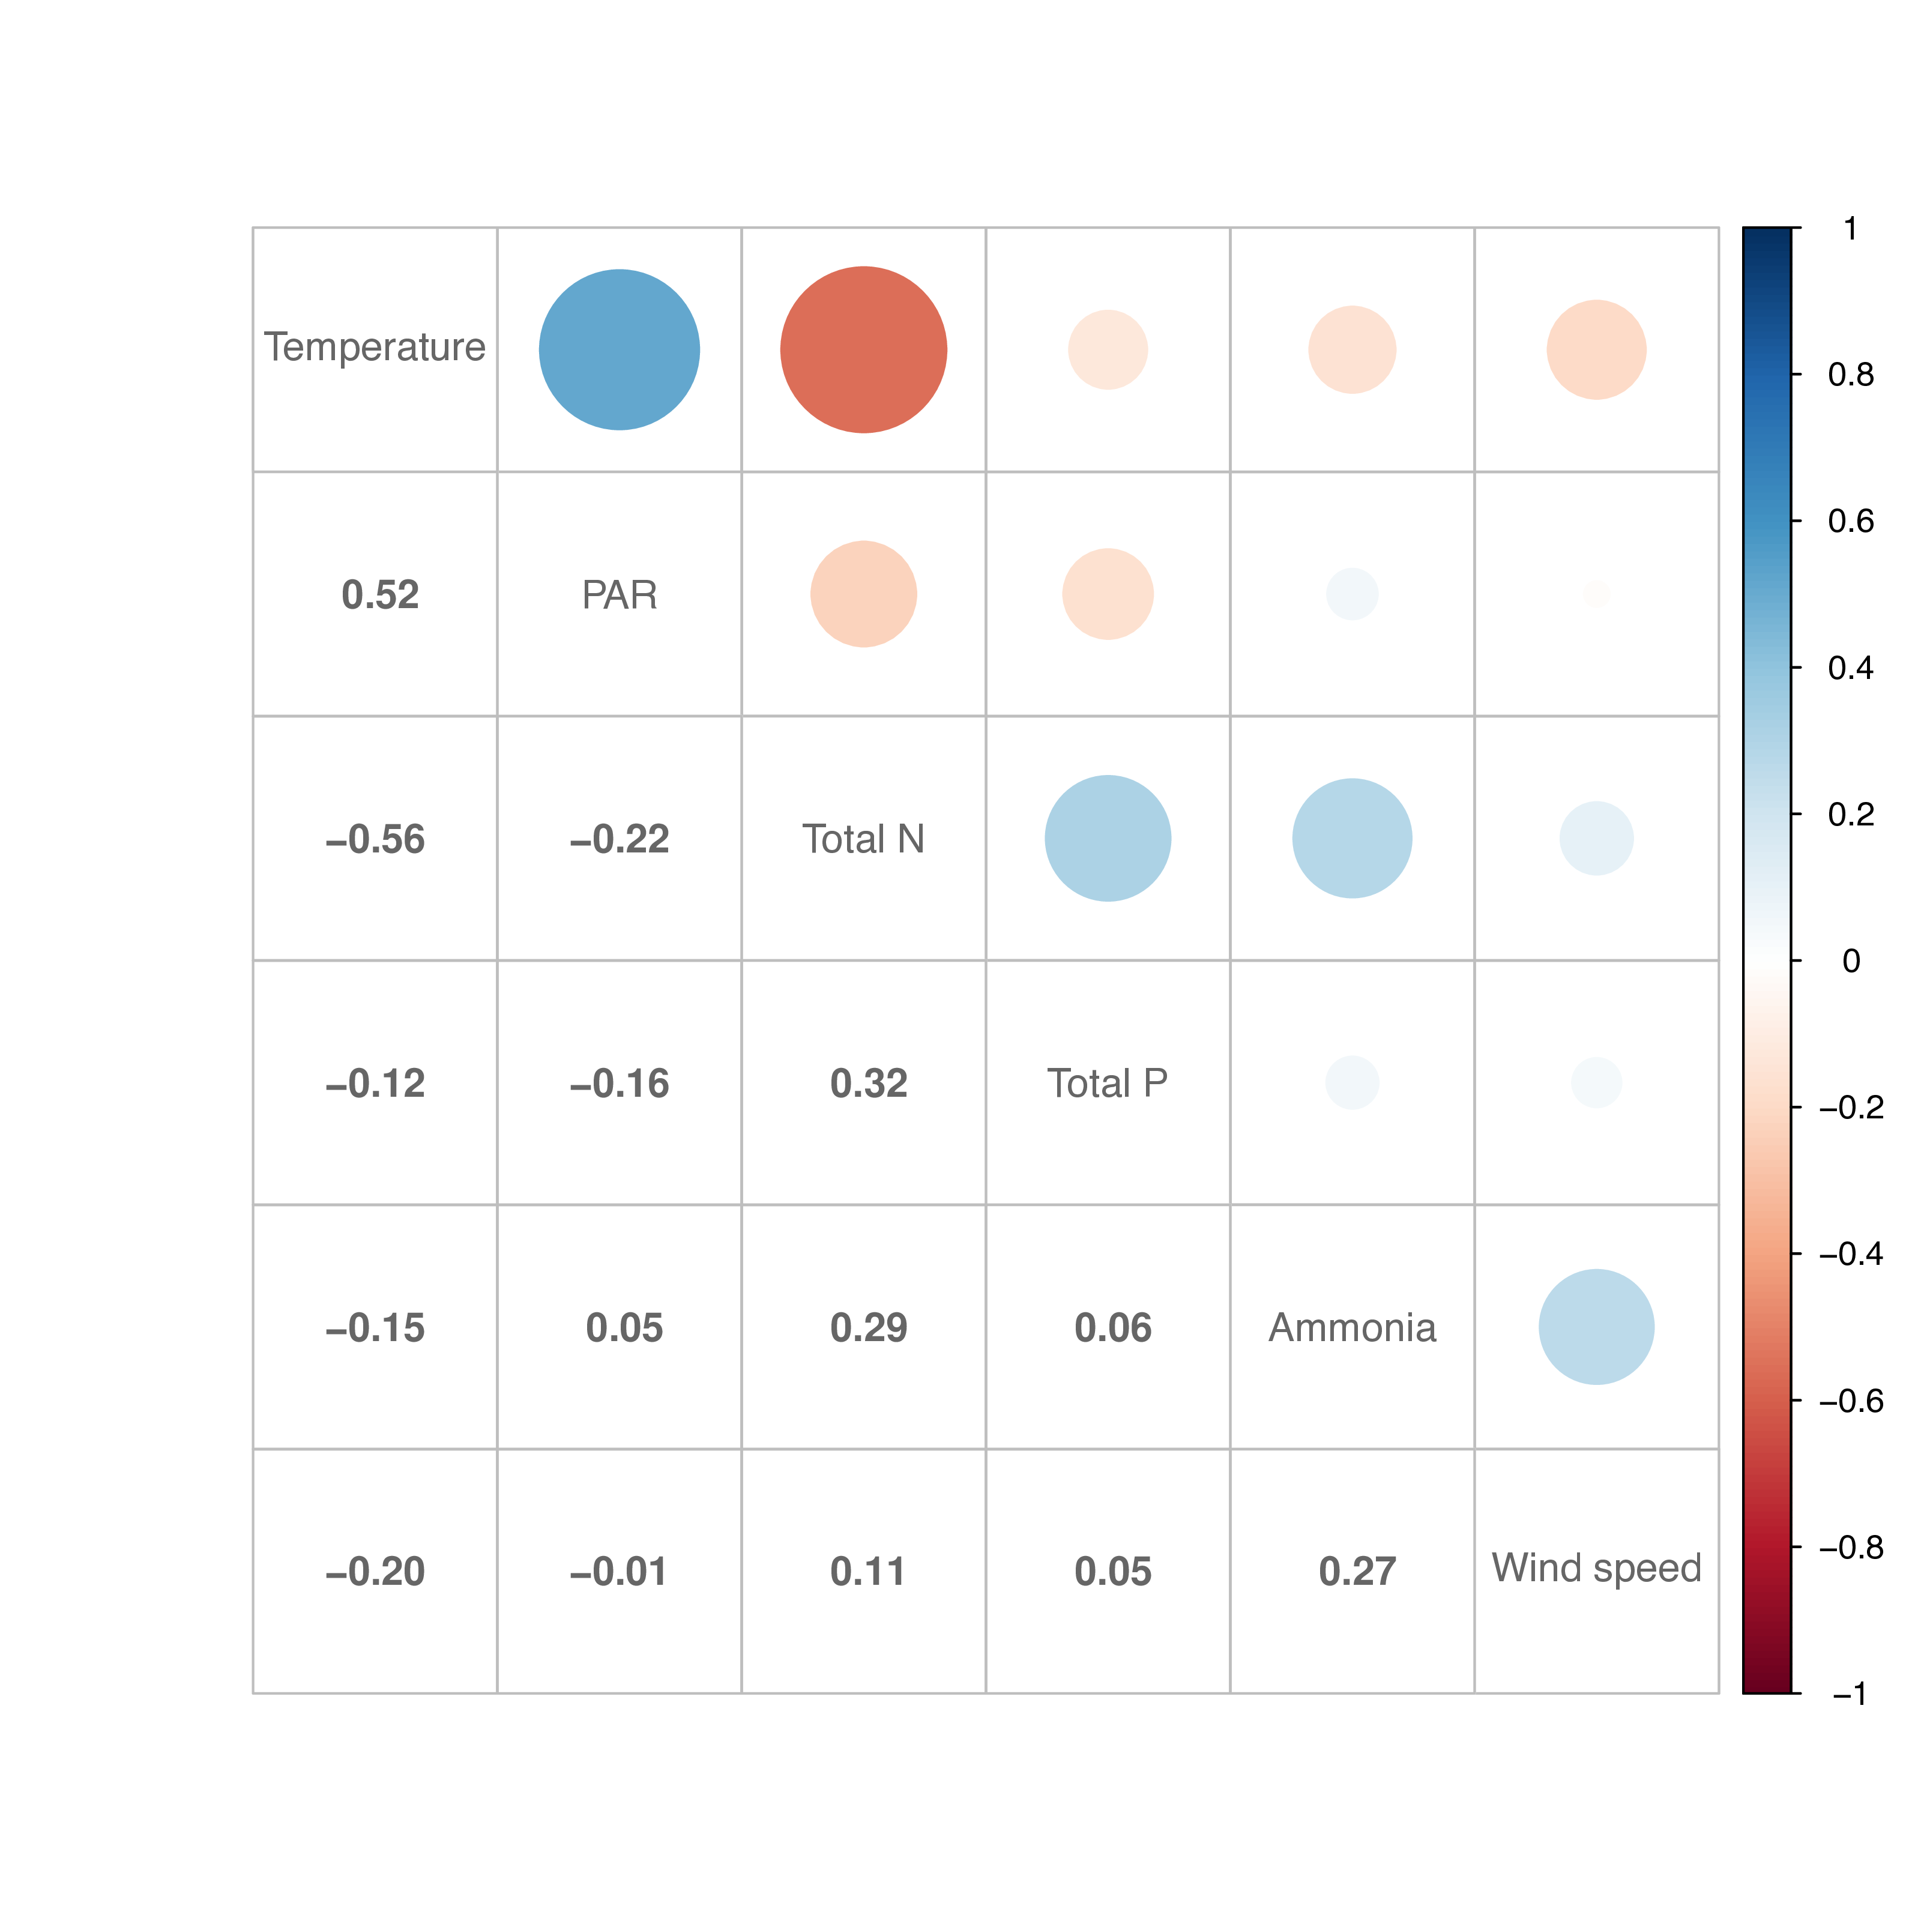
Fig. S8 Correlation between environmental factors
Correlation coefficients among these predictors were computed by Pearson Method, as illustrated in Fig. S8. The results were used for the optimization of non-parameter smooth functions (smoother) in following GAMs for Planktothrix and Pseudanabaena. Specifically, high correlation coefficient between water temperature (temp) and pre-week PAR (PAR) suggests they are interacting predictors; similarly, total nitrogen (TN) and ammonia (NH4) are interacting predictors.
Term | edf | ref.df | Statistic | p-value
t2(temp, weekPAR) | 2.999974 | 2.999974 | 8.441657 | 2.12287e-05
t2(TN, NH4) | 2.999898 | 2.999898 | 2.800880 | 0.04014
s(TP) | 1.000008 | 1.000008 | 0.759490 | 0.38418
s(wind) | 1.000000 | 1.000000 | 3.944025 | 0.04794
Table S14 Summary of GAM model with 6 predictors for Planktothrix (named as GAM1)
Iterations between water temperature and pre-week PAR (t2(temp, weekPAR)), and between total nitrogen and ammonia (t2(TN, NH4)) were both evaluated by the tensor products ($f_{1}\left(x_{1}\right)⊗f_{2}\left(x_{2}\right)$).
The results of “GAM1” suggest water temperature (temp), pre-week PAR (weekPAR), total nitrogen (TN) and ammonia (NH4) are most important predictors for Planktothrix abundance.
Term | edf | ref.df | Statistic | p-value
t2(temp, weekPAR) | 5.733091 | 5.733091 | 9.604014 | 0
t2(TN, NH4) | 2.999999 | 2.999999 | 0.964346 | 0.41001
s(TP) | 2.236544 | 2.236544 | 2.650483 | 0.1095
s(wind) | 4.787511 | 4.787511 | 3.886710 | 0.00265
Table S15 Summary of GAM model with 6 predictors for Pseudanabaena (named as GAM2)
The results of “GAM2” suggest water temperature (temp), pre-week PAR (weekPAR), total phosphrus (TP) and wind speed (wind) are most important predictors for Pseudanabaena abundance.
Term | edf | ref.df | Statistic | p-value
t2(temp, weekPAR) | 2.999993 | 2.999993 | 8.439392 | 1.912541e-05
t2(TN, NH4) | 2.999870 | 2.999870 | 4.088651 | 0.00689
Table S16 Summary of GAM model with 4 predictors for Planktothrix (named as GAM3)
According to “GAM1”, the predictors of Planktothrix abundances were further optimized to 4 factors, which are water temperature (temp), pre-week PAR (weekPAR), total nitrogen (TN) and ammonia (NH4). The summary of optimized Planktothrix GAM (GAM3) results is shown in Table S16.
Term | edf | ref.df | Statistic | p-value
t2(temp, weekPAR) | 5.870002 | 5.870002 | 9.200651 | 0
s(TP) | 2.222784 | 2.222784 | 3.073369 | 0.06404
s(wind) | 4.665106 | 4.665106 | 3.782337 | 0.00378
Table S17 Summary of GAM model with 4 predictors for Pseudanabaena (named as GAM4)
According to “GAM2”, the predictors of Pseudanabaena abundances were further optimized to 4 factors, which are water temperature (temp), pre-week PAR (weekPAR), total phosphorus (TP) and wind speed (wind). The summary of optimized Pseudanabaena GAM (GAM4) results is shown in Table S17.

R Language demonstration code
# demo data frame
require(lubridate)
require(mgcv)
modeldf <- data.frame(date = ymd("2020-01-01") + 0:365,
y = rnorm(366))
# seasonal pattern: week number
modeldf$x1 <- week(modeldf$date)
# long-term pattern: decimal number
modeldf$x2 <- year(modeldf$date) + yday(modeldf$date) / 366
# demo gam model
m <- gamm(y ~ s(x1, bs = "cc") + s(x2), data = modeldf)
1. R Core Team. R: A language and environment for statistical computing. (R Foundation for Statistical Computing, 2020).
2. Wickham, H., François, R., Henry, L. & Müller, K. dplyr: A grammar of data manipulation. (2018).
3. Wood, S. N. Stable and efficient multiple smoothing parameter estimation for generalized additive models. Journal of the American Statistical Association 99, 673–686 (2004).
4. Wood, S. N. Fast stable restricted maximum likelihood and marginal likelihood estimation of semiparametric generalized linear models. Journal of the Royal Statistical Society (b) 73, 3–36 (2011).
5. Koenker, R. Quantreg: Quantile regression. (2017).
6. Wickham, H. ggplot2: Elegant graphics for data analysis. (Springer-verlag New York, 2016).

